Contents

Chapter 11

Introduction2

1.1 Purpose3

1.2 Intended Audience3

1.3 Intended Use3

1.1 Product Scope3

**Chapter 24**

System Architecture description5

2.1 Overview of modules/components6

2.2 Database6

2.3 Class Libraries6

**Chapter 34**

Diagrams5

3.1 E-R diagrams6

3.2 Database schema6

3.3 UML diagrams6

**3.3.1 Class diagrams6**

**3.3.2** **Sequence diagrams6**

**Chapter 44**

Designs5

4.1 UI design6

4.2 Time Detail6

4.3 Project Cost6

# 

# **Chapter 1**

# **Introduction**

## **1.1 Purpose**

The purpose of this report is to give detailed description of the application for online medicine purchasing and ordering named EasyMed. It will clarify the main motive and functionalities of the proposed application, the interfaces of the system, what this application will do, etc. This document will also show the constrains of the app and how to overcome those obliges.

## 

## **1.2 Intended Audience**

This project is about online medicine ordering and purchasing. The intended audience is the honorable faculty member of Software Engineering course and the supervisor of this project Md. Musfique Anwar and the project managers & developers.

## **1.3 Intended Use**

This project is intended to make buying medicine easy for everyone. By using this app anyone can buy medicine and deliver it to them without having to go to a pharmacy. Furthermore, anyone can see the description and side effects without confronting anyone.

## **1.4 Product Scope**

The primary purpose of EasyMed is to purchase medicine by just a single click and to reduce the time consumption. This system will allow user to purchase the medicines and healthcare products through an app and get delivery at home 24/7. The user can also get symptoms-based suggestion and expert advice. This system will save a lot of time of the user. This app-based system will also serve patients in case of emergency.

# **Chapter 2**

# **System Architecture Description**

2.1 Overview of modules/components

2.2 Database

**2.3 Class Libraries**

# **Chapter 3**

# **Diagrams**

3.1 E-R diagrams

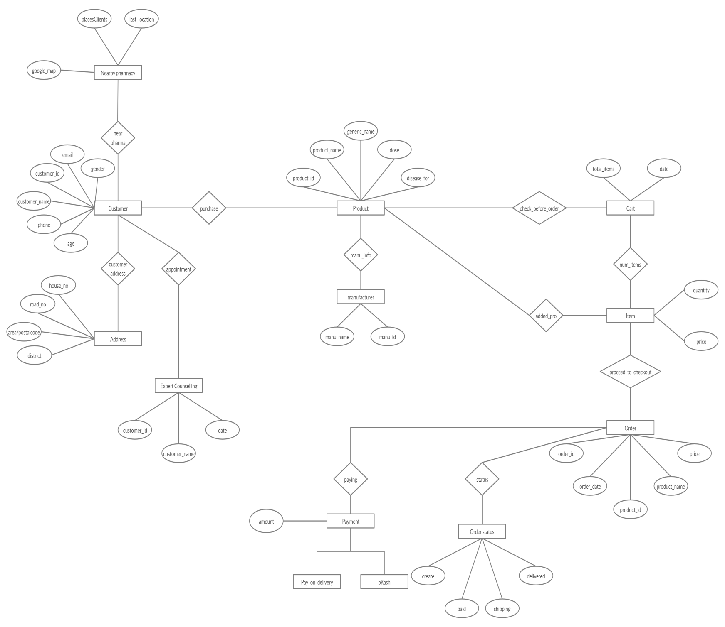

3.2 Database schema

3.3 UML diagrams

3.3.1 Class diagrams

**3.3.2 Sequence diagrams**

* Sequence diagram of login interface

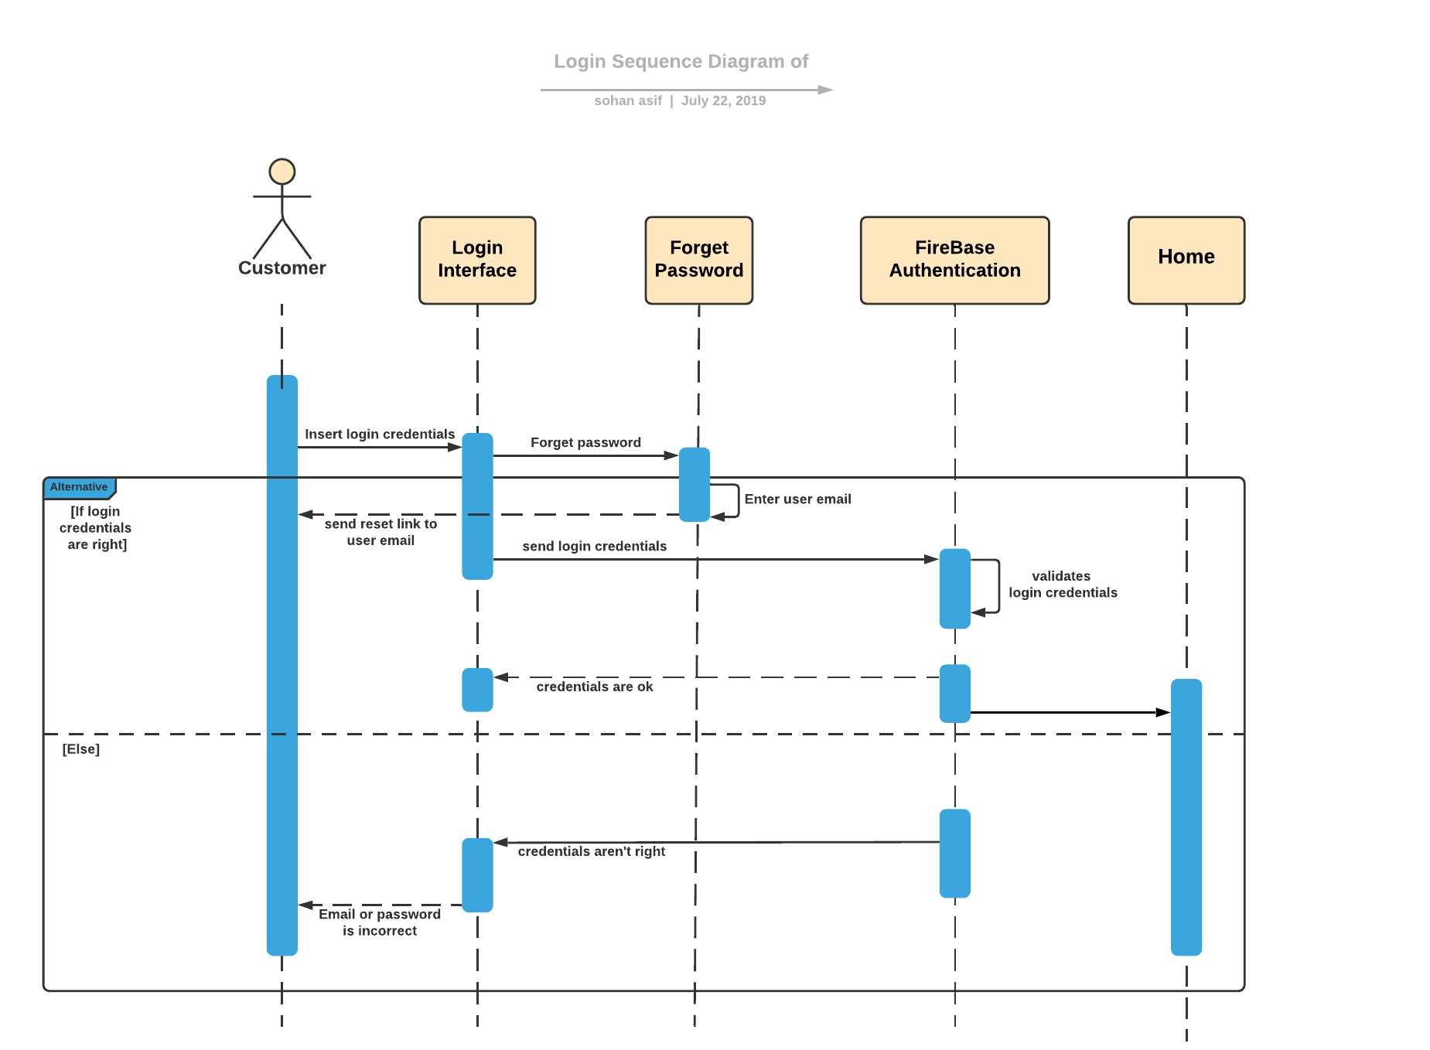

* Sequence Diagram of services of EasyMed

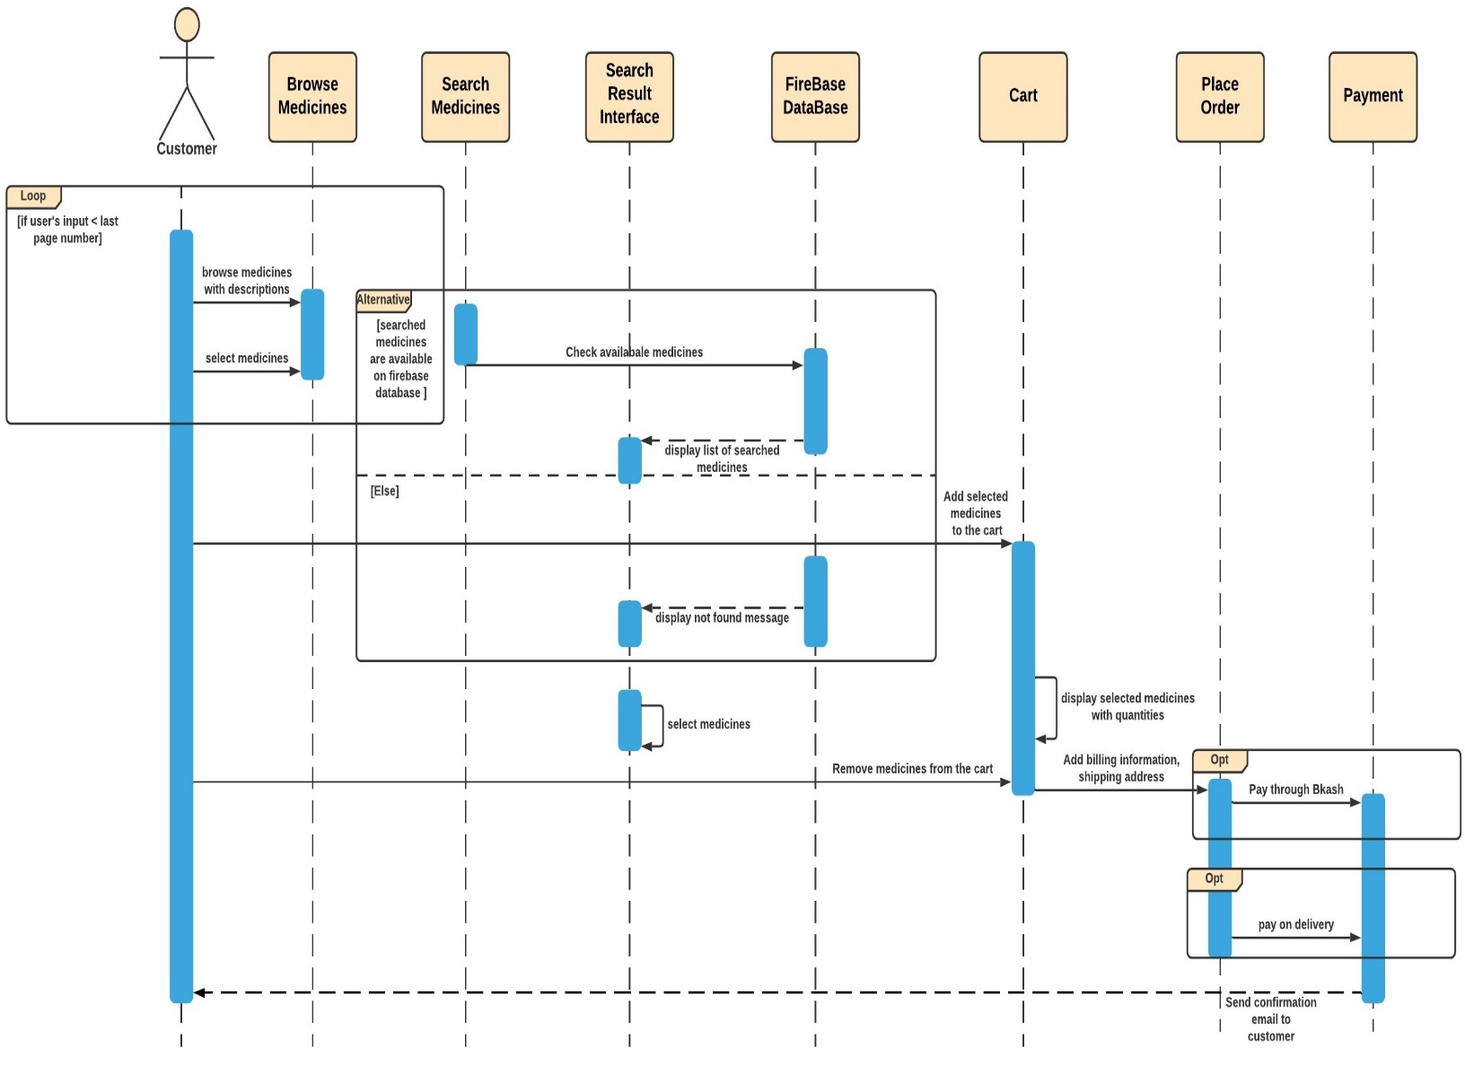

* Sequence diagram of Suggest Medicines based on symptoms

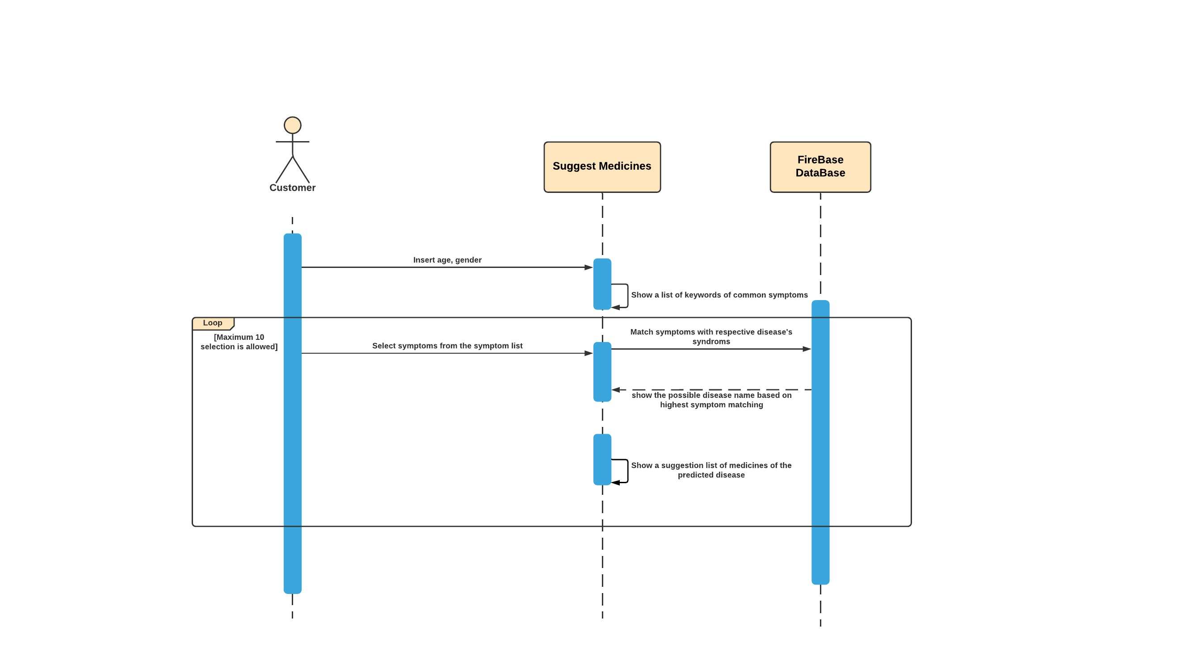

* Sequence diagram of Expert Counselling service

