Test Description: K.S.P Registration(Sign UP)
<Testing the sign up to KSP website>
Test Purpose: <test Sign up for “KSP Web Site”>
Test Run Instructions: <Describe any special instructions needed to execute this test (“Run” phase) >
Test Run Information:  Tester Name: sohayb  Date of Test: 09/01/2024 | Prerequisites for this test: None
Software Versions:
Application: KSP
Browser: google chrome
Database: N/A
Operating System: windows 11
Required Configuration: [ browser setup, security or user ID roles]
No special setup needed
NOTES and RESULTS:

TEST SCRIPT STEPS/RESULTS
STEP | TEST STEP/INPUT | EXPECTED RESULTS | ACTUAL RESULTS | Requirements Validated | PASS/FAIL
<System Test> <Smoke Test>
 | Click on “account” | Menu opens | Menu opens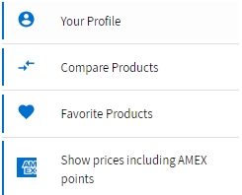 |  | PASS
 | Click on “your Profile”  | Navigate to Sign IN/UP page | Navigate to Sign IN/UP page |  | PASS
 | Click on “Register” | Show Sign up page | Show Sign up page |  | PASS

TEST SCRIPT STEPS/RESULTS
STEP | TEST STEP/INPUT | EXPECTED RESULTS | ACTUAL RESULTS | Requirements Validated | PASS/FAIL
<Sanity Test><Functional Negative Test>
 | Click on “הרשם” while the document is empty | Show error with notice | Show error with notice |  | PASS
 | Fill the First name with numbers | An error is shown | There is no error shown |  | FAIL
 | Fill the Last name with numbers | An error is shown | There is no error shown |  | FAIL
 | Write on E-mail invalid mail “sohayb.saleh” | The error / red notice is shown | The error / red notice is shown |  | PASS
 | Write on E-mail invalid mail “sohayb.saleh.com” | The error / red notice is shown | The error / red notice is shown |  | PASS
 | Write on E-mail invalid mail “sohayb.salehgmail.com” | The error / red notice is shown | The error / red notice is shown |  | PASS
 | Write on E-mail invalid mail “sohayb.saleh@.com” | The error / red notice is shown | The error / red notice is shown |  | PASS
 | Write on E-mail invalid mail “sohayb.saleh@gmasol.com” | The error / red notice is not gone(register unsuccessful) | The error is gone  (register successful) |  | FAIL
 | Write on Phone invalid PhoneNum  (10 num)“6854898498”  - Didn’t start with (050,/1-9) | The error / red notice is shown | The error / red notice is shown |  | PASS
 | Fill the phone  number with letters | Error /red notice is shown | Error /red notice is shown |  | PASS
 | Write on Phone valid number from aboard | No error shown | Error /red notice is shown |  | FAIL
 | Write onנוספת" סיסמה " password didn’t match | Error / red notice is shown | The error / red notice is not gone |  | PASS

TEST SCRIPT STEPS/RESULTS
STEP | TEST STEP/INPUT | EXPECTED RESULTS | ACTUAL RESULTS | Requirements Validated | PASS/FAIL
<Functional Test >
 | Write on First name “sohayb” | No error shown | No error shown |  | PASS
 | Write on Last name “saleh” | No error shown | No error shown |  | PASS
 | Write on E-mail valid mail “sohayb.saleh@gmail.com” | No error shown | No error shown |  | PASS
 | Write on Phone valid PhoneNum  (10 num)“0524558214” | No error shown | No error shown |  | PASS
 | Write on "סיסמה" “so123456” | No error shown | No error shown |  | PASS
 | Write onנוספת" "סיסמה “so123456” | No error shown | No error shown |  | PASS
 | Click on “הרשם” while the document is completed | Navigate to KSP web site successfully | Navigate to KSP web site successfully |  | PASS

TEST SCRIPT STEPS/RESULTS
STEP | TEST STEP/INPUT | EXPECTED RESULTS | ACTUAL RESULTS | Requirements Validated |  | PASS/FAIL
<Boundary Test>
 | Fill the firstname with one letter “s” | Register successfully | Register successfully |  | PASS
 | Fill the lastname with one letter “s” | Register successfully | Register successfully |  | PASS
 | First name and Last name have zero letters | Error /red notice is shown | Error /red notice is shown |  | PASS
 | Phone number has zero digits | Error /red notice is shown | Error /red notice is shown |  | PASS
 | Fill the phone number with 1-9 digits | The error is shown | The error is shown |  | PASS
 | Password has zero chars | Error /red notice is shown | Error /red notice is shown |  | PASS
 | Fill the password with 1-5 digits | Red notice is shown with min limit for password | Red notice is shown with min limit for password |  | PASS

TEST SCRIPT STEPS/RESULTS
STEP | TEST STEP/INPUT | EXPECTED RESULTS | ACTUAL RESULTS | Requirements Validated | PASS/FAIL
<Sanity Test> <useability test>
 | Check if the required field is marked and easy to user to notice them | The required fields are marked with star | The required fields are marked with star |  | PASS
 | Click on “הרשם” while fields are clear | * register unsuccessfully  *every required field will appear an error | * register unsuccessfully  * appear with every field error that shown that is required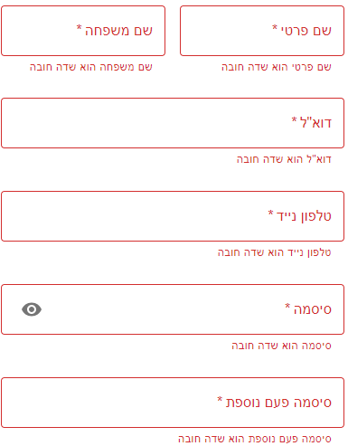 |  | PASS

TEST SCRIPT STEPS/RESULTS
STEP | TEST STEP/INPUT | EXPECTED RESULTS | ACTUAL RESULTS | Requirements Validated | PASS/FAIL
<GUI TEST>
 | Check that is spelling error | There is no spelling error in sign up page  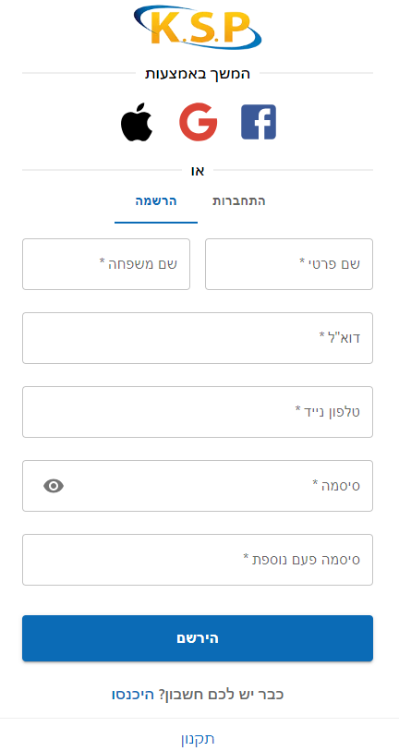 | There is no spelling error |  | PASS
 | Check if there is spelling error with notices | There is no spelling error | There is spelling error in Password field  (סיסמה קצר =>סיסמה קצרה) 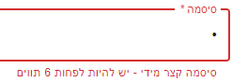 |  | FAIL
 | Check if different display screen is ok | -There is no fields or elements disappear .  -There is scroll up/down when minimize the page. | -There is no fields or elements disappear .  -There is scroll up/down when minimize the page. |  | PASS
 | Check if required fields is clear and click on “הירשם” are shown with red notice | Red notice or an error is shown | Red notice is shown |  | PASS
 | Check if all elements and buttons responds to interactions and their functionality | Every button on has to responds to his interaction  (his job) | Every button work as well |  | PASS

