Test Description: K.S.P Log In(Sign IN)
<Testing the sign IN to KSP website>
Test Purpose: <test Sign in for “KSP Web Site”>

Test Run Information:  Tester Name: sohayb  Date of Test: 09/01/2024 | Prerequisites for this test: None
Software Versions:
Application: KSP
Browser: google chrome
Database: N/A
Operating System: windows 11
 | Required Configuration: E-mail , Password
NOTES and RESULTS:

TEST SCRIPT STEPS/RESULTS
STEP | TEST STEP/INPUT | EXPECTED RESULTS | ACTUAL RESULTS | Requirements Validated | PASS/FAIL
<Sanity Test><Functional Negative Test>
 | Click on “התחבר” while the document is empty | An error/notice shown | An error/notice shown |  | PASS
 | Entering an invalid email for a valid password | An error/notice shown | An error/notice shown |  | PASS
 | Entering an invalid password for a valid username | An error/notice shown | An error/notice shown |  | PASS
 | Entering an empty email field | An error/notice shown | An error/notice shown |  | PASS
 | Entering an empty password field | An error/notice shown | An error/notice shown |  | PASS
 | Entering an Email that does not exist in the system | An error/notice shown | An error/notice shown |  | PASS

TEST SCRIPT STEPS/RESULTS
STEP |  | TEST STEP/INPUT | EXPECTED RESULTS | ACTUAL RESULTS | Requirements Validated | PASS/FAIL
<Functional Test >
 | Enter valid mail “sohayb.saleh@gmail.com” |  | No error shown | No error shown |  | PASS
 | Enter valid password “so123456” |  | No error shown | No error shown |  | PASS
 | Check if there remember me option  (close window and go to ksp again) |  | No needed to enter details (LogIN auto) | No needed to enter details (LogIN auto) |  | PASS

TEST SCRIPT STEPS/RESULTS
STEP | TEST STEP/INPUT | EXPECTED RESULTS | ACTUAL RESULTS | Requirements Validated | PASS/FAIL
<Sanity Test> <useability test>
 | Check if the required field is marked and easy to user to notice them | The required fields are marked with star | The required fields are marked with star |  | PASS
 | Click on “התחבר” while fields are clear | * Log IN unsuccessfully  *every required field will appear an error | * Log IN unsuccessfully  * appear with every field error that shown that is required  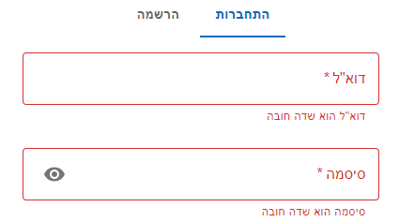 |  | PASS

TEST SCRIPT STEPS/RESULTS
STEP | TEST STEP/INPUT | EXPECTED RESULTS | ACTUAL RESULTS | Requirements Validated | PASS/FAIL
<GUI TEST>
 | Check that there is no spelling error | There is no spelling error in sign In page | There is no spelling error in sign In page |  | PASS
 | Check if there is spelling error with notices | There is no spelling error | There is no spelling error |  | PASS
 | Check if different display screen is ok | -There is no fields or elements disappear .  -There is scroll up/down when minimize the page. | -There is no fields or elements disappear .  -There is scroll up/down when minimize the page. |  | PASS
 | Check if required fields is clear and click on “התחבר” are shown with red notice | Red notice or an error is shown | Red notice is shown |  | PASS
 | Check if all elements and buttons responds to interactions and their functionality | Every button on has to responds to his interaction  (his job) | Every button work as well |  | PASS

TEST SCRIPT STEPS/RESULTS
STEP | TEST STEP/INPUT | EXPECTED RESULTS | ACTUAL RESULTS | Requirements Validated | PASS/FAIL
<DT DEVTOOLS Test >
 | After sign in Response / Request Headers encoded | Response / Request Headers encoded  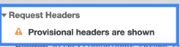 | Response / Request Headers are not encoded  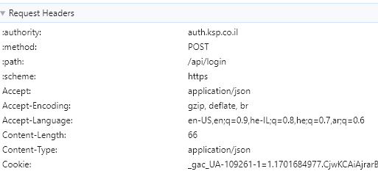 |  | FAIL
 | Check if Payload encoded | Payload not shows details  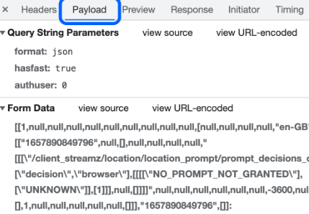 | Payload shows Email and Password  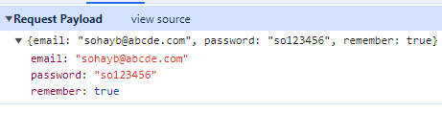 |  | FAIL
 | Check navigation to website | Navigate successfully | Navigate successfully |  | PASS
 | Check the security.js/xml | Request headers encoded | Request headers encoded |  | PASS

