Problem Statement
It is required to implement a Unix shell program. A shell is simply a program that conveniently allows you to run other programs.
_________________________________________________________________

Objectives
- Understanding processes and how they’re nested.
- Understanding Unix commands and system calls.
- Understanding signals and interrupts.
_________________________________________________________________

Design and Implementation

Tools & Libraries Used
- Coded with c++.
- Libraries
  - iostream, string, stdio, stdlib, sys/wait, sys/types and unisted.
_________________________________________________________________

Data Structures
- Char*
  - Read the command line.
- Char**
  - Get the arguments of the command line.

_________________________________________________________________

Built in Functions
- Strings
  - strcmp(), strtok(), memset(), strlen().
- Execution
  - fork(), exit(), execvp(), waitpid().
- Synchronization
  - setpgid(), setpgrp().
_________________________________________________________________

Assumptions
- If a background command is entered a space must exist between the command and the ‘&’.
- The log file contains
  - Shell staring, exit_failure and its termination.
  - The creation of a process and its termination.

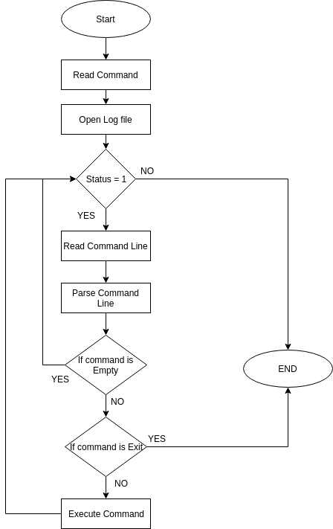
Functionality

Overall
- Upon Entering a command.
  - Parse the line entered and split it around the space delimeter.
  - If the command is empty (=NULL), the loop will continue normally and no action will be taken.
  - If the command is exit, the shell terminates.
  - If the command is ended with ‘&’ then a flag is set to indicate that this is a background process.
- If the command is not empty and not exit, the shell starts the execution process.
  - A forking occurs.
  - If the background flag is set then the parent process (shell) does not wait and continues the shell normally.
  - If the background flag is not set then the parent waits until the child terminates.
  - Some errors can be issued as to indicate either an invalid command or an error in the forking or execution process.
- If the child is working in the background it sends a signal to the parent process to indicate that it has finished the job.
- A log file is updated with every process running or terminated, or any exit-failure errors that could occur.

Functions
- void readCommand()
  - Parameters : NONE.
  - Return type : void.
  - Functionality
    - contains the shell loop.
    - Reads a line from the user, send it to the parser.
    - Checks if either no or exit command is entered.
    - Sends the arguments to the execution function.
- void parseLine(char* line, char ** args)
  - Parameters :
    - Array of characters containing the command.
    - Array of strings to store the arguments separately.
  - Return type : void.
  - Functionality
    - splits the command line into arguments.
    - Checks if the command ends with ‘&’ or not, if yes it sets the background flag.
- int shellExecute(char **args)
  - Parameters
    - Array of strings containing the arguments.
  - Return type : int.
Functionality
    - Execute the commands by the use of the sent arguments.
    - Check for signals from background children.
- void signalHandler(int signal)
  - Parameters
    - An int representing a signal sent from a process.
  - Return type : void.
  - Functionality
    - If a signal is send it checks if it’s from a child process.
    - If yes it prints into the log file that the child is terminated if the child ID is (>0).
- void writeLogFile(int pid, int flag)
  - Parameters
    - An int representing an ID of a process.
    - A flag indicating what entry is set for the log file.
  - Return type : void.
  - Functionality
    - Does entries for the log file.

Sample Runs
Running firefox and gedit in the background
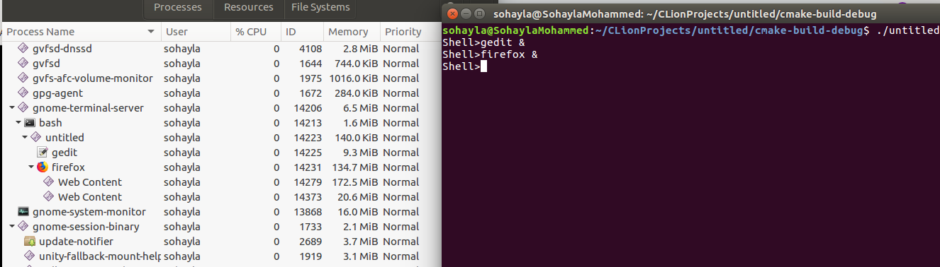
'ls’ command and opening gedit
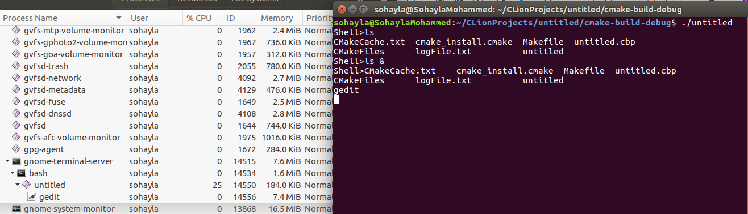
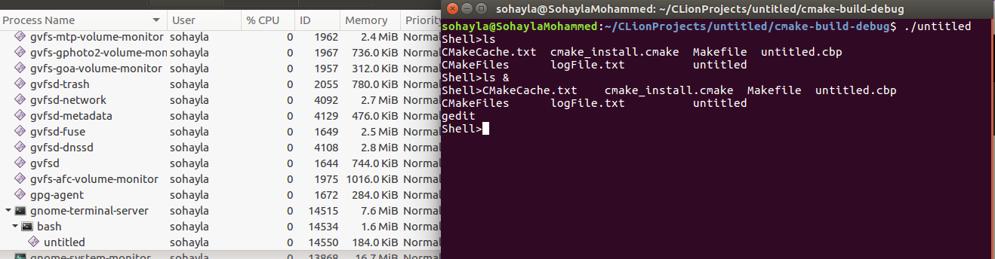
After closing gedit editor, wait terminates and shell continues normally

Log File
