Information and Communications Technologies

* Messekher Younes
* Morsli mahdi
* Touil Soheib
* Angar Yacine
* Douaouira Rassim Amine

1. **Introduction**:
   1. **What are TIC**

Information and Communications Technologies or TIC for short are the infrastructures and components that enable modern computing.

* 1. **The importance of TIC in modern society:**

Information and Communications Technology (TIC) plays a pivotal role in our daily lives, revolutionizing the way we access information and connect with others. Online newspapers enable us to stay updated locally, while electronic communication tools like email, Yahoo Messenger, and video conferences bridge geographical gaps with family, relatives, and colleagues. The integration of digital computers and networks has transformed our economic landscape, creating a boundary-free economy where transactions occur seamlessly across time and space. Recognized as a key pillar of economic development, TIC contributes to national competitive advantage by improving the quality of human life through educational media, mass communication for health and social issues, and providing widespread access to information. As TIC continues to evolve, it is becoming an essential literacy skill, expected to be a functional requirement in work, social interactions, and personal lives. Additionally, TIC enhances education by adding value to teaching and learning, fostering collaboration, and motivating students to engage more effectively with their studies.



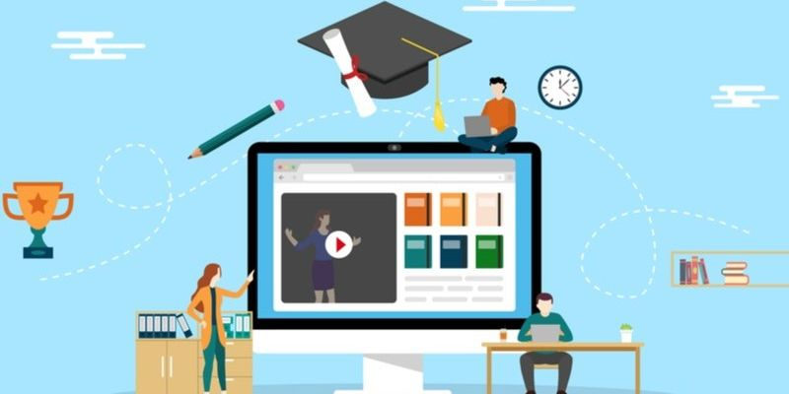

1. TIC in education:

The emergence of modern technologies in our daily lives has significantly elevated the integration of Information and Communications Technology (ICT) in education over the recent years. ICTs have become increasingly significant in our surroundings, offering a diverse range of applications across various sectors, including entertainment, administration, robotics, education, and diverse industries.

* 1. The benefits and negatives of TIC in education:
     1. Benefits:

The integration of new technological tools in academic settings brings about innovation, accelerating information transfer, increasing student engagement, and automating processes. These tools not only enhance concentration and comprehension through digital and interactive activities but also promote flexibility and autonomy in learning, allowing students to progress at their own pace with the flexibility provided by digitalization and connectivity. Moreover, technology fosters critical thinking by exposing students to diverse information sources, encouraging debate, and facilitating the acceptance of different perspectives. It also improves communication between teachers and students, enabling direct and immediate interaction, a crucial aspect highlighted during the 2020 health crisis. Additionally, technology enhances classroom productivity, supports collaborative work, stimulates motivation, and allows educators to incorporate new teaching methods, ultimately improving academic outcomes and addressing the digital skills needed to prevent a digital divide.

* + 1. Negatives:

While technologies offer numerous benefits to education, they come with notable drawbacks. The accessibility of diverse online resources poses the risk of distractions, diverting attention away from the subject matter. Excessive and inappropriate use of technology can lead to a compulsive relationship, negatively impacting students' health, social life, and academic performance. Moreover, the widespread adoption of digitization in academic institutions may hinder the development of essential skills such as writing, public speaking, and reasoning, as highlighted by a recent study from the University of California. Additionally, the prevalence of false information on the internet challenges students' media literacy, with a significant portion unable to discern fake news, particularly in the ESO educational stage. Furthermore, the lack of awareness about cybercrime dangers can inadvertently expose students' personal data, raising concerns, especially for minors. The incorporation of new technologies also diminishes human contact, potentially leading to isolation and hindering students' personal development. Lastly, the digital landscape amplifies the risk of bullying, with the absence of physical contact contributing to the misuse of online tools and platforms, fostering situations of digital bullying.

1. Skills used in TIC:

To master TIC many skills are required some are skills we use in everyday life and others are skills required for computer work.

* 1. Computer skills:
     1. Technological knowledge:

Working in ICT demands an understanding of a company's technology preferences for daily tasks, encompassing general proficiency with computers, mobile devices, and basic operations. This knowledge extends to maintaining and updating technology to enhance overall efficiency.

* + 1. Online research:

Online research is the process of gathering information from the internet, utilizing search engines and educational websites for research purposes. It involves establishing methods to accumulate data, which may include customer surveys, online interviews, and the collection of metric data.



* + 1. Netiquette:

Netiquette refers to a set of guidelines designed to promote respectful online communication. These rules apply across various internet platforms, including email, messaging forums, and video/audio chats. Netiquette entails learning appropriate conduct in online communities and educating coworkers, particularly those less experienced with internet communication methods, about these guidelines.

* + 1. Data management

Data management is the systematic process of gathering, organizing, and storing large volumes of business metrics for analysis and future decision-making. It encompasses the management of database and spreadsheet software, organizing data for clarity, and handling files and folders within an organization's network. Additionally, data management involves tasks such as uploading, downloading, copying, or moving files between company computers. It also includes the management of online accounts, including keeping track of usernames and passwords.

* + 1. Desktop publishing:

Desktop publishing involves creating documents using software that prepares digital information for transition to a physical medium, such as webpages, postcards, brochures, business cards, or labels. It enables companies to use marketing information to craft visually appealing displays to attract customers. Proficiency in desktop publishing can lead to roles as a graphic designer, involving the creation of original assets, or collaborating with a graphic designer to prepare assets for printing.

* + 1. Word processing:

Word processing refers to the creation and manipulation of text on a computer using specialized software. It involves preparing documents for various purposes by typing written content and formatting it according to organizational specifications. Additionally, word processing includes data entry, where information is organized in spreadsheets, and visual aids are generated using slideshow creation programs.



* 1. Social skills:
     1. Problem-solving:

Problem-solving skills enable individuals to identify the source of an issue and devise effective solutions. This process typically involves analysis, active listening, research, and decision-making. Individuals with strong problem-solving skills may specialize in researching, analyzing, and organizing data. They may also apply their skills to assist organizations in identifying the most suitable technology or programs to meet their specific needs.

* + 1. Collaboration:

Collaboration involves working with others to achieve a common task or project. Technology professionals leverage their collaboration skills to assist coworkers with technological challenges, including teaching new software or resolving issues. Using online communication services facilitates connecting coworkers, fostering collaboration over the internet.

* + 1. Organization:

Organizational skills involve effectively managing time, workspace, and energy to ensure the completion of tasks. This includes digital schedule management, organizing files for easy access, and optimizing technology for efficiency. Such skills are particularly valuable in roles requiring consistent maintenance of computer systems.

1. Technologies related to TIC:
   1. Some technlogies related to TIC:

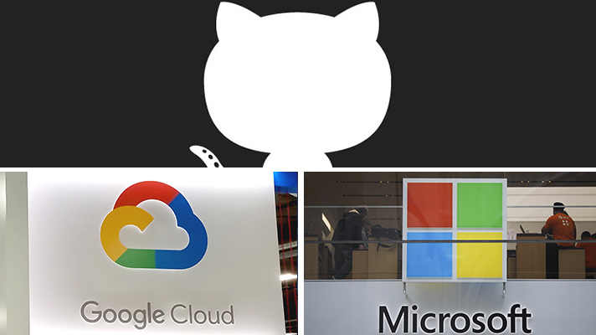

|  |  |  |  |
| --- | --- | --- | --- |
| Tool | Date of creation | Users | Creator |
| Google services | September 4, 1998 | 4.3 billion | Larry Page and Sergey Brin |
| Git | April 7, 2005 | 100 million | Linus Torvalds and Junio C Hamano |
| GitHub | 100 million |  | Tom Preston-Werner, Chris Wanstrath, P. J. Hyett |
| Microsoft Tools | 1990 | 1.2 billion | Bill Gates and Paul Allen |

Google, Microsoft, Git, and GitHub represent pivotal pillars in the realm of technology, each playing a distinctive role in shaping the digital landscape. Google, a tech behemoth, dominates the search engine domain, revolutionizing how information is accessed globally. Its innovative products, from Android to Google Workspace, redefine the way individuals and businesses interact with technology. Microsoft, an industry giant, boasts a diverse array of software solutions, from the ubiquitous Windows operating system to the powerful Office suite, influencing personal and professional computing experiences.

Git, a distributed version control system, emerges as a linchpin in software development, providing a robust framework for collaborative coding. Developers leverage Git to track changes, coordinate workflows, and facilitate seamless collaboration across diverse teams. GitHub, a platform built atop Git, amplifies these capabilities by offering a centralized hub for hosting, sharing, and collaborating on code repositories. Developers worldwide converge on GitHub to contribute to open-source projects, fostering a dynamic community-driven ecosystem.

In essence, Google and Microsoft shape our daily digital interactions, while Git and GitHub empower the collaborative spirit that propels software development into new frontiers. Together, these entities exemplify the dynamic synergy between innovation, collaboration, and the evolution of technology.

