NILM Project - Milestone 1
Modeling, Simulation and Automation of Electrical Energy Systems
Team | Soheil Ayati (11153003), Marc Steffgen ()
Milestone | 1 — Signal acquisition, preprocessing, storage, visualization
Repository | [GitHub URL]

1. Problem framing
NILM (Non-Intrusive Load Monitoring) recovers per-appliance power consumption from a single aggregate measurement at the Point of Common Coupling (PCC). Milestone 1 covers signal acquisition, preprocessing, data storage, and visualization on synthetic data, with the explicit goal of preparing all downstream infrastructure for Milestone 2's real PAC4200 measurements.
Beyond the milestone requirements, the project deliberately targets two challenges that distinguish good NILM systems from passing demonstrations:
- PV-aware disaggregation. Two/Three PV panels mean the meter signal can go negative. We address it explicitly through signed power channels and inverter harmonic signatures.
- Multi-feature fusion. Combining steady-state, harmonic, and transient features rather than choosing one. Different appliances are most distinguishable in different feature domains.
The Milestone 1 deliverables are: (a) a complete synthetic data pipeline producing PAC4200-format scenario files; (b) preprocessing that handles realistic data quality issues; (c) a PAC4200 Modbus TCP reader ready for Milestone 2 connection; (d) five technical specifications documenting every architectural decision.

2. Pipeline architecture
The pipeline is designed so the same downstream code runs on synthetic and real data. Only the data acquisition step differs:
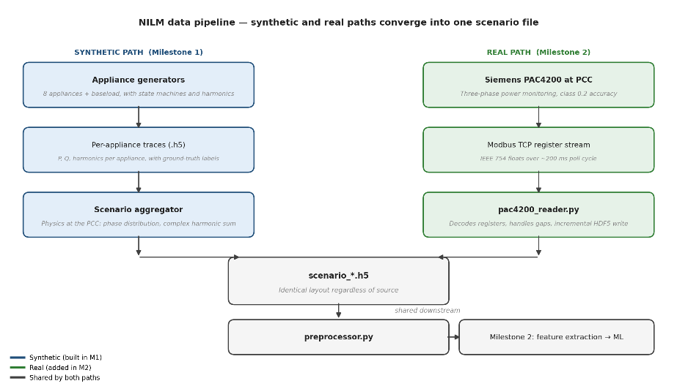
Figure 1. Two acquisition paths produce identically-structured scenario files. The synthetic path (used in Milestone 1) generates per-appliance traces and aggregates them. The real path (Milestone 2) polls a Siemens PAC4200 over Modbus TCP. Downstream of the scenario file, preprocessing, feature engineering, and ML are the same code regardless of source.
In Milestone 1 we built and validated the complete synthetic path (generators → aggregator → preprocessor). For Milestone 2, the aggregator is replaced by the PAC4200 reader; every other stage stays unchanged. By the time the meter is connected, the only new work is verifying register addresses against the live device; preprocessing is already implemented on synthetic data, although it must be validated and its parameters must be fine-tuned.

Components implemented
- Appliance generators. Eight appliance models (fridge, PC, hair dryer, washing machine, EV with multiple charging modes, PV, synchronous machine, variable resistive load) plus an always-on baseload. Each has a defined state machine, signature, harmonic content, and time-of-day usage pattern.
- Scenario aggregator. Combines per-appliance traces into a PAC4200-format scenario file, performing the physics the meter does at the PCC: phase distribution, complex harmonic vector summation, voltage synthesis, neutral current calculation.
- Preprocessor. Universal data-hygiene and feature-engineering stage. Validates input, handles NaN and Inf, imputes short gaps, clips outliers to physical bounds, builds 12 derived features for downstream ML.
- PAC4200 reader. Polls a real PAC4200 over Modbus TCP at 5 Hz, decodes IEEE 754 floats from register pairs, writes scenario files structurally identical to aggregator output. Includes a simulation mode for testing without hardware.
- Data format specification. Channels, sampling rates, file structure, sign conventions, metadata schema.

3. Key design decisions
Four decisions worth defending explicitly. Each is grounded in either a documented PAC4200 capability, an explicit NILM literature requirement, or a synthetic-data advantage.
Why 5 Hz sampling, not higher? The PAC4200 internally samples at 8.5 kHz (170 samples per cycle at 50 Hz), but it does not stream raw waveform over Modbus TCP. It exposes processed values (RMS, P, Q, harmonics), and a full register block poll cycle takes ~200 ms in practice. 5 Hz matches what the meter can actually deliver, and is comfortably above the time scale of appliance behavior (seconds to minutes).
Why harmonics 2nd through 40th, not all 64? PAC4200 exposes harmonics up to the 64th, but appliance harmonic content decays rapidly above the 25th. Truncating at 40 keeps headroom while saving ~38% storage on harmonic columns. All harmonics are stored at 5 Hz (the same rate as P and Q) so switching transients and multi-state transitions are temporally resolved at the same resolution as the power signal.
Why synthesize data with embedded ground truth? Real datasets like UK-DALE and REDD provide aggregate measurements but per-appliance ground truth only through expensive intrusive sub-metering. Because we generate the data, we know exactly which appliance contributed how much power at every timestep. This makes supervised ML in Milestone 2 trivially clean, and enables construction of adversarial benchmark scenarios that no real dataset offers.
Why universal preprocessing? The preprocessor makes no assumption about its input source. For synthetic data it mostly engineers features (the data is already clean); for real PAC4200 data it also handles gaps, outliers, and acquisition noise. Same script, same output schema, no branching by source. This is the architectural choice that makes Milestone 1 actually prepare us for Milestone 2.

4. Results
Synthetic data was generated for all eight appliances plus baseload, aggregated into scenario files, and preprocessed using the production pipeline. Selected outputs are shown below.
[ FIGURE 2 — placeholder ]
Per-appliance signatures over a 24-hour day
Figure 2. Synthetic traces of P (active power) for each of the eight project appliances plus baseload. Fridge cycles through compressor on/off with visible inrush transients; hair dryer shows brief evening bursts at ~2 kW; washing machine displays its multi-phase fill-heat-wash-spin sequence; PV produces negative power following a solar bell curve (summer solstice anchor); the synchronous machine spans all four quadrants of the (P, Q) plane.
[ FIGURE 3 — placeholder ]
Aggregated scenario at the PCC, with ground-truth decomposition
Figure 3. Top panel: aggregate P_total at the point of common coupling — the only signal a real PAC4200 sees. Per-phase and neutral currents shown in middle panels. Bottom panel: ground-truth per-appliance breakdown, available only because the data is synthetic. The Milestone 2 ML task is precisely to recover the bottom panel from the top, given only the aggregate.
[ FIGURE 4 — placeholder ]
Preprocessing demonstration — handling injected data-quality issues
Figure 4. Raw scenario data was corrupted with 50 single-sample dropouts, 5 dropout bursts, an infinity-valued spike, and out-of-bounds outliers, then run through the universal preprocessor. The preprocessor imputed all short gaps via linear interpolation, flagged longer gaps, and clipped outliers to physical bounds. The same code path will run on real PAC4200 data in Milestone 2.
[ FIGURE 5 — placeholder ]
Event-detection feature: |dP_total/dt|
Figure 5. First-difference of P_total computed by the preprocessor — the headline event-detection feature for Milestone 2. Each peak corresponds to an appliance switching event; the largest peak corresponds to the EV plugging in at ~21:00. This is a direct input to event-based NILM classifiers in Milestone 2.

5. Milestone 2 readiness
The PAC4200 reader has been validated end-to-end in simulation mode. The reader produces files structurally identical to aggregator outputs, the preprocessor handles both transparently, and gap imputation works on simulated Modbus dropouts using the same code path it applies to synthetic data.
For Milestone 2, the work reduces to:
- Verifying register addresses against the live PAC4200.
- Confirming float byte order (we have already a single command-line flag if it differs from the PAC4200 default).
- Beginning lab recordings; the downstream pipeline is already built.
- Most imporant: Event detection, feature extraction, classification, ML training and implementation.
Milestone 2 ML development can however begin in parallel with hardware verification. The synthetic scenarios we generated are already in the format the ML will consume.

6. Documentation and repository
Detailed specifications for every component are committed to the project repository in the Docs/ folder:
- 01_data_format.md — on-disk format, channels, sampling rates, sign conventions
- 02_appliance_generator.md — per-appliance state machines, signatures, parameters
- 03_aggregator.md — aggregation math, voltage synthesis, complex harmonic summation
- 04_preprocessor.md — validation, gap handling, outlier policy, 12 derived features
- 05_pac4200_reader.md — Modbus register map, threading, M2 verification checklist
All source code (synthetic generators, aggregator, preprocessor, PAC4200 reader, plus generation manifest for reproducibility) is in the repository. HDF5 data files for the scenarios (aggregated appliances) are not committed (the full dataset is ~500 MB compressed); the synthetic dataset is regeneratable from the included scripts and the manifest, which is the reproducibility convention common in machine learning research.

