NILM Project - Milestone 1
Modeling, Simulation and Automation of Electrical Energy Systems
Team | Soheil Ayati (11153003), Marc Steffgen (11149043)
Milestone | 1 - Signal acquisition, preprocessing, storage, visualization
Repository | https://github.com/SoheilAyati/MSAEES

1. Problem framing
NILM (Non-Intrusive Load Monitoring) [1] recovers per-appliance power consumption from a single aggregate measurement at the Point of Common Coupling (PCC). Milestone 1 covers signal acquisition, preprocessing, data storage, and visualization on synthetic data, with the explicit goal of preparing all downstream infrastructure for the real PAC4200 measurements planned for Milestone 2.
Beyond the milestone requirements, the project deliberately targets two challenges that distinguish good NILM systems from passing demonstrations:
- PV-aware disaggregation. The presence of two or three PV panels means the meter signal can go negative. This system causes failure in the traditional NILM methods because behind-the-meter generation a so-called signal eclipse [2]. We address it explicitly through signed power channels and inverter harmonic signatures.
- Multi-feature fusion. Combining steady-state, harmonic, and transient features rather than choosing one. Different appliances are most distinguishable in different feature domains [3].
The Milestone 1 deliverables are: (a) a complete synthetic data pipeline producing PAC4200-format scenario files; (b) preprocessing that handles realistic data quality issues; (c) a PAC4200 Modbus TCP reader ready for Milestone 2 connection; (d) five technical specifications documenting every architectural decision.

2. Pipeline architecture
The pipeline is designed so the same downstream code runs on synthetic and real data. Only the data acquisition step differs:
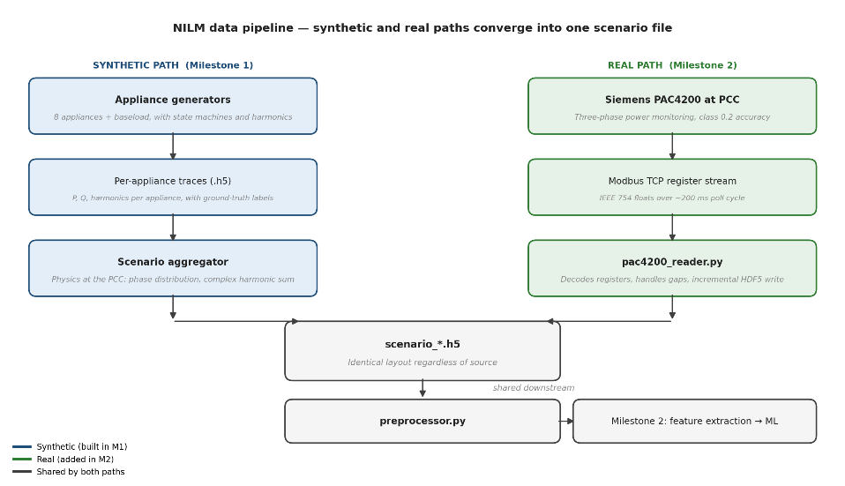
Figure 1. Two acquisition paths produce identically structured scenario files. The synthetic path (used in Milestone 1) generates per-appliance traces and aggregates them. The real path (Milestone 2) polls a Siemens PAC4200 over Modbus TCP. Downstream of the scenario file, preprocessing, feature engineering, and ML are the same code regardless of source.
In Milestone 1 we built the complete synthetic path (generators → aggregator → preprocessor). For Milestone 2, the aggregator is replaced by the PAC4200 reader; every other stage stays unchanged. By the time the meter is connected, the only new work is verifying register addresses against the live device; preprocessing is already implemented on synthetic data, although it must be validated and its parameters must be fine-tuned.

Components implemented
- Appliance generators. Eight appliance models (fridge, PC, hair dryer, washing machine, EV with multiple charging modes, PV, synchronous machine, variable resistive load) plus an always-on baseload. Each has a defined state machine, signature, harmonic content, and time-of-day usage pattern.
- Scenario aggregator. Combines per-appliance traces into a PAC4200-format scenario file, performing the physics the meter does at the PCC: phase distribution, complex harmonic vector summation, voltage synthesis, neutral current calculation.
- Preprocessor. Universal data-hygiene and feature-engineering stage. Validates input, handles NaN and Inf values, imputes short gaps, clips outliers to physical bounds, builds 12 derived features for downstream ML.
- PAC4200 reader. Polls a real PAC4200 over Modbus TCP at 5 Hz, decodes IEEE 754 floats from register pairs, writes scenario files structurally identical to aggregator output. Includes a simulation mode for testing without hardware.
- Data format specification. Channels, sampling rates, file structure, sign conventions, metadata schema.

3. Key design decisions
Four decisions worth defending explicitly. Each is grounded in either a documented PAC4200 capability, an explicit NILM literature requirement, or a synthetic-data advantage.
Why 5 Hz sampling, not higher? The PAC4200 internally samples at 8.5 kHz (170 samples per cycle at 50 Hz) [4], but it does not stream raw waveform over Modbus TCP. It exposes processed values (RMS, P, Q, harmonics), and a full register block poll cycle takes ~200 ms in practice. 5 Hz matches what the meter can actually deliver, and is comfortably above the time scale of appliance behavior (seconds to minutes).
Why harmonics 2nd through 15th, not all 64? PAC4200 exposes harmonics up to the 64th [4], but appliance signatures in the NILM literature are typically characterized by the lowest odd orders (3rd, 5th, 7th). For example, Tsironi et al. (IEEE 2022) [5] used only the 3rd, 5th, and 7th harmonic currents for NILM appliance identification. Truncating at 15 keeps headroom while saving storage on harmonic columns. All harmonics are stored at 5 Hz (the same rate as P and Q) so switching transients and multi-state transitions are temporally resolved at the same resolution as the power signal.
Why synthesize data with embedded ground truth? Real datasets such as UK-DALE and REDD provide aggregate measurements, while per-appliance ground truth requires intrusive sub-metering. Because we generate the data, we know exactly which appliance contributed how much power at every timestep. This makes supervised ML in Milestone 2 straightforward, and enables construction of adversarial benchmark scenarios that no real dataset offers.
Why universal preprocessing? The preprocessor makes no assumption about its input source. For synthetic data it mostly engineers features (the data is already clean); for real PAC4200 data it also handles gaps, outliers, and acquisition noise. Same script, same output schema, no branching by source. This is the architectural choice that makes Milestone 1 prepare us for Milestone 2.

4. Results
Synthetic data was generated for all eight appliances plus baseload, aggregated into scenario files, and preprocessed using the production pipeline. Selected outputs are shown below.

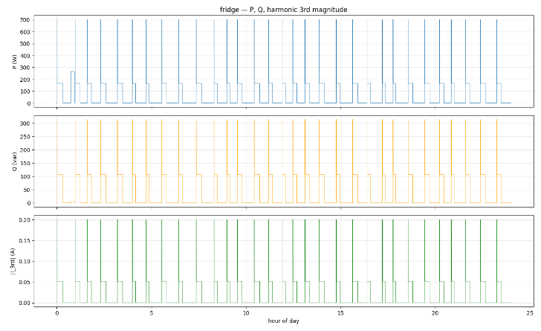
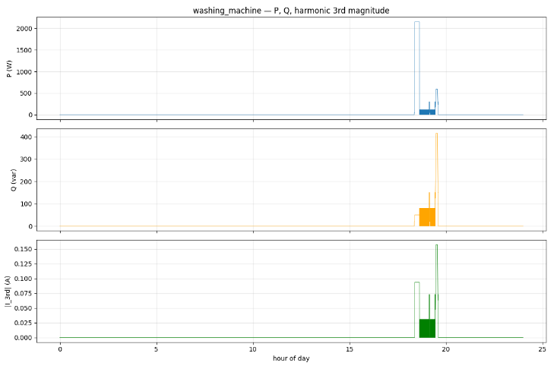
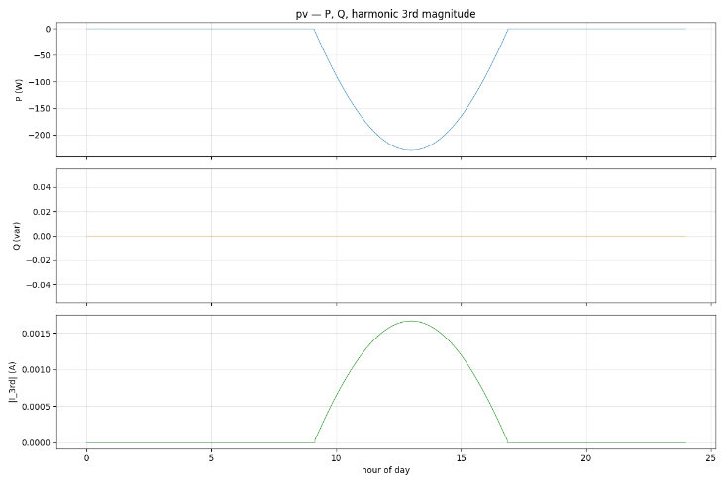

Figure 2. Synthetic per-appliance signatures over a 24-hour day, generated by appliance_generator.py. Each subplot shows three panels: active power P (top), reactive power Q (middle), and the magnitude of the 3rd harmonic current |I_3rd| (bottom). The 3rd harmonic is shown as a representative signature feature, nonlinear loads such as inverters and switch-mode supplies produce significant 3rd-harmonic content. Top: fridge, a simple cyclic load with regular compressor on/off behavior, modest reactive component, and near-linear current. Middle: washing machine, a medium-complexity multi-state appliance whose distinct fill, heat, wash, and spin phases produce a stepped P signature with phase-dependent Q. Bottom: PV generation, a hard case for NILM, with continuously time-varying negative P following a solar bell curve, near-zero Q (unity-power-factor inverter operation), and 3rd-harmonic content present only when the inverter is active.
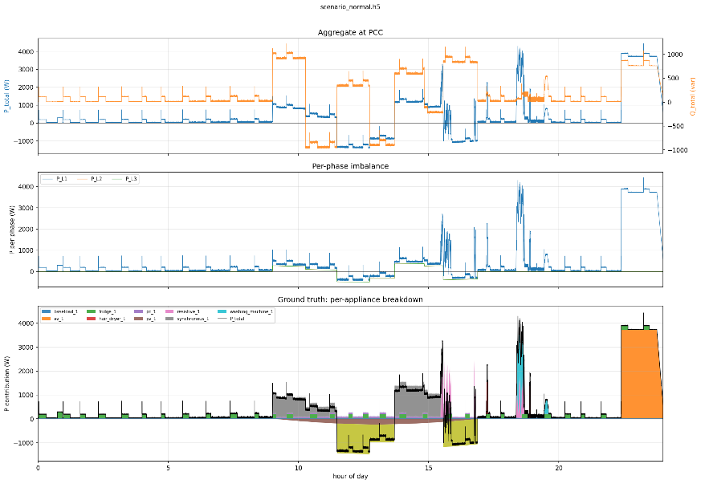
Figure 3. A normal-tier aggregated scenario (scenario_normal.h5) over 24 hours at 5 Hz, produced by scenario_aggregator.py from the per-appliance traces. The signal at the Point of Common Coupling combines eight appliances plus baseload, with PV generation pulling the aggregate negative during midday, and evening activity (cooking, EV charging) dominating after sunset. This is the only signal a real PAC4200 sees at the PCC; the Milestone 2 ML task is to recover the per-appliance contributions from precisely this kind of trace.

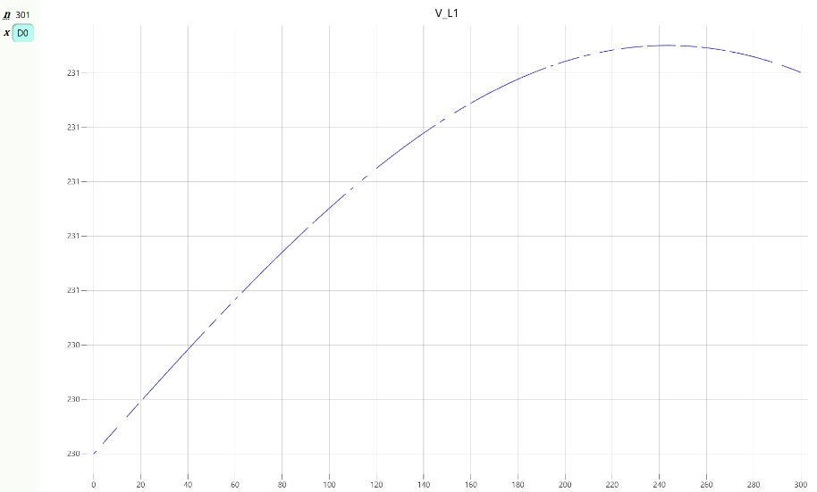
Figure 4. Raw V_L1 recorded from pac_reader.py running in simulation mode with --sim-dropout-rate 0.1 (60-second recording, 10% per-sample dropout rate). The dropouts appear as gaps and discontinuities where Modbus polls failed and the reader wrote NaN with synthesized timestamps. This realistically emulates the kind of network-level acquisition issues that occur on real PAC4200 deployments. The same data-quality issues will be present in Milestone 2 recordings, just at lower rates (typically <2% dropouts on a stable local network).
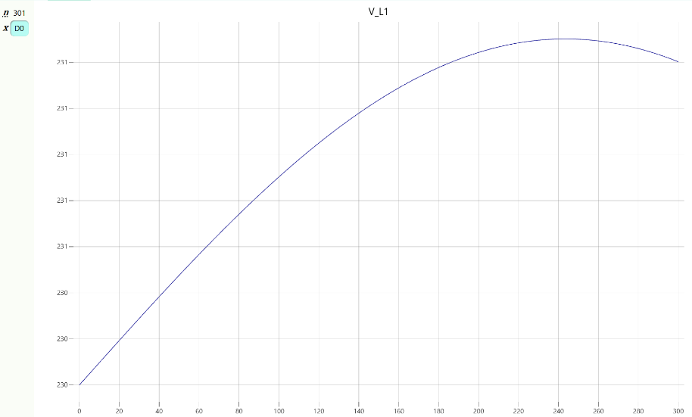
Figure 5. The same V_L1 recording from Figure 4 after running through preprocessor.py. The preprocessor's gap-imputation step has filled short NaN runs (≤5 samples = 1 second at 5 Hz) by linear interpolation between neighboring valid samples; longer gaps would have been preserved as NaN and flagged in the report. The reconstructed signal is now suitable for downstream feature extraction and ML, with the data-quality summary recorded in the file's /preprocessed/attrs/report metadata for audit. The same preprocessing code path runs unchanged on synthetic aggregator output and real PAC4200 recordings.

5. Milestone 2 readiness
The PAC4200 reader has been validated end-to-end in simulation mode. The reader produces files structurally identical to aggregator outputs, the preprocessor handles both transparently, and gap imputation works on simulated Modbus dropouts using the same code path it applies to synthetic data.
For Milestone 2, the work includes:
- Verifying register addresses against the live PAC4200.
- Confirming float byte order (we already have a single command-line flag if it differs from the PAC4200 default).
- Beginning lab recordings; the downstream pipeline is already built.
- Most important: Event detection, feature extraction, classification, ML training and implementation.
Milestone 2 ML development can, however, begin in parallel with hardware verification. The synthetic scenarios we generated are already in the format the ML will consume.

6. Documentation and repository
Detailed specifications for every component are committed to the project repository in the Docs/ folder:
- 01_data_format.md — on-disk format, channels, sampling rates, sign conventions
- 02_appliance_generator.md — per-appliance state machines, signatures, parameters
- 03_aggregator.md — aggregation math, voltage synthesis, complex harmonic summation
- 04_preprocessor.md — validation, gap handling, outlier policy, 12 derived features
- 05_pac4200_reader.md — Modbus register map, threading, M2 verification checklist
All source code (synthetic generators, aggregator, preprocessor, PAC4200 reader, plus generation manifest for reproducibility) is in the repository. HDF5 data files for the scenarios (aggregated appliances) are not committed (the full dataset is ~500 MB compressed); the synthetic dataset is reproducible from the included scripts and the manifest, which is the reproducibility convention common in machine learning research.

Appendix: Data channel overview
The PAC4200 exposes a fixed set of channels over Modbus TCP at the configured poll rate; we receive all of them when the reader runs. Additional derived features are computed by the preprocessor on top of the received data. The table below summarises both.

Channel | Measured / Calculated | Purpose
V_L1, V_L2, V_L3 | Measured | RMS line-to-neutral voltages; baseline of grid quality
I_L1, I_L2, I_L3 | Measured | RMS phase currents; main load indicator
I_N | Measured | Neutral current; indicates phase imbalance
freq | Measured | Grid frequency; sanity check and slow drift indicator
P_L1, P_L2, P_L3, P_total | Measured | Active power; the headline signal for NILM event detection
Q_L1, Q_L2, Q_L3, Q_total | Measured | Reactive power; distinguishes inductive from resistive loads
S_L1, S_L2, S_L3, S_total | Measured | Apparent power; basis for power-factor analysis
PF_L1, PF_L2, PF_L3, PF_total | Measured | Signed power factor (+ consumption, − export)
cosphi_L1, cosphi_L2, cosphi_L3, cosphi_total | Measured | Displacement factor (fundamental only); separates distortion from genuine PF degradation
THD_V_L1, THD_V_L2, THD_V_L3 | Measured | Voltage harmonic distortion; grid quality indicator
THD_I_L1, THD_I_L2, THD_I_L3 | Measured | Current harmonic distortion; rises with nonlinear loads (PCs, EV chargers)
I_mag_{L1,L2,L3} (orders 2–40) | Measured | Current harmonic magnitudes; fine-grained appliance signature
I_phase_{L1,L2,L3} (orders 2–40) | Measured | Current harmonic phases; complement magnitudes for unique signatures
V_mag_{L1,L2,L3} (orders 2–40) | Measured | Voltage harmonic magnitudes
V_phase_{L1,L2,L3} (orders 2–40) | Measured | Voltage harmonic phases
dP_total | Calculated | Time derivative of P_total; event-detection feature, peaks at switching
abs_dP_total | Calculated | Magnitude of dP_total; symmetric event indicator for thresholding
P_total_rolling_mean_short (5 s) | Calculated | Smoothed P for steady-state matching of fast-cycle appliances
P_total_rolling_mean_long (30 s) | Calculated | Smoothed P for steady-state matching of slow-cycle appliances (fridge)
P_total_rolling_std_short (5 s) | Calculated | Power variability; detects bursts vs steady state
P_{L1,L2,L3}_rolling_mean_short (5 s) | Calculated | Per-phase steady-state for phase-aware disaggregation
mean_THD_I | Calculated | Aggregate current-distortion summary across phases
mean_THD_V | Calculated | Aggregate voltage-distortion summary across phases
P_phase_imbalance | Calculated | Distinguishes 3-phase from single-phase loads
I_neutral_to_phase_ratio | Calculated | Indicates dominant single-phase loading

Useful References

[1] G. W. Hart, "Nonintrusive appliance load monitoring," Proceedings of the IEEE, vol. 80, no. 12, pp. 1870–1891, Dec. 1992, doi: 10.1109/5.192069.

[2] Y. Wu, J. Yu, J. Chen, X. Yang, H. Shao, and X. Wang, "DualNILM: Energy Injection Identification Enabled Disaggregation with Deep Multi-Task Learning," arXiv preprint arXiv:2508.14600, Aug. 2025. [Online]. Available: https://arxiv.org/abs/2508.14600

[3] S. R. Sahoo, F. Khalaj, B. Karki, and M. Khalaj, "A feature fusion technique for improved non-intrusive load monitoring," Energy Informatics, vol. 3, no. 1, p. 13, Sep. 2020, doi: 10.1186/s42162-020-00112-w.

[4] Siemens AG, SENTRON PAC4200 Power Monitoring Device Manual, Siemens Documentation, 2023. [Online]. Available: https://cache.industry.siemens.com/dl/files/595/34261595/att_951630/v1/manual_pac4200_en-US_en-US.pdf (Last access 13.05.2026)

[5] N. Tsironi, A. P. Sakis Meliopoulos, et al., "Odd Harmonic Distortion Contribution on a Support Vector Machine NILM Approach," in 2022 IEEE International Conference, 2022, doi: 10.1109/SyNERGYMED55767.2022.9941416. Available: https://ieeexplore.ieee.org/document/9941416

