Unit 71 — Principal Component Analysis Worksheet
Pen and paper. A calculator is fine; a laptop is not. Five students were measured on two things: hours studied in a week, and practice problems completed. We are going to build both principal components of this data by hand, and then read what they mean.

Part 1 · Centre the data
About 6 minutes.
PCA measures how spread out the data is. Spread is measured from the mean, so the first move is always to subtract each column's mean.
Student | hours | problems | hours − 12 | problems − 30
A | 10 | 19
B | 2 | 25
C | 12 | 30
D | 22 | 35
E | 14 | 41
mean | 12 | 30

- Fill in the last two columns of the table.
- Add up each of your two new columns. What should they come to, and do they?
- Square every value in the “hours − 12” column and add them up. Do the same for “problems − 30”. Add your two answers together.

Part 2 · Project onto a direction
About 10 minutes.
A direction is a pair u = (u₁, u₂) with u₁² + u₂² = 1. To project a centred point (x₁, x₂) onto it, take the dot product:
projection = u₁ × x₁ + u₂ × x₂
That single number says how far along the direction the point sits. Two columns in, one column out — this is the new feature.
Student | centred point | u = (1, 0) | u = (0, 1) | u = (0.6, 0.8)
A | (−2, −11)
B | (−10, −5)
C | (0, 0)
D | (10, 5)
E | (2, 11)
 | sum of squares

- Fill in the three projection columns, then the sum of squares at the bottom of each.
- Check that (0.6, 0.8) really is a direction: compute 0.6² + 0.8².
- The first two directions are just the original columns — “keep hours, throw away problems”, and the reverse. The third is a mixture. Which of the three keeps the most spread?
- Suppose we had used (6, 8) instead of (0.6, 0.8). Every projection would be 10 times larger and the sum of squares 100 times larger. Why does that make the length-1 rule necessary?

Part 3 · Search every direction
About 12 minutes.
The projections below are already worked out for eight directions. You only need the last column: square the five projections and add them up.
angle | u | A | B | C | D | E | sum of squares
0° | (1.00, 0.00) | −2.0 | −10.0 | 0.0 | 10.0 | 2.0
20° | (0.94, 0.34) | −5.6 | −11.1 | 0.0 | 11.1 | 5.6
35° | (0.82, 0.57) | −7.9 | −11.1 | 0.0 | 11.1 | 7.9
53° | (0.60, 0.80) | −10.0 | −10.0 | 0.0 | 10.0 | 10.0
70° | (0.34, 0.94) | −11.0 | −8.1 | 0.0 | 8.1 | 11.0
90° | (0.00, 1.00) | −11.0 | −5.0 | 0.0 | 5.0 | 11.0
120° | (−0.50, 0.87) | −8.5 | 0.7 | 0.0 | −0.7 | 8.5
143° | (−0.80, 0.60) | −5.0 | 5.0 | 0.0 | −5.0 | 5.0

- Fill in the last column.
- Plot your eight values on the grid below (angle across, sum of squares up). Join them with a smooth curve.
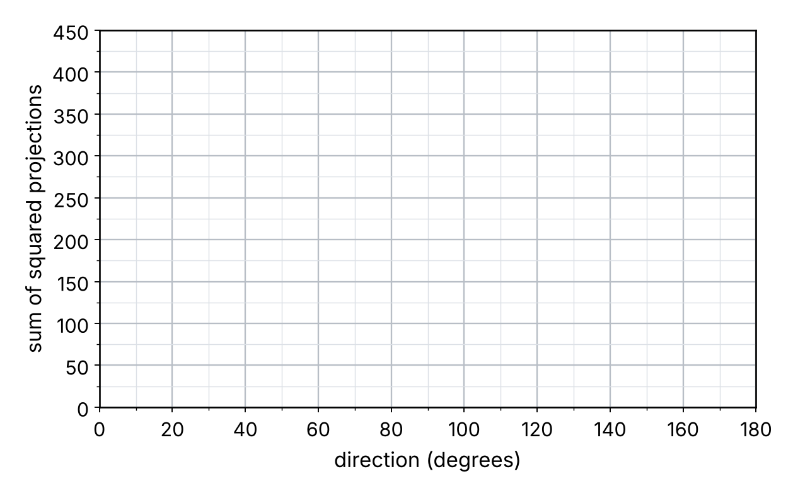
- Circle the highest point on your curve. Which direction is it, and what is its sum of squares?
- On the scatter plot below, draw the line through the origin in the direction you circled.
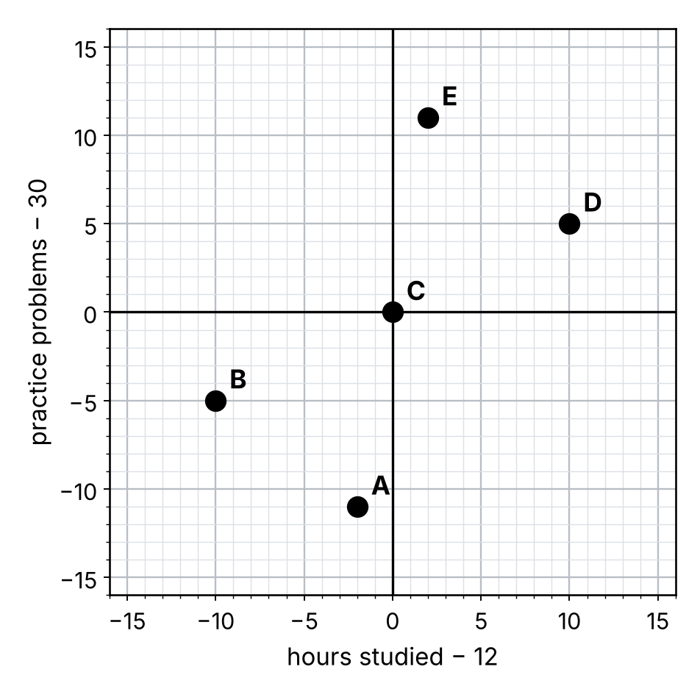

Part 4 · The second component
About 7 minutes.
The second component is the best direction at right angles to the first. With only two features there is just one such direction: u₂ = (0.8, −0.6).
Student | centred point | u₂ = (0.8, −0.6)
A | (−2, −11)
B | (−10, −5)
C | (0, 0)
D | (10, 5)
E | (2, 11)
 | sum of squares

- Fill in the projections and the sum of squares.
- Add the sum of squares for PC1 (Part 3) to the one you just found. Compare it with the total spread from Part 1, question 3.
- Check that the two components really are at right angles: compute (0.6 × 0.8) + (0.8 × −0.6).
- Write each component's share of the total as a percentage.
Component | sum of squares | share of the total
PC1
PC2
total

- Why insist that PC2 be at right angles to PC1, instead of just taking the second-highest point on your Part 3 curve?

Part 5 · Reading components, and choosing how many
About 10 minutes.
Written out in full, the first component is:
PC1 = 0.6 × hours + 0.8 × problems
The weights are called the loadings of the component.
- Both loadings are positive. In one sentence, what kind of student scores high on PC1?
- Suppose a component had come out as 0.7 × hours − 0.7 × problems instead. What would a high score mean then?
- Give PC1 a short name of your own. Then write one sentence saying why your name might be misleading.

Below is the real output of PCA on a wine data set: 13 chemical measurements on 178 bottles, scaled first. Only the first eight components are shown.
Component | share of spread | running total
PC1 | 36.2%
PC2 | 19.2%
PC3 | 11.1%
PC4 | 7.1%
PC5 | 6.6%
PC6 | 4.9%
PC7 | 4.2%
PC8 | 2.7%

- Fill in the running total column.
- How many components would you keep to hold at least 80% of the spread? Give one sentence of justification.
- The original data had 13 columns. Does keeping 5 components mean you can stop measuring 8 of the 13 chemicals? Explain.

Part 6 · The units trap
About 5 minutes.
No arithmetic in this part. A data set has these two columns:
Column | units | typical values
annual income | dollars | 41,000 to 96,000
years of schooling | years | 10 to 22

- Without scaling, which column will the first principal component be almost entirely made of? Why?
- Now suppose income were recorded in cents instead of dollars. Does the data change? Does the first component change?
- What should you do before running PCA on this data, and when is that step unnecessary?

When you are done: notebook 71_PCA.ipynb picks up with these same five students and checks your answers against sklearn.

