Neural Networks Worksheet
From weighted averages to a network
A neural network is built from one simple piece: multiply the inputs by weights, add them up, add a bias, and pass the result through a function. You have already used this piece—it is logistic regression. In this worksheet you will build it up step by step.

Part 1 — The Dot Product as a Weighted Score
Your course grade is a weighted average of three scores. The syllabus says homework counts 20%, the midterm 30%, and the final 50%.
Student | Homework | Midterm | Final
A | 90 | 70 | 80
B | 60 | 90 | 85

1. Compute Student A’s course grade.

2. Write the weights as a vector w = (w₁, w₂, w₃) and Student A’s scores as a vector x = (x₁, x₂, x₃). Then write the grade using a sum, and using the dot product notation wᵀx.

3. Compute Student B’s grade. Student B has a much lower homework score. Who ends up with the higher grade, and why?

4. The instructor changes the weights to w = (0.4, 0.3, 0.3). Recompute both grades. What happened to the ranking? In one sentence: what do the weights control?

Part 2 — Linear Regression Is a Dot Product Plus a Bias
A linear regression model predicts house price (in $1000s) from size x₁ (in 1000 sq ft) and number of bedrooms x₂:
ŷ = β₀ + β₁x₁ + β₂x₂ with β₀ = 50, β₁ = 100, β₂ = 20
1. Predict the price of a 2000 sq ft house with 3 bedrooms.

2. Neural network books write the same model as ŷ = wᵀx + b. Fill in the table to translate between the two notations.
Regression notation | Neural network notation | Value here
β₁, β₂
β₀

3. Set b = 0 and predict the price of a house with x = (0, 0). Now do it with b = 50. In your own words, what job does the bias do?

Part 3 — One Neuron = Logistic Regression
A neuron takes the weighted sum z = wᵀx + b and passes it through an activation function. If the activation is the sigmoid σ(z) = 1 / (1 + e⁻ᶻ), the neuron is exactly logistic regression: its output p̂ is a probability.
A neuron predicts whether a day is comfortable for spending time outside, from x₁ = temperature (°C) and x₂ = humidity (%). Its parameters are:
w = (0.5, −0.1) b = −6
Use this table of sigmoid values:
z | −3 | −2 | −1 | 0 | 1 | 2 | 3
σ(z) | 0.047 | 0.119 | 0.269 | 0.500 | 0.731 | 0.881 | 0.953

1. Monday is 20 °C with 30% humidity. Fill in every blank on the diagram for Monday.
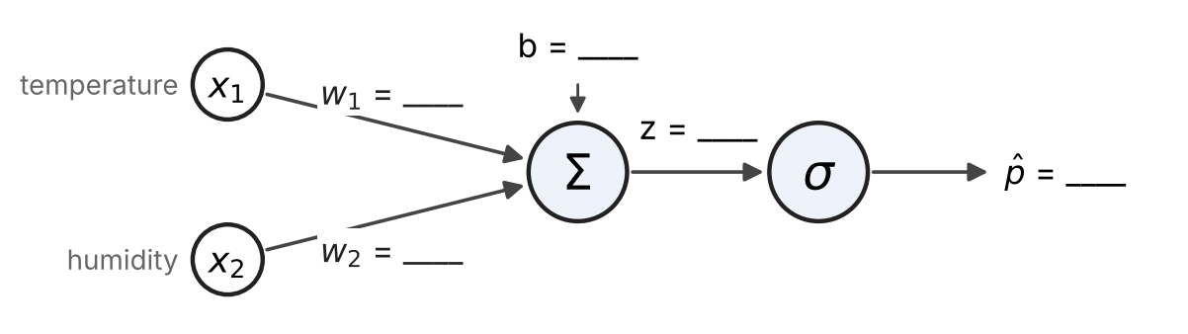

2. Complete the table. Predict “comfortable” when p̂ ≥ 0.5.
Day | x = (x₁, x₂) | z = wᵀx + b | p̂ = σ(z) | Prediction
Monday | (20, 30)
Tuesday | (16, 50)
Wednesday | (24, 70)
Thursday | (26, 40)

3. Wednesday is warmer than Monday but is predicted to be uncomfortable. Which input caused this, and how can you tell from the weights?

Part 4 — Hidden Layers: When It Is Too Hot
In Part 3 you learned to predict with one neuron. We used that same neuron, z = 0.5x₁ − 0.1x₂ − 6, to predict five more days (comfortable when z > 0). The last column shows what actually happened.
Day | Temp. x₁ (°C) | Humidity x₂ (%) | z | Prediction | Actual y
A | 15 | 50 | −3.5 | 0 | 0 (too cold)
B | 22 | 35 | 1.5 | 1 | 1
C | 24 | 80 | −2 | 0 | 0 (muggy)
D | 25 | 30 | 3.5 | 1 | 1
E | 29 | 20 | 6.5 | 1 (wrong) | 0 (too hot)

The neuron gets Day E wrong. Its weight on temperature is positive, so it believes that warmer is always better and can never say “too hot.”
1. The grid shows the five days (● comfortable, ○ not comfortable). Explain why no single straight line can separate the comfortable days from the others. Hint: compare Day B with Days A and E.
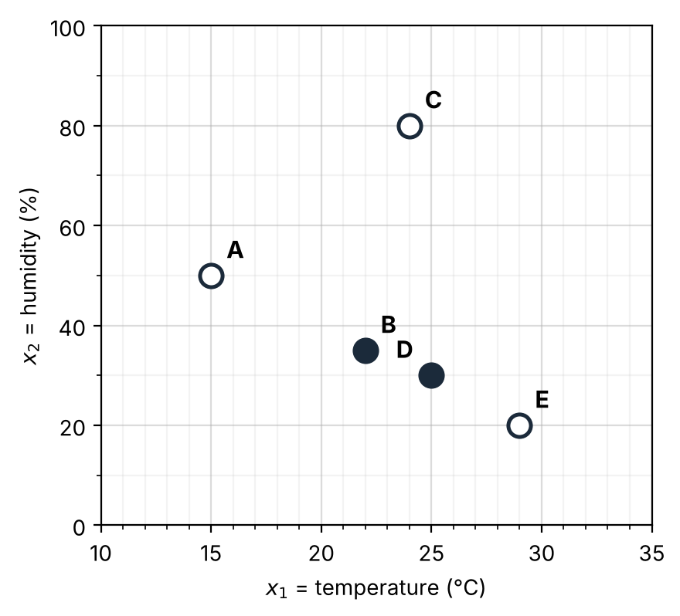

The idea: use several neurons. Two neurons each answer a simple yes/no question, and a third neuron combines their answers:
• Neuron h₁ asks: is it warm enough?
• Neuron h₂ asks: does it feel too hot? (Humid air feels hotter.)
• The output neuron decides: comfortable = warm enough and not too hot.
Step activation. Each neuron here outputs a plain yes (1) or no (0): step(z) = 1 if z > 0, otherwise 0. This is the same as applying the 0.5 threshold from Part 3, because p̂ ≥ 0.5 exactly when z ≥ 0.
Step 1 — Neuron h₁: warm enough? z₁ = 1·x₁ + 0·x₂ − 18, h₁ = step(z₁)
2. The values of z₁ are computed for you. Fill in the h₁ column.
Day | x₁ | z₁ | h₁
A | 15 | −3
B | 22 | 4
C | 24 | 6
D | 25 | 7
E | 29 | 11

Step 2 — Neuron h₂: feels too hot? z₂ = 1·x₁ + 0.1·x₂ − 30, h₂ = step(z₂)
3. The values of z₂ are computed for you. Fill in the h₂ column.
Day | x₁ | x₂ | z₂ | h₂
A | 15 | 50 | −10
B | 22 | 35 | −4.5
C | 24 | 80 | 2
D | 25 | 30 | −2
E | 29 | 20 | 1

Step 3 — The output neuron z_out = 1·h₁ − 1·h₂ − 0.5, ŷ = step(z_out)
The output neuron never sees the temperature or the humidity. Its only inputs are the answers h₁ and h₂.
4. The values of z_out are computed for you. Fill in the ŷ column and compare it with the actual y.
Day | h₁ | h₂ | z_out | ŷ | Actual y
A | 0 | 0 | −0.5 |  | 0
B | 1 | 0 | 0.5 |  | 1
C | 1 | 1 | −0.5 |  | 0
D | 1 | 0 | 0.5 |  | 1
E | 1 | 1 | −0.5 |  | 0

Your table should confirm this statement: the network predicts “comfortable” only when h₁ = 1 (warm enough) and h₂ = 0 (not too hot). On a too-hot day, h₂’s weight of −1 cancels h₁’s +1, so z_out drops below 0.
Step 4 — Why this works: two lines
5. Each hidden neuron draws a line where its z equals 0. On the grid, draw h₁’s line x₁ = 18 and h₂’s line x₁ + 0.1x₂ = 30 (it passes through (30, 0) and (20, 100)). Shade the region where the network predicts “comfortable.” Which days are inside it?

Putting it together. Here are the three neurons drawn as one network. h₁ and h₂ form the hidden layer: their values never appear in the data, because the network creates them as new features.
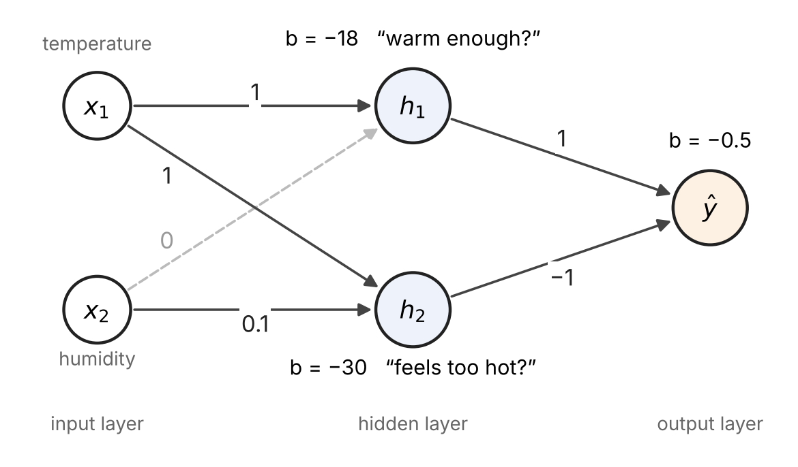
Step 5 — Writing the network with matrices
When a layer has several neurons, we stack their weight vectors as the rows of a matrix W and their biases into a vector b. A layer then computes a = g(Wx + b), where g is the activation applied to each entry. Superscripts in brackets name the layer: W⁽¹⁾ is the first layer’s weight matrix.
6. Write the hidden layer as W⁽¹⁾ and b⁽¹⁾, and the output layer as W⁽²⁾ and b⁽²⁾. What does each row of W⁽¹⁾ stand for? What does each column stand for?

7. Fill in the shapes and count the parameters of this network. How many parameters did the single neuron in Part 3 have?
 | Shape | Number of parameters
W⁽¹⁾
b⁽¹⁾
W⁽²⁾
b⁽²⁾
Total

Note: In this worksheet we were given the weights. In practice, a network learns its weights from data by minimizing a loss function—just as logistic regression does—using an algorithm called gradient descent. That is our next topic.

