UNIVERSITY OF DHAKA
Institute of Leather Engineering and Technology
Department of Leather Engineering
LABORATORY REPORT
Course Code: LE-410
Course Title: Wastewater and Solid Waste Management Lab
B.Sc. in Leather Engineering · 4th Year 2nd Semester · Examination 2025
EXPERIMENT NO. 01
Characterization of Physiochemical Parameters of Effluent.

Name of the student | Md Ruhul Amin Talukder
Class roll number | ZH-192-009
Examination roll number | 00
Registration number | 2021212433
Session | 2021-22
Group number | A(odd)
Date of performance
Date of submission | 2026-09-07

Submitted to:
Md. Jawad Hasan
Lecturer, ILET, DU
Institute of Leather Engineering and Technology, University of Dhaka

Declaration of Originality

I declare that this laboratory report is my own work.
I understand and accept the following:
• The experimental readings were obtained by my group, and the group’s raw data and the pooled class data may legitimately be identical to those of my group members and classmates.
• Everything else in this report - the theory, the procedure as I have written it, the calculations, the discussion and the conclusion - must be written in my own words and represent my own understanding.
• Copying text from another student, from a previous year’s report, or from any source without acknowledgement is plagiarism.
• All reports submitted for this course are compared with one another. Where the written sections of two or more reports are found to be substantially the same, all the students concerned will be penalised, whatever the source of the copying.

Scanned Signature of the student: Ruhul
Date: 07/09/26

1. OBJECTIVE
1. To determine the important physicochemical properties of effluent.
2. To measure parameters such as pH, BOD, COD, TSS, TDS and EC.
3. To evaluate the pollution level and overall quality of the effluent.
4. To understand the environmental impact of untreated effluent.
2. THEORY AND PRINCIPLE
Theory: Effluent is wastewater discharged from industrial, domestic, or other activities. It contains various dissolved and suspended substances that can pollute the environment. Physicochemical characterization determines the physical and chemical properties of effluent to assess its quality and pollution level.
Principle: The parameters are determined using appropriate analytical methods. pH is measured with a calibrated pH meter; EC is measured using a conductivity meter; TDS indicates dissolved solids; TSS is determined from solids retained on a filter; BOD represents oxygen consumed by microorganisms during biodegradation; and COD represents the oxygen equivalent required to chemically oxidize oxidizable substances.
3. APPARATUS AND REAGENTS
3.1 Apparatus and Instruments
1. Multiparameter Meter
2. 500 mL Beaker
3. Glass Rod
4. Hand Gloves
3.2 Reagents and Materials
1. Wastewater/Effluent Sample for Multiparameter Analysis
4. PROCEDURE
1. The wastewater/effluent sample was collected in a clean container.
2. The sample was gently mixed to obtain a representative sample without producing excessive bubbles.
3. The multiparameter meter was calibrated according to the manufacturer’s instructions using appropriate standard calibration solutions.
4. A sufficient amount of the wastewater sample was transferred into a clean beaker.
5. The probe of the multiparameter meter was immersed in the sample, ensuring that the sensing portion was completely covered.
6. The readings were allowed to stabilize, and all measured values were recorded.
5. OBSERVATIONS AND DATA
5.1 Sample and Conditions
Parameter | Observation
Sample/Stream Tested | Lime Liquor
Variables Assigned | pH, BOD, COD, TSS, TDS, EC
Date of Sampling | 2026-06-12
Temperature | 89.22 °F
pH | 11–13
Initial Condition | Turbid appearance
5.2 Your Group’s Data
Parameter | Value
pH | 11–13
BOD | —
COD | —
TSS | —
TDS | 18200 mg/L
EC (Conductivity) | 28.43 mS/cm
Note: BOD, COD and TSS values were not available in the provided lime liquor readings, so they are left blank (—).

6. REFERENCE WATER QUALITY PARAMETERS
Reference values provided in the supplied source
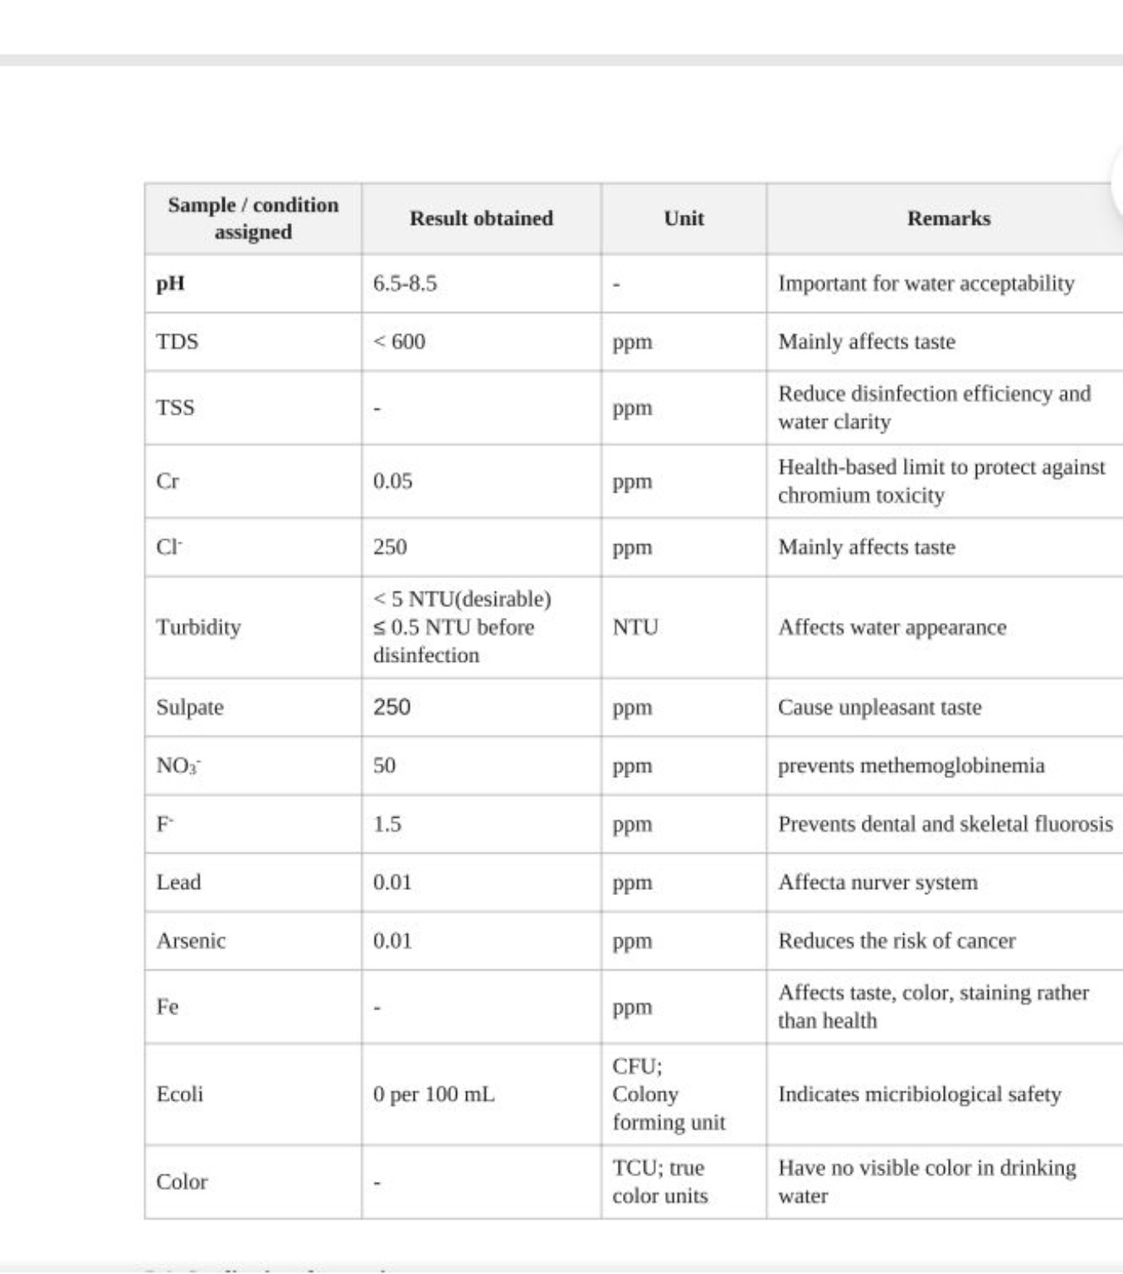

Parameter / Trial | Trial 1 | Trial 2 | Trial 3 | Mean Value
Volume of Sample Taken (mL) | 10.0 | 10.0 | 10.0 | 10.0
Titrant HCl Volume - Phenolphthalein (mL) | 21.0 | 21.2 | 20.8 | 21.00
Titrant HCl Volume - Total (mL) | 28.9 | 29.2 | 28.9 | 29.00
6. CALCULATIONS
6.1 Formulae Used
Alkalinity (mg/L as CaCO₃) = (V × N × 50,000) / Sample Volume (mL)
• V = Volume of standard HCl consumed (mL)
• N = Normality of standard HCl (0.1 N)
• 50,000 = Equivalent weight factor of CaCO₃ (50 g/eq × 1000 mg/g)
6.2 Specimen Calculations (Mean Data)
A. Phenolphthalein Alkalinity (PA):
PA = (21.00 mL × 0.1 N × 50,000) / 10.0 mL
PA = 105,000 / 10.0 = 10,500 mg/L as CaCO₃
B. Total Alkalinity (TA):
TA = (29.00 mL × 0.1 N × 50,000) / 10.0 mL
TA = 145,000 / 10.0 = 14,500 mg/L as CaCO₃

7. RESULTS SUMMARY
Parameter Determined | Experimental Result | Standard Discharge Limit (ECR 2023 / DoE) | Compliance Status
pH | 12.43 | 6.0 - 9.0 | Non-Compliant (Extremely Alkaline)
Electrical Conductivity (EC) | 28.43 mS/cm | 1.2 mS/cm (1200 µS/cm) | Non-Compliant (23.7× higher)
Total Dissolved Solids (TDS) | 18,200 mg/L | 2,100 mg/L | Non-Compliant (8.6× higher)
Total Alkalinity | 14,500 mg/L as CaCO₃ | Not explicitly specified (Max ~500 mg/L limit) | Non-Compliant (Severely High)

8. DISCUSSION
The experimental results indicate that the beamhouse lime liquor is a highly concentrated and strongly alkaline wastewater stream. The measured values of pH, electrical conductivity (EC), total dissolved solids (TDS), and alkalinity show that this wastewater requires suitable treatment before discharge or further biological treatment.
1. Interpretation of pH and Alkalinity
The mean pH of 12.43 indicates a highly alkaline condition. This alkalinity is associated with chemicals used during beamhouse operations, particularly lime and sulfide-containing chemicals. Such a high pH can adversely affect aquatic organisms and disturb the natural chemical balance of receiving water bodies. The total alkalinity of 14,500 mg/L as CaCO₃ also confirms the strong alkaline character of the liquor.
2. Conductivity and Dissolved Solids
The measured EC of 28.43 mS/cm and TDS of 18,200 mg/L indicate a very high concentration of dissolved ionic and soluble materials. These may originate from sodium-based chemicals, dissolved organic matter, and other substances released during beamhouse processing. Such a high dissolved-solids load can create osmotic stress and may reduce the efficiency of biological wastewater-treatment processes.
3. Comparison with Discharge Standards
The measured results show clear non-compliance with the reference discharge limits presented in the report. The pH of 12.43 is above the stated range of 6.0–9.0, while the EC and TDS values are substantially higher than their respective reference limits. The total alkalinity is also extremely high compared with the reference value. Therefore, untreated lime liquor should not be discharged directly and requires appropriate pre-treatment.
4. Possible Sources of Experimental Error
Some experimental errors may have influenced the results. Suspended materials in the sample could affect endpoint observation during titration. Absorption of atmospheric CO₂ during sample handling may slightly change the pH and alkalinity. In addition, calibration drift or improper calibration of the pH and EC meters could introduce measurement errors.
5. Industrial and Practical Relevance
The results emphasize the importance of segregated treatment of lime liquor in tannery wastewater management. Suitable neutralization and primary treatment can reduce excessive alkalinity and dissolved loads before subsequent treatment. Proper management of sulfide-containing wastewater is also important to minimize the risk associated with sulfide conversion and hydrogen sulfide formation.

10. CONCLUSION
The physicochemical assessment of the tannery lime liquor was completed successfully. The sample showed a mean pH of 12.43, electrical conductivity of 28.43 mS/cm, TDS of 18,200 mg/L, and total alkalinity of 14,500 mg/L as CaCO₃. These results indicate that the measured characteristics are considerably above the relevant environmental discharge limits. Therefore, segregated primary treatment, including appropriate neutralization and oxidation, is necessary before the beamhouse effluent is transferred to a Common Effluent Treatment Plant (CETP).
11. PRECAUTIONS AND SAFETY MEASURES
• Appropriate PPE such as a laboratory coat, nitrile gloves, and safety goggles was used throughout the experiment because the lime liquor and acid reagents can be corrosive.
• Titration work was carried out in a well-ventilated area to reduce the risk associated with sulfide-containing fumes and possible H₂S exposure.
• The pH and EC probes were rinsed carefully with distilled water between successive measurements to minimize cross-contamination.
• Acid-containing waste and remaining effluent residues were neutralized and placed in the designated laboratory waste containers for safe disposal.

12. REFERENCES
1. APHA (2017). Standard Methods for the Examination of Water and Wastewater, 23rd Edition. American Public Health Association, Washington, DC.
2. Department of Environment (DoE) (2023). Environment Conservation Rules (ECR 2023). Ministry of Environment, Forest and Climate Change, Government of Bangladesh.
3. Covington, A. D. (2009). Tanning Chemistry: The Science of Leather. Royal Society of Chemistry, Cambridge, UK, pp. 120–145.
4. ILET Laboratory Manual (2025). LE-410: Solid Waste Management Lab Manual. Department of Leather Engineering, Institute of Leather Engineering and Technology, University of Dhaka.

