**Title:** Smart Agent System for Efficiently Monitoring and Preventing Kidnap Activity

**Acknowledgement**

This app is used for kidnapping which is also said to be rape alarm. In the play store, many applications are available such as personal safety app and women safety app. It benefits parents by alerting them about their missing children or identifying any others. An alert message is given via text message format to locate the missing child based on the amber alert system and GPS tracing. The location of emergency vehicle is introduced with the help of GPS satellite signal based on real-time authentication.

Certain applications are used to determine whether the equipment is entered or exited in a 2-D geographical zone and alerted the user. Another mapping mobile application has been designed for organizing and storing the data about the route. An application based on low-power tracking mechanism can meet the security requirement of the mobile equipment.

A few systems are involved to track animal moving information effectively. An organized GPS - GSM system has invented for tracking the vehicles by means of Google earth application personal safety app was released after 2012 Delhi gang rape case. In play store, “be safe” is available, which includes an SOS button. It appears in red. While clicking on it, an alarm sound comes out of device and a message will be sent; but it requires network connection to access the application. Emergency button is the easiest way to alarming the phone contacts.

**Abstract**

The main aspect of developing this community service research work is to prevent kidnapping activity as well as effectively monitoring such a kind of incident. Nowadays working women are kidnapped and even they are murdered by the strangers. To avoid such kidnapping, we have planned to develop an intelligent agent system to be worked as part of community and to prevent and monitor kidnap activities when women are in critical situation. This app makes the people aware of certain harassment happening all over the world in order to save the sufferers. This can be done by using simple Java (or) XML which uses only less memory (RAM) so that every people with smart phone can get access to it without any difficulty. This app alerts the nearby police stations through our agent system that particular person is in risk and needs immediate attention. This is a privacy app which can be used only by female gender by giving valid identity. The primary intention of this intelligent agent system is to save all girls in the society, where the girls and women truly deserve care and help. Keywords: Smart agent, Anti-kidnapping, GPS tracker, Harassment, Monitoring.

**INTRODUCTION**

Nowadays women harassment takes place in many places. The main aim of this research work is to safeguard women from the attackers, strangers and terrorists. In our society, many people are not employed till now. Even educated people are not having jobs and they are interfering in such type of crime activities. Our government is also not giving severe punishments to the kidnappers thereby directly encouraging the kidnappers. So government should strictly order severe punishments to them, and therefore such crimes can be avoided to an extreme extent. An anti-kidnapping team would be beneficial in such case to avoid kidnapping and at the same time, we can able to provide jobs to them.

Anti-kidnapping and monitoring is a high risk technique done with the help of the GPRS tracking. If a girl with anti-kidnap monitoring system installed smart phone is

kidnapped by the strangers, it alerts the contacts registered with the app by a single click on the particular application. Within a fraction of seconds, alert message with different alarm sounds is sent to the registered contacts. These different alarm sounds help these persons to see it immediately. Once the message is received, they take immediate action to save the particular girl. They can be able to track the girl with the help of GPRS available in her smart phone in such a way we can safeguard the girls from strangers [1-7].

Smart agent for alerting event

In such environment the role of CBI agent, which is a set of team member is vital. By clicking on this particular application, a message will be sent to this agent too. Like that we also have set a team but they may not by physically fit . So these team members who are good at technology (tracking) collect required information and convey to higher authorities such as CBI agent or police officers etc.

**Methodology**

The proposed application works both online and offline, which processes irrespective of any signal strength and is also available in the play store. Moreover, it also enables immediate accessing while sending the alert message to other people. Our application is done using android studio software. It also supports working in another window such that it can be viewed in smart phones. A single click or a touch is enough and while installing the application, three important contact numbers have to be entered and it can be stored using SQL database. The required message can also be entered in it. Even a small coding can be inserted and viewed in the window. The messages are sent with different alarm sounds, and the sounds itself represent danger, insisting the need for the instant help. The application can be installed free of cost, and the algorithm is completely based on the server to server connectivity. In such a way mistakes in sending message can be reduced and the action can be accessed in a very quick manner. There is no need for internet connectivity as well, for this type of operation.

The proposed anti-kidnapping and intelligent agent works based on this strategy. We hope that this system works well to safeguard especially women in our country, mainly introduced to reduce the crime that is common and wide spreading. It is our responsibility to respect and save women, and it is not wise to take part in any illegal activities against them. Figures 1 and 2 show the proposed scheme.

**Pie-Charts of survey reports:**

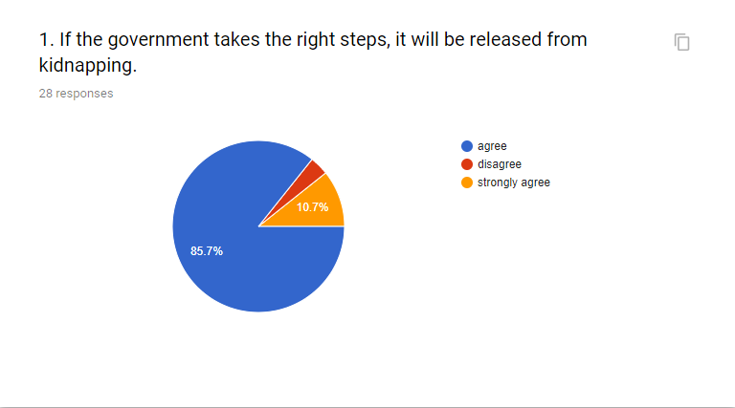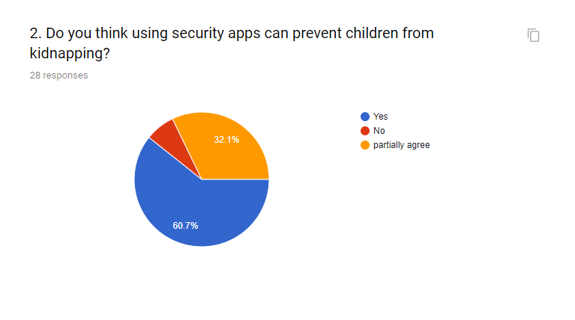

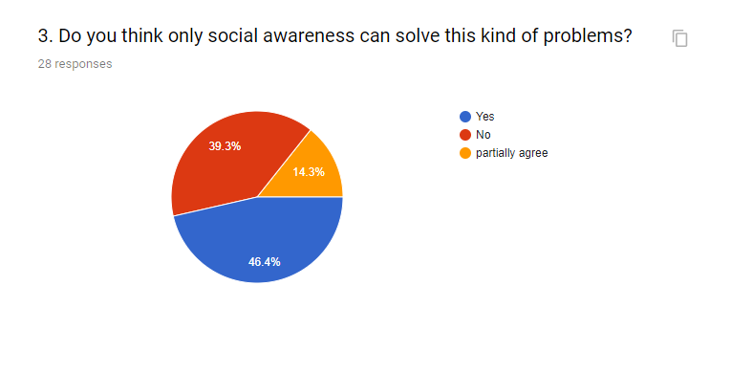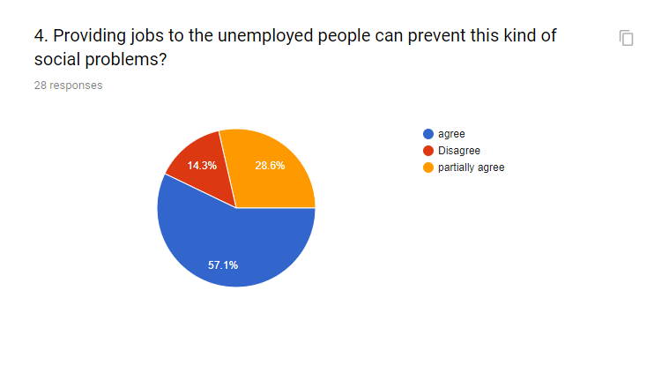

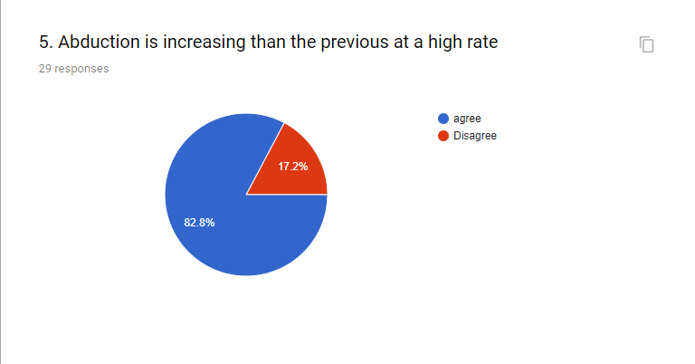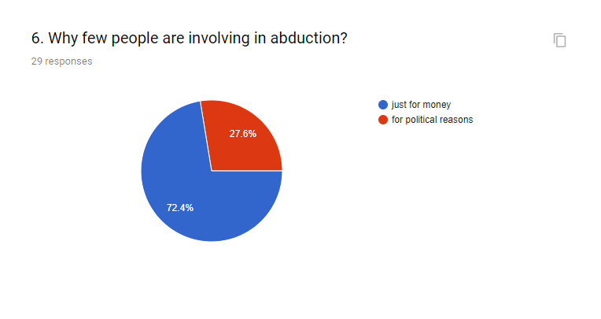

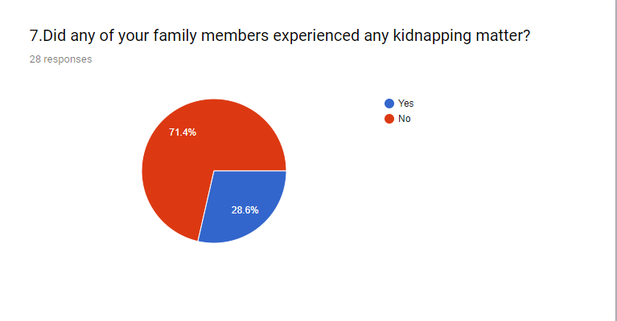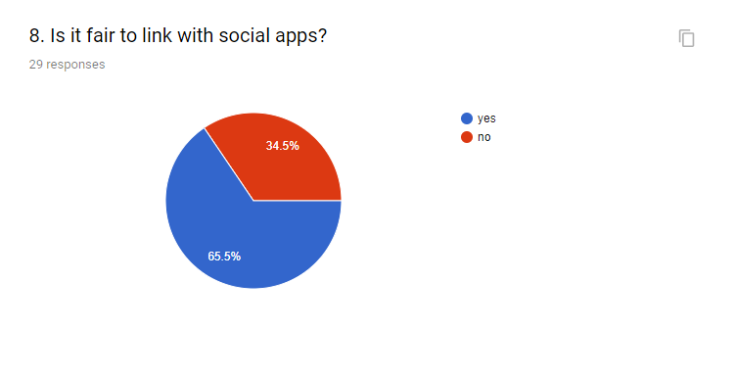

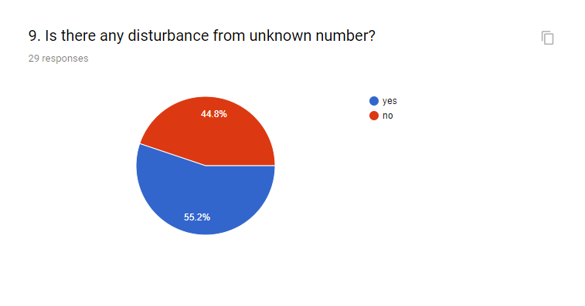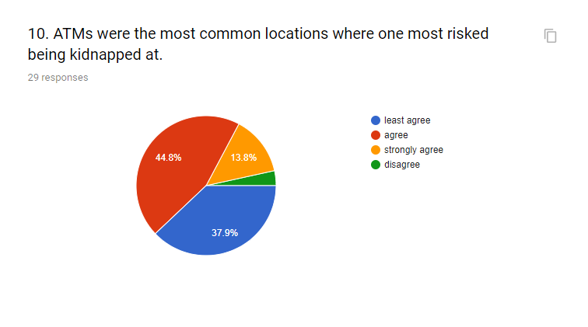

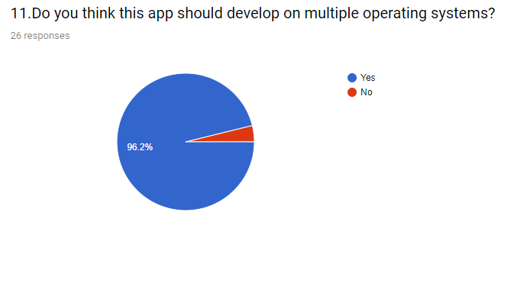

**Conclusion**

This article effectively defines the modern smart agent system to safeguard the women community. Constructive planning is essential to completely get rid such kind of crimes in future. At present, only software implementation has been done and we have planned to do with hardware also. In addition to power button, other keys would be attached to facilitate further security so that it enables the surrounding people react more to save the affected ones.

**Recommendation**

. [1]  ElisabethIlie-Zudora, Zsolt Kemenya, Fredvan Blommestein, Laszlo Monostoria and Andrevan der Meulen, A Survey of Applications and Requirements of Unique Identification Systems and RFID Techniques, Computers in Industry, Vol. 62, No. 3, 2011, pp. 227-252, https://dx.doi.org/10.1016/j.compind.2 010.10.004.

. [2]  Meenakshi N.Mehta, Shalini S.Bhatt and M.G.Gore, Kidnapping a Social Evil, Child Abuse & Neglect, Vol. 3, No. 2, 1979, pp. 615-621, https://dx.doi.org/10.1016/0145- 2134(79)90088-7.

. [3]  Y.Vidya and B.Shemimol, Secured Friending in Proximity Based Mobile Social Network, Journal of Excellence in Computer Science and Engineering, Vol. 1, No. 2, 2015, pp. 1-10 http://dx.doi.org/10.18831/djcse.in/201 5021001.

. [4]  Kexin Yu and Wing Kam Fung, Evaluation of Parentage Testing

Accuracy of Child Trafficking Cases: Combining the Exclusion Probability and Likelihood Ratio Approaches, Forensic Science International: Genetics, Vol. 34, 2018, pp. 81-87.

[5] C.Berin Jones, Cyber-Security and Combatting Cyber-Attacks: A Study, Journal of Excellence in Computer Science and Engineering, Vol. 3, No. 2, 2017, pp. 1-16, https://dx.doi.org/10.18831/djcse.in/20 17021001.

. [6]  Claudio Detotto, Bryan C.McCannon and Marco Vannini, Evidence of Marginal Deterrence: Kidnapping and Murder in Italy, International Review of Law and Economics, Vol. 41, 2015, pp. 63-67, https://dx.doi.org/10.1016/j.irle.2014.1 1.001.

. [7]  M.Julie Emerald Jiju and E.Arun, Cloud Computing: Characteristics, Issues and Possible Security Solutions - A Review, DJ Journal of Advances in Electronics and Communication Engineering, Vol. 1, No. 2, 2015, pp. 12-23, http://dx.doi.org/10.18831/djece.org/2 015021002.

. [8]  C.Yamagata, J.F.Coppola, M.Kowtko, and S.Joyce, Mobile App Development and Usability Research to Help Dementia and Alzheimer Patient, IEEE Annual Conference on Long Island Systems, Applications and Technology, USA, 2013, pp. 1-6, https://dx.doi.org/10.1109/LISAT.201 3.6578252.

. [9]  R.Mammone, Child Locator Apparatus and Method, US 10 689 216, 2003.

. [10]  P.J.Kennedy, Mobile Phone Amber Alert Notification System and Method, US 7 228 121 B2, 2007.

. [11]  B.King and D.A.Ancey, GPS-Based Vehicle Warning and Location System and Method, US 6 895 332 B2, 2005.

. [12]  D.Curran, J.Demmel and R.A.Fanshier, Geo-fence with Minimal False Alarms, US 8 125 332 B2, 2012.

. [13]  V.Pankaj and J.S.Bhatia, Design and Development of GPS -GSM Based Tracking System with Goole Map Based Monitoring, International Journal of Computer Science,

3

S.Dhanasekaran andV.Vasudevan./Journal of Excellence in Computer Science and Engineering, Vol. 4(2), 2018 pp. 1-4

Engineering and applications, Vol. 3,

No. 3, 2013, pp. 33-40.

. [14]  P.Wang, Z.Zhao, C.Xu, Z.Wu, and   
Y.Luo, Design and Implementation of the Low Power Tracking System Based on GPS-GPRS Module, IEEE Conference on Industrial Electronics and Applications, Taiwan, 2010, pp. 207-210, https://dx.doi.org/10.1109/ICIEA.2010 .5516772.

. [15]  M.Kunal, S.Mandeep, and J.Neelu, Real Time Vehicle Tracking System Using GSM and GPS Technology-An Anti-Theft Tracking System, International Journal of Electronics and Computer Science Engineering, Vol. 1, No. 3, pp. 1103-1107, 2012.

. [16]  Mohammad A.AL-Khedher, Hybrid GPS-GSM Localization of Automobile Tracking system, International Journal of Computer Science and Information Technology, Vol. 3, No. 6, pp. 75-85, 2011.