|  |  |
| --- | --- |
|  | Database    Database project  Group name:  **Submitted to:**  **REZWAN AHMED**  **18/04/19** |

DATABASE

A REPORT SUBMITED TO DEPARTMENT OF COMPUTER SCIENCE AND ENGINEERING,

EXAMINATION IN INRTODUCTION TO DATABASE, FALL SEMESTER 2018-19

PREPARED & SUBMITTED BY GROUP

1)ARIF AHMED------(18-37994-2)

2)SOHELEE SEN-----(18-38045-2)

3)ABDULLAH-----------(18-37853-2)

4)MD, ASIF AHMED-(18-36650-1)

GROUP NAME:

SECTION:(M)

COURSE ISTRUCTOR: REZWAN AHMED

**PREFACE:**

Database is a systematic collection of data. Database supports storage and manipulation of data. Databases make data management easy, Database Management System (DBMS) is a collection of programs which enables its users to access database, manipulate data, representation of data.

**ACKNOWLEDGEMENT:**

First, we would like to thank our course instructor of this introduction to database course REZWAN AHMED sir for his valuable guidance and advice. He inspired us greatly to work in this project .His willingness motivates us to contribute tremendously to our work.

**TABLE OF CONTENT**

TITLE PAGE-------------------------------1-2  
PREFACE-----------------------------------3

ACKNOWLEDGEMENT---------------4

TABLE OF CONTENT ----------------5

ABSTRACT-------------------------------6

MAPING----------------------------------7-8

ER-DIAGRAM--------------------------9

NORMALIZATON ----------------------10-20  
QUERY------------------------------------21-22  
VIEW --------------------------------------23-25

CONCLUSION---------------------------26

ABSTRACT:

Database is a large quantity of indexed digital information. It can be searched, referenced, compared, changed or otherwise manipulated with optimal speed and minimal processing expenses. Schema, Table, Column Row are database several main components.

***Management System of a Food Factory***

***Situation :***

Suppose, a factory that produces frozen food maintains a database system. Every food produced here has a unique barcode, batch number, item name, some ingredients, a production date and an expiration date that can be found from production date. 2 types of Employee are present there- Workers whom are involved with production have ID, employee name, section they work at, address, contact number, email and salary. Managers have unique ID, manager name, section they supervise, address, contact number, email and salary and they supervise the production employees. The company investors have name, contact number, email and the amount they invest. Every shop that sells the food after delivery has a unique shop ID, shop name which can be derived from the ID, address, post code found from the address and an owner who is recognized with a name and a contact number. The managers check on to production time-to-time.

**Entity set :**

Frozen_food, Worker, Manager, Investor, Selling_place.

**Attributes :**

**Frozen food :** Barcode, batch_no, item_name, ingredients, produc_date, exp_date.

**Manager :** m_id, m_name, supervise_section, address, contact_no, email.

**Worker :** w id, w_name, work_section, address, contact_no, email.

**Investor :**  iv_id,inv_name, contact_no, email, inv_amount

**Selling place :** shop_id, shop_name, postcode, address, o_name, contact_no.

**Relationship set :**

* **Food---Employee :** Produces
* **Employee---Manager :** Supervise
* **Manager---Food :** Check_on
* **Investor---Food :** Invests
* **Food---Selling_place :** Deliver
* **Manager---Selling_place :** Record
* **Manager---Investor :** Contacts

**ER-DAIGRAM**

Deliver

Record

Selling_place

supervise

contacts

Invest_on

Investor

Check_on

Manager

Worker

produce

Frozen food

NORMALIZATION

Table: Frozen Food

|  |  |  |  |  |  |
| --- | --- | --- | --- | --- | --- |
| Batch No | Item Name | Barcode | Ingredients | Produce Date | Expire Date |
| 201 | Burger | 12345 | Bread,  Chicken,  Onion | 20 April’19 | 22April’19 |
| 202 | Naga chicken | 678910 | Chicken,  Alligator Gar | 20 April’19 | 22April’19 |
| 203 | Pasta | 111213 | Mashroom,  Chicken,  Cheez | 20 April’19 | 22April’19 |

Now:

1NF:

In the 1NF, Never Stay multivalued attribute in the table. All the values in the table will be Atomic.

|  |  |  |  |  |  |
| --- | --- | --- | --- | --- | --- |
| Batch No | Item Name | Barcode | Ingredients | Produce Date | Expire Date |
| 201 | Burger | 12345 | Bread | 20 April’19 | 22April’19 |
| 201 | Burger | 12345 | Chicken | 20 April’19 | 22April’19 |
| 201 | Burger | 12345 | Onion | 20 April’19 | 22April’19 |
| 202 | Naga chicken | 678910 | Chicken | 20 April’19 | 22April’19 |
| 202 | Naga chicken | 678910 | Alligator Gar | 20 April’19 | 22April’19 |
| 203 | Pasta | 111213 | Mashroom | 20 April’19 | 22April’19 |
| 203 | Pasta | 111213 | Chicken | 20 April’19 | 22April’19 |
| 203 | Pasta | 111213 | Cheez | 20 April’19 | 22April’19 |

Now:

2NF:

In the 2NF, Non-prime-attribute can’t depends on sub-set off primary key

|  |  |  |  |  |
| --- | --- | --- | --- | --- |
| Batch No | Item Name | Barcode | Produce Date | Expire Date |
| 201 | Burger | 12345 | 20 April’19 | 22April’19 |
| 202 | Naga chicken | 678910 | 20 April’19 | 22April’19 |
| 203 | Pasta | 111213 | 20 April’19 | 22April’19 |

|  |  |
| --- | --- |
| Batch No | Ingredients |
| 201 | Bread |
| 201 | Chicken |
| 201 | Onion |
| 202 | Chicken |
| 202 | Alligator Gar |
| 203 | Mashroom |
| 203 | Chicken |
| 203 | Cheez |

Now:

3NF:

In the 3NF, There is no transitive functional dependency in the table.

|  |  |  |
| --- | --- | --- |
| Batch No | Produce Date | Expire Date |
| 201 | 20 April’19 | 22April’19 |
| 202 | 20 April’19 | 22April’19 |
| 203 | 20 April’19 | 22April’19 |

|  |  |
| --- | --- |
| Item Name | Barcode |
| Burger | 12345 |
| Naga chicken | 678910 |
| Pasta | 111213 |

|  |  |
| --- | --- |
| Batch No | Ingredients |
| 201 | Bread |
| 201 | Chicken |
| 201 | Onion |
| 202 | Chicken |
| 202 | Alligator Gar |
| 203 | Mashroom |
| 203 | Chicken |
| 203 | Cheez |

Table:

Manager:

|  |  |  |  |  |  |
| --- | --- | --- | --- | --- | --- |
| M_Id | M_Name | Supervise Section | Address | Contact No | Email |
| A-701 | Siddique | SEC-ST1  SEC-ST2  SEC-ST3 | DHAKA | ********* | Sidd12@gmail.com |
| A-702 | Mubarak | SEC-AS1  SEC-AS2  SEC-AS3 | SYLHET | ********* | Mub12@gmail.com |
| A-703 | Jakir | SEC-BN1  SEC-BN2 | CHITTAGONG | ********* | Jar11@gmail.c0m |

Now:

1NF:

In the 1NF, Never Stay multivalued attribute in the table. All the values in the table will be Atomic.

|  |  |  |  |  |  |
| --- | --- | --- | --- | --- | --- |
| M_Id | M_Name | Supervise Section | Address | Contact No | Email |
| A-701 | Siddique | SEC-ST1 | DHAKA | ********* | Sidd12@gmail.com |
| A-701 | Siddique | SEC-ST2 | DHAKA | ********* | Sidd12@gmail.com |
| A-701 | Siddique | SEC-ST3 | DHAKA | ********* | Sidd12@gmail.com |
| A-702 | Mubarak | SEC-AS1 | SYLHET | ********* | Mub12@gmail.com |
| A-702 | Mubarak | SEC-AS2 | SYLHET | ********* | Mub12@gmail.com |
| A-702 | Mubarak | SEC-AS3 | SYLHET | ********* | Mub12@gmail.com |
| A-703 | Jakir | SEC-BN1 | CHITTAGONG | ********* | Jar11@gmail.c0m |
| A-703 | Jakir | SEC-BN2 | CHITTAGONG | ********* | Jar11@gmail.c0m |

Now:

2NF:

In the 2NF, Non-prime-attribute can’t depends on sub-set off primary key

|  |  |
| --- | --- |
| M_Id | Supervise Section |
| A-701 | SEC-ST1 |
| A-701 | SEC-ST2 |
| A-701 | SEC-ST3 |
| A-702 | SEC-AS1 |
| A-702 | SEC-AS2 |
| A-702 | SEC-AS3 |
| A-703 | SEC-BN1 |
| A-703 | SEC-BN2 |

|  |  |  |  |  |
| --- | --- | --- | --- | --- |
| M_Id | M_Name | Address | Contact No | Email |
| A-701 | Siddique | DHAKA | ********* | Sidd12@gmail.com |
| A-701 | Siddique | DHAKA | ********* | Sidd12@gmail.com |
| A-701 | Siddique | DHAKA | ********* | Sidd12@gmail.com |
| A-702 | Mubarak | SYLHET | ********* | Mub12@gmail.com |
| A-702 | Mubarak | SYLHET | ********* | Mub12@gmail.com |
| A-702 | Mubarak | SYLHET | ********* | Mub12@gmail.com |
| A-703 | Jakir | CHITTAGONG | ********* | Jar11@gmail.c0m |
| A-703 | Jakir | CHITTAGONG | ********* | Jar11@gmail.c0m |

Now:

3NF:

In the 3NF, There is no transitive functional dependency in the table.

|  |  |  |  |
| --- | --- | --- | --- |
| M_Id | M_Name | Address | Email |
| A-701 | Siddique | DHAKA | Sidd12@gmail.com |
| A-701 | Siddique | DHAKA | Sidd12@gmail.com |
| A-701 | Siddique | DHAKA | Sidd12@gmail.com |
| A-702 | Mubarak | SYLHET | Mub12@gmail.com |
| A-702 | Mubarak | SYLHET | Mub12@gmail.com |
| A-702 | Mubarak | SYLHET | Mub12@gmail.com |
| A-703 | Jakir | CHITTAGONG | Jar11@gmail.c0m |
| A-703 | Jakir | CHITTAGONG | Jar11@gmail.c0m |

|  |  |
| --- | --- |
| Address | Email |
| DHAKA | Sidd12@gmail.com |
| DHAKA | Sidd12@gmail.com |
| DHAKA | Sidd12@gmail.com |
| SYLHET | Mub12@gmail.com |
| SYLHET | Mub12@gmail.com |
| SYLHET | Mub12@gmail.com |
| CHITTAGONG | Jar11@gmail.c0m |
| CHITTAGONG | Jar11@gmail.c0m |

|  |  |
| --- | --- |
| M_Id | Supervise Section |
| A-701 | SEC-ST1 |
| A-701 | SEC-ST2 |
| A-701 | SEC-ST3 |
| A-702 | SEC-AS1 |
| A-702 | SEC-AS2 |
| A-702 | SEC-AS3 |
| A-703 | SEC-BN1 |
| A-703 | SEC-BN2 |

Table:

Worker:

|  |  |  |  |  |  |
| --- | --- | --- | --- | --- | --- |
| W_ Id | W_ Name | Work Section | Address | Contact No | Email |
| W-17 | Ali | B21  B22  B23 | Dhaka | ******** | ali@gmail.com |
| W-18 | Oli | K24  K25  K26 | Khulna | ******** | oli@gmail.com |
| W-19 | Mustak | M27,M28 | Barishal | ********* | Mus2@gmail.com |

Now:

1NF:

In the 1NF, Never Stay multivalued attribute in the table. All the values in the table will be Atomic.

|  |  |  |  |  |  |
| --- | --- | --- | --- | --- | --- |
| W_ Id | W_ Name | Work Section | Address | Contact No | Email |
| W-17 | Ali | B21 | Dhaka | ******** | ali@gmail.com |
| W-17 | Ali | B22 | Dhaka | ******** | ali@gmail.com |
| W-17 | Ali | B23 | Dhaka | ******** | ali@gmail.com |
| W-18 | Oli | K24 | Khulna | ******** | oli@gmail.com |
| W-18 | Oli | K25 | Khulna | ******** | oli@gmail.com |
| W-18 | Oli | K26 | Khulna | ******** | oli@gmail.com |
| W-19 | Mustak | M27 | Barishal | ********* | Mus2@gmail.com |
| W-19 | Mustak | M28 | Barishal | ********* | Mus2@gmail.com |

Now:

2NF:

In the 2NF, Non-prime-attribute can’t depends on sub-set off primary key .

|  |  |
| --- | --- |
| W_ Id | Work Section |
| W-17 | B21 |
| W-17 | B22 |
| W-17 | B23 |
| W-18 | K24 |
| W-18 | K25 |
| W-18 | K26 |
| W-19 | M27 |
| W-19 | M28 |

|  |  |  |  |  |
| --- | --- | --- | --- | --- |
| W_ Id | W_ Name | Address | Contact No | Email |
| W-17 | Ali | Dhaka | ******** | ali@gmail.com |
| W-17 | Ali | Dhaka | ******** | ali@gmail.com |
| W-17 | Ali | Dhaka | ******** | ali@gmail.com |
| W-18 | Oli | Khulna | ******** | oli@gmail.com |
| W-18 | Oli | Khulna | ******** | oli@gmail.com |
| W-18 | Oli | Khulna | ******** | oli@gmail.com |
| W-19 | Mustak | Barishal | ********* | Mus2@gmail.com |
| W-19 | Mustak | Barishal | ********* | Mus2@gmail.com |

Now:

3NF:

In the 3NF, There is no transitive functional dependency in the table.

|  |  |  |  |
| --- | --- | --- | --- |
| W_ Id | W_ Name | Address | Contact No |
| W-17 | Ali | Dhaka | ******** |
| W-17 | Ali | Dhaka | ******** |
| W-17 | Ali | Dhaka | ******** |
| W-18 | Oli | Khulna | ******** |
| W-18 | Oli | Khulna | ******** |
| W-18 | Oli | Khulna | ******** |
| W-19 | Mustak | Barishal | ********* |
| W-19 | Mustak | Barishal | ********* |

|  |  |
| --- | --- |
| Address | Email |
| Dhaka | ali@gmail.com |
| Dhaka | ali@gmail.com |
| Dhaka | ali@gmail.com |
| Khulna | oli@gmail.com |
| Khulna | oli@gmail.com |
| Khulna | oli@gmail.com |
| Barishal | Mus2@gmail.com |
| Barishal | Mus2@gmail.com |

|  |  |
| --- | --- |
| W_ Id | Work Section |
| W-17 | B21 |
| W-17 | B22 |
| W-17 | B23 |
| W-18 | K24 |
| W-18 | K25 |
| W-18 | K26 |
| W-19 | M27 |
| W-19 | M28 |

Table:

Investor:

|  |  |  |  |  |
| --- | --- | --- | --- | --- |
| Iv_ Id | Iv_ Name | Iv_ amount | Contact No | Email |
| IV-12 | karim | 1500 | ******** | [ka@gmail.com](mailto:ka@gmail.com)  kr@gmail.com |
| IV-13 | Rahim | 2000 | ******** | [R4@gmail.com](mailto:R4@gmail.com)  Ra3@gmail.com |
| IV-14 | Jasim | 2500 | ******** | [Ja3@gmail.com](mailto:Ja3@gmail.com)  jsm@gmail.com |

Now:

1NF:

In the 1NF, Never Stay multivalued attribute in the table. All the values in the table will be Atomic.

|  |  |  |  |  |
| --- | --- | --- | --- | --- |
| Iv_ Id | Iv_ Name | Iv_ amount | Contact No | Email |
| IV-12 | karim | 1500 | ******* | [ka@gmail.com](mailto:ka@gmail.com) |
| IV-12 | karim | 1500 | ******** | kr@gmail.com |
| IV-13 | Rahim | 2000 | ******** | [R4@gmail.com](mailto:R4@gmail.com) |
| IV-13 | Rahim | 2000 | ******** | Ra3@gmail.com |
| IV-14 | Jasim | 2500 | ******** | [Ja3@gmail.com](mailto:Ja3@gmail.com) |
| IV-14 | Jasim | 2500 | ******** | jsm@gmail.com |

Now:

2NF:

In the 2NF, Non-prime-attribute can’t depends on sub-set off primary key

|  |  |
| --- | --- |
| Iv_ Id | Iv_ amount |
| IV-12 | 1500 |
| IV-12 | 1500 |
| IV-13 | 2000 |
| IV-13 | 2000 |
| IV-14 | 2500 |
| IV-14 | 2500 |

|  |  |  |  |
| --- | --- | --- | --- |
| Iv_ Id | Iv_ Name | Contact No | Email |
| IV-12 | karim | ******* | [ka@gmail.com](mailto:ka@gmail.com) |
| IV-12 | karim | ******** | kr@gmail.com |
| IV-13 | Rahim | ******** | [R4@gmail.com](mailto:R4@gmail.com) |
| IV-13 | Rahim | ******** | Ra3@gmail.com |
| IV-14 | Jasim | ******** | [Ja3@gmail.com](mailto:Ja3@gmail.com) |
| IV-14 | Jasim | ******** | jsm@gmail.com |

Now:

3NF:

In the 3NF, There is no transitive functional dependency in the table.

|  |  |
| --- | --- |
| Iv_ Name | Email |
| karim | [ka@gmail.com](mailto:ka@gmail.com) |
| karim | kr@gmail.com |
| Rahim | [R4@gmail.com](mailto:R4@gmail.com) |
| Rahim | Ra3@gmail.com |
| Jasim | [Ja3@gmail.com](mailto:Ja3@gmail.com) |
| Jasim | jsm@gmail.com |

|  |  |  |
| --- | --- | --- |
| Iv_ Id | Iv_ Name | Contact No |
| IV-12 | karim | ******* |
| IV-12 | karim | ******** |
| IV-13 | Rahim | ******** |
| IV-13 | Rahim | ******** |
| IV-14 | Jasim | ******** |
| IV-14 | Jasim | ******** |

|  |  |
| --- | --- |
| Iv_ Id | Iv_ amount |
| IV-12 | 1500 |
| IV-12 | 1500 |
| IV-13 | 2000 |
| IV-13 | 2000 |
| IV-14 | 2500 |
| IV-14 | 2500 |

Table:

Selling Place:

|  |  |  |  |  |  |
| --- | --- | --- | --- | --- | --- |
| Shop Id | Shop_Name | O_ Name | Post_ Code | Address | Contact No |
| SH-1 | Shopno-Stor | Emon  Rahim | 1997 | Dhaka | ******* |
| SH-2 | Sony-stor | Rafid  Shuvo | 1995 | Dhaka | ******* |
| SH-3 | King-Stor | Sakib  mahi | 2000 | Rajshahi | ******* |

Now:

1NF:

In the 1NF, Never Stay multivalued attribute in the table. All the values in the table will be Atomic.

|  |  |  |  |  |  |
| --- | --- | --- | --- | --- | --- |
| Shop Id | Shop_Name | O_ Name | Post_ Code | Address | Contact No |
| SH-1 | Shopno-Stor | Emon | 1997 | Dhaka | ******* |
| SH-1 | Shopno-Stor | Rahim | 1997 | Dhaka | ******* |
| SH-2 | Sony-stor | Rafid | 1995 | Dhaka | ******* |
| SH-2 | Sony-stor | Shuvo | 1995 | Dhaka | ******* |
| SH-3 | King-Stor | Sakib | 2000 | Rajshahi | ******* |
| SH-3 | King-Stor | mahi | 2000 | Rajshahi | ******* |

Now:

2NF:

In the 2NF, Non-prime-attribute can’t depends on sub-set off primary key

|  |  |
| --- | --- |
| Shop Id | O_ Name |
| SH-1 | Emon |
| SH-1 | Rahim |
| SH-2 | Rafid |
| SH-2 | Shuvo |
| SH-3 | Sakib |
| SH-3 | mahi |

|  |  |  |  |  |
| --- | --- | --- | --- | --- |
| Shop Id | Shop_Name | Post_ Code | Address | Contact No |
| SH-1 | Shopno-Stor | 1997 | Dhaka | ******* |
| SH-1 | Shopno-Stor | 1997 | Dhaka | ******* |
| SH-2 | Sony-stor | 1995 | Dhaka | ******* |
| SH-2 | Sony-stor | 1995 | Dhaka | ******* |
| SH-3 | King-Stor | 2000 | Rajshahi | ******* |
| SH-3 | King-Stor | 2000 | Rajshahi | ******* |

Now:

3NF:

In the 3NF, There is no transitive functional dependency in the table.

|  |  |  |  |
| --- | --- | --- | --- |
| Shop Id | Shop_Name | Post_ Code | Contact No |
| SH-1 | Shopno-Stor | 1997 | ******* |
| SH-1 | Shopno-Stor | 1997 | ******* |
| SH-2 | Sony-stor | 1995 | ******* |
| SH-2 | Sony-stor | 1995 | ******* |
| SH-3 | King-Stor | 2000 | ******* |
| SH-3 | King-Stor | 2000 | ******* |

|  |  |
| --- | --- |
| Post_ Code | Address |
| 1997 | Dhaka |
| 1997 | Dhaka |
| 1995 | Dhaka |
| 1995 | Dhaka |
| 2000 | Rajshahi |
| 2000 | Rajshahi |

|  |  |
| --- | --- |
| Shop Id | O_ Name |
| SH-1 | Emon |
| SH-1 | Rahim |
| SH-2 | Rafid |
| SH-2 | Shuvo |
| SH-3 | Sakib |
| SH-3 | mahi |

QUERY:

1)Find item name from frozen table?

select * from Frozen_item where barcode=1234

2)Find Ingredients from frozen table?

select * from frozen_item where ingredients='chicken'

3)Find address and email from manager table?

select * from manager where address='Dhaka' and email='stark56@gmail.com'

4)Find supervise section and contact number from manager table?

select * from manager where SUPERVISE_SECTION='A' and CONTRACT__NUMBER=895456666

5)Find shop name and post code from Selling_Place table?

select * from SELLING_PLACE where SHOP_NAME='Holy Store' and POST_CODE=1999

6) Find how many people works in workers table?

select count(*) from worker

7)change the SELLING_PLACE name into SELL_PLACE?

ALTER table SELLING_PLACE rename to SELL_PLACE

8) Add a new column in manager table?

alter table manager add salary number (2)

**9)**Sal of any manager of manager table.  
select * from emp where job = ‘manager’

10) List the manager whose Jobs are same as stark

select * from manager where job = (select job from where ename =’

Stark');

**VIEW:**

1)

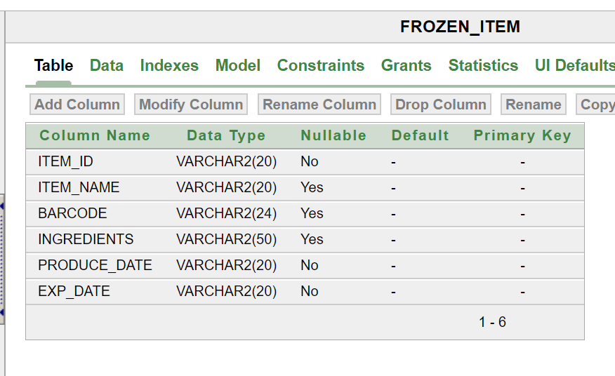

2)

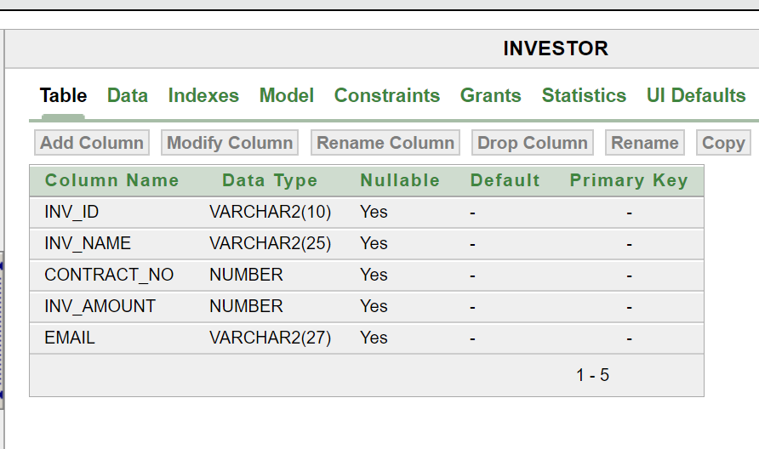

3)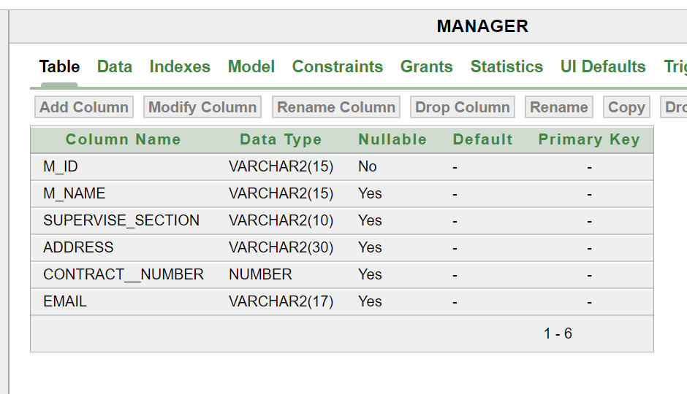

4)

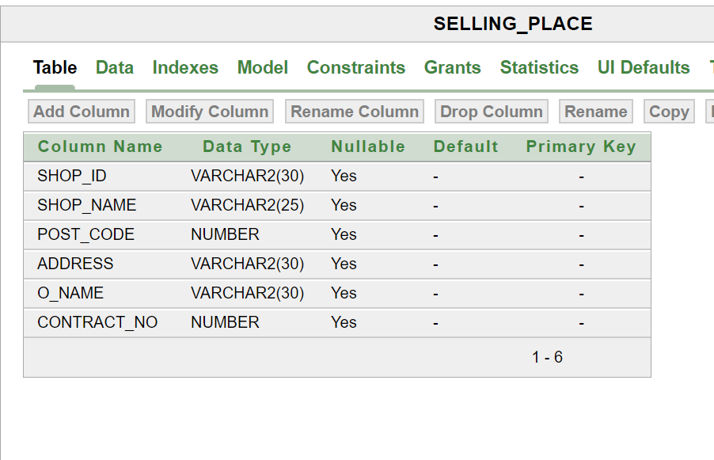

5)

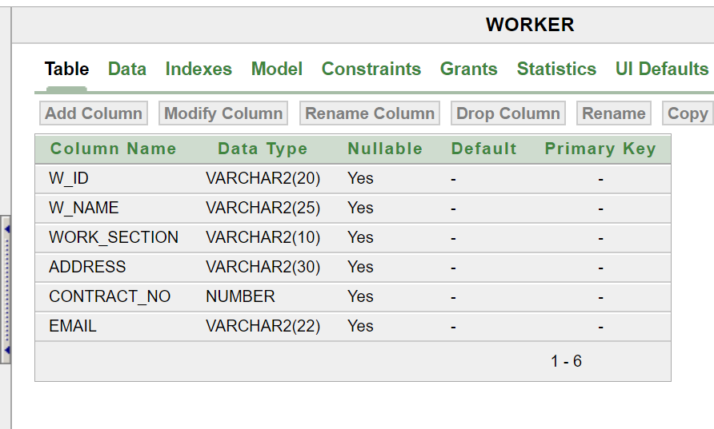

**Conclusion:**

During our database project we have learned about the Table, ER-Diagram, and of database design. This project gave us the opportunity to try our new skills in practice. While doing this project we have also gained deeper understanding on database and how it can be implemented in real life situations. We believe we can use our database project skills in other project.