**FINDING FREE**

**GARAGES**

**Submitted By:**

**Group name:**

**1.NAME: ASIF AHMED, ID:18-38441-2**

**2.NAME: NAHIDUL ISLAM, ID:18-38450-2**

**3.NAME: ARIF AHMED, ID: 18-37994-2**

**4.NAME: SOHELEE SEN , ID: 18-38045-2**

**A1.**

**PROBLEM STATEMENT :**

Finding free garages near us is sometimes a nightmare . Whenever we go to fix our car ,we face lots of problems .First of all ,the big amount of crowd or line around the garages .We go to long distance garages to avoid this kind of crowd,,but we can not.We do not have any other option without waiting.Sometimes,we wait for hours to repair our car.But the long lines of cars our valuable time.And when we get the chance to repair our car,we see the less amount of mechanics.We face problem having less amount of machanics who can not give us proper time our has required.just because of short amount of mechanics.First we face the crowd problem,the when you get to enter in a garage,we see short amount of mechanics busy with big amount of customers.However there is another problem.When we go to garages to get fuel,we face the proble of shortage amount of problems in the garages.We do not before going that there will be enough fuel or not.This is a big problem when we are in hurry.We go to one garage to another for getting fuel.As we do not know which garage is near us,sometimes we go far away garage when we already have garages near us.When we realize it,it becomes a curse.We face problems while service booking.We also face problems to purchase accessories.All garages never have the necessary accessories.We go to a garage to purchase necessary accessories,but they do not have requires accessories.Then we run to another garages to purchase,If we know it before going that which garages have the accessories,it would be great.After going to a garage,we face financial problems.we do not know before going that which amount of money we have to pay.We do not even know about the finance packages.There is no GPS locating system.We can not see other customer’s reviews.We can not book any appointment to view our vehicles.If there is a reminder to customers before this appointment or booking it would be great.Their should be photo and video gallery of past repair jobs.Loyality stamps are very impotant in garages.A garage have to keep the system of garage loyality stamps.

**A2.**

**EXISTING SOLUTIONS:**

The user can choose a point of interest by clicking one point with his or her finger on the screen, and then an icon will appear on the location. In this function, spots near the point and their text and image description can be got, at the same time these data will be cached into the local memory. As the questionnaire shown the textual and pictorial information are needed by the user to help them plan the travel route and also gain their knowledge about a place’s culture and history. If there is a place mark which is attached with a balloon (searched result, inserted by the user or spots near a point on the map, the Perl file from GSW with a list of spots near the point has been achieved. After that the Perl file can be processed by SAX parser, and the text descriptions and image can be achieved as attributes of every spot object. After the user clicking the text or image button in the balloon the contents needed can be displayed in a new text view This function is used to locate the user’s position via GPS, Wi-Fi or GPRS and draw his or her track. It should be noted that in search and route functions the phone’s positioning system are also used to collect coordinates if the input content is default String “My Location”. This function can help display the user’s location which can help read the maps more easily. In this project there are generally two ways to collect the location data (latitude and longitude) from a mobile device. One is using GPS Location Provider to get the user location. While recently the wireless technologies including 3G, Wi-Fi, WiMax, their transmission speed and scope are different (shyue-win, 2006). Though GPS is most accurate and common, it only works outdoors when the signal from the satellite can be reached. Also, in terms of saving battery power and being efficient, another choice is utilizing the Android's Network Location Provider to collect the user location. To obtain the user location in the application, either GPS or the Network Location Provider can be used.

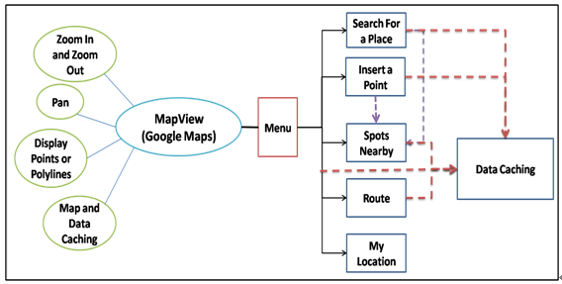

A3.

**PROPOSED SOLUTION:**

The concept behind the system is simple, sensors are used to detect individual car repairing shops. The data is transmitted to the Siemens Stratos traffic management system via IP connectivity using the Intelligent tracking system, with the data generated being utilised for applications that range from real-time driver information to linking data to payment or enforcement services.

By introducing a system where garages are integrated with it.Functionality is augmented in such way that it provides cities with a demand-responsive environment, where automatic triggers can be created based on sensor inputs. In turn, the data generated by the system can be used for planning purposes, allowing strategies to be created as part of the systems, in such way that can boost revenue, increase customer satisfaction and increase compliance.

The Siemens Intelligent Sensor is an ultra-low power, microwave radar detector. The technology embedded in the sensor is used to detect free garages, measuring start and end times. These sensors lie beneath the road, with each containing an in-built wireless transmitter/receiver with a dedicated battery that transmits detection data to an associated access point or repeater, which forwards it on to the back office system for analysis.

The sensors are easily installed by ‘coring’ an appropriate 100mm diameter hole in the carriageway and fixing in place with a specific epoxy resin compound. The process takes around 15 minutes.

The system can be installed in on-street and outdoor off-street environments. With a configurable detection range of up to 90 degrees and 3 metres in width, the system provides accurate garage location and these garages are free and have sufficient technicians. The configurability also means that the system can cater for parallel, diagonal and perpendicular setups.

The microwave radar technology adopted by Siemens is advantageous over other sensing technologies for Intelligent tracing such as infrared and radar. Accuracy is not affected by lighting conditions nor dirt, dust or oil on the sensor.

All firmware upgrades can be done remotely via the Stratos hosted traffic management system or via local PC connection.

One of the key benefits of the Siemens Intelligent system is its integration with Stratos, the Siemens hosted traffic management solution. Stratos provides the ability to monitor and control parking spaces, utilising the sensor input for the creation of strategies using road and virtual signs, journey times and environmental information.

The data produced by the sensors can be provided to other road traffic infrastructure, including Variable Message Signs (VMS) to alert drivers of the number of spaces available and the nearest available free garages, improving the information available to drivers and enhancing the overall driving experience.

The system can also offer links to third-party applications via open standards such as DATEX II. This interface can allow integration of the data produced by the system for payment providers, enforcement and in-vehicle platforms that consume data in order to provide services that add value to the infrastructure in place.

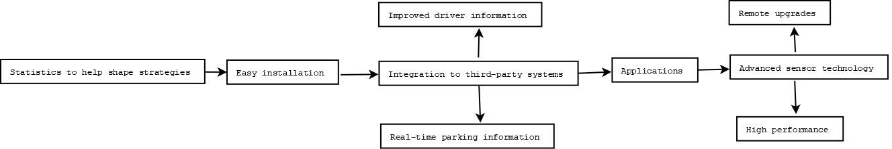

**A4.**

**Project Scopes:**

* This system works by internet , so without internet this system won’t work.
* User must turn on their gps services.Otherwise this system can’t trace the user.
* This system can trace only those garages who are parts or connected with the system.
* User must have the compatible device that can install or run this system.

**A5.**

System Features:

**•Advanced sensor technology**

**• Easy installation**  
**• Applications**

**• High performance**

**• Remote upgrades**

**• Statistics to help shape strategies**

**• Improved driver information**

**• Integration to third-party systems**

**• Real-time parking information**

