Employee Task and Attendance Management System

User documentation

Authors:
Sohibjon Hakimov
…

2024

1. Admin Module

1.1 Login Screen

The login screen allows users to access the system by providing their credentials.
Steps to log in:
1. Enter your username in the "Username" field.
1. Enter your password in the "Password" field.
1. Click the "Login" button to proceed.
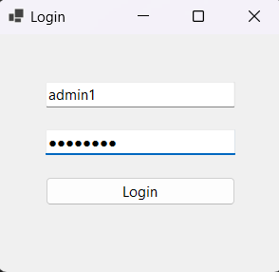
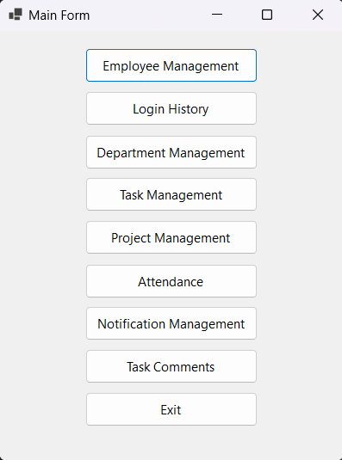
If the credentials are valid, you will be redirected to the main dashboard.

1.2 Main Dashboard

The main dashboard contains various management options for the admin,
- Employee Management
2. Login History
3. Department Management
4. Task Management
5. Project Management
6. Attendance
7. Notification Management
8. Task Comments
9. Exit
Select the desired option by clicking the corresponding button.

1.3 Employee Management
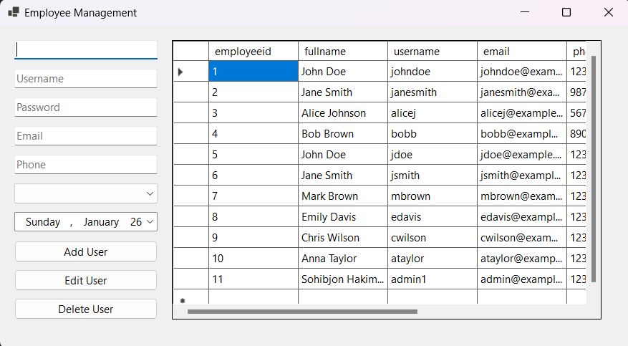
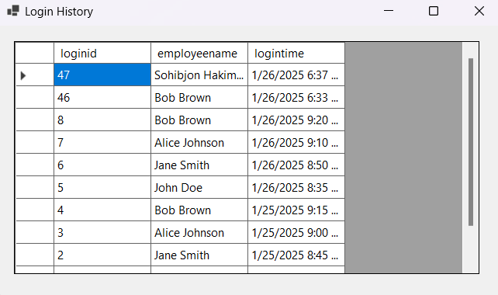
This module allows the admin to manage employee data, including adding, editing, and deleting records.
Steps:
1. Use the form on the left to input details like Username, Password, Email, and Phone.
2. To add a new employee, fill in the required fields and click "Add User".
3. To edit an existing employee, select their record from the table, make changes in the fields, and click "Edit User".
4. To delete an employee, select their record from the table and click "Delete User”.

1.4 Login History

The Login History module displays a record of all login activities.
Features:
- View login attempts with details such as employee name and login time.
- Scroll through the table to view historical data.

1.5 Department Management
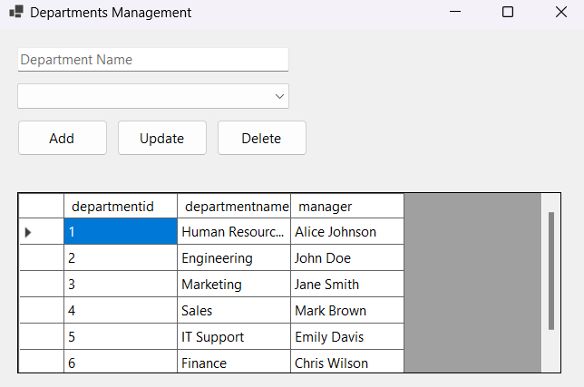
This module allows the admin to manage departments.
Steps:
1. Enter the department name in the input field.
2. Use the dropdown to assign a manager to the department.
3. Click "Add" to create a new department.
4. Select an existing department from the table and click "Update" to modify its details.
5. Click "Delete" to remove a department.

1.6 Task Management

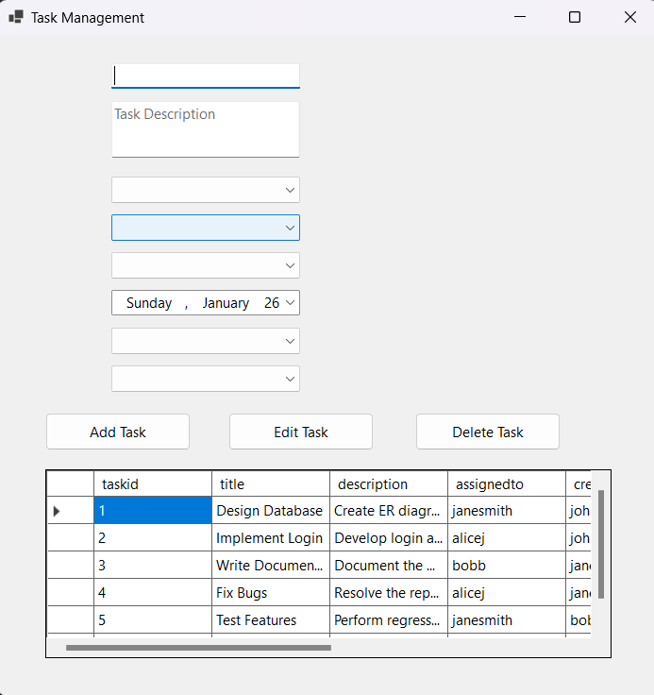
This module allows the admin to manage tasks.
Steps:
1. Enter the task details like Title, Description, Assigned Employee, and Date.
2. Click "Add Task" to create a new task.
3. Select an existing task from the table and click "Edit Task" to modify it.
4. Click "Delete Task" to remove a task.

1.7 Project Management

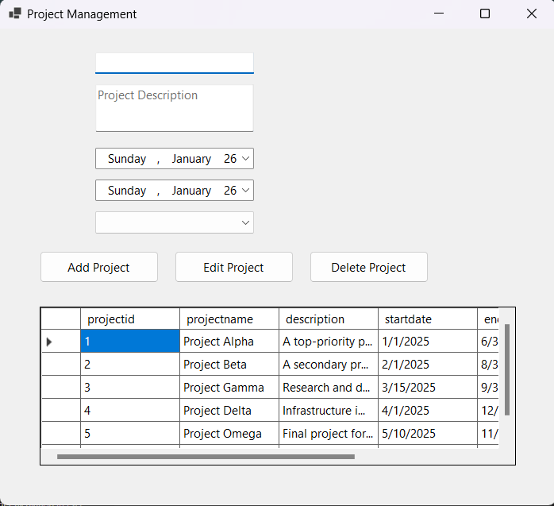
This module allows the admin to manage projects.
Steps:
1. Enter the project details like Name, Description, Start Date, and End Date.
2. Click "Add Project" to create a new project.
3. Select an existing project from the table and click "Edit Project" to modify it.
4. Click "Delete Project" to remove a project.

1.8 Attendance Management
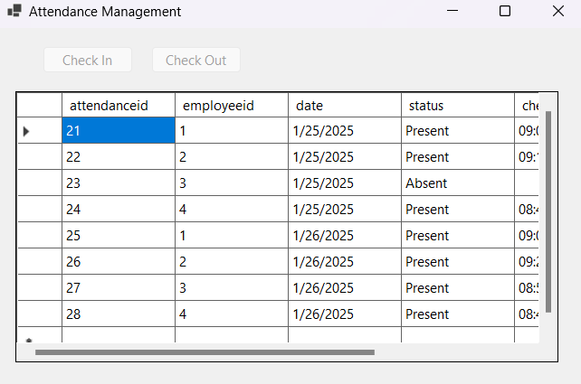
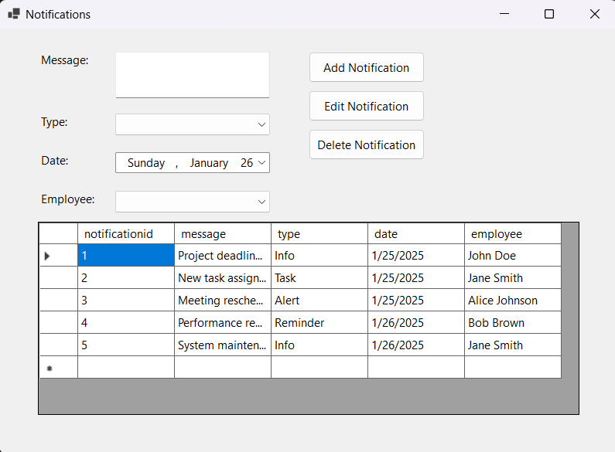
This module allows the admin to manage employee attendance.
Features:
- Use "Check In" and "Check Out" buttons to record attendance.
- View attendance records in the table.

1.9 Notification Management

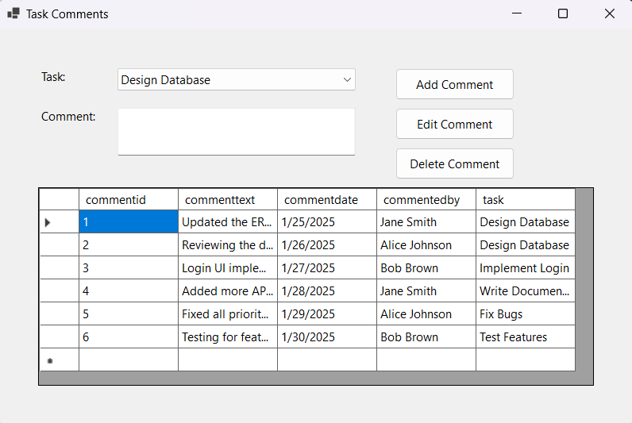
This module allows the admin to manage notifications.
Steps:
1. Enter the message details in the "Message" field.
2. Select the type and assign it to an employee using the dropdowns.
3. Click "Add Notification" to create a notification.
4. Select an existing notification and click "Edit Notification" to modify it.
5. Click "Delete Notification" to remove a notification.

1.10 Task Comments
This module allows the admin to manage comments related to tasks.
Steps:
1. Select a task from the dropdown menu.
2. Enter the comment in the "Comment" field.
3. Click "Add Comment" to create a new comment.
4. Select an existing comment and click "Edit Comment" to modify it.
5. Click "Delete Comment" to remove a comment.

2. Manager Module

2.1 Login Screen

The login screen allows managers to access the system by providing their credentials.
Steps to log in:
1. Enter your username in the "Username" field.
2. Enter your password in the "Password" field.
3. Click the "Login" button to proceed.
If the credentials are valid, you will be redirected to the main dashboard.

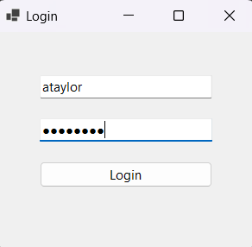
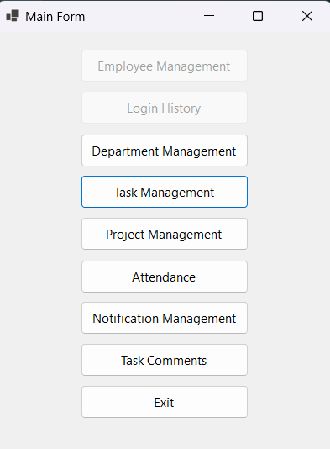
2.2 Main Dashboard

The main dashboard provides access to the management features. Some sections have restricted based on user roles.
Restricted sections are grayed out and cannot be accessed by Managers.
The accessible sections for Managers are:
1. Department Management
2. Task Management
3. Project Management
4. Attendance
5. Notification Management
6. Task Comments

2.3 Department Management
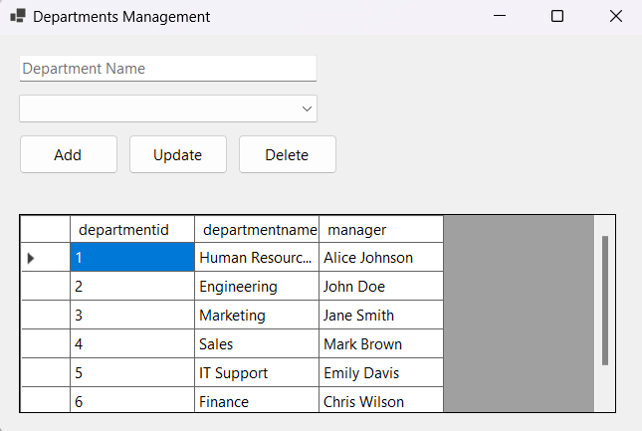
This module allows managers to view and manage departments.
Steps:
1. Enter the department name in the input field.
2. Use the dropdown to assign or update the manager for the department.
3. Click "Add" to create a new department.
4. Select an existing department from the table and click "Update" to modify its details.
5. Click "Delete" to remove a department.

2.4 Task Management
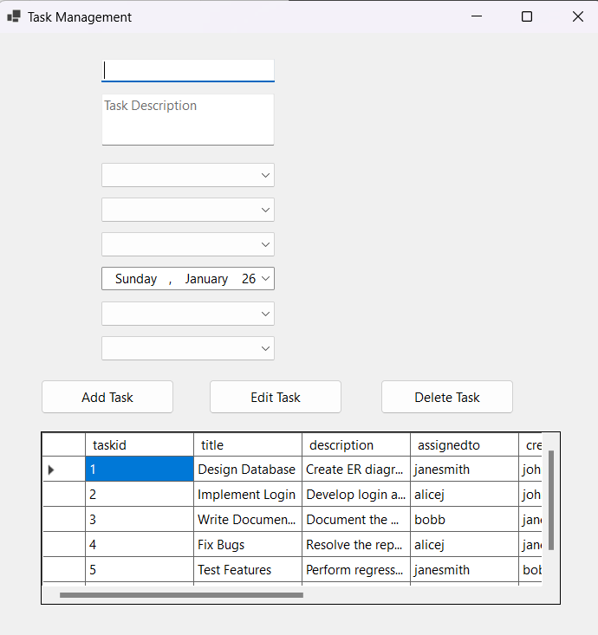
This module allows managers to view and manage tasks assigned to their department.
Steps:
1. Enter task details such as Title, Description, Assigned Employee, and Date.
2. Click "Add Task" to create a new task.
3. Select an existing task from the table and click "Edit Task" to modify it.
4. Click "Delete Task" to remove a task.

2.5 Project Management
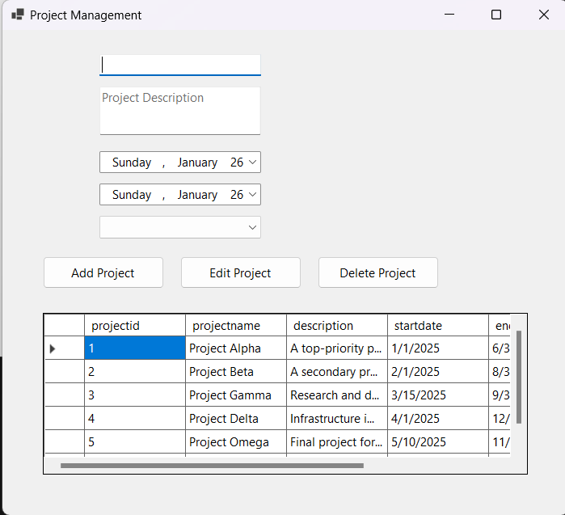
This module allows managers to view and manage their projects
Steps:
1. Enter project details such as Name, Description, Start Date, and End Date.
2. Click "Add Project" to create a new project.
3. Select an existing project from the table and click "Edit Project" to modify it.
4. Click "Delete Project" to remove a project.

2.6 Attendance Management

This module allows managers to view attendance records for employees
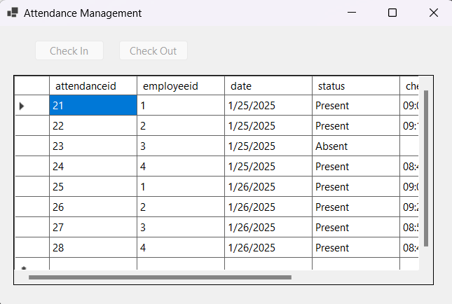
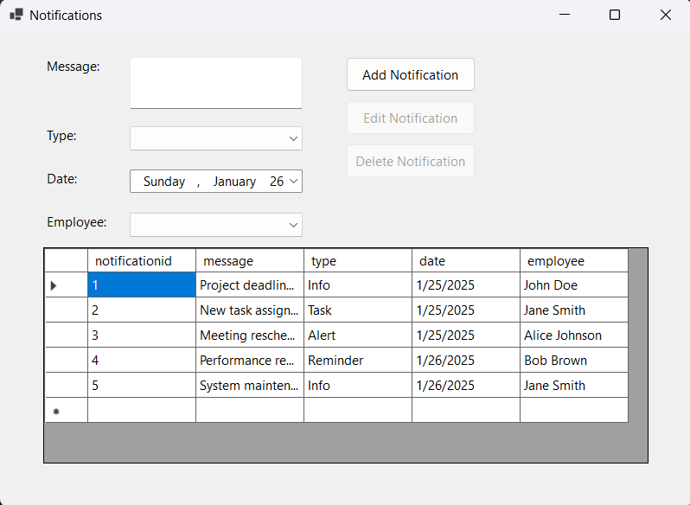
Features:
- View attendance records in the table.
- Restricted Features: Managers cannot check in or check out attendance records.

2.7 Notification Management

This module allows managers to send notifications to employees
Steps:
1. Enter the message in the "Message" field.
2. Select the type and assign it to an employee using the dropdowns.
3. Click "Add Notification" to create a notification.
Restricted Features: Managers can only view and add notificationt.

2.8 Task Comments
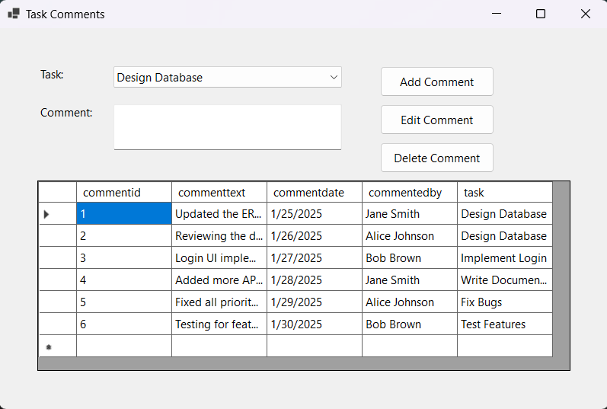
This module allows managers to view and manage comments related to tasks.
Steps:
1. Select a task from the dropdown menu.
2. Enter the comment in the "Comment" field.
3. Click "Add Comment" to create a new comment.
4. Select a comment and make some changes then click "Edit Comment" to modify it.
5. Click "Delete Comment" to remove a comment.

3. Employee Module

3.1 Login Screen

The login screen allows employees to access the system by providing their credentials.
Steps to log in:
1. Enter your username in the "Username" field.
2. Enter your password in the "Password" field.
3. Click the "Login" button to proceed.
If the credentials are valid, you will be redirected to the main dashboard.

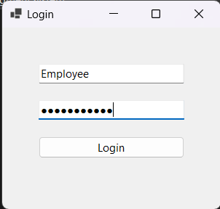

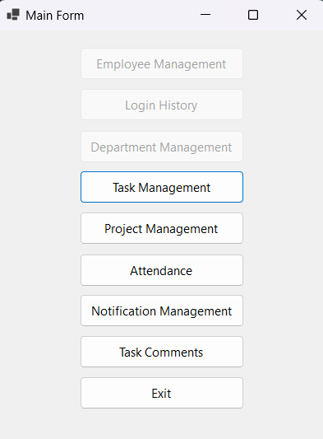
3.2 Main Dashboard

The main dashboard provides access to the features allowed for employees. Restricted sections are grayed out and cannot be accessed. The accessible sections for employees are:
1. Task Management
2. Project Management
3. Attendance
4. Notifications
5. Task Comments
Select the desired option by clicking the corresponding button.

3.3 Task Management
This module allows employees to view, edit and delete tasks assigned to them.
Steps:
1. View the task details such as Title, Description, Assigned Date, and Status in the table.
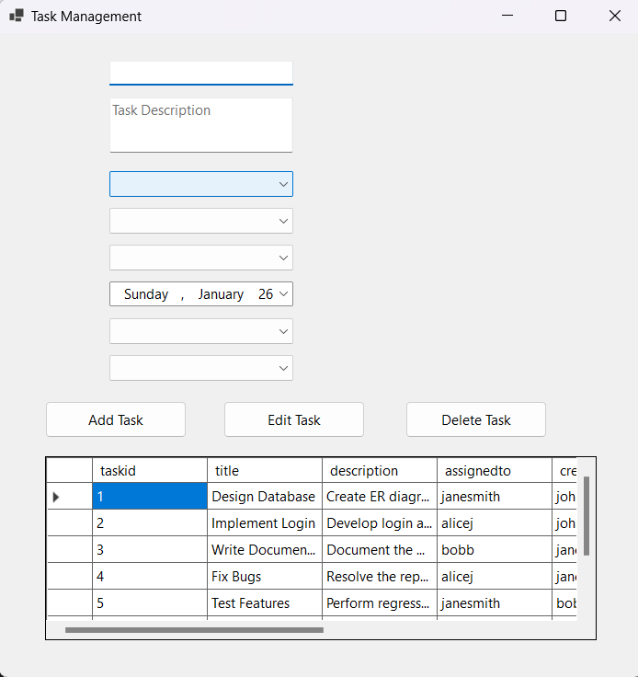
2. Fill the necessary informations and click “Add Task” to add
3. Choose task from list, make a change and click “Edit Task” to edit.
4. If you want you can choose task and delete it

3.4 Project Management

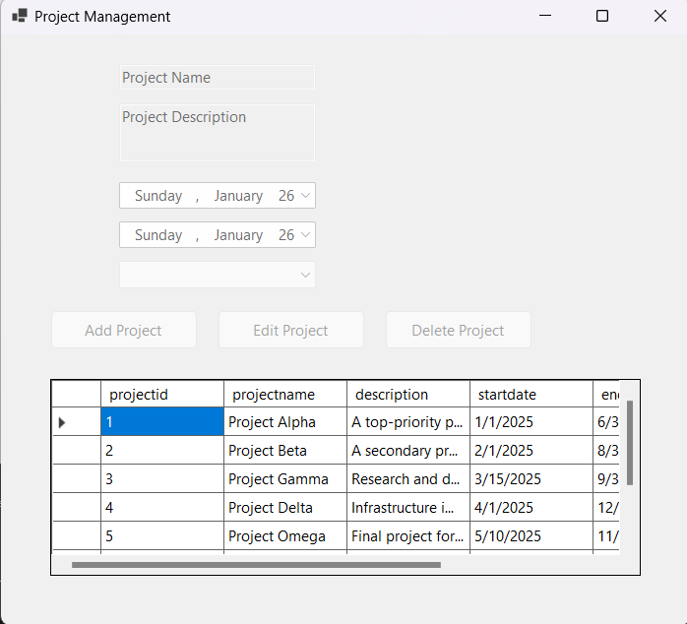
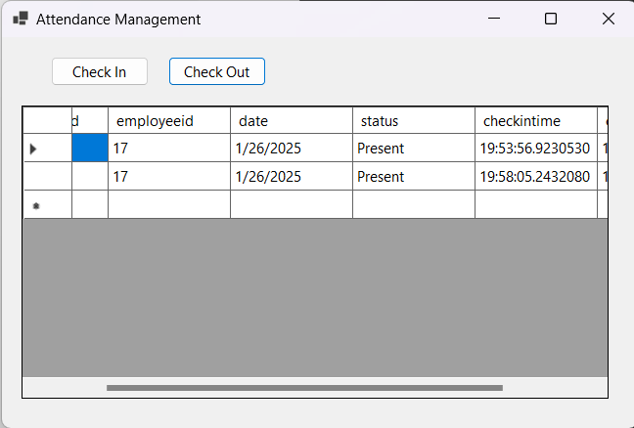
This module only allows employees to view project details.
Steps:
1. View project details such as Name, Description, Start Date, and End Date in the table.
2. Restricted Features: Employees cannot add, edit, or delete projects.

3.5 Attendance Management

This module allows employees to check in and check out their attendance.
Steps:
1. Click "Check In" to record the time when starting work.
2. Click "Check Out" to record the time when finishing work.
3. View attendance records in the table.

3.6 Notification Management
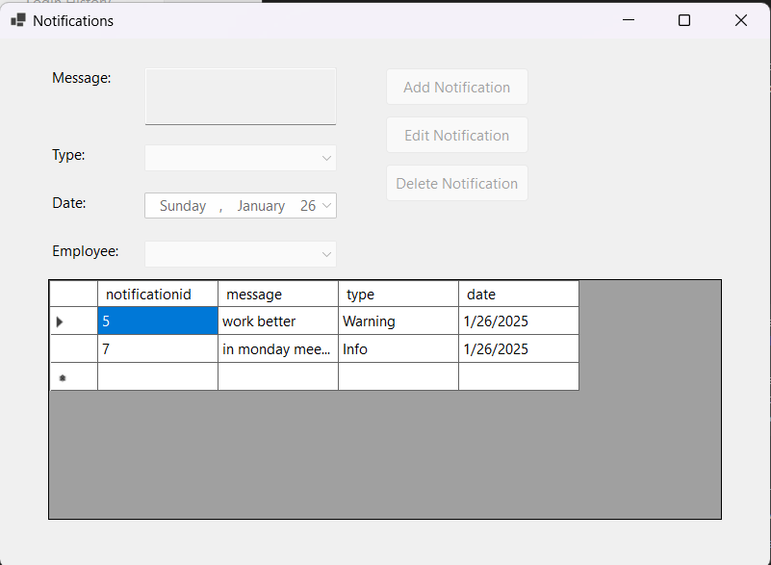
This module allows employees to view notifications sent by managers or administrators.
Steps:
1. View the notification details such as Message, Type, and Date in the table.
2. Restricted Features: Employees cannot add, edit, or delete notifications.

3.7 Task Comments

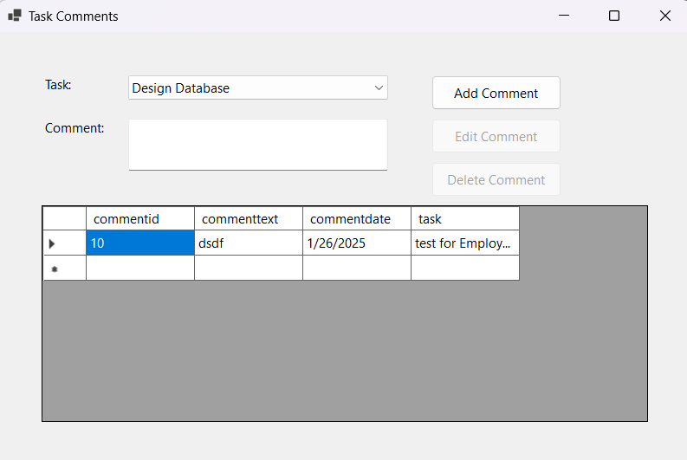
This module allows employees to view and add comments related to tasks assigned to them.
Steps:
1. Select a task from the dropdown menu.
2. Enter the comment in the "Comment" field.
3. Click "Add Comment" to create a new comment.
4. Restricted Features: Employees cannot edit or delete comments.

