# shortlinksv0.0
version0.0 //connect on local db
#unauthorized user , get request
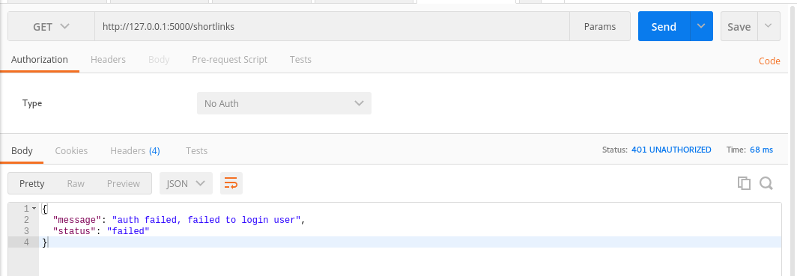

#non json get request
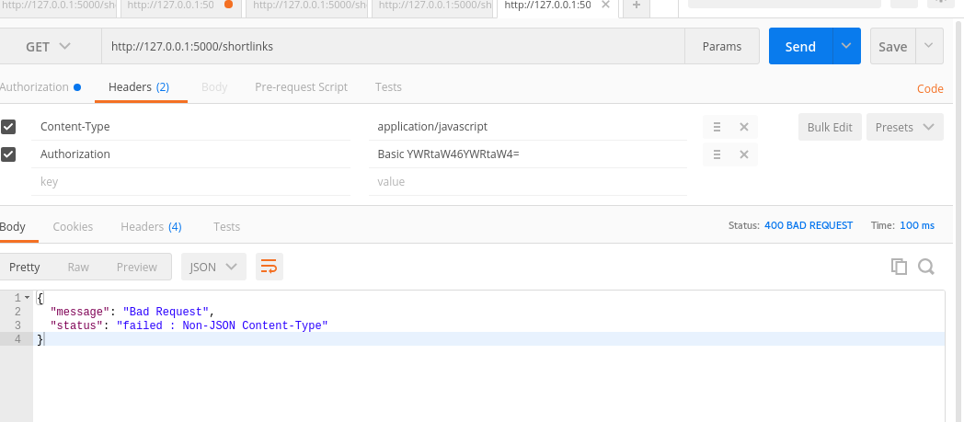

#response 200 ok in get request
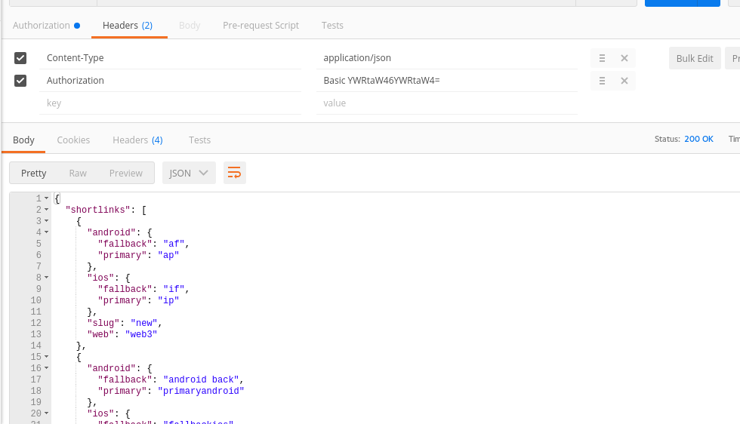

#case error in writing url get request
