Commands-FS

Exercise 1: Basic Navigation
- Use ls to list all files and directories in the current directory.
- Use cd to navigate to a specific directory.
- Use pwd to print the current working directory.
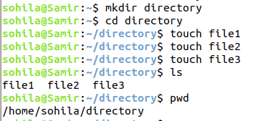

Exercise 2: File and Directory Operations
- Create a directory named “practice” in the current directory using mkdir.
- Create an empty file named “file.txt” within the “practice” directory using touch.
- Copy “file.txt” to a new file “file_backup.txt” using cp.
- Move “file_backup.txt” to another directory using mv.
- Rename “file.txt” to “new_file.txt” using mv.
- Delete the “new_file.txt” using rm.
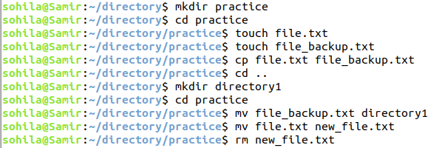

Exercise 3: File Viewing and Editing
Create a text file using echo or a text editor like nano. View the contents of the file using cat. View the contents of the file using less. Edit the file using nano or another text editor. Redirect the output of a command (e.g., ls) to a file using >.

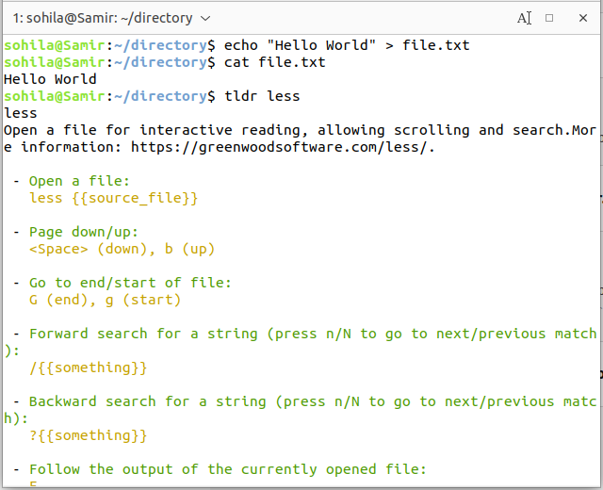
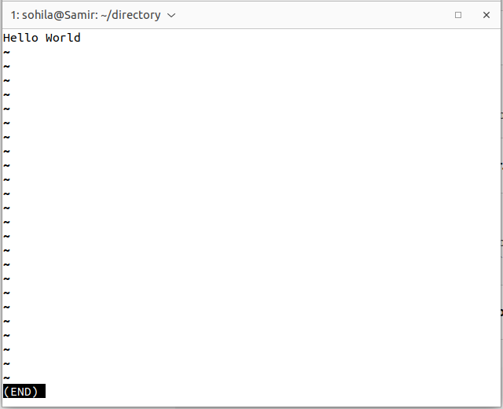
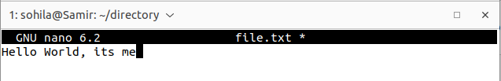

Exercise 4: File Permissions
Create a file and set specific permissions using chmod. Check the permissions of the file using ls -l. Change the owner and group of the file using chown. Verify the changes using ls -l.
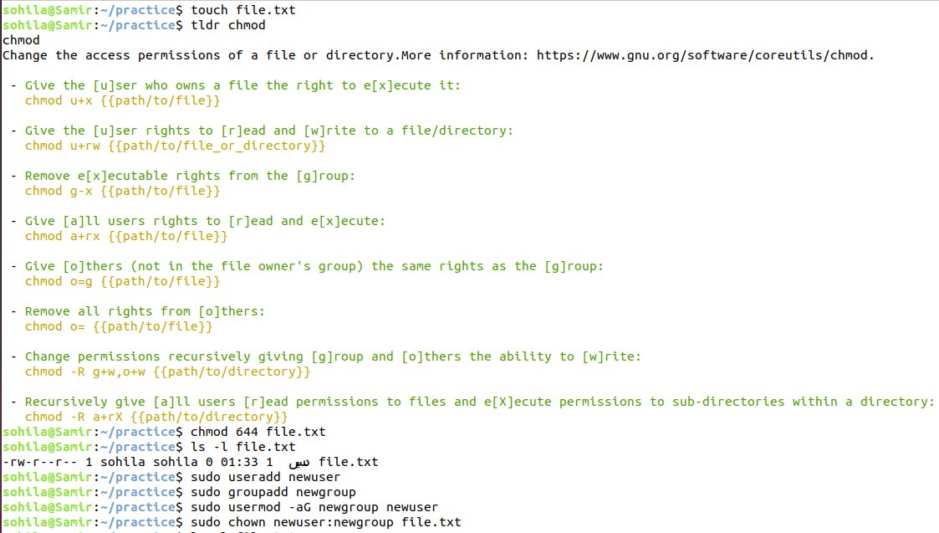

Exercise 5: User and Group Management
Create a new user using useradd. Set a password for the new user using passwd. Create a new group using groupadd. Add the user to the newly created group using usermod.
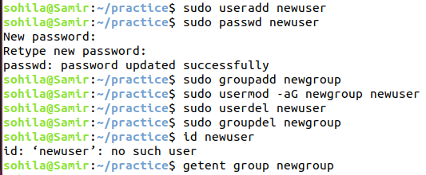

Exercise 6: Process Management
List all processes using ps. List processes in real-time using top. Find a specific process using pgrep. Terminate a process using kill.
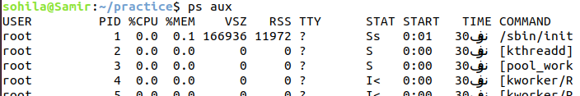
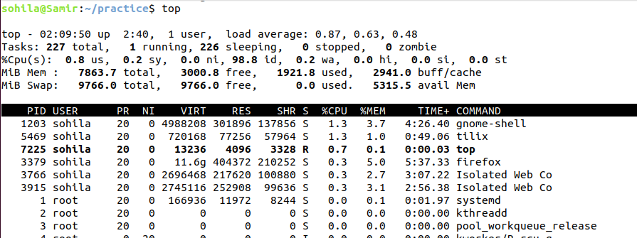
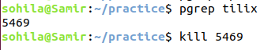

Exercise 7: File Searching
Use find to search for a specific file or directory. Use grep to search for a specific string in a file.
