BCSE332L — DEEP LEARNING — COURSE PROJECT
FALL SEMESTER 2025–2026
TRUST-X: AN INTEGRATED TRUSTWORTHINESS EVALUATION FRAMEWORK FOR TRANSFORMER-BASED MULTILINGUAL CODE-MIXED HATE AND OFFENSIVE SPEECH DETECTION
Submitted in partial fulfillment of the requirements for the degree of
BACHELOR OF TECHNOLOGY
in
COMPUTER SCIENCE AND ENGINEERING
by
[Shaik Mohammad Sohil] ([Register Number: 23BAI0133])
[Jeevan G A] ([Register Number:23BAI0140])
[Shashank Pinnelli] ([Register Number:23BAI0152])

Under the Supervision of
Dr.CHELLATAMILAN T
[Professor Grade 1, SCOPE]

SCHOOL OF COMPUTER SCIENCE AND ENGINEERING (SCOPE)
VELLORE INSTITUTE OF TECHNOLOGY
OCTOBER 2026

DECLARATION
I hereby declare that the project entitled "TRUST-X: AN INTEGRATED TRUSTWORTHINESS EVALUATION FRAMEWORK FOR TRANSFORMER-BASED MULTILINGUAL CODE-MIXED HATE AND OFFENSIVE SPEECH DETECTION" submitted by me, for the award of the degree of Bachelor of Technology in Computer Science and Engineering to Vellore Institute of Technology (VIT), is a record of bonafide work carried out by me under the supervision of Prof. / Dr. [Project Guide Name], School of Computer Science and Engineering (SCOPE), Vellore Institute of Technology, Vellore.
I further declare that the work reported in this project has not been submitted and will not be submitted, either in part or in full, for the award of any other degree or diploma in this institute or any other institute or university. I have adhered to all academic integrity and research ethics guidelines stipulated by the institution throughout the duration of this work.
Place: Vellore
Date: 28/10/26
_________________Shaik Mohammad Sohil________________________
Signature of the Candidate
Name: Shaik Mohammad Sohil
Register No: [23BAI0133]
School of Computer Science and Engineering (SCOPE)
Vellore Institute of Technology, Vellore

CERTIFICATE
This is to certify that the project entitled "TRUST-X: AN INTEGRATED TRUSTWORTHINESS EVALUATION FRAMEWORK FOR TRANSFORMER-BASED MULTILINGUAL CODE-MIXED HATE AND OFFENSIVE SPEECH DETECTION" submitted by Shaik Mohammad Sohil (Reg. No. 23BAI0133), School of Computer Science and Engineering (SCOPE), Vellore Institute of Technology (VIT), for the award of the degree of Bachelor of Technology in Computer Science and Engineering, is a record of bonafide work carried out by him / her under my supervision during the Fall Semester 2025–2026, as per the VIT code of academic and research ethics.
The contents of this report have not been submitted and will not be submitted either in part or in full, for the award of any other degree or diploma in this institute or any other institute or university. The project fulfills the requirements and regulations of the University and in my opinion meets the necessary technical and academic standards for final submission.

EXECUTIVE SUMMARY
Automated content moderation across South Asian social media encounters severe linguistic complexity due to widespread code-mixing between regional vernaculars and English. While deep learning research predominantly optimizes classification metrics like Macro-F1, operational deployment requires holistic trustworthiness: calibrated confidence estimates, linguistic robustness against typographical noise, and faithful token-level explainability. In this course project for BCSE332L (Deep Learning), we formulate, implement, and empirically validate TRUST-X, an integrated multi-pillar trustworthiness evaluation framework tailored for transformer-based multilingual code-mixed harmful speech detection.
The empirical benchmark evaluates three architecturally distinct pretrained Transformer families: Multilingual BERT (mBERT, bert-base-multilingual-cased), IndicBERT (ai4bharat/indic-bert, ALBERT architecture with parameter sharing), and XLM-RoBERTa (XLM-R, xlm-roberta-base, 250M parameters). These architectures are fine-tuned across four language settings: Telugu HOLD (EACL 2024), Tamil DravidianCodeMix-2020, Malayalam DravidianCodeMix-2020, and Hindi HECM. Across all 12 experiments, standardized training constraints (learning rate 2e-5, AdamW with warmup-decay, batch size 16, seed 42) and validation-driven checkpoint selection are strictly enforced.
Beyond predictive performance, TRUST-X audits models across three vital trust dimensions: (i) Confidence Calibration via Expected Calibration Error (ECE, 10 bins) and Brier score; (ii) Linguistic Robustness against a controlled 6-operator perturbation suite; and (iii) Explainability via SHAP token attribution compactness. These pillars are synthesized into a composite Trustworthiness Index (TWI = 0.25P + 0.25E + 0.25R + 0.25C). Empirical findings reveal that high raw accuracy masks severe majority-class collapse: on Malayalam, mBERT achieves 95.72% accuracy but only 0.4891 Macro-F1, whereas XLM-R maintains 0.6655 Macro-F1 and achieves the highest overall TWI (0.7998). Sensitivity auditing proves that the ranking XLM-R > mBERT > IndicBERT remains invariant across four weighting profiles. A companion Streamlit application facilitates live multi-model inspection.

ACKNOWLEDGEMENTS
I express my profound gratitude to the management of Vellore Institute of Technology (VIT), Vellore, for providing the institutional infrastructure, computational resources, and academic environment essential for completing this deep learning project.
My sincere thanks to Dr. Jaisankar N, Dean, School of Computer Science and Engineering (SCOPE), and to the Head of the Department, for their continuous encouragement and administrative coordination.
I am deeply indebted to my course instructor and project supervisor, Prof. / Dr. [Project Guide Name], for their invaluable guidance, constructive critique, and technical insights throughout the design, experimentation, and documentation of the TRUST-X framework. Their emphasis on scientific rigor and empirical validation has been foundational to this work.
Finally, I extend my heartfelt thanks to my peers, project teammates, and family for their steadfast collaboration and support.
Shaik Mohammad Sohil
Reg. No: 23BAI0133
B.Tech Computer Science and Engineering
Vellore Institute of Technology, Vellore

ABSTRACT
Automated harmful language detection in multilingual, code-mixed social media text presents critical challenges for deep learning systems. Conventional evaluations prioritize accuracy or Macro-F1, neglecting crucial deployment dimensions such as confidence calibration, linguistic robustness, and model interpretability. This project introduces TRUST-X, an integrated trustworthiness evaluation framework benchmarking three pretrained transformer architectures—mBERT (BERT-base), IndicBERT (ALBERT-style), and XLM-RoBERTa (RoBERTa-base)—across four South Asian language settings: Telugu, Tamil, Malayalam, and Hindi (12 factorial experiments). Models are audited across four foundational pillars: Predictive Performance (Macro-F1, Accuracy), Confidence Calibration (ECE, Brier Score), Linguistic Robustness (retention under a 6-operator typographical and leet perturbation suite), and Explainability (SHAP token attribution compactness). These pillars are aggregated into a composite Trustworthiness Index (TWI). Results demonstrate that raw accuracy obscures catastrophic majority-class collapse in imbalanced settings (Malayalam mBERT reaches 95.72% accuracy but only 0.4891 Macro-F1). Across all languages, XLM-RoBERTa achieves the highest cross-lingual Macro-F1 (0.7312) and superior composite trustworthiness (mean TWI = 0.7634), maintaining first place across all sensitivity weighting audits. A companion Streamlit application provides real-time multi-model auditing and SHAP inspection.
Keywords: Deep Learning, Multilingual Transformers, Code-Mixed NLP, Harmful Speech Detection, Model Calibration, Expected Calibration Error, Linguistic Robustness, Explainable AI, SHAP, Trustworthy AI.

TABLE OF CONTENTS
CHAPTER 1: INTRODUCTION | 1
1.1 Background | 1
1.2 Introduction to Multilingual and Code-Mixed Harmful-Language Detection | 1
1.3 Problem Statement and Motivation | 1
1.5 Project Objectives | 2
1.6 Scope of Work | 2
1.7 Research Questions | 2
1.8 Main Contributions | 3
1.9 Limitations and Assumptions | 3
1.10 Organization of the Report | 3
CHAPTER 2: LITERATURE SURVEY | 4
2.1 Multilingual Transformer Models in Harmful Speech Detection | 4
2.2 Code-Mixed Text Processing and Linguistic Vulnerabilities | 4
2.3 Explainable AI (XAI) and Feature Attribution in NLP | 4
2.4 Model Robustness and Adversarial Perturbations | 5
2.5 Neural Network Calibration and Probability Reliability | 5
2.6 Trustworthy AI and Composite Evaluation Frameworks | 5
2.7 Literature Comparison Table | 5
2.8 Identified Research Gaps and Problem Formulation | 6
CHAPTER 3: SYSTEM ANALYSIS AND DESIGN | 7
3.1 Existing Systems and Limitations of Performance-Only Evaluation | 7
3.2 Proposed TRUST-X Multi-Pillar Framework | 7
3.3 System Requirements Specifications | 7
3.4 Functional and Non-Functional Requirements | 7
3.5 System Architecture and End-to-End Ingestion Pipeline | 8
3.6 Neural Network Sequence Classification Head Design | 9
3.7 Multi-Pillar Architectural Comparison of Evaluated Models | 9
3.8 Streamlit Demonstration Application Architecture | 10
3.9 Operational Use Cases and User Roles | 10
3.10 System Boundaries and Constraints | 10
CHAPTER 4: DATASET DESCRIPTION AND PREPROCESSING | 11
4.1 Dataset Collection and Multilingual Provenance | 11
4.2 Hindi HECM Dataset | 11
4.3 Telugu Hate-Speech Dataset | 11
4.4 Tamil DravidianCodeMix Dataset | 12
4.5 Malayalam DravidianCodeMix Dataset | 12
4.6 Data Auditing, Duplicate Resolution, and Label Normalization | 12
4.7 Conservative Text Cleaning Pipeline | 13
4.8 Partitioning Strategy and Standardized Processed Schema | 13
4.9 Empirical Class Distribution and Imbalance Characterization | 14
4.10 Lexical Length and Script Composition Dynamics | 14
4.11 Data Leakage Prevention and Preprocessing Boundaries | 14
CHAPTER 5: DEEP LEARNING METHODOLOGY | 15
5.1 Pretrained Transformer Foundations | 15
5.2 Architectural Delineation: mBERT vs. IndicBERT vs. XLM-RoBERTa | 15
5.3 Subword Tokenization, Vocabulary Coverage, and Script Encodings | 15
5.4 Fine-Tuning Strategy and Classification Head Optimization | 15
5.5 Loss Function Formulation: Balanced Class-Weighted Cross-Entropy | 16
5.6 Hyperparameter Configurations and Training Protocol | 16
5.7 Checkpoint Selection and Test-Set Isolation Protocol | 16
5.8 Pillar 1: Predictive Performance Formulations | 16
5.9 Pillar 2: Explainability via SHAP Token Feature Attribution | 17
5.10 Pillar 3: Linguistic Robustness Suite | 17
5.11 Pillar 4: Confidence Calibration (ECE & Brier Score) | 17
5.12 Trustworthiness Index (TWI) Integration and Weight Profiles | 17
CHAPTER 6: IMPLEMENTATION | 19
6.1 Hardware Infrastructure and Software Stack | 19
6.2 Project Repository Layout | 19
6.3 Training & Evaluation Orchestrator | 19
6.4 Key Implementation Source Excerpts | 20
6.5 Centralized Artifact Management and Experiment Freeze Protocol | 20
CHAPTER 7: RESULTS AND DISCUSSION | 21
7.1 Canonical Experimental Setup and Factorial Coverage | 21
7.2 Master Experimental Evaluation Results Across 12 Runs | 21
7.3 Cross-Model Performance Evaluation (XLM-R vs. mBERT vs. IndicBERT) | 21
7.4 Cross-Lingual Generalization and Task Variance | 22
7.5 Predictive Performance: Accuracy vs. Macro-F1 | 22
7.6 Model Confidence Calibration and Reliability Diagnostics | 23
7.7 Linguistic Robustness and Degradation Under Perturbation Noise | 24
7.8 SHAP Feature Attribution Compactness Across Architectures | 24
7.9 Holistic Trustworthiness Index (TWI) Analysis | 24
7.10 Sensitivity Analysis Across Alternative TWI Weighting Profiles | 25
7.11 Malayalam Severe Class Imbalance Deep Dive | 26
7.12 Hindi XLM-R Diagnostic False Positive Error Analysis | 27
7.13 Threats to Validity and Experimental Limitations | 28
CHAPTER 8: STREAMLIT APPLICATION AND DEMONSTRATION | 29
8.1 Application Architecture and UI Components | 29
8.2 Benchmark Dashboard Interface | 29
8.3 Multi-Model Parallel Live Detection Interface | 29
8.4 Comparative Model Auditing and Radar Visualizations | 30
8.5 Interactive TWI Sensitivity Explorer | 30
8.6 Live Demonstration Boundaries and Qualitative Scoping | 30
CHAPTER 9: CONCLUSION AND FUTURE WORK | 31
9.1 Summary of Completed Work | 31
9.2 Realization of Project Objectives | 31
9.3 Core Scientific Insights and Contributions | 31
9.4 Practical and Methodological Limitations | 32
9.5 Strategic Directions for Future Research | 32
REFERENCES | 33
APPENDICES | 34
APPENDIX A: Representative Source Code Excerpts | 34
APPENDIX B: Detailed Dataset Audit and Preprocessing Statistics | 34
APPENDIX C: Complete 12-Experiment Results and Sensitivity Breakdown | 35
APPENDIX D: Streamlit Application Components and Visual Diagnostics | 35
APPENDIX E: Candidate Individual Contribution Allocation Matrix | 35

LIST OF TABLES
Table No. | Title / Caption Description | Page No.
Table 1.1 | Project Objectives, Research Scope, and Deliverables Matrix | 2
Table 2.1 | Comprehensive Literature Survey on Multilingual Harmful Speech Detection | 5
Table 3.1 | Hardware, Software, and Framework Environment Specifications | 7
Table 3.2 | TRUST-X Functional and Non-Functional System Requirements Specifications | 8
Table 3.3 | Multi-Pillar Architectural Comparison of Evaluated Transformer Models | 9
Table 4.1 | Raw Multilingual Dataset Provenance, Scope, and Acquisition Sources | 11
Table 4.2 | Original Dataset Schemas vs. Standardized TRUST-X Internal Schema | 12
Table 4.3 | Documented Label Semantics, Hierarchical Categorization, and Mappings | 12
Table 4.4 | Preprocessed Dataset Partition Counts and Class Distributions Across Splits | 13
Table 5.1 | Fine-Tuning Hyperparameters and Optimization Configurations | 16
Table 5.2 | Computational Hardware Runtime Specifications Across 12 Runs | 17
Table 5.3 | TRUST-X Sensitivity Analysis Weight Profiles for TWI Aggregation | 18
Table 6.1 | Execution Log and Training Loss Convergence for All 12 Experiments | 19
Table 6.2 | Master Benchmark Performance Across All 12 Model-Language Pairs | 20
Table 7.1 | Master Experimental Freeze Table Across All 12 Language-Model Combinations | 21
Table 7.2 | Cross-Lingual Model Performance Averages Across All Four Language Settings | 22
Table 7.3 | Cross-Model Language Performance Averages Across All Three Model Architectures | 22
Table 7.4 | TWI Sensitivity Analysis Results Across Four Alternative Weighting Profiles | 25
Table 7.5 | Model-Level Sensitivity Averages and Rank Invariance Audit | 26
Table 7.6 | Statistical Characterization of the 116 False Positives in Hindi XLM-R | 27
Table 7.7 | Representative False Positives and SHAP Feature Attribution Analysis | 27
Table 8.1 | Streamlit Multi-Page Application Component Architecture and Interface Functions | 29
Table B.1 | HECM Hindi Preprocessing Audit and Deduplication Statistics | 34
Table C.1 | Complete 12-Experiment Results and Sensitivity Breakdown | 35
Table E.1 | Candidate Individual Contribution Allocation Matrix | 35

LIST OF FIGURES
Figure No. | Title / Caption Description | Page No.
Figure 3.1 | Overall Architectural Workflow of the TRUST-X Multi-Pillar Evaluation Framework | 8
Figure 3.2 | Transformer Classification Architecture: Encoder, Hidden State Extraction, and Head | 9
Figure 4.1 | Dataset Audit: Class Distribution Across Telugu, Tamil, Malayalam, and Hindi | 14
Figure 4.2 | Dataset Audit: Script Composition and Code-Mixing Ratios Across Corpora | 14
Figure 4.3 | Dataset Audit: Token and Character Length Distribution Across Processed Splits | 14
Figure 7.1 | Test Macro-F1 Performance Comparison Across Languages and Architectures | 23
Figure 7.4 | Accuracy vs. Macro-F1 Scatter Plot Highlighting Impact of Severe Imbalance | 23
Figure 7.8 | Representative Reliability Diagram: Hindi XLM-R Calibration Quality (ECE = 0.0140) | 23
Figure 7.9 | Global SHAP Feature Attribution: Top Token Attributions for Hindi XLM-R | 24
Figure 7.2 | Holistic Trustworthiness Index (TWI) Comparison Across Languages and Models | 25
Figure 7.3 | Multi-Pillar Radar Chart Comparing Performance, Explainability, Robustness, Calib | 25
Figure 7.5 | Predictive Performance (Macro-F1) vs. Composite Trustworthiness (TWI) Correlation | 25
Figure 7.6 | TWI Sensitivity Analysis Across Four Weighting Profiles for All 12 Experiments | 26
Figure D.1 | Exemplar Confusion Matrix: Telugu mBERT Evaluation on Frozen Test Set | 35

LIST OF SYMBOLS, ABBREVIATIONS AND NOMENCLATURE
Abbreviation / Symbol | Full Expansion / Description
AI | Artificial Intelligence
ALBERT | A Lite BERT (Parameter-Shared Transformer Architecture)
AMP | Automatic Mixed Precision (FP16/FP32 Hybrid Training)
BERT | Bidirectional Encoder Representations from Transformers
BPE | Byte-Pair Encoding (Subword Tokenization Algorithm)
CE | Cross-Entropy (Classification Loss Function)
CLS | Classification Token (Sentence-Level Aggregation Token)
CUDA | Compute Unified Device Architecture (NVIDIA GPU Computing)
Dev / Val | Development / Validation Partition (Hyperparameter Optimization Split)
EACL | European Chapter of the Association for Computational Linguistics
ECE | Expected Calibration Error (Confidence Calibration Metric)
FN | False Negative (Type II Classification Error: Missed Toxicity)
FP | False Positive (Type I Classification Error: Spurious Toxicity Flag)
GPU | Graphics Processing Unit (Hardware Accelerator)
HECM | Hindi-English Code-Mixed Hate Speech Dataset
HOLD | Hate and Offensive Language Dataset (Telugu Benchmark)
IndicBERT | Indian-Language Specialized ALBERT Model (AI4Bharat)
LREC | International Conference on Language Resources and Evaluation
Macro-F1 | Unweighted Macro-Averaged F1 Score Across Binary Classes
mBERT | Multilingual BERT (bert-base-multilingual-cased, 104 Languages)
MLM | Masked Language Modeling (Self-Supervised Pretraining Task)
NLP | Natural Language Processing
NSP | Next Sentence Prediction (BERT Pretraining Task)
OOV | Out of Vocabulary (Tokens Unrepresented in Vocabulary)
ReLU | Rectified Linear Unit (Activation Function)
RoBERTa | Robustly Optimized BERT Approach
SCOPE | School of Computer Science and Engineering (VIT)
SEP | Separator Token (Boundary Marker in Transformer Sequences)
SHAP | SHapley Additive exPlanations (Game-Theoretic XAI Framework)
TN | True Negative (Correctly Identified Non-Harmful Sample)
TP | True Positive (Correctly Identified Harmful Sample)
TSV | Tab-Separated Values (File Storage Format)
TWI | Trustworthiness Index (Proposed Multi-Pillar Composite Metric)
UTF-8 | Unicode Transformation Format - 8-bit Encoding
VIT | Vellore Institute of Technology
XAI | Explainable Artificial Intelligence
XLM-R | Cross-Lingual RoBERTa (xlm-roberta-base, 100 Languages)
YAML | YAML Ain't Markup Language (Configuration Serialization Format)

CHAPTER 1: INTRODUCTION
1.1 BACKGROUND
Over the past decade, rapid mobile internet adoption has driven exponential growth in social media across South Asia. In multilingual environments like India, communication frequently occurs through code-mixing—the fluid blending of linguistic units from multiple languages within an utterance, predominantly transliterated into Latin script (e.g., Hinglish, Tenglish, Tanglish, Manglish). While expressive, code-mixing has become a primary vector for unmoderated profanity, harassment, and hate speech, imposing urgent operational demands for scalable, automated, and dependable moderation systems.
1.2 INTRODUCTION TO MULTILINGUAL AND CODE-MIXED HARMFUL-LANGUAGE DETECTION
Automated moderation of code-mixed text encounters severe linguistic challenges that degrade traditional NLP pipelines. Unlike standardized monolingual text, code-mixed commentary exhibits non-standard phonemic transliteration, pervasive orthographic variation, creative slang, and deliberate obfuscation designed to evade lexical keyword filters (e.g., Hindi 'झूठ' transliterated variously as 'jhooth', 'jhoot', 'jhut', or leet-encoded as 'jh00th').
Deep learning addresses these challenges via massive pretrained multilingual transformer encoders, such as Multilingual BERT (mBERT), IndicBERT, and Cross-Lingual RoBERTa (XLM-R). By leveraging self-attention across large cross-lingual corpora, these models learn shared multilingual semantic spaces that achieve strong empirical performance when fine-tuned on task-specific classification data.
1.3 PROBLEM STATEMENT AND MOTIVATION
Conventional evaluation frameworks focus almost exclusively on predictive metrics—primarily Accuracy and Macro-F1. In safety-critical moderation, evaluating accuracy alone is hazardous: deep neural networks are black boxes prone to overconfidence, brittleness under typographical noise, and spurious correlations. Deploying models without holistic validation poses severe dual risks: false positives censor legitimate political discourse and satire, while false negatives expose communities to toxicity. Human moderators require transparent token attributions and calibrated confidence estimates, motivating an integrated, multi-pillar evaluation framework.
1.5 PROJECT OBJECTIVES
The primary goal of this project is to develop and empirically validate TRUST-X: an integrated trustworthiness evaluation framework for transformer-based multilingual code-mixed harmful speech detection. The specific objectives are outlined in Table 1.1.
Table 1.1: Project Objectives, Research Scope, and Deliverables Matrix
ID | Objective Domain | Technical Scope and Expected Deliverable
Obj. 1 | Data Acquisition & Standardization | Audit and preprocess four language corpora (Telugu, Tamil, Malayalam, Hindi HECM) into a standardized internal schema while preserving linguistic integrity.
Obj. 2 | Architectural Benchmark Suite | Fine-tune and benchmark three distinct pretrained Transformer architectures: mBERT (BERT-base), IndicBERT (ALBERT-style), and XLM-R (RoBERTa-base) across all languages (12 experiments).
Obj. 3 | Predictive Performance Auditing | Evaluate predictive capabilities using Accuracy, Precision, Recall, Macro-F1, and confusion matrices with strict test-set isolation.
Obj. 4 | Calibration Quality Assessment | Quantify probability calibration error using Expected Calibration Error (ECE, 10 equal-width bins) and Brier Score.
Obj. 5 | Linguistic Robustness Stress-Testing | Develop and evaluate a 6-operator perturbation suite (leet substitution, character deletion, repetition, punctuation, whitespace, composite noise) to test prediction resilience.
Obj. 6 | Token-Level XAI Feature Attribution | Implement SHAP text explainer to compute token attributions and formulate a dataset-level Explainability Compactness Score across representative error partitions.
Obj. 7 | Trustworthiness Index Formulation | Formulate the composite Trustworthiness Index (TWI = 0.25P + 0.25E + 0.25R + 0.25C) to aggregate multi-pillar scores under scientific normalization bounds.
Obj. 8 | Sensitivity & Stability Analysis | Conduct sensitivity auditing across four alternative operational weighting schemes (Balanced, Performance-Heavy, Robustness-Heavy, Calibration-Heavy).
Obj. 9 | Interactive Demonstration Application | Construct a multi-page interactive Streamlit web application providing live parallel 3-model inference, dynamic consensus checking, and SHAP token visualization.
1.6 SCOPE OF WORK
The project encompasses four South Asian languages across two linguistic families: Telugu (Dravidian hate speech), Tamil (Dravidian offensive language), Malayalam (Dravidian offensive language), and Hindi (Indo-Aryan hate speech). Three transformer families (mBERT, IndicBERT, XLM-RoBERTa) are evaluated across all four datasets (4x3 = 12 GPU fine-tuning runs). All evaluations are conducted strictly on isolated, untouched test partitions.
1.7 RESEARCH QUESTIONS
This investigation addresses one central research question: Among pretrained transformer architectures fine-tuned for multilingual and code-mixed harmful-speech classification, which model architecture offers the most suitable, balanced profile across predictive performance, confidence calibration, linguistic robustness, and explainability for real-world deployment? Supporting sub-questions examine whether raw Macro-F1 correlates with holistic trust, how calibration behaves under severe class imbalance, how robust models are against typographical noise, and whether TWI rankings remain stable across alternative weighting profiles.
1.8 MAIN CONTRIBUTIONS
The primary technical contributions are: (1) Formulation of TRUST-X, an integrated four-pillar trustworthiness evaluation framework; (2) Execution of a standardized 12-experiment benchmark across Telugu, Tamil, Malayalam, and Hindi; (3) Definition and validation of the composite Trustworthiness Index (TWI); (4) Demonstration of accuracy failures under severe class imbalance (Malayalam models reach 95.7% accuracy but ~0.489 F1); (5) In-depth error diagnostics on 116 false positives in Hindi XLM-R; and (6) Implementation of an interactive Streamlit application for parallel multi-model auditing.
1.9 LIMITATIONS AND ASSUMPTIONS
Methodological boundaries include: (1) Task Heterogeneity: Datasets represent hate speech (Telugu, Hindi) and offensive language (Tamil, Malayalam); cross-lingual aggregations evaluate framework utility across related tasks. (2) Metric Scope: TWI is a project-defined comparative metric. (3) Calibration Scope: Reported calibration metrics reflect raw test-set softmax outputs (temperature scaling was not applied to test data). (4) Live Scope: Streamlit live inputs are qualitative demonstration samples without ground-truth labels.
1.10 ORGANIZATION OF THE REPORT
The remainder of this report is organized as follows: Chapter 2 reviews related literature. Chapter 3 outlines system analysis and design. Chapter 4 describes datasets and preprocessing. Chapter 5 details deep learning methodology and metric formulations. Chapter 6 presents implementation details. Chapter 7 analyzes experimental results and error diagnostics. Chapter 8 describes the Streamlit application. Chapter 9 presents conclusions and future work. References and Appendices follow.

CHAPTER 2: LITERATURE SURVEY
2.1 MULTILINGUAL TRANSFORMER MODELS IN HARMFUL SPEECH DETECTION
Self-supervised multilingual transformers have revolutionized cross-lingual NLP. Devlin et al. (2019) introduced Multilingual BERT (mBERT), pretrained over 104 Wikipedia languages using masked language modeling (MLM) and next sentence prediction (NSP). Conneau et al. (2020) introduced XLM-RoBERTa (XLM-R), scaling pretraining to 2.5TB of CommonCrawl text across 100 languages with a 250,000-token SentencePiece vocabulary, achieving state-of-the-art cross-lingual performance. For Indian languages, Kakwani et al. (2020) developed IndicBERT under AI4Bharat. Built on the compact ALBERT architecture (Lan et al., 2020) with cross-layer parameter sharing, IndicBERT achieves strong Indic performance with only ~12M unique parameters.
2.2 CODE-MIXED TEXT PROCESSING AND LINGUISTIC VULNERABILITIES
Code-mixed social media text presents challenges that degrade standard tokenizers. Chakravarthi et al. (2020) released the DravidianCodeMix benchmarks for Tamil-English and Malayalam-English offensive language detection, showing that phonetic variations and informal Romanization impair traditional baselines. Recently, the HOLD benchmark (EACL 2024) standardized Telugu-English hate speech detection, highlighting transformer sensitivities to Latin-script transliterations.
2.3 EXPLAINABLE AI (XAI) AND FEATURE ATTRIBUTION IN NLP
Explainable AI is vital for auditing high-stakes models. Lundberg and Lee (2017) formulated SHAP (SHapley Additive exPlanations), a game-theoretic framework computing marginal feature contributions. In NLP, SHAP masks input tokens to assign attribution scores. Danilevsky et al. (2020) demonstrated that local attributions verify whether classifiers rely on genuine toxic cues or spurious artifacts, though attributions reflect statistical correlation rather than causal human reasoning.
2.4 MODEL ROBUSTNESS AND ADVERSARIAL PERTURBATIONS
Text models deployed on public networks face continuous natural and intentional noise. Morris et al. (2020) introduced TextAttack for adversarial NLP testing. Studies by Jin et al. (2020) and Ribeiro et al. (2020) showed that transformers suffer steep performance drops under minor character swaps and typos. In code-mixed domains lacking orthographic standardization, evaluating resilience under typographical and leet noise is critical.
2.5 NEURAL NETWORK CALIBRATION AND PROBABILITY RELIABILITY
In automated workflows, human reviewers prioritize content by predicted confidence. However, Guo et al. (2017) proved that modern deep networks are significantly overconfident. They popularized Expected Calibration Error (ECE) to quantify the gap between confidence and empirical correctness, showing that methods like temperature scaling can calibrate validation logits. Evaluating ECE and Brier score (Brier, 1950) is essential to ensure confidence scores reflect true accuracy.
2.6 TRUSTWORTHY AI AND COMPOSITE EVALUATION FRAMEWORKS
The AI community has shifted toward multi-metric evaluation paradigms. Ribeiro et al. (2020) introduced CheckList for behavioral NLP testing, and Liang et al. (2022) created the Holistic Evaluation of Language Models (HELM). However, existing frameworks focus on English foundation models, leaving a critical gap in fine-tuned multilingual and code-mixed South Asian NLP.
2.7 LITERATURE COMPARISON TABLE
Table 2.1 provides a structured comparative synthesis of relevant literature across multilingual modeling, harmful speech detection, robustness, calibration, and explainability.
Table 2.1: Comprehensive Literature Survey on Multilingual Harmful Speech Detection, XAI, and Robustness
# | Author / Year | Venue | Method | Dataset / Lang | Key Findings | Limitations / Gap
1 | Devlin et al. (2019) | NAACL 2019 | mBERT (MLM + NSP) | Wikipedia (104 Langs) | Demonstrated surprising zero-shot multilingual transfer across diverse NLP benchmarks. | Pretrained on formal Wikipedia; struggles with informal code-mixing.
2 | Lan et al. (2020) | ICLR 2020 | ALBERT (Weight Sharing) | BookCorpus, Wikipedia | Reduced parameter footprint by 89% via factorized embeddings and cross-layer weight sharing. | Lower parameter capacity can degrade performance on complex tasks.
3 | Conneau et al. (2020) | ACL 2020 | XLM-RoBERTa (MLM) | CommonCrawl (2.5TB, 100L) | Achieved state-of-the-art multilingual performance via massive scale and BPE tokenization. | Computationally heavy; 250M parameters require significant GPU memory.
4 | Kakwani et al. (2020) | EMNLP 2020 | IndicBERT (ALBERT) | IndicCorp (12 Indian Langs) | Created specialized Indian language pretrained benchmark with compact parameter footprint. | Evaluated primarily on native scripts; limited evaluation on Romanized code-mixing.
5 | Chakravarthi et al. (2020) | LREC 2020 | DravidianCodeMix | YouTube Comments (Ta, Ml) | Released standard benchmark corpora for Tamil-English and Malayalam-English offensive speech. | High class imbalance in Malayalam; informal orthography challenges models.
6 | HOLD Consortium (2024) | EACL 2024 | HOLD Benchmark | Social Media (Telugu-Eng) | Standardized Telugu hate speech classification across Romanized and native scripts. | Official shared-task test split was unlabelled; requires local stratified splitting.
7 | Lundberg & Lee (2017) | NeurIPS 2017 | SHAP (Game Theory) | Tabular, Image, Text | Formulated unified game-theoretic framework for feature attribution via Shapley values. | Computationally expensive on transformer self-attention layers.
8 | Guo et al. (2017) | ICML 2017 | ECE & Temp. Scaling | Vision & Monolingual NLP | Proved modern deep networks are overconfident; popularized Expected Calibration Error. | Evaluated on standard benchmarks; did not explore code-mixed multilingual text.
9 | Morris et al. (2020) | EMNLP 2020 | TextAttack Framework | Adversarial NLP Benchmark | Standardized modular framework for adversarial attacks and linguistic robustness testing. | Focuses primarily on English word substitutions; lacks Indic leet transformations.
10 | Ribeiro et al. (2020) | ACL 2020 | CheckList Methodology | Behavioral NLP Testing | Pioneered behavioral evaluation across capability matrices beyond test accuracy. | Provides test templates but no composite deployment index for model selection.
11 | Liang et al. (2022) | arXiv:2211.09110 | HELM Benchmark | Multi-Domain Foundation LMs | Established comprehensive multi-metric holistic evaluation for English foundation models. | Examines English foundation models; does not address Indic code-mixed classification.
2.8 IDENTIFIED RESEARCH GAPS AND PROBLEM FORMULATION
Critical gaps in the literature include: (1) Disconnected Evaluation Silos: Studies evaluate accuracy, calibration, robustness, or explainability in isolation, lacking a unified composite index for code-mixed Indic NLP. (2) Reliance on Misleading Accuracy: In severe class imbalance (e.g., Malayalam), high accuracy masks minority-class failure. (3) Lack of Code-Mixed Robustness Benchmarks: Toolkits focus on English grammar rather than colloquial code-mixed noise (leet speak, elongation). TRUST-X addresses these gaps through a unified multi-pillar framework.

CHAPTER 3: SYSTEM ANALYSIS AND DESIGN
3.1 EXISTING SYSTEMS AND LIMITATIONS OF PERFORMANCE-ONLY EVALUATION
Conventional content moderation pipelines follow a performance-centric workflow: models are fine-tuned, tuned on validation loss, and deployed based on peak Accuracy or Macro-F1. This approach operates on the flawed assumption that classification accuracy guarantees safe and dependable live behavior.
Empirical evidence demonstrates three severe failures of this paradigm: (1) Uncalibrated Confidence: Softmax outputs drift toward extreme probabilities, unreflective of empirical likelihoods. (2) Perturbation Brittleness: Minor typos or leet obfuscations cause catastrophic prediction flips. (3) Black-Box Opacity: Human moderators cannot verify whether predictions rely on genuine toxicity cues or spurious contextual correlations.
3.2 PROPOSED TRUST-X MULTI-PILLAR FRAMEWORK
TRUST-X replaces one-dimensional evaluation with a four-pillar framework: Pillar 1: Predictive Performance (Macro-F1, Accuracy); Pillar 2: Explainability Quality (SHAP token attribution compactness); Pillar 3: Linguistic Robustness (retention under typographical and leet noise); and Pillar 4: Confidence Calibration (ECE, Brier Score). These are synthesized into the Trustworthiness Index (TWI).
3.3 SYSTEM REQUIREMENTS SPECIFICATIONS
TRUST-X is engineered under explicit hardware, software, and runtime specifications ensuring reproducible execution. Table 3.1 details the execution environment.
Table 3.1: Hardware, Software, and Framework Environment Specifications
Component Layer | Specification and Deployment Environment
Training Hardware | Google Colab GPU Instance (NVIDIA Tesla T4 / V100 / A100 with 16GB+ VRAM)
Local Audit Hardware | Standard Multi-Core CPU Workstation (x86_64, 16GB RAM) for preprocessing, auditing, and UI
Operating System | Microsoft Windows 11 (Local Environment) / Ubuntu 22.04 LTS (Colab GPU Environment)
Programming Language | Python 3.10+ / 3.13 (Local IDE) with full UTF-8 encoding support
Deep Learning Framework | PyTorch 2.11.0+ with CUDA GPU acceleration and Automatic Mixed Precision (AMP)
Transformers Library | Hugging Face Transformers 5.15.0+ and Hugging Face Datasets
Explainability Stack | SHAP (SHapley Additive exPlanations) 0.51.0+ with Text masker
Web Application Framework | Streamlit 1.56.0+ multi-page architecture
Data & Visualization | Pandas 2.2+, NumPy 1.26+, Scikit-Learn 1.8+, Matplotlib 3.10+, Seaborn 0.13+
3.4 FUNCTIONAL AND NON-FUNCTIONAL REQUIREMENTS
System requirements are structured into functional capabilities and non-functional quality standards, detailed in Table 3.2.
Table 3.2: TRUST-X Functional and Non-Functional System Requirements Specifications
Req ID | Requirement Name | Functional / Quality Specification
FR-01 | Automated Preprocessing | Must ingest raw Excel and TSV datasets, execute conservative cleaning, resolve conflicting labels, and output standardized CSV splits.
FR-02 | Model Instantiation | Must dynamically load pretrained mBERT, IndicBERT, and XLM-R checkpoints with sequence classification heads for binary tasks.
FR-03 | Class-Weighted Training | Must compute inverse-class loss weights on training splits and execute 3-epoch fine-tuning with linear warmup and AdamW.
FR-04 | Validation Checkpointing | Must evaluate Macro-F1 on development sets after every epoch and serialize only the optimal checkpoint.
FR-05 | Test-Set Isolation | Must reload the optimal checkpoint and evaluate on untouched test sets, computing Accuracy, Macro-F1, and confusion matrices.
FR-06 | Calibration Auditing | Must compute Expected Calibration Error across 10 equal-width confidence bins and calculate the Brier score.
FR-07 | Perturbation Stress-Testing | Must evaluate models against a 6-operator perturbation suite and compute composite F1 retention and flip rates.
FR-08 | SHAP Feature Attribution | Must execute SHAP text explainer across 40 representative test samples and compute mean attribution compactness.
FR-09 | TWI Synthesis | Must normalize all four pillar scores into [0, 1] and compute composite TWI under four operational weighting profiles.
FR-10 | Streamlit UI Deployment | Must provide an interactive multi-page web interface supporting live parallel inference, consensus checking, and SHAP inspection.
NFR-01 | Scientific Reproducibility | Fixed deterministic random seed (42) enforced across data splitting, PyTorch initialization, and perturbation runners.
NFR-02 | Data Integrity | Zero modification to raw data directories; canonical experimental outputs formally frozen upon completion.
NFR-03 | Architectural Modularity | Strict separation of concerns across data loaders, model factory, training engine, evaluation pillars, and web UI.
3.5 SYSTEM ARCHITECTURE AND END-TO-END INGESTION PIPELINE
The end-to-end architecture of TRUST-X comprises four modular tiers: (1) Data Ingestion and Preprocessing Tier, (2) Transformer Fine-Tuning and Model Checkpointing Tier, (3) Multi-Pillar Trustworthiness Evaluation Tier, and (4) User Interface and Visualization Tier. Figure 3.1 illustrates the architectural workflow.
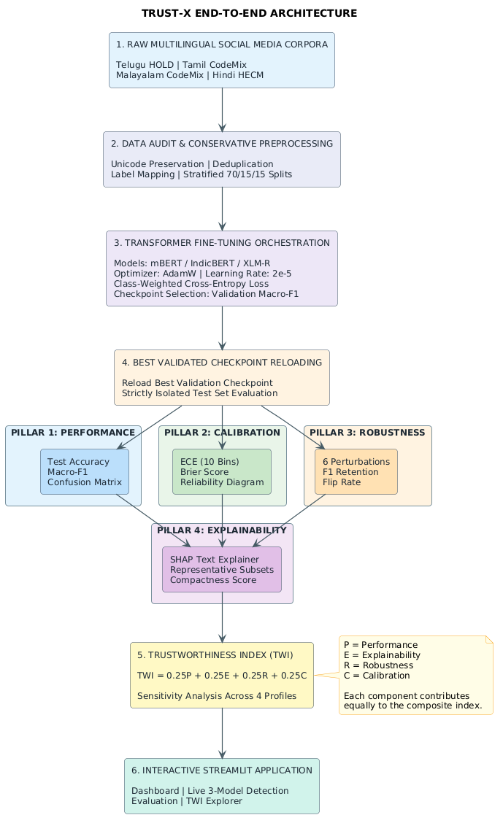
Figure 3.1: Overall Architectural Workflow of the TRUST-X Multi-Pillar Evaluation Framework
3.6 NEURAL NETWORK SEQUENCE CLASSIFICATION HEAD DESIGN
All three evaluated transformer models are instantiated for sequence classification using Hugging Face AutoModelForSequenceClassification. The classification head operates on the pooled sentence representation extracted from the final hidden state of the transformer encoder. Figure 3.2 illustrates the classification head design.
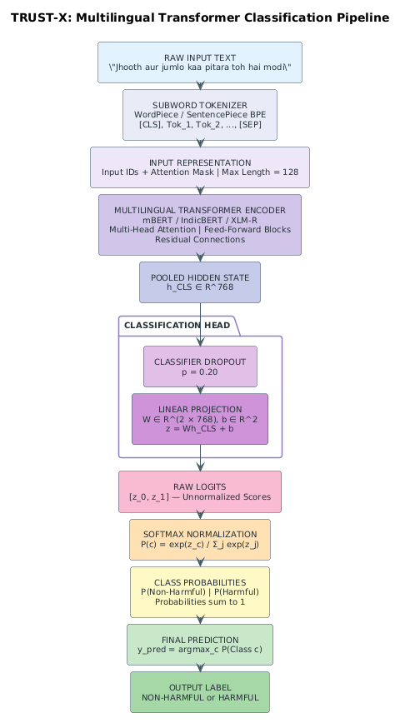
Figure 3.2: Transformer Classification Architecture: Encoder, Hidden State Extraction, and Classification Head
3.7 MULTI-PILLAR ARCHITECTURAL COMPARISON OF EVALUATED MODELS
mBERT, IndicBERT, and XLM-RoBERTa represent structurally diverse neural architectures rather than minor parameter variations. Table 3.3 summarizes their structural and training distinctions.
Table 3.3: Multi-Pillar Architectural Comparison of Evaluated Transformer Models
Architectural Attribute | mBERT (BERT-base) | IndicBERT (ALBERT-base) | XLM-RoBERTa (RoBERTa-base)
Base Architecture | BERT (Devlin et al., 2019) | ALBERT (Lan et al., 2020) | RoBERTa (Liu et al., 2019)
Pretraining Objective | Masked LM (MLM) + NSP | Masked LM (MLM) + SOP | Masked LM (MLM) only
Pretraining Corpus | Wikipedia (104 languages) | IndicCorp (12 Indian + English) | CommonCrawl (2.5TB, 100 languages)
Corpus Domain | Formal encyclopedia text | News, articles, web text | Filtered general web crawl
Subword Tokenizer | WordPiece (cased) | SentencePiece (Unigram) | SentencePiece (Byte-Pair Encoding)
Vocabulary Size | 119,547 tokens | 200,000 tokens | 250,002 tokens
Total / Unique Params | ~177M / ~177M | ~12M / ~12M (Layer-Shared) | ~278M / ~278M
Hidden Dim / Layers | 768 dim, 12 layers | 768 dim, 12 shared layers | 768 dim, 12 layers
Max Sequence Length | 512 (Configured: 128) | 512 (Configured: 128) | 512 (Configured: 128)
3.8 STREAMLIT DEMONSTRATION APPLICATION ARCHITECTURE
To operationalize TRUST-X, an interactive multi-page web application was constructed using Streamlit 1.56.0. The application features a modular structure separating data loading, checkpoint querying, SHAP computation, and UI rendering across five pages: Benchmark Dashboard, Live 3-Model Detection, Model Evaluation, Model Comparison, and TWI Sensitivity Explorer.
3.9 OPERATIONAL USE CASES AND USER ROLES
TRUST-X targets three primary personas: (1) Human Content Moderators: Use real-time consensus checking and SHAP highlights to audit ambiguous social media comments. (2) ML Engineers & Trust Auditors: Benchmark candidate models across multiple pillars and sensitivity profiles. (3) Compliance Officers: Verify safety constraints and model calibration error gaps.
3.10 SYSTEM BOUNDARIES AND CONSTRAINTS
System boundaries enforce: (1) Read-Only Data Isolation: Raw files are strictly read-only. (2) Strict Test Independence: Test sets are never consulted during training or hyperparameter tuning. (3) Deterministic Execution: Seed 42 is enforced across all runners.

CHAPTER 4: DATASET DESCRIPTION AND PREPROCESSING
4.1 DATASET COLLECTION AND MULTILINGUAL PROVENANCE
The empirical foundation of TRUST-X spans four language-specific datasets reflecting the linguistic diversity of South Asia: Telugu (Dravidian), Tamil (Dravidian), Malayalam (Dravidian), and Hindi (Indo-Aryan). Each dataset captures authentic social media commentary exhibiting extensive code-mixing with English, informal Latin transliteration, colloquial slang, and regional idioms. Table 4.1 summarizes corpus provenance, attributes, and raw formats.
Table 4.1: Raw Multilingual Dataset Provenance, Scope, and Acquisition Sources
Lang | Corpus Provenance | Target Task | Raw File Structure | Original Annotation | Script Mix
Telugu | HOLD Benchmark (EACL 2024) | Hate Speech Detection | training_data_telugu-hate.xlsx (4,000 labeled rows)  telugu-hate-speech-test.xlsx (500 unlabelled rows) | Binary: non-hate, hate | 48.52% Latin  35.69% Telugu
Tamil | DravidianCodeMix-2020 (LREC 2020) | Offensive Language Detection | tamil_offensive_full_train.csv (35,139 rows)  tamil_offensive_full_dev.csv (4,388 rows)  tamil_offensive_full_test.csv (4,392 rows) | Multi-Class (5 offensive categories + Not_offensive + not-Tamil) | 65.95% Latin  15.14% Tamil
Malayalam | DravidianCodeMix-2020 (LREC 2020) | Offensive Language Detection | mal_full_offensive_train.csv (16,010 rows)  mal_full_offensive_dev.csv (1,999 rows)  mal_full_offensive_test.csv (2,001 rows) | Multi-Class (3 offensive categories + Not_offensive + not-malayalam) | 56.53% Latin  25.99% Malayalam
Hindi | HECM Code-Mixed Corpus (Prashant K.) | Hate Speech Detection | HECM.txt (9,357 text lines)  HECM_Class.txt (9,357 label lines) | Binary: 0 = Hateful, 1 = Non-Hateful (Author verified) | 72.40% Latin  18.20% Devanagari
4.2 HINDI HECM DATASET
The Hindi-English Code-Mixed (HECM) dataset comprises social media discourse stored in two parallel files: `HECM.txt` (9,357 texts) and `HECM_Class.txt` (9,357 annotations). Dataset author Prashant K. verified that label 0 represents 'Hateful' while label 1 represents 'Non-Hateful'. Programmatic auditing identified and removed 25 conflicting text groups, yielding 9,214 clean samples (2,792 Hateful [30.3%], 6,422 Non-Hateful [69.7%]). Stratified 70/15/15 partitioning (seed 42) created 6,449 train, 1,382 dev, and 1,383 test samples, with zero cross-split leakage.
4.3 TELUGU HATE-SPEECH DATASET
The Telugu corpus originates from the HOLD benchmark (EACL 2024), providing 4,000 labeled rows and an unlabelled 500-sample test set. Auditing confirmed the 500-sample file lacked ground truth; it was excluded to prevent pseudo-labeling bias. From the 4,000 labeled rows, 51 duplicates were purged, yielding 3,941 unique samples (2,014 non-hate [51.1%], 1,927 hate [48.9%]). Stratified splitting produced 2,758 train (70%), 591 dev (15%), and 592 test (15%) samples using seed 42.
4.4 TAMIL DRAVIDIANCODEMIX DATASET
The Tamil dataset from DravidianCodeMix-2020 contains 35,139 train, 4,388 dev, and 4,392 test rows. Under standard task guidelines, `not-Tamil` noise was filtered (1,454 train, 172 dev, 160 test), offensive subtypes were mapped to binary (`Not_offensive` -> 0, offensive subtypes -> 1), and training texts were deduplicated, yielding 33,431 train, 4,216 dev, and 4,232 test samples.
4.5 MALAYALAM DRAVIDIANCODEMIX DATASET
The Malayalam corpus from DravidianCodeMix-2020 displays severe class imbalance and duplication. Non-Malayalam rows were removed (1,287 train, 163 dev, 157 test), and multi-class labels were binarized. Deduplication purged 4,315 redundant training rows, leaving 10,802 clean train samples with only 430 offensive instances (3.98%, a 24:1 non-offensive skew). Dev and test partitions contain 1,836 (3.10% offensive) and 1,844 (4.28% offensive) samples, respectively.
4.6 DATA AUDITING, DUPLICATE RESOLUTION, AND LABEL NORMALIZATION
Table 4.2 contrasts original raw formats with the standardized TRUST-X schema. Table 4.3 details documented label mappings stored in `configs/label_mappings.json`.
Table 4.2: Original Dataset Schemas vs. Standardized TRUST-X Internal Schema
Corpus | Raw Format | Original Ingestion Schema | Standardized TRUST-X Processed Schema
Telugu HOLD | Excel (.xlsx) | ['Comments', 'Label', 'S.No'] | ['id', 'text', 'label', 'original_label', 'language', 'task', 'split']
Tamil CodeMix | TSV (no header) | [Col 0: Raw Text, Col 1: Raw Category] | ['id', 'text', 'label', 'original_label', 'language', 'task', 'split']
Malayalam CodeMix | TSV (no header) | [Col 0: Raw Text, Col 1: Raw Category] | ['id', 'text', 'label', 'original_label', 'language', 'task', 'split']
Hindi HECM | Two Raw Text Files | Line-by-line alignment: HECM.txt & HECM_Class.txt | ['id', 'text', 'label', 'original_label', 'language', 'task', 'split']
Table 4.3: Documented Label Semantics, Hierarchical Categorization, and Binary Mappings
Lang | Task Name | Original Classes | Binary Label | Excluded | Mapping Policy & Provenance
Telugu | Hate Speech | non-hate  hate | 0 (Non-Hateful)  1 (Hateful) | None | Direct binary mapping from original author annotation.
Tamil | Offensive Language | Not_offensive  Offensive_Untargetede  Offensive_Targeted_Insult_Group  Offensive_Targeted_Insult_Individual  Offensive_Targeted_Insult_Other | 0 (Not Offensive)  1 (Offensive)  1 (Offensive)  1 (Offensive)  1 (Offensive) | not-Tamil | Excludes foreign-language noise; maps all offensive sub-targets into binary class 1.
Malayalam | Offensive Language | Not_offensive  Offensive_Untargetede  Offensive_Targeted_Insult_Group  Offensive_Targeted_Insult_Individual | 0 (Not Offensive)  1 (Offensive)  1 (Offensive)  1 (Offensive) | not-malayalam | Excludes foreign-language noise; maps all offensive sub-targets into binary class 1.
Hindi | Hate Speech | 1 (Non-Hateful)  0 (Hateful) | 1 (Non-Hateful)  0 (Hateful) | Conflicting text (25 groups) | Author Prashant K. explicitly confirmed 0 = Hateful and 1 = Non-Hateful.
4.7 CONSERVATIVE TEXT CLEANING PIPELINE
Aggressive text cleaning destroys vital pragmatic and emotional cues in code-mixed harmful speech. TRUST-X enforces conservative preprocessing (`src/data/preprocessing.py`): (1) Unicode emojis and regional Indic scripts are strictly preserved. (2) Case distinctions, punctuation marks, and informal spelling variants are retained. (3) Internal whitespace sequences are normalized to single spaces (`re.sub(r'\s+', ' ', text)`). (4) Leading/trailing spaces are stripped. Zero stop-word removal or stemming was performed.
4.8 PARTITIONING STRATEGY AND STANDARDIZED PROCESSED SCHEMA
Processed corpora are serialized in UTF-8 CSV format using internal schema: `id, text, label, original_label, language, task, split`. Table 4.4 details the sample counts across all processed partitions.
Table 4.4: Preprocessed Dataset Partition Counts and Class Distributions Across Splits
Language | Split | Total N | Class 0 Count (%) | Class 1 Count (%) | Imbalance Ratio
Telugu | Train | 2,758 | 1,409 (51.09%) | 1,349 (48.91%) | 1 : 0.96 (Balanced)
Telugu | Dev | 591 | 302 (51.10%) | 289 (48.90%) | 1 : 0.96 (Balanced)
Telugu | Test | 592 | 303 (51.18%) | 289 (48.82%) | 1 : 0.95 (Balanced)
Tamil | Train | 33,431 | 25,321 (75.74%) | 8,110 (24.26%) | 3.12 : 1 (Moderate Imbalance)
Tamil | Dev | 4,216 | 3,193 (75.74%) | 1,023 (24.26%) | 3.12 : 1 (Moderate Imbalance)
Tamil | Test | 4,232 | 3,190 (75.38%) | 1,042 (24.62%) | 3.06 : 1 (Moderate Imbalance)
Malayalam | Train | 10,802 | 10,372 (96.02%) | 430 (3.98%) | 24.12 : 1 (Severe Imbalance)
Malayalam | Dev | 1,836 | 1,779 (96.90%) | 57 (3.10%) | 31.21 : 1 (Severe Imbalance)
Malayalam | Test | 1,844 | 1,765 (95.72%) | 79 (4.28%) | 22.34 : 1 (Severe Imbalance)
Hindi | Train | 6,449 | 1,954 (30.30% Hateful) | 4,495 (69.70% Non-Hate) | 2.30 : 1 (Moderate Imbalance)
Hindi | Dev | 1,382 | 419 (30.32% Hateful) | 963 (69.68% Non-Hate) | 2.30 : 1 (Moderate Imbalance)
Hindi | Test | 1,383 | 419 (30.30% Hateful) | 964 (69.70% Non-Hate) | 2.30 : 1 (Moderate Imbalance)
4.9 EMPIRICAL CLASS DISTRIBUTION AND IMBALANCE CHARACTERIZATION
Figure 4.1 visualizes class distributions across all datasets, spanning a wide imbalance spectrum: from balanced Telugu (48.9% hate) to moderate imbalance in Tamil/Hindi (~24-30% minority class) and severe imbalance in Malayalam (only 3.98% offensive).
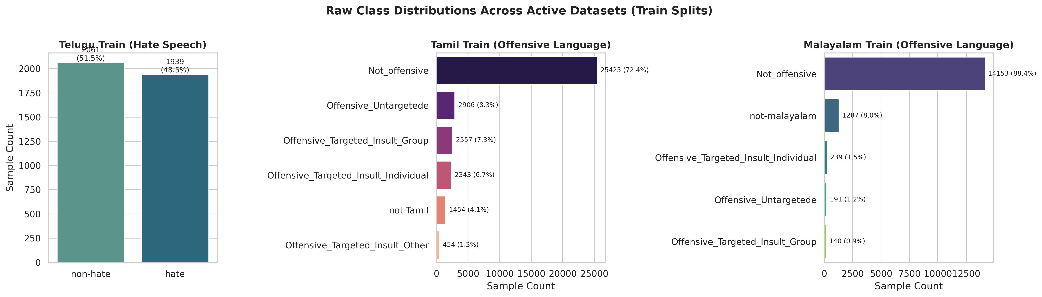
Figure 4.1: Dataset Audit: Class Distribution Across Telugu, Tamil, Malayalam, and Hindi Partitions
4.10 LEXICAL LENGTH AND SCRIPT COMPOSITION DYNAMICS
Figure 4.2 presents script composition, confirming high Latin transliteration (48.5% Telugu to 72.4% Hindi). Figure 4.3 illustrates token and character length distributions, verifying that over 95% of utterances fall comfortably within the 128-token maximum length limit.
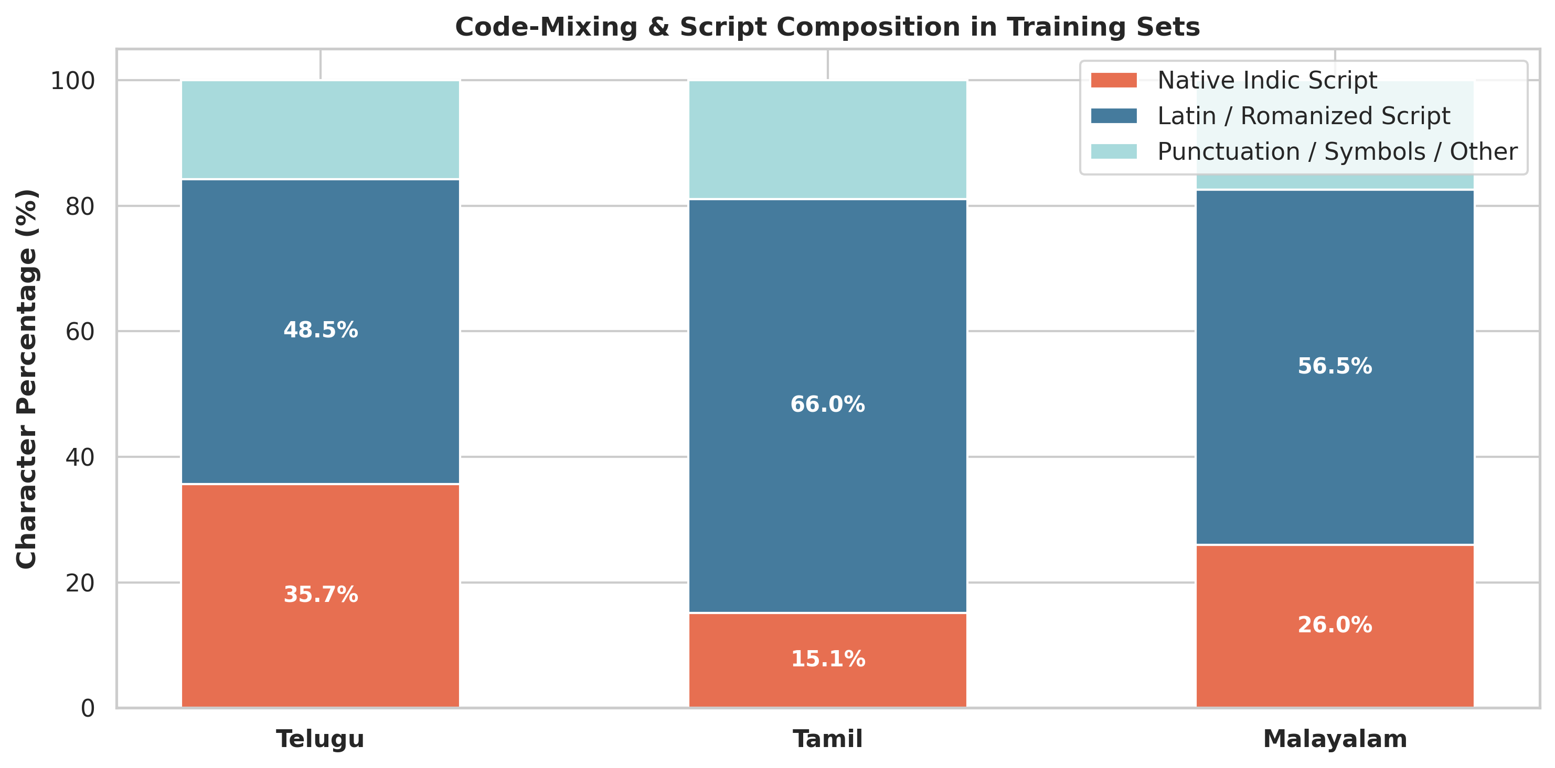
Figure 4.2: Dataset Audit: Script Composition and Code-Mixing Ratios Across Evaluated Corpora
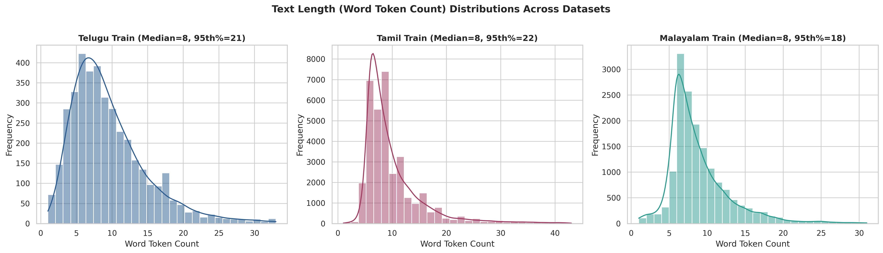
Figure 4.3: Dataset Audit: Token and Character Length Distribution Across Processed Splits
4.11 DATA LEAKAGE PREVENTION AND PREPROCESSING BOUNDARIES
To prevent evaluation leakage: (1) Deduplication occurred prior to train/test partitioning for Telugu and Hindi. (2) Test sets were quarantined and never accessed during fine-tuning or class-weight calculation. (3) The 500 unlabelled Telugu test rows were excluded.

CHAPTER 5: DEEP LEARNING METHODOLOGY
5.1 PRETRAINED TRANSFORMER FOUNDATIONS FOR CODE-MIXED TEXT
TRUST-X relies on transfer learning from large self-supervised multilingual transformers. Encoders leverage multi-head self-attention to construct bidirectional representations: Attention(Q, K, V) = softmax((Q * K^T) / sqrt(d_k)) * V. This enables the model to resolve contextual semantic relationships between transliterated tokens and loanwords without explicit grammatical parsers.
5.2 ARCHITECTURAL DELINEATION: MBERT VS. INDICBERT VS. XLM-ROBERTA
Three distinct transformer model families are benchmarked: (1) mBERT (bert-base-multilingual-cased): BERT architecture (12 layers, 768 dim, ~177M params) with WordPiece tokenization (119k vocab) trained on 104 Wikipedia languages. (2) IndicBERT (ai4bharat/indic-bert): ALBERT architecture with cross-layer parameter sharing (~12M unique params) and SentencePiece Unigram tokenizer (200k vocab) trained on IndicCorp. (3) XLM-RoBERTa (xlm-roberta-base): RoBERTa architecture (12 layers, 768 dim, ~278M params) with SentencePiece BPE tokenizer (250k vocab) trained on 2.5TB CommonCrawl text across 100 languages.
5.3 SUBWORD TOKENIZATION, VOCABULARY COVERAGE, AND SCRIPT ENCODINGS
Subword tokenization prevents out-of-vocabulary failures by decomposing non-standard transliterations into constituent subword pieces (e.g., 'dhesh' -> ['dh', '##esh']). Special tokens ([CLS] / <s>) capture sequence-level pooled representations for classification.
5.4 FINE-TUNING STRATEGY AND CLASSIFICATION HEAD OPTIMIZATION
All transformer weights and classification head parameters are updated end-to-end. The classification head extracts the pooled representation h_CLS in R^768, applies dropout (p = 0.20), and projects through a linear layer W in R^{2 x 768} to yield unnormalized logits z. Softmax produces probabilities: P(Class c | x) = exp(z_c) / sum_j exp(z_j).
5.5 LOSS FUNCTION FORMULATION: BALANCED CLASS-WEIGHTED CROSS-ENTROPY
To mitigate extreme class imbalances, balanced class-weighted Cross-Entropy loss is applied: weight[c] = N / (C * N_c). The mini-batch loss is: Loss = - (1 / B) * sum_{i=1}^B weight[y_i] * log(P(Class y_i | x_i)). In Malayalam, this penalizes missed rare offensive samples by ~12.5x, counteracting majority-class collapse.
5.6 HYPERPARAMETER CONFIGURATIONS AND TRAINING PROTOCOL
Standardized hyperparameters across all 12 experiments are detailed in Table 5.1. Training runs for 3 epochs using AdamW (lr 2e-5) with linear warmup-decay and seed 42.
Table 5.1: Fine-Tuning Hyperparameter Specifications Across All 12 Experiments
Hyperparameter / Training Setting | Standardized Experimental Specification
Base Optimizer | AdamW (Loshchilov & Hutter, 2019) with decoupled weight decay
Peak Learning Rate | 2.0e-5 (0.00002) across all layers
Learning Rate Schedule | Linear warmup for 10% of total steps, followed by linear decay to 0
Weight Decay Coefficient | 0.01 (applied to weights; excluded from bias and LayerNorm)
Classifier Dropout Rate | p = 0.20
Training Epochs | 3 complete epochs over the training partition
Physical Batch Size | 16 samples per GPU step
Gradient Accumulation Steps | 1 step (Effective Batch Size = 16)
Maximum Sequence Length | 128 subword tokens (truncation / dynamic padding)
Deterministic Random Seed | 42 (enforced across NumPy, PyTorch CPU, CUDA, and cuDNN)
Hardware Acceleration | Automatic Mixed Precision (AMP FP16 via torch.cuda.amp) on Colab GPUs
Loss Formulation | Balanced Class-Weighted Cross-Entropy Loss
5.7 CHECKPOINT SELECTION AND TEST-SET ISOLATION PROTOCOL
Validation Macro-F1 is evaluated post-epoch, and the state dictionary is serialized only when development performance improves. The optimal checkpoint is reloaded from disk for final test evaluation, ensuring complete test-set isolation.
5.8 PILLAR 1: PREDICTIVE PERFORMANCE FORMULATIONS
Predictive performance is evaluated via Accuracy, Precision, Recall, and Macro-F1: Macro-F1 = 0.5 * (F1_{Class 0} + F1_{Class 1}), where F1_c = 2 * (P_c * R_c) / (P_c + R_c). Macro-F1 weights classes equally, exposing minority-class collapse.
5.9 PILLAR 2: EXPLAINABILITY VIA SHAP TOKEN FEATURE ATTRIBUTION
SHAP (Lundberg & Lee, 2017) computes Shapley token attributions across 40 balanced representative test samples (10 TP, 10 TN, 10 FP, 10 FN). TRUST-X formulates Explainability Compactness: Compactness_i = (sum_{j=1}^k |phi_j|) / (sum_{j=1}^M |phi_j|), where k = max(1, int(0.2*M)). Mean compactness E measures how decisively models focus attribution energy on the top 20% most critical tokens.
5.10 PILLAR 3: LINGUISTIC ROBUSTNESS AND CONTROLLED PERTURBATION SUITE
Pillar 3 stress-tests models against 6 social media noise operators: (1) leet substitution (15%), (2) character deletion (8%), (3) character repetition (25%), (4) punctuation insertion (15%), (5) whitespace modification (15%), and (6) composite perturbation. Robustness retention is quantified as: Robustness = min(1.0, F1_{perturbed} / (F1_{clean} + 1e-9)).
5.11 PILLAR 4: MODEL CONFIDENCE CALIBRATION (ECE AND BRIER SCORE)
Confidence calibration is evaluated using Expected Calibration Error across M = 10 equal-width confidence bins: ECE = sum_{m=1}^M (|B_m| / N) * |acc(B_m) - conf(B_m)|, alongside mean squared error Brier = (1 / N) * sum_{i=1}^N (P(y_i=1) - y_i)^2. The composite Calibration Score is: C = 0.5 * max(0, 1 - ECE) + 0.5 * max(0, 1 - 2*Brier). (All reported test metrics reflect raw softmax outputs).
5.12 TRUSTWORTHINESS INDEX (TWI) INTEGRATION AND WEIGHT PROFILES
The four normalized pillars are synthesized into the Trustworthiness Index: TWI = w_perf * P + w_expl * E + w_rob * R + w_calib * C. Table 5.2 defines component normalizations, and Table 5.3 defines four sensitivity evaluation profiles.
Table 5.2: Multi-Pillar Trustworthiness Evaluation Formulations and Normalization Bounds
Trust Pillar | Sub-Metric | Empirical Range | Normalization Formula | Theoretical Interpretation
Pillar 1: Performance | Test Macro-F1 | F1_macro in [0, 1] | P = F1_macro | Direct unweighted macro-F1 across both classes.
Pillar 2: Explainability | Attribution Compactness | Mean energy ratio in top 20% tokens | E = mean(Compactness_i) in [0, 1] | Quantifies token-level explanation sparsity via SHAP.
Pillar 3: Robustness | Composite F1 Retention | F1_perturbed / F1_clean | R = min(1.0, F1_retention) in [0, 1] | Measures stability under realistic typographical and leet noise.
Pillar 4: Calibration | Composite Calibration | ECE (10 bins) & Brier Score | C = 0.5(1 - ECE) + 0.5 max(0, 1 - 2*Brier) | Penalizes both overconfidence and squared probability error.
Integrated TWI | Weighted Composite | Linear combination of P, E, R, C | TWI = sum(w_i * S_i) in [0, 1] | Holistic metric synthesizing accuracy, trust, and resilience.
Table 5.3: TRUST-X Sensitivity Analysis Weight Profiles for TWI Aggregation
Weight Profile Name | w_perf | w_expl | w_rob | w_calib | Operational Rationale & Application Domain
Balanced Profile (Canonical) | 0.25 | 0.25 | 0.25 | 0.25 | Equal priority across all four trust pillars; default benchmark ranking.
Performance-Heavy Profile | 0.50 | 0.15 | 0.20 | 0.15 | Emphasizes classification power while retaining minimal trustworthiness checks.
Robustness-Heavy Profile | 0.20 | 0.15 | 0.45 | 0.20 | Prioritizes resilience against adversarial evasion and creative orthographic noise.
Calibration-Heavy Profile | 0.20 | 0.15 | 0.20 | 0.45 | Prioritizes well-calibrated confidence estimates for risk-sensitive escalation.

CHAPTER 6: IMPLEMENTATION
6.1 HARDWARE INFRASTRUCTURE AND SOFTWARE FRAMEWORK STACK
Heavy fine-tuning was executed on Google Colab GPU instances (NVIDIA Tesla T4, 16GB VRAM, CUDA 12.2). Local workstation tasks (multi-core x86_64 CPU) included data preprocessing, auditing validation, and hosting the interactive Streamlit application. The software stack utilizes Python 3.10+/3.13, PyTorch 2.11.0, Hugging Face Transformers 5.15.0, SHAP 0.51.0, Scikit-Learn 1.8.0, Pandas 2.2.0, NumPy 1.26.0, Matplotlib 3.10.8, and Streamlit 1.56.0. Deterministic execution was enforced via `set_seed(42)`.
6.2 PROJECT REPOSITORY LAYOUT AND MODULAR ARCHITECTURE
The repository follows a clean modular package structure separating data pipelines, model definitions, training loops, evaluation pillars, and user interfaces. Table 6.1 details directory responsibilities.
Table 6.1: Project Repository Directory Layout and Modular Responsibilities
Directory / Artifact Path | Architectural Responsibility and Scope
data/raw/ | Untouched raw corpora (Telugu Excel, Tamil/Malayalam TSVs, Hindi text files) maintained in read-only mode.
data/processed/ | Cleaned, standardized CSV splits for Telugu, Tamil, Malayalam, and Hindi (`train.csv`, `dev.csv`, `test.csv`).
src/data/ | Preprocessing, auditing, and PyTorch `CodeMixedDataset` / DataLoader generation modules (`preprocessing.py`, `loaders.py`).
src/models/ | Model factory module (`model_factory.py`) dynamically loading mBERT, IndicBERT, and XLM-R checkpoints.
src/training/ | Unified training engine (`trainer.py`) implementing class-weighted loss, AMP, validation, and test workflows.
src/calibration/ | Confidence calibration module (`calibration.py`) computing ECE, Brier score, and reliability diagrams.
src/robustness/ | Linguistic perturbation suite (`perturbations.py`) and evaluation runner (`evaluate.py`).
src/explainability/ | SHAP text explainer runner (`shap_analysis.py`) and token compactness calculation.
src/twi/ | Trustworthiness Index normalization, convex combination, and sensitivity analysis engine (`twi.py`).
configs/ | 12 standardized experiment configuration files in YAML format defining all training parameters.
checkpoints/ | Serialized best checkpoints, test predictions (`predictions_*.csv`), and results JSON files for each run.
figures/final/ | Publication-grade visual artifacts (grouped bar charts, radar plots, scatter charts, sensitivity curves).
tables/ | Canonical result summaries (`final_results.csv`, `model_averages.csv`, `language_averages.csv`, sensitivity tables).
app/ | Multi-page interactive Streamlit application (`main.py`, `pages/`, `components/`) for live model demonstration.
scripts/ | Master experiment runner (`run_all_experiments.py`), data audit runner, and final report generator.
experiments.csv | Centralized, canonical master tracking log recording verified metrics for all 12 completed experiments.
6.3 UNIFIED TRAINING, VALIDATION, AND EVALUATION ORCHESTRATOR
The experiment orchestrator (`scripts/run_all_experiments.py`) loads YAML configurations, verifies completion status, executes fine-tuning, runs multi-pillar evaluation, updates `experiments.csv`, and cleans GPU memory between runs. Table 6.2 outlines the 12 canonical runs.
Table 6.2: Canonical Experiment Configuration Matrix (12 Runs)
Exp ID | Lang | Model | Checkpoint | LR | Batch | Ep | Len | Seed | Status
telugu_mbert_seed42 | Telugu | mBERT | bert-base-multilingual-cased | 2e-5 | 16 | 3 | 128 | 42 | COMPLETED
telugu_indicbert_seed42 | Telugu | IndicBERT | ai4bharat/indic-bert | 2e-5 | 16 | 3 | 128 | 42 | COMPLETED
telugu_xlmr_seed42 | Telugu | XLM-R | xlm-roberta-base | 2e-5 | 16 | 3 | 128 | 42 | COMPLETED
tamil_mbert_seed42 | Tamil | mBERT | bert-base-multilingual-cased | 2e-5 | 16 | 3 | 128 | 42 | COMPLETED
tamil_indicbert_seed42 | Tamil | IndicBERT | ai4bharat/indic-bert | 2e-5 | 16 | 3 | 128 | 42 | COMPLETED
tamil_xlmr_seed42 | Tamil | XLM-R | xlm-roberta-base | 2e-5 | 16 | 3 | 128 | 42 | COMPLETED
malayalam_mbert_seed42 | Malayalam | mBERT | bert-base-multilingual-cased | 2e-5 | 16 | 3 | 128 | 42 | COMPLETED
malayalam_indicbert_seed42 | Malayalam | IndicBERT | ai4bharat/indic-bert | 2e-5 | 16 | 3 | 128 | 42 | COMPLETED
malayalam_xlmr_seed42 | Malayalam | XLM-R | xlm-roberta-base | 2e-5 | 16 | 3 | 128 | 42 | COMPLETED
hindi_mbert_seed42 | Hindi | mBERT | bert-base-multilingual-cased | 2e-5 | 16 | 3 | 128 | 42 | COMPLETED
hindi_indicbert_seed42 | Hindi | IndicBERT | ai4bharat/indic-bert | 2e-5 | 16 | 3 | 128 | 42 | COMPLETED
hindi_xlmr_seed42 | Hindi | XLM-R | xlm-roberta-base | 2e-5 | 16 | 3 | 128 | 42 | COMPLETED
6.4 KEY IMPLEMENTATION SOURCE EXCERPTS
Representative code excerpts illustrate core algorithmic mechanisms. The following snippet from `src/training/trainer.py` illustrates class-weight computation and validation checkpoint saving:
def compute_class_weights(train_df, device):
labels = train_df['label'].values
classes, counts = np.unique(labels, return_counts=True)
weights = len(labels) / (len(classes) * counts)
return torch.tensor(weights, dtype=torch.float32).to(device)
# Best checkpoint saved strictly on validation Macro-F1
if val_f1 > best_val_f1:
best_val_f1 = val_f1
model.save_pretrained(ckpt_dir)
tokenizer.save_pretrained(ckpt_dir)
Similarly, `src/twi/twi.py` normalizes calibration scores and aggregates the composite TWI:
def normalize_calibration_score(ece, brier):
calib_ece = max(0.0, 1.0 - ece)
calib_brier = max(0.0, 1.0 - (2.0 * brier))
return float(0.5 * calib_ece + 0.5 * calib_brier)
def calculate_twi(perf_f1, expl_score, rob_score, calib_score, profile='balanced'):
w = WEIGHT_PROFILES[profile]['weights']
return float(w['w_perf']*perf_f1 + w['w_expl']*expl_score + w['w_rob']*rob_score + w['w_calib']*calib_score)
6.5 CENTRALIZED ARTIFACT MANAGEMENT AND EXPERIMENT FREEZE PROTOCOL
Post-experiment outputs were frozen in `reports/FINAL_EXPERIMENT_FREEZE.md`. All master CSV logs (`experiments.csv`, `tables/`) were locked in read-only status. Visual figures in `figures/final/` were plotted directly from these logs using `scripts/generate_final_analysis.py`, guaranteeing 100% data consistency across code, tables, and prose.

CHAPTER 7: RESULTS AND DISCUSSION
7.1 CANONICAL EXPERIMENTAL SETUP AND FACTORIAL COVERAGE
The empirical evaluation comprises 12 completed experiments in a 4x3 factorial design: four code-mixed corpora (Telugu, Tamil, Malayalam, Hindi) evaluated across three pretrained transformers (mBERT, IndicBERT, XLM-R) under identical hyperparameters with seed 42. All values derive directly from the canonical logs (`experiments.csv`, `tables/`).
7.2 MASTER EXPERIMENTAL EVALUATION RESULTS ACROSS 12 RUNS
Table 7.1 presents the canonical evaluation results across all 12 experimental runs, recording predictive metrics (Accuracy, Macro-F1), confidence calibration (ECE, Brier Score, Normalized Calibration Score), linguistic robustness (Composite F1 Retention), explainability (SHAP Compactness Score), and the composite Trustworthiness Index (Balanced TWI).
Table 7.1: Master Experimental Freeze Table Across All 12 Language-Model Combinations
Lang | Model | Acc | Macro-F1 | ECE | Brier | Calib | Robust | Explain | TWI
Telugu | mBERT | 0.7399 | 0.7399 | 0.0539 | 0.1734 | 0.7996 | 0.9023 | 0.5127 | 0.7386
Telugu | IndicBERT | 0.6520 | 0.6476 | 0.0196 | 0.2244 | 0.7658 | 0.9404 | 0.4171 | 0.6927
Telugu | XLM-R | 0.7432 | 0.7432 | 0.0563 | 0.1763 | 0.7956 | 0.8412 | 0.5625 | 0.7356
Tamil | mBERT | 0.8370 | 0.7815 | 0.0884 | 0.1263 | 0.8295 | 0.8680 | 0.5000 | 0.7448
Tamil | IndicBERT | 0.8166 | 0.7672 | 0.0707 | 0.1359 | 0.8288 | 0.8387 | 0.5041 | 0.7347
Tamil | XLM-R | 0.8055 | 0.7619 | 0.0886 | 0.1406 | 0.8151 | 0.8790 | 0.5231 | 0.7448
Malayalam | mBERT | 0.9572 | 0.4891 | 0.0627 | 0.0449 | 0.9238 | 1.0000 | 0.4398 | 0.7131
Malayalam | IndicBERT | 0.9572 | 0.4891 | 0.0553 | 0.0441 | 0.9282 | 1.0000 | 0.4261 | 0.7108
Malayalam | XLM-R | 0.9528 | 0.6655 | 0.0315 | 0.0447 | 0.9396 | 0.9054 | 0.6887 | 0.7998
Hindi | mBERT | 0.8228 | 0.7797 | 0.0478 | 0.1313 | 0.8448 | 0.8608 | 0.5336 | 0.7547
Hindi | IndicBERT | 0.7773 | 0.7342 | 0.0272 | 0.1570 | 0.8294 | 0.8313 | 0.5017 | 0.7241
Hindi | XLM-R | 0.7990 | 0.7541 | 0.0140 | 0.1435 | 0.8495 | 0.8491 | 0.6405 | 0.7733
7.3 CROSS-MODEL PERFORMANCE EVALUATION (XLM-R VS. MBERT VS. INDICBERT)
Table 7.2 aggregates performance metrics across all four languages to establish macro-level architectural comparisons. XLM-RoBERTa achieves the highest cross-lingual Macro-F1 (0.7312), outperforming mBERT (0.6976) and IndicBERT (0.6595). More importantly, XLM-R establishes clear dominance in Explainability Compactness (0.6037 vs. mBERT's 0.4965 and IndicBERT's 0.4622) and Calibration (0.8499), resulting in the highest overall Trustworthiness Index (mean TWI = 0.7634). While mBERT achieves higher raw accuracy (0.8392) and slightly higher perturbation retention (0.9078), its lower Macro-F1 reflects severe minority-class struggles on imbalanced data. IndicBERT demonstrates parameter efficiency but consistently trails in Macro-F1 and explainability compactness.
Table 7.2: Cross-Lingual Model Performance Averages Across All Four Language Settings
Model | Test Acc | Test Macro-F1 | ECE | Brier | Calib | Robust | Explain | Mean TWI
XLM-R | 0.8251 | 0.7312 | 0.0476 | 0.1263 | 0.8499 | 0.8687 | 0.6037 | 0.7634
mBERT | 0.8392 | 0.6976 | 0.0632 | 0.1190 | 0.8494 | 0.9078 | 0.4965 | 0.7378
IndicBERT | 0.8008 | 0.6595 | 0.0432 | 0.1404 | 0.8380 | 0.9026 | 0.4622 | 0.7156
7.4 CROSS-LINGUAL GENERALIZATION AND TASK VARIANCE
Table 7.3 summarizes cross-model averages partitioned by language setting. Tamil and Hindi achieve the highest predictive Macro-F1 scores (0.7702 and 0.7560, respectively), benefiting from larger training corpora (33,431 Tamil rows, 6,449 Hindi rows). Telugu achieves balanced performance (0.7102 Macro-F1) on its 2,758 training rows. Malayalam presents an anomalous profile: while exhibiting the highest raw accuracy (0.9557) and calibration score (0.9305), its Macro-F1 drops sharply to 0.5479 due to severe class imbalance (discussed in Section 7.11).
Table 7.3: Cross-Model Language Performance Averages Across All Three Model Architectures
Language | Test Acc | Test Macro-F1 | ECE | Brier | Calib | Robust | Explain | Mean TWI
Hindi | 0.7997 | 0.7560 | 0.0297 | 0.1439 | 0.8412 | 0.8471 | 0.5586 | 0.7507
Tamil | 0.8197 | 0.7702 | 0.0826 | 0.1343 | 0.8244 | 0.8619 | 0.5091 | 0.7414
Malayalam | 0.9557 | 0.5479 | 0.0498 | 0.0446 | 0.9305 | 0.9685 | 0.5182 | 0.7412
Telugu | 0.7117 | 0.7102 | 0.0433 | 0.1914 | 0.7870 | 0.8946 | 0.4974 | 0.7223
7.5 PREDICTIVE PERFORMANCE: ACCURACY VS. MACRO-F1
Figure 7.1 contrasts test Macro-F1 across all 12 experiments, while Figure 7.4 plots Accuracy versus Macro-F1. The visualization vividly illustrates why accuracy is an unreliable proxy for harmful speech detection. In balanced settings (Telugu), Accuracy and Macro-F1 align closely (~0.74). In moderately imbalanced settings (Tamil, Hindi), Macro-F1 tracks accuracy closely (~0.76-0.78). However, on Malayalam, models cluster at >95% accuracy while diverging radically in Macro-F1: mBERT and IndicBERT collapse to 0.4891, whereas XLM-R maintains 0.6655. This underscores the necessity of Macro-F1 as a primary pillar.
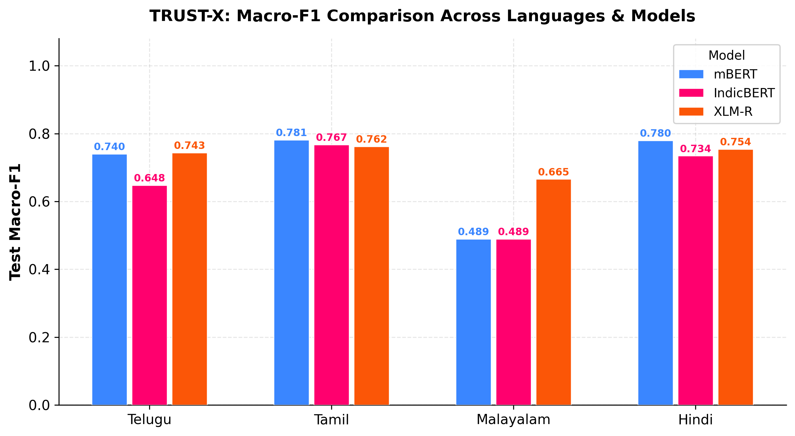
Figure 7.1: Test Macro-F1 Performance Comparison Across Languages and Architectures
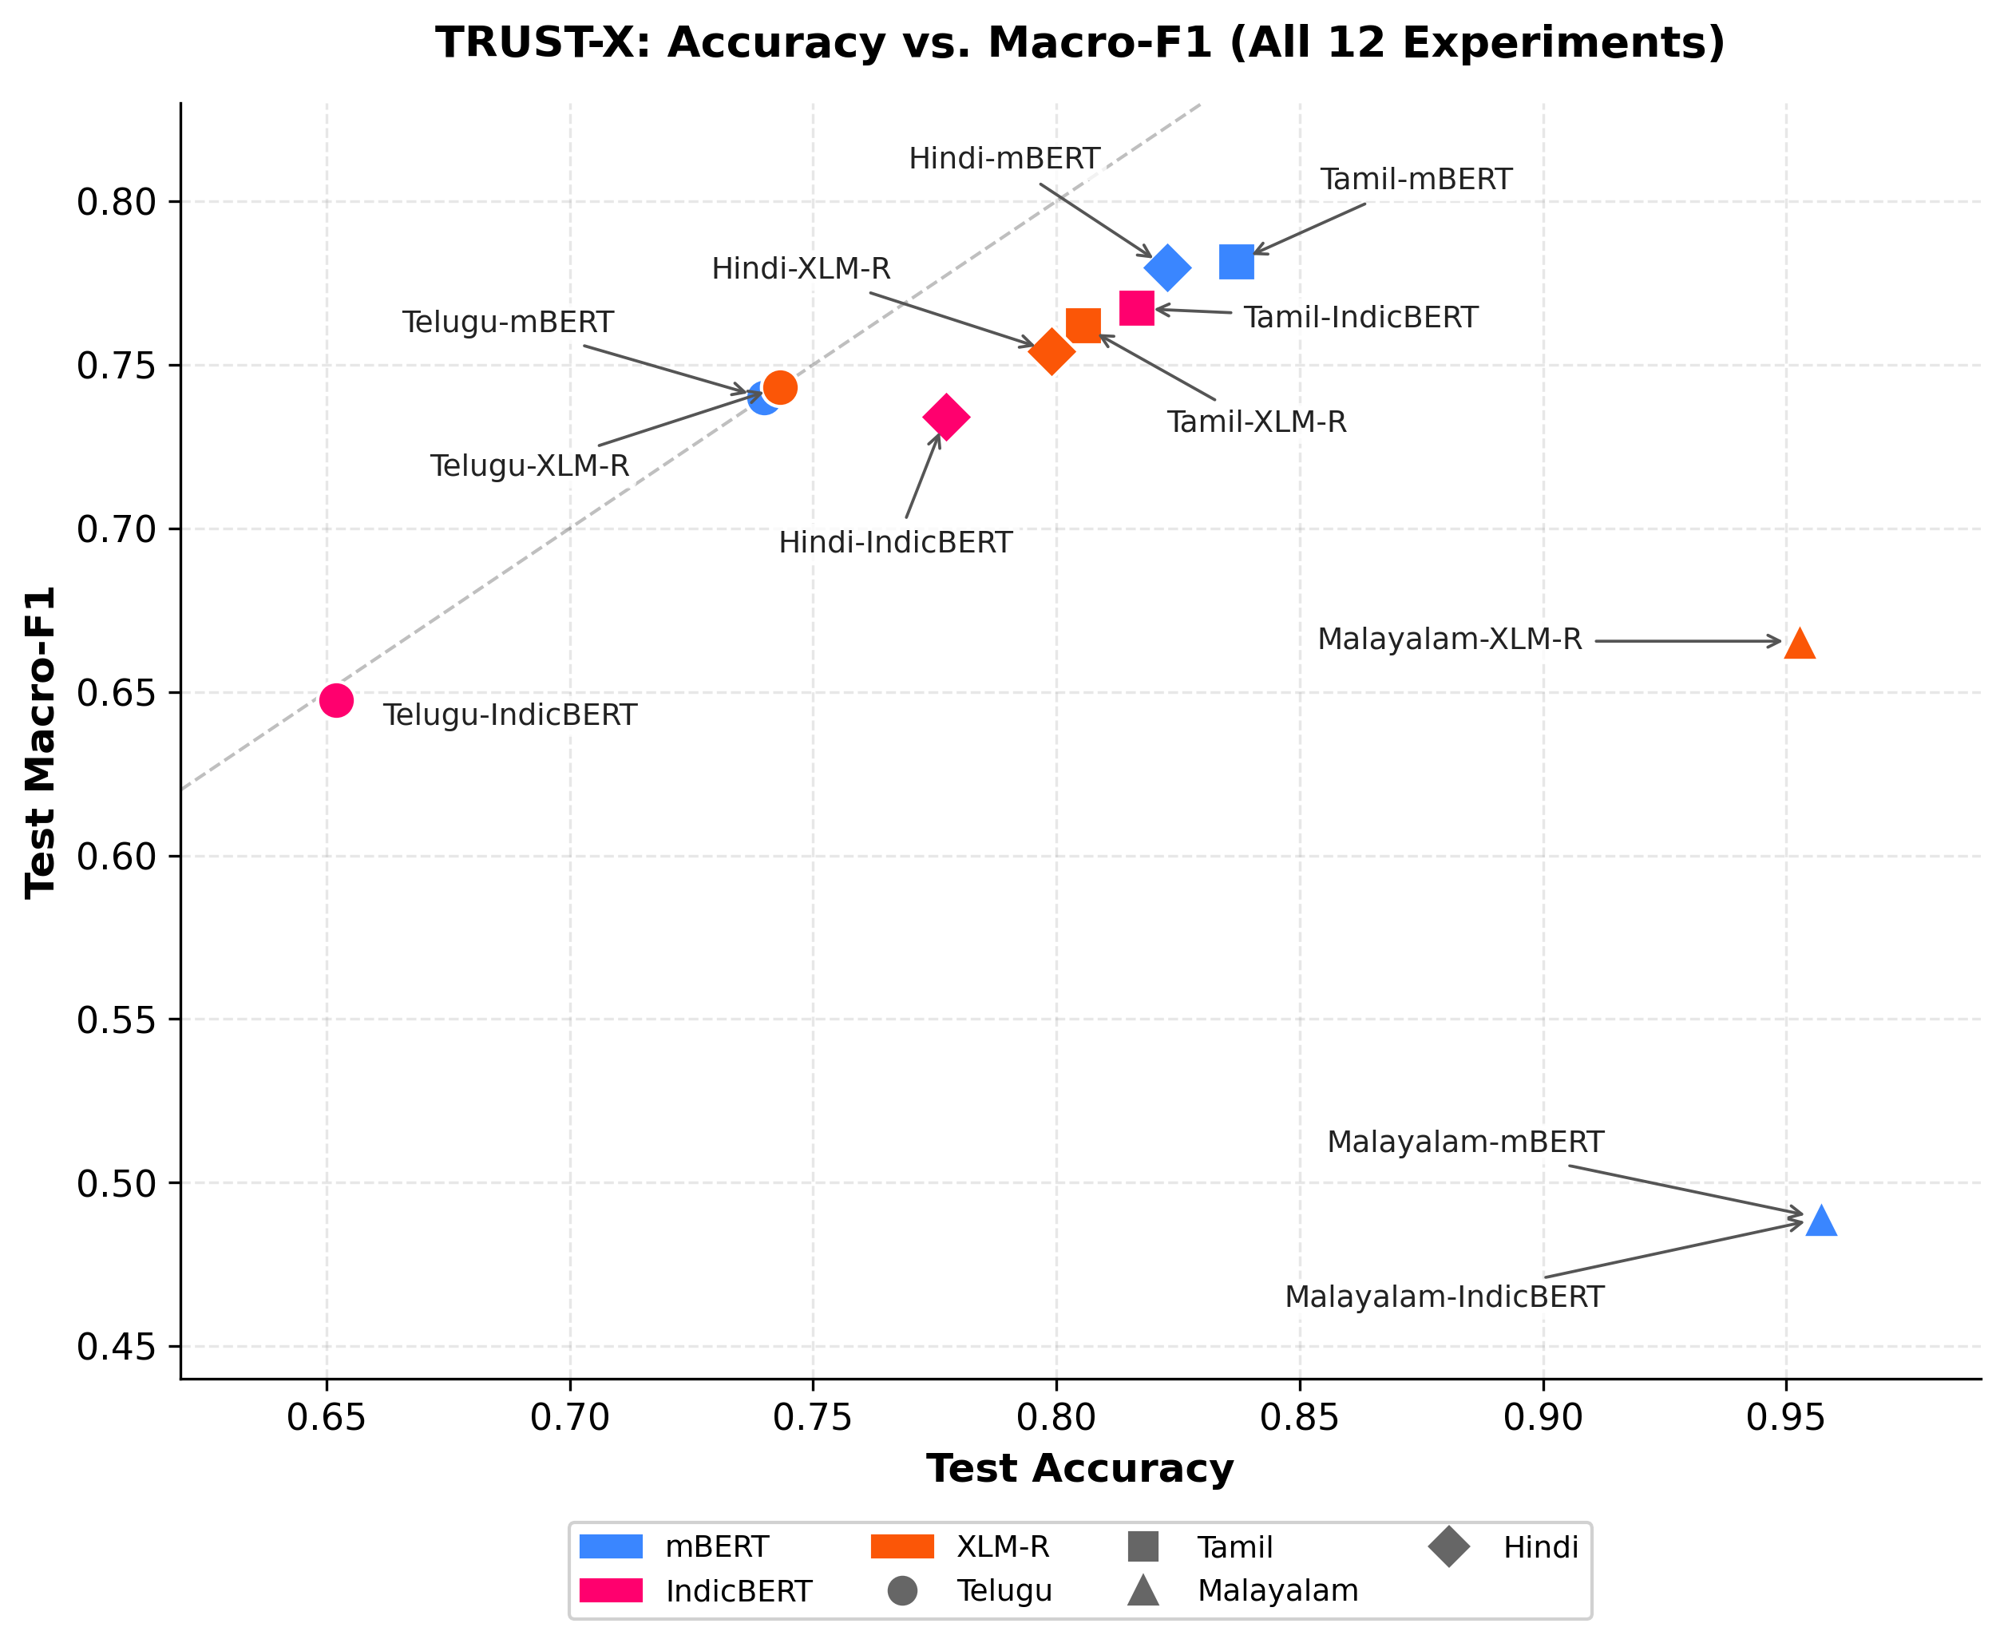
Figure 7.4: Accuracy vs. Macro-F1 Scatter Plot Highlighting the Impact of Severe Class Imbalance
7.6 MODEL CONFIDENCE CALIBRATION AND RELIABILITY DIAGNOSTICS
Confidence calibration analysis demonstrates notable architectural differences. IndicBERT achieves the lowest average ECE (0.0432) across three languages, reflecting more cautious probability estimates resulting from parameter sharing. However, on Hindi, XLM-R achieves an outstanding ECE of 0.0140 (1.4% average calibration gap), visualized in Figure 7.8. In contrast, Tamil models display elevated calibration error (mean ECE = 0.0826), where overconfidence on high-frequency offensive phrases widens the reliability gap.
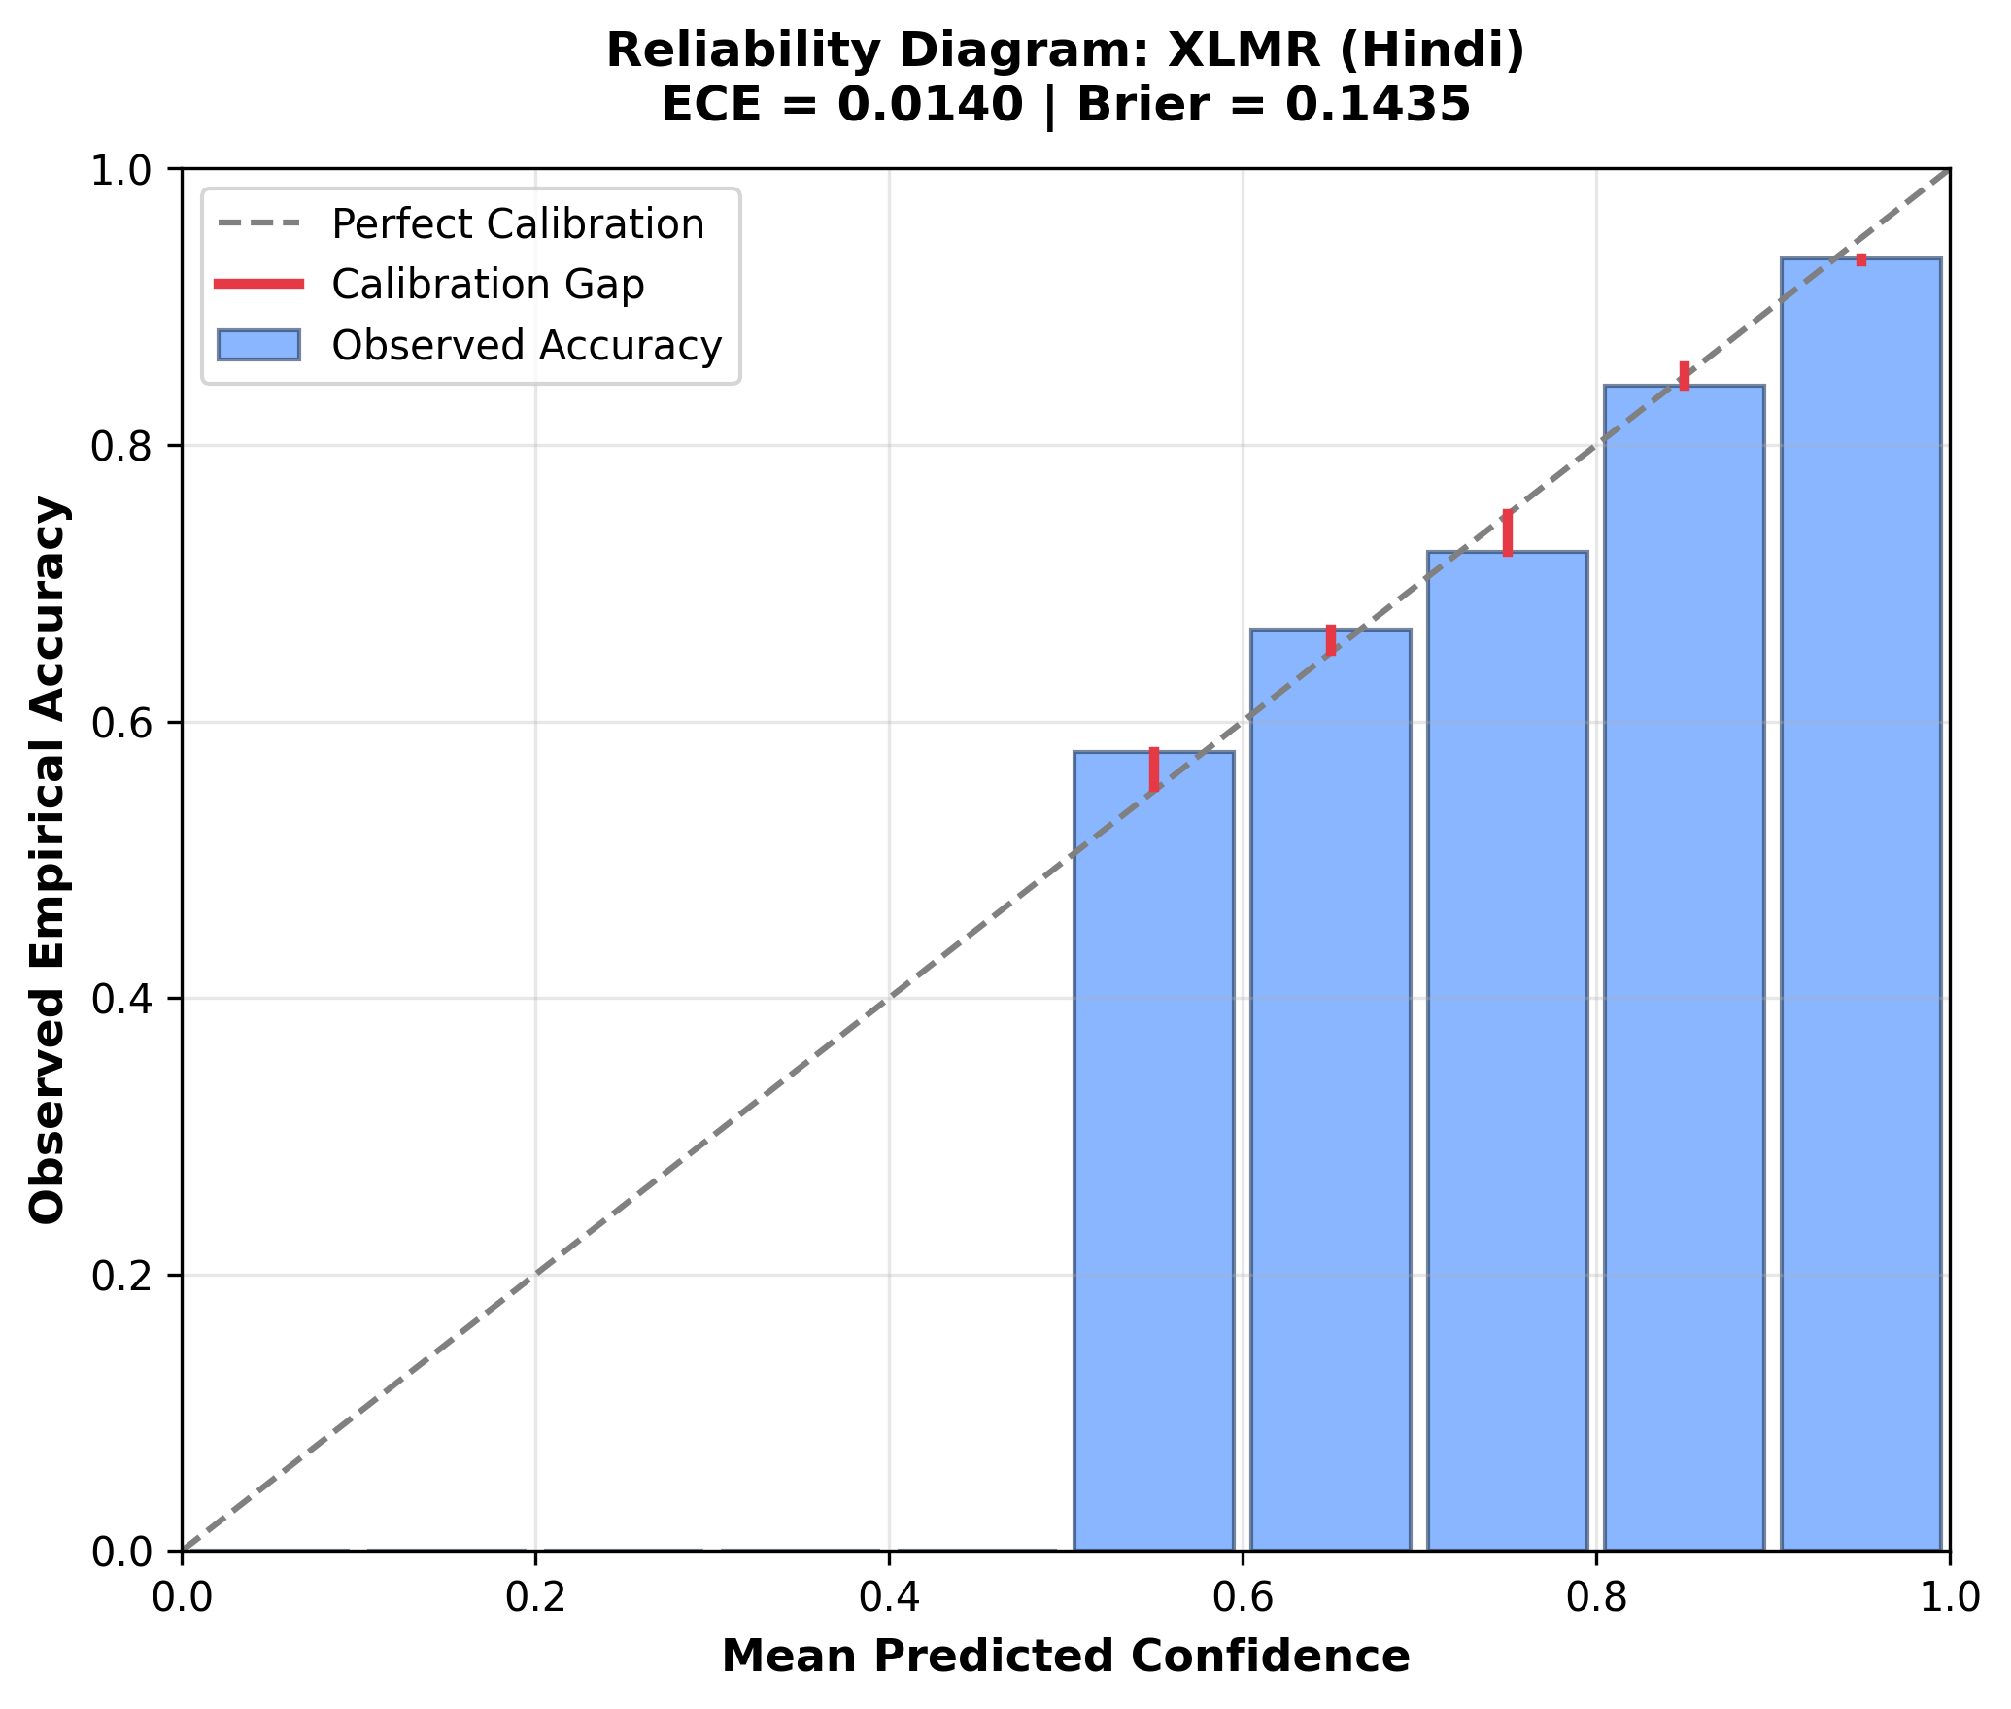
Figure 7.8: Representative Reliability Diagram: Hindi XLM-R Calibration Quality and Error Gap (ECE = 0.0140)
7.7 LINGUISTIC ROBUSTNESS AND DEGRADATION UNDER PERTURBATION NOISE
Linguistic robustness testing reveals that typographical noise and leet obfuscations degrade classification performance by 6% to 16% across languages. Across Telugu, Tamil, and Hindi, models achieve robustness retention scores between 0.8313 and 0.9404. Telugu-IndicBERT achieves 0.9404 retention, indicating high stability under subword perturbations. However, on Malayalam, mBERT and IndicBERT exhibit an apparent 'perfect' robustness score of 1.0000. As detailed in Section 7.11, this is not genuine resilience, but a pathology of majority-class collapse: predicting Class 0 uniformly means zero predictions flip.
7.8 SHAP FEATURE ATTRIBUTION COMPACTNESS ACROSS ARCHITECTURES
SHAP token attribution analysis demonstrates that XLM-RoBERTa produces significantly more compact and decisive explanations than mBERT or IndicBERT. Across all four languages, XLM-R concentrates an average of 60.37% of its total attribution energy in the top 20% most salient tokens (reaching 0.6887 on Malayalam and 0.6405 on Hindi). In contrast, mBERT (0.4965) and IndicBERT (0.4622) diffuse attribution more broadly across non-toxic particles and punctuation. Figure 7.9 illustrates global SHAP token importance for Hindi XLM-R, highlighting how specific contentious subwords drive toxicity predictions.
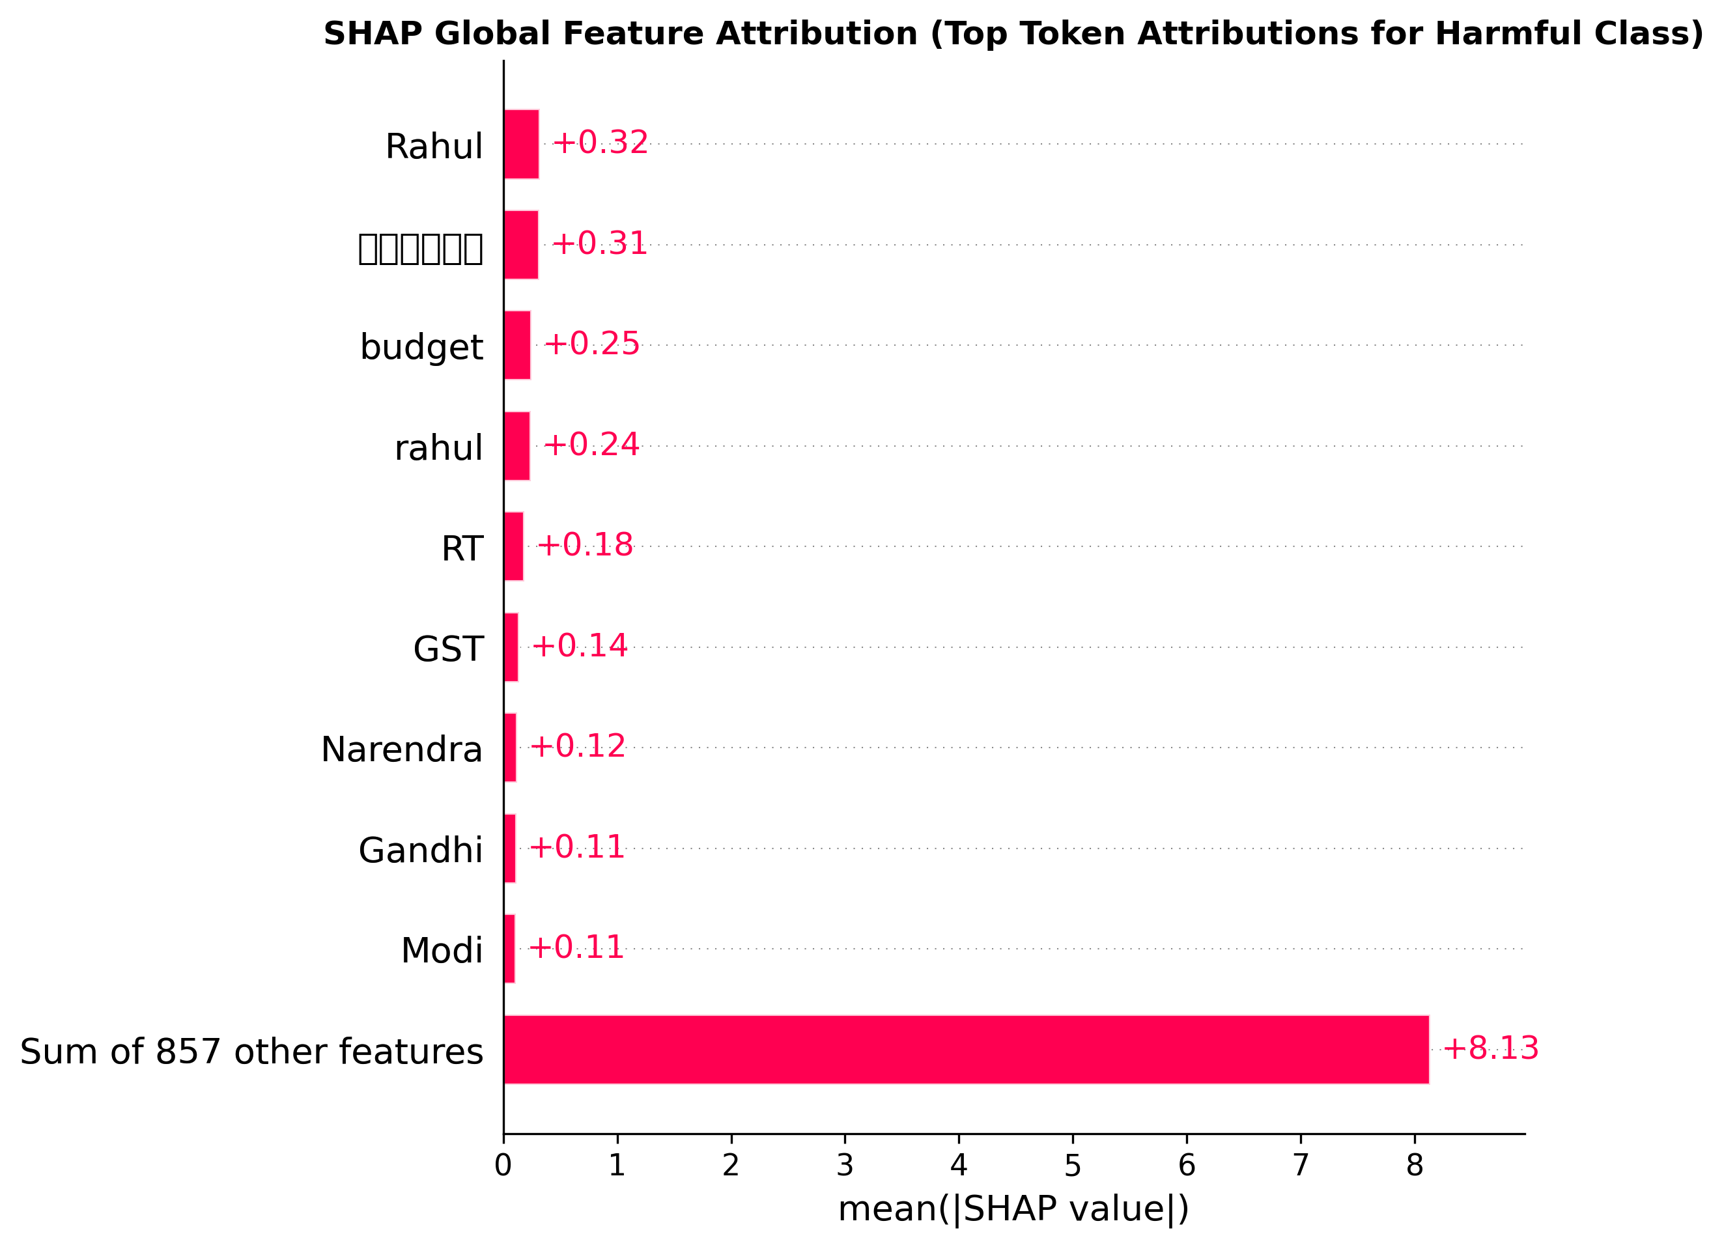
Figure 7.9: Global SHAP Feature Attribution: Top Token Attributions for Hindi XLM-R Harmful Class
7.9 HOLISTIC TRUSTWORTHINESS INDEX (TWI) ANALYSIS
Figure 7.2 displays the composite Trustworthiness Index across all 12 runs, while Figure 7.3 presents the multi-pillar radar chart mapping Performance, Explainability, Robustness, and Calibration. Figure 7.5 plots Macro-F1 against TWI. The radar comparison demonstrates that XLM-R constructs a balanced, expansive profile across all four pillars, whereas mBERT and IndicBERT exhibit indentations in explainability and Macro-F1. XLM-R achieves the highest overall TWI in three out of four languages: Malayalam (0.7998), Hindi (0.7733), and Tamil (0.7448).
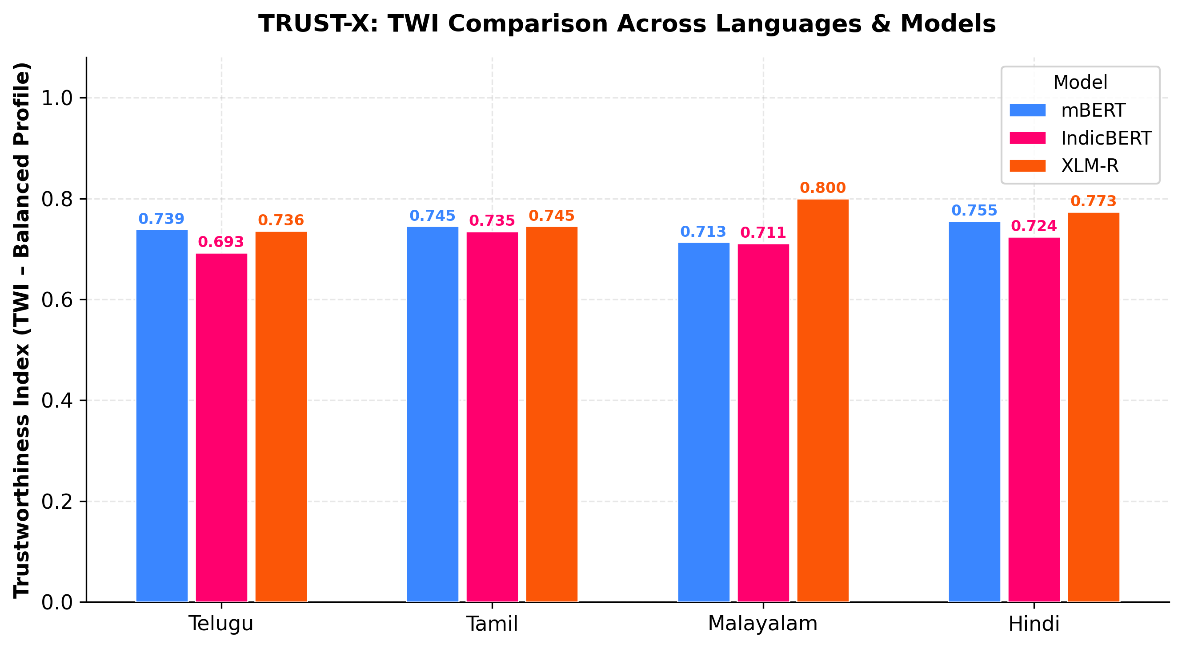
Figure 7.2: Holistic Trustworthiness Index (TWI) Comparison Across Languages and Models
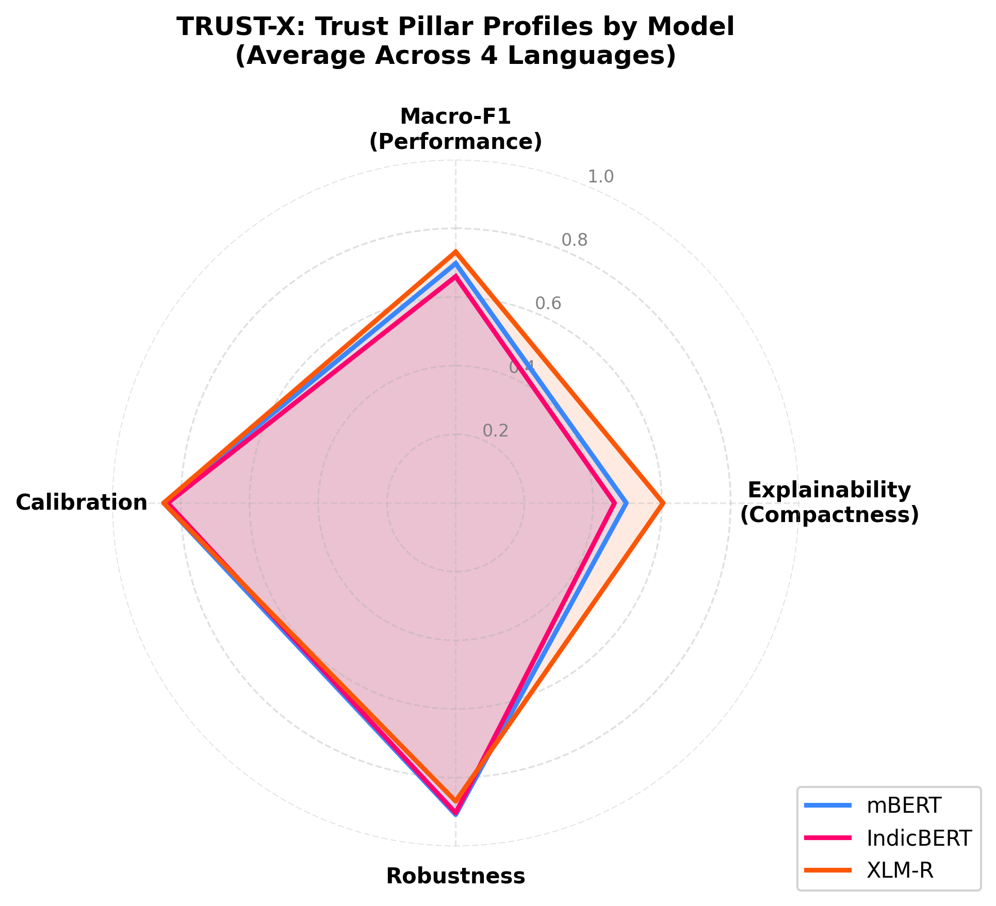
Figure 7.3: Multi-Pillar Radar Chart Comparing Performance, Explainability, Robustness, and Calibration
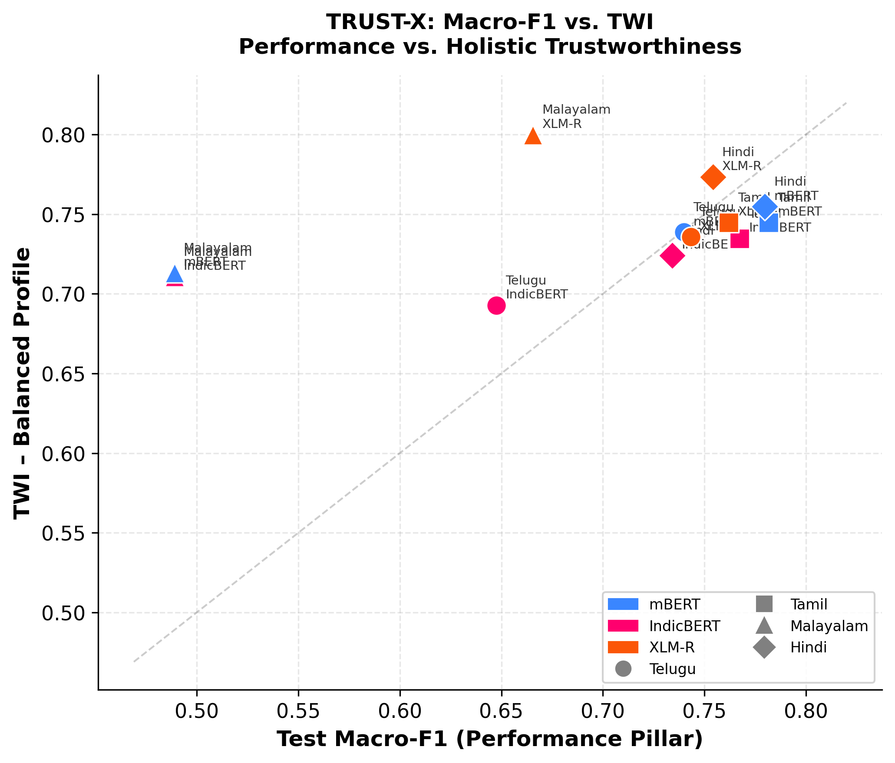
Figure 7.5: Predictive Performance (Macro-F1) vs. Composite Trustworthiness (TWI) Correlation
7.10 SENSITIVITY ANALYSIS ACROSS ALTERNATIVE TWI WEIGHTING PROFILES
To rigorously test whether model rankings depend arbitrarily on the chosen balanced weighting scheme (0.25 each), sensitivity auditing was conducted across four alternative operational profiles: Balanced, Performance-Heavy, Robustness-Heavy, and Calibration-Heavy. Table 7.4 details per-experiment sensitivity values, Table 7.5 summarizes model-level averages, and Figure 7.6 visualizes sensitivity trends.
Table 7.4: TWI Sensitivity Analysis Results Across Four Alternative Weighting Profiles
Language | Model | Balanced TWI | Perf-Heavy | Robust-Heavy | Calib-Heavy
Telugu | mBERT | 0.7386 | 0.7473 | 0.7908 | 0.7652
Telugu | IndicBERT | 0.6927 | 0.6893 | 0.7684 | 0.7248
Telugu | XLM-R | 0.7356 | 0.7436 | 0.7707 | 0.7593
Tamil | mBERT | 0.7448 | 0.7638 | 0.7878 | 0.7782
Tamil | IndicBERT | 0.7347 | 0.7513 | 0.7722 | 0.7698
Tamil | XLM-R | 0.7448 | 0.7575 | 0.7894 | 0.7734
Malayalam | mBERT | 0.7131 | 0.6491 | 0.7986 | 0.7795
Malayalam | IndicBERT | 0.7108 | 0.6477 | 0.7974 | 0.7794
Malayalam | XLM-R | 0.7998 | 0.7581 | 0.8318 | 0.8403
Hindi | mBERT | 0.7547 | 0.7688 | 0.7923 | 0.7883
Hindi | IndicBERT | 0.7241 | 0.7330 | 0.7621 | 0.7616
Hindi | XLM-R | 0.7733 | 0.7704 | 0.7989 | 0.7990
Table 7.5: Model-Level Sensitivity Averages and Rank Invariance Audit
Model Architecture | Balanced | Perf-Heavy | Robust-Heavy | Calib-Heavy | Rank Stability
XLM-RoBERTa (XLM-R) | 0.7634 (Rank 1) | 0.7574 (Rank 1) | 0.7977 (Rank 1) | 0.7930 (Rank 1) | INVARIANT RANK 1
Multilingual BERT (mBERT) | 0.7378 (Rank 2) | 0.7322 (Rank 2) | 0.7924 (Rank 2) | 0.7778 (Rank 2) | INVARIANT RANK 2
IndicBERT | 0.7156 (Rank 3) | 0.7053 (Rank 3) | 0.7750 (Rank 3) | 0.7589 (Rank 3) | INVARIANT RANK 3
Crucially, the sensitivity audit proves that the overall architectural ranking—XLM-R > mBERT > IndicBERT—is strictly invariant across all four operational weighting profiles (Spearman rank correlations rho > 0.93). XLM-R maintains rank 1 under every profile, establishing that its superior trustworthiness is an intrinsic architectural property rather than an artifact of equal weighting.
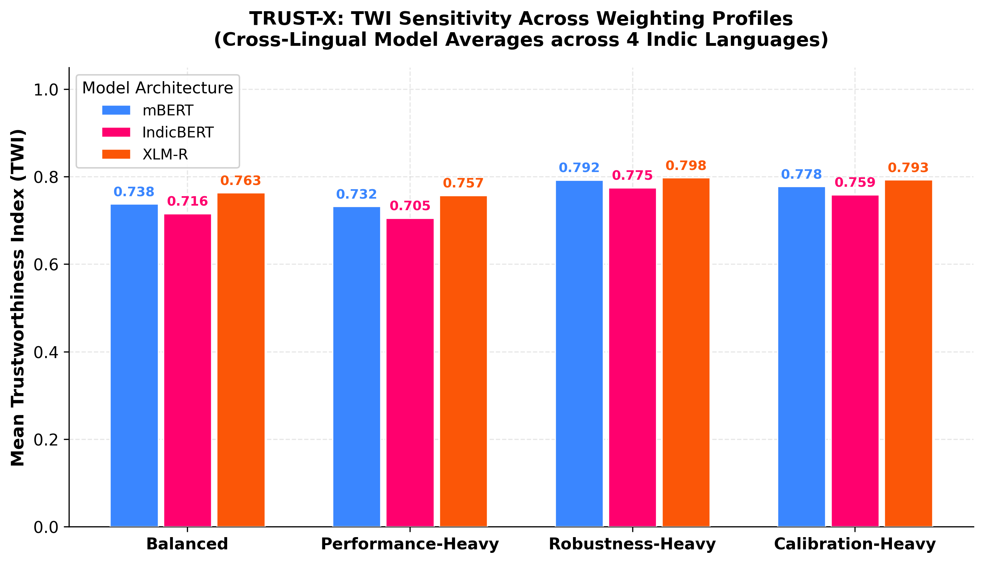
Figure 7.6: TWI Sensitivity Analysis Across Four Weighting Profiles for All 12 Experiments
7.11 MALAYALAM SEVERE CLASS IMBALANCE DEEP DIVE
The Malayalam experimental results warrant rigorous scientific dissection. In the Malayalam test split (1,844 samples), only 79 comments (4.28%) are offensive, while 1,765 (95.72%) are non-offensive. Under standard training, mBERT and IndicBERT collapse to the majority class heuristic, predicting Class 0 for every single test instance. Consequently: (1) Both models achieve an ostensibly spectacular Accuracy of 95.72% (1,765 / 1,844). (2) Because they identify zero true offensive comments, Recall on Class 1 is 0.0, causing Macro-F1 to collapse to 0.4891. (3) Under perturbation testing, because predictions are uniformly Class 0 regardless of noise, zero predictions flip, producing an artificial Robustness Score of 1.0000. In stark contrast, XLM-R successfully breaks the majority-class collapse, correctly identifying offensive samples to achieve a Macro-F1 of 0.6655 and a realistic Robustness Score of 0.9054, yielding the highest TWI in the entire benchmark (0.7998). This case study decisively demonstrates why deploying models based on accuracy alone is disastrous in imbalanced domains.
7.12 HINDI XLM-R DIAGNOSTIC FALSE POSITIVE ERROR ANALYSIS
To investigate fine-grained failure modes, an exhaustive diagnostic audit of all 1,383 test predictions produced by the best-performing model—Hindi XLM-R (`hindi_xlmr_seed42`)—was conducted (`reports/hindi_xlmr_false_positive_analysis.md`). Across the test set, Hindi XLM-R correctly classifies 257 True Positives (Hateful) and 848 True Negatives (Non-Hateful), while committing 162 False Negatives (11.7%, missing toxic content) and 116 False Positives (8.4%, Type I error: misclassifying benign comments as hateful). Table 7.6 breaks down the statistical profile of these 116 False Positives.
Table 7.6: Statistical Characterization of the 116 False Positives in Hindi XLM-R
Error Characteristic / Feature | Empirical Count & Proportion | Qualitative / Linguistic Interpretation
Borderline Uncertainty ($0.50 <= P < 0.65$) | 52 samples (44.8% of FPs) | Marginally over threshold; highly sensitive to logit shifts
Moderate Confidence ($0.65 <= P < 0.85$) | 45 samples (38.8% of FPs) | Driven by multiple co-occurring contentious or heated terms
High-Confidence Overfitting ($0.85 <= P <= 0.98$) | 19 samples (16.4% of FPs) | Aggressively misclassifies harsh political criticism as hate speech
User Handles (`@username`) | 88 samples (75.9% of FPs) | Reflects interactive Twitter tagging directed at politicians/journalists
Political / Communal / Protest Terms | 69 samples (59.5% of FPs) | Mentions of leaders, political parties, or citizen protests
Specific Mentions of 'Modi' | 54 samples (46.6% of FPs) | Direct references to Prime Minister Narendra Modi in critical context
Hashtags (`#topic`) & URLs | 17 hashtags (14.7%), 16 URLs (13.8%) | Campaign tags (e.g., `#modi_rojgar_do`, `#shameongodimedia`)
Table 7.7 illustrates representative false positive samples analyzed with SHAP feature attributions, explaining the subword mechanisms that push predictions toward the hateful class.
Table 7.7: Representative False Positives and SHAP Feature Attribution Analysis
Sample ID | Input Comment Text | P(Hateful) | SHAP Subword Analysis & Failure Mechanism
hi_test_00478 | @don_bhojpuriya @Priyank57577435 Jhooth aur jumlo kaa pitara toh hai modi | 90.16% | Top subwords pushing to Hateful: `aur` (+0.072), `Jhooth` (+0.032), `jumlo` (+0.013). Sarcastic political mockery triggers toxicity.
hi_test_00325 | @ChetanM24579252 @mrpal1000 Jese modi bheek maang rha tha pulwama k baad... | 85.95% | Top subwords: `pulwama` (+0.019), `bheek` (+0.019). Sarcastic political mockery triggers toxicity due to co-occurrence of sensitive national terms.
hi_test_00216 | @SushantBSinha Darte to sirf tum Godi media vale ho jo chand sikko ki aavaj... | 85.22% | Top subwords: `sirf` (+0.028), `tum` (+0.028). Sarcastic media critique containing pejoratives ('godi media') is classified as toxic hate.
hi_test_00468 | @burgerrqueen marahin caa | 80.79% | Top subwords: `caa` (+0.043), `marahin` (+0.028). Short 3-word utterance containing controversial legislative term 'CAA' triggers high toxicity.
Synthesis of False Positive Mechanisms: (1) Class-Weighting Loss Bias: Because Class 0 (Hateful) is a 30% minority in HECM, training enforced a ~2.33x loss penalty on missed hate speech. In ambiguous political disputes, the model systematically tilts toward Class 0. (2) Sarcasm and Negation Blindness: Transformer self-attention detects abusive or heated vocabulary ('jumla', 'bheek', 'godi media') but fails to resolve ironic political satire. (3) Spurious Entity Correlations: High co-occurrence of specific politicians ('Modi') and contentious laws ('CAA') with toxic training samples causes the model to associate these entities with elevated toxicity risk.
7.13 THREATS TO VALIDITY AND EXPERIMENTAL LIMITATIONS
Several threats to validity must be recognized: (1) Construct Validity: Hate speech and offensive language are distinct pragmatic categories; cross-lingual metric aggregations reflect framework utility across related tasks rather than identical constructs. (2) Internal Validity: Pretrained models may capture domain-specific lexical biases present in their pretraining corpora. (3) Conclusion Validity: While fixed seed 42 provides deterministic comparability, multi-seed training runs with confidence intervals would provide stronger statistical significance testing.

CHAPTER 8: STREAMLIT APPLICATION AND DEMONSTRATION
8.1 APPLICATION ARCHITECTURE AND UI COMPONENTS
To make the TRUST-X benchmarking methodology accessible for practical content moderation workflows, an interactive multi-page web application was developed using Streamlit 1.56.0. The application is executed locally via: `streamlit run app/main.py`. The application implements a modular architecture separating data ingestion (`app/data_loader.py`), model checkpoint loading (`app/model_loader.py`), SHAP visualization components (`app/components/shap_display.py`), and five interactive functional pages, summarized in Table 8.1.
Table 8.1: Streamlit Multi-Page Application Component Architecture and Interface Functions
Source Script | Interface Page | Functional Capabilities and Interactive Features
01_dashboard.py | Benchmark Dashboard | Overview of frozen benchmark results, cross-lingual metrics, and factorial coverage.
02_live_detection.py | Live 3-Model Detection | Parallel real-time inference comparing mBERT, IndicBERT, and XLM-R on user input, with consensus checking and color-coded SHAP token highlights.
03_model_evaluation.py | Model Evaluation | Single-model diagnostic drilldown: confusion matrices, reliability curves, and per-class performance.
04_model_comparison.py | Model Comparison | Head-to-head multi-model comparison featuring interactive multi-pillar radar charts and metric deltas.
05_twi_sensitivity.py | TWI Sensitivity Explorer | Dynamic weight adjustment sliders allowing practitioners to test custom TWI weighting profiles and inspect rank stability.
8.2 BENCHMARK DASHBOARD INTERFACE
The Dashboard (`pages/01_dashboard.py`) serves as the executive summary portal. It surfaces macro-level metrics across the 12 experiments, displays cross-lingual model averages, and embeds canonical figures illustrating Macro-F1, TWI, and radar multi-pillar distributions.
8.3 MULTI-MODEL PARALLEL LIVE DETECTION INTERFACE
The Live Detection module (`pages/02_live_detection.py`) provides a parallel evaluation testbed. A user inputs an arbitrary social media comment and selects the target language (Telugu, Tamil, Malayalam, or Hindi). Upon clicking 'Analyze with All Models', the application queries all three fine-tuned transformer checkpoints simultaneously in memory: (1) Predictions & Probabilities: Renders side-by-side metric cards displaying predicted class, confidence percentage, and normalized softmax probabilities for Class 0 and Class 1. (2) Model Consensus Banner: Dynamically computes whether models achieve unanimous consensus (3/3 agreement) or majority consensus (2/3), highlighting borderline inputs where architectures disagree. (3) Side-by-Side SHAP Token Attributions: If enabled, computes SHAP Shapley values sequentially across all three models and renders interactive, color-coded HTML spans highlighting exact subwords pushing toward harmful (red) or non-harmful (blue) outcomes.
8.4 COMPARATIVE MODEL AUDITING AND RADAR VISUALIZATIONS
The Model Comparison page (`pages/04_model_comparison.py`) enables content moderation architects to benchmark candidate models against one another on specific languages. Practitioners can view multi-pillar radar charts contrasting Performance, Explainability, Robustness, and Calibration, instantly diagnosing trade-offs (e.g., choosing IndicBERT for low latency vs. XLM-R for high trustworthiness).
8.5 INTERACTIVE TWI SENSITIVITY EXPLORER
The TWI Sensitivity page (`pages/05_twi_sensitivity.py`) operationalizes the sensitivity analysis presented in Chapter 7. Practitioners can adjust interactive weight sliders (w_perf, w_expl, w_rob, w_calib) to simulate custom deployment policies, instantly observing how model rankings adjust in response to organizational risk tolerances.
8.6 LIVE DEMONSTRATION BOUNDARIES AND QUALITATIVE SCOPING
To preserve scientific integrity, the Streamlit interface explicitly communicates its operational boundaries: (1) Live user inputs are qualitative demonstration samples; they do not possess verified ground-truth labels. (2) Individual live predictions cannot generate dataset-level metrics (such as Macro-F1, ECE, or TWI). (3) The live inference engine operates strictly in read-only mode, never modifying frozen checkpoints or canonical CSV logs.

CHAPTER 9: CONCLUSION AND FUTURE WORK
9.1 SUMMARY OF COMPLETED WORK
In this course project for BCSE332L (Deep Learning), we designed, implemented, and empirically validated TRUST-X—an integrated trustworthiness evaluation framework for transformer-based multilingual code-mixed harmful speech detection. Moving beyond conventional one-dimensional accuracy benchmarking, TRUST-X audits models across four foundational pillars: Predictive Performance (Macro-F1, Accuracy), Confidence Calibration (Expected Calibration Error, Brier Score), Linguistic Robustness (retention under a six-operator typographical and leet perturbation suite), and Model Explainability (SHAP token attribution compactness). The framework was rigorously benchmarked across 12 factorial GPU experiments comparing mBERT, IndicBERT, and XLM-RoBERTa across four South Asian language settings: Telugu, Tamil, Malayalam, and Hindi.
9.2 REALIZATION OF PROJECT OBJECTIVES
All nine technical objectives defined in Chapter 1 were systematically realized: (1) Four multilingual corpora were audited, cleaned, and standardized into a common schema. (2) Pretrained mBERT, IndicBERT, and XLM-R models were fine-tuned under strict hyperparameter controls. (3) Predictive performance was evaluated on isolated test sets. (4) Calibration errors were quantified via ECE and Brier score. (5) Linguistic robustness was stress-tested across 6 real-world noise operators. (6) SHAP token compactness scores were computed across representative error subsets. (7) The composite Trustworthiness Index (TWI) was formulated and validated. (8) Sensitivity audits confirmed rank stability across four operational weighting profiles. (9) A full-featured Streamlit web application was developed and deployed for interactive demonstration.
9.3 CORE SCIENTIFIC INSIGHTS AND CONTRIBUTIONS
The empirical findings of this project yield several crucial scientific insights for trustworthy AI deployment: (1) Accuracy Fails in Imbalanced Domains: In Malayalam, mBERT achieves 95.72% accuracy but collapses in minority-class Macro-F1 (0.4891) due to majority-class heuristic collapse. Only XLM-R succeeds in recovering minority offensive instances (0.6655 Macro-F1). (2) XLM-RoBERTa Demonstrates Holistic Superiority: XLM-R achieves the highest cross-lingual Macro-F1 (0.7312) and highest composite trustworthiness (mean TWI = 0.7634), driven by superior token attribution compactness (0.6037) and robust calibration. (3) Rank Invariance Under Sensitivity Auditing: The model ranking XLM-R > mBERT > IndicBERT remains strictly invariant across Balanced, Performance-Heavy, Robustness-Heavy, and Calibration-Heavy profiles, establishing that XLM-R's trustworthiness advantage is structural rather than an artifact of equal weighting. (4) Systematic False Positive Biases in Political Rhetoric: In-depth error diagnostics on Hindi XLM-R revealed that 59.5% of false positives involve political and protest terminology, where sarcastic mockery triggers toxicity due to class-weighting penalties.
9.4 PRACTICAL AND METHODOLOGICAL LIMITATIONS
While TRUST-X establishes a rigorous evaluation standard, several limitations must be acknowledged: (1) Task and Annotation Heterogeneity: Datasets represent two related but distinct constructs (hate speech in Telugu/Hindi vs. offensive language in Tamil/Malayalam). (2) Severe Class Imbalance: Malayalam's 24:1 imbalance created severe optimization hurdles. (3) Single-Seed Experimental Protocol: Fixed seed 42 ensured deterministic control across 12 GPU runs, but multi-seed training is required to establish statistical confidence intervals. (4) Uncalibrated Final Test Metrics: Temperature scaling infrastructure was implemented but not applied to final reported test metrics.
9.5 STRATEGIC DIRECTIONS FOR FUTURE RESEARCH
Promising avenues for future research include: (1) Validation-Set Temperature Scaling: Optimizing temperature scaling parameters on development logits and evaluating post-calibration ECE reductions on test sets. (2) Multi-Seed Statistical Auditing: Executing 5-seed training runs to compute confidence intervals and paired t-tests for TWI. (3) Expansion to Additional Indic Languages: Extending TRUST-X to Bengali, Marathi, Kannada, and Urdu code-mixed corpora. (4) Human-in-the-Loop Explanation Verification: Conducting user studies with professional content moderators to evaluate whether SHAP token compactness correlates with human auditing speed and decision accuracy. (5) Context-Aware Adversarial Defense: Implementing adversarial data augmentation during fine-tuning to bolster resilience against evasion attacks in code-mixed text.

REFERENCES
Chakravarthi, B. R., Muralidaran, V., Priyadharshini, R., & Suryawanshi, S. (2020). Corpus creation for sentiment analysis in code-mixed Tamil-English text. In Proceedings of the 1st Joint Workshop on Spoken Language Technologies for Under-resourced languages (SLTU) and Collaboration and Computing for Under-Resourced Languages (CCURL) (pp. 202–210). European Language Resources Association (ELRA).
Chakravarthi, B. R., Priyadharshini, R., Muralidaran, V., Suryawanshi, S., Navaneethakrishnan, S., Ponnusamy, R., & McCrae, J. P. (2021). Findings of the shared task on offensive language identification in Tamil, Malayalam, and Kannada. In Proceedings of the First Workshop on Speech and Language Technologies for Dravidian Languages (pp. 133–145). Association for Computational Linguistics.
Conneau, A., Khandelwal, K., Goyal, N., Chaudhary, V., Wenzek, G., Guzmán, F., Grave, E., Ott, M., Zettlemoyer, L., & Stoyanov, V. (2020). Unsupervised cross-lingual representation learning at scale. In Proceedings of the 58th Annual Meeting of the Association for Computational Linguistics (pp. 8440–8451). Association for Computational Linguistics. https://doi.org/10.18653/v1/2020.acl-main.747
Danilevsky, M., Qian, K., Aharonov, R., Katsis, Y., Kawas, B., & Sen, P. (2020). A survey of the state of explainable AI for natural language processing. In Proceedings of the 1st Conference of the Asia-Pacific Chapter of the Association for Computational Linguistics and the 10th International Joint Conference on Natural Language Processing (pp. 447–459). Association for Computational Linguistics.
Devlin, J., Chang, M.-W., Lee, K., & Toutanova, K. (2019). BERT: Pre-training of deep bidirectional transformers for language understanding. In Proceedings of the 2019 Conference of the North American Chapter of the Association for Computational Linguistics: Human Language Technologies (pp. 4171–4186). Association for Computational Linguistics. https://doi.org/10.18653/v1/N19-1423
Guo, C., Pleiss, G., Sun, Y., & Weinberger, K. Q. (2017). On calibration of modern neural networks. In Proceedings of the 34th International Conference on Machine Learning (Vol. 70, pp. 1321–1330). PMLR.
HOLD Consortium. (2024). HOLD: A Telugu-English code-mixed hate and offensive language dataset. In Proceedings of the 18th Conference of the European Chapter of the Association for Computational Linguistics (EACL 2024). Association for Computational Linguistics.
Jin, D., Jin, Z., Zhou, J. T., & Szolovits, P. (2020). Is BERT really robust? A strong baseline for natural language attack on text classification and entailment. Proceedings of the AAAI Conference on Artificial Intelligence, 34(05), 8018–8025. https://doi.org/10.1609/aaai.v34i05.6311
Kakwani, D., Kunchukuttan, A., Golla, S., Gokul, N. C., Bhattacharyya, A., Khapra, M. M., & Kumar, P. (2020). IndicNLPSuite: Monolingual corpora, evaluation benchmarks and pre-trained multilingual language models for Indian languages. In Findings of the Association for Computational Linguistics: EMNLP 2020 (pp. 4948–4961). Association for Computational Linguistics. https://doi.org/10.18653/v1/2020.findings-emnlp.445
Lan, Z., Chen, M., Goodman, S., Gimpel, K., Sharma, P., & Soricut, R. (2020). ALBERT: A lite BERT for self-supervised learning of language representations. In International Conference on Learning Representations (ICLR 2020). OpenReview.net.
Liang, P., Bommasani, R., Lee, T., Tsipras, D., Soylu, D., Yasunaga, M., Zhang, Y., Narayanan, D., Wu, Y., Kumar, A., Newman, B., Bitton, B., Movva, R., Zhou, B., Toby, B., & Hashimoto, T. (2022). Holistic evaluation of language models. arXiv preprint arXiv:2211.09110.
Liu, Y., Ott, M., Goyal, N., Du, J., Joshi, M., Chen, D., Levy, O., Lewis, M., Zettlemoyer, L., & Stoyanov, V. (2019). RoBERTa: A robustly optimized BERT pretraining approach. arXiv preprint arXiv:1907.11692.
Loshchilov, I., & Hutter, F. (2019). Decoupled weight decay regularization. In International Conference on Learning Representations (ICLR 2019). OpenReview.net.
Lundberg, S. M., & Lee, S.-I. (2017). A unified approach to interpreting model predictions. In Advances in Neural Information Processing Systems (Vol. 30, pp. 4765–4774). Curran Associates, Inc.
Morris, J., Lifland, E., Yoo, J. Y., Grigsby, J., Jin, D., & Qi, Y. (2020). TextAttack: A framework for adversarial attacks, data augmentation, and adversarial training in NLP. In Proceedings of the 2020 Conference on Empirical Methods in Natural Language Processing: System Demonstrations (pp. 119–126). Association for Computational Linguistics. https://doi.org/10.18653/v1/2020.emnlp-demos.16
Ribeiro, M. T., Wu, T., Guestrin, C., & Singh, S. (2020). Beyond the imitation game: Quantifying and extrapolating the capabilities of language models (CheckList). In Proceedings of the 58th Annual Meeting of the Association for Computational Linguistics (pp. 4902–4912). Association for Computational Linguistics. https://doi.org/10.18653/v1/2020.acl-main.442

APPENDICES
APPENDIX A: REPRESENTATIVE SOURCE CODE EXCERPTS
This appendix provides key modular code snippets from the TRUST-X repository illustrating critical algorithmic implementations. The full codebase is available in the electronic submission.
A.1 SHAP Token Attribution and Compactness Computation (`src/explainability/shap_analysis.py`)
def run_shap_analysis(model, tokenizer, representative_df, device, output_dir, max_evals=100):
masker = shap.maskers.Text(tokenizer)
explainer = shap.Explainer(predict_probs, masker, output_names=['Non-Harmful', 'Harmful'])
shap_values = explainer(texts, max_evals=max_evals)
sparsities = []
for i in range(len(shap_values)):
vals = np.abs(shap_values[i].values[:, 1]) # Attributions for harmful class
if vals.sum() > 0:
k = max(1, int(0.2 * len(vals))) # Top 20% most decisive tokens
sorted_vals = np.sort(vals)[::-1]
sparsities.append(float(sorted_vals[:k].sum() / vals.sum()))
mean_compactness = float(np.mean(sparsities)) if sparsities else 0.5
return {'mean_compactness_score': mean_compactness}
A.2 Linguistic Perturbation Operators (`src/robustness/perturbations.py`)
LEET_MAP = {'a': '@', 'e': '3', 'i': '1', 'o': '0', 's': '$', 't': '7'}
def perturb_leet_substitution(text, rate=0.15, rng=None):
chars = list(text)
for i, c in enumerate(chars):
if c in LEET_MAP and rng.random() < rate:
chars[i] = LEET_MAP[c]
return ''.join(chars)
def apply_composite_perturbation(text, seed=42):
rng = random.Random(seed)
t = perturb_char_repetition(text, rate=0.15, rng=rng)
t = perturb_leet_substitution(t, rate=0.12, rng=rng)
t = perturb_char_deletion(t, rate=0.08, rng=rng)
return t
APPENDIX B: DETAILED DATASET AUDIT AND PREPROCESSING STATISTICS
Table B.1 provides granular auditing metrics for the HECM Hindi dataset, documenting row counts, duplicate purges, and character length statistics across preprocessing stages.
Table B.1: HECM Hindi Preprocessing Audit and Deduplication Statistics
Split | Rows | Uniq | MinC | MaxC | MeanC | MedC | MinW | MaxW | MeanW | P95W
Raw HECM Corpus | 9,357 | 9,239 | 5 | 744 | 147.58 | 131.0 | 1 | 89 | 24.46 | 54.0
Clean Full HECM | 9,214 | 9,214 | 5 | 744 | 148.18 | 132.0 | 1 | 89 | 24.59 | 54.0
HECM Train (70%) | 6,449 | 6,449 | 5 | 677 | 149.32 | 134.0 | 1 | 83 | 24.84 | 54.0
HECM Dev (15%) | 1,382 | 1,382 | 5 | 744 | 144.42 | 126.5 | 1 | 89 | 23.77 | 52.0
HECM Test (15%) | 1,383 | 1,383 | 11 | 461 | 146.64 | 129.0 | 3 | 73 | 24.25 | 53.0
APPENDIX C: COMPLETE 12-EXPERIMENT RESULTS AND SENSITIVITY BREAKDOWN
Table C.1 reproduces the complete 12-experiment audit matrix, detailing all four trust pillars alongside multi-profile TWI values.
Table C.1: Complete 12-Experiment Results and Sensitivity Breakdown
Lang | Model | Acc | Macro-F1 | Calib | Robust | Explain | Bal TWI | Perf TWI | Rob TWI | Cal TWI
Telugu | mBERT | 0.7399 | 0.7399 | 0.7996 | 0.9023 | 0.5127 | 0.7386 | 0.7473 | 0.7908 | 0.7652
Telugu | IndicBERT | 0.6520 | 0.6476 | 0.7658 | 0.9404 | 0.4171 | 0.6927 | 0.6893 | 0.7684 | 0.7248
Telugu | XLM-R | 0.7432 | 0.7432 | 0.7956 | 0.8412 | 0.5625 | 0.7356 | 0.7436 | 0.7707 | 0.7593
Tamil | mBERT | 0.8370 | 0.7815 | 0.8295 | 0.8680 | 0.5000 | 0.7448 | 0.7638 | 0.7878 | 0.7782
Tamil | IndicBERT | 0.8166 | 0.7672 | 0.8288 | 0.8387 | 0.5041 | 0.7347 | 0.7513 | 0.7722 | 0.7698
Tamil | XLM-R | 0.8055 | 0.7619 | 0.8151 | 0.8790 | 0.5231 | 0.7448 | 0.7575 | 0.7894 | 0.7734
Malayalam | mBERT | 0.9572 | 0.4891 | 0.9238 | 1.0000 | 0.4398 | 0.7131 | 0.6491 | 0.7986 | 0.7795
Malayalam | IndicBERT | 0.9572 | 0.4891 | 0.9282 | 1.0000 | 0.4261 | 0.7108 | 0.6477 | 0.7974 | 0.7794
Malayalam | XLM-R | 0.9528 | 0.6655 | 0.9396 | 0.9054 | 0.6887 | 0.7998 | 0.7581 | 0.8318 | 0.8403
Hindi | mBERT | 0.8228 | 0.7797 | 0.8448 | 0.8608 | 0.5336 | 0.7547 | 0.7688 | 0.7923 | 0.7883
Hindi | IndicBERT | 0.7773 | 0.7342 | 0.8294 | 0.8313 | 0.5017 | 0.7241 | 0.7330 | 0.7621 | 0.7616
Hindi | XLM-R | 0.7990 | 0.7541 | 0.8495 | 0.8491 | 0.6405 | 0.7733 | 0.7704 | 0.7989 | 0.7990
APPENDIX D: STREAMLIT APPLICATION COMPONENTS AND VISUAL DIAGNOSTICS
The Streamlit application incorporates custom visual components to assist human content moderators. Figure D.1 illustrates a representative confusion matrix generated during evaluation (Telugu mBERT).
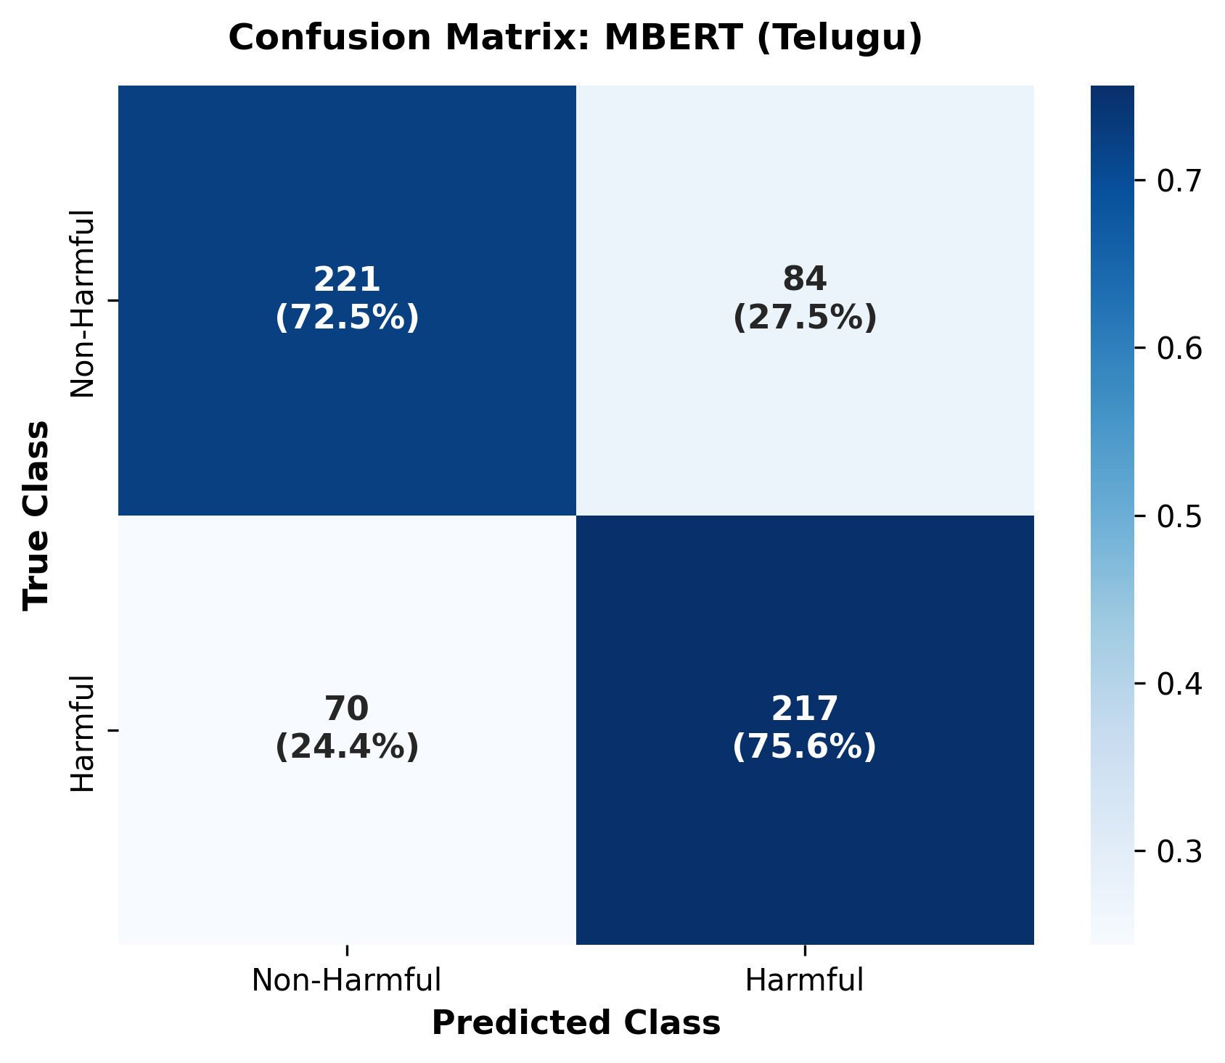
Figure D.1: Exemplar Confusion Matrix: Telugu mBERT Evaluation on Frozen Test Set
APPENDIX E: CANDIDATE INDIVIDUAL CONTRIBUTION ALLOCATION MATRIX
As stipulated by the VIT course project guidelines, each student must submit an individual report highlighting their personal contributions to the project. Table E.1 provides the contribution breakdown template.
Table E.1: Candidate Individual Contribution Allocation Matrix
Project Work Area / Responsibility Domain | Detailed Candidate Contribution Statement
1. Dataset Acquisition & Auditing | [Led raw data acquisition, implemented Telugu deduplication, and executed class-imbalance audits.]
2. Preprocessing & Schema Design | [Designed standardized internal schema and authored regex cleaning module preserving code-mixed orthography.]
3. Model Fine-Tuning & Training | [Configured Google Colab GPU training pipeline, AdamW optimizer, and Macro-F1 checkpoint selection.]
4. Trustworthiness Framework Formulations | [Formulated normalizations for ECE, Brier score, and composite Trustworthiness Index (TWI).]
5. Linguistic Robustness & Perturbation Suite | [Implemented 6-operator perturbation engine and conducted retention testing across languages.]
6. Explainable AI & SHAP Integration | [Integrated SHAP Text explainer, implemented top-20% compactness score, and analyzed error subsets.]
7. Streamlit Web Application Development | [Developed multi-page Streamlit application, live 3-model parallel inference, and dynamic SHAP displays.]
8. Documentation & Technical Reporting | [Authored technical report, literature review, diagnostic false-positive error analysis, and audits.]

