**Assignment number:** 6

**Problem definition:** Upload a static website on S3.

Step 1: Sign in to your AWS account as the root user.

Step 2: From the AWS Management Console, type “S3” in the search bar and click on the Amazon S3 service. Click on **“Create bucket”**.

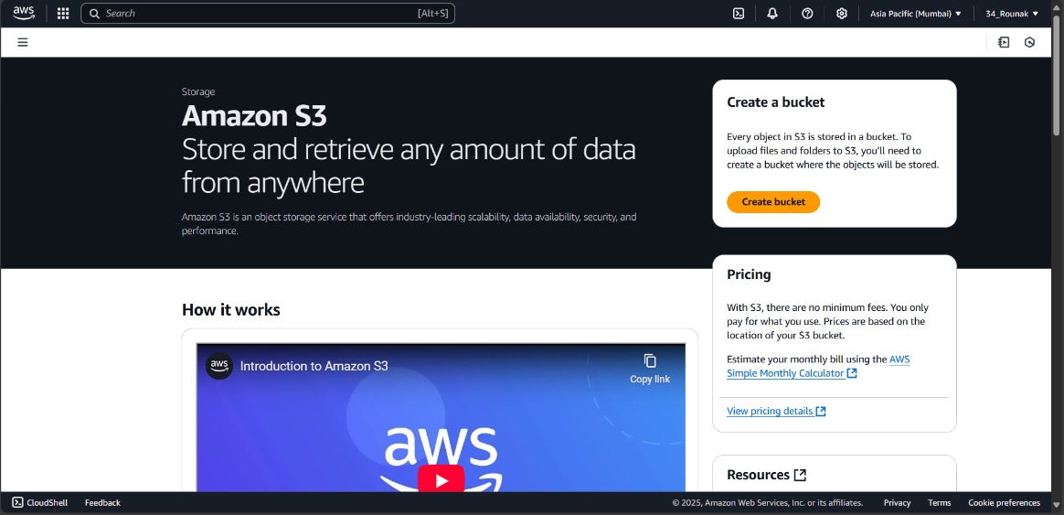

Step 3: On the Create Bucket page, provide a globally unique bucket name using only lowercase letters and no spaces, and choose the Asia Pacific (Mumbai) ap-south-1 region. In the Object Ownership section, ensure that ACLs are enabled by checking the “Bucket owner preferred” option, and then uncheck the “Block all public access” option. Make sure to acknowledge that these settings may make your bucket and its objects public and leave all other settings as default before clicking the “**Create bucket”** button.

Step 4: Once the bucket is created, click on its name from the list of buckets to open the bucket details page.

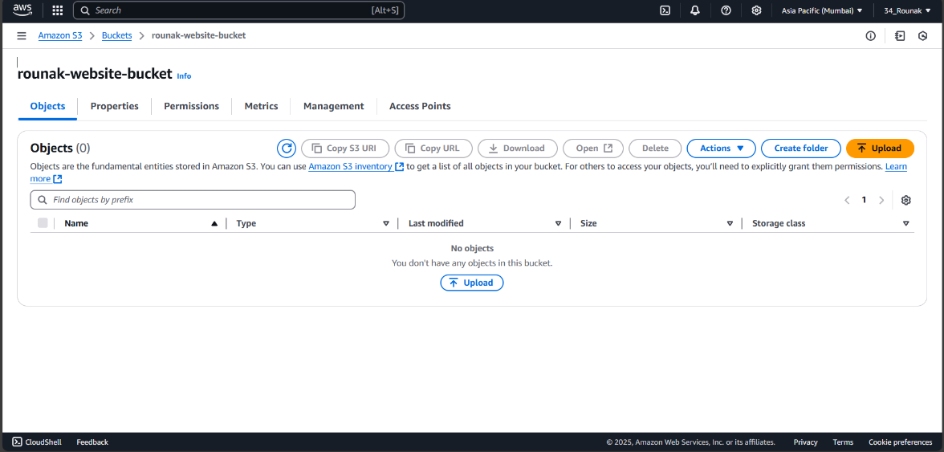

Step 5: Click the “**Upload”** button to begin the process of adding a file to your bucket. In the upload interface, click on “**Add files”**, select the desired file from your computer, and then click “**Upload”** to start the file transfer.

Step 6: With the files selected, click on the **“Actions”** dropdown menu at the top of the file list. From the dropdown, select **“Make public using ACL”**. A confirmation prompt will appear. Confirm the action to change the file permissions.

Step 7: With your bucket open, click on the **“Properties”** tab. Scroll down to **“Static website hosting”**.Click on **“Edit”**. Choose **“Enable”** for static website hosting. In the field for **Index document**, enter the name of your main file (commonly index.html). Optionally, you can also specify an **Error document** (like error.html) if desired. Click on **“Save changes”**.

Step 8: In the **Static website hosting** section, locate and copy the **Bucket website endpoint**.

Step 9: Open a new browser tab, paste the copied URL into the address bar, and hit Enter. Your static website should now display as expected.

