**Assignment number:** 8

**Problem definition:** Deploy a project from a local machine to GitHub and vice versa.

Step 1: Sign in at GitHub. If you don’t have an account, click **Sign Up** and follow the on-screen instructions. Download and install Git.

Step 2: Click the **+** icon (top right, beside your profile picture) and select **Create a new repository**. Enter your desired repository name. Select **Public** and then click **Create repository**. Once created, you’ll be redirected to your repository’s code page. Click the **Code** button and copy the HTTPS clone URL.

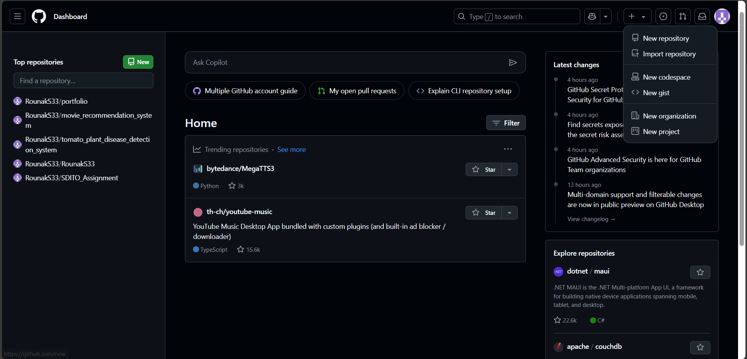

Step 3: Click your profile picture (top right) and select **Settings**. In the left sidebar, click **Developer settings**. Click on the **Personal access tokens** dropdown and choose **Tokens (classic)**. Click **Generate new token** and then select **Generate new token (classic)**. Provide a descriptive note, set the expiration, select all required scopes (or the ones you need) to allow repository access, and click **Generate token**. Copy the generated token and save it securely in a text document. You’ll use this token in place of your GitHub password when pushing code.

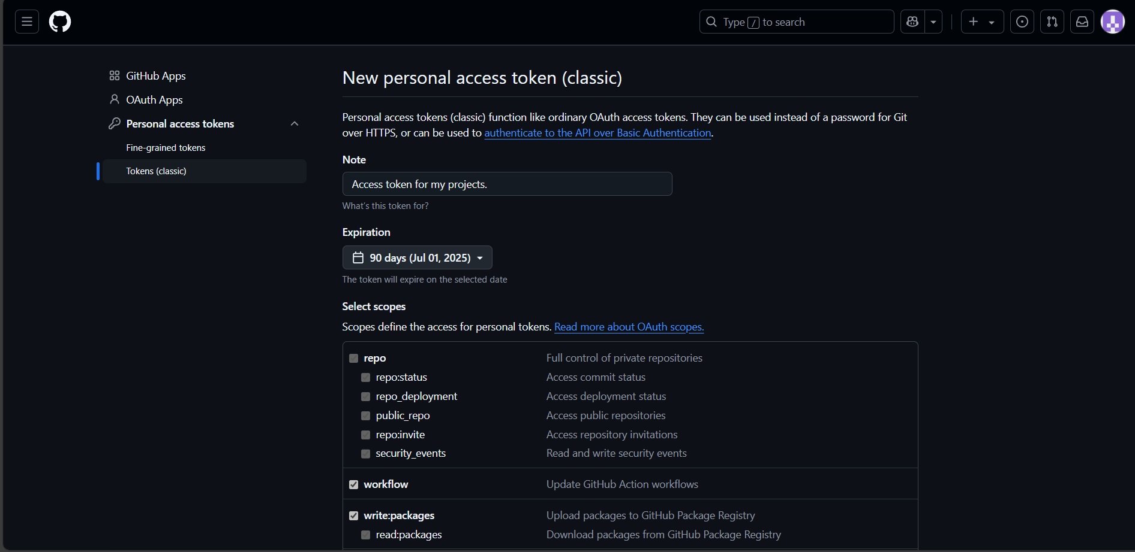

Step 4: Go to **Control Panel** → **User Accounts** → **Credential Manager** → **Windows Credentials**. Under **Generic Credentials**, locate any GitHub-related credentials. Remove them to avoid conflicts with the new token.

Step 5: Navigate to the folder containing your project files. Right-click inside the folder and select **Open Git Bash Here**.

Step 6: Initialize a new Git repository by running **‘git init’**. Configure your Git user details with **‘git config --global user.name "RounakS33@"’** and **‘git config --global user.email "singhrounak927@gmail.com"’**, so that your commits are properly attributed. Stage all your project files for commit by executing **‘git add .’** and then record your changes with a commit message using **‘git commit -m "Initial commit"’**. Link your repository to the corresponding GitHub repository by adding a remote with **‘git remote add origin https://github.com/RounakS33/Rounak_SDITO_A8.git’**. Push your commits to GitHub by running **‘git push -u origin master’**. A **Connect to GitHub** window may pop up. Choose the option to sign in with a token. Paste the Personal Access Token you saved earlier into the token field and sign in.

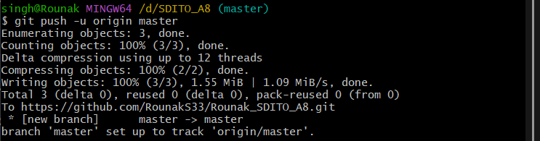

Step 7: Once the push is complete, refresh your GitHub repository page to verify that your files have been successfully added.

Step 8: In your GitHub repository page, click on **Code** and copy the HTTPS clone URL.

Step 9: Create a new folder where you want the repository to be copied. Right-click inside this new folder and select **Open Git Bash Here**. Run the clone command **‘git clone https://github.com/RounakS33/Rounak_SDITO_A8.git’**. The repository will be copied into the new folder.

