**Case Study: Revolutionizing Design in Manufacturing with Generative AI**

**Context**: Clint wants to create a wide array of designs very quickly and choose the best fitted design from the broad spectrum of designs. Traditional design processes was limited by manual ideation and prototyping, resulting in extended development cycles.

**Challenges:**

* Extended periods spent in conceptualizing and prototyping designs.
* Human designers constrained by inherent biases and traditional thinking.
* High costs and material usage in physical prototyping.
* Slower adaptation to evolving market trends and consumer preferences.

**Gain:**

* AI algorithms provide novel design alternatives, pushing beyond human limitations.
* Rapid generation and evaluation of a broader range of designs improves efficiency.
* Decreased reliance on physical prototypes, cutting down material and labor costs.
* CFaster adaptation to market changes through swift design alterations.
* Choosing best design from the wide range of designs.
* Innovation in design creation would lead to product diversification.

**Traditional Design Generation Process**

**Solution Approach:**

* 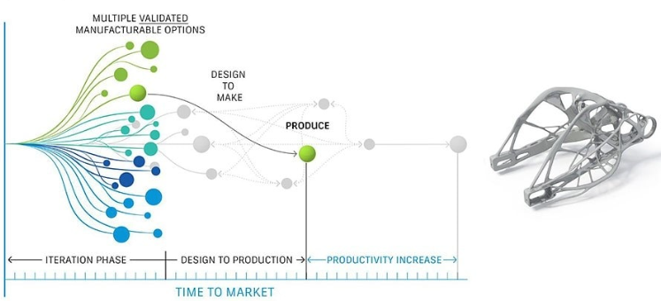Developed prompt based engine capable of generating multiple design concepts.
* Generated synthetic data/testing scenarios for product testing ensuring more robust and comprehensive testing process using Generative AI generated designs.
* Seamlessly incorporated AI into the existing design and production workflows.

Apply Gen AI

**Outcome:**

* Reduction in design phase significantly (>30%)
* Faster process lead to higher product variation.
* Overall reduction in prototyping costs significantly(>20%).
* Faster market entry leading to a increase in market share (15%).

Page 9 : Transformation of product R&D

<https://www.cognizant.com/en_us/industries/documents/generative-ai-in-the-manufacturing-industry.pdf>

<https://pressroom.toyota.com/toyota-research-institute-unveils-new-generative-ai-technique-for-vehicle-design/>

<https://www.maket.ai/post/optimizing-building-performance-with-generative-ai-driven-design-meeting-criteria-and-constraints>

**Case Study:** **Transforming Predictive Maintenance in Manufacturing with Generative AI**

**Context:** In the manufacturing sector, where machinery and equipment are pivotal to operations, the traditional reactive maintenance approach often leads to substantial unplanned downtime and escalated costs. Client wants to reduce business interruption and losses for that. The industry's heavy reliance on mechanical systems necessitates a more efficient and predictive approach to maintenance to ensure continuous, uninterrupted production.

**Challenges:**

* Breakdowns occurring without warning, disrupting production schedules.
* High costs associated with emergency repairs and maintenance.
* Underutilization of machinery due to unplanned maintenance and repairs.
* Premature equipment failure due to lack of optimal maintenance schedules.

**Gain:**

* AI's ability to analyze patterns in historical data to predict equipment failures.
* Proactive maintenance scheduling, minimizing production interruptions.
* Lower overall maintenance costs by avoiding emergency repairs.
* Extended life of machinery through timely maintenance.

**Solution Approach:**

* Collected historical data including images related to machinery breakdown.
* Generated images of equipment with rust, cracks using Generative AI with and that was used to train AI model for prediction
* Continuous monitoring of equipment conditions using sensors and AI to detect early signs of malfunction.
* AI recommendations for maintenance schedules based on predictive analysis.
* Model monitoring and improvement.



**Enterprise Data**

**Embedded Model**

**Langchain**



**LLM**



Azure blob storage/ Azure Data Lake Storage/Cosmos DB

**Outcome**:

* Achieved a significant reduction (30%) in emergency maintenance costs.
* Reduced unplanned downtime by 45%.
* Improved equipment utilization rates by 25%.
* Increased average machinery lifespan by 20%.

<https://eqw.ai/learn-how-we-applied-gan-for-predictive-maintenance-of-wind-turbines/>

<https://www.linkedin.com/pulse/generative-ai-predictive-maintenance-maximizing-efficiency-industrial/>

<https://youtu.be/2ZJJbefrXnE?feature=shared>

**Case Study: Revolutionizing Technical Documentation with Generative AI**

**Context:** The software industry, known for its rapid pace and constant evolution, faces a significant challenge in keeping technical documentation up-to-date. Traditional methods of creating and updating documentation are often time-consuming and struggle to keep pace with the rapid development cycles.

**Challenges**:

* Frequent software updates lead to quickly outdated documentation.
* Significant human resources required for writing and updating manuals.
* Varied writing styles and terminologies across documents.
* Difficulty in scaling documentation efforts parallel to software development.

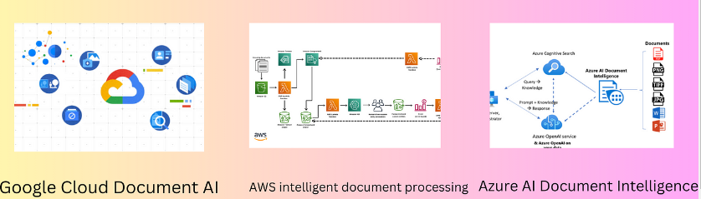

**Solution Approach:**

* Employing AI to automatically generate initial drafts of documentation based on code changes and developer inputs.
* Using Generative AI to maintain a consistent style and terminology across all documents.
* Chatbot has been created to incorporate prompt based user feedback into the AI model to continually improve the relevance and clarity of the documentation.
* Improve model from the historical chat/solution

**Outcome**

* Reduced time spent on documentation by 40%, allowing technical writers to focus on complex documentation tasks.
* Improved consistency in documentation, with a 30% increase in user satisfaction regarding clarity and usefulness.
* Enabled scaling of documentation processes in line with software development, ensuring all updates are documented in real-time.
* Decreased overall cost associated with technical documentation by 25%.

**RAG for technical documentation search from ansul’s document**