# Lorlatinib is a potent, brain-penetrant, third-generation ALK/ROS1 TKI.We performed an analysis of CNS and non-CNS pro-gression in patients with pretreated ALK+ NSCLC.Our results indicate that lorlatinib is active in the treat-ment and prevention of CNS metastases in patients with ALK+ NSCLC, including those who had progressed on crizotinib or second-generation TKIs.

# 研究患者

The full methodology for this ongoing, open-label, single- arm, multicenter phase II tr ial has been published [18]. Eligible patients were aged ≥ 18  years and had histologi- cally or cytologically confirmed metastatic NSCLC with either ALK or ROS1 rear rangement.

# 样本量

Background Lorlatinib is a potent, third-generation ALK/ROS1 tyrosine kinase inhibitor (TKI) designed to penetrate the blood–brain barrier. Objective We report the cumulative incidence of central nervous system (CNS) and non-CNS progression with lorlatinib in patients with ALK-positive non-small-cell lung cancer (NSCLC) previously treated with ALK TKIs. Patients and methods In an ongoing phase II study (NCT01970865), 198 patients with ALK-positive NSCLC with ≥ 1 prior ALK TKI were enrolled into expansion cohor ts (EXP) based on treatment history.

# 基线特征

Table 1 Baseline characteristics

# 试验设计

Background Lorlatinib is a potent, third-generation ALK/ROS1 tyrosine kinase inhibitor (TKI) designed to penetrate the blood–brain barrier. Objective We report the cumulative incidence of central nervous system (CNS) and non-CNS progression with lorlatinib in patients with ALK-positive non-small-cell lung cancer (NSCLC) previously treated with ALK TKIs. Patients and methods In an ongoing phase II study (NCT01970865), 198 patients with ALK-positive NSCLC with ≥ 1 prior ALK TKI were enrolled into expansion cohor ts (EXP) based on treatment history.

# 研究背景

Background Lorlatinib is a potent, third-generation ALK/ROS1 tyrosine kinase inhibitor (TKI) designed to penetrate the blood–brain barrier. Objective We report the cumulative incidence of central nervous system (CNS) and non-CNS progression with lorlatinib in patients with ALK-positive non-small-cell lung cancer (NSCLC) previously treated with ALK TKIs.

# 研究结果

Results Fifty-nine patients received crizotinib as their only prior ALK TKI (EXP2–3A); cumulative incidence rates (CIRs) of CNS and non-CNS progression were both 22% at 12 months in patients with baseline CNS metastases (n = 37), and CIR of non-CNS progression at 12 months was higher versus that for CNS progression in patients without baseline CNS metas- tases [43% vs. 9% (n = 22)].

# 研究结论

Conclusions Lorlatinib showed substantial intracranial activity in patients with pretreated ALK-positive NSCLC, with or without baseline CNS metastases, whose disease progressed on crizotinib or second-generation ALK TKIs.

# 表格及图片陈述

>>>>>>>>>>>>>>>>>>

Patients were enrolled between 15 September 2015, and 3 October 2016. Baseline character istics of the overall phase II popu la t ion (EXP1–6) have been prev ious ly repor ted [18]. In this analysis, we repor t data from the 198 patients w i th ALK-pos i t ive NSCLC who had rece ived ≥ 1 ALK TKI and received ≥ 1 dose of lorlatinib (EXP2–5). Of these pa t ien ts , 59 rece ived cr izot in ib as the ir on ly pr ior ALK TKI (EXP2–3A) and 139 received ≥ 1 pr ior second-gen- eration ALK TKI (EXP3B–5). Baseline CNS metastases (measurable/non-measurable) were present in 37 patients (62.7%) from EXP2–3A and in 94 patients (67.6%) from EXP3B–5. Baseline character istics of the subgroups ana- lyzed are shown in Table 1 and were generally comparable. There were more Asian patients (51.1%)

>>>>>>>>>>>>>>>>>>

Figure  1 shows the cumulative incidences for CNS pro- gression, non-CNS progression, and death with lorlatinib in patients who had received pr ior cr izotinib as their only ALK TKI (EXP2–3A). In patients with baseline CNS metas- tases (n = 37), the cumulative incidence rates (CIRs) of CNS and non-CNS progression were 16% and 11% at 6 months, respectively, and 22% and 22% at 12 months, respectively (Fig. 1a; Table 2)

>>>>>>>>>>>>>>>>>>

. In patients without baseline CNS metas- tases (n = 22), the CIR of non-CNS progression was higher versus that for CNS progression at both 6 months (24% vs. 9%) and 12 months (43% vs. 9%; Fig. 1b and Table 2)

>>>>>>>>>>>>>>>>>>

ve rsus tha t fo r CNS p rog ress ion a t 6   mon ths (25% vs . 14%) and at 12 months (35% vs. 23%; Fig.  2a; Table 2)

>>>>>>>>>>>>>>>>>>

. Patients without baseline CNS metastases (n = 45) also had a higher CIR of non-CNS progression versus that for CNS progression, with CIRs of 37% versus 12% at 6 months and 55% versus 12% at 12 months (Fig. 2b; Table 2)

>>>>>>>>>>>>>>>>>>

metastases at 6 months (27% vs . 15% and 38% vs . 11% , respectively) and at 12 months (37% vs. 23% and 53% vs. 11%, respectively; Supplementary Table A.1)

>>>>>>>>>>>>>>>>>>

Baseline measurable CNS metastases were present in 24 (64.9%) out of 37 patients in EXP2–3A and 57 (60.6%) out of 94 patients in EXP3B–5. In EXP2–3A, intracranial responses were observed in 21 (87.5%, 95% CI 67.6–97.3) of 24 patients (Table 3)

>>>>>>>>>>>>>>>>>>

In EXP2–3A, intracranial responses in ir radiated brain lesions with progression at baseline were observed in four (50.0%; 95% CI 15.7–84.3) of eight patients and median duration of intracranial response was not reached (95% CI 2.8–not estimable; Fig. 4a; Supplementary Table A.2)

>>>>>>>>>>>>>>>>>>

. Of 30 patients in EXP3B–5, 12 (40.0%; 95% CI 22.7–59.4) achieved an intracranial response in irradiated brain lesions with progression at baseline and median duration of intrac- ranial response was 12.4 months (95% CI 11.1–not estima- ble; Fig. 4b; Supplementary Table A.2)

>>>>>>>>>>>>>>>>>>

. Best responses of stable disease in ir radiated brain lesions with progression at baseline were observed in three (37.5%) and ten (33.3%) patients, respectively, with some lasting > 6 months (Fig. 4; Supplementary Table A.2)

>>>>>>>>>>>>>>>>>>

mo s t common t rea tmen t - re la ted AE s [18] . Trea tmen t - re la ted AEs assoc ia ted w i th the CNS (any g rade ) we re repor ted in 71 of 131 patients (54.2%) with baseline CNS metastases and 33 of 67 patients (49.3%) without baseline CNS metastases (Supplementary Table A.3)

# 表格及图片

## 表格

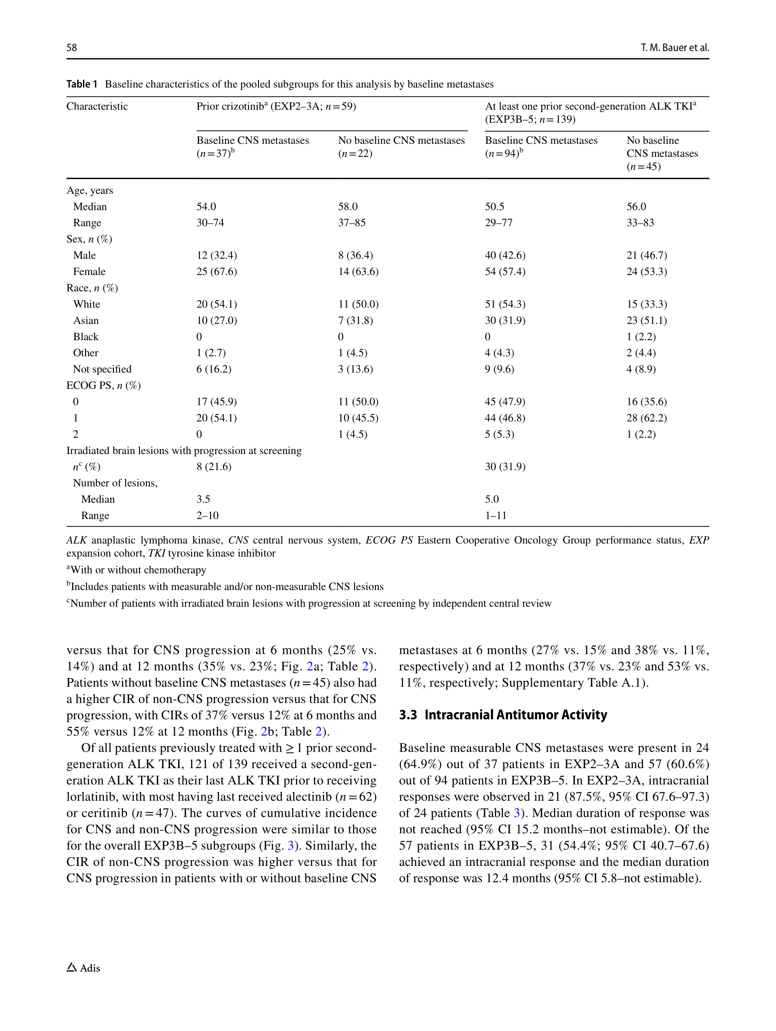

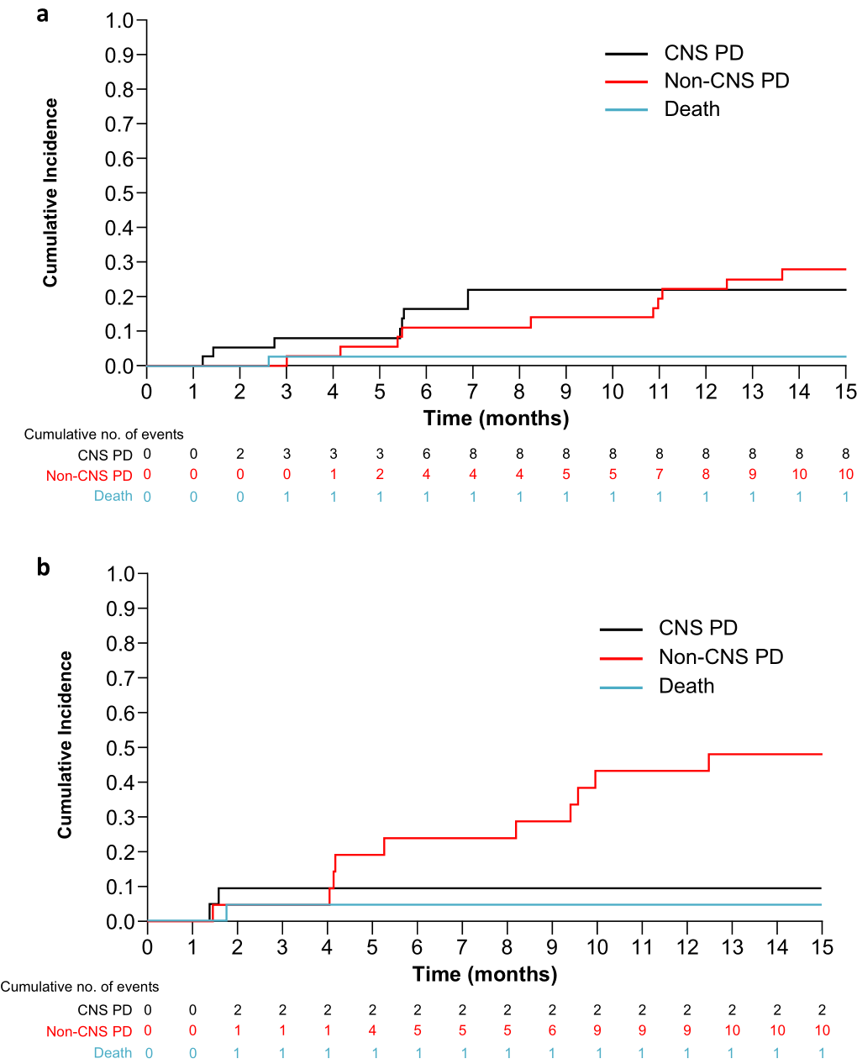

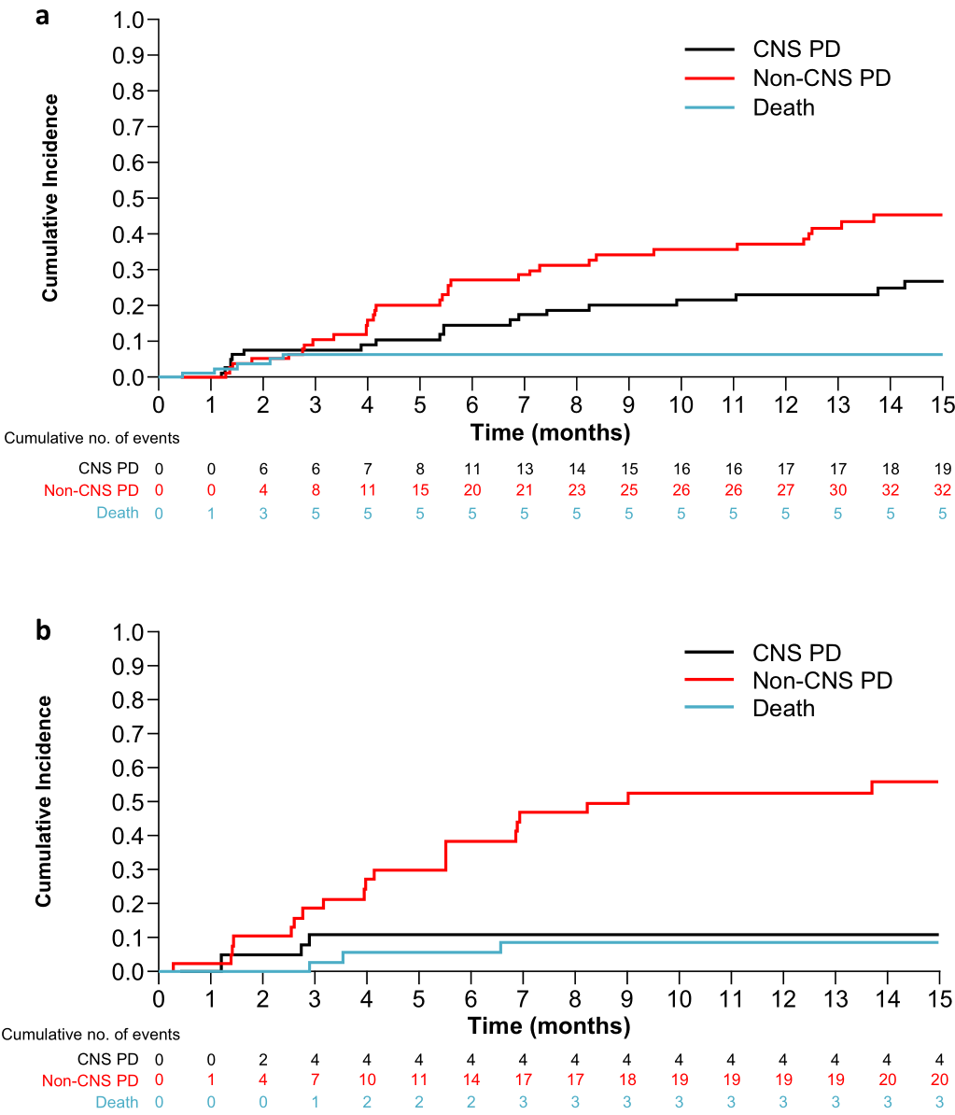

## 图片

