# Durvalumab plus platinum–etoposide versus platinum–etoposide in first-line treatment of extensive-stage small-cell lung cancer (CASPIAN): a randomised, controlled, open-label, phase 3 trial

# 研究患者

Methods This randomised, open-label, phase 3 trial was done at 209 sites across 23 countries. Eligible patients were adults with untreated ES-SCLC, with WHO performance status 0 or 1 and measurable disease as per Response Evaluation Criteria in Solid Tumors, version 1.

# 样本量

Findings Patients were enrolled between March 27, 2017, and May 29, 2018. 268 patients were allocated to the durvalumab plus platinum–etoposide group and 269 to the platinum–etoposide group.

# 基线特征

response. A prespecified subgroup analysis of overall survival was done to establish the consistency of the treatment effect according to predefined baseline characteristics of planned platinum (carboplatin vs cisplatin), age (<65 years vs ≥65 years), sex (women vs men), WHO performance status (0 vs 1), smoking status (smoker vs non-smoker), brain or CNS metastases (yes vs no), disease stage at diagnosis (stage III vs stage IV), race (Asian vs non-Asian), and region (Asia vs Europe vs North and South America).

# 试验设计

publication practice guidelines, was provided by Craig Turner and Samantha Holmes, of Cirrus Communications (Macclesfield, UK), an Ashfield company, and was funded by AstraZeneca. References 1 Oronsky B, Reid TR, Oronsky A, Carter CA. What’s new in SCLC? A review. Neoplasia 2017; 19: 842–47. 2 Wang S, Tang J, Sun T, et al. Survival changes in patients with small cell lung cancer and disparities between different sexes, socioeconomic statuses and ages. Sci Rep 2017; 7: 1339. Byers LA, Rudin CM. Small cell lung cancer: where do we go from here? Cancer 2015; 121: 664–72. Pietanza MC, Byers LA, Minna JD, Rudin CM. Small cell lung cancer: will recent progress lead to improved outcomes? Clin Cancer Res 2015; 21: 2244–55. Früh M, De Ruysscher D, Popat S, Crinò L, Peters S, Felip E. Small-cell lung cancer (SCLC): ESMO clinical practice guidelines for diagnosis, treatment and follow-up. Ann Oncol 2013; 24 (suppl 6): vi99–105. 6 Rudin CM, Ismaila N, Hann CL, et al. Treatment of small-cell lung cancer: American Society of Clinical Oncology endorsement of the American College of Chest Physicians guideline. J Clin Oncol 2015; 33: 4106–11. Japan Lung Cancer Society. Lung cancer clinical practice guidelines 2018 version III. Small cell lung cancer (in Japanese). https://www. haigan.gr.jp/guideline/2018/1/3/180103020100.html (accessed Aug 2, 2019). Farago AF, Keane FK. Current standards for clinical management of small cell lung cancer. Transl Lung Cancer Res 2018; 7: 69–79. Fukuoka M, Furuse K, Saijo N, et al. Randomized trial of cyclophosphamide, doxorubicin, and vincristine versus cisplatin and etoposide versus alternation of these regimens in small-cell lung cancer. J Natl Cancer Inst 1991; 83: 855–61. 10 Rossi A, Di Maio M, Chiodini P, et al. Carboplatin- or cisplatin-based chemotherapy in first-line treatment of small-cell lung cancer: the COCIS meta-analysis of individual patient data. J Clin Oncol 2012; 30: 1692–98. 11 Horita N, Yamamoto M, Sato T, et al. Topotecan for relapsed small-cell lung cancer: systematic review and meta-analysis of 1347 patients. Sci Rep 2015; 5: 15437. 12 Horn L, Mansfield AS, Szczęsna A, et al. First-line atezolizumab plus chemotherapy in extensive-stage small-cell lung cancer. N Engl J Med 2018; 379: 2220–29. 13 Stewart R, Morrow M, Hammond SA, et al. Identification and characterization of MEDI4736, an antagonistic anti-PD-L1 monoclonal antibody. Cancer Immunol Res 2015; 3: 1052–62. 14 AstraZeneca. Imfinzi (durvalumab) prescribing information. August, 2019. https://www.azpicentral.com/imfinzi/imfinzi. pdf#page=1 (accessed Aug 2, 2019). 15 AstraZeneca. Imfinzi (durvalumab) summary of product characteristics. September, 2018. https://www.medicines.org.uk/ emc/product/9495/smpc (accessed Aug 2, 2019). 16 Antonia SJ, Villegas A, Daniel D, et al. Durvalumab after chemoradiotherapy in stage III non-small-cell lung cancer. N Engl J Med 2017; 377: 1919–29. 17 Antonia SJ, Villegas A, Daniel D, et al. Overall survival with durvalumab after chemoradiotherapy in stage III NSCLC. N Engl J Med 2018; 379: 2342–50. 18 Cho DC, Mahipal A, Dowlati A, et al. Safety and clinical activity of durvalumab in combination with tremelimumab in extensive disease small-cell lung cancer (ED-SCLC). Proc Am Soc Clin Oncol 2018; 36 (suppl): abstr 8517. 19 Goldman JW, Dowlati A, Antonia SJ, et al. Safety and antitumor activity of durvalumab monotherapy in patients with pretreated extensive disease small-cell lung cancer (ED-SCLC). Proc Am Soc Clin Oncol 2018; 36 (suppl): abstr 8518. 20 Bondarenko I, Juan-Vidal O, Pajkos G, et al. Preliminary efficacy of durvalumab plus tremelimumab in platinum-refractory/resistant ED-SCLC from arm A of the phase II BALTIC study.

# 研究背景

Background Most patients with small-cell lung cancer (SCLC) have extensive-stage disease at presentation, and prognosis remains poor. Recently, immunotherapy has demonstrated clinical activity in extensive-stage SCLC (ES-SCLC).

# 研究结果

results for the durvalumab plus platinum– etoposide group versus the platinum–etoposide group from a planned interim analysis. Safety was assessed in all patients who received at least one dose of their assigned study treatment.

# 研究结论

conclusions. In conclusion, this randomised, open-label, phase 3 trial demonstrated that the addition of durvalumab to platinum–etoposide as first-line treatment for ES-SCLC resulted in significantly longer overall survival than with a control group reflective of current clinical practice worldwide.

# 表格及图片陈述

>>>>>>>>>>>>>>>>>>

disease characteristics were well balanced between the durvalumab plus platinum–etoposide and platinum– etoposide groups (table 1)

>>>>>>>>>>>>>>>>>>

>>>>>>>>>>>>>>>>>>

Articles Three patients in each group did not receive at least one dose of study treatment. Of the 531 patients who did receive treatment, 416 (78%) received carboplatin and 132 (25%) received cisplatin. In the durvalumab plus platinum–etoposide group, the median number of durvalumab doses received was 7 (IQR 6–11); 64 (24%) of 265 treated patients received 12 or more doses (table 2)

>>>>>>>>>>>>>>>>>>

>>>>>>>>>>>>>>>>>>

. In the durvalumab plus platinum–etoposide group, 230 patients (87%) received the planned maxi- mum of four cycles of platinum–etoposide. In the platinum–etoposide group, 225 (85%) of 266 treated patients received at least four cycles of platinum– etoposide, and 151 patients (57%) received the maximum six cycles (table 2)

>>>>>>>>>>>>>>>>>>

>>>>>>>>>>>>>>>>>>

response, the estimated percentage remaining in response at 12 months was higher with durvalumab plus platinum– etoposide than with platinum–etoposide. Adverse events of any cause and grade occurred in 260 (98%) of 265 patients treated with durvalumab plus platinum–etoposide and 258 (97%) of 266 patients treated with platinum–etoposide (table 4)

>>>>>>>>>>>>>>>>>>

>>>>>>>>>>>>>>>>>>

. Grade 3 or 4 adverse events occurred in 163 (62%) patients in the durvalumab plus platinum–etoposide group and 166 (62%) patients in the platinum–etoposide group and adverse events leading to discontinuation occurred in 25 (9%) patients in each group. The most common grade 3 or 4 adverse events were neutropenia and anaemia. Deaths due to adverse events of any cause occurred in 13 (5%) patients in the durvalumab plus platinum–etoposide group and 15 (6%) patients in the platinum–etoposide group (table 4)

>>>>>>>>>>>>>>>>>>

>>>>>>>>>>>>>>>>>>

Articles Three patients in each group did not receive at least one dose of study treatment. Of the 531 patients who did receive treatment, 416 (78%) received carboplatin and 132 (25%) received cisplatin. In the durvalumab plus platinum–etoposide group, the median number of durvalumab doses received was 7 (IQR 6–11); 64 (24%) of 265 treated patients received 12 or more doses (table 2). In the durvalumab plus platinum–etoposide group, 230 patients (87%) received the planned maxi- mum of four cycles of platinum–etoposide. In the platinum–etoposide group, 225 (85%) of 266 treated patients received at least four cycles of platinum– etoposide, and 151 patients (57%) received the maximum six cycles (table 2). As of March 11, 2019 (data cutoff), 43 patients in the durvalumab plus platinum–etoposide group and none in the platinum–etoposide group remained on study treatment. 113 (42%) of 268 patients in the durvalumab plus platinum–etoposide group and 119 (44%) of 269 in the platinum–etoposide group received at least one subsequent systemic anti- cancer therapy, with nearly all receiving chemotherapy; a small proportion of patients received subsequent immuno therapy (five [2%] in the durvalumab plus platinum–etoposide group and 14 [5%] in the platinum– etoposide group; appendix p 13). 21 (8%) of 269 patients in the platinum–etoposide group received PCI after chemotherapy. At data cutoff, the median duration of follow-up for overall survival in censored patients was 14·2 months (IQR 11·7–17·0). There were 336 deaths across the durvalumab plus platinum–etoposide and platinum– etoposide groups (62·6% maturity); 155 (58%) patients had died in the durvalumab plus platinum–etoposide group and 181 (67%) had died in the platinum–etoposide group. The multiplicity-adjusted, two-sided α spent at this interim analysis was 1·78% (ie, a p value less than 0·0178 was considered statistically significant). Overall survival was significantly longer in the durvalumab plus platinum–etoposide group than the platinum–etoposide group, with an HR of 0·73 (95% CI 0·59–0·91; p=0·0047; figure 2A). Median overall survival was 13·0 months (95% CI 11·5–14·8) with durvalumab plus platinum– etoposide versus 10·3 months (9·3–11·2) with platinum– etoposide; the post-hoc 12-month overall survival rates were 54% (47·4–59·5) versus 40% (33·7–45·8); and the prespecified 18-month overall survival rates were 34% (26·9–41·0) versus 25% (18·4–31·6). The overall survival benefit with durvalumab plus platinum–etoposide was consistently observed across prespecified patient subgroups defined by baseline clinical and demographic characteristics (figure 2B)

>>>>>>>>>>>>>>>>>>

>>>>>>>>>>>>>>>>>>

Early censoring (>10 weeks before data cutoff) occurred in two (1%) of 268 patients for durvalumab plus platinum– etoposide compared with eight (3%) of 269 patients for platinum–etoposide. Most of these cases (nine of ten) were because of withdrawal of consent. At the time of data cutoff, 226 (84%) of 268 patients in the durvalumab plus platinum–etoposide group and 233 (87%) of 269 patients in the platinum–etoposide group had disease progression or died. Although progression-free survival could not be tested for sig- nificance within the multiple-testing procedure at the time of the interim analysis because of the design of the study, an HR of 0·78 (95% CI 0·65–0·94) for the comparison was recorded (figure 2C)

>>>>>>>>>>>>>>>>>>

# 表格及图片

## 表格

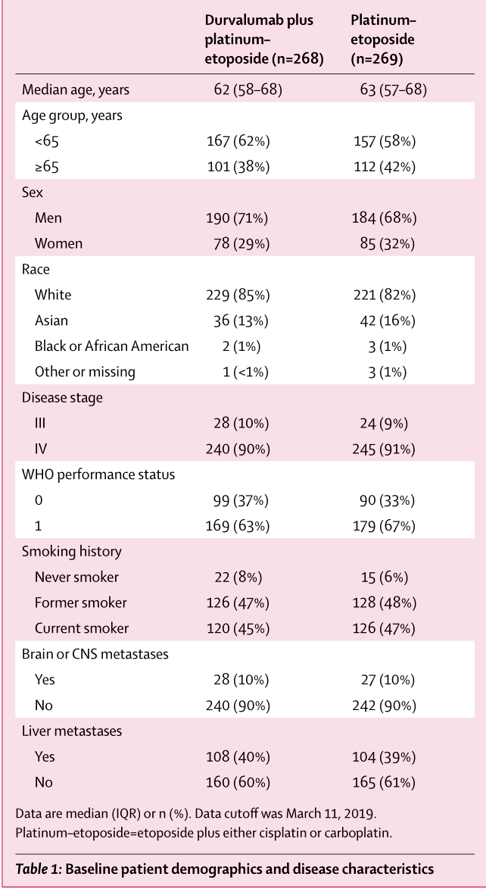

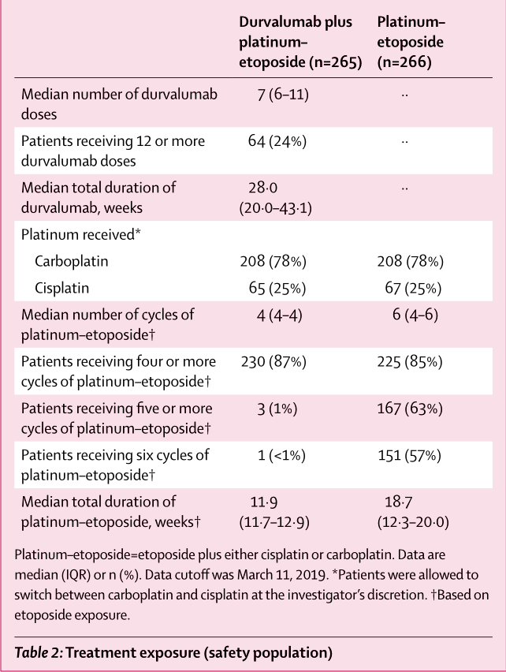

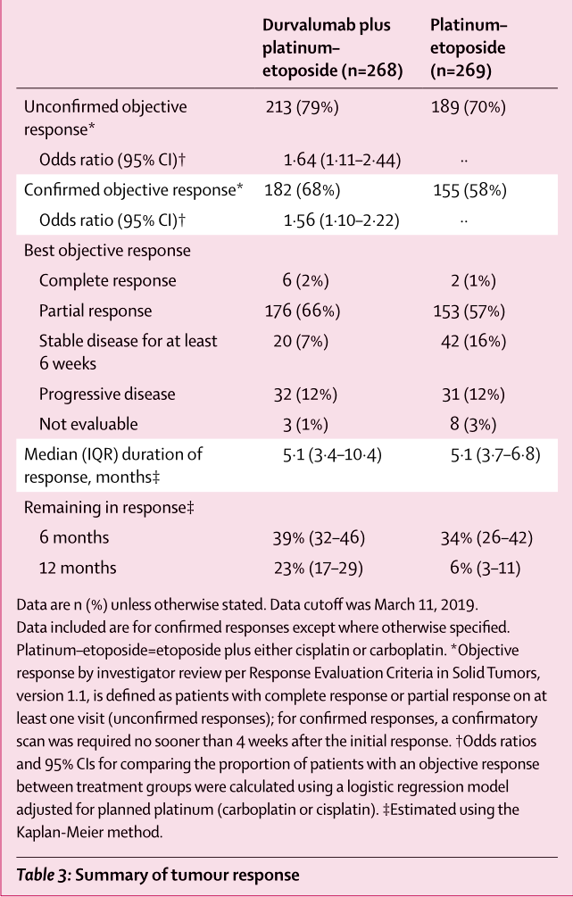

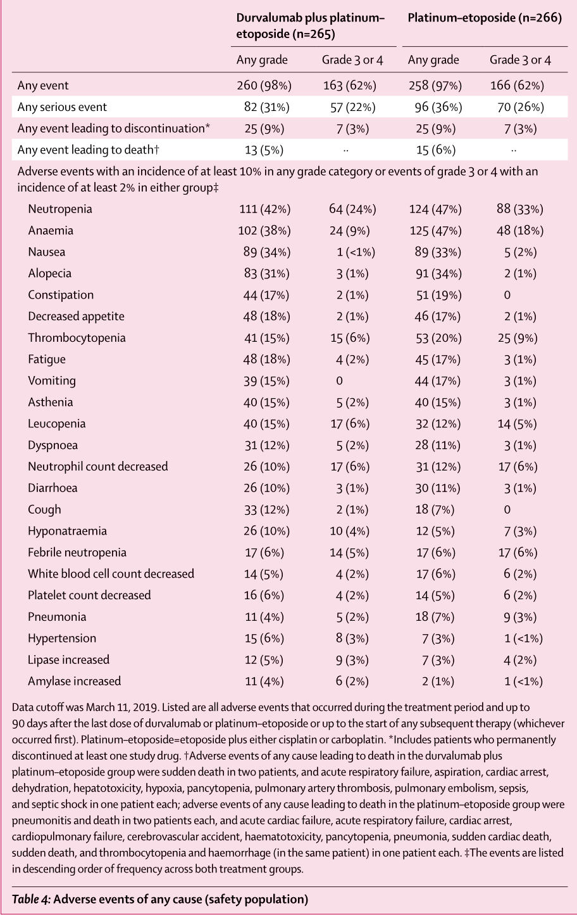

## 图片

