# Atezolizumab for First-Line Treatment of Metastatic Nonsquamous NSCLC

# 研究患者

Pat ients were eligible for inclusion in the study if they had stage IV or recurrent metastat ic non- squamous NSCLC (classif ied according to cri- teria for measurable disease in Response Eva l- uat ion Criteria in Solid Tumors, version 1.

# 样本量

In the WT population, 356 patients were assigned to the ABCP group, and 336 to the BCP group.

# 基线特征

Table 1. Baseline Characteristics of All Enrolled Patients (Intention-to-Treat Population).

# 试验设计

8. Rit tmeyer A, Barlesi F, Waterkamp D, et al. Atezolizumab versus docetaxel in pa- t ients with previously t reated non-sma ll- cell lung cancer (OAK): a phase 3, open- label, mult icent re randomised cont rolled t ria l. Lancet 2017; 389: 255-65. 9. Liu SV, Camidge DR, Get t inger SN, et a l. Atezolizumab (atezo) plus plat inum- based chemotherapy (chemo) in non-small cell lung cancer (NSCLC): update from a phase Ib study.

# 研究背景

BACKGROUND  
The cancer-cell–killing property of atezolizumab may be enhanced by the blockade of vascular endothelial growth factor–mediated immunosuppression with bevacizumab. This open-label, phase 3 study evaluated atezolizumab plus bevacizumab plus chemo- therapy in patients with metastatic nonsquamous non–small-cell lung cancer (NSCLC) who had not previously received chemotherapy.

# 研究结果

RESULTS  
In the WT population, 356 patients were assigned to the ABCP group, and 336 to the BCP group. The median progression-free survival was longer in the ABCP group than in the BCP group (8.3 months vs.

# 研究结论

CONCLUSIONS  
The addition of atezolizumab to bevacizumab plus chemotherapy signif icantly improved progression-free survival and overall survival among patients with metastatic nonsqua- mous NSCLC, regardless of PD-L1 expression and EGFR or ALK genetic alteration status.

# 表格及图片陈述

>>>>>>>>>>>>>>>>>>

In this internat ional, open-label, phase 3 study, patients were randomly assigned, in a 1:1:1 ratio, to receive atezolizumab plus carboplat in plus paclitaxel (ACP group), atezolizumab plus beva- cizumab plus carboplat in plus paclitaxel (ABCP group), or bevacizumab plus carboplat in plus paclitaxel (BCP group). Randomization was strat- if ied according to sex, presence or absence of liver metastases at baseline, and PD-L1 tumor expression (as assessed by immunohistochemi- cal analysis). PD-L1 expression on tumor cells or tumor-inf ilt rat ing immune cells was ana lyzed in archival or freshly collected tumor t issue (or both) and scored as described previously (Table S1 in the Supplementar y Appendix, available at NEJM.org)

>>>>>>>>>>>>>>>>>>

From March 2015 through December 2016, a total of 1202 pat ients (intent ion-to-treat popula- t ion) were enrolled at 240 sites in 26 countries and were randomly assigned to the ACP group (402 pat ients), the ABCP group (400 pat ients), or the BCP group (400 pat ients) (Fig. 1). The WT populat ion comprised 1040 of these pat ients (86.5%): 348 in the ACP group, 356 in the ABCP group, and 336 in the BCP group. Tef f gene- signature expression could be evaluated in 95.6% of the pat ients in the WT populat ion. A total of 445 of the 1040 pat ients in the WT populat ion (42.8%) had high Tef f gene-signature expression (Teff-high WT population): 161 in the ACP group, 155 in the ABCP group, and 129 in the BCP group. Baseline characterist ics were genera lly ba l- anced between the ABCP group and the BCP group in the intent ion-to-t reat populat ion as a whole (Table 1)

>>>>>>>>>>>>>>>>>>

In the WT populat ion, the rate of invest igator- assessed unconf irmed object ive response (data cutof f, September 15, 2017) was 63.5% in the ABCP group and 48.0% in the BCP group; 3.7% of the pat ients in the ABCP group had complete responses, as compared with 1.2% of the pa- t ients in the BCP group. The results were similar in the Tef f-high WT populat ion (Table 2)

>>>>>>>>>>>>>>>>>>

5.7 months in the BCP group; in the Tef f-high WT populat ion, the median durat ion of re- sponse was 11.2 months in the ABCP group and 5.7 months in the BCP group (Table 2)

>>>>>>>>>>>>>>>>>>

Adverse events related to any treatment (as determined by the investigator) occurred in 94.4% of the pat ients in the ABCP group and in 95.4% of the pat ients in the BCP group (Table 3)

>>>>>>>>>>>>>>>>>>

in the BCP group (Table 3)

>>>>>>>>>>>>>>>>>>

In this internat ional, open-label, phase 3 study, patients were randomly assigned, in a 1:1:1 ratio, to receive atezolizumab plus carboplat in plus paclitaxel (ACP group), atezolizumab plus beva- cizumab plus carboplat in plus paclitaxel (ABCP group), or bevacizumab plus carboplat in plus paclitaxel (BCP group). Randomization was strat- if ied according to sex, presence or absence of liver metastases at baseline, and PD-L1 tumor expression (as assessed by immunohistochemi- cal analysis). PD-L1 expression on tumor cells or tumor-inf ilt rat ing immune cells was ana lyzed in archival or freshly collected tumor t issue (or both) and scored as described previously (Table S1 in the Supplementar y Appendix, available at NEJM.org)

>>>>>>>>>>>>>>>>>>

From March 2015 through December 2016, a total of 1202 pat ients (intent ion-to-treat popula- t ion) were enrolled at 240 sites in 26 countries and were randomly assigned to the ACP group (402 pat ients), the ABCP group (400 pat ients), or the BCP group (400 pat ients) (Fig. 1). The WT populat ion comprised 1040 of these pat ients (86.5%): 348 in the ACP group, 356 in the ABCP group, and 336 in the BCP group. Tef f gene- signature expression could be evaluated in 95.6% of the pat ients in the WT populat ion. A total of 445 of the 1040 pat ients in the WT populat ion (42.8%) had high Tef f gene-signature expression (Teff-high WT population): 161 in the ACP group, 155 in the ABCP group, and 129 in the BCP group. Baseline characterist ics were genera lly ba l- anced between the ABCP group and the BCP group in the intent ion-to-t reat populat ion as a whole (Table 1)

>>>>>>>>>>>>>>>>>>

In the WT populat ion, the rate of invest igator- assessed unconf irmed object ive response (data cutof f, September 15, 2017) was 63.5% in the ABCP group and 48.0% in the BCP group; 3.7% of the pat ients in the ABCP group had complete responses, as compared with 1.2% of the pa- t ients in the BCP group. The results were similar in the Tef f-high WT populat ion (Table 2)

>>>>>>>>>>>>>>>>>>

5.7 months in the BCP group; in the Tef f-high WT populat ion, the median durat ion of re- sponse was 11.2 months in the ABCP group and 5.7 months in the BCP group (Table 2)

>>>>>>>>>>>>>>>>>>

Adverse events related to any treatment (as determined by the investigator) occurred in 94.4% of the pat ients in the ABCP group and in 95.4% of the pat ients in the BCP group (Table 3)

>>>>>>>>>>>>>>>>>>

in the BCP group (Table 3)

# 表格及图片

## 表格

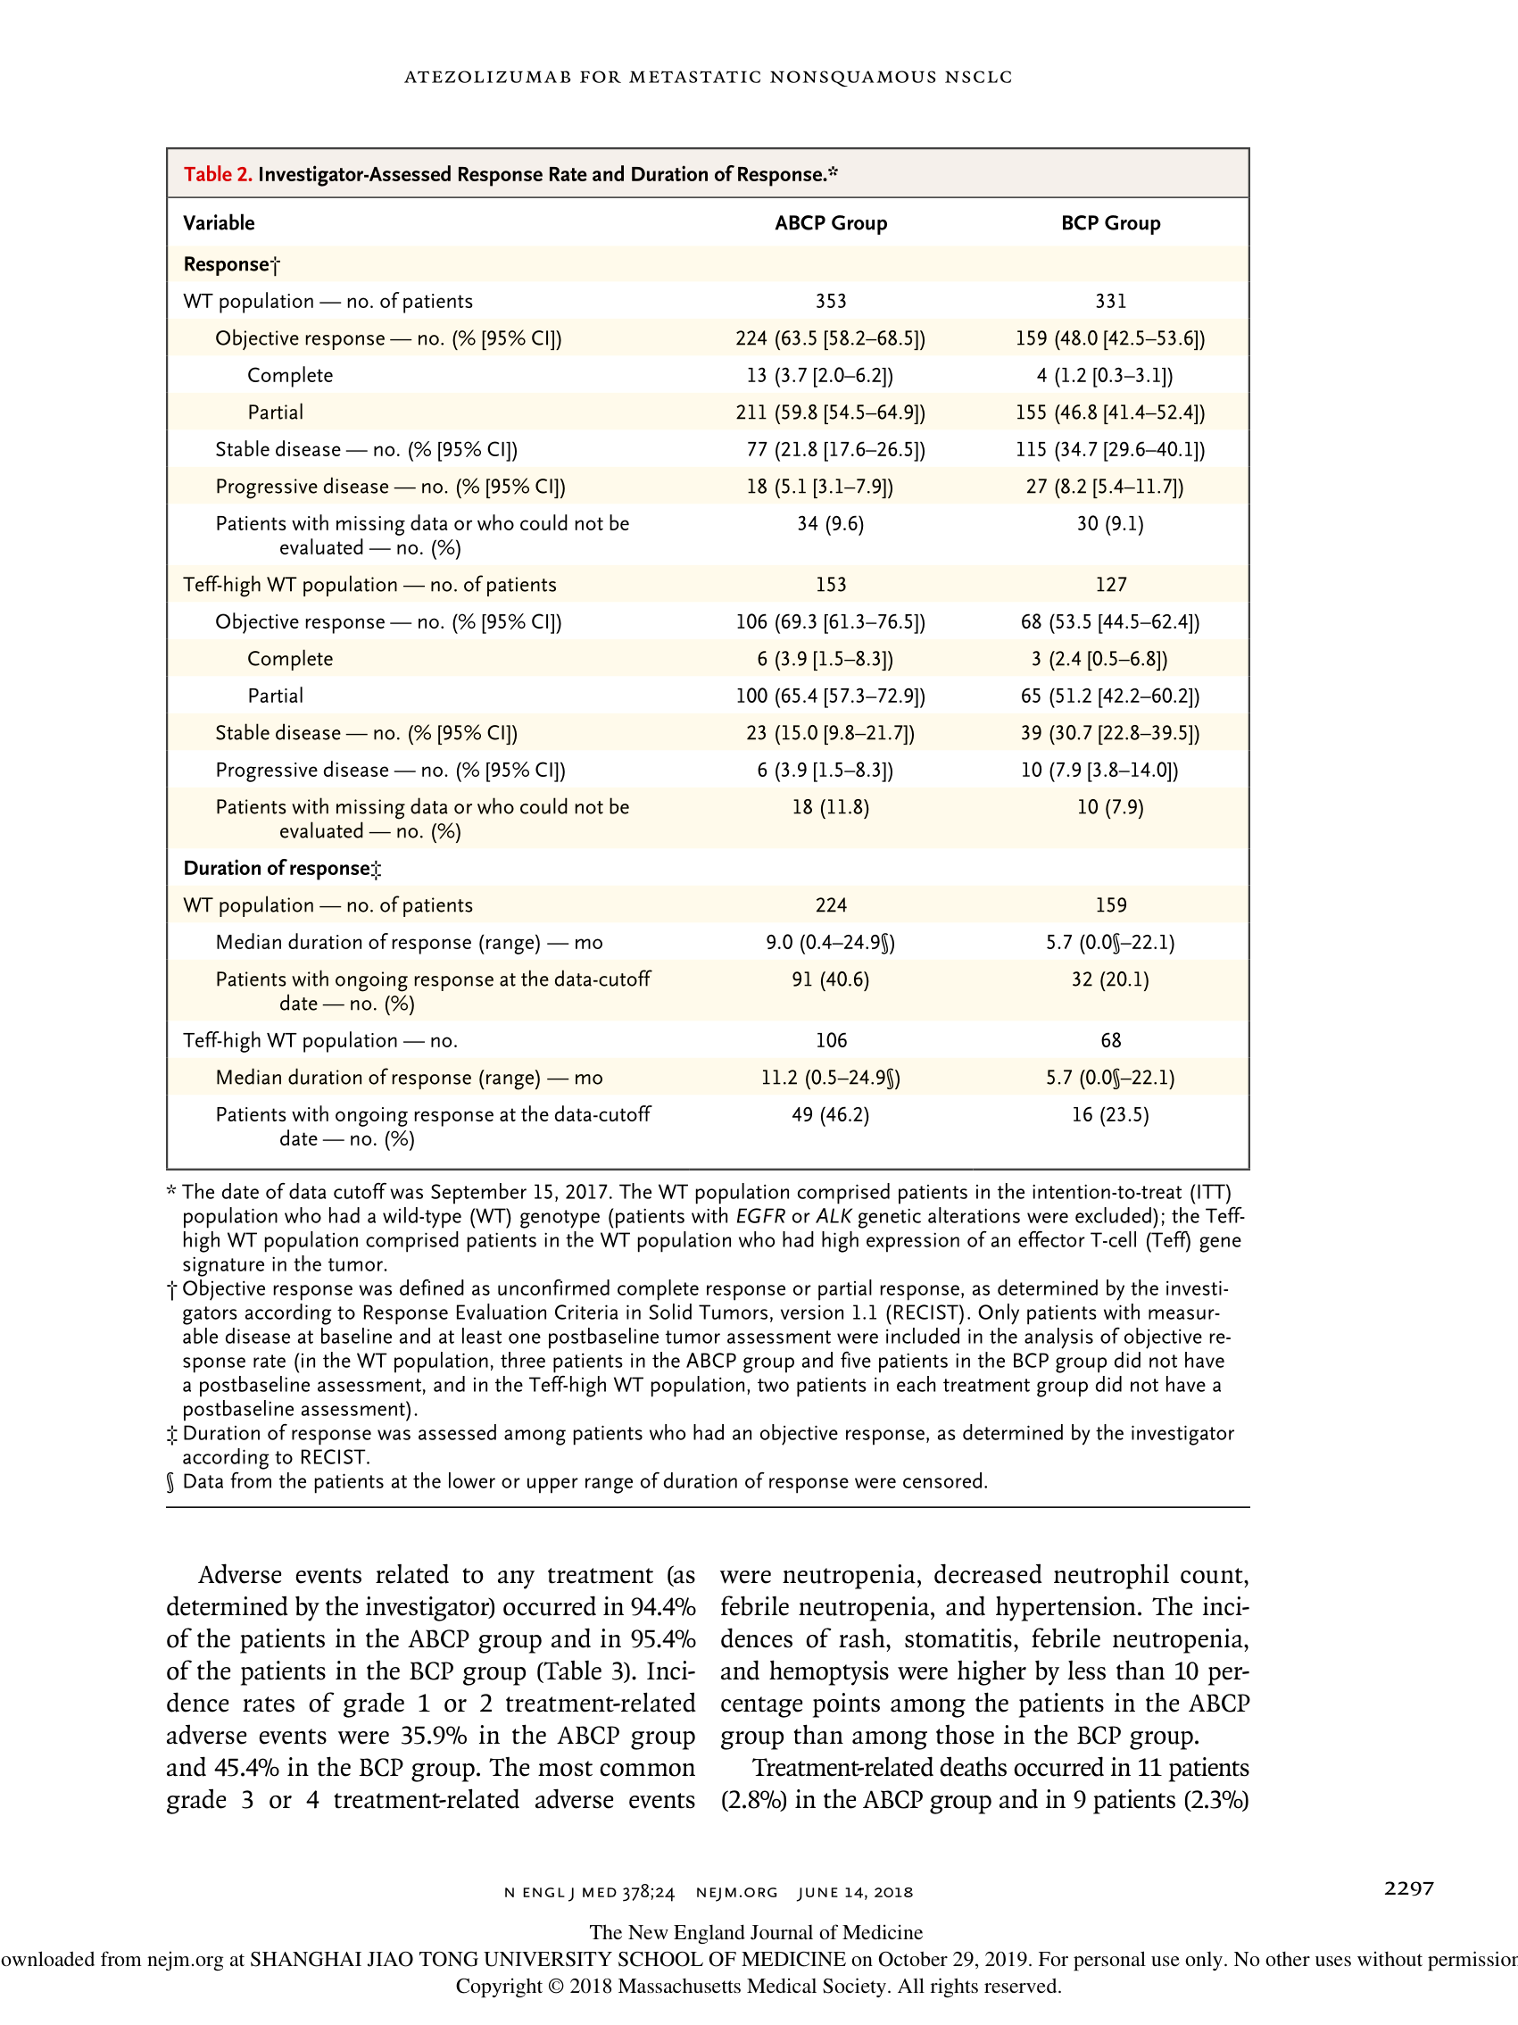

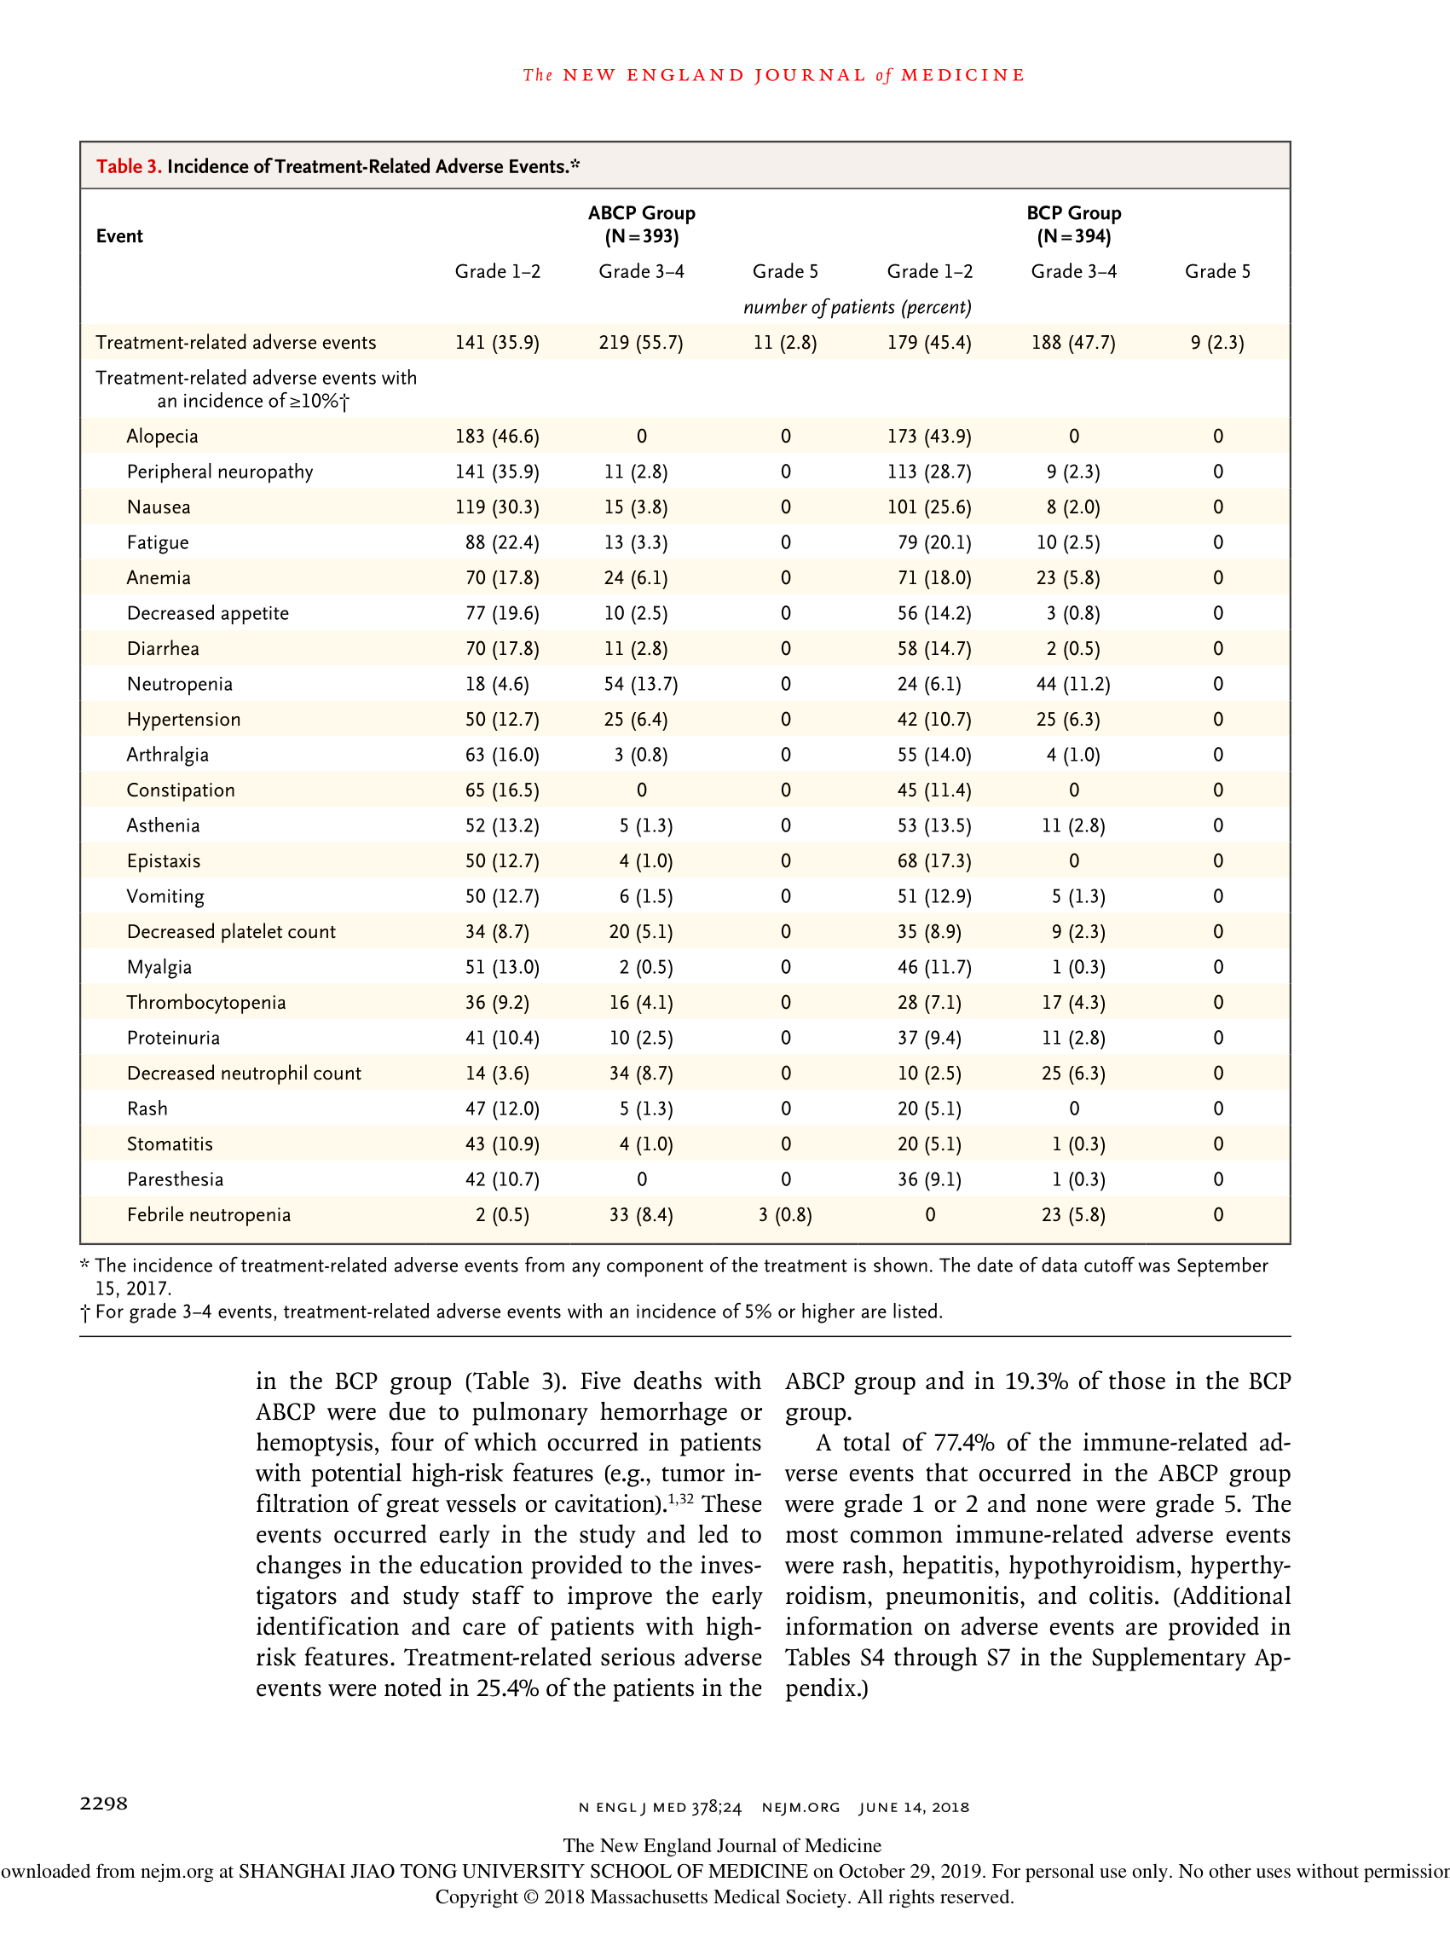

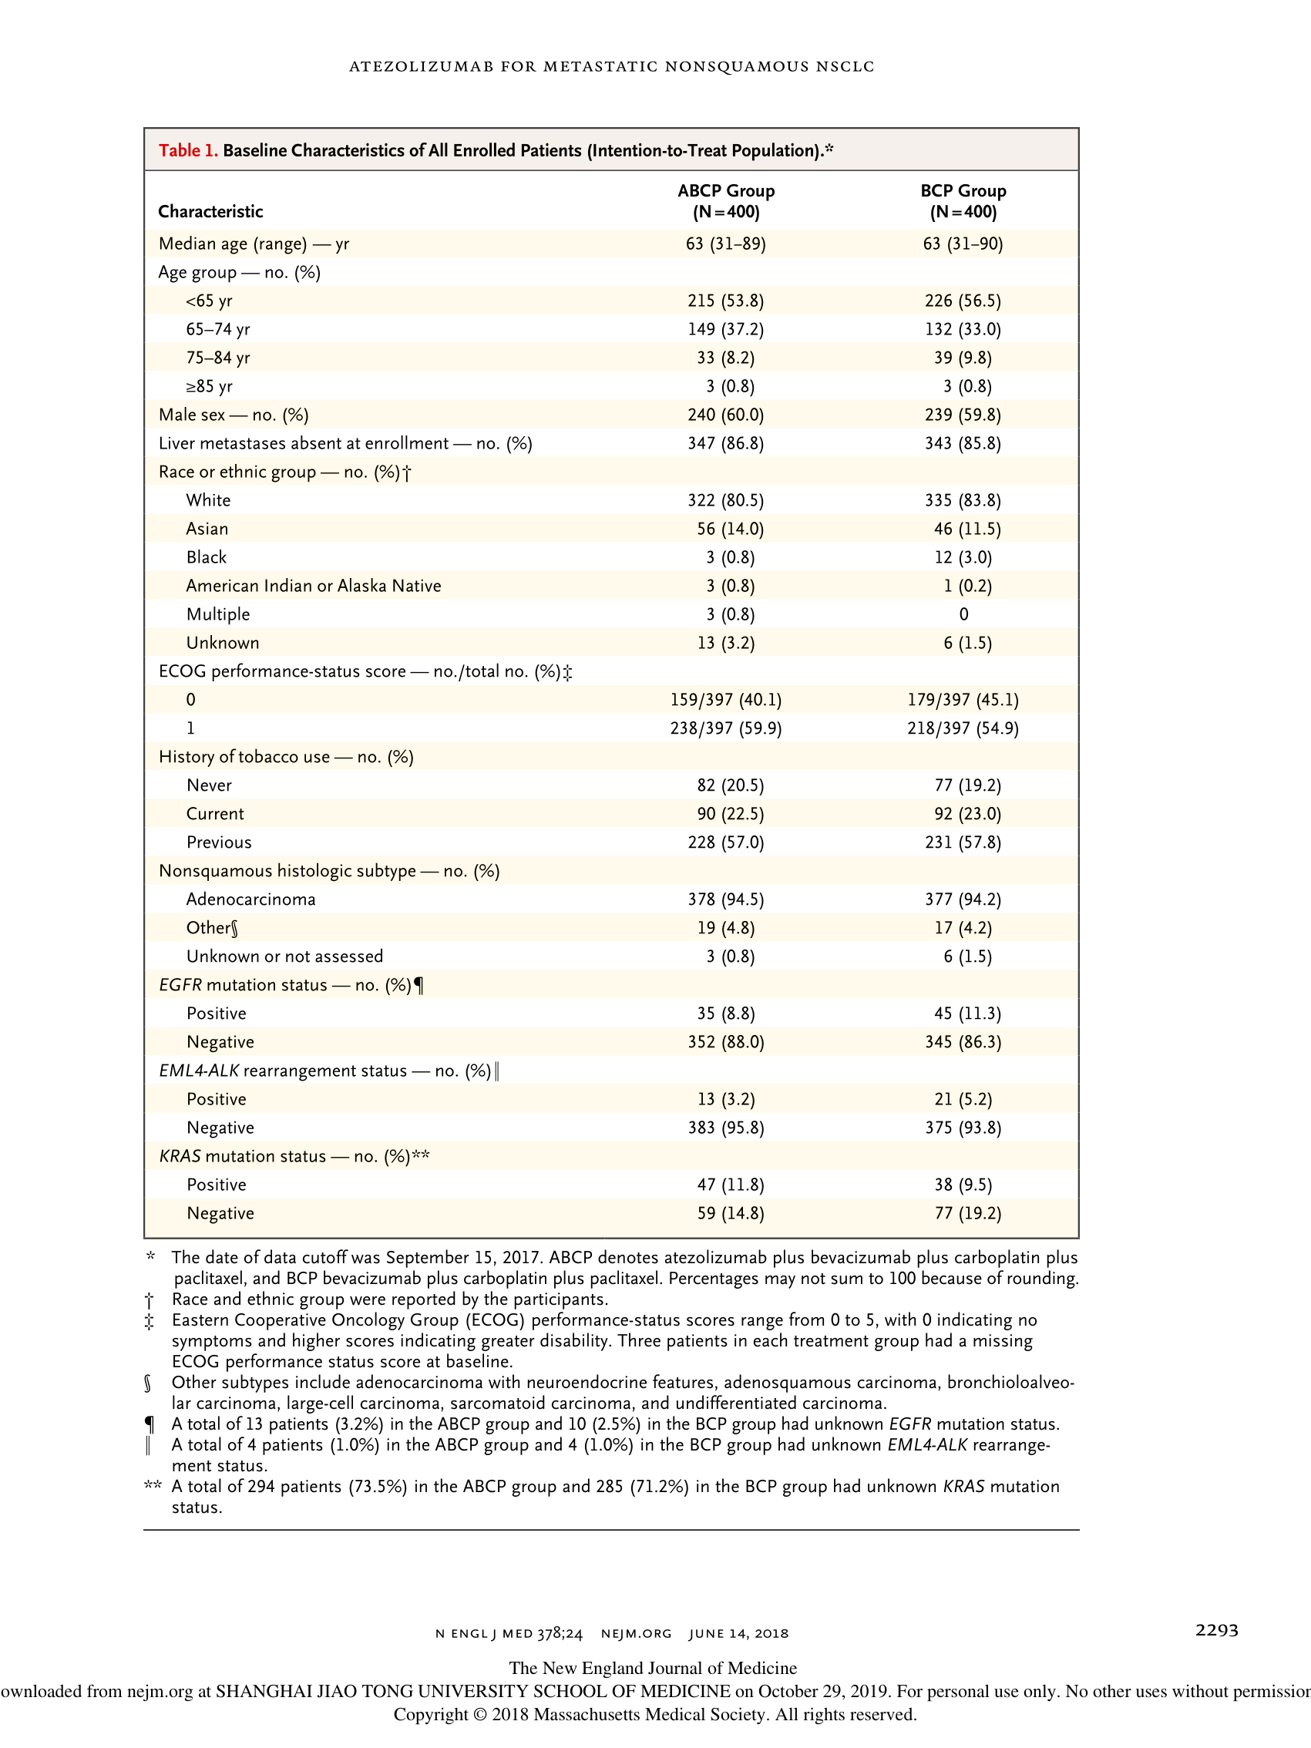

## 图片

