# Pembrolizumab versus Chemotherapy for PD-L1–Positive Non–Small-Cell Lung Cancer

# 研究患者

>>>>>>>>>>>>>>>>>>>>>>>>  
In this open-label, phase 3 trial, we randomly assigned 305 patients who had previously untreated advanced NSCLC with PD-L1 expression on at least 50% of tumor cells and no sensit izing mutat ion of the epidermal growth factor receptor gene or translocat ion of the anaplast ic lymphoma kinase gene to receive either pembrolizumab (at a f ixed dose of 200 mg every 3 weeks) or the investigator’s choice of platinum-based chemotherapy.  
>>>>>>>>>>>>>>>>>>>>>>>>
>>>>>>>>>>>>>>>>>>>>>>>>  
In patients with advanced NSCLC and PD-L1 expression on at least 50% of tumor cells, pembrolizumab was associated with signif icantly longer progression-free and overall survival and with fewer adverse events than was platinum-based chemotherapy.  
>>>>>>>>>>>>>>>>>>>>>>>>

# 样本量

In this open-label, phase 3 trial, we randomly assigned 305 patients who had previously untreated advanced NSCLC with PD-L1 expression on at least 50% of tumor cells and no sensit izing mutat ion of the epidermal growth factor receptor gene or translocat ion of the anaplast ic lymphoma kinase gene to receive either pembrolizumab (at a f ixed dose of 200 mg every 3 weeks) or the investigator’s choice of platinum-based chemotherapy.

# 基线特征

Table 1. Baseline Demographic and Disease Characteristics of Patients in the Intention-to-Treat Population.

# 试验设计

Pembrolizumab in pat ients with advanced t r iple-negat ive breast cancer: phase Ib KEYNOTE-012 study.

# 研究背景

No Match

# 研究结果

RESULTS  
Median progression-free survival was 10.3 months (95% conf idence interval [CI], 6.7 to not reached) in the pembrolizumab group versus 6.0 months (95% CI, 4.2 to 6.2) in the chemotherapy group (hazard ratio for disease progression or death, 0.50; 95% CI, 0.37 to 0.68; P<0.001).

# 研究结论

CONCLUSIONS  
In patients with advanced NSCLC and PD-L1 expression on at least 50% of tumor cells, pembrolizumab was associated with signif icantly longer progression-free and overall survival and with fewer adverse events than was platinum-based chemotherapy.

# 表格及图片

## 表格

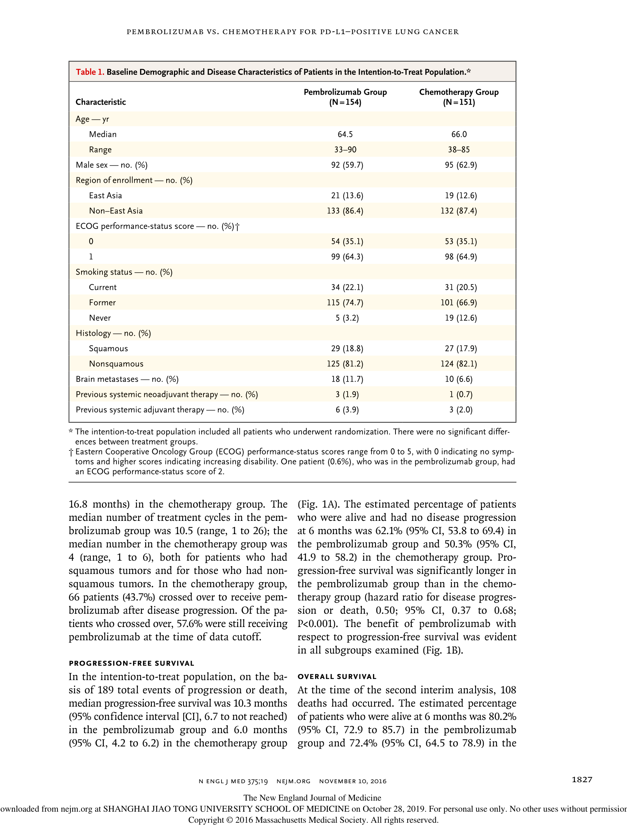

Pat ients were randomly assigned, in a 1:1 rat io, to receive treatment with either pembrolizumab (administered intravenously at a dose of 200 mg ever y 3 weeks) for 35 cycles or the invest igator’s choice of one of the following f ive plat inum- based chemotherapy regimens for 4 to 6 cycles: carboplatin plus pemetrexed, cisplatin plus peme- t rexed, carboplat in plus gemcitabine, cisplat in plus gemcitabine, or carboplat in plus paclitaxel (Table S1 in the Supplementar y Appendix, avail- able with the full text of this article at NEJM.org)

>>>>>>>>>>>>>>>>>>

A total of 1934 pat ients at 142 sites in 16 coun- t ries were screened for enrollment, including 1729 who submitted samples for PD-L1 assess- ment (Fig. S1 in the Supplementar y Appendix). Of the 1653 pat ients whose samples could be evaluated for PD-L1, 500 (30.2%) had a PD-L1 tumor proport ion score of 50% or greater. Be- tween September 19, 2014, and October 29, 2015, a total of 305 pat ients at 102 sites who met inclu- sion criteria were randomly assigned to either the pembrolizumab group (154 pat ients) or the chemotherapy group (151 patients). In the chemo- therapy group, the most common regimen was carboplat in plus pemetrexed (in 67 pat ients). All the pat ients in the pembrolizumab group re- ceived the trial treatment. In the chemotherapy group, 1 pat ient withdrew consent before receiv- ing the planned trial treatment, and 46 pat ients received pemetrexed maintenance therapy after complet ion of combinat ion chemotherapy. The demographic characterist ics of the pat ients and the disease characterist ics at baseline were gen- erally well balanced between treatment groups (Table 1)

>>>>>>>>>>>>>>>>>>

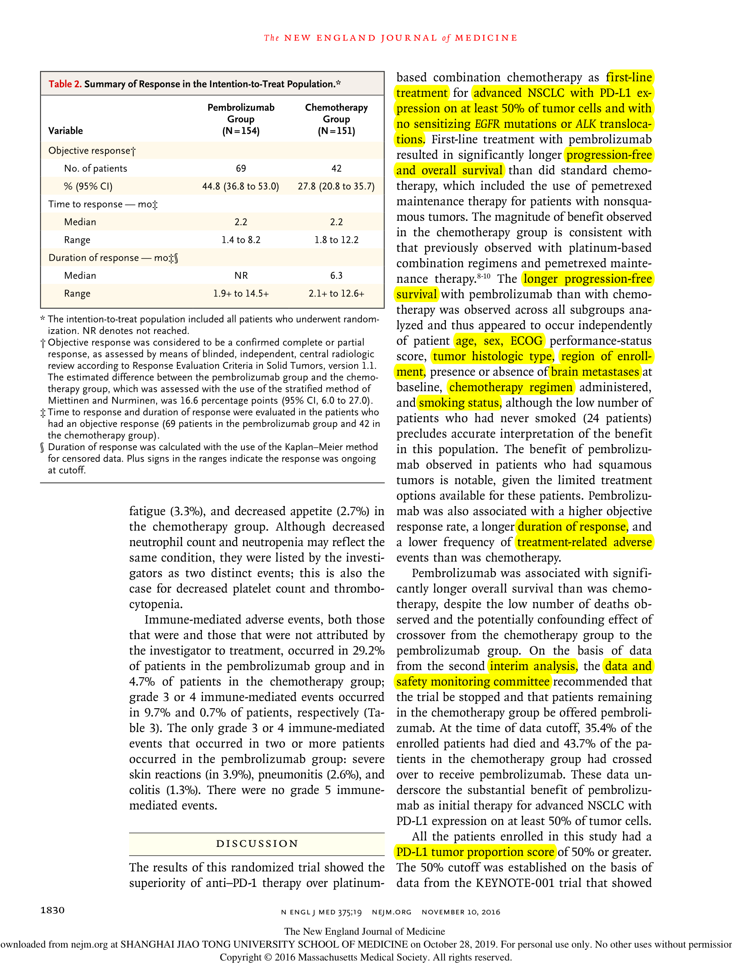

The object ive response rate, assessed according to RECIST, was 44.8% (95% CI, 36.8 to 53.0) in the pembrolizumab group and 27.8% (95% CI, 20.8 to 35.7) in the chemotherapy group (Table 2)

>>>>>>>>>>>>>>>>>>

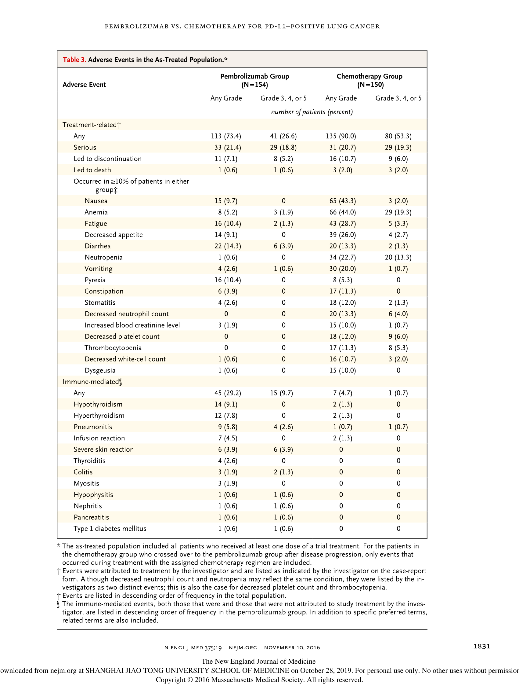

During t reatment with the init ia lly assigned therapy, treatment-related adverse events occurred in 73.4% of the pat ients in the pembrolizumab group and in 90.0% of the pat ients in the che- motherapy group (Table 3)

>>>>>>>>>>>>>>>>>>

(21.4% and 20.7%, respect ively). Discont inuat ion of treatment because of treatment-related adverse events occurred in 7.1% of pat ients in the pem- brolizumab group and in 10.7% of patients in the chemotherapy group. Treatment-related adverse events that led to death occurred in one pat ient in the pembrolizumab group (sudden death of unknown cause on day 2) and three pat ients in the chemotherapy group (one death due to pul- monar y sepsis on day 25, one death due to pulmonar y alveolar hemorrhage on day 112, and one death of unknown cause on day 8). The most common treatment-related adverse events were diarrhea (in 14.3% of the pat ients), fat igue (10.4%), and pyrexia (10.4%) in the pem- brolizumab group and anemia (44.0%), nausea (43.3%), and fatigue (28.7%) in the chemotherapy group (Table 3)

>>>>>>>>>>>>>>>>>>

## 图片

