# Nivolumab versus Docetaxel in Advanced Squamous-Cell Non–Small-Cell Lung Cancer

# 研究患者

Patients with stage IIIB or IV squamous-cell NSCLC who had disease recurrence after one prior platinum-containing regimen were eligible for participation in the study.

# 样本量

Methods— We randomly assigned 272 patients to receive nivolumab, at a dose of 3 mg per kilogram of body weight every 2 weeks, or docetaxel, at a dose of 75 mg per square meter of body-surface area every 3 weeks.

# 基线特征

The median age of the patients was 63 years. Most patients were men, had an ECOG performance-status score of 1, had stage IV cancer, and were current or former smokers (Table 1, and Table S1 in the Supplementary Appendix). All the patients had received platinum-based therapy previously; 34% had received paclitaxel previously. The demographic and clinical characteristics of the patients were generally well balanced between the groups, with slight between-group imbalances in the percentages of female patients, patients 75 years of age or older, and patients with an ECOG performance-status score of 1.

# 试验设计

1. Travis WD. Pathology of lung cancer. Clin Chest Med. 2011; 32:669–92. [PubMed: 22054879] 2. Fossella FV, DeVore R, Kerr RN, et al. Randomized phase III trial of docetaxel versus vinorelbine or ifosfamide in patients with advanced non-small-cell lung cancer previously treated with platinum-containing chemotherapy regimens: the TAX 320 Non-Small Cell Lung Cancer Study Group.

# 研究背景

Abstract  
Background— Patients with advanced squamous-cell non–small-cell lung cancer (NSCLC) who have disease progression during or after first-line chemotherapy have limited treatment options. This randomized, open-label, international, phase 3 study evaluated the efficacy and safety of nivolumab, a fully human IgG4 programmed death 1 (PD-1) immune-checkpoint–inhibitor antibody, as compared with docetaxel in this patient population.

# 研究结果

Results— The median overall survival was 9.2 months (95% confidence interval [CI], 7.3 to 13.3) with nivolumab versus 6.0 months (95% CI, 5.1 to 7.3) with docetaxel.

# 研究结论

Conclusions— Among patients with advanced, previously treated squamous-cell NSCLC, overall survival, response rate, and progression-free survival were significantly better with nivolumab than with docetaxel, regardless of PD-L1 expression level.

# 表格及图片

## 表格

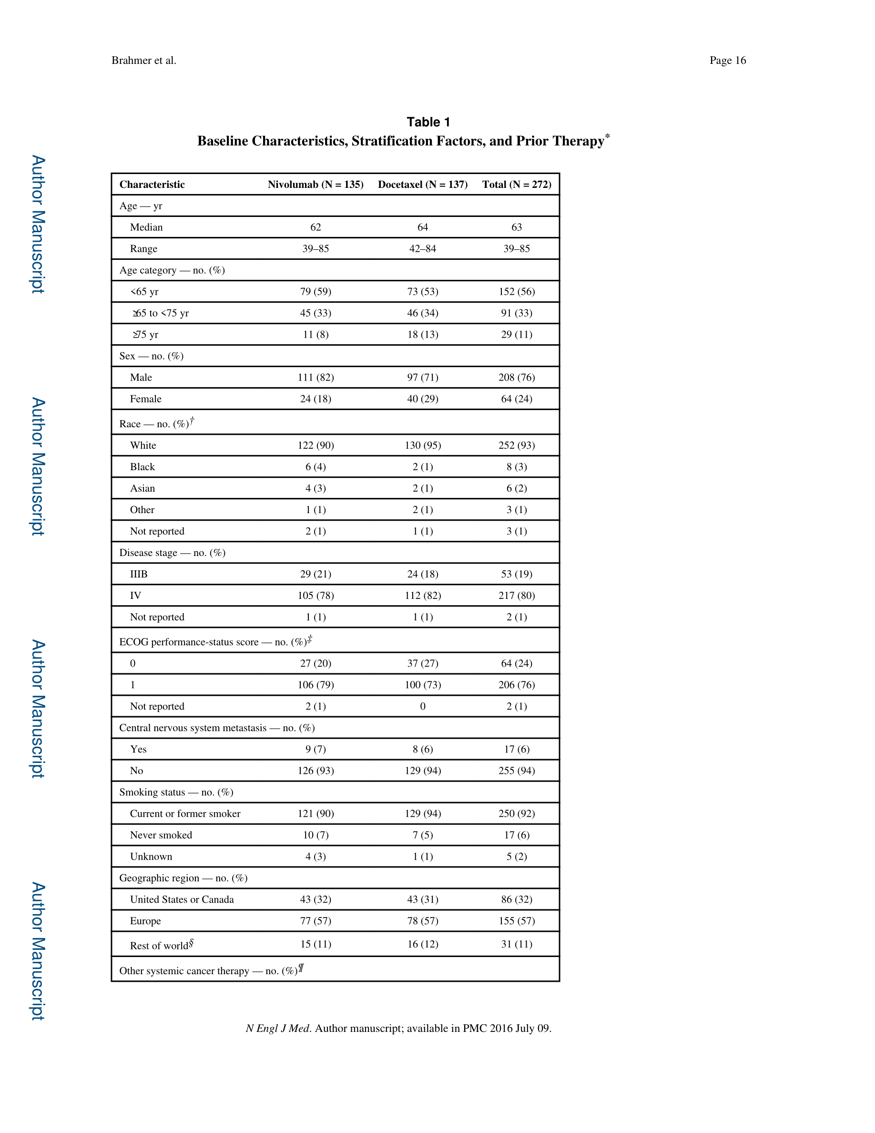

The median age of the patients was 63 years. Most patients were men, had an ECOG performance-status score of 1, had stage IV cancer, and were current or former smokers (Table 1, and Table S1 in the Supplementary Appendix)

>>>>>>>>>>>>>>>>>>

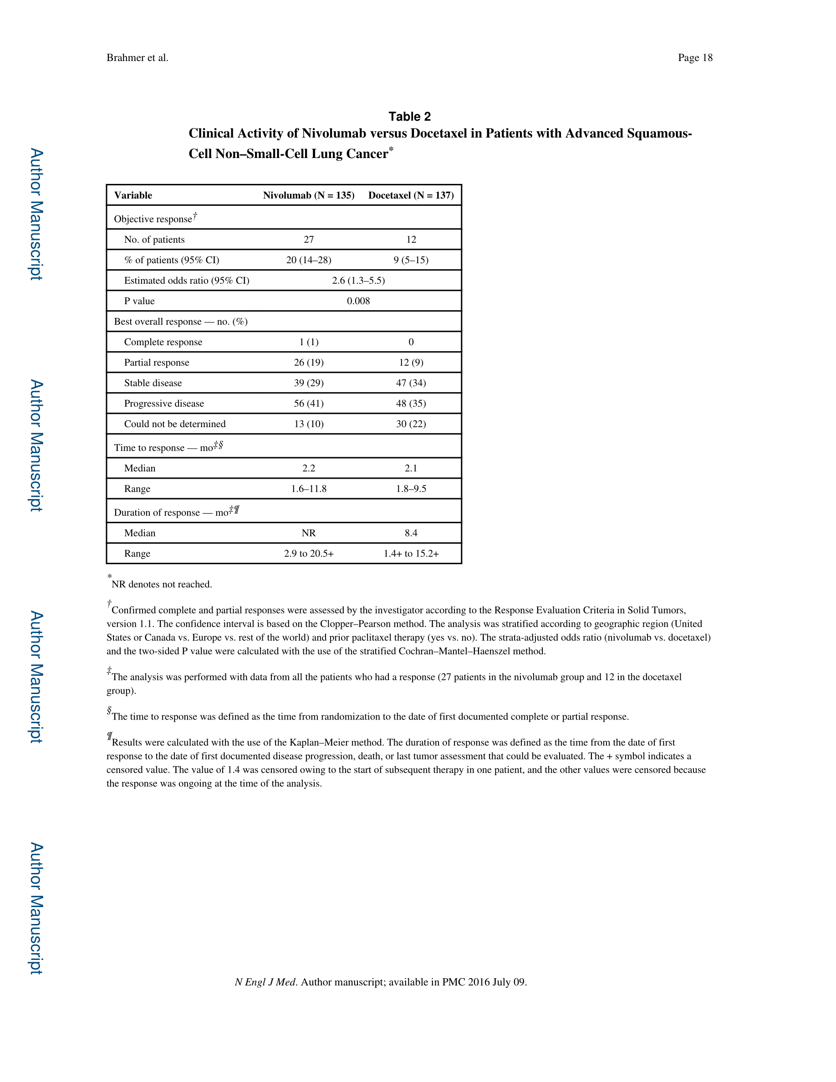

At the time of the database lock, 16% of the patients in the nivolumab group and 2% of those in the docetaxel group were continuing treatment (Table S2 in the Supplementary Appendix)

>>>>>>>>>>>>>>>>>>

The rate of confirmed objective response was significantly higher with nivolumab than with docetaxel (20% [95% CI, 14 to 28] vs. 9% [95% CI, 5 to 15]; P = 0.008) (Table 2, and Fig. S3 in the Supplementary Appendix)

>>>>>>>>>>>>>>>>>>

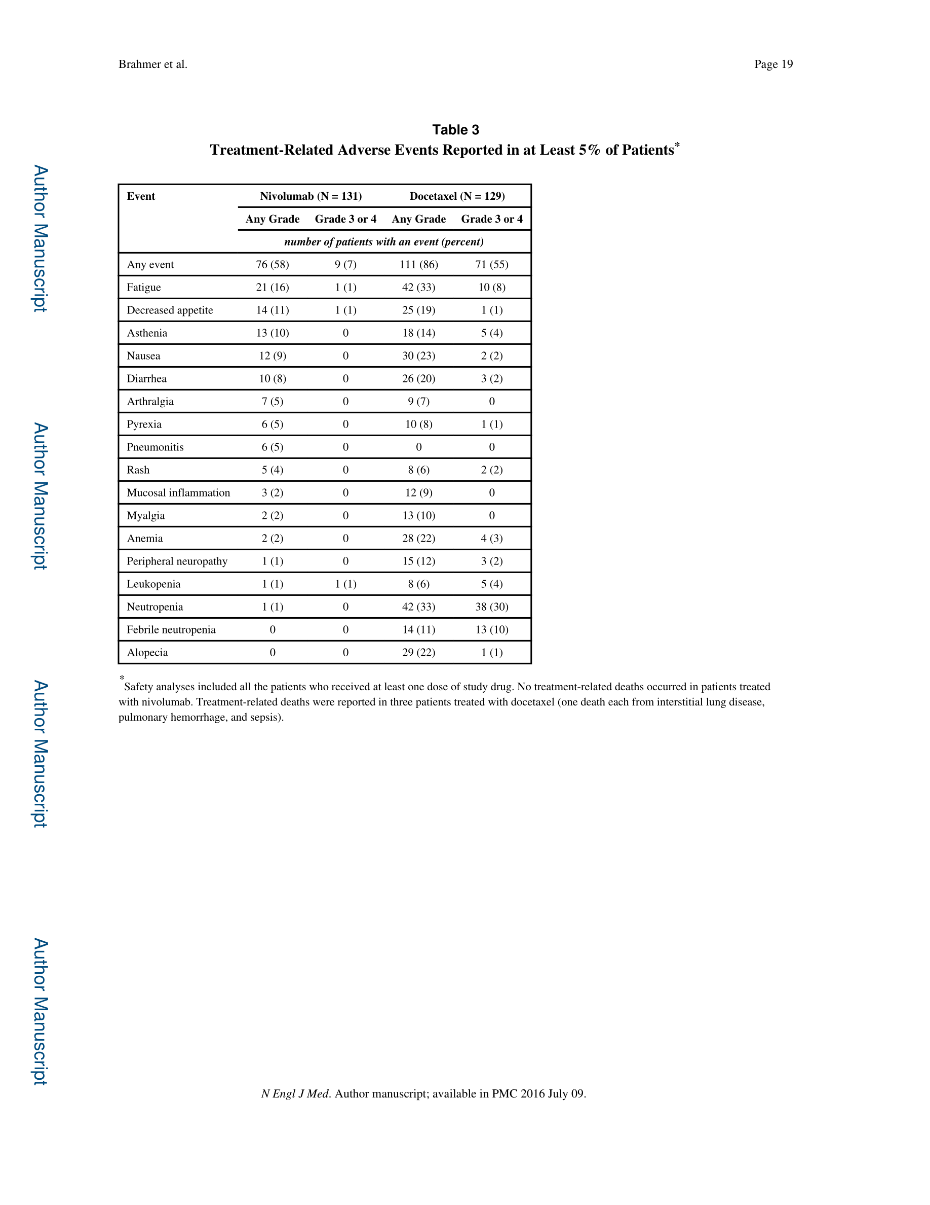

label nature of the study; 2% of the patients in the docetaxel group received subsequent immunotherapy (Table S3 in the Supplementary Appendix)

>>>>>>>>>>>>>>>>>>

Treatment-related adverse events, including both hematologic and nonhematologic toxic events, occurred less frequently with nivolumab than with docetaxel. In the nivolumab group, 58% of the patients had events of any grade, 7% had events of grade 3 or 4, and none had grade 5 events; in the docetaxel group, 86% of the patients had events of any grade, 55% had events of grade 3 or 4, and 2% had events of grade 5 (Table 3, and Table S7 in the Supplementary Appendix)

>>>>>>>>>>>>>>>>>>

## 图片

