**Problem No. & Statement: 01**

Write a ‘C-Program’ to print a Star Pyramid pattern using stars.

**Source Code:**

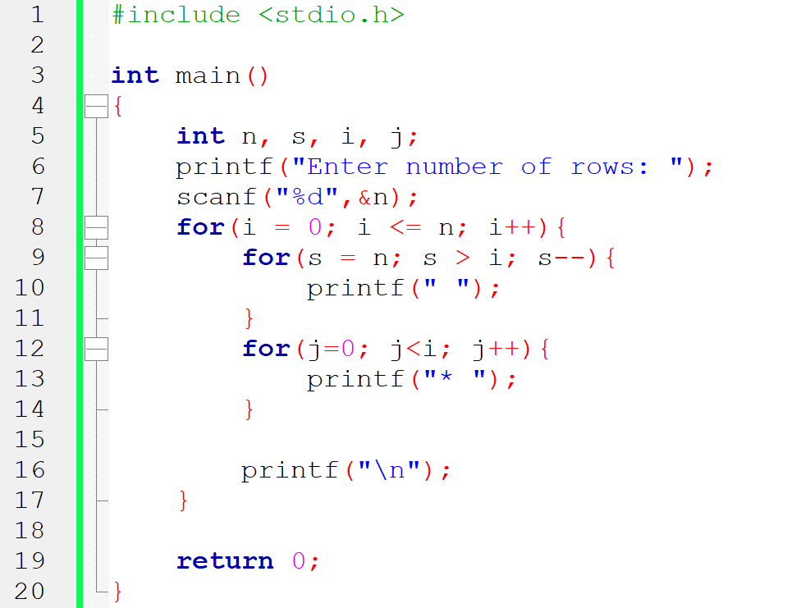

**Input:** 15

**Output:**

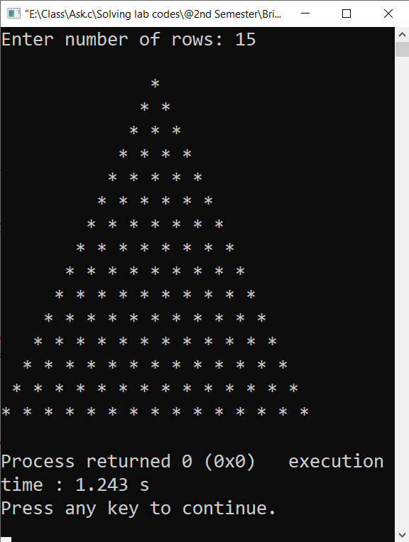

**Problem No. & Statement: 02**

Write a ‘C-Program’ to print a Inverted Star Pyramid pattern using stars.

**Source Code:**

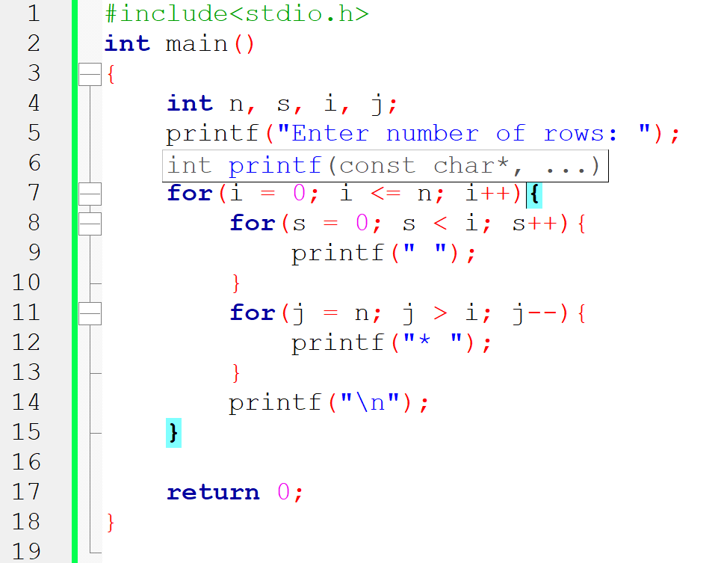

**Input:** 15

**Output:**

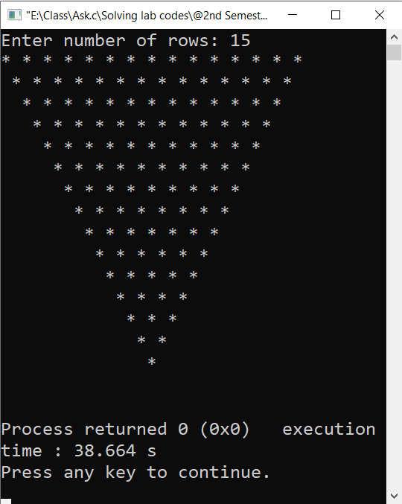

**Problem No. & Statement: 03**

Write a ‘C-Program’ to print a Diamond pattern using stars.

**Source Code:**

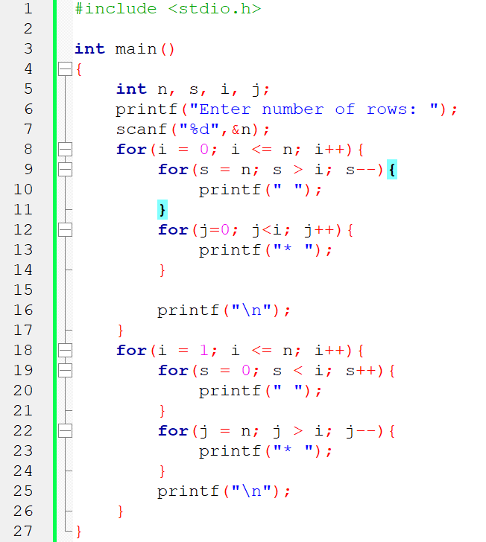

**Input:** 15

**Output:**

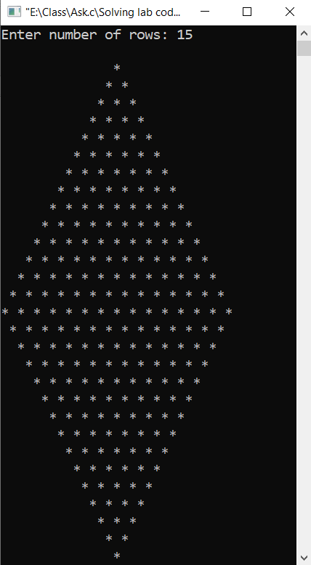

**Problem No. & Statement: 04**

Write a ‘C-Program’ to print CSE and then your ID Number (Last Two digits) using star pattern.

**Source Code:**

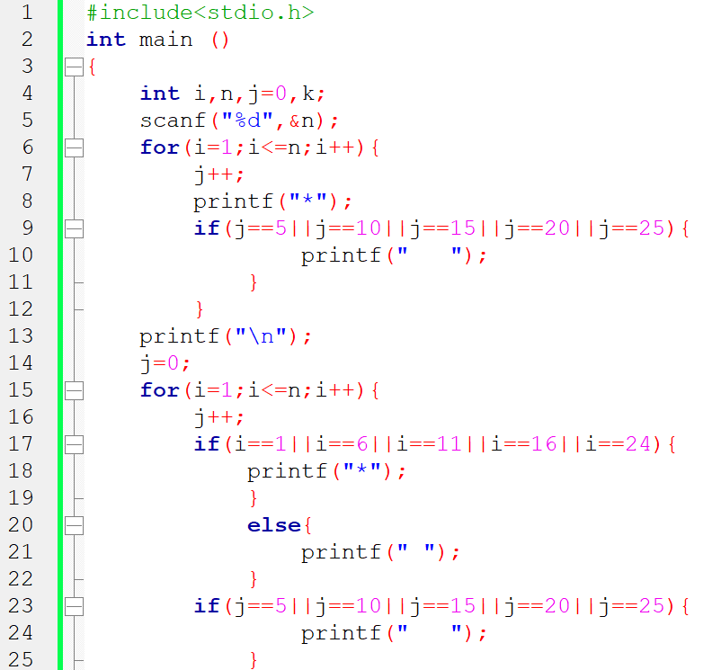

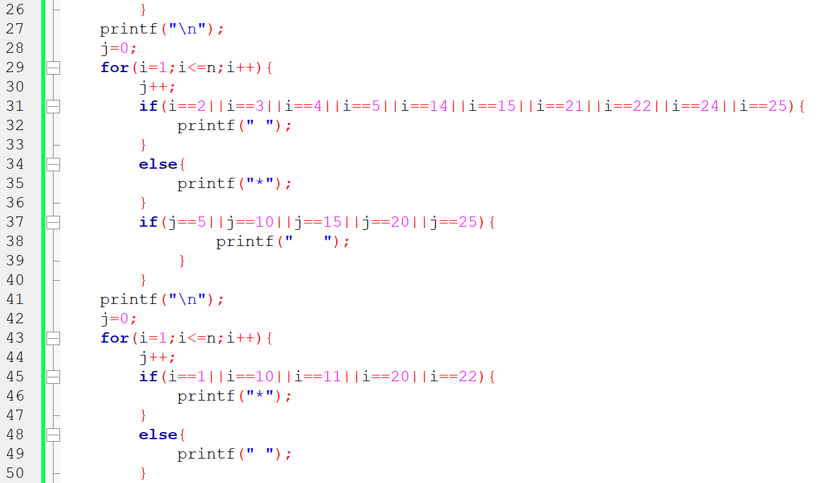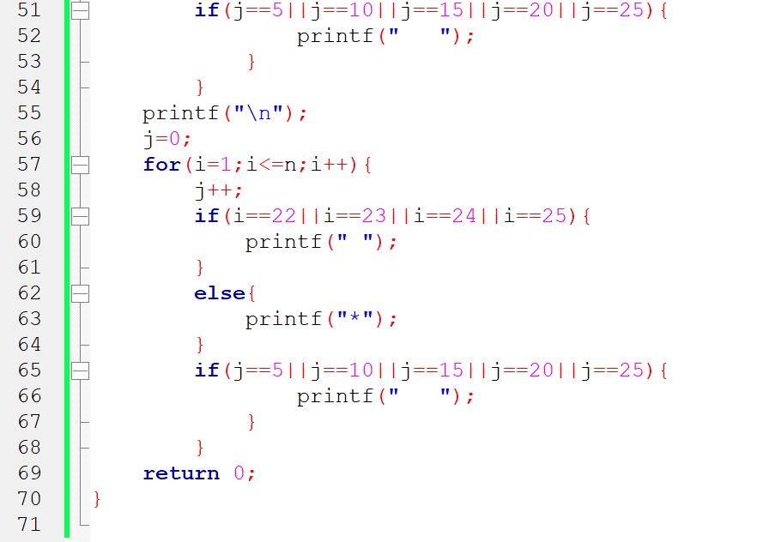

**Input:** 25

**Output:**

