**Purpose: Set up an Jump box (public instance) in AWS allowing to access in your instance private across the NAT instance.**

**Step 1 : Environment requirement ( Create VPC, subnet, IGW, Elastic IP, Instances)**

* Create VPC 🡪 Create one public subnet 🡪 Create IGW
* Public subnet will attached to internet gateway (IGW)

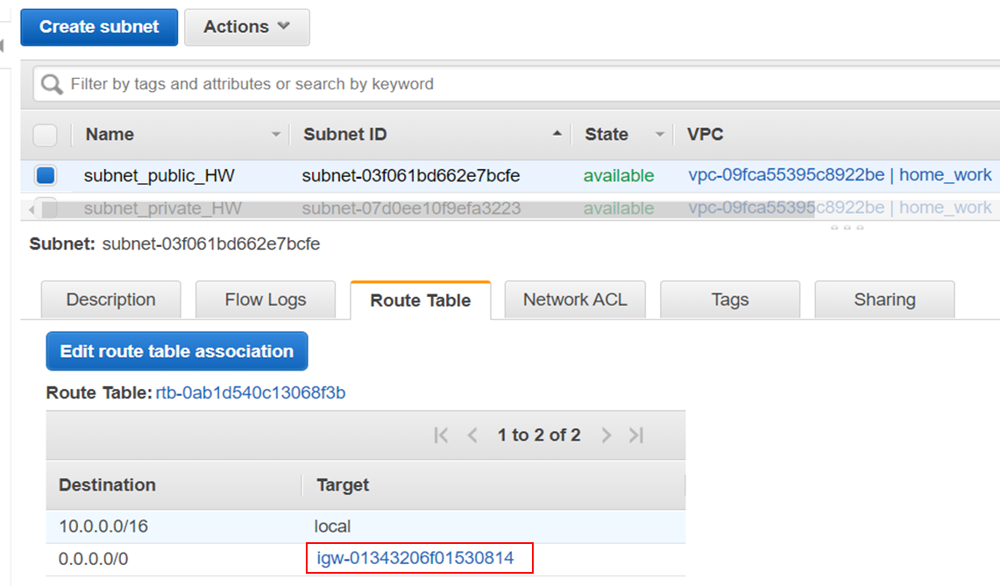

* Private Subnet will be attached to the NAT instance.

For that, Create first one route table, go to <edit route table association >, choice the one that you come to create. Then this one will be replace by the NAT instance that you create after. That’s why you obtain something look like in the red box.

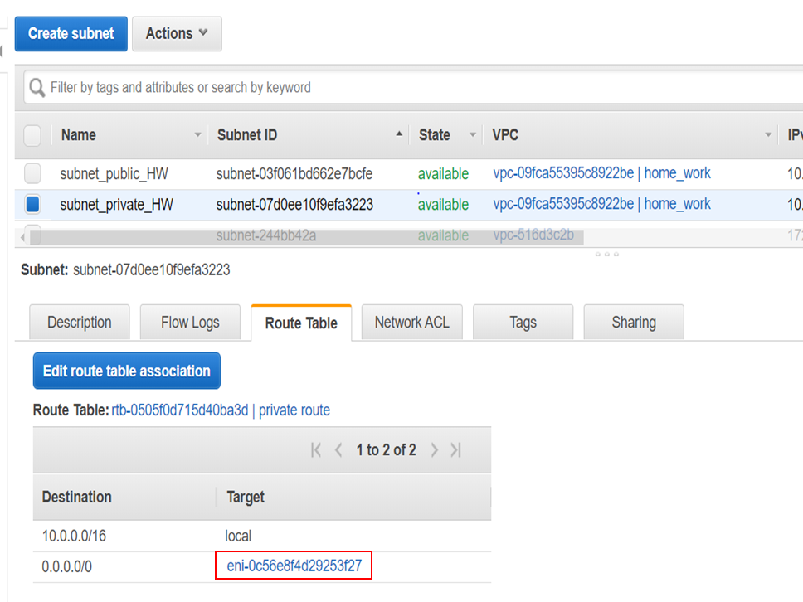

**Step 2. Create 3 instances**

* Jump box (Possible to add Elastic IP for more flexibility of your instance)

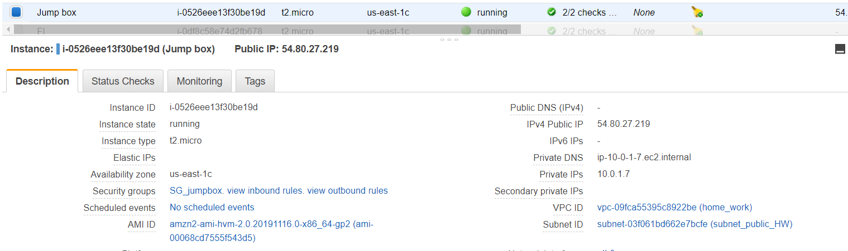

Inbound Outbound

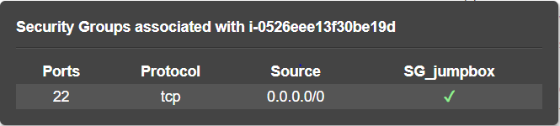 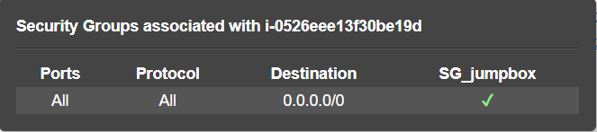

* NAT instance (Possible to add Elastic IP for more flexibility of your instance)

In AWS management console, Choice EC2 then Launch instance.

In the left navigation pane, choice community and search <**amzn-ami-vpc-nat**>, take in preference the first. Normally you obtain something in below :

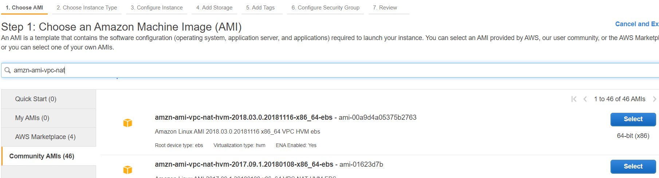

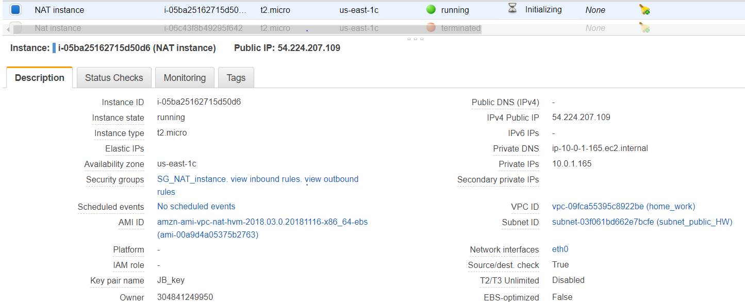

Inbound (Source : Security group Outbound

of the private instance )

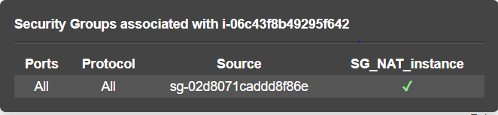 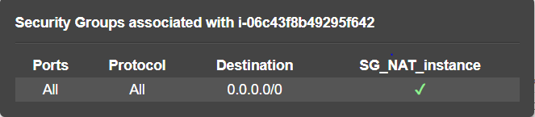

In this instance you need tick these statements following :

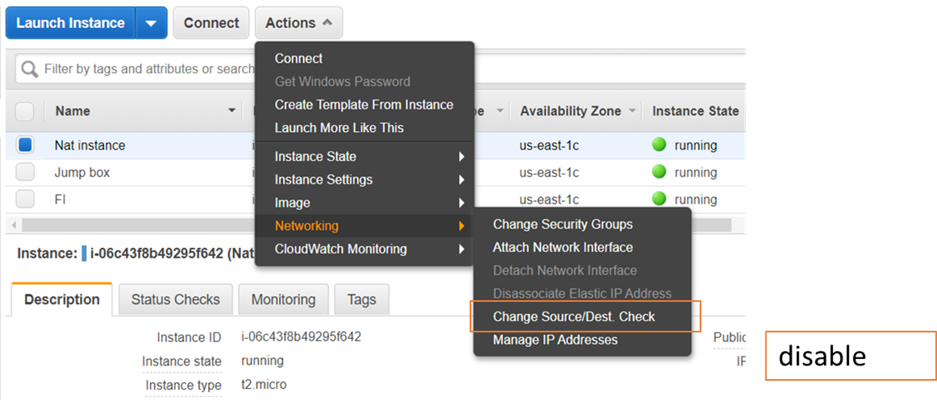

* **Private Instance**

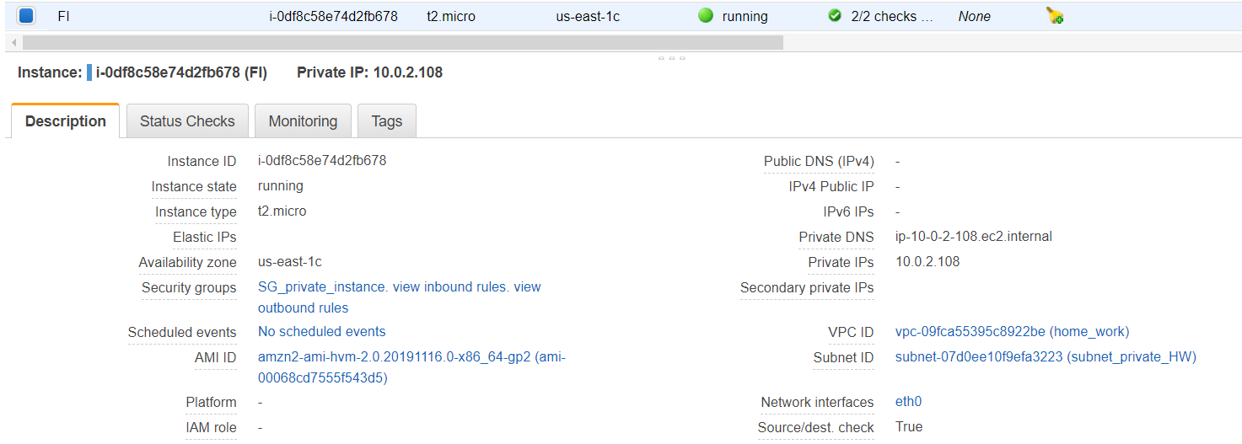

Inbound (Source : security group Outbound

of the Jump box)

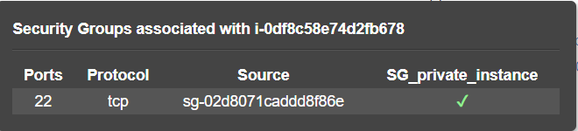 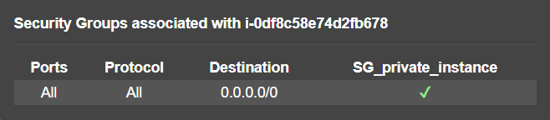

**Step 3. Checking If it’s work or not by pinging google.com in Ubuntu console**

* First access in your local directory of Key < JB_key.pem >

cd /mnt/c/Users/

* Copy the key file in your home directory ubuntu

cp -i <JB_key.pem> ~

cd ~

* Use Ssh allow you to access in the instance

chmod 400 < JB_key.pem >

* Connect to the Jump box

ssh -i "JB_key.pem" ec2-user@<IP address Jump box>

* Connect to the Instance private

ssh -i "JB_key.pem" ec2-user@<IP address private instance>

* Check if it’s work or not

Ping google.com

