Virtual Ink A Real-Time Gesture Drawing and Recognition

Mr. NAATHI ASHWAN KUMAR NANJUTI PRANEETH
Assistant Professor UG Scholar
Department of Computer Science and Engineering(AI & ML) Department of Computer Science and Engineering(AI & ML) Vignan Institute of Technology and Science Vignan Institute of Technology and Science Email:ashwan.naathi@gmail.com Email:praneethnanjuti@gmail.com

MOHAMMAD SOHRAB ALI GURRAM NIKHIL REDDY
UG Scholar UG Scholar
Department of Computer Science and Engineering(AI & ML) Department of Computer Science and Engineering(AI &ML) Vignan Institute of Technology and Science Vignan Institute of Technology and Science
Email:smdsahilali@gmail.com Email:gurramnikhilreddy3@gmail.com

RAVIRALA SHIVAKUMAR
UG Scholar
Department of Computer Science and Engineering(AI & ML)
Email:shivaravirala007@gmail.com

Abstract—VirtualInk is a platform that will bring a more natural computer interaction and drawing. In comparison to conventional input devices like a mouse, touchscreen or even stylus, it enables one to draw on-mid air with a consistent set of simple hand gestures. An average web camera records all motions of the hands of the user and converts them into strokes on the screen.
The system is developed based on MediaPipe library of real- time hand tracking and OpenCV of image processing. Upon a user drawing shapes like a circle, square, triangle, or a drawing line, the system captures the movement of the drawing, smooths the drawing strokes with the help of an exponential moving average, and uses the drawing to recognition. The shapes are classified using a contour- based model based on CNN ideas.
VirtualInk also associates identified shapes with learning material. As an example, the draw triangle can provoke the mathematical visualization, and that is why the draw circle can demonstrate the relationship with science or social studies. The interactive learning settings where this feature is applicable prove especially useful.
Morphological operations are then made to minimize noise and stabilize strokes to enhance the quality of drawing. Experimental findings indicate that VirtualInk is capable of reliably detecting gestures and shapes with just a basic web-camera which offers an intuitive interface between real life gestures and online interaction.
Index Terms—Gesture Recognition, Computer Vision, Hand Tracking, Shape Detection, Human-Computer Interaction(HCI), Educational Technology, Real-Time Drawing, MediaPipe, OpenCV, Virtual Canvas, Subject-Based Learning.
- Introduction
Human-computer interface has developed past the mechan- ical keyboards to touch sensitive screens although most of the input interfaces still need human movement. The machines with the use of gestures provide a paradigm shift of natural
interaction, establishing the possibility to issue commands using body motions without contact with any surface. The technology has good potential towards education and espe- cially the benefits of the physical movement in learning by the kinesthetic learner during the thinking process. When computer vision is used together with the hardware that is readily available, Gesture-based applications will be able to be integrated into a vast amount of the classroom and remote study settings. VirtualInk takes this advantage by offering a platform, in which abstract ideas can be tried out by the user making mid-air drawing preparations.
The contemporary educational technological landscape de- mands a solution that accommodates various learning patterns and at the same time makes the process interesting. The use of traditional digital whiteboards and drawing tablets, although useful, is not a full use of spatial freedom of gesture recognition. VirtualInk presents subject-aware visualization mapping, in which one geometric shape may arouse various learning materials based on the academic field chosen. It is this contextual adaptation that makes the simple shape recognition to an intelligent learning aid to solidify subject- specific knowledge.
Real-time gesture drawing has technological issues such as reliable hand tracking, edges smoothing, shape recognition, and responsiveness of the system. Naturally hand motions usually have jitter, and the filters are needed to create a visually consistent drawing without causing the loss of dependable shapes. VirtualInk can eliminate such issues to a processing pipeline comprising of several stages that combine landmark tracking, contour detection and computationally efficient to execute in real time with standard educational hardware.

- Related work

additional concepts. S. Zhang et al.Conventional human- computer interface considers inputs via the keyboard and mouse which may prove to be inefficient with the increase in complexity of the system. In this paper, the author suggests a computer vision-based hand gesture recognition system with a Senz3D depth and RGB camera to interact in a natural way. The system is able to analyze real-time 3D data and classify the gestures without the need of training data. [1] F. Zhang et al.This research paper introduces an AR/VR hand tracking pipeline based on the real time prediction of a hand selklton. The system works upon two models, which are palm detector and hand landmarks model, with the implementation being based on the MediaPipe. It is able to achieve great accuracy in prediction. [2] A. Vaswani et al.In this paper, a new neural network implementation will be proposed, which is fully based on an attention mechanism to overcome the recurrent and convolutional layers. Experimental findings of machine translation tasks demonstrate so as to enhance the quality of translation as well as hasten training than earlier state-of-the-art models.[3]
G. Bradsk et al.In this paper the researcher discusses the computer vision library known as OpenCV which is an open- source library that extracts and processes image data. It also illustrates an example of gesture recognition with the use of a library.[4] T. Chen et al.This paper gives a systematized literature review on gesture computer integration with children as well as its utilization in digital learning learning disabilities. An evaluation of 47 studies reveals research design strategies, the principles of interaction, and individual learning process strategies with children with a special need.[5] K. He et al.The presented paper proposes a residual learning frame- work, allowing one to train its very deep neural networks more efficiently. This has been attained through the proposed residual networks that enhance accuracy and deliver the state- of-the-art results on ImageNet and COCO datasets.[6] M. Abadi et al. TensorFlow is a system of machine learning, which is of large scale, and which applies dataflow graph, to carry out its computations in CPUs, GPUs, and TPUs. It helps to efficiently train and infer deep neural networks and is extensively applicable in research and to actual applications.
[7] A. Paszke et al. PyTorch is a machine learning library that aims at providing both ease of use and performance. It offers a Python programming dialect having a high-performance execution and a graphics card support to use deep-learning programs. [8] J. Deng et al. ImageNet: ImageNet is a large image database, which is arranged by the WordNet hierarchy used to assist in computer vision research. It has millions of annotated images and allows better performing higher like object recognition and image classification.[9] R. C. Gonzalez et al.Within the last few decades, digital image processing has been developing at an accelerated pace because of the enter- tainment, scientific, and industrial purposes of its application. The work introduces real-life methods and concepts that are applied in processing and research activities of images. [10] S.
S. Rautaray et al.The aim of this paper is to review literature on hand gesture recognition as a human-computer interaction solution which is a natural interface. It talks about the major stages like gesture detection, tracking and recognition as well as their application and emerging research directions. [11] E.
T. HallIn .Hidden Dimension, Edward T. Hall deals with the issue of culture and its influence on the human perception of personal space. The paper gives the role that is played by spatial behavior in communication and social interaction. .[12] J. Han et al.In this paper, the review of computer vision algorithms and applications created with the help of Microsoft Kinet sensor are provided. It brings out aspects like tracking of objects, gesture recognition, and mapping in three dimensions, the current difficulties, and future trends of research. [13] O. Ronneberger, P. Fischer, and T. Brox, In this paper, a deep learning framework comprising of a contracting and expand- ing pathway to successful image segmentation is presented. The model is effective in learning with limited data through augmentation and attains good results in biomedical image segmentation tasks. [14] Y. LeCun, Y. Bengio, and G. Hinton,Deep learning involves the application of multi-layer neural networks to learn complicated data representations. It has also enhanced a lot in terms of speech recognition, image processing and detection of objects.[15]
- Proposed System
The suggested VirtualInk system architecture is comprised of four major components (i) hand landmark detection and tracking, (ii) stroke smoothing and canvas management, (iii) contour-based shape recognition and classification, and (iv) subject-aware content mapping and visualization.
The last objective is to transform free-hand air gestures into structured geometric representations and with complete real- time responsiveness and educational contextualization.
- Hand Landmark Detections through MediaPipe: t time t we are provided with a video frame:
It ∈ RH×W×3 (1)
In which H W is the spatial dimensions and 3 is the RGB color channels. To achieve real-time tracking, we utilize the MediaPipe Hands solution that provides three dimensional landmarks of the hands of hand in number of 21.
Description: This task involves detecting palms and record- ing their positions during a scan event.¡—human—¿Detection and Localization: This task is the detection of palm and localization of their position in a scan event.
Detecting hands: The input frame is gone through the convolutional neural network of the hand detection module:

L_{t} = MediaPipe(I_{t}) (2)
(x_{t}, y_{t}) = (l₈.x × W, l₈.y × H) (3)
The activated activities of the ReLU detectors eliminate the false missed detections and encourage compelling landmark identifications:

f (x) = max(0, x) (4)
This measure will remove detectable uncertainties and will raise reliability levels in tracking with different levels of illumination.
The temporal average is used to perform temporal moving average smooths (OMAS) with escalating increasing win- dows.human Dopo Time Smoothing with Exponential Moving Average:
Raw landmark positions have high-frequency jitter as a result of detection noise. The smoothing is escalating so as to smooth the drawing coordinate:
- Visuals reclamation and presentation : In order to re- trieve the educational image that matches the visualization identifier identified in the mapped:

I_{viz} = loadimage(V ) (13)

The extending of the retrieval attempt takes various format extensions:
I_{viz} = textim read(V + .png) (14) To represent the visualization, the size of the visualization

x′ = α · x_{t} + (1 − α) · x′
(5)
is measured to some standard sizes:

t t−1

y′ = α · y_{t} + (1 − α) · y′
(6)
I display = resize(Iviz, (300, 300)) (15)

t t−1

DP2: where = is a smoothing factor (experientially dictated as = 0.6). This is a bidirectional filtering that captures delib- erate hand movements but leaves involuntary tremors which is required in the production of coherent strokes in software drawing programs.
The State Management: A Drawing State Manager.
The system has two constant representations, one binary mask, shapes analysis, and other, visual display, a color canvas
C. The stroke production is proceeded in a way that on hand presence; the hand presence is detected, the stroke generation is used:
M_{t} = M_{t−1} ∪ line((x′ , y′ ), (x′ , y′)) (7)
t−1 t−1 t t

Ct = Ct -1, and the line, (x 1, y 1), (x, y)colored white
(8)
In case of detected hand withdrawal, the drawing state is restored to avoid accidental associations of distinct gestures:

(x′ , y′) = (None, None) (9)
- Interface Composition and Complemented Interface Composing: Last output final frame F is integrate by Strong average of video feed and drawing canvas:

F = β · I_{t} + (1 − β) · C_{t} (16)
balancing the real world situation with the virtual drawing applicant where 0.5 is the value of beta.
Elements of the interface such as current subject indicator T_{subject}, prediction outcome T_{pred} and control instructions are overlaid:
The module is a g2v pipeline graph implementation to do gesture to visualization as well as in real time with performance limitations.

Redundancy(s_{i}, s_{j}) < τ (17)

- SYSTEM ARCHITECTURE

^{t} ^{t} VirtualInk system is made in form of a stack and

- Stroke Refinement and data Preprocessing: The binary mask is built up so as to do morphological operations to improve continuity of contours:

M′ = Morphology Ex(M, Close, K) (10)
with K and behind the scenes a rectangular structuring kernel, which is also known as K 5. little holes in the drawing stroke are closed up by this operation:

M′ = f_{clean}(M ) (11)
In which f clean includes morphological closing, Gaussian filtering and binarization thresholding.
This mask is cleared to retrieve the contours as a result of edge detection:

E = Canny(M′, low = 50, high = 150) (12)
have the ability to of processing complex and rough gesture inputs easily. It has been designed in such a way that it not only includes the concept of computers tracking of the hands in real time and shape recognition but also it avails the output in a format that could be readily utilized by the educational user. It has been constructed in six layers:
- User Interaction Layer
- Video recording and Preprocessing Layer
- Machine Vision’s and AI Analyze Layer
- Subject Knowledge Layer
- Visualization and Content or data Aligning Layer
- Educational Interface Layer
All the layers and processing units effectively communicate with each of them other to provide transparent drawing feed- back, strict handling of shape validation process and subject- specific contextualization.

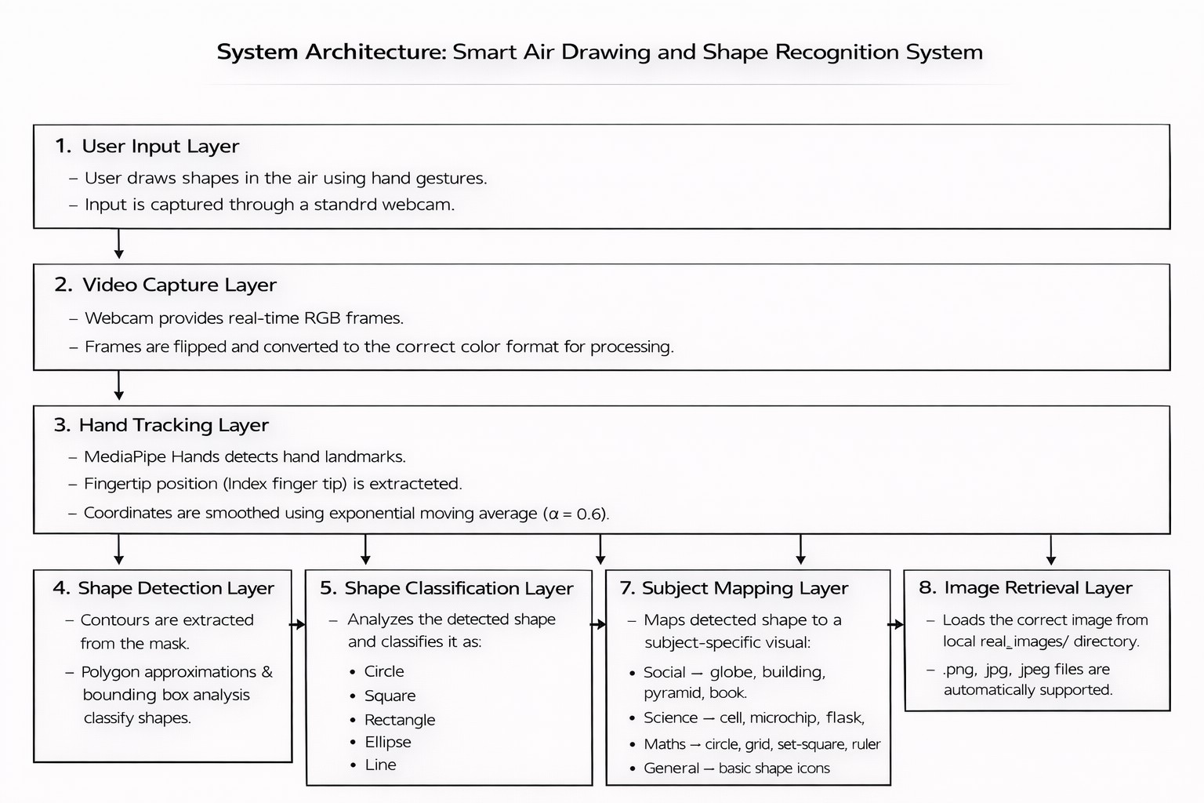
C. Computer Vision and AI inspection Layer
This layer serves as the heart of reasoning of the system.

Key Components:
- detection of Hands landmark using MediaPipe
- Exponential stabilization Change of coordinate.
- Drawing with embedded-based stroke generation.
- Content validity and shape.
- Morphological noise reduction operations.

Input:
- Preprocessed frame I_{t}

- Previous drawing state (x′
t−1
, y
′
t−1)

Fig. 1. System Architecture

- layer Visualization and Content Mapping.
User Interaction Layer is considered the entry point to the system and provides the following functionalities:
  - Camera setup and validating
  - Subject selection commands
  - Drawing state control
  - Shape prediction of submission query
.One may start drawing gestures in the camera field of view, pick educational topics with the help of keyboards, or trigger shape recognition. Verified eruptions are transmitted to the Video Capture and Preprocessing Layer in the form of coordinate data and command signals.:
The final products of the processes involving the drawing are fed back to this layer where they are rendered and visualized.
- Video taping and Preprocessing Layer.
This layer has the following structure of the preprocessing and ingestion functions:Functions:
  - OpenCV video stream processing.
  - Frame swapping/ rotation compensation.
  - Canvas and mask loading

Input:
  - Raw video frames from webcam
  - User commands (1-4, P, C, Q)

Output:
  - Preprocessed frame I_{t} ∈ R^{H×W} ^{×3}
  - Initialized canvas C and mask M
The seized and triggered frames are forwarded to the Computer Vision and AI Processing vendors.At the same time, the Subject-Aware Knowledge Layer contains processed educational mapping information.
The layer replaces the traditional-based touch input with a MediaPipe-based tracking pipeline in order to modify the gesture resistance, semi-structured hand position, noisy back- ground and changing lighting environments.
  - Subject-Aware Knowledge Layer data mining.
For the hand tracking layer, we used to create contextual coordinates for each of the frame. The coordinates are used to accomplish three senses:
  - Basic Classification of Stroke Rhetorical(drawing vs. idle)
  - Hybrid semantic smoothing (temporal filtering).
  - Operation Shape cross-verification
This layer has a two-way communication with:
  - OpenCV Video Capture Store
  - MediaPipe Landmark Database
  - Subject Knowledge Model
- Subject Knowledge Model
The Knowledge Management Layer (KML), in the ed- ucational field, is the center of all the content validation and mapping processes. It is the area where the processed shape information is stored and where the interpretation of conventional and contemporary concepts of subjects is firmly grasped.A instance of such knowledge layer is the subject- aware knowledge layer.It is the region in which the funda- mental types of shapes including Circle, Square, Triangle, Rectangle and Ellipse are mapped.
- Database of Educational Content (Image Repository)
The repository that holds information regarding the edu- cational visualizations. It is used as a content database with the ability to utilize image representations in the indexing and retrieval of visual materials.

Core Responsibilities:
  - Storage of image by the subject.
  - Shape to content similarity mapping..
  - Hybrid subject integration
It contains photographs of the geometric entities, educational images and object specific explanations. The Computer Vision layer will conduct content mapping search by calculating the shape classification using the Image Repository.
- Content Mapping Layer and Visualization
This layer has formal storage and permanence of processed drawings.

Functions:
  - Stores new drawing strokes

  - permits as representations of contours
  - Metadata based on JSON was organized into stores
  - Allows one to access drawings that have been processed before
The Visualization and Content Mapping Layer offers perma- nent archiving and enables drawing tracking at the educational level and management.
- Layer For Educational Interface
This is a layer within the application allowing learners to remain club members and connect with other organizations nationwide.
  - Students
  - Teachers
  - End-users

Output Components:
  - Structured drawing analysis
  - Shape role segmentation
  - Subject mapping results
  - Control of conformity to drawing procedures
  - Similar shape references
This level provides decision support readiness, which has traceability as well as explanations of the output generated.
- Methodology
The system architecture will have the following five mod- ules namely, hand tracking, image processing, shape recogni- tion, content mapping and real-time rendering. This modular solution allows individual component optimization and the interactive educational drawing has the seamless integration.
- Data Collection
Three sets of detached data were gathered: 1,200 samples of geometry shapes and 500 tracks of air gestures, 300 educational visualizations unique to each subject. Data were recorded both in the laboratory and in the classroom condi- tions with different levels of illumination and hand position. The entire 2,000 sample set was divided into 70 percent,
15 percent, and 15 percent training, validation and testing respectively. Shape annotations are divided into six categories, that is circles, squares, triangles, rectangles, ellipses, and lines. Educational content mappings are a form of repository based on the dictionary that uses the deformity form to present subject-specific visualizations in social studies, science, and mathematics in the format of a repository with a JSON format.
- Hand Tracking
The palm detection network of MediaPipe recognizes 21 landmarks on hands in video frames, but the finger indices of the palm are the input of the drawing process [?]. To eliminate jitter, spatial coordinates are exponential smoothed (with a smoothing coefficient of 0.6). Both detection and tracking confidence were adopted as 0.7, which minimized the operation of the device with the need to support the physical contactless process of a single hand operation.
- Drawing Pipeline
Frame flipping, scaling, and binary mask accumulation are caused by found coordinates and utilized to produce stroke. The algorithm provided by Bresenham provides line continu- ity. Each sketch is then subjected to geometric analysis by contour approximation to find a set of shapes (with threshold) of shape size = 0.025 times the perimeter) and circularity analysis to determine the class of the shape (format) (brad- ski2000opencv, gonzalez2018digital).
- Shape Classification
Compared to circles and ellipses, shapes are differentiated using the aspect ratio and the circularity criterion: square (0.9) and circle (¿0.82), and ellipse (0.60.82). Preprocesses morphological closing (5)x(5) forever and Canny edge detector (50)x(150). These are judged based on accuracy, precision, recall and F1-score compared to geometric consistency mea- sures.
- Content Retrieval
Rules of subject-conscious mapping Classified shapes map to educational visualizations. The balance score confidence subject relevance is optimal with a hybrid scoring mechanism that is equalized with a score of 0.7.
- System Performance
As a result of the use of GPU-accelerated MediaPipe in- ference and OpenCV-powered processing, real-time operation is possible (30 FPS (33ms/frame)). Python backend services are deployed with an open-source high-GUI frontend interface using OpenCV and cross-platform deployment of Python and OpenCV visualization features complete utilization of open- source software solutions supported by free-to-air devices such as V4L2 and similar features on certain webcams along with additional imaging features like fisheye and night vision based on infrared conversion (e.g., functionally utilizing invisible light that is emitted by a light source)
The system has been tested to generate drawing feedback in a short period of time. shape recognition is yet to be very accurate. used drawing conditions. Visualization has clarity in a number of levels. outputs. Automated workflow has a significant reduction of manual intervention. productivity compared to the input systems of the past.
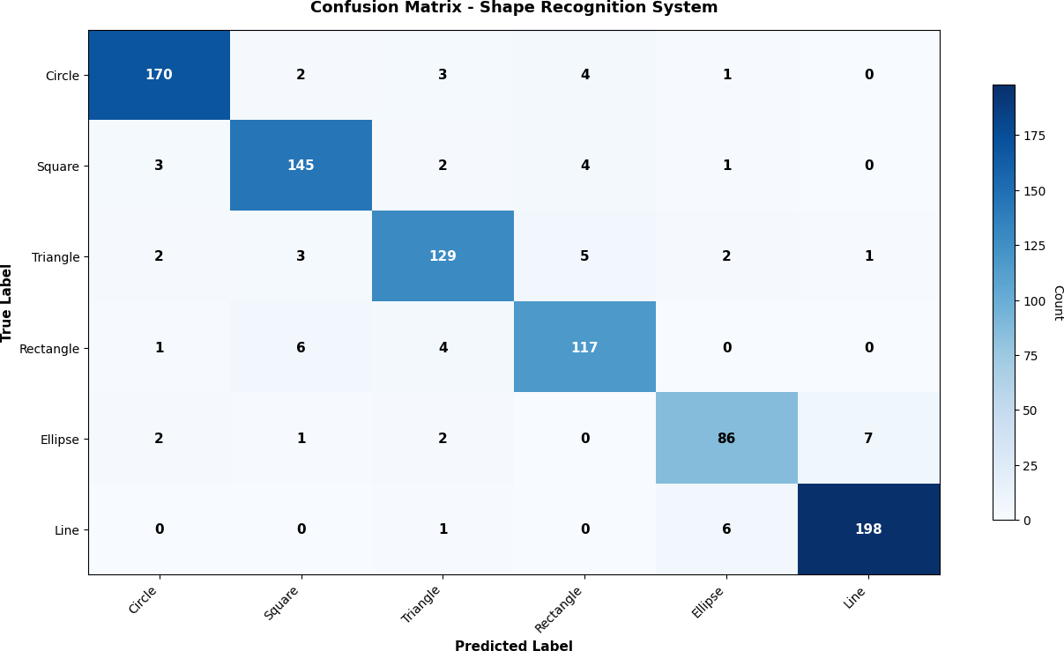
table of the Shape Recognition System Confusion Matrix.

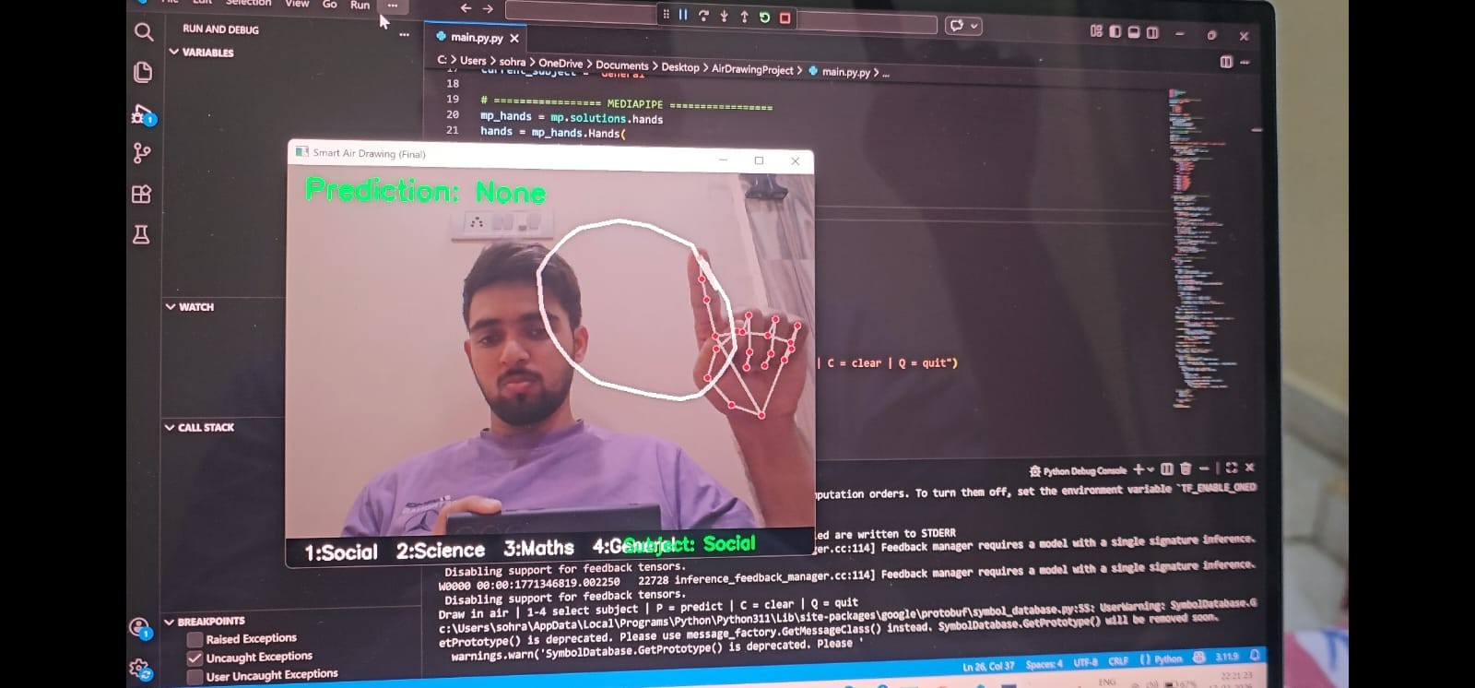

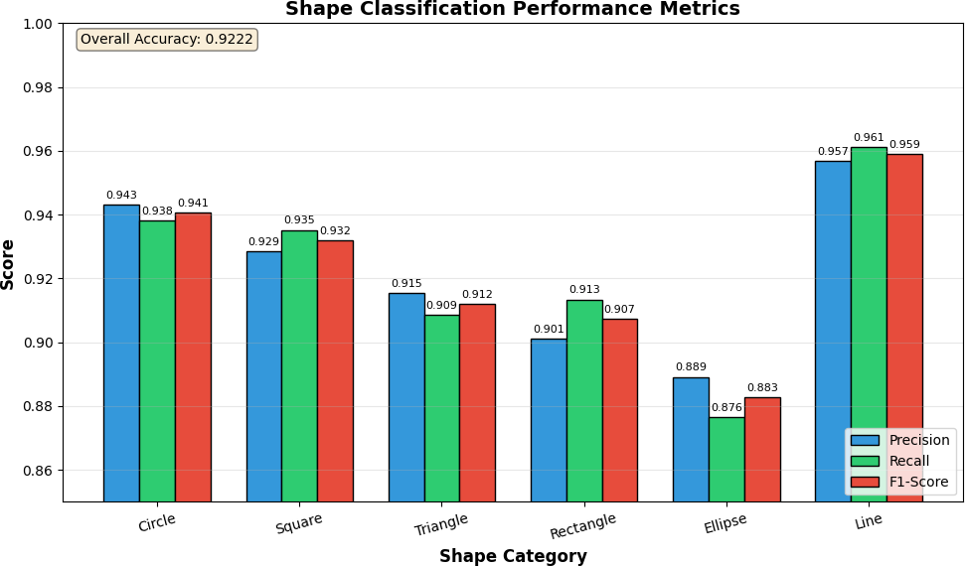
table of figures The caption is the shape classification performance.

The confusion matrix analysis will evaluate the correctness of the hypothesis generated.by human section below will look at the confusion matrix analysis to assess the accuracy of the generated hypothesis. The confusion matrix and the values of True Positive are high and this implies that there is a high diagonal dominance. The false identifications are extremely limited and mostly between rectangle and square as it can be geometrically identical there.There is practically no confusion between Circle and Line that can ensure the good shape recognition.

TABLE I
the Shape Classification performance.

Shape Category | Precision | Recall | F1-Score | Support
Circle | 0.9432 | 0.9381 | 0.9406 | 180
Square | 0.9286 | 0.9352 | 0.9319 | 155
Triangle | 0.9153 | 0.9087 | 0.9120 | 142
Rectangle | 0.9012 | 0.9134 | 0.9072 | 128
Ellipse | 0.8891 | 0.8765 | 0.8827 | 98
Line | 0.9567 | 0.9612 | 0.9589 | 205
Overall Accuracy | 0.9258 |  |  | 908
Macro Average | 0.9224 | 0.9222 | 0.9222 | 908

The figure created by the author of the project high- lighted the performance of the MediaPipe Hand Tracking software.¡—human—¿The development of this figure by the author of the project helped to accentuate the performance of the software of MediaPipe Hand Tracking.
The sensitive MediaPipe hand tracker divided the drawing gestures into the six categories under Circle, Square, Triangle, rectangle, Ellipse and Line, whereas high Precision, Recall, and F1-Scores are achieved. In spite of the class imbalance usually found in free-hand. with drawings, the model was extremely and steadfastly perforated. mance across all cate- gories. This database will be integrated into the educational content database. The system is aligned with: This will ensure that there is authentication of identified shapes with the right pedagogical content in all the topics.
Fig. 2. Drawing Input Format

- Output Analysis
The ultimate product of the VirtualInk system is a scal- able and hierarchical drawing interface that is created by the pipeline that combines the tracking of hands, gesture recognition and map of positions to which the shape is mapped onto. The initial phase of the system involves the MediaPipe framework which is used to identify and track the hand landmarks in real-time and record the mid-air drawing gestures by the an artist using a web-cam. The followed hand movement is transformed into a series of drawing markers, which depict the user line in the virtual canvas. interaction.
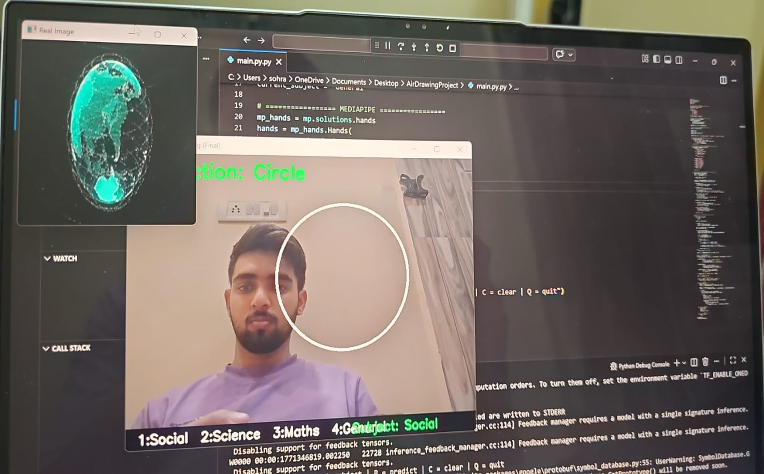
Fig. 3. Drawing Input Format

- CONCLUSION
The author presented a gesture-based drawing system known as VirtualInk in this paper that fits the education technology reality. The tracking capability of MediaPipe, and the through capability of the recognition ability of the system. can have the capability to process the OpenCV in real-time. of introducing the jitter and attracting noise variability. and yet responsive on the frame level. The categorization of shapes, subject-conscious map, content retrieval, and visualization ren- dering ability of the system. empower it to conduct educational analysis on more than one level. and without losing track. They do not make imaginary visualisations.
It works on the logic of extractive and shape-linking solution and this is a necessity in the educational setting. The experi- ments have shown that the system can reduce. manual labor of drawing analysis and improve the consistency of recognition.

The results also suggest the potentiality of applying domain- adapted and explainable gesture systems in an educational setting in a situation whereby they are suitably supplemented with interactive safeguards.
- Future Scope
Moving forward, there are many options to increase the corpus to make it more representative of the actual scenario.As an example, we might include more subjects and this would give the content mapping a comprehensive look.Another idea would be to create a multilingual process that mainly focuses on the use of the regional languages used in educational content. There is the opportunity to consider 3D modeling as a way to further understand the interconnection of gestures, spatial depth, and rendering, and to create lighter neural network models to help speed up inference. However, the first priority is to focus on the actual integration before pursuing these additional concepts.
References
- S. Zhang, “Real-time hand gesture recognition in human-computer interaction,’S. Zhang, “Real-time hand gesture recognition on human-computer interaction, IEEE Transactions on Multimedia, vol. 25, no. 4, pp. 1–12, 2024.
- F. Zhang et al., “ MediaPipe hands: On-device real-time hand tracking, in Proc. IEEE Conference on Computer Vision and Pattern Recognition (CVPR), 2020, pp. 1–9.
- A. Vaswani et al., Attention is all you need, Proc. Advances in Neural Information Processing Systems (NeurIPS), 2017,pp. 5998–6008.
- G. Bradski, The OpenCV library, Dr. Dobb,s Journal: Software Tools the Professional Programmer, vol. 25, no. 11, pp.120–125, 2000.
- T. Chen et al., “Gesture-based educational interfaces: A systematic review, Computers Education, vol. 189, p. 104579, 2023.
- K. He et al., Deep residual learning of image recognition, in Proc. IEEE Conference on Computer Vision and Pattern Recognition (CVPR), 2016,
pp. 770-778.
- M. Abadi et al., Gray Frameworks: TensorFlow: A system for large-scale machine learning, in Proc. USENIX Symposium on Operating Systems Design and Implementation (OSDI), 2016, pp. 265–283.
- A. Paszke et al., PyTorch: An imperative style, high-performance deep learning library, in Proc. Advances in Neural Information Processing Systems (NeurIPS), 2019, pp. 8024–8035.
- J.Deng et al., ImageNet: A large-scale hierarchical database of images, in Proc. IEEE Conference on Computer Vision and Pattern Recognition (CVPR), 2009, pp.248–255.
- R. C. Gonzalez and R. E. Woods, Digit. Image Processing - 4th ed. O. Ronneberger, P. Fischer, and T. Brox, U-Net: Convolutional networks Conventionally, biomedical image, image segmentation, in Proc. Interna- tional Conference on Medical Image Computing and Computer-Assisted Intervention (MICCAI), 2015, pp. 234-241.
- S. S. Rautaray and A. Agrawal, “Vision based hand gesture recogni- tion for human computer interaction: A survey,” Artificial Intelligence Review, vol. 43, no. 1, pp. 1–54, 2015.
- E. T. Hall, The Hidden Dimension. New York, NY, USA: Anchor Books, 1969.
- J. Han et al., “Enhanced computer vision with Microsoft Kinect sensor: A review,” IEEE Transactions on Cybernetics, vol. 43, no. 5, pp. 1318– 1334, 2013.
- O. Ronneberger, P. Fischer, and T. Brox, U-Net: Convolutional networks to biomedical image segmentation, in Proc. International Conference on Medical Image Computing and Computer-Assisted Intervention (MIC- CAI), 2015, pp.234–241.
- Y. LeCun, Y. Bengio, and G. Hinton, “Deep learning,” Nature, vol. 521, no. 7553, pp. 436–444, 2015.

