Supplemental tables and figures

**Table 1.** Table of student and teacher features

|  |  |  |
| --- | --- | --- |
|  | Student features | Teacher features |
| 1 | startLAs - Number of started assigned learning activities | LTadd – Number of learning tracks added to library |
| 2 | completeLAs - Number of completed assigned learning activities | LTedit - Number of learning tracks edited |
| 3 | ratioLA - Ratio of completed learning activities to assigned learning activities | groupcreate - Number of groups created |
| 4 | exercises - Number of exercise activities | groupedit - Number of edits to groups |
| 5 | engages - Number of engagement activities | LTassigngroup - Total learning tracks assigned to groups |
| 6 | coms - Number of communication activities | ratioLTassign - Number of assigned learning tracks per group created |
| 7 | vids - Number of video activities |  |
| 8 | games - Number of game activities |  |
| 9 | fls - Number of unassigned learning activities |  |
| 10 | unifls - Number of unique unassigned learning activities |  |
| 11 | startLTs - Number of started learning tracks |  |
| 12 | completeLTs - Number of completed learning tracks |  |
| 13 | languagetracks - Number of language learning tracks started |  |
| 14 | STEMtracks - Number of stem learning tracks started |  |
| 15 | musictracks - Number of music learning tracks started |  |
| 16 | religiontracks - Number of religion learning tracks started |  |
| 17 | prob - Number of problems |  |
| 18 | diff - Average difficulty rating |  |
| 19 | fun - Average fun rating |  |

**Table 2.** Mean and standard deviation of features for all students. Features are labeled according to list of student features above.

|  |  |  |  |  |  |  |  |  |  |  |  |  |  |  |  |  |  |  |  |
| --- | --- | --- | --- | --- | --- | --- | --- | --- | --- | --- | --- | --- | --- | --- | --- | --- | --- | --- | --- |
|  | 1 | 2 | 3 | 4 | 5 | 6 | 7 | 8 | 9 | 10 | 11 | 12 | 13 | 14 | 15 | 16 | 17 | 18 | 19 |
| M | 16.42 | 14.50 | 0.60 | 9.94 | 3.53 | 1.19 | 1.44 | 0.32 | 0.17 | 0.12 | 2.11 | 0.75 | 1.24 | 0.55 | 0.17 | 0.00 | 0.33 | 2.69 | 3.47 |
| STD | 16.82 | 16.40 | 0.40 | 11.04 | 4.26 | 2.14 | 2.31 | 0.50 | 0.91 | 0.64 | 1.76 | 1.03 | 1.26 | 1.04 | 0.40 | 0.04 | 1.49 | 0.62 | 0.82 |

**Table 3.** Table of differences between usage groups. Reference category is the high use cluster. Bolded and underlined values are statistically significant at the .001 and .01 levels respectively. Primary is a dummy variable where 0 is for primary school students and 1 is for secondary school students.

|  |  |  |  |  |  |  |  |  |  |  |  |  |  |  |  |  |  |  |  |
| --- | --- | --- | --- | --- | --- | --- | --- | --- | --- | --- | --- | --- | --- | --- | --- | --- | --- | --- | --- |
|  | 1 | 2 | 3 | 4 | 5 | 6 | 7 | 8 | 9 | 10 | 11 | 12 | 13 | 14 | 15 | 16 | 17 | 19 | Primary |
| M | **32.16** | **30.94** | 0.02 | **20.15** | **7.35** | **1.42** | **2.90** | **0.34** | -0.21 | -0.15 | **2.15** | **1.01** | **1.39** | 0.13 | **0.42** | 0.00 | 0.34 | 0.12 | **-0.59** |
| STD | **8.95** | **10.05** | -0.26 | **7.30** | **2.36** | **2.29** | **1.18** | **0.09** | -0.90 | -0.58 | **0.97** | **0.50** | **0.47** | 0.62 | **0.32** | -0.04 | 0.34 | -0.01 | **0.12** |

**Table 3.** – Table of differences between primary and secondary schools. Reference category is secondary schools. Bolded and italicized values are significant at the .001 level and .05 level respectively

|  |  |  |  |  |  |  |  |  |  |  |  |  |  |  |  |  |  |  |  |
| --- | --- | --- | --- | --- | --- | --- | --- | --- | --- | --- | --- | --- | --- | --- | --- | --- | --- | --- | --- |
|  | 1 | 2 | 3 | 4 | 5 | 6 | 7 | 8 | 9 | 10 | 11 | 12 | 13 | 14 | 15 | 16 | 17 | 18 | 19 |
| M | **21.89** | **19.75** | **-0.17** | **13.39** | **4.69** | 0.26 | **3.18** | **0.38** | *-0.15* | *-0.10* | **2.74** | **0.92** | **1.54** | **0.35** | **0.61** | 0.00 | **0.46** | **0.45** | **21.89** |
| STD | **9.30** | **9.25** | **-0.22** | **7.77** | **1.02** | -0.99 | **1.71** | **0.11** | *-0.69* | *-0.46* | **1.54** | **0.70** | **0.63** | **1.07** | **0.56** | -0.04 | **0.71** | **-0.26** | **9.30** |

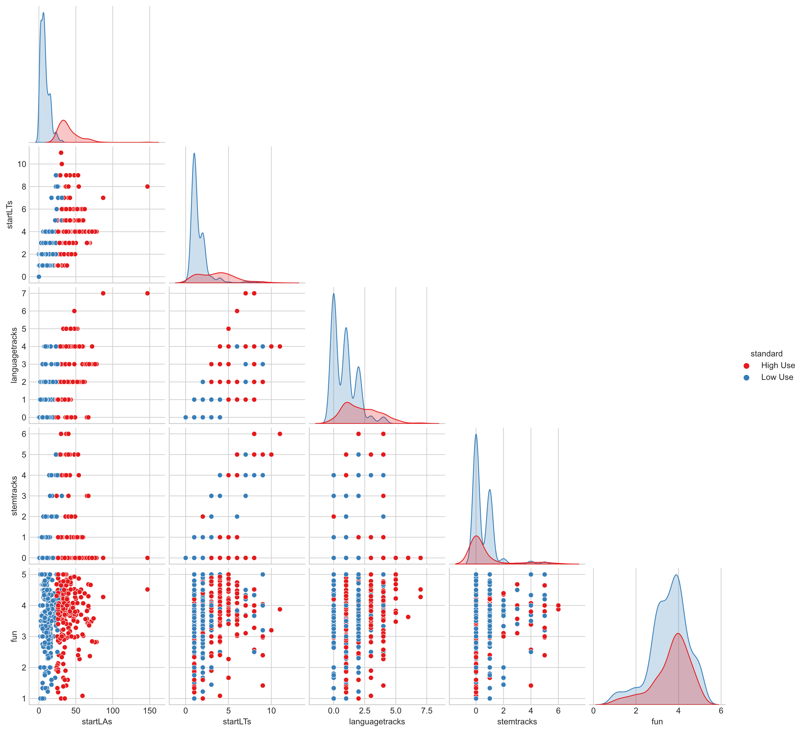

**Fig. 1.** Corner plot of student clustering

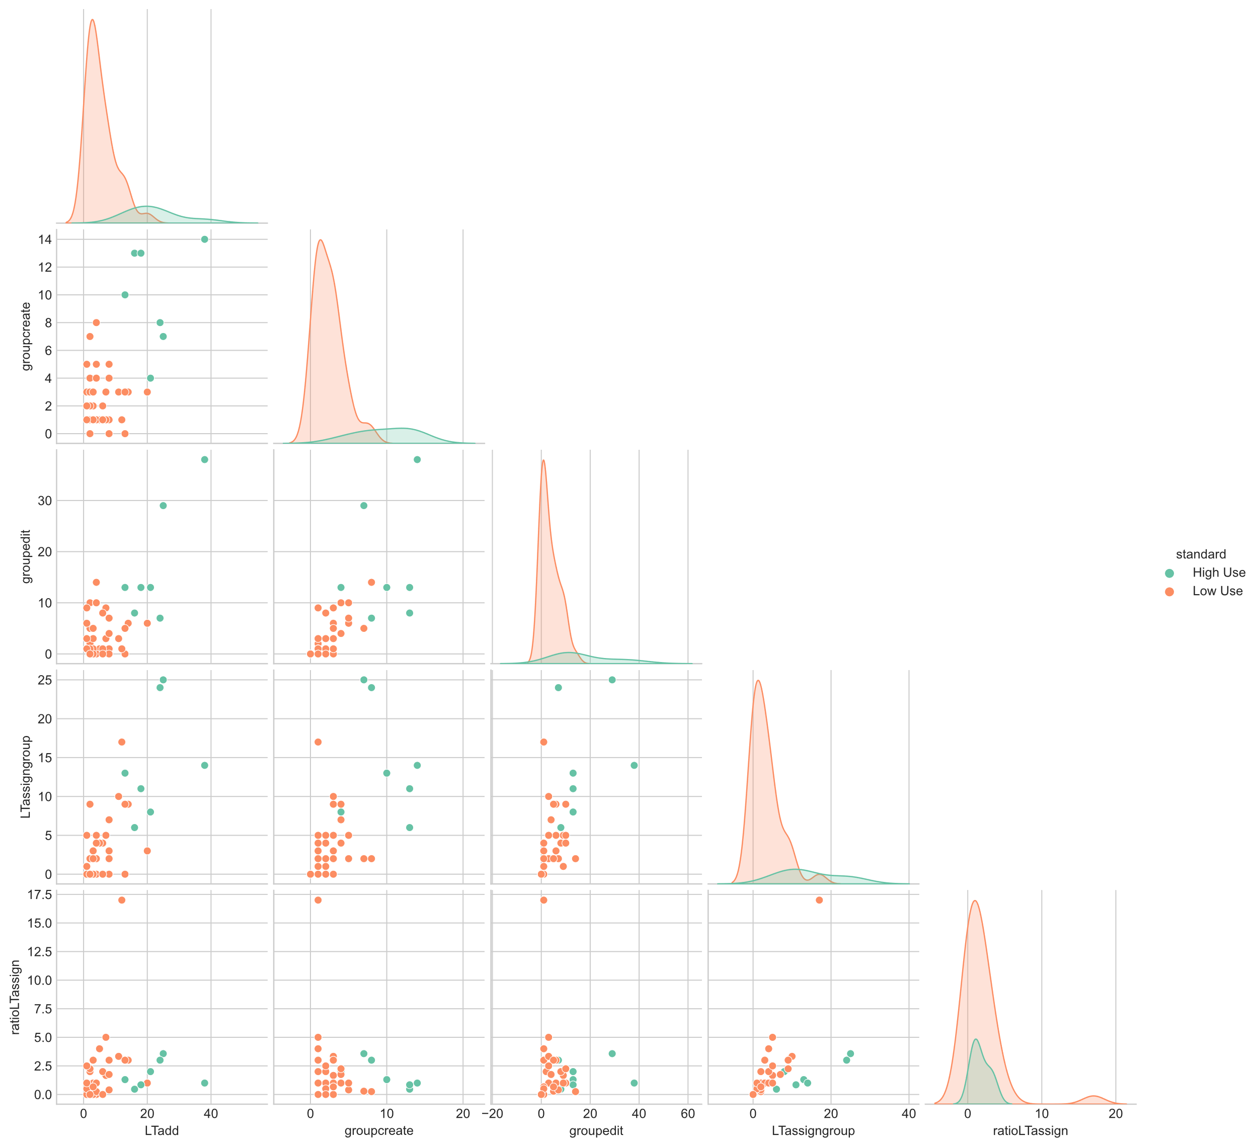

**Fig. 2.** Corner plot of teacher clustering