< HW1 Report>



|  |  |
| --- | --- |
| 과 목 명 : | 데이터베이스 |
| 교 수 명 : | 김 연 정 교수님 |
| 학 과 : | 사이버보안전공 |
| 학 번 : | 1971070 |
| 이 름 : | 박 소 현 |

**1.**

**(a)**

CREATE TABLE Constructors

(

constructor varchar(20) not null,

country varchar(10),

engine varchar(10),

races_entered int,

height int,

width int,

PRIMARY KEY(constructor)

)

describe Constructors;

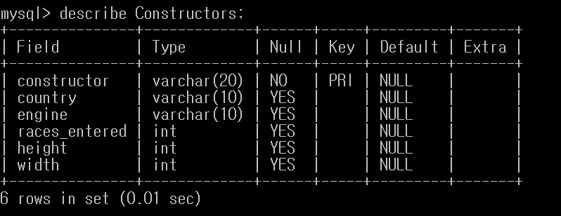

**(b)**

CREATE TABLE Drivers

(

name varchar(15) not null,

birthday date,

country varchar(10),

constructor varchar(20),

PRIMARY KEY(name),

FOREIGN KEY (constructor) REFERENCES Constructors);

)

describe Drivers;

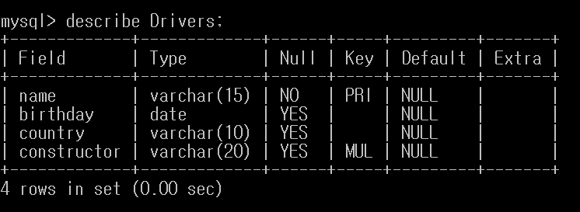

**(C)**

CREATE TABLE Races

(

name varchar(30) not null,

date date,

area varchar(20)

PRIMARY KEY(name),

)

describe Races;

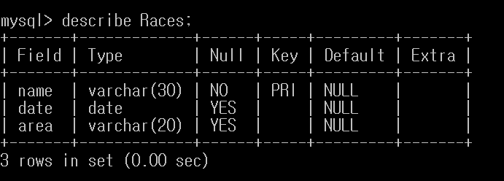

**(d)**

CREATE TABLE Results

(

race varchar(30) not null,

driver varchar(15) not null,

race_rank varchar(15),

PRIMARY KEY(race, driver),

FOREIGN KEY (race) REFERENCES Races,

FOREIGN KEY (driver) REFERENCES Drivers

)

describe Results;

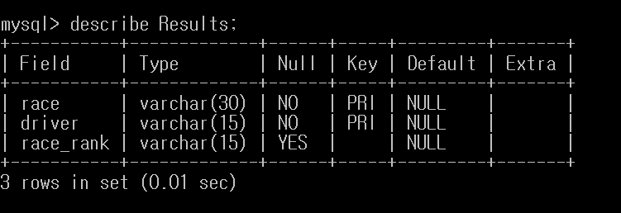

**2.**

**(a)**

INSERT INTO Constructors VALUES('McLaren','British','Mercedes','884','95','180');

INSERT INTO Constructors VALUES('BMW Sauber', 'German','BMW','70','95','180');

INSERT INTO Constructors VALUES('Renault','French','Renault','660','91','175');

INSERT INTO Constructors VALUES('Ferrari','Italian','Ferrari','1010', '93', '180');

INSERT INTO Constructors VALUES('Toyota', 'Japanese','Toyota','1140', '91','175');

INSERT INTO Constructors VALUES('Red Bull', 'Austrian', 'Honda', '304', '91', '175');

INSERT INTO Constructors VALUES('Honda', 'Japanese', 'Honda', '88', '91', '175');

INSERT INTO Constructors VALUES('Toro Rosso', 'Italian', 'Ferrari', '268', '93', '180');

INSERT INTO Constructors VALUES('Jaguar', 'British', 'Cosworth', '85', '93', '178');

SELECT * FROM Constructors;

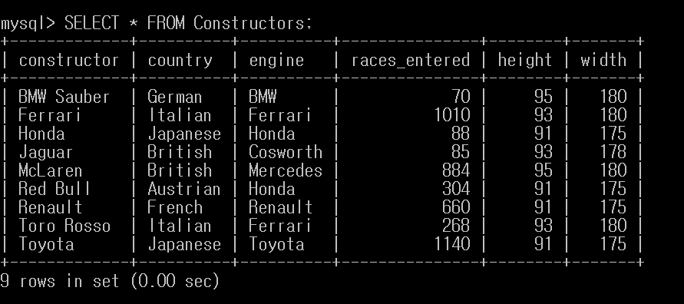

**(b)**

INSERT INTO Drivers VALUES('hamilton', str_to_date('07/01/1985', '%d/%m/%Y'), 'British', 'McLaren');

INSERT INTO Drivers VALUES('heidfeld', str_to_date('10/05/1977', '%d/%m/%Y'), 'German', 'BMW Sauber');

INSERT INTO Drivers VALUES('alonso', str_to_date('29/07/1981', '%d/%m/%Y'), 'Spanish', 'Renault');

INSERT INTO Drivers VALUES('raikkonen', str_to_date('17/10/1979', '%d/%m/%Y'), 'Finnish', 'Ferrari',);

INSERT INTO Drivers VALUES('kubica', str_to_date('07/12/1984', '%d/%m/%Y'), 'Polish', 'BMW Sauber');

INSERT INTO Drivers VALUES('massa', str_to_date('25/04/1981', '%d/%m/%Y'), 'Brazilian', 'Ferrari');

INSERT INTO Drivers VALUES('trulli', str_to_date('13/07/1974', '%d/%m/%Y'), 'Italian', 'Toyota');

INSERT INTO Drivers VALUES('webber', str_to_date('27/08/1976', '%d/%m/%Y'), 'Australian', 'Red Bull');

INSERT INTO Drivers VALUES('button', str_to_date('19/01/1980', '%d/%m/%Y'), 'British', 'Honda');

INSERT INTO Drivers VALUES('vettel', str_to_date('03/07/1987', '%d/%m/%Y'), 'German', 'Toro Rosso');

INSERT INTO Drivers VALUES('barrichello', str_to_date('23/05/1972', '%d/%m/%Y'), 'Brazilian', 'Honda');

INSERT INTO Drivers VALUES('Irvine', str_to_date('10/11/1965', '%d/%m/%Y'), 'British', 'Jaguar');

INSERT INTO Drivers VALUES('Schmacher', str_to_date('03/01/1969', '%d/%m/%Y'), 'German', 'Ferrari');

SELECT * FROM Drivers;

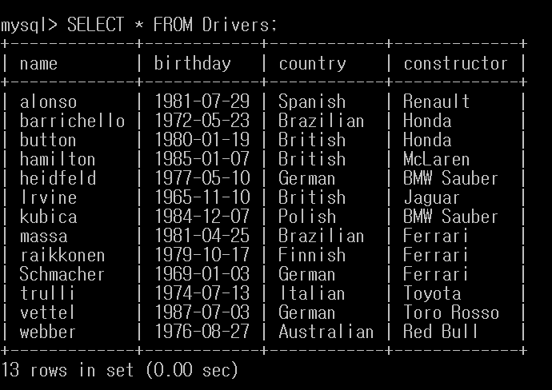

**(c)**

INSERT INTO Races VALUES('Australian Grand Prix','2009-03-29', 'Australia');

INSERT INTO Races VALUES('British Grand Prix','2009-06-21','Europe');

INSERT INTO Races VALUES('German Grand Prix','2009-07-12', 'Europe');

INSERT INTO Races VALUES('European Grand Prix','2009-08-23', 'Europe');

INSERT INTO Races VALUES('Abu Dhabi Grand Prix','2009-11-01', 'Middle East');

INSERT INTO Races VALUES('Malaysian Grand Prix','2008-03-23', 'Asia');

INSERT INTO Races VALUES('Spanish Grand Prix','2008-04-27', 'Europe');

INSERT INTO Races VALUES('Singapore Grand Prix','2008-09-28', 'Asia');

INSERT INTO Races VALUES('Brazilian Grand Prix','2008-11-02', 'South America');

INSERT INTO Races VALUES('Monaco Grand Prix','2007-05-27', 'Africa');

INSERT INTO Races VALUES('Canadian Grand Prix','2007-06-10', 'North America');

INSERT INTO Races VALUES('United States Grand Prix','2007-06-17', 'North America');

INSERT INTO Races VALUES('French Grand Prix','2007-07-01', 'Europe');

INSERT INTO Races VALUES('Italian Grand Prix','2007-09-09', 'Europe');

INSERT INTO Races VALUES('San Marino Grand Prix','2004-04-25', 'Europe');

SELECT * FROM Races;

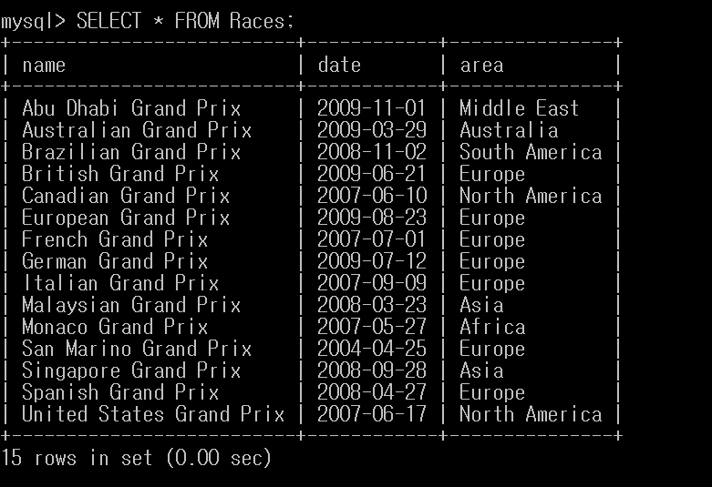

**(d)**

INSERT INTO Results VALUES('Australian Grand Prix', 'trulli', 'first place');

INSERT INTO Results VALUES('Australian Grand Prix', 'barrichello', 'second place');

INSERT INTO Results VALUES('Australian Grand Prix', 'button', 'third place');

INSERT INTO Results VALUES('British Grand Prix', 'button', 'first place');

INSERT INTO Results VALUES('British Grand Prix', 'barrichello', 'second place');

INSERT INTO Results VALUES('British Grand Prix', 'vettel', 'third place');

INSERT INTO Results VALUES('German Grand Prix', 'button', 'first place');

INSERT INTO Results VALUES('German Grand Prix', 'vettel', 'second place');

INSERT INTO Results VALUES('German Grand Prix', 'webber', 'third place');

INSERT INTO Results VALUES('European Grand Prix', 'button', 'first place');

INSERT INTO Results VALUES('European Grand Prix', 'barrichello', 'second place');

INSERT INTO Results VALUES('European Grand Prix', 'webber', 'third place');

INSERT INTO Results VALUES('Abu Dhabi Grand Prix', 'button', 'first place');

INSERT INTO Results VALUES('Abu Dhabi Grand Prix', 'vettel', 'second place');

INSERT INTO Results VALUES('Abu Dhabi Grand Prix', 'barrichello', 'third place');

INSERT INTO Results VALUES('Malaysian Grand Prix', 'hamilton', 'first place');

INSERT INTO Results VALUES('Malaysian Grand Prix', 'heidfeld', 'second place');

INSERT INTO Results VALUES('Malaysian Grand Prix', 'raikkonen', 'third place');

INSERT INTO Results VALUES('Spanish Grand Prix', 'hamilton', 'second place');

INSERT INTO Results VALUES('Singapore Grand Prix', 'hamilton', 'first place');

INSERT INTO Results VALUES('Singapore Grand Prix', 'massa', 'second place');

INSERT INTO Results VALUES('Singapore Grand Prix', 'kubica', 'third place');

INSERT INTO Results VALUES('Brazilian Grand Prix', 'hamilton', 'first place');

INSERT INTO Results VALUES('Brazilian Grand Prix', 'massa', 'second place');

INSERT INTO Results VALUES('Monaco Grand Prix', 'alonso', 'first place');

INSERT INTO Results VALUES('Monaco Grand Prix', 'hamilton', 'second place');

INSERT INTO Results VALUES('Monaco Grand Prix', 'massa', 'third place');

INSERT INTO Results VALUES('Canadian Grand Prix', 'hamilton', 'first place');

INSERT INTO Results VALUES('Canadian Grand Prix', 'alonso', 'second place');

INSERT INTO Results VALUES('Canadian Grand Prix', 'massa', 'third place');

INSERT INTO Results VALUES('United States Grand Prix', 'hamilton', 'first place');

INSERT INTO Results VALUES('United States Grand Prix', 'alonso', 'second place');

INSERT INTO Results VALUES('United States Grand Prix', 'massa', 'third place');

INSERT INTO Results VALUES('French Grand Prix', 'hamilton', 'first place');

INSERT INTO Results VALUES('French Grand Prix', 'alonso', 'second place');

INSERT INTO Results VALUES('French Grand Prix', 'massa', 'third place');

INSERT INTO Results VALUES('Italian Grand Prix', 'hamilton', 'first place');

INSERT INTO Results VALUES('Italian Grand Prix', 'alonso', 'second place');

INSERT INTO Results VALUES('San Marino Grand Prix', 'Schmacher', 'first place');

INSERT INTO Results VALUES('San Marino Grand Prix', 'barrichello', 'second place');

SELECT * FROM Results;

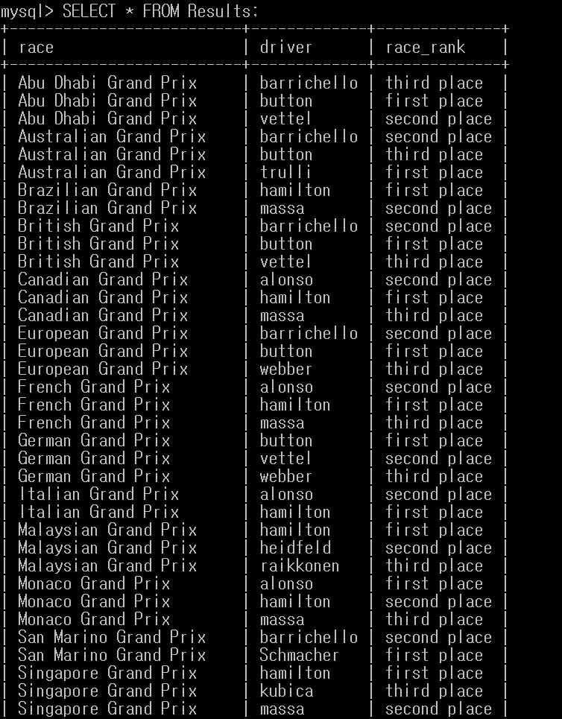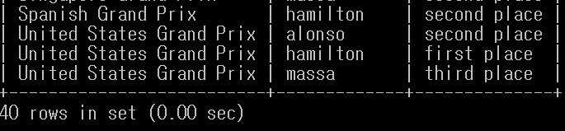

**3.**

**(a)**

SELECT constructor, country FROM Constructors WHERE races_entered >=100;

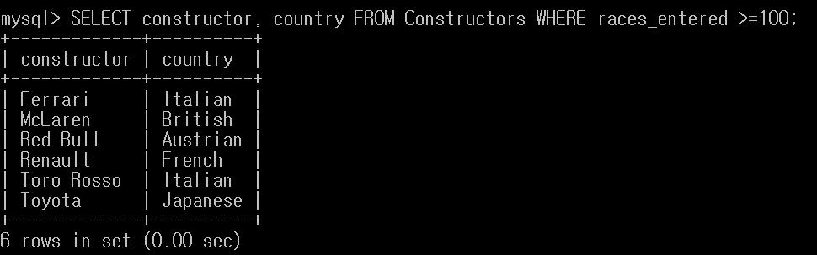

**(b)**

SELECT constructor, engine, races_entered FROM Constructors WHERE height<>95 AND width<180 ORDER BY engine ASC, races_entered ASC;

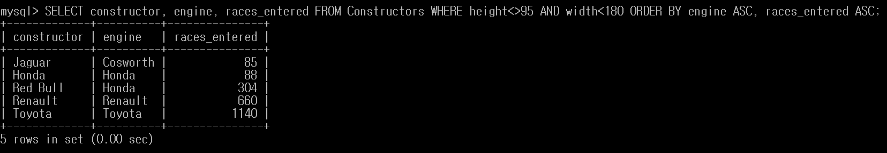

**(c)**

SELECT constructor FROM Constructors WHERE engine='Ferrari';

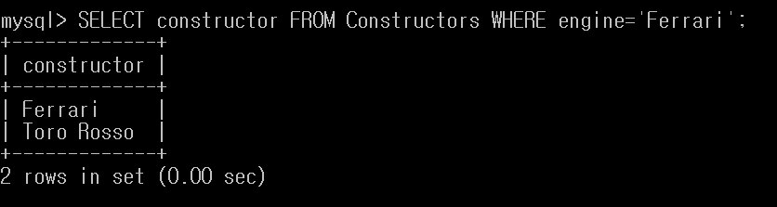

**(d)**

SELECT name as newBoys FROM Drivers WHERE EXTRACT(YEAR FROM birthday)>=1980;

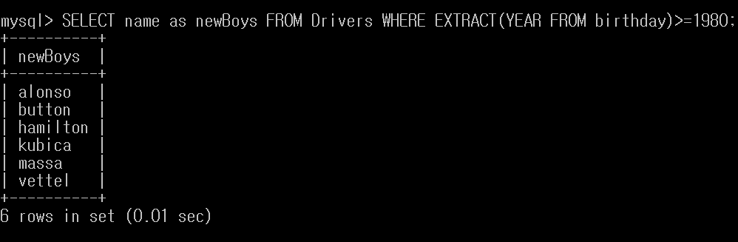

**(e)**

SELECT driver, race FROM Results Where race_rank = 'first place';

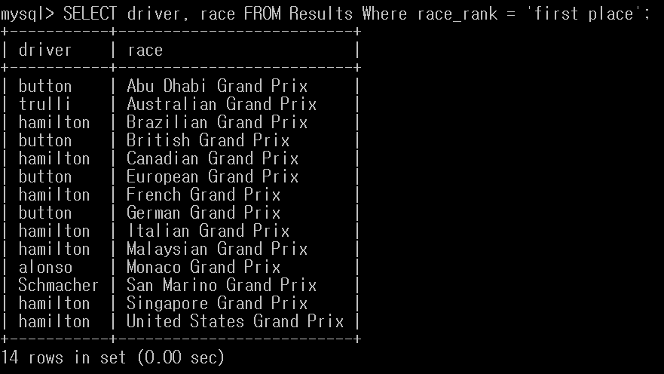

**(f)**

SELECT name FROM Races WHERE area='Europe' ORDER BY name ASC;

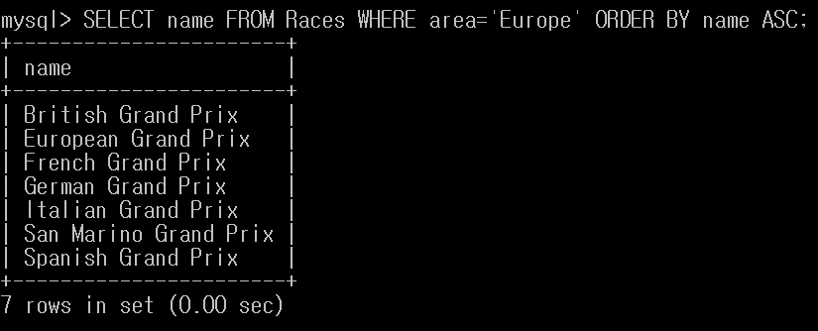

**(g)**

SELECT all name from Drivers WHERE name LIKE 'H%';

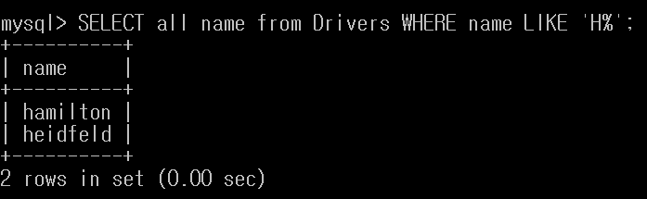

**(h)**

SELECT constructor FROM Constructors WHERE constructor LIKE '% %';

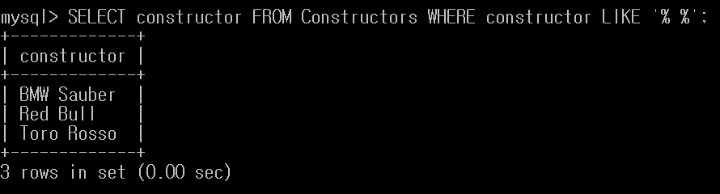

**4.**

**(a)**

SELECT name FROM Constructors, Drivers WHERE Constructors.country = 'Italian' and Constructors.constructor = Drivers.constructor;

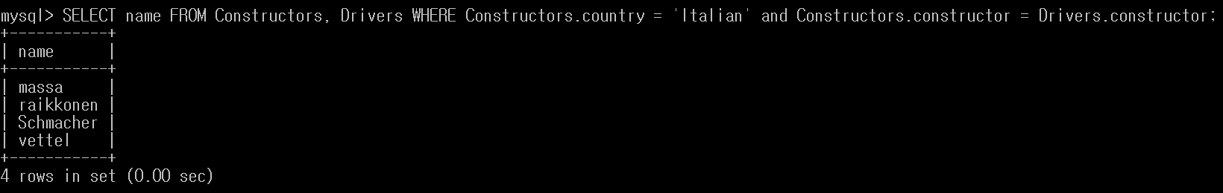

**(b)**

SELECT name FROM Constructors, Drivers WHERE Constructors.constructor = Drivers.constructor and Constructors.country = Drivers.country;

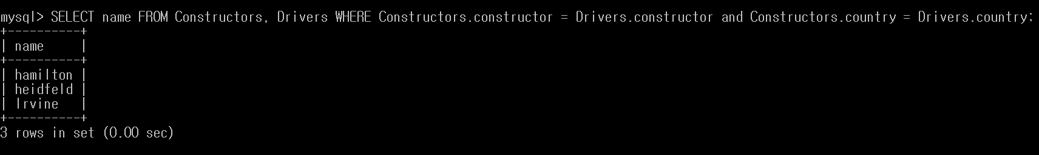

**(c)**

SELECT Results.driver, Constructors.engine, Constructors.races_entered FROM Results, Drivers, Constructors where (Results.race = 'Monaco Grand Prix' and Results.driver = Drivers.name and Drivers.constructor = Constructors.constructor);

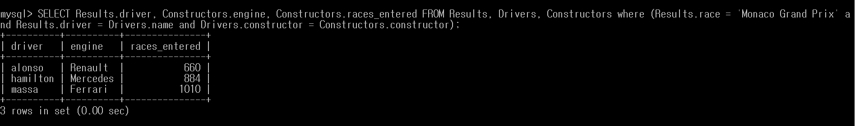

**(d)**

SELECT constructor from Drivers group by constructor having count(name)=1;

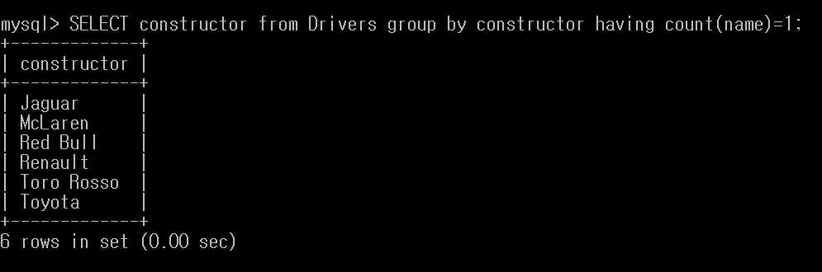

**(e)**

SELECT distinct(Drivers.name) from Drivers, Results WHERE (Results.driver = Drivers.name and Results.race = 'Spanish Grand Prix' or Drivers.constructor = 'BMW Sauber');

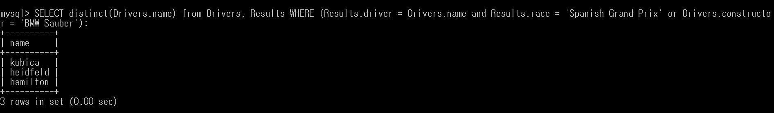

**(f)**

SELECT Drivers.name, Constructors.races_entered from Drivers, Constructors WHERE Drivers.constructor = Constructors.constructor ORDER BY Constructors.races_entered DESC, Drivers.name DESC;

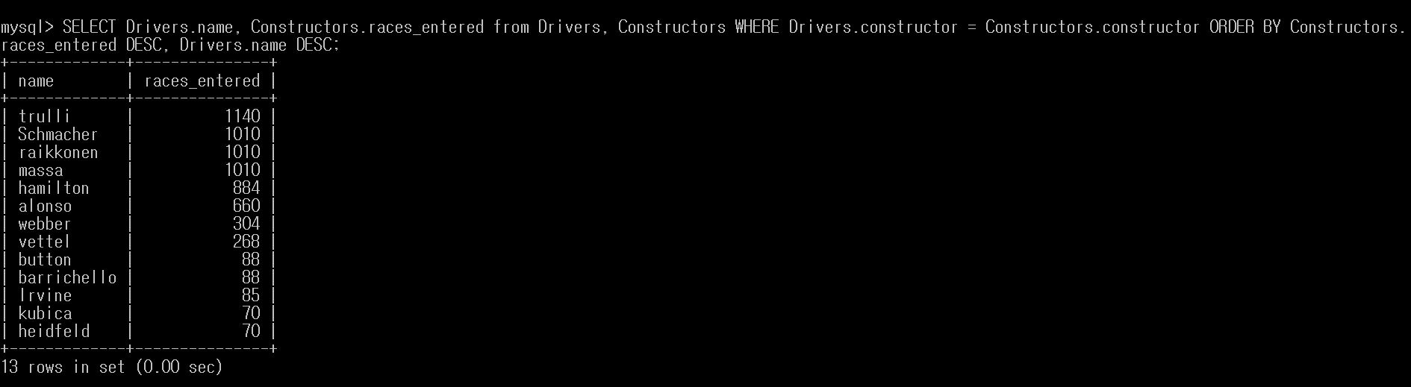

**(g)**

(select country from Constructors where engine='Cosworth') union (select country from Constructors where engine='Mercedes');

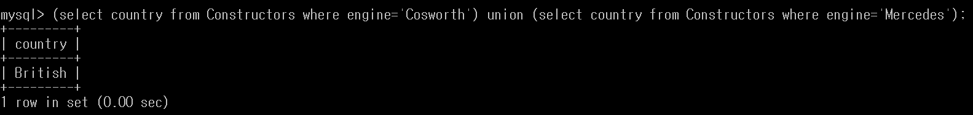

**(h)**

with first(driver) as (select driver from Results where race_rank = 'first place'), secthr(driver) as (select driver from Results where (race_rank = 'second place' or race_rank = 'third place')) select distinct first.driver from first,secthr where first.driver=secthr.driver;

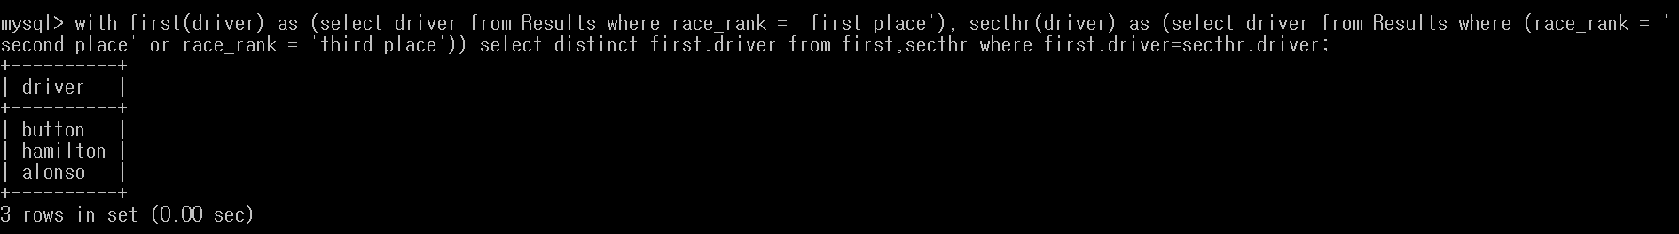

**(i)**

SELECT Results.driver, DATE_FORMAT(Races.date, '%m-%Y') as beginDate FROM Results, Races WHERE (YEAR(Races.date)='2008' or YEAR(Races.date)='2009') and Races.name=Results.race;

