< HW2 Report>



|  |  |
| --- | --- |
| 과 목 명 : | 데이터베이스 |
| 교 수 명 : | 김 연 정 교수님 |
| 학 과 : | 사이버보안전공 |
| 학 번 : | 1971070 |
| 이 름 : | 박 소 현 |

**5.**

**(a)**

select country from Constructors where races_entered in (select max(races_entered) from Constructors);

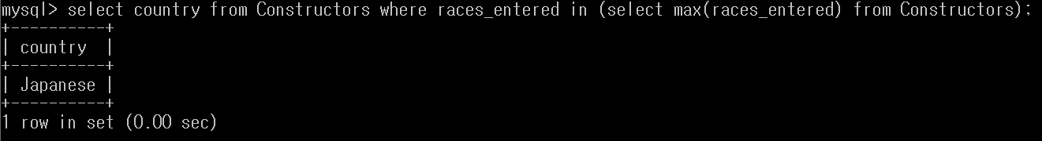

**(b)**

select distinct D.constructor from Drivers as D, Results where exists (select * from Results as R where R.driver = D.name and R.race_rank = 'first place');

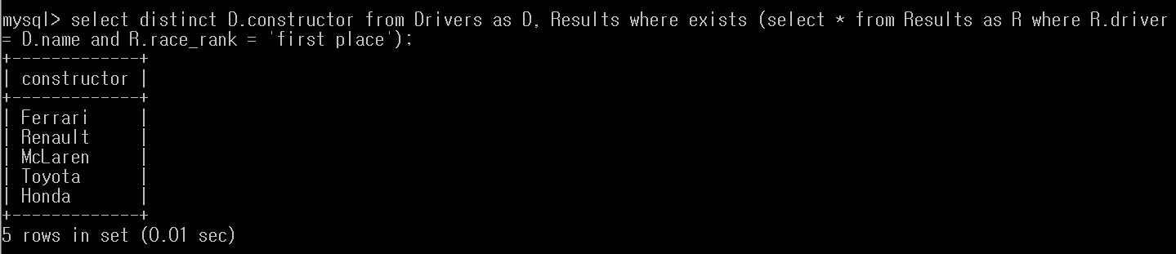

**(C)**

select distinct name from Constructors, Drivers where Drivers.constructor = all(select constructor from Constructors where engine = 'Mercedes');

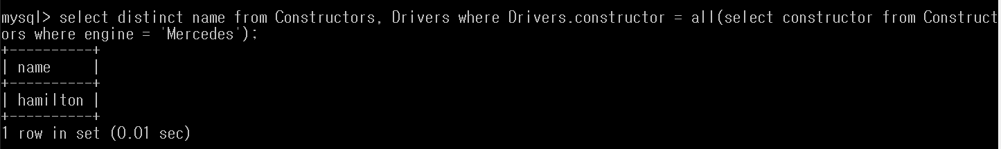

**(d)**

select distinct race from Results, Drivers where Results.driver = any(select name from Drivers where constructor = 'Ferrari');

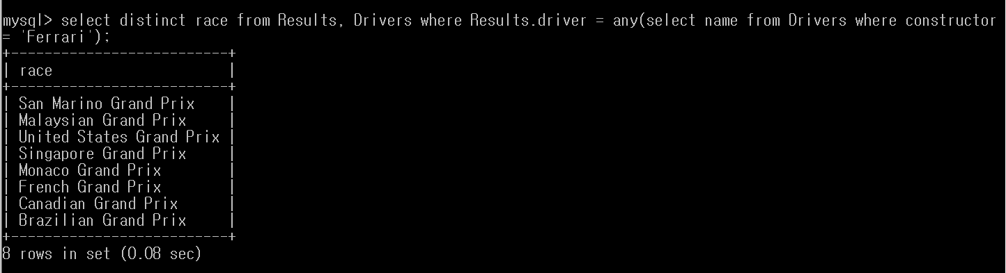

**(e)**

SELECT name FROM drivers WHERE constructor = some (SELECT DISTINCT C1.constructor FROM constructors as C1, constructors as C2 WHERE (C1.height = C2.height AND C1.width > C2.width));

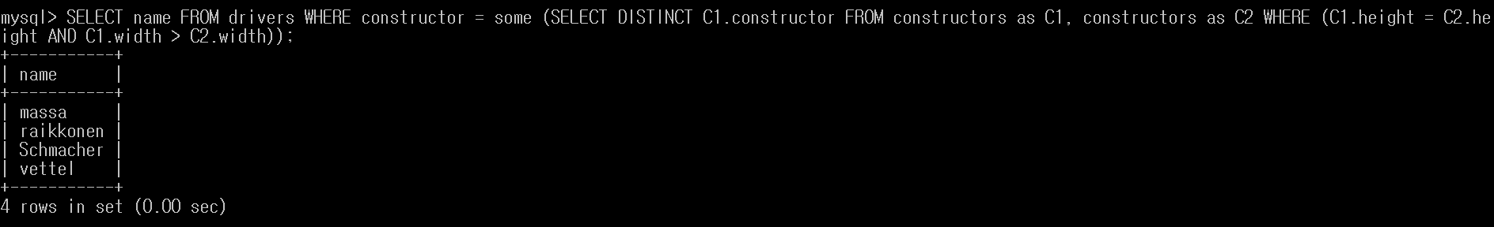

**6.**

**(a)**

select count(*) as count_constructors from Constructors where engine = 'ferrari';

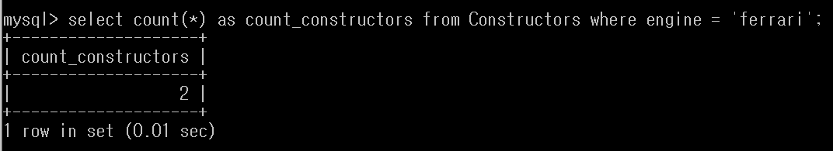

**(b)**

select avg(races_entered) as avg_entered from Constructors where country ='British';

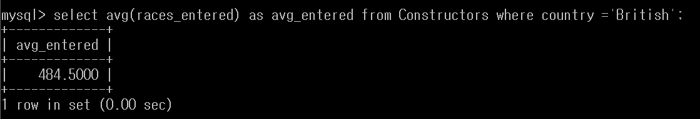

**(c)**

select t1.constructor, t1.birthday from Drivers as t1, (select constructor, max(birthday) as youngest from Drivers group by constructor) as t2 where t1.constructor = t2.constructor and t1.birthday = t2.youngest;

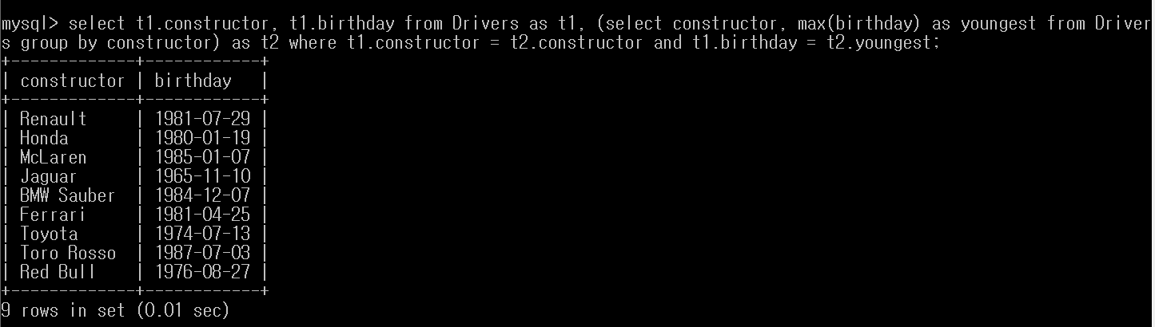

**(d)**

select avg(height) from Constructors, Drivers where Drivers.country = 'German' and Drivers.constructor = Constructors.constructor;

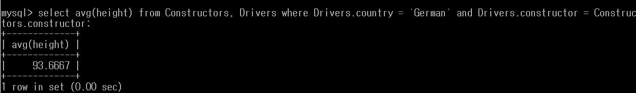

**(e)**

select constructor, count(race_rank) from Results as R, Drivers as D where R.driver = D.name and R.race_rank='first place' group by constructor;

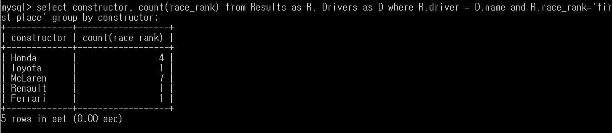

**(f)**

select count(distinct t1.constructor) as numberConstructor from Results as R, Drivers as D, (select constructor from Drivers group by constructor having count(name) >= 2) as t1 where (t1.constructor = D.constructor and R.race_rank = 'first place' and D.name = R.driver);

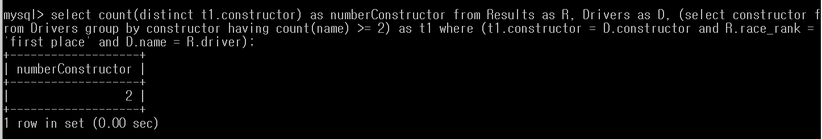

**(g)**

select Constructors.country, Constructors.constructor, avg(timestampdiff(year, birthday, now())) as age from Drivers, Constructors where Constructors.constructor = Drivers.constructor group by Constructors.country, constructor order by country;

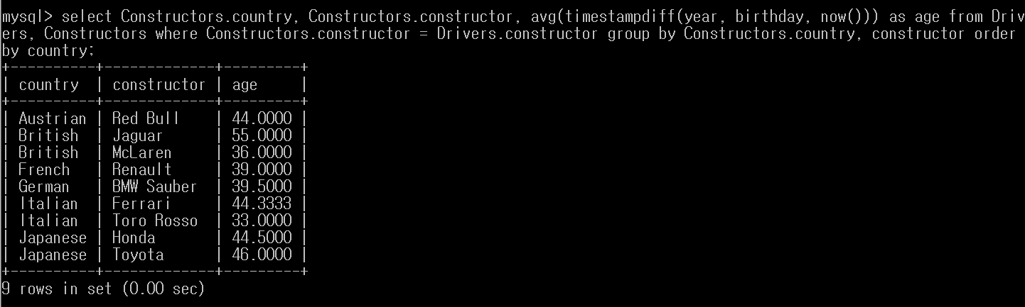

**(h)**

select race, constructor, count(driver) from Drivers join Results on drivers.name = Results.driver group by race, constructor having count(driver)>=2;

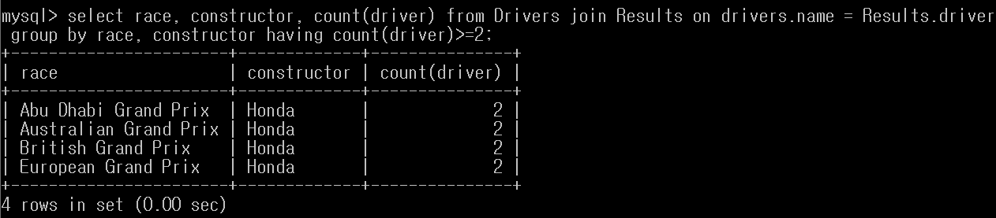

**7.**

**(a)**

INSERT INTO Drivers VALUES('Russell', str_to_date('15/02/1998', '%d/%m/%Y'), 'British', 'BMW Sauber');

INSERT INTO Drivers VALUES('Villeneuve', str_to_date('09/04/1971', '%d/%m/%Y'), 'Canadian', 'BMW Sauber');

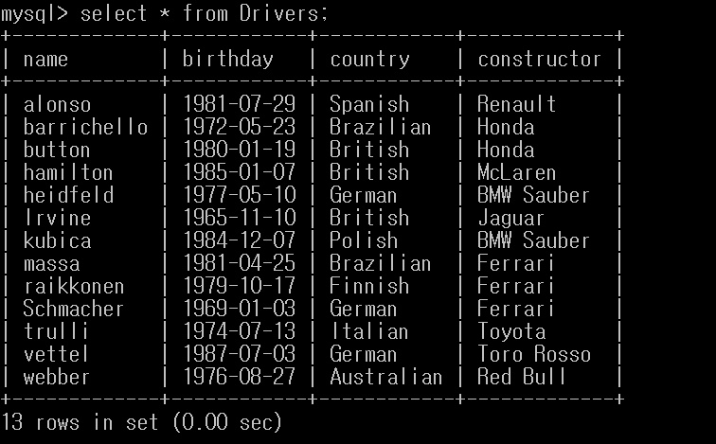

------------쿼리문 입력 후 --------------

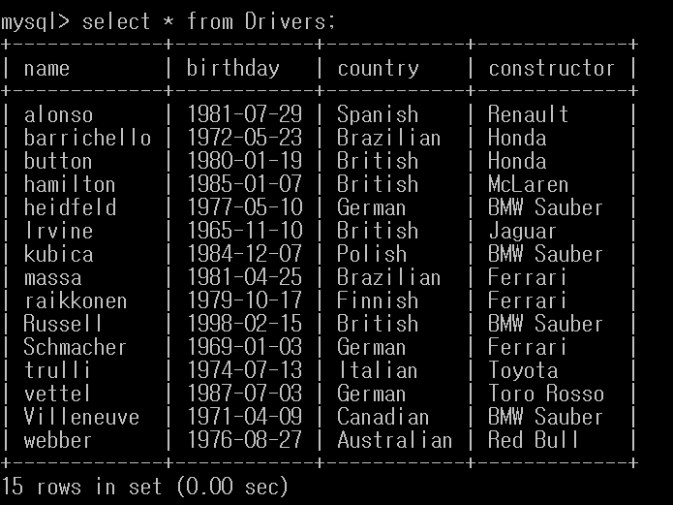

**(b)**

INSERT INTO Constructors VALUES('Sauber', 'Swiss', 'Mercedes', '0', '93', '180');

INSERT INTO Drivers VALUES('Frentzen', str_to_date('18/05/1967', '%d/%m/%Y'), 'German', 'Sauber');

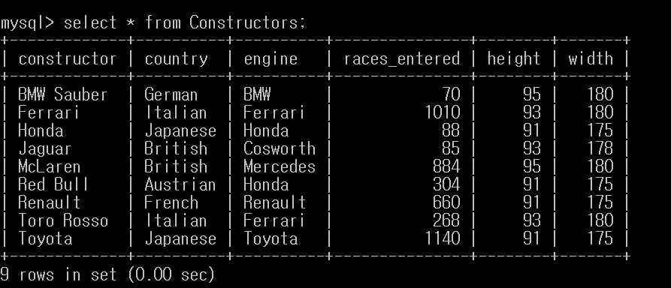

------------쿼리문 입력 후 --------------

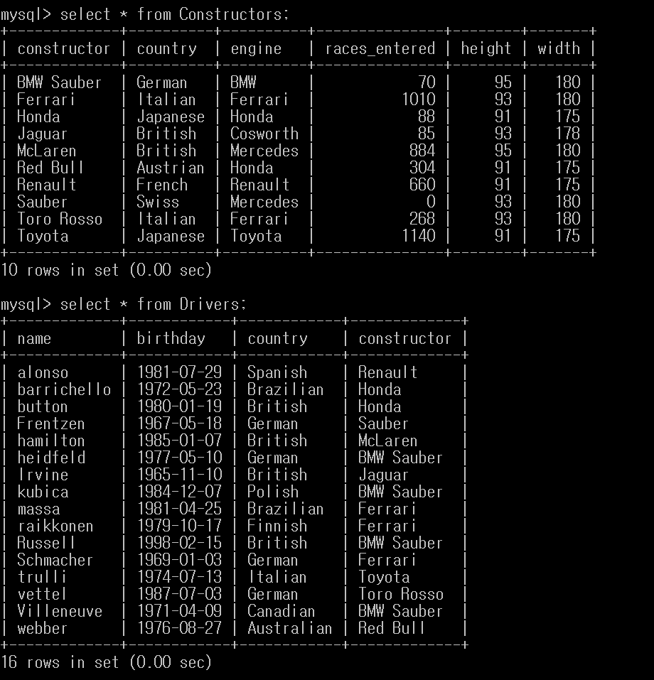

**(c)**

create table temp1 (driver varchar(15), primary key(driver));

INSERT into temp1 (select driver from Results, Races where race = name and area = 'Asia' and race_rank = 'third place');

delete from Results where driver in (select * from temp1);

delete from Drivers where name in (select * from temp1);



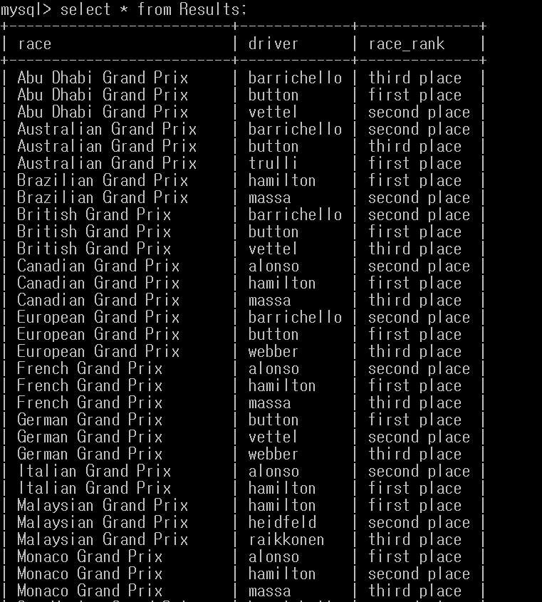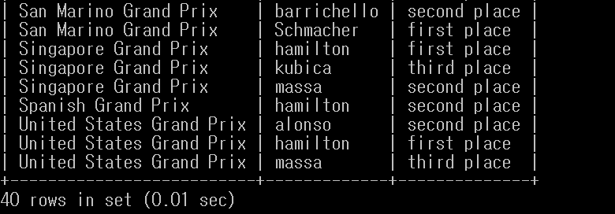

------쿼리문 입력 후------------

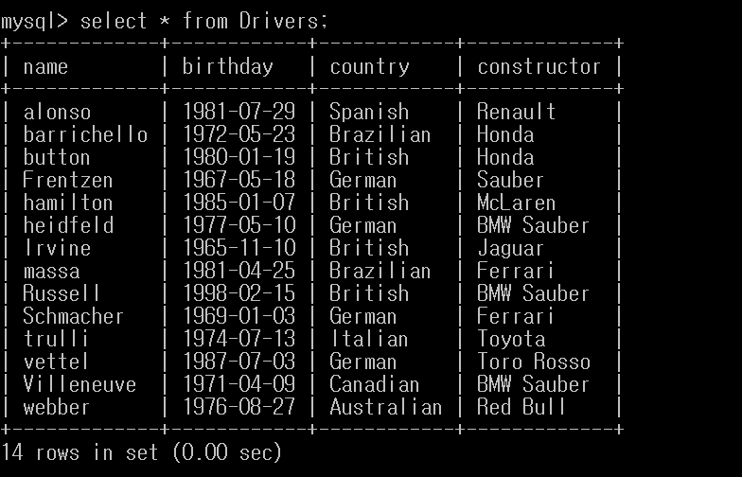

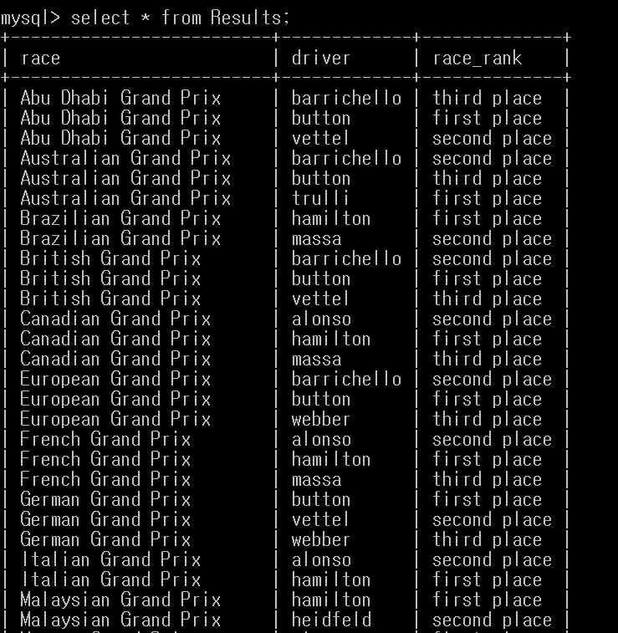

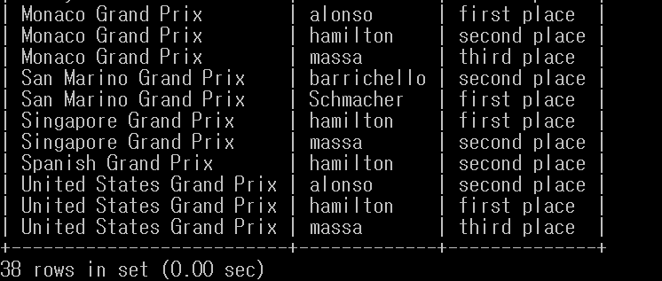

**(d)**

update constructors set width = width/2.5;

update constructors set height = height/2.5;

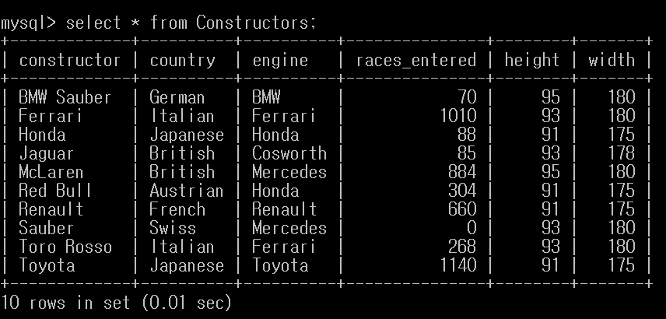

---------------쿼리문 입력 후 --------------

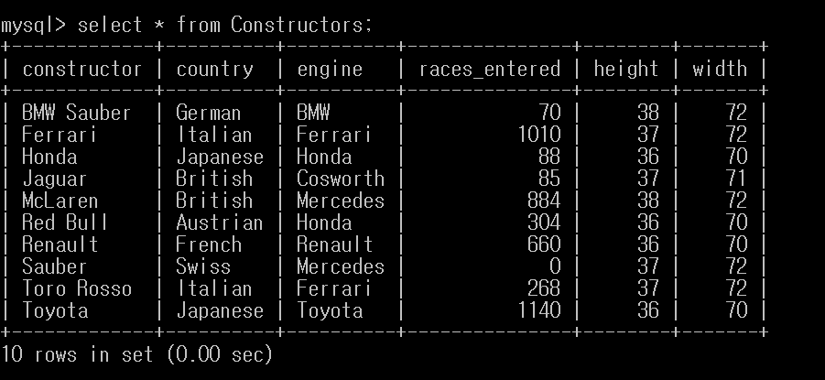

**(e)**

update Results, Constructors, Drivers set race_rank='drop out' where engine='Honda' and Constructors.constructor = Drivers.constructor and Drivers.name = Results.driver;





----------------------쿼리문 입력 후 -------------

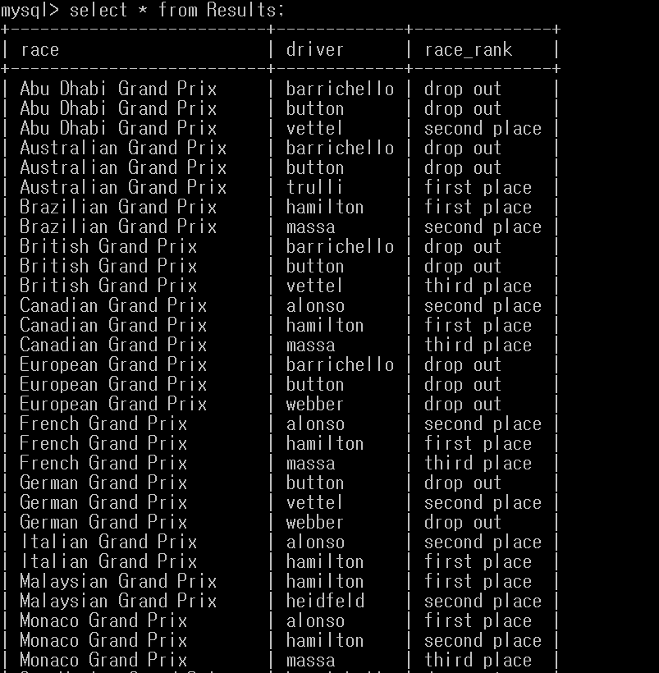

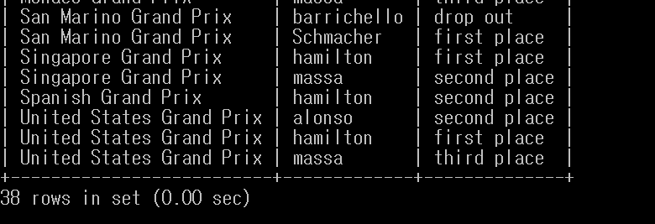

**(f)**

create table con(constructor varchar(15), primary key (constructor));

insert into con(select constructor from Drivers group by constructor having count(constructor)>=2);

create table temp2(driver varchar(15), primary key(driver));

insert into temp2 (select name from drivers where constructor in (select * from con));

delete from results where driver in (select * from temp2);

delete from drivers where name in (select * from temp2);



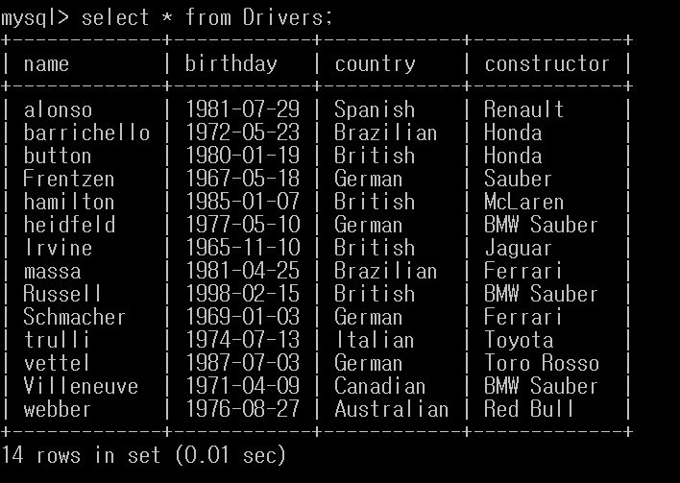

-------------------쿼리문 입력 후 -----------------

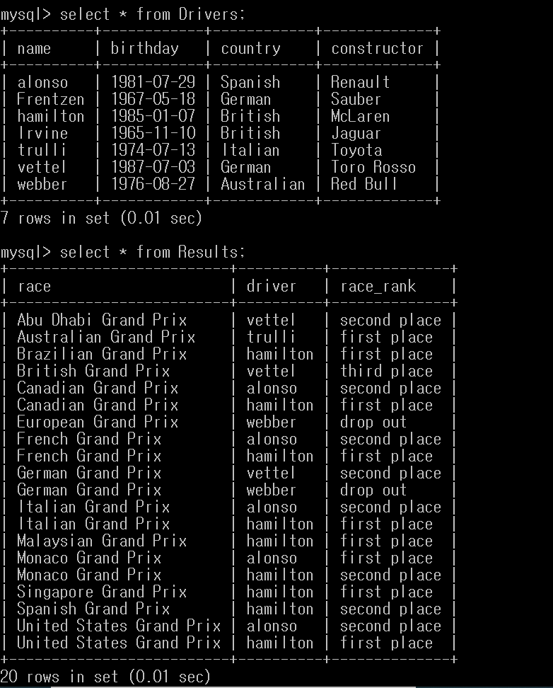

**8.**

**(a)**

alter table constructors drop races_entered;

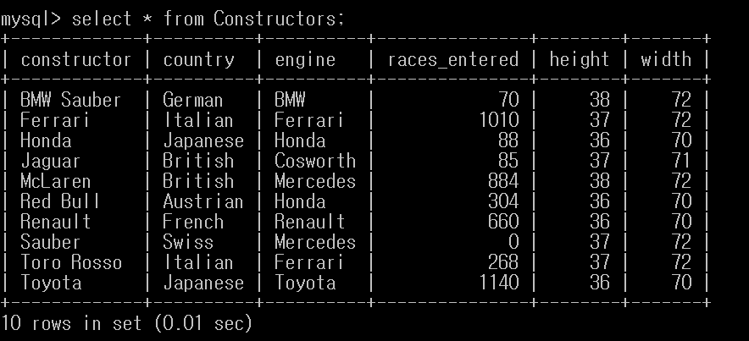

------------쿼리문 입력 후 -------------

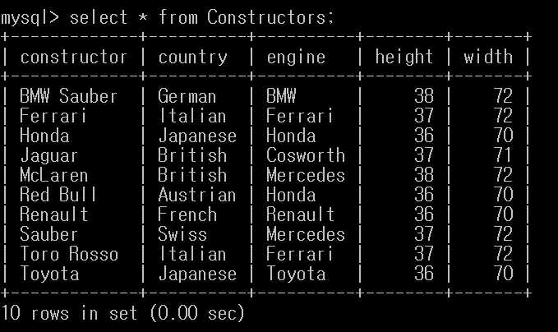

**(b)**

alter table Constructors add tire varchar(20) default 'KoreanCompany';



----------------------쿼리문 입력 후 ----------------

