Process Book 9

Our 4 Major Design Decisions

Simplicity vs functionality:

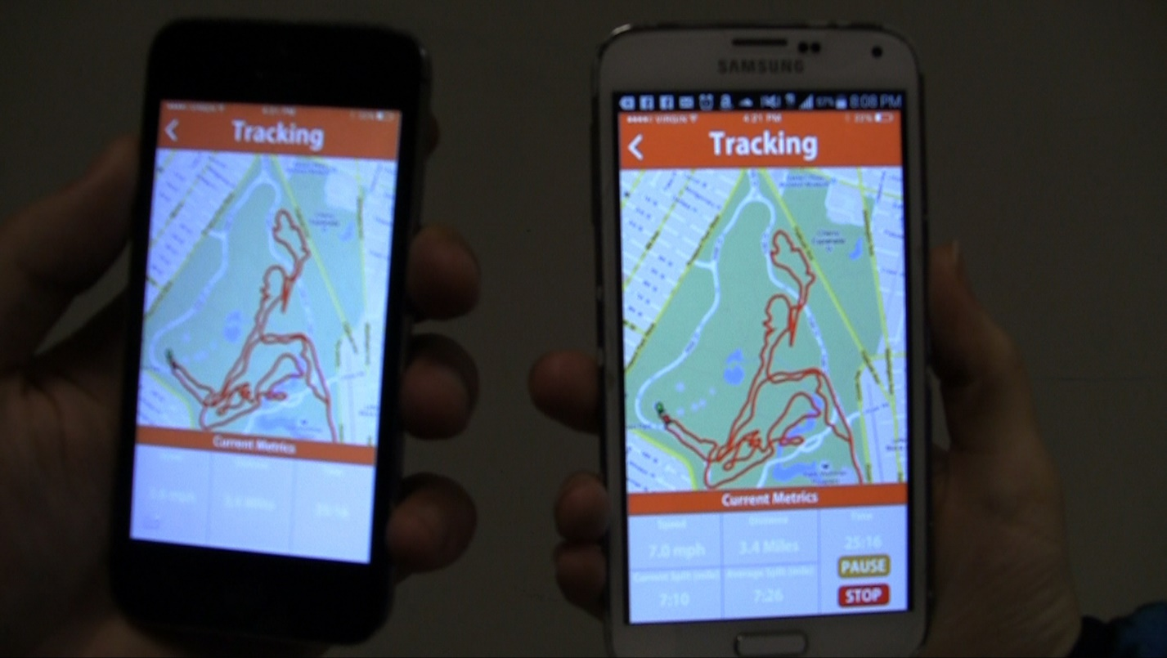

One of the big design decisions we had to make was on simplicity vs functionality for the user-interface of our app. Should we show lots of data for our Smart Soles or should we try to keep it as simple as possible? There seemed to be an inverse relationship between simplicity and functionality. This was the digital portion of our product and when we were stuck on this decision, we decided to think back to our transition. Our transition was getting started with fitness, so we needed to dedicate our design to the average beginner. For beginners, we believed focusing on a simpler user-interface would be more appropriate since it would be easy for them to start using and the interface not being cluttered and hard to use will reduce any stress that could cause beginners to give up.

Thinking deeply about our transition - Accuracy vs Emotions:

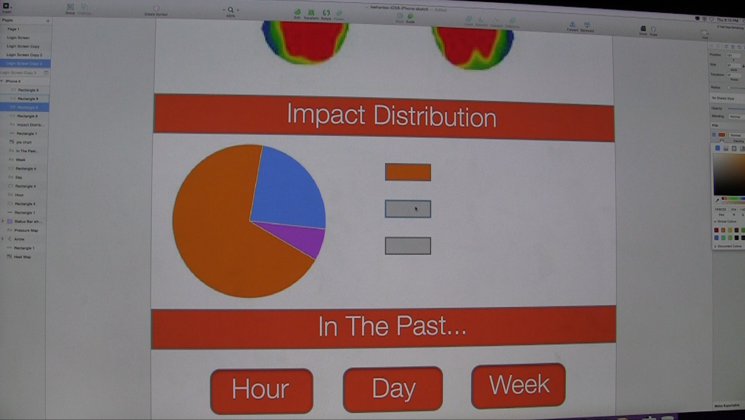

Like mentioned above, our design was catered towards beginners so we wanted to create a UX that will help support their goals. We want the UI not just to be simple, but also to help motivate beginners by showing progress and eliminate anything that could de-motivate users. We even went as far as to consider a design that lied and always showed progress even when the user wasn’t making any at all to keep them from being discouraged. Obviously, the cost of the data being purposely inaccurate was too much for us to take so we went with showing accurate data. This is another inverse relationship that many people won’t think about unless going into the depths of design, and it was interesting to think about because the design problem dove into ethics as well. Another design decision we made was with the background color of our mobile app, which was orange. Dark orange was a nice bright color that psychologically raises the energy of users. This was another subtle design we implemented to help motivate users, although many of them will take the design for granted. Good design will often go unnoticed.

Hardware functionality vs durability:



This issue focused on the physical component of our Smart Soles. We needed certain hardware to record different sets of data but the hardware will be placed within the insole, which takes in the entire body-weight pressure. We don’t want any of the hardware to break easily and we wanted it to last as long as possible. This led us to the decision of sacrificing one of our hardware pieces that takes in data for foot-to-foot pace. We still get the data for speed but not the pace in-between each footstep. Although that was one good idea suggested by one of the users we interviewed, it was not a common need for our average user. The design decisions for our physical hardware lines up with our decisions for our digital app because we are compromising the need for data that is not as important for our main users.

Functionality vs comfort:

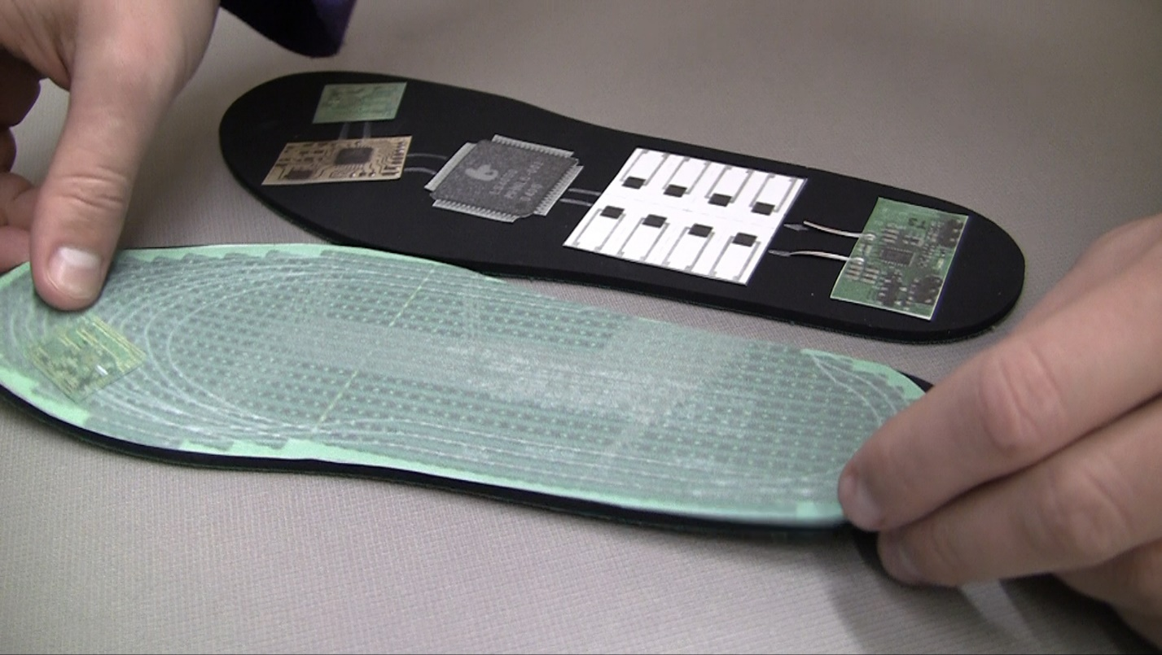

This is similar to the design decision above where we traded off our functionality for something we believed was more important. Comfort is something we kept in mind during the whole design-process. What good is it if our insoles can track all the best data in the world if it’s uncomfortable to wear? We chose comfort over functionality for obvious reasons. Some of the hardware pieces inside the insoles had to be moved around so it can’t be felt by the user’s feet and we added a layer on top of our insoles for extra cushion.