# **Culvert Model v.2.0 Guide**

*This reference is for the updated 2.0 version of the Cornell Culvert Model (updated January 2019). The directory structure has been modified from the earlier version – make sure you use the new file structure when using the new model version python files. Currently this version will work with field data in the NAACC format only.*

***Important note:*** *the tools are currently set up to default to the UTM 18N projection. If this is not the correct projection for your region, you will have to adjust the output extent of the culvert tools.*

1. Set up your file structure

* The File structure diagram is in A.1 of this document. Your files must be organized in this precise way because the python scripts assume this structure to find your input files. Make sure your data files (i.e. field data and precipitation normal for the region) contain the same name as the project folder.
  + Save your NAACC field data in a csv file with the same name as your project directory (e.g. **ALB/ALB.csv**).
  + Make a copy of the GIS_files folder and save it in your working directory (e.g. ALB/GIS_files)
  + Save a copy of the CulvertModelFiles folder in the same location as your working directory.
  + Download NRCC precipitation data from http://precip.eas.cornell.edu/
    - Select the “Data and Products” tab
    - In the “Select Product” column on the left hand side, select “Extreme Precipitation Tables-Text/CSV”
    - Type the name of the county that contains the study watershed.
    - Save the output text file as **‘your project name’_precip.csv** (e.g. **ALB_precip.csv**)

1. Export Data

* Right-click on the extract_NAACC.py file in the “CulvertModelFiles” folder. Chose “Edit with IDLE”
* Press F5 to run the program. The first prompt “Enter the name of your data folder:” type in the name of your project folder (e.g. ALB)
* For the second prompt, input ‘y’ if the columns are in the specified columns in Appendix 2 (the same as the file NAACC_sample.csv). It does not matter the exact column name.
  + Type ‘n’ if instead of these column placements, your data simply has the **exact** column names noted in Appendix 2.
* Upon successful completion of the program, you should now have two new files in your project folder called (e.g.) ALB_field_data.csv, and ALB_not_extracted.csv

1. Open the Template ArcMap document in the GIS_files folder in your working directory, rename it for your project, and gather all the required layers for the culvert run.

* Create new point shapefile in ArcCatalog from the extracted culvert file, project it to UTM coordinates (call it **XY_utm)**, and load points to map.
* Load a DEM of the region large enough to capture the full watersheds contributing to the culverts.
* Load NHD flowlines for culvert area – make sure it is in UTM coordinates (project if not)
* Create a new polygon in the clip shapefile that encompasses a large enough area to contain all contributing areas flowing to culverts. Use the NHD flowlines to determine that area by looking to make sure that any stream on which there is a culvert point downstream is fully included within the clip area, and allow the clip polygon to extend at least as far as the headwaters of unconnected streams in order to ensure you will not be cutting-off any watersheds (See figure 1, below).
* Load the All_Culverts shapefile to the map
* Load a raster file of curve numbers for your region.

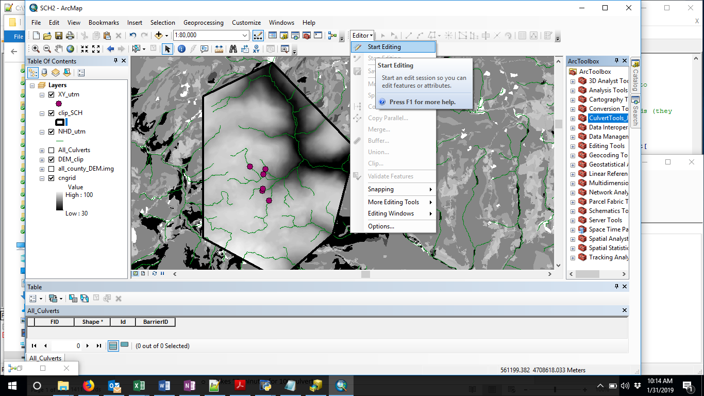

**Figure 1:** Create a polygon in your clip shapefile.

1. Right click to edit the 00_clip_files tool in the CulvertToolbox . Set all the blue ellipses to reference the relevant files and folders for your project (Figure 2). Make sure that all files are projected to UTM. This will create smaller files to speed up processing time. It will also resample the CN file so that the raster cells are the same size as the DEM, which will prevent errors curve number values for culvert watersheds.

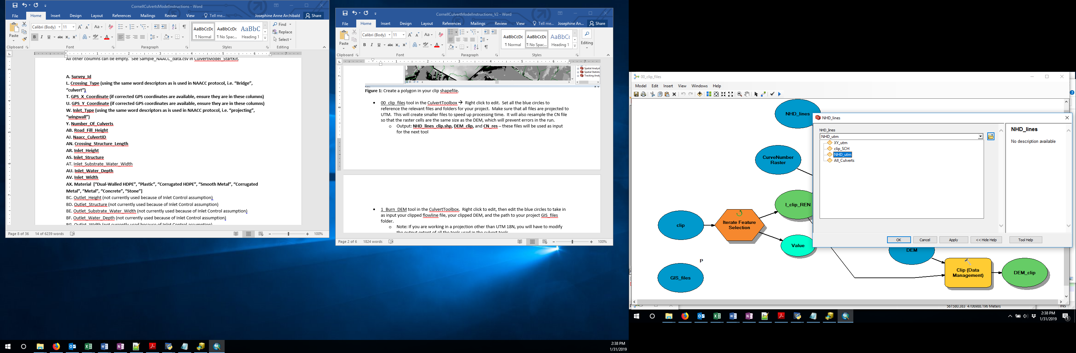

Figure 2: Showing the layer NHD_utm being chosen for the NHD_lines model parameter.

* Output: **NHD_lines_clip.shp, DEM_clip,** and **CN_res –** these files will be used as input for the next tool

1. Right click on the 01_Culvert_Watershed_Model to edit it. If you named your projected filed data points “XY_utm”, and created the clip files using the clip tool above, you only need to edit the GIS_files blue ellipse, to make it point to your project GIS_files folder location. If you created your input files differently, then make sure you click on all ellipses to make them point to the correct files. This tool calls on a number of sub-tools, and can take several hours depending on the size of your clipped DEM and the number of culverts. If you run into errors, you can run each of the sub-tools separately, making sure to edit the blue ellipses of each tool for all your files and folders.
2. Once the run has completed, do a visual inspection of the All_Culverts shapefile, to make sure the culvert watersheds look reasonable and have not been cut off by the clip outline. If the watersheds appear to have been delineated incorrectly and it’s not clear why, take a look at the other files in the DEMs folder – in particular, facc.tif is the flow accumulation file, and should have 8 categories (e.g. see figure 3).

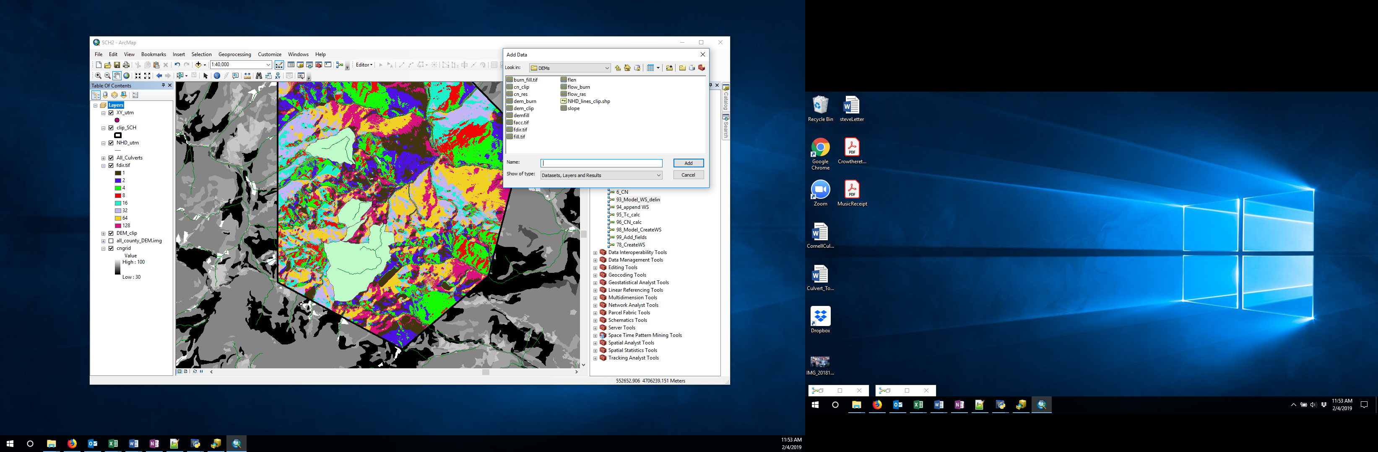

**Figure 3**. After the model has run, the All_Culverts file will have watershed shapes associated with each culvert. You can look at intermediate files created to generate this output in the GIS_files/DEMs folder (see Appendix 3 for details)

1. Right click on the All_Culverts shapefile, and take a look at the attribute table. Click on the icon in the top-left of the table, and select “Export”. Save your file within your project folder, calling it **“All_Culverts.csv”,** after choosing ‘Text file’ in the drop-down menu for file type (Figure 4). It is important you use this exact file name, so that the python scripts can recognize it.

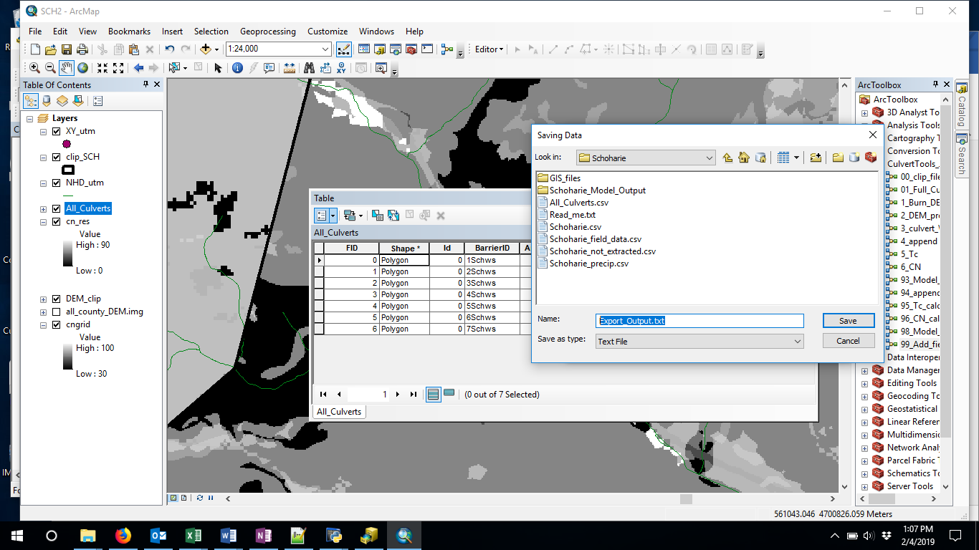

**Figure 4:** Saving the All_Culverts attribute table as a csv file – change the highlighted output name in the figure above to “All_Culverts.csv” after selecting Text File as the file type.

* If errors occur when running the model, it can be useful to run each component separately, so that the user can visually inspect intermediate results and determine when errors occur. If that is the case, the user can run models 1_Burn_DEM – 6_CN to create the shapefile and attribute table above. Any time the model has to be re-run, the user should make sure to have a new copy of the All_Culverts shapefile loaded onto their map (so that it has no rows of data in its attribute table before the model is run)

1. Use the python script to compute the peak discharge, capacity and max return periods

* Right click on the Culverts_Eval.py file in the “CulvertModelFiles” folder
  + - Select “Edit with IDLE”
    - Once the script is open, hit F5 (This will open the python shell)
    - This script will read in the output from the Arc Model, and needs the input file names to follow the naming convention described (e.g. if ALB is your project):
      * ALB/All_Culverts.csv (Arc culvert run export file)
      * ALB/ALB_precip.csv
      * ALB/ALB_field_data.csv

Script Outputs (in a new folder in your project folder, called “_Model_Output”):

1. culv_geometry: a csv file containing the areas of each culvert and assigned coefficients used in the capacity calculations
2. capacity_output: a CSV file containing the maximum capacity of each culvert before the headwater overtops the road surface
3. current_runoff: a CSV file containing the calculated runoff of each culvert watershed under the 1, 2, 5, 10, 25, 50, 100, 200 and 500 year storm events with current precipitation data
4. future_runoff: a CSV file containing the calculated runoff of each culvert watershed under the 1, 2, 5, 10, 25, 50, 100, 200 and 500 year storm events with projected 2050 precipitation data
5. return_periods: a CSV file containing the maximum return period storm that each culvert can safely pass for the current and projected 2050 precipitation data.
6. model_output: a CSV file containing a summary of the above 5 outputs. The file contains the maximum return period that each culvert can safely pass, the capacity of each culvert and information about culvert geometry. This file can be viewed as the final output of this model.

# Appendix 1: File structure for the Cornell Culvert Model V.2.0

**Figure A.1.** File structure for the Cornell Model run. Blue rectangles represent files and folders from the Cornell Culvert Model (Dark blue – ArcGIS toolbox; blue – Culvert model folders; light blue – culvert model files). Orange rectangles represent user-created folders and files, and green rectangles represent model output files and folders. Folder names have white text, file names have black text. The user created data folder must have the same name as the user-created data files name prefix, and be in the same directory as the CulvertModelFiles folder.

The schematic shows multiple data folders that the user might have – each would have the file structure indicated for Data Folder 1. Dark outlined folders (CulvertModelFiles and GIS_files) are copied from the CulvertModel GitHub account.

# Appendix 2: Required column numbers or names for the extract.py program

* If you respond ‘n’ to the prompt, it does not matter what order your data columns take, but they must have the following **exact** names:
  + 'Survey_Id','Naacc_Culvert_Id','GPS_Y_Coordinate','GPS_X_Coordinate','Road','Material','Inlet_Type', 'Inlet_Structure_Type', 'Inlet_Width', 'Inlet_Height', 'Road_Fill_Height', 'Slope_Percent', 'Crossing_Structure_Length' ,'Outlet_Structure_Type', 'Outlet_Width', 'Outlet_Height', 'Crossing_Type' ,'Crossing_Comment', 'Number_Of_Culverts'
* If you respond “y” to the prompt, you must have these exact columns in your csv spreadsheet, but the names themselves don’t matter.

**A**. Survey_Id

**L**. Crossing_Type (using the same word descriptors as is used in NAACC protocol, i.e. “Bridge”, “culvert”)

**T.** GPS_X_Coordinate (if corrected GPS coordinates are available, ensure they are in these columns)

**U.** GPS_Y_Coordinate

**W.** Inlet_Type (using the same wording as NAACC protocol, i.e. “projecting”, “wingwall”)

**Y.** Number_Of_Culverts

**AB.** Road_Fill_Height AJ. Naacc_Culvert_Id

**AN.** Crossing_Structure_Length

**AR.** Inlet_Height

**AS.** Inlet_Structure

**AU**. Inlet_Water_Depth

**AV.** Inlet_Width

**AX**. Material [“Dual-Walled HDPE”, “Plastic”, “Corrugated HDPE”, “Smooth Metal”, “Corrugated Metal”, “Metal”, “Concrete”, “Stone”]

**BJ.** Slope_Percent

# Appendix 3: Intermediate files created by the Culvert Toolbox

* GIS_files/DEMs (all files clipped to the size of the clip shapefile)
  + burn_fill: The original DEM with streams burned and pits filled. This is the file used to determine flow accumulation, flow direction, and ultimately the watershed boundaries.
  + cn_clip: The original CN file, clipped to the extend specified by the user
  + cn_res: The resampled clipped CN file, resampled to the DEM raster size
  + demfill: Filled DEM (without burned streams)
  + facc: Flow accumulation raster
  + fdir: Flow direction raster – created using D8, meaning flow can come to any particular cell from any of the 8 raster cells around it. This file should have 8 distinct values (1,2 4,8,16,32,64,128)
  + flen: Flow length raster – used to calculate Time of Concentration (Tc) for each watershed
  + flow_burn: raster created from the NHD lines used to burn in streams to the DEM. Streams are represented by 1, all other areas are 0
  + flow_ras: Raster version of the NHD lines file – used to create the flow_burn file
  + slope: A raster of the slope values (in % rise), created from the filled DEM. Used to calculate the Time of Concentration

# Appendix 4: Intermediate tools in the Culvert Toolbox in Arc

If the full watershed model does not work, you can run each model component separately to see where the error occurs. Make sure you have run the 00_clip_files tool, and that you have a new, empty All_Culverts shapefile saved in your project’s GIS_files folder. Also, delete all files previously created in the GIS_files/WS_Poly folder. Don’t worry about deleting files in the DEMs folder – these will be rewritten.

* 1_Burn_DEM tool in the CulvertToolbox. Right click to edit, then edit the blue circles to take in as input your clipped flowline file, your clipped DEM, and the path to your project GIS_files folder.
  1. Note: If you are working in a projection other than UTM 18N, you will have to modify the output extent of all the tools used in the culvert tools
* 2_Dem_prep
  + Change the blue workspace to your DEM folder, and check that the Projected DEM blue circle references your burned DEM (which it should if you follow the tool order here.
    - Creates intermediate files needed for watershed delineation – filled DEM, flow accumulation, flow direction, flow length (“flen”)
  + This step is relatively quick
* 3_culvert_ws_delineation: Delineate watersheds for each culvert
  + Right-click to Edit 3_culvert_ws_delineation tool
  + Edit the four blue ellipses with your files and folders. This step takes the longest
* 4_append_ws
  + Check attribute table of the All_Culvert shapefile is empty
  + Edit 4_append_ws tool to make the three blue ellipses point to your files/folders
  + Run 🡪 all watersheds into one shapefile
* 99_Add_fields: In this final step, you will add additional fields to the All_Culvert shapefile attribute table, and calculate the values for each watershed. You can do this in one step by editing the 99_Add_fields tool to reference your files which will complete the Arc portion of the model, or if you want to go slowly to error check, you can break it down further:
  + Add empty columns to the All_Culverts file for“Area_sqkm” (type=float), Tc_hr (float), CN (float)
    - Right click on the heading of the Area_sqkm, select “Calculate Geometry” and hit “yes” when the dialogue box pops up. Change units to square kilometers
  + Calculate Tc for each watershed
    - Edit the 5_Tc tool and change the blue circles for your files and paths. Use the slope raster that was created with the BurnDEM tool
  + Calculate the weighted CN for each culvert watershed by editing the Blue ellipses for your files in the 6_CN tool
* Once completed, export the attribute table from the All_Culverts file, by continuing to step 7.