The spatial files required to run the Cornell Culvert Model, used in ArcMap, include the following:

* A DEM of the region large enough to capture the full watersheds contributing to the culverts.
* NHD flowlines for culvert area – make sure it is in UTM coordinates (project if not)
* The empty All_Culverts shapefile contained in the GIS_files folder (from GitHub)
* A raster file of curve numbers for your region, projected to UTM.
* OPTIONAL:
  1. NOAA precipitation rasters for Return Intervals 1,2,5,10,25,50,100,200,500 years
  2. The NY StreamStats Region shapefile (ff_region)

OR

* 1. NRCC precipitation data saved as a csv file in the project folder (not used in ArcMap)
* User-created files:
  1. Projected point shapefile that includes all stream-crossing locations
  2. Clip shapefile

1. DEM file (Digital Elevation Model). The model can run reasonably well with a 10m DEM, available from the USGS. Higher-resolution DEM files can lead to more accurate watershed delineation, and less failed culverts, but would make the model run-time much longer. *For culverts located in New York State:*
   1. Go to the NYS GIS clearinghouse (gis.ny.gov)
   2. Click on the “Data” tab on the left of the gray bar (as of April 2016)
   3. Click on “Elevation” in the Data tab dropdown
   4. From the top of the list of options on the left-hand side of the window, select “Statewide Interactive DEM Download”
   5. Once the map appears, click on the green tool icon, and select the download icon (second from the top).

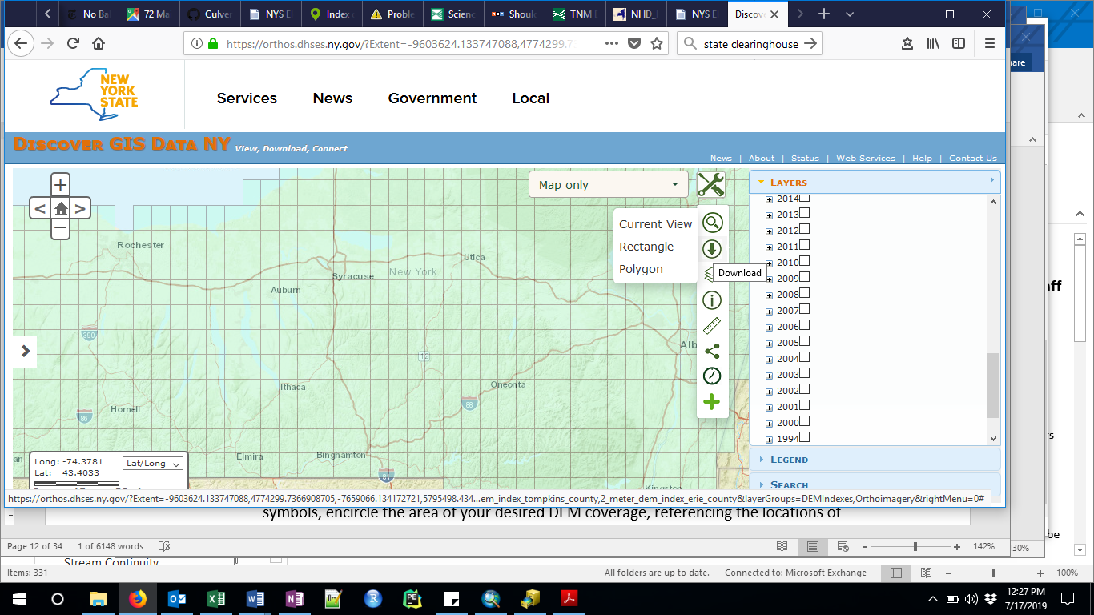

1. NHD line shapefile The NHD Flowlines can be downloaded from the USGS [here](https://viewer.nationalmap.gov/basic/?basemap=b1&category=nhd&title=NHD%20View). Project this file to UTM in ArcCatalog before loading into ArcMap.
2. The Soil and Water Lab has a CN file created from 2006 landuse data for NY State (Contact mtw5@cornell.edu).
3. Precip options:
   1. Download NOAA precipitation raster files from <https://hdsc.nws.noaa.gov/hdsc/pfds/pfds_gis.html>
      1. Although metadata comes with the files, the rasters are not projected. You will need to tell ArcGIS the projection they are in, which is GCS North American 83. (Geographic Coordinate Systems → North America → US and Territories → NAD 83)
      2. Download the 24-hour precipitation raster layers for all return periods of interest (1,2,5,10,25,50,100,200,500 year return intervals).
   2. Download NRCC precipitation data from http://precip.eas.cornell.edu/
      * 1. Select the “Data and Products” tab
        2. In the “Select Product” column on the left hand side, select “Extreme Precipitation Tables-Text/CSV”
        3. Type the name of the county that contains the study watershed.
        4. Save the output text file as **‘your project name’_precip.csv** (e.g. **ALB_precip.csv**)