MongoDB report - DBLP

MANIP M'EBOBISSE Séthi-MOHAMED Soilhat-NGATCHA Nancy-ROMANO Léa

13 février 2019

## How do we import the dataset in the NoSQL database

mongoimport --host localhost:27017 --db DBLP --collection publis --file "path" --jsonArray

1. **Simple queries**

* Find all books written by Dov M. Gabbay and print only the title.

**db.dblp.find({"authors" : "Dov M. Gabbay"},{"title" : 1, "_id" : 0})**

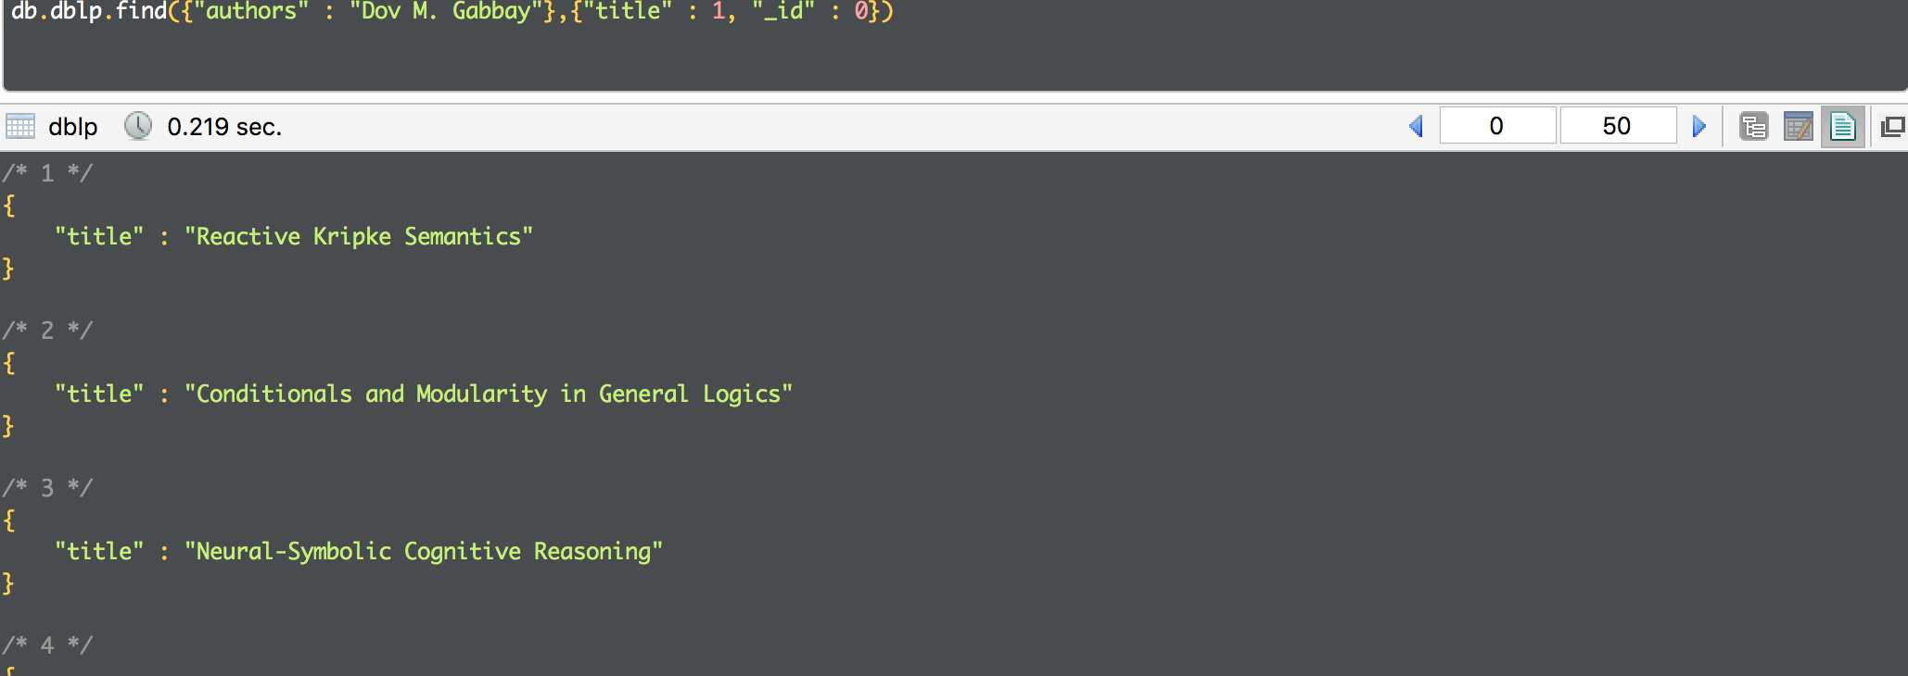

* Find books or articles written before 2010

**db.dblp.find({"year" : {$lte : 2010}},{"title" : 1, "year" : 1})**

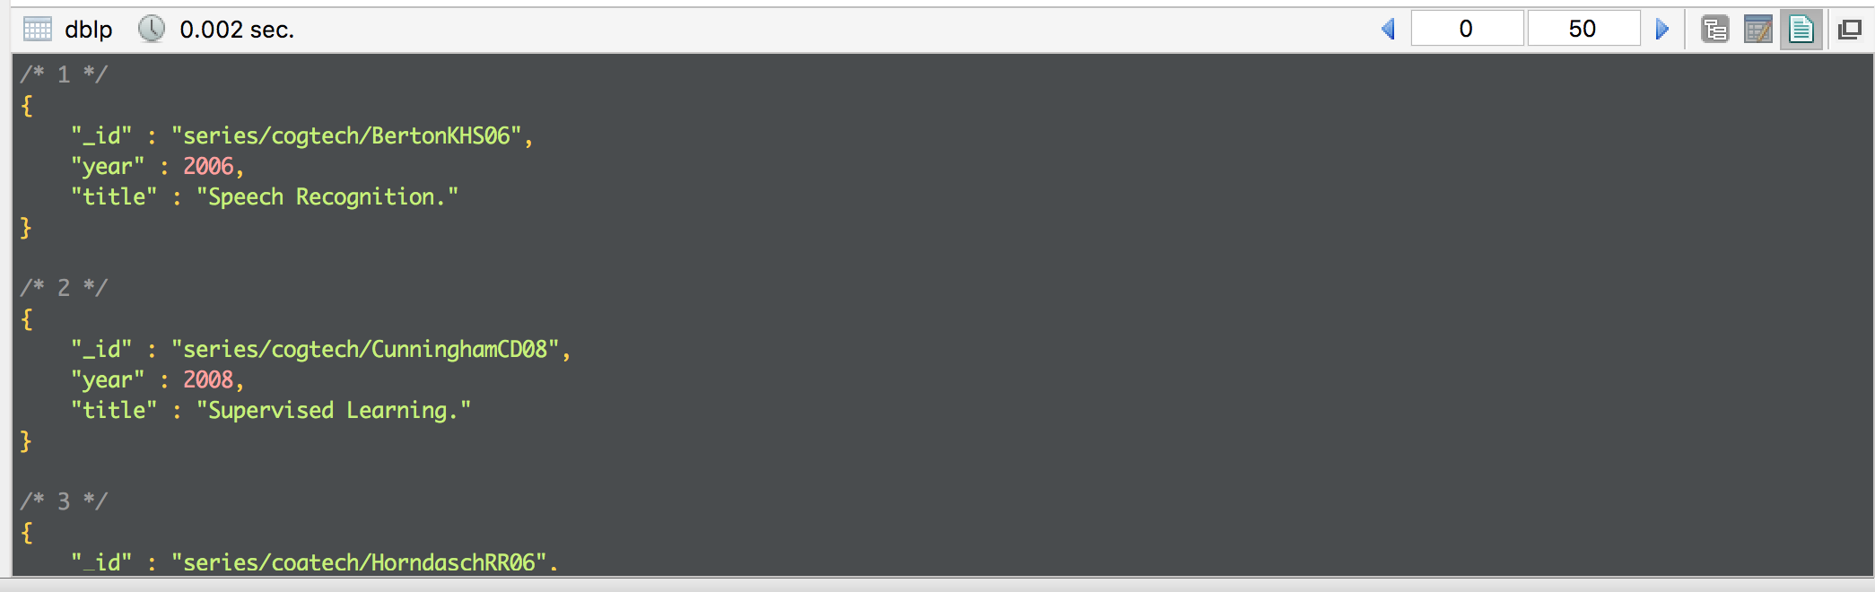

* Findthe number of books in the database

**db.dblp.count({"type" : « Book"});**

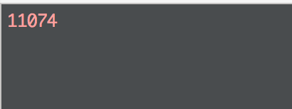

* Find the authors of the book "The Complexity of Valued Constraint Satisfaction Problems »

**db.dblp.find({"title" :"The Complexity of Valued Constraint Satisfaction Problems"},{"title" : 1, "_id" : 0,"authors" : 1})**

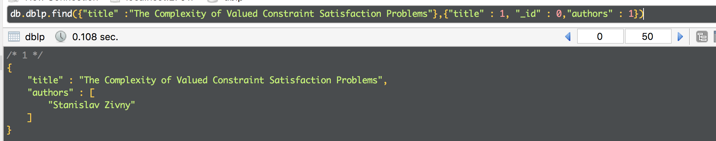

* List of authors

**db.dblp.distinct("authors")**

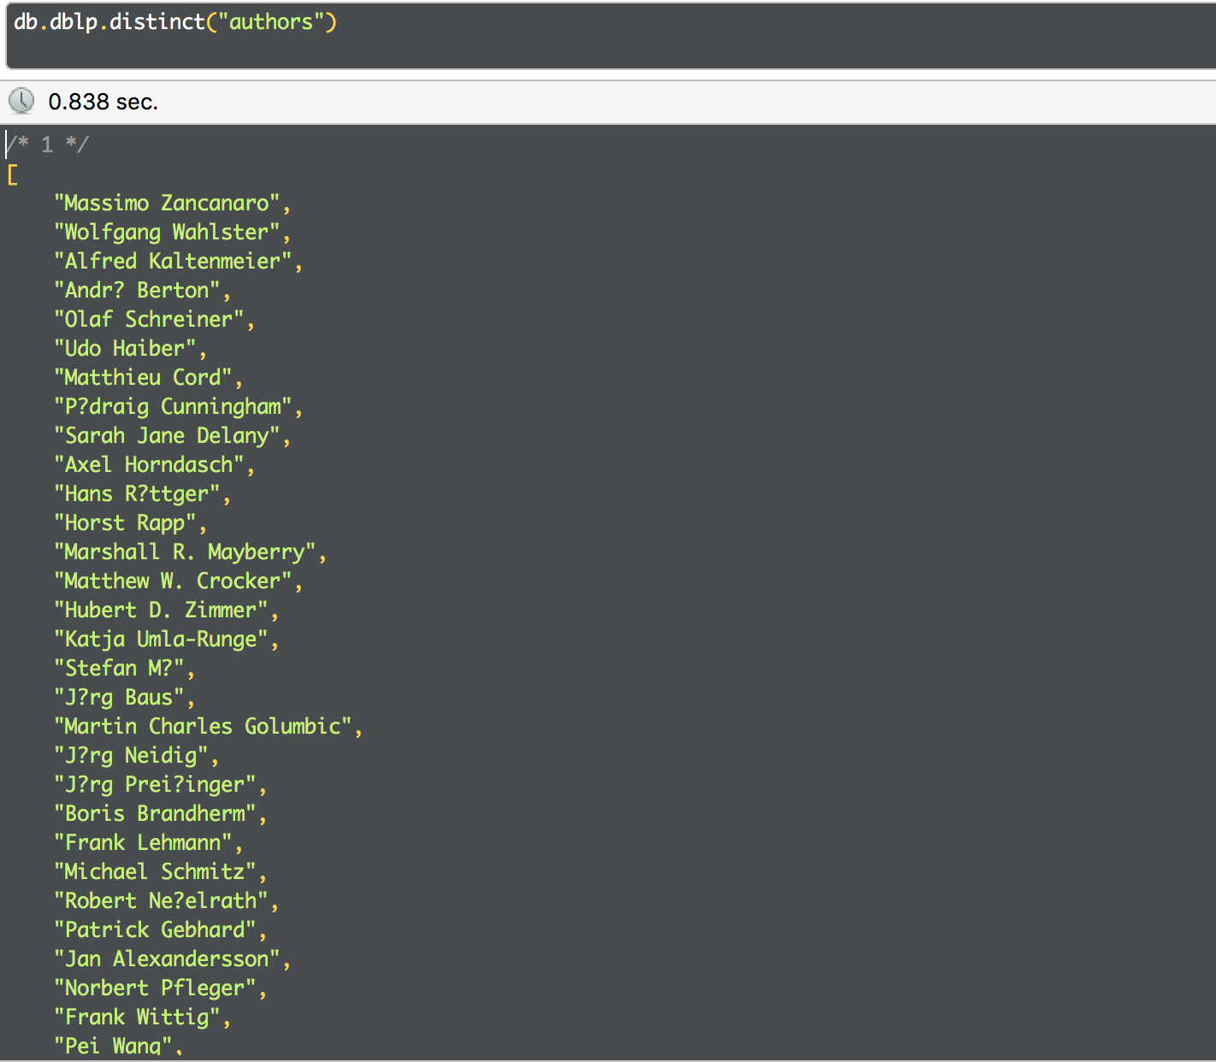

* List of all publications which title contains the word “theory”

**db.dblp.find({"title" : /theory/i},{"title" : 1, "_id" : 0})**

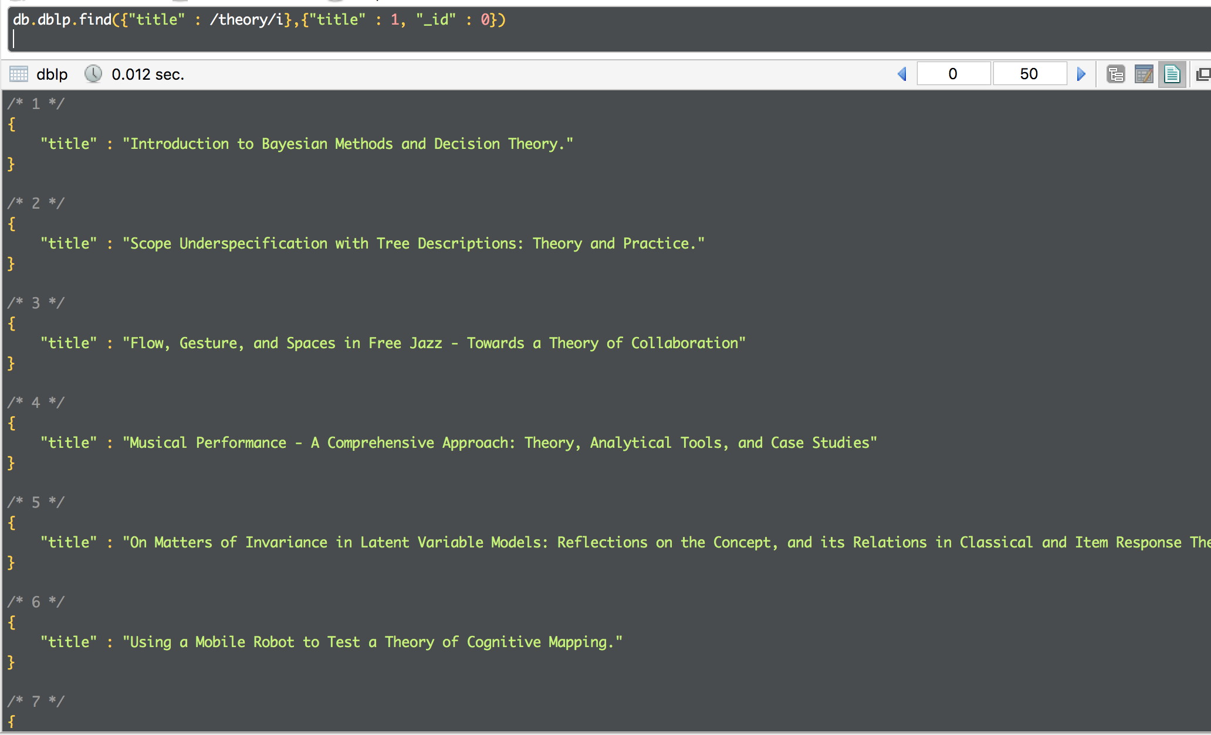

1. **Complex queries**

* All Dov M. Gabbay’s publications, projected the title and sorted by the starting page

varMatch = {$match : {"authors" : "Dov M. Gabbay"}};

varProject = {$project : {"title" : 1, "pages.start" :1}};

varSort = { $sort : {"pages.start" : 1}}; //trie par ordre alpha, -1 pour inverser

db.dblp.aggregate([varMatch, varProject, varSort]);

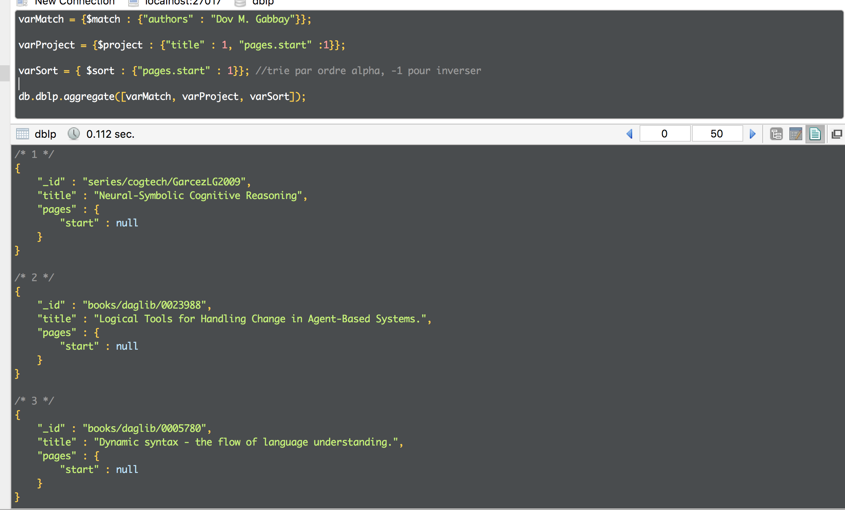

* Count how much publications have “theory” in their title

**db.dblp.find({"title" : /theory/i}).count()**

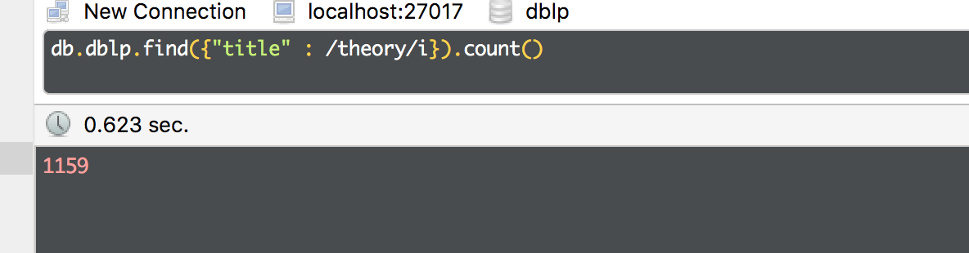

4.Hard queries