MCD

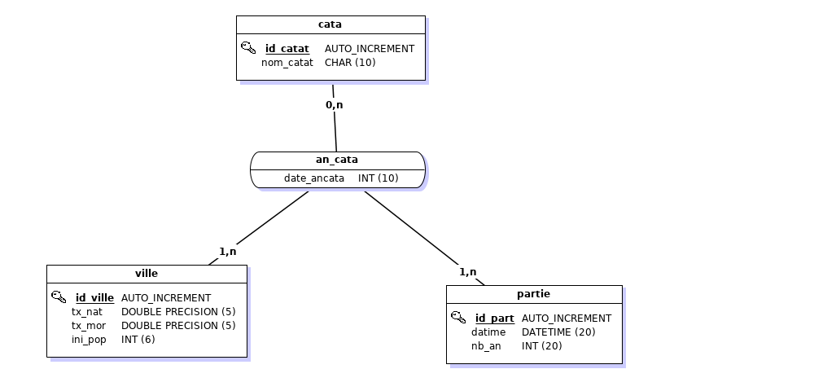

MLD

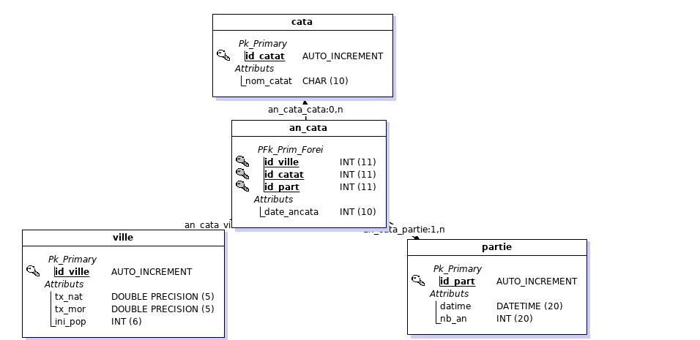

MPD

#------------------------------------------------------------

# Script MySQL.

#------------------------------------------------------------

#------------------------------------------------------------

# Table: cata

#------------------------------------------------------------

CREATE TABLE cata(

id_catat Int Auto_increment NOT NULL ,

nom_catat Char (10)

,CONSTRAINT cata_PK PRIMARY KEY (id_catat)

)ENGINE=InnoDB;

#------------------------------------------------------------

# Table: ville

#------------------------------------------------------------

CREATE TABLE ville(

id_ville Int Auto_increment NOT NULL ,

tx_nat Double NOT NULL ,

tx_mor Double NOT NULL ,

ini_pop Int NOT NULL

,CONSTRAINT ville_PK PRIMARY KEY (id_ville)

)ENGINE=InnoDB;

#------------------------------------------------------------

# Table: partie

#------------------------------------------------------------

CREATE TABLE partie(

id_part Int Auto_increment NOT NULL ,

datime Datetime NOT NULL ,

nb_an Int NOT NULL

,CONSTRAINT partie_PK PRIMARY KEY (id_part)

)ENGINE=InnoDB;

#------------------------------------------------------------

# Table: an_cata

#------------------------------------------------------------

CREATE TABLE an_cata(

id_ville Int NOT NULL ,

id_catat Int NOT NULL ,

id_part Int NOT NULL ,

date_ancata Int

,CONSTRAINT an_cata_PK PRIMARY KEY (id_ville,id_catat,id_part)

,CONSTRAINT an_cata_ville_FK FOREIGN KEY (id_ville) REFERENCES ville(id_ville)

,CONSTRAINT an_cata_cata0_FK FOREIGN KEY (id_catat) REFERENCES cata(id_catat)

,CONSTRAINT an_cata_partie1_FK FOREIGN KEY (id_part) REFERENCES partie(id_part)

)ENGINE=InnoDB;

Diagramme de classe

