中南大学

Web应用开发技术
实验报告

姓 名： | 王永恒
学 号： | 8209190514
班 级： | 软件工程1905
指导老师： | 宋 铁
完成时间：
分 数：
批阅日期：
实验一 基于MVC用JSP/Servlet实现JPetStore

- 实验内容——基本任务。
- 商品展示业务模块，包括大类Category、小类Product和具体商品Item的展示和搜索功能。
- 用户管理业务模块，包括用户注册、登录、修改用户信息、查询用户相关订单等业务功能。
- 订单管理模块，包括购物车管理、新增订单、地址信息等业务功能。

//以上三个业务模块，用运行界面截图和核心代码展示功能完成情况。

- 商品展示业务模块，包括大类Category、小类Product和具体商品Item的展示和搜索功能。

1.1大类Category

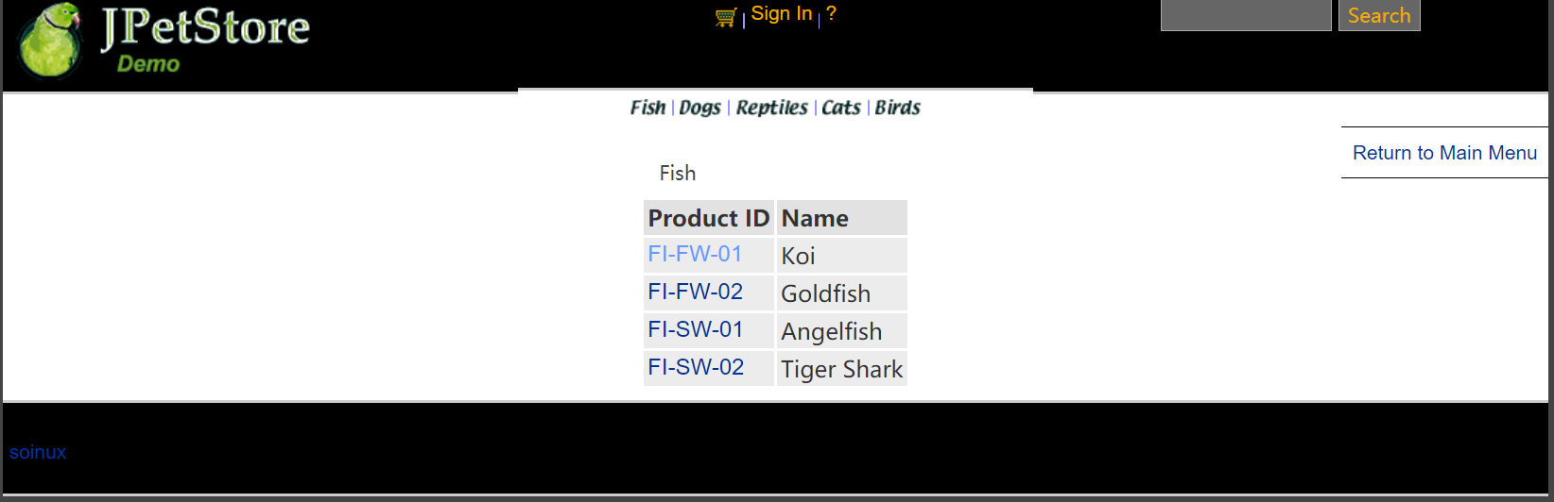

ViewCategoryServlet：
public class ViewCategoryServlet extends HttpServlet {
private static final String VIEW_CATEGORY = "/WEB-INF/jsp/catalog/Category.jsp";
private String categoryId;
protected void doPost(HttpServletRequest request, HttpServletResponse response) throws ServletException, IOException {
doGet(request, response);
}
protected void doGet(HttpServletRequest request, HttpServletResponse response) throws ServletException, IOException {
categoryId = request.getParameter("categoryId");
CatalogService service = new CatalogService();
Category category = service.getCategory(categoryId);
List<Product> productList = service.getProductListByCategory(categoryId);
//保存数据
HttpSession session = request.getSession();
session.setAttribute("category", category);
session.setAttribute("productList", productList);
//HttpSession session = request.getSession();
Account account = (Account)session.getAttribute("account");
if(account != null){
HttpServletRequest httpRequest= request;
String strBackUrl = "http://" + request.getServerName() + ":" + request.getServerPort()
+ httpRequest.getContextPath() + httpRequest.getServletPath() + "?" + (httpRequest.getQueryString());
LogService logService = new LogService();
String logInfo = logService.logInfo(" ") + strBackUrl + " 跳转到商品种类 " + category;
logService.insertLogInfo(account.getUsername(), logInfo);
}
//跳转页面
request.getRequestDispatcher(VIEW_CATEGORY).forward(request, response);
}

1.2小类Product

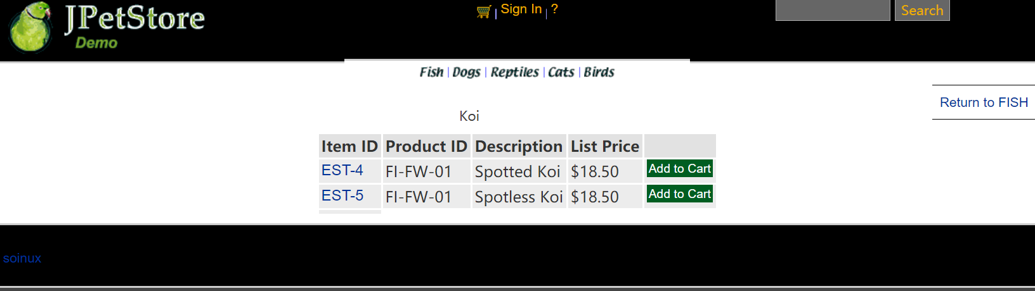

ViewProductServlet：
public class ViewProductServlet extends HttpServlet {
private static final String VIEW_PRODUCT = "/WEB-INF/jsp/catalog/Product.jsp";
private String productId;
protected void doPost(HttpServletRequest request, HttpServletResponse response) throws ServletException, IOException {
doGet(request, response);
}
protected void doGet(HttpServletRequest request, HttpServletResponse response) throws ServletException, IOException {
productId = request.getParameter("productId");
CatalogService service = new CatalogService();
Product product = service.getProduct(productId);
List<Item> itemList = service.getItemListByProduct(productId);
HttpSession session = request.getSession();
session.setAttribute("product", product);
session.setAttribute("itemList", itemList);
Account account = (Account)session.getAttribute("account");
if(account != null){
HttpServletRequest httpRequest= request;
String strBackUrl = "http://" + request.getServerName() + ":" + request.getServerPort()
+ httpRequest.getContextPath() + httpRequest.getServletPath() + "?" + (httpRequest.getQueryString());
LogService logService = new LogService();
String logInfo = logService.logInfo(" ") + strBackUrl + " 查看产品 " + product;
logService.insertLogInfo(account.getUsername(), logInfo);
}
request.getRequestDispatcher(VIEW_PRODUCT).forward(request, response);
}
}

1.3具体商品Item

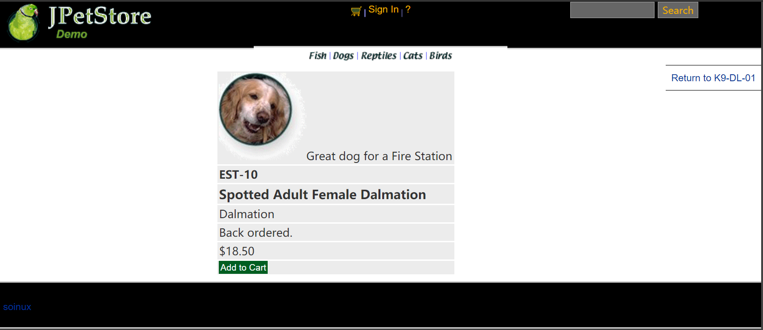

ViewItemServlet：
public class ViewItemServlet extends HttpServlet {
private static final String VIEW_ITEM = "/WEB-INF/jsp/catalog/Item.jsp";
private String itemId;
protected void doPost(HttpServletRequest request, HttpServletResponse response) throws ServletException, IOException {
doGet(request, response);
}
protected void doGet(HttpServletRequest request, HttpServletResponse response) throws ServletException, IOException {
itemId = request.getParameter("itemId");
CatalogService service = new CatalogService();
Item item = service.getItem(itemId);
HttpSession session = request.getSession();
session.setAttribute("item", item);
//HttpSession session = request.getSession();
Account account = (Account)session.getAttribute("account");
if(account != null){
HttpServletRequest httpRequest= request;
String strBackUrl = "http://" + request.getServerName() + ":" + request.getServerPort()
+ httpRequest.getContextPath() + httpRequest.getServletPath() + "?" + (httpRequest.getQueryString());
LogService logService = new LogService();
String logInfo = logService.logInfo(" ") + strBackUrl + " 查看具体商品 " + item;
logService.insertLogInfo(account.getUsername(), logInfo);
}
request.getRequestDispatcher(VIEW_ITEM).forward(request, response);
}
}

1.4搜索功能

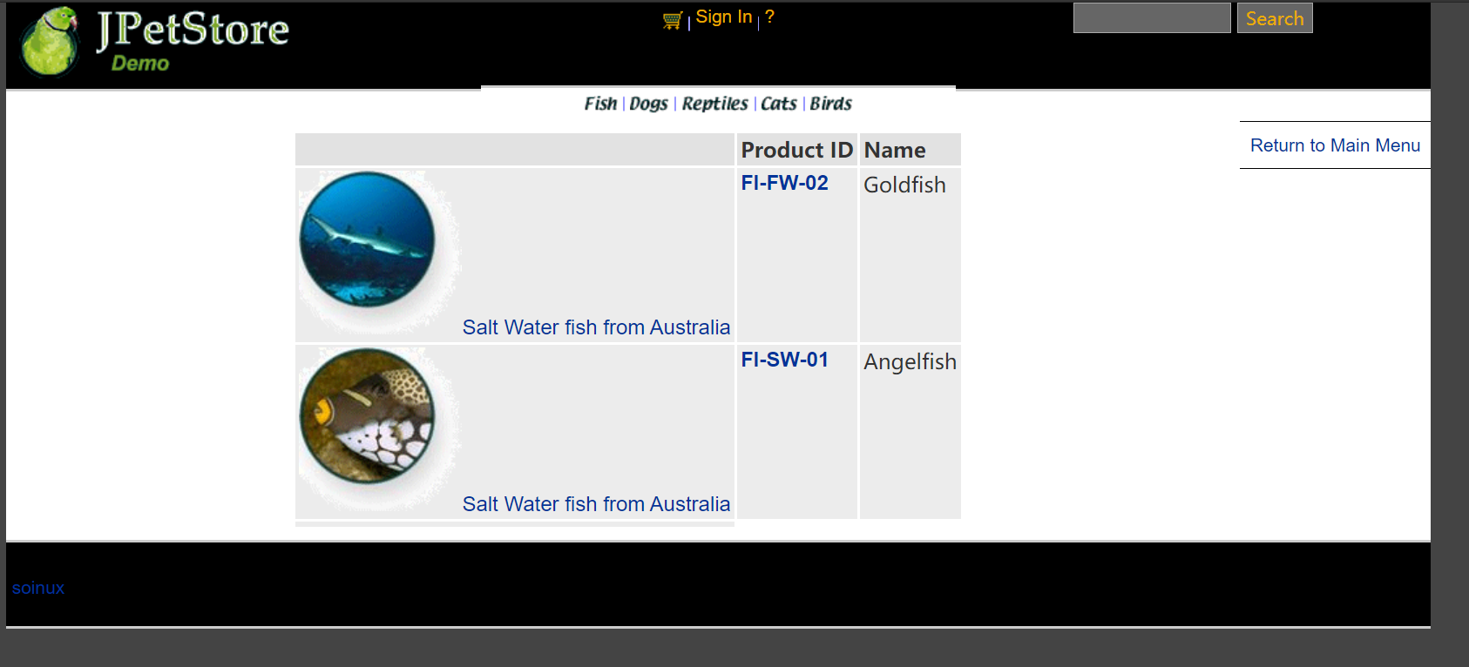

SearchProductServlet：
- public class SearchProductServlet extends HttpServlet {
- private static final String SEARCH_PRODUCTS = "/WEB-INF/jsp/catalog/SearchProducts.jsp";
private String keyword;
protected void doPost(HttpServletRequest request, HttpServletResponse response) throws ServletException, IOException {
doGet(request, response);
}
protected void doGet(HttpServletRequest request, HttpServletResponse response) throws ServletException, IOException {
keyword = request.getParameter("keyword");
//request.setAttribute("keyword", keyword);
CatalogService service = new CatalogService();
List<Product> productList = service.searchProductList(keyword);
//保存数据
HttpSession session = request.getSession();
session.setAttribute("keyword", keyword);
session.setAttribute("productList", productList);
Account account = (Account)session.getAttribute("account");
if(account != null){
HttpServletRequest httpRequest= request;
String strBackUrl = "http://" + request.getServerName() + ":" + request.getServerPort()
+ httpRequest.getContextPath() + httpRequest.getServletPath() + "?" + (httpRequest.getQueryString());
LogService logService = new LogService();
String logInfo = logService.logInfo(" ") + strBackUrl + " 查找商品" + " " + productList;
logService.insertLogInfo(account.getUsername(), logInfo);
}
//跳转页面
request.getRequestDispatcher(SEARCH_PRODUCTS).forward(request, response);
}
}

用户管理业务模块，包括用户注册、登录、修改用户信息、查询用户相关订单等业务功能。

2.1用户注册

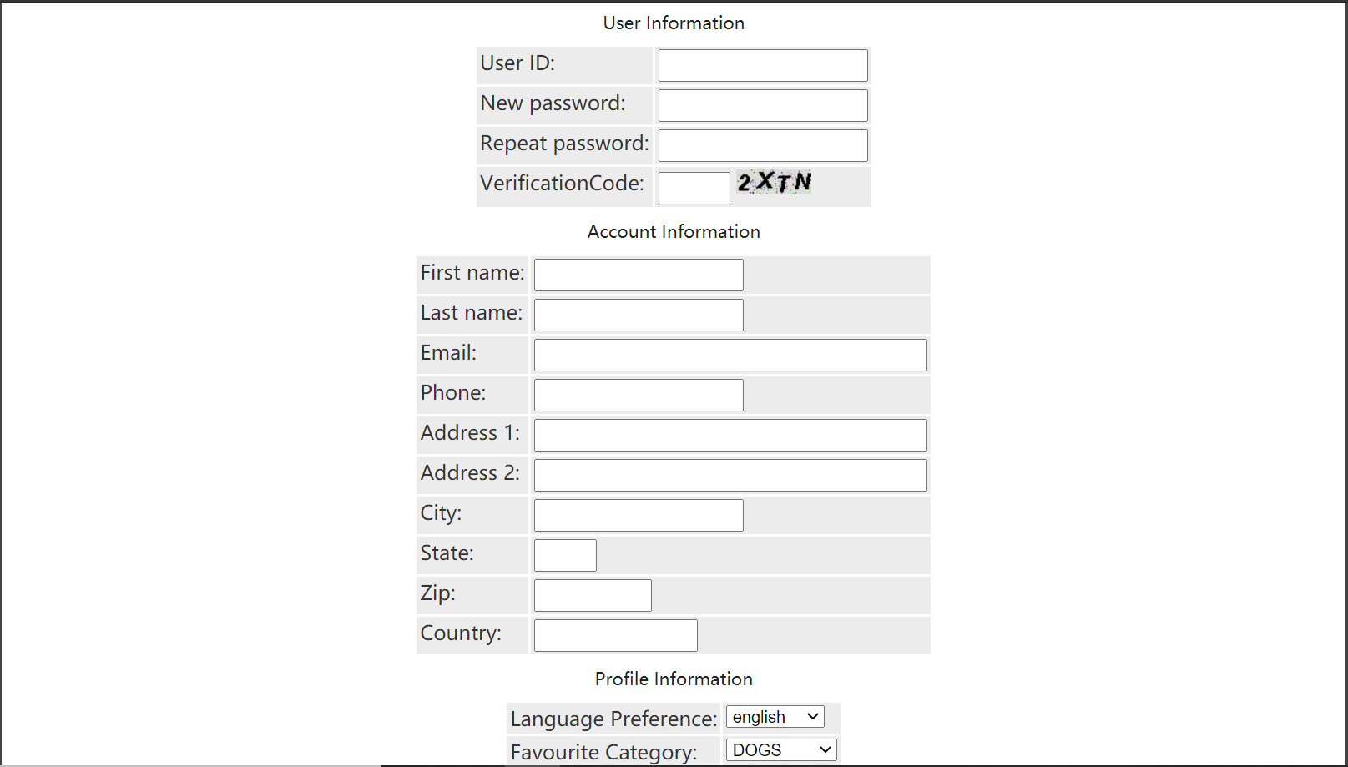

AccountService：
public class AccountService {
private AccountDAO accountDAO;
public AccountService(){
accountDAO = new AccountDAOImpl();
}
public Account getAccount(String username) {
return accountDAO.getAccountByUsername(username);
}
public Account getAccount(String username, String password) {
Account account = new Account();
account.setUsername(username);
account.setPassword(password);
return accountDAO.getAccountByUsernameAndPassword(account);
}
public void insertAccount(Account account) {
accountDAO.insertAccount(account);
accountDAO.insertProfile(account);
accountDAO.insertSignon(account);
}
public void updateAccount(Account account) {
accountDAO.updateAccount(account);
accountDAO.updateProfile(account);
if (account.getPassword() != null && account.getPassword().length() > 0) {
accountDAO.updateSignon(account);
}
}
}

NewAccountServlet：
public class NewAccountServlet extends HttpServlet {
private static final String MAIN = "/WEB-INF/jsp/catalog/Main.jsp";
private static final String NEWACCOUNTFORM = "/WEB-INF/jsp/account/NewAccountForm.jsp";
private Account account;
private Account account1;
private AccountService accountService;
protected void doPost(HttpServletRequest request, HttpServletResponse response) throws ServletException, IOException {
doGet(request, response);
}
protected void doGet(HttpServletRequest request, HttpServletResponse response) throws ServletException, IOException {
HttpSession session = request.getSession();
account = (Account) session.getAttribute("account");
account = null;
session.setAttribute("account", account);
//获得输入的验证码值
String value1=request.getParameter("vCode");
/*获取图片的值*/
String value2=(String)session.getAttribute("checkcode");
Boolean isSame = false;
/*对比两个值（字母不区分大小写）*/
if(value2.equalsIgnoreCase(value1)){
isSame = true;
}
String username = request.getParameter("username");
String password = request.getParameter("password");
String firstName = request.getParameter("firstName");
String lastName = request.getParameter("lastName");
String email = request.getParameter("email");
String phone = request.getParameter("phone");
String address1 = request.getParameter("address1");
String address2 = request.getParameter("address2");
String city = request.getParameter("city");
String state = request.getParameter("state");
String zip = request.getParameter("zip");
String country = request.getParameter("country");
String languagePreference = request.getParameter("languagePreference");
String favouriteCategoryId = request.getParameter("favouriteCategoryId");
String listOption = request.getParameter("listOption");
String bannerOption = request.getParameter("bannerOption");
account1 = new Account();
account1.setUsername(username);
account1.setPassword(password);
account1.setFirstName(firstName);
account1.setLastName(lastName);
account1.setEmail(email);
account1.setPhone(phone);
account1.setAddress1(address1);
account1.setAddress2(address2);
account1.setCity(city);
account1.setState(state);
account1.setZip(zip);
account1.setCountry(country);
account1.setLanguagePreference(languagePreference);
account1.setFavouriteCategoryId(favouriteCategoryId);
account1.setListOption(Boolean.parseBoolean(listOption));
account1.setBannerOption(Boolean.parseBoolean(bannerOption));
if(isSame){
accountService = new AccountService();
accountService.insertAccount(account1);
if(account1 != null){
HttpServletRequest httpRequest= request;
String strBackUrl = "http://" + request.getServerName() + ":" + request.getServerPort()
+ httpRequest.getContextPath() + httpRequest.getServletPath() + "?" + (httpRequest.getQueryString());
LogService logService = new LogService();
String logInfo = logService.logInfo(" ") + strBackUrl + " 注册新账号";
logService.insertLogInfo(account1.getUsername(), logInfo);
}
request.getRequestDispatcher(MAIN).forward(request, response);
}else{
session.setAttribute("messageAccount", "Invalid Verification Code.");
if(account1 != null){
HttpServletRequest httpRequest= request;
String strBackUrl = "http://" + request.getServerName() + ":" + request.getServerPort()
+ httpRequest.getContextPath() + httpRequest.getServletPath() + "?" + (httpRequest.getQueryString());
LogService logService = new LogService();
String logInfo = logService.logInfo(" ") + strBackUrl + " 注册账号，验证码错误";
logService.insertLogInfo(account1.getUsername(), logInfo);
}
request.getRequestDispatcher(NEWACCOUNTFORM).forward(request, response);
}
}
}

2.2用户登录

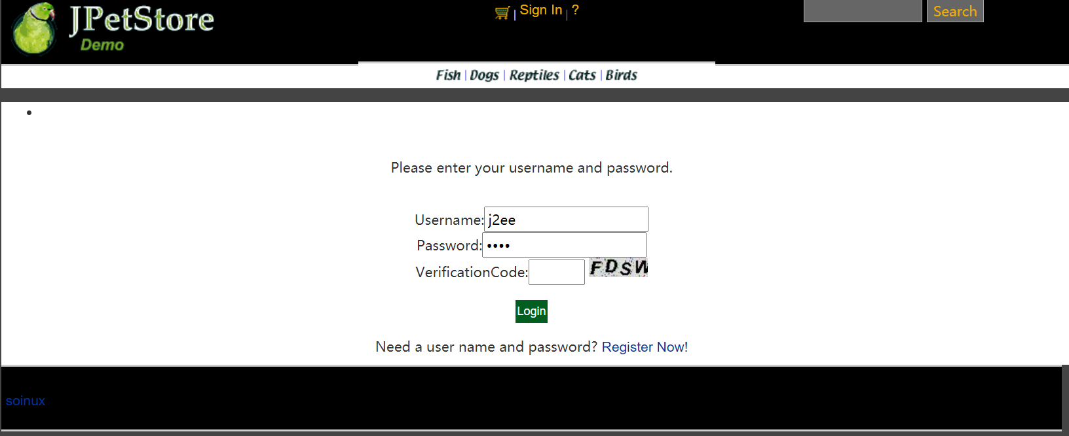

SignOnFormServlet：
public class SignOnFormServlet extends HttpServlet {
private static final String SIGNONFORM = "/WEB-INF/jsp/account/SignonForm.jsp";
private Account account;
protected void doPost(HttpServletRequest request, HttpServletResponse response) throws ServletException, IOException {
doGet(request, response);
}
protected void doGet(HttpServletRequest request, HttpServletResponse response) throws ServletException, IOException {
HttpSession session = request.getSession();
account = (Account)session.getAttribute("account");
if(account != null){
HttpServletRequest httpRequest= request;
String strBackUrl = "http://" + request.getServerName() + ":" + request.getServerPort()
+ httpRequest.getContextPath() + httpRequest.getServletPath() + "?" + (httpRequest.getQueryString());
LogService logService = new LogService();
String logInfo = logService.logInfo(" ") + strBackUrl + " 用户进入登录界面";
logService.insertLogInfo(account.getUsername(), logInfo);
}
request.getRequestDispatcher(SIGNONFORM).forward(request, response);
}
}

SignOnServlet：
public class SignOnServlet extends HttpServlet {
private static final String MAIN = "/WEB-INF/jsp/catalog/Main.jsp";
private static final String SIGNONFORM = "/WEB-INF/jsp/account/SignonForm.jsp";
private Account account;
private AccountService accountService;
protected void doPost(HttpServletRequest request, HttpServletResponse response) throws ServletException, IOException {
doGet(request, response);
}
protected void doGet(HttpServletRequest request, HttpServletResponse response) throws ServletException, IOException {
String username = request.getParameter("username");
String password = request.getParameter("password");
accountService = new AccountService();
account = accountService.getAccount(username, password);
HttpSession session = request.getSession();
session.setAttribute("account", account);
if(account != null){
HttpServletRequest httpRequest= request;
String strBackUrl = "http://" + request.getServerName() + ":" + request.getServerPort()
+ httpRequest.getContextPath() + httpRequest.getServletPath() + "?" + (httpRequest.getQueryString());
LogService logService = new LogService();
String logInfo = logService.logInfo(" ") + strBackUrl + " 用户登录";
logService.insertLogInfo(account.getUsername(), logInfo);
}
//获得输入的验证码值
String value1=request.getParameter("vCode");
/*获取图片的值*/
String value2=(String)session.getAttribute("checkcode");
Boolean isSame = false;
/*对比两个值（字母不区分大小写）*/
if(value2.equalsIgnoreCase(value1)){
isSame = true;
}
if (account == null || !isSame){
if(!isSame){
session.setAttribute("messageSignOn", "Invalid Verification Code. Signon failed.");
}else{
session.setAttribute("messageSignOn", "Invalid username or password. Signon failed.");
}
session.setAttribute("account", null);
request.getRequestDispatcher(SIGNONFORM).forward(request, response);
}else{
account.setPassword(null);
request.getRequestDispatcher(MAIN).forward(request, response);
}
}
}

2.3用户修改信息

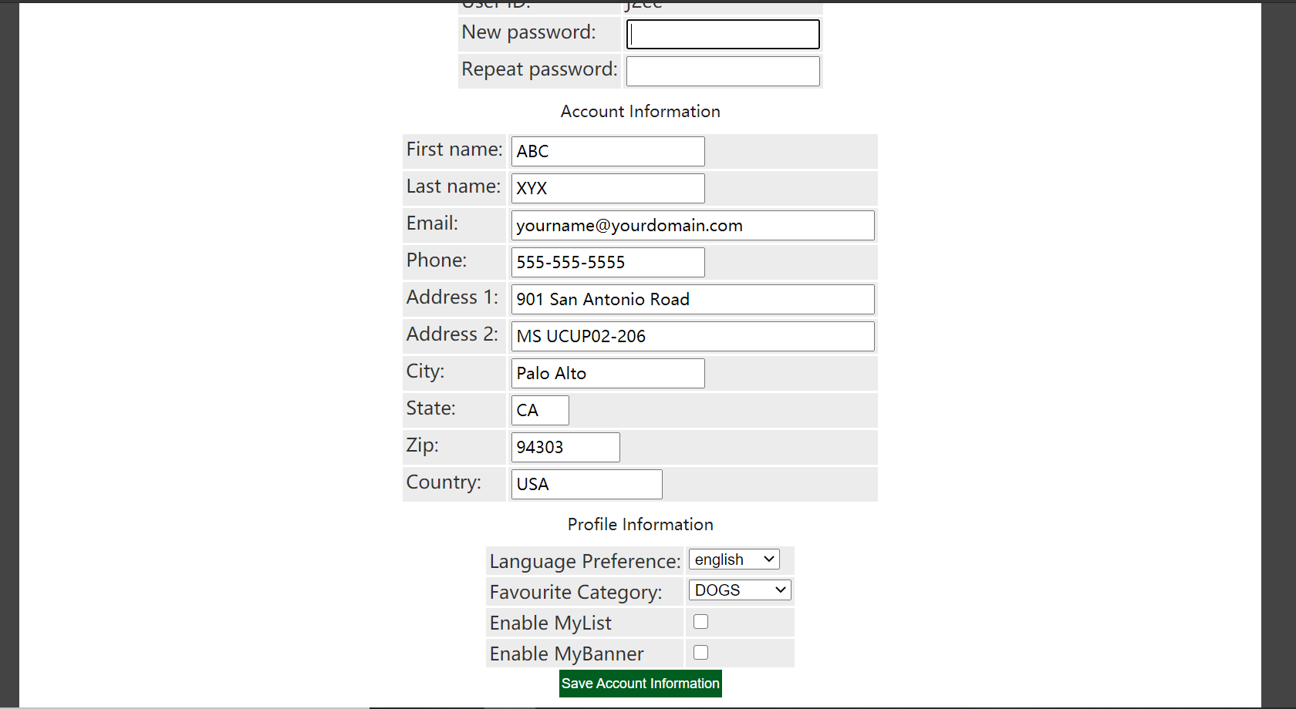

EditAccountServlet：
public class EditAccountServlet extends HttpServlet {
private static final String EDITACOUNT = "/WEB-INF/jsp/account/EditAccountForm.jsp";
protected void doPost(HttpServletRequest request, HttpServletResponse response) throws ServletException, IOException {
doGet(request, response);
}
protected void doGet(HttpServletRequest request, HttpServletResponse response) throws ServletException, IOException {
HttpSession session = request.getSession();
Account account = (Account)session.getAttribute("account");
if(account != null){
HttpServletRequest httpRequest= request;
String strBackUrl = "http://" + request.getServerName() + ":" + request.getServerPort()
+ httpRequest.getContextPath() + httpRequest.getServletPath() + "?" + (httpRequest.getQueryString());
LogService logService = new LogService();
String logInfo = logService.logInfo(" ") + strBackUrl + " 跳转到编辑账号信息界面";
logService.insertLogInfo(account.getUsername(), logInfo);
}
request.getRequestDispatcher(EDITACOUNT).forward(request, response);
}
}

SaveAccountServlet：
public class SaveAccountServlet extends HttpServlet {
private static final String EDITACOUNT = "/WEB-INF/jsp/account/EditAccountForm.jsp";
private Account account;
private AccountService accountService;
protected void doPost(HttpServletRequest request, HttpServletResponse response) throws ServletException, IOException {
doGet(request, response);
}
protected void doGet(HttpServletRequest request, HttpServletResponse response) throws ServletException, IOException {
HttpSession session = request.getSession();
account = (Account) session.getAttribute("account");
String username = account.getUsername();
String password = request.getParameter("password");
String firstName = request.getParameter("firstName");
String lastName = request.getParameter("lastName");
String email = request.getParameter("email");
String phone = request.getParameter("phone");
String address1 = request.getParameter("address1");
String address2 = request.getParameter("address2");
String city = request.getParameter("city");
String state = request.getParameter("state");
String zip = request.getParameter("zip");
String country = request.getParameter("country");
String languagePreference = request.getParameter("languagePreference");
String favouriteCategoryId = request.getParameter("favouriteCategoryId");
String listOption = request.getParameter("listOption");
String bannerOption = request.getParameter("bannerOption");
account.setUsername(username);
account.setPassword(password);
account.setFirstName(firstName);
account.setLastName(lastName);
account.setEmail(email);
account.setPhone(phone);
account.setAddress1(address1);
account.setAddress2(address2);
account.setCity(city);
account.setState(state);
account.setZip(zip);
account.setCountry(country);
account.setLanguagePreference(languagePreference);
account.setFavouriteCategoryId(favouriteCategoryId);
account.setListOption(Boolean.parseBoolean(listOption));
account.setBannerOption(Boolean.parseBoolean(bannerOption));
accountService = new AccountService();
accountService.updateAccount(account);
session.setAttribute("account", account);
if(account != null){
HttpServletRequest httpRequest= request;
String strBackUrl = "http://" + request.getServerName() + ":" + request.getServerPort()
+ httpRequest.getContextPath() + httpRequest.getServletPath() + "?" + (httpRequest.getQueryString());
LogService logService = new LogService();
String logInfo = logService.logInfo(" ") + strBackUrl + " 账号信息更改";
logService.insertLogInfo(account.getUsername(), logInfo);
}
request.getRequestDispatcher(EDITACOUNT).forward(request, response);
}
}

2.4查询订单

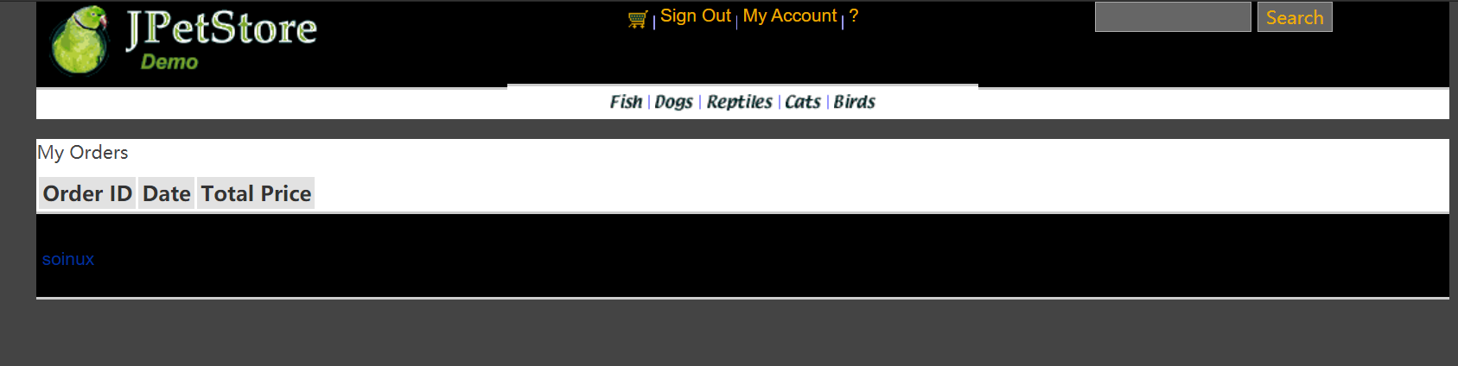

OrderService
public class OrderService {
private ItemDAO itemDAO;
private OrderDAO orderDAO;
private SequenceDAO sequenceDAO;
private LineItemDAO lineItemDAO;
public OrderService(){
itemDAO = new ItemDAOImpl();
orderDAO = new OrderDAOImpl();
sequenceDAO = new SequenceDAOImpl();
lineItemDAO = new LineItemDAOImpl();
}
public void insertOrder(Order order) {
order.setOrderId(getNextId("ordernum"));
for (int i = 0; i < order.getLineItems().size(); i++) {
LineItem lineItem = (LineItem) order.getLineItems().get(i);
String itemId = lineItem.getItemId();
Integer increment = new Integer(lineItem.getQuantity());
Map<String, Object> param = new HashMap<String, Object>(2);
param.put("itemId", itemId);
param.put("increment", increment);
itemDAO.updateInventoryQuantity(param);
}
orderDAO.insertOrder(order);
orderDAO.insertOrderStatus(order);
for (int i = 0; i < order.getLineItems().size(); i++) {
LineItem lineItem = (LineItem) order.getLineItems().get(i);
lineItem.setOrderId(order.getOrderId());
lineItemDAO.insertLineItem(lineItem);
}
}
public Order getOrder(int orderId) {
Order order = orderDAO.getOrder(orderId);
order.setLineItems(lineItemDAO.getLineItemsByOrderId(orderId));
for (int i = 0; i < order.getLineItems().size(); i++) {
LineItem lineItem = (LineItem) order.getLineItems().get(i);
Item item = itemDAO.getItem(lineItem.getItemId());
item.setQuantity(itemDAO.getInventoryQuantity(lineItem.getItemId()));
lineItem.setItem(item);
}
return order;
}
public List<Order> getOrdersByUsername(String username) {
return orderDAO.getOrdersByUsername(username);
}
public int getNextId(String name) {
Sequence sequence = new Sequence(name, -1);
sequence = sequenceDAO.getSequence(sequence);
if (sequence == null) {
throw new RuntimeException("Error: A null sequence was returned from the database (could not get next " + name
+ " sequence).");
}
Sequence parameterObject = new Sequence(name, sequence.getNextId() + 1);
sequenceDAO.updateSequence(parameterObject);
return sequence.getNextId();
}
}

ViewListOrderServlet：
public class ViewListOrderServlet extends HttpServlet {
private static final String VIEWLISTORDER = "/WEB-INF/jsp/order/ListOrders.jsp";
private String username;
private OrderService orderService;
private List<Order> orderList = new ArrayList<Order>();
protected void doPost(HttpServletRequest request, HttpServletResponse response) throws ServletException, IOException {
doGet(request, response);
}
protected void doGet(HttpServletRequest request, HttpServletResponse response) throws ServletException, IOException {
username = request.getParameter("username");
orderService = new OrderService();
orderList = orderService.getOrdersByUsername(username);
HttpSession session = request.getSession();
session.setAttribute("orderList", orderList);
//HttpSession session = request.getSession();
Account account = (Account)session.getAttribute("account");
if(account != null){
HttpServletRequest httpRequest= request;
String strBackUrl = "http://" + request.getServerName() + ":" + request.getServerPort()
+ httpRequest.getContextPath() + httpRequest.getServletPath() + "?" + (httpRequest.getQueryString());
LogService logService = new LogService();
String logInfo = logService.logInfo(" ") + strBackUrl + " 查看订单 " + orderList;
logService.insertLogInfo(account.getUsername(), logInfo);
}
request.getRequestDispatcher(VIEWLISTORDER).forward(request, response);
}
}

订单管理模块，包括购物车管理、新增订单、地址信息等业务功能。

3.1添加商品到购物车

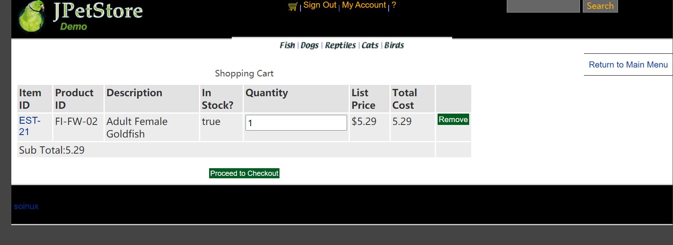

AddItemToCartServlet
public class AddItemToCartServlet extends HttpServlet {
//Servlet的功能即负责中转
//1.处理完请求后的跳转页面
private static final String VIEW_CART = "/WEB-INF/jsp/cart/Cart.jsp";
//2.定义处理该请求所需要的数据
private String workingItemId;
private Cart cart;
private CatalogService catalogService;
protected void doPost(HttpServletRequest request, HttpServletResponse response) throws ServletException, IOException {
doGet(request, response);
}
protected void doGet(HttpServletRequest request, HttpServletResponse response) throws ServletException, IOException {
workingItemId = request.getParameter("workingItemId");
Account account;
//从对话中，获取购物车
HttpSession session = request.getSession();
cart = (Cart)session.getAttribute("cart");
account = (Account)session.getAttribute("account");
if(cart == null){
//第一次使用购物车
cart = new Cart();
}
if(cart.containsItemId(workingItemId)){
//已有该物品，数量加一
cart.incrementQuantityByItemId(workingItemId);
if(account != null){
HttpServletRequest httpRequest= (HttpServletRequest) request;
String strBackUrl = "http://" + request.getServerName() + ":" + request.getServerPort()
+ httpRequest.getContextPath() + httpRequest.getServletPath() + "?" + (httpRequest.getQueryString());
LogService logService = new LogService();
Item item = catalogService.getItem(workingItemId);
String logInfo = logService.logInfo(" ") + strBackUrl + " " + item + "数量+1 ";
logService.insertLogInfo(account.getUsername(), logInfo);
}
}else{
catalogService = new CatalogService();
boolean isInStock = catalogService.isItemInStock(workingItemId);
Item item = catalogService.getItem(workingItemId);
cart.addItem(item, isInStock);
session.setAttribute("cart", cart);
if(account != null){
HttpServletRequest httpRequest= request;
String strBackUrl = "http://" + request.getServerName() + ":" + request.getServerPort()
+ httpRequest.getContextPath() + httpRequest.getServletPath() + "?" + (httpRequest.getQueryString());
LogService logService = new LogService();
String logInfo = logService.logInfo(" ") + strBackUrl + " 添加物品 " + item + " 到购物车";
logService.insertLogInfo(account.getUsername(), logInfo);
}
request.getRequestDispatcher(VIEW_CART).forward(request, response);
}
}
}

3.2更改购物车商品的数量信息

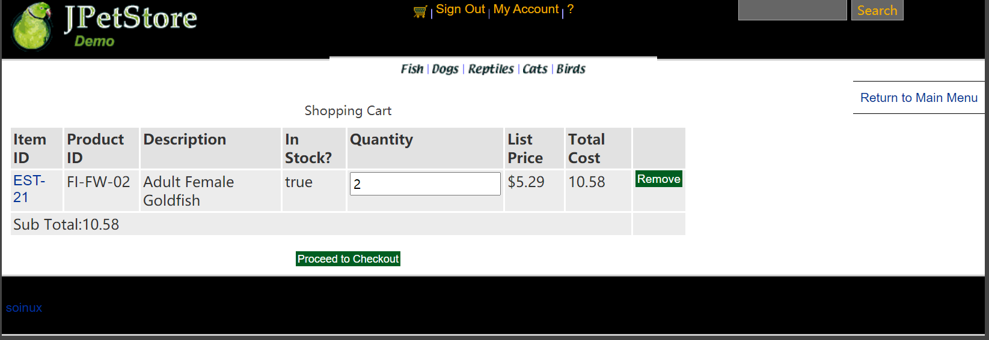

UpdateCartQuantitiesServlet：
public class UpdateCartQuantitiesServlet extends HttpServlet {
private static final String VIEW_CART = "/WEB-INF/jsp/cart/Cart.jsp";
private String workingItemId;
private Cart cart;
protected void doPost(HttpServletRequest request, HttpServletResponse response) throws ServletException, IOException {
doGet(request, response);
}
protected void doGet(HttpServletRequest request, HttpServletResponse response) throws ServletException, IOException {
workingItemId = request.getParameter("workingItemId");
CatalogService catalogService = new CatalogService();
//从对话中，获取购物车
HttpSession session = request.getSession();
cart = (Cart)session.getAttribute("cart");
Iterator<CartItem> cartItemIterator = cart.getAllCartItems();
while (cartItemIterator.hasNext()){
//产品数量增加
CartItem cartItem = (CartItem)cartItemIterator.next();
String itemId = cartItem.getItem().getItemId();
try {
int quantity = Integer.parseInt((String) request.getParameter(itemId));
cart.setQuantityByItemId(itemId, quantity);
if (quantity < 1) {
cartItemIterator.remove();
}
} catch (Exception e) {
//ignore parse exceptions on purpose
e.printStackTrace();
}
//CartItem cartItem = cartItemIterator.next();
//cartItem.incrementQuantity();
}
session.setAttribute("cart", cart);
//HttpSession session = request.getSession();
Account account = (Account)session.getAttribute("account");
if(account != null){
HttpServletRequest httpRequest= request;
String strBackUrl = "http://" + request.getServerName() + ":" + request.getServerPort()
+ httpRequest.getContextPath() + httpRequest.getServletPath() + "?" + (httpRequest.getQueryString());
LogService logService = new LogService();
String logInfo = logService.logInfo(" ") + strBackUrl + " 更新购物车商品数量";
logService.insertLogInfo(account.getUsername(), logInfo);
}
request.getRequestDispatcher(VIEW_CART).forward(request, response);
}
}

3.3移除购物车中的商品

RemoveItemFromCartServlet：
public class RemoveItemFromCartServlet extends HttpServlet {
private static final String VIEW_CART = "/WEB-INF/jsp/cart/Cart.jsp";
private static final String ERROR = "/WEB-INF/jsp/common/Error.jsp";
private String workingItemId;
private Cart cart;
protected void doPost(HttpServletRequest request, HttpServletResponse response) throws ServletException, IOException {
doGet(request, response);
}
protected void doGet(HttpServletRequest request, HttpServletResponse response) throws ServletException, IOException {
workingItemId = request.getParameter("workingItemId");
HttpSession session = request.getSession();
cart = (Cart)session.getAttribute("cart");
Item item = cart.removeItemById(workingItemId);
if(item == null) {
session.setAttribute("message", "Attempted to remove null CartItem from Cart.");
Account account = (Account)session.getAttribute("account");
if(account != null){
HttpServletRequest httpRequest= request;
String strBackUrl = "http://" + request.getServerName() + ":" + request.getServerPort()
+ httpRequest.getContextPath() + httpRequest.getServletPath() + "?" + (httpRequest.getQueryString());
LogService logService = new LogService();
String logInfo = logService.logInfo(" ") + strBackUrl + " 物品为空，不能移除";
logService.insertLogInfo(account.getUsername(), logInfo);
}
request.getRequestDispatcher(ERROR).forward(request, response);
}else{
Account account = (Account)session.getAttribute("account");
if(account != null){
HttpServletRequest httpRequest= request;
String strBackUrl = "http://" + request.getServerName() + ":" + request.getServerPort()
+ httpRequest.getContextPath() + httpRequest.getServletPath() + "?" + (httpRequest.getQueryString());
LogService logService = new LogService();
String logInfo = logService.logInfo(" ") + strBackUrl + " " + item + " 已从购物车中移除";
logService.insertLogInfo(account.getUsername(), logInfo);
}
request.getRequestDispatcher(VIEW_CART).forward(request, response);
}
}
}

3.4新增订单——跳转到查看寄件人与收件人地址

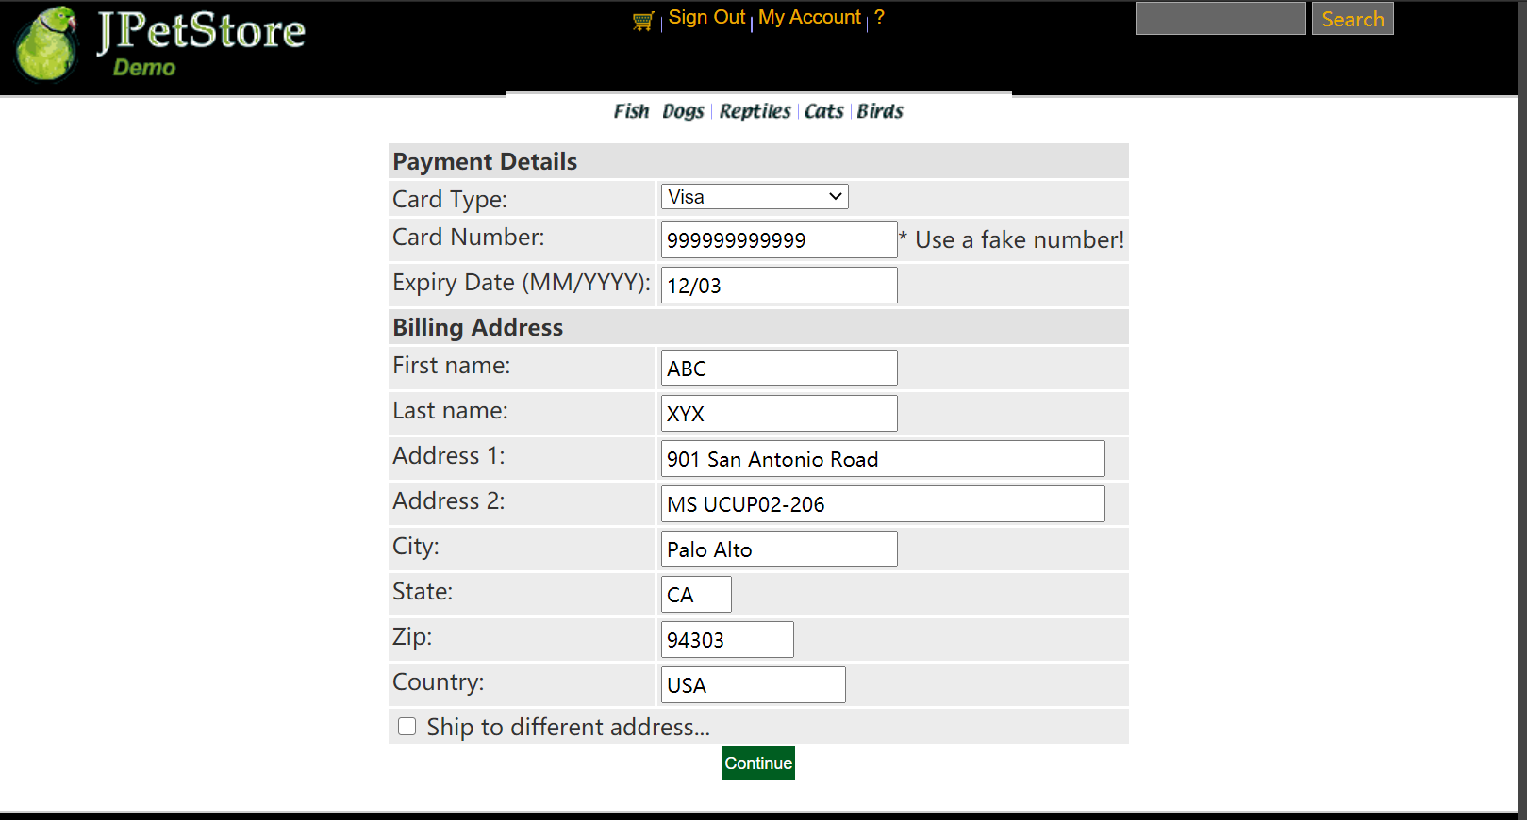

NewOrderFormServlet:
public class NewOrderFormServlet extends HttpServlet {
private static final String NEW_ORDER = "/WEB-INF/jsp/order/NewOrderForm.jsp";
private static final String SIGNONFORM = "/WEB-INF/jsp/account/SignonForm.jsp";
private static final String ERROR = "/WEB-INF/jsp/common/Error.jsp";
private Account account;
private Order order;
private Cart cart;
protected void doPost(HttpServletRequest request, HttpServletResponse response) throws ServletException, IOException {
doGet(request, response);
}
protected void doGet(HttpServletRequest request, HttpServletResponse response) throws ServletException, IOException {
HttpSession session = request.getSession();
account = (Account)session.getAttribute("account");
cart = (Cart)session.getAttribute("cart");
if (account == null){
session.setAttribute("message", "You must sign on before attempting to check out. Please sign on and try checking out again.");
request.getRequestDispatcher(SIGNONFORM).forward(request, response);
} else if(cart != null){
order = new Order();
order.initOrder(account, cart);
session.setAttribute("order", order);
Account account = (Account)session.getAttribute("account");
if(account != null){
HttpServletRequest httpRequest= request;
String strBackUrl = "http://" + request.getServerName() + ":" + request.getServerPort()
+ httpRequest.getContextPath() + httpRequest.getServletPath() + "?" + (httpRequest.getQueryString());
LogService logService = new LogService();
String logInfo = logService.logInfo(" ") + strBackUrl + " 跳转到新订单页面";
logService.insertLogInfo(account.getUsername(), logInfo);
}
request.getRequestDispatcher(NEW_ORDER).forward(request, response);
}else{
session.setAttribute("message", "An order could not be created because a cart could not be found.");
Account account = (Account)session.getAttribute("account");
if(account != null){
HttpServletRequest httpRequest= request;
String strBackUrl = "http://" + request.getServerName() + ":" + request.getServerPort()
+ httpRequest.getContextPath() + httpRequest.getServletPath() + "?" + (httpRequest.getQueryString());
LogService logService = new LogService();
String logInfo = logService.logInfo(" ") + strBackUrl + " 生成订单页面信息错误";
logService.insertLogInfo(account.getUsername(), logInfo);
}
request.getRequestDispatcher(ERROR).forward(request, response);
}
}
}

3.5新增订单——地址信息即修改收件人地址

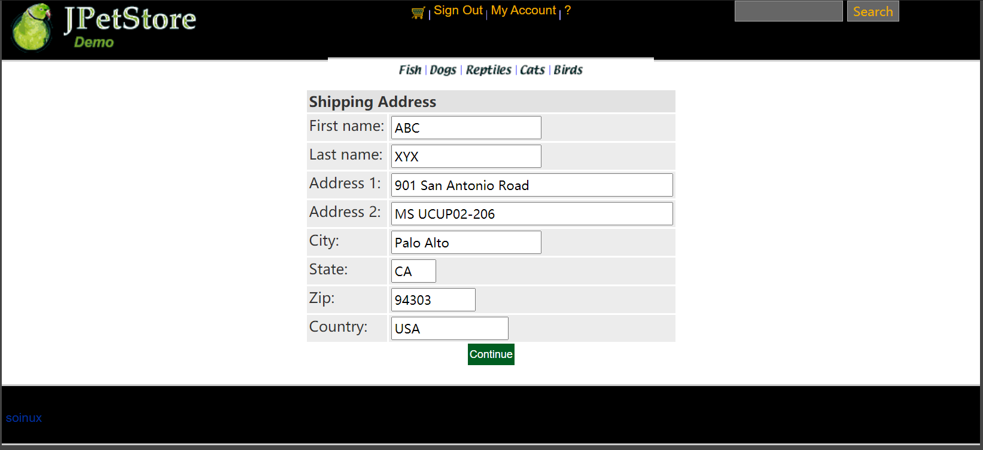

ShippingFormServlet：
public class ShippingFormServlet extends HttpServlet {
private static final String SHIPPINGFORM = "/WEB-INF/jsp/order/ShippingForm.jsp";
private static final String SIGNONFORM = "/WEB-INF/jsp/account/SignonForm.jsp";
private Account account;
protected void doPost(HttpServletRequest request, HttpServletResponse response) throws ServletException, IOException {
doGet(request, response);
}
protected void doGet(HttpServletRequest request, HttpServletResponse response) throws ServletException, IOException {
HttpSession session = request.getSession();
account = (Account)session.getAttribute("account");
if (account == null){
request.getRequestDispatcher(SIGNONFORM).forward(request, response);
} else{
//HttpSession session = request.getSession();
Account account = (Account)session.getAttribute("account");
if(account != null){
HttpServletRequest httpRequest= request;
String strBackUrl = "http://" + request.getServerName() + ":" + request.getServerPort()
+ httpRequest.getContextPath() + httpRequest.getServletPath() + "?" + (httpRequest.getQueryString());
LogService logService = new LogService();
String logInfo = logService.logInfo(" ") + strBackUrl + " 跳转到修改地址界面";
logService.insertLogInfo(account.getUsername(), logInfo);
}
request.getRequestDispatcher(SHIPPINGFORM).forward(request, response);
}
}
}

ShippingAdressServlet：
public class ShippingAddressServlet extends HttpServlet {
private static final String CONFIRM_ORDER_FORM = "/WEB-INF/jsp/order/ConfirmOrder.jsp";
private Order order;
private String shipToFirstName;
private String shipToLastName;
private String shipAddress1;
private String shipAddress2;
private String shipCity;
private String shipState;
private String shipZip;
private String shipCountry;
protected void doPost(HttpServletRequest request, HttpServletResponse response) throws ServletException, IOException {
doGet(request, response);
}
protected void doGet(HttpServletRequest request, HttpServletResponse response) throws ServletException, IOException {
shipToFirstName = request.getParameter("shipToFirstName");
shipToLastName = request.getParameter("shipToLastName");
shipAddress1 = request.getParameter("shipAddress1");
shipAddress2 = request.getParameter("shipAddress2");
shipCity = request.getParameter("shipCity");
shipState = request.getParameter("shipState");
shipZip = request.getParameter("shipZip");
shipCountry = request.getParameter("shipCountry");
HttpSession session = request.getSession();
order = (Order)session.getAttribute("order");
order.setShipToFirstName(shipToFirstName);
order.setShipToLastName(shipToLastName);
order.setShipAddress1(shipAddress1);
order.setShipAddress2(shipAddress2);
order.setShipCity(shipCity);
order.setShipState(shipState);
order.setShipZip(shipZip);
order.setCourier(shipCountry);
session.setAttribute("order", order);
Account account = (Account)session.getAttribute("account");
if(account != null){
HttpServletRequest httpRequest= request;
String strBackUrl = "http://" + request.getServerName() + ":" + request.getServerPort()
+ httpRequest.getContextPath() + httpRequest.getServletPath() + "?" + (httpRequest.getQueryString());
LogService logService = new LogService();
String logInfo = logService.logInfo(" ") + strBackUrl + " 修改订单邮寄地址";
logService.insertLogInfo(account.getUsername(), logInfo);
}
request.getRequestDispatcher(CONFIRM_ORDER_FORM).forward(request, response);
}
}

3.6新增订单——确定订单信息

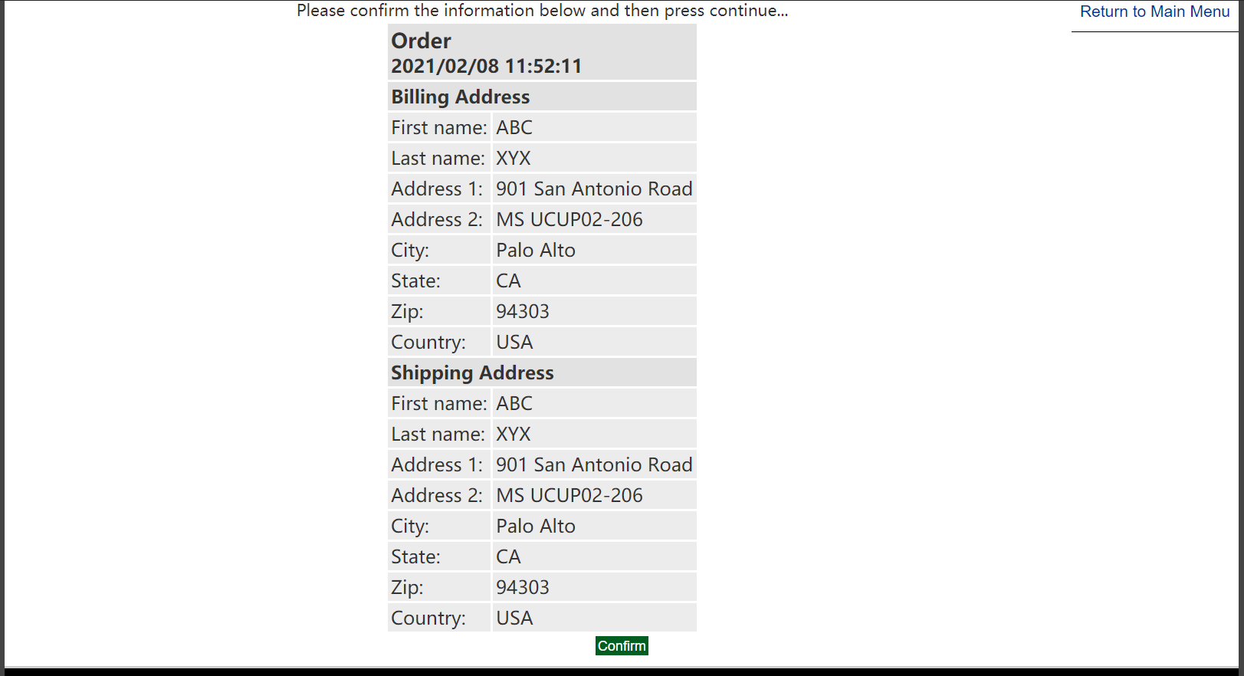

ConfirmOrderFormServlet：
public class ConfirmOrderFormServlet extends HttpServlet {
private static final String CONFIRM_ORDER_FORM = "/WEB-INF/jsp/order/ConfirmOrder.jsp";
private static final String SHIPPINGFORM = "/WEB-INF/jsp/order/ShippingForm.jsp";
private String shippingAddressRequired;
private Order order;
private OrderService orderService;
protected void doPost(HttpServletRequest request, HttpServletResponse response) throws ServletException, IOException {
doGet(request, response);
}
protected void doGet(HttpServletRequest request, HttpServletResponse response) throws ServletException, IOException {
shippingAddressRequired = request.getParameter("shippingAddressRequired");
order = new Order();
HttpSession session = request.getSession();
order = (Order)session.getAttribute("order");
Account account = (Account)session.getAttribute("account");
if (shippingAddressRequired == null){
if(account != null){
HttpServletRequest httpRequest= request;
String strBackUrl = "http://" + request.getServerName() + ":" + request.getServerPort()
+ httpRequest.getContextPath() + httpRequest.getServletPath() + "?" + (httpRequest.getQueryString());
LogService logService = new LogService();
String logInfo = logService.logInfo(" ") + strBackUrl + " 确认生成订单 ";
logService.insertLogInfo(account.getUsername(), logInfo);
}
request.getRequestDispatcher(CONFIRM_ORDER_FORM).forward(request, response);
}
else{
shippingAddressRequired = null;
if(account != null){
HttpServletRequest httpRequest= request;
String strBackUrl = "http://" + request.getServerName() + ":" + request.getServerPort()
+ httpRequest.getContextPath() + httpRequest.getServletPath() + "?" + (httpRequest.getQueryString());
LogService logService = new LogService();
String logInfo = logService.logInfo(" ") + strBackUrl + " 更改收货地址";
logService.insertLogInfo(account.getUsername(), logInfo);
}
request.getRequestDispatcher(SHIPPINGFORM).forward(request, response);
}
}
}

3.7新增订单——生成最终订单

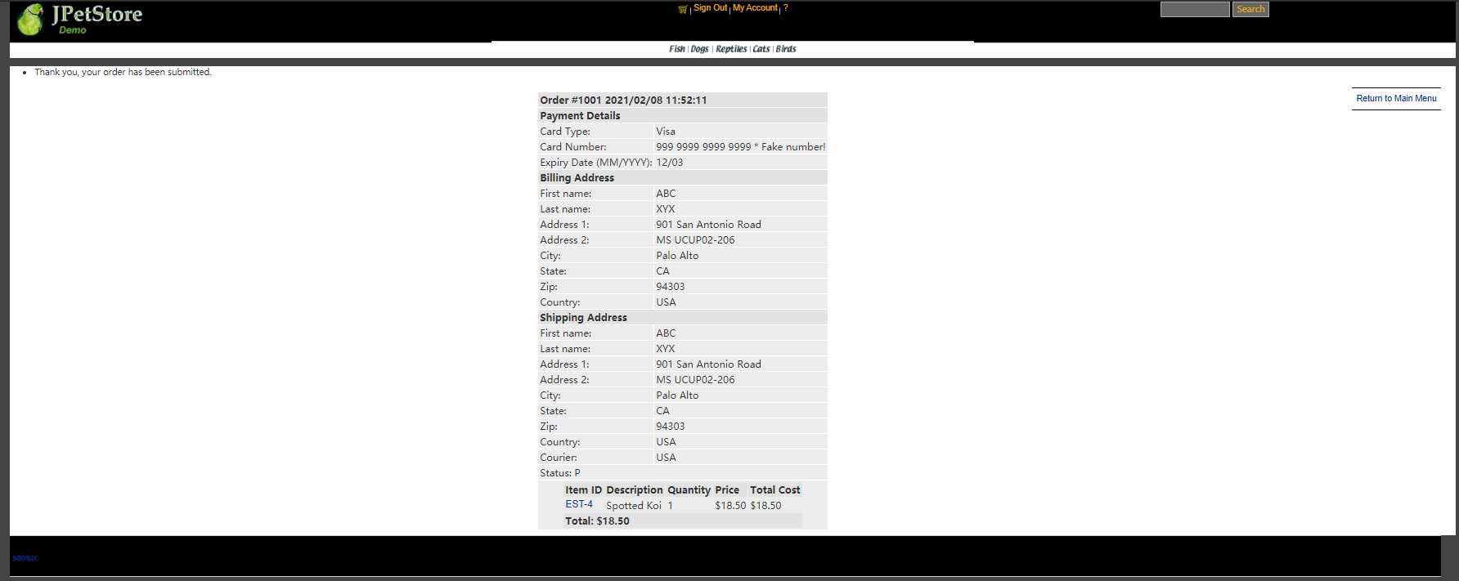

ViewOrderServlet：
public class ViewOrderServlet extends HttpServlet {
private static final String VIEWORDER = "/WEB-INF/jsp/order/ViewOrder.jsp";
private static final String ERROR = "/WEB-INF/jsp/common/Error.jsp";
private Order order;
private OrderService orderService;
private Cart cart;
protected void doPost(HttpServletRequest request, HttpServletResponse response) throws ServletException, IOException {
doGet(request, response);
}
protected void doGet(HttpServletRequest request, HttpServletResponse response) throws ServletException, IOException {
HttpSession session = request.getSession();
order = (Order) session.getAttribute("order");
cart = (Cart) session.getAttribute("cart");
if (order != null) {
orderService = new OrderService();
orderService.insertOrder(order);
session.setAttribute("order", order);
//清空购物车
cart = null;
session.setAttribute("cart", cart);
session.setAttribute("message", "Thank you, your order has been submitted.");
//HttpSession session = request.getSession();
Account account = (Account)session.getAttribute("account");
if(account != null){
HttpServletRequest httpRequest= request;
String strBackUrl = "http://" + request.getServerName() + ":" + request.getServerPort()
+ httpRequest.getContextPath() + httpRequest.getServletPath() + "?" + (httpRequest.getQueryString());
LogService logService = new LogService();
String logInfo = logService.logInfo(" ") + strBackUrl + " 查看订单 " + order;
logService.insertLogInfo(account.getUsername(), logInfo);
}
request.getRequestDispatcher(VIEWORDER).forward(request, response);
} else {
session.setAttribute("message", "An error occurred processing your order (order was null).");
request.getRequestDispatcher(ERROR).forward(request, response);
}
}
}

- 实验内容——扩展任务
- 添加验证码功能：在用户注册和用户登录模块中添加验证码功能。
- 日志功能：数据库中添加日志信息表，给项目添加日志功能，用户登录后记录用户行为，比如浏览了哪些商品、将商品添加进购物车、生成订单等。
//以上两个扩展任务，除用界面截图和核心代码展示功能完成情况外，验证码功能还需说明验证码的基本原理和实现方案，日志功能需描述项目所完成的功能情况（能记录哪些日志、怎么记录等）。

- 添加验证码功能：在用户注册和用户登录模块中添加验证码功能。

1.1界面截图

见上文

1.2基本原理

利用字符表产生随机验证码，同时随机产生多个个干扰点，产生图像，画背景，在不同高度输出验证码的不同字符，设置浏览器不要缓存此图片，然后创建内存图像并获得图形，将图像传到客户端，验证码功能即可实现随机显示。

1.3实现方案

用VerificationCode.java实现随机生成数字和字母组成图片的功能，在SigninForm.jsp 和NewAccountForm.jsp页面中添加实现显示验证码和用户输入验证码的功能，再用SignOnServlet和NewAccountServlet分别获取图片和用户输入的数据，判断两个数据是否一致，之后再进行登录功能与注册功能的实现。

1.4核心代码展示

VerificationCode.java：
public class VerificationCode extends HttpServlet {
public VerificationCode() {
super();
}
public void destroy() {
super.destroy();
}
public void doGet(HttpServletRequest request, HttpServletResponse response)
throws ServletException, IOException {
doPost(request, response);
}
/*实现的核心代码*/
public void doPost(HttpServletRequest request, HttpServletResponse response)
throws ServletException, IOException {
response.setContentType("image/jpeg");
HttpSession session=request.getSession();
int width=60;
int height=20;
//设置浏览器不要缓存此图片
response.setHeader("Pragma", "No-cache");
response.setHeader("Cache-Control", "no-cache");
response.setDateHeader("Expires", 0);
//创建内存图像并获得图形上下文
BufferedImage image=new BufferedImage(width, height,BufferedImage.TYPE_INT_RGB);
Graphics g=image.getGraphics();
/*
* 产生随机验证码
* 定义验证码的字符表
*/
String chars="0123456789ABCDEFGHIJKLMNOPQRSTUVWXYZ";
char[] rands=new char[4];
for(int i=0;i<4;i++){
int rand=(int) (Math.random() *36);
rands[i]=chars.charAt(rand);
}
/*
* 产生图像
* 画背景
*/
g.setColor(new Color(0xDCDCDC));
g.fillRect(0, 0, width, height);
/*
* 随机产生120个干扰点
*/
for(int i=0;i<120;i++){
int x=(int)(Math.random()*width);
int y=(int)(Math.random()*height);
int red=(int)(Math.random()*255);
int green=(int)(Math.random()*255);
int blue=(int)(Math.random()*255);
g.setColor(new Color(red,green,blue));
g.drawOval(x, y, 1, 0);
}
g.setColor(Color.BLACK);
g.setFont(new Font(null, Font.ITALIC|Font.BOLD,18));
//在不同高度输出验证码的不同字符
g.drawString(""+rands[0], 1, 17);
g.drawString(""+rands[1], 16, 15);
g.drawString(""+rands[2], 31, 18);
g.drawString(""+rands[3], 46, 16);
g.dispose();
//将图像传到客户端
ServletOutputStream sos=response.getOutputStream();
ByteArrayOutputStream baos=new ByteArrayOutputStream();
ImageIO.write(image, "JPEG", baos);
byte[] buffer=baos.toByteArray();
response.setContentLength(buffer.length);
sos.write(buffer);
baos.close();
sos.close();
session.setAttribute("checkcode", new String(rands));
}
public void init() throws ServletException {
// Put your code here
}
}
- 日志功能：数据库中添加日志信息表，给项目添加日志功能，用户登录后记录用户行为，比如浏览了哪些商品、将商品添加进购物车、生成订单等。
2.1截图展示
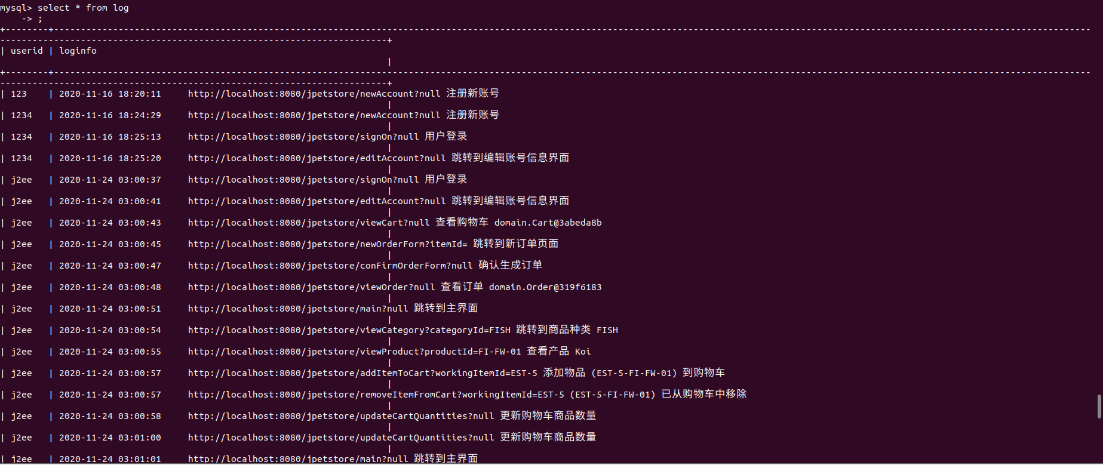

2.2记录内容
用户账号、跳转时间、当前操作页面的网址、具体操作页面的名字、操作的商品信息、设计者自定义的具体操作说明。

核心代码
Log.java:
public class Log {
public final static int OUT_CONSOLE=1;
public final static int OUT_FILE=2;
public final static int OUT_BOTH=3;
public final static int DEBUG_LEVEL=0;
public final static int LOG_LEVEL=3;
public final static int INFO_LEVEL=6;
public final static int WARN_LEVEL=9;
public final static int ERROR_LEVEL=12;
public final static int FATAL_LEVEL=15;
protected static int level=DEBUG_LEVEL;// 输出的级别开关，高于指定级别的输出
protected static int out=OUT_CONSOLE; //输出模式，输出到控制台，文件或者都输出
public static String logdir="log"; // 保存日志文件的目录
protected static BufferedWriter bw =null;
protected static String currentDate = "";
protected static Date data=null;
protected static StringBuilder bb=new StringBuilder();
protected static String marsk=" [ERROE] ";
/**
* 日志函数，不受 level 限制，始终打印，最高级别
* @param s
*/
synchronized public static String log(Object ...s) {
bb.delete(0, bb.length());
bb.append(time());
bb.append(marsk);
for(Object str : s) {
bb.append(str);
bb.append(" ");
}
//out(bb.toString());
return bb.toString();
}
public static String logInfomation(Object ...s){
marsk = " ";
return log(s);
}
protected static BufferedWriter getWriter() {
if(currentDate.equals(new SimpleDateFormat("dd").format(data))) {
return bw;
}
File fi=new File(logdir
+File.separator+new SimpleDateFormat("yyyy年").format(data)
+File.separator+new SimpleDateFormat("MM月").format(data)
+File.separator+new SimpleDateFormat("dd").format(data)+"日.log");
try {
if(!fi.exists()) {
if(!fi.getParentFile().exists())
fi.getParentFile().mkdirs();
fi.createNewFile();
}
FileOutputStream fiou = new FileOutputStream(fi,true);
OutputStreamWriter opw = new OutputStreamWriter(fiou, "UTF-8");
bw= new BufferedWriter(opw);
}catch(Exception e) {
}
return bw;
}
protected static String time() {
data = new Date();
return new SimpleDateFormat("yyyy-MM-dd HH:mm:ss").format(data);
}
public static void init(int out_put_level,int out2where,String log_dir) {
level = out_put_level;
out = out2where;
logdir = log_dir;
}
public static void main(String[] args) {
}
}

LogService:
public class LogService {
Log log;
private LogDAO logDAO;
public LogService(){
log = new Log();
logDAO = new LogDAOImpl();
}
public String logInfo(Object ...s){
return log.logInfomation(s);
}
public void insertLogInfo(String username, String logInfo){
logDAO.insertLog(username, logInfo);
}
}

- 小组成员分工及实验总结

实验总结

实验总结记录实验过程遇到的问题和解决的方法，以及心得体会，字数不少于500字。
问题1.mysql数据库无法连接
解决方法：检查ip地址正常，用户名密码正确，ping数据库所在虚拟机发现无法ping通，虚拟机网络连接方式为net模式，对应网卡为VMnet8， ipconfig查看后发现VMnet8对应ip地址与虚拟机ip地址不同， 修改并重启适配器后可以正常连接（配置完之后一定要重启，配置完之后VMnet8会有两个对应的ipv4地址，原因暂时未知，且一段时间后新配置的ipv4地址会失效，重启适配器后恢复）
问题2.图片无法正常显示
解决方法：经过检查jsp页面内容都没有出错，直接输入图片链接可以正常加载，说明图片链接错误，修改了数据库中的descn字段后解决
问题3.数据库相关的impl时间类型错误
解决方法：一直报类型转换错误的异常，异常中写道必须为Date类，可是确实用的Date类的对象。后来通过上网查找问题发现这是由于数据库Date对象为java.sql.Date类的对象。而我使用的为java.util.Date类的对象，更改后问题解决
问题4.如何查询一个用户在不同表中的数据
解决方法：使用sql外联查询语句，可进行跨表查询

这个项目主要难点还是对于MVC架构的理解，初次接触，Model，View， Controller的边界容易模糊，在对MVC架构有基本的认识后，结合网上教程和老师的视频，完成整个项目不算太难，只是对于网页调试不太熟悉，遇到相关问题的时候，问题的定位和解决都比较慢。对于代码的编写， 变量名，id等能复制则复制，不然敲错了可能会很难检查出错误，浪费大量时间

实验二 使用AJAX和jQuery改善用户体验
- 实验内容——基本任务。
- 账号管理模块。在新建账号和修改账号信息页面上用AJAX技术进行表单验证，如“判断用户名是否已存在”等功能。
- 查询商品模块。在主页面右上角的查询商品功能中添加自动补全功能。
- 购物车模块。在购物车模块中修改购买数量时，通过AJAX修改购物车信息。

//以上三个业务模块，用运行界面截图和核心代码展示功能完成情况。

1.账号管理模块。在新建账号信息页面上使用AJAX进行表单验证，实现“判断用户名是否已存在”功能。

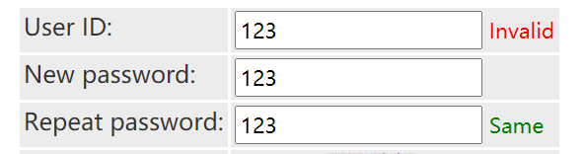
jsp：
<tr>
<td>User ID:</td>
<td>
<input id="username" type="text" name="username" onblur="checkUsername();"/>
<span id="usernameTips"></span>
</td>
</tr>
<tr>
<td>New password:</td>
<td><input id="password" type="text" name="password" /></td>
</tr>
<tr>
<td>Repeat password:</td>
<td>
<input id="repeatedPassword" type="text" name="repeatedPassword" onblur="checkPasswordSame()"/>
<span id="repeatedPasswordTips"></span>
</td>
</tr>

js：
<script>
var xhr;
function checkUsername() {
var username = document.getElementById("username").value;
xhr = new XMLHttpRequest();
xhr.onreadystatechange = f1;
function f1() {
if (xhr.readyState === 4)
if (xhr.status === 200) {
var tips = document.getElementById("usernameTips");
let responseInfo = xhr.responseText;
if (responseInfo === "Exist") {
tips.className = "errorTips";
tips.innerText = "Invalid";
} else if (responseInfo === "Not Exist") {
tips.className = "okTips";
tips.innerText = "Available";
}
}
}
xhr.open("GET", "usernameExist?username=" + username, true);
xhr.send(null);
}
function checkPasswordSame() {
var pw1 = document.getElementById("password").value;
var pw2 = document.getElementById("repeatedPassword").value;
xhr = new XMLHttpRequest();
xhr.onreadystatechange = f1;
function f1() {
if (xhr.readyState === 4)
if (xhr.status === 200) {
var tips = document.getElementById("repeatedPasswordTips");
let responseInfo = xhr.responseText;
if (responseInfo === "Not Same") {
tips.className = "errorTips";
tips.innerText = "Not Same";
} else if (responseInfo === "Same") {
tips.className = "okTips";
tips.innerText = "Same";
}
}
}
xhr.open("GET", "passwordSame?pw1=" + pw1 + "&pw2=" + pw2, true);
xhr.send(null);
}
</script>

PasswordSameServlet：
public class PasswordSameServlet extends HttpServlet {
@Override
protected void doGet(HttpServletRequest req, HttpServletResponse resp) throws ServletException, IOException {
String pw1 = req.getParameter("pw1");
String pw2 = req.getParameter("pw2");
resp.setContentType("text/plain");
PrintWriter out = resp.getWriter();
if (pw1.equals(pw2)) {
out.print("Same");
} else {
out.print("Not Same");
}
}
}
UsernameExistServlet：
public class UsernameExistServlet extends HttpServlet {
@Override
protected void doGet(HttpServletRequest req, HttpServletResponse resp) throws ServletException, IOException {
String username = req.getParameter("username");
AccountService accountService= new AccountService();
Account rslt = accountService.getAccount(username);
resp.setContentType("text/plain");
PrintWriter out = resp.getWriter();
if (rslt == null) {
out.print("Not Exist");
} else {
out.print("Exist");
}
}
}

2.查询商品模块。
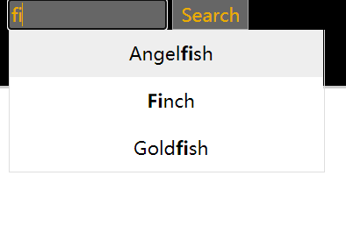

js：
Array.prototype.unique = function(){
this.sort();
var res = [];
var json = {};
for (var i = 0; i < this.length; i++) {
if(!json[this[i]]){
res.push(this[i]);
json[this[i]] = 1;
}
}
return res;
}
var setClass = {
hasClass: function(elements,cName){
if(elements.className.match(new RegExp( "(\\s|^)" + cName + "(\\s|$)") ))
return true;
else
return false;
},
addClass: function(elements,cName){ if( !this.hasClass( elements,cName ) ){
elements.className += " " + cName;
};
},
removeClass: function(elements,cName){
if( this.hasClass( elements,cName ) ){
elements.className = elements.className.replace( new RegExp( "(\\s|^)" + cName + "(\\s|$)" )," " );
}
}
}
var Bind = function(This){
return function(){
This.init();
}
}
function AutoComplete(keyword,auto,arr) {
this.obj = document.getElementById(keyword);
this.autoObj = document.getElementById(auto);
this.search_value = "";
this.index = -1;
this.value_arr = arr;
}
AutoComplete.prototype = {
// 初始化
init: function(){
var This = this;
setClass.removeClass(This.autoObj,"hidden");
this.autoObj.style.left = this.obj.offsetLeft + "px";
this.autoObj.style.top = this.obj.offsetTop + this.obj.offsetHeight + "px";
},
//删除自动完成需要的所有DIV
deleteDIV: function(){
while(this.autoObj.hasChildNodes()){
this.autoObj.removeChild(this.autoObj.firstChild);
}
setClass.addClass(this.autoObj,"hidden");
},
autoOnmouseover: function(index){
if(index != this.index){
setClass.addClass(this.autoObj.children[index],"on");
setClass.removeClass(this.autoObj.children[this.index],"on");
this.index = index;
}
},
setValue: function(This){
return function(){
This.obj.value = this.seq;
setClass.addClass(This.autoObj,"hidden");
}
},
// 响应键盘
pressKey: function(event){
var code = event.keyCode;
var length = this.autoObj.children.length;
if(code == 38){ //↑
setClass.removeClass(this.autoObj.children[this.index],"on");
this.index--;
if(this.index < 0){
this.index = length - 1;
}
setClass.addClass(this.autoObj.children[this.index],"on");
this.obj.value = this.autoObj.children[this.index].seq;
}else if(code == 40){ //↓
setClass.removeClass(this.autoObj.children[this.index],"on");
this.index++;
if(this.index > length-1){
this.index = 0;
}
setClass.addClass(this.autoObj.children[this.index],"on");
this.obj.value = this.autoObj.children[this.index].seq;
}else{ //回车
this.obj.value = this.autoObj.children[this.index].seq;
setClass.addClass(this.autoObj,"hidden");
this.index = -1;
}
},
// 程序入口
start: function(event){
event = event || window.event;
var code = event.keyCode;
var This = this;
if(code != 13 && code != 38 && code != 40){
this.init();
this.deleteDIV();
this.search_value = this.obj.value;
var valueArr = this.value_arr.unique();
if(this.obj.value.replace(/(^\s*)|(\s*$)/g,"") == ""){ return;}
try{
var reg = new RegExp("("+ this.obj.value +")","i"); //输入"aaa" 则 reg = /(aaa)/i
}catch(e){
alert(e.message);
}
var div_index = 0;
for (var i = 0; i < valueArr.length; i++) {
if(reg.test(valueArr[i])){
var div = document.createElement("div");
div.className = "auto_out";
div.seq = valueArr[i];
div.index = div_index;
div.innerHTML = valueArr[i].replace(reg,"<strong>$1</strong>");
this.autoObj.appendChild(div);
setClass.removeClass(this.autoObj,"hidden");
div_index++;
if(div_index == 1) {
setClass.addClass(this.autoObj.firstChild,"on");
this.index = 0;
}
div.onmouseover = function(){
This.autoOnmouseover(this.index);
}
div.onclick = this.setValue(This);
}
}
}else{
this.pressKey(event);
}
window.onresize = Bind(This);
}
}
var xmlHttpRequest;
function createXMLHttpRequest(){
……
}
var keyword = document.getElementById('keyword').value;
sendRequest("findResultServlet?keyword=" + keyword);
function sendRequest(url) {
……
}
function processResponse() {
if (xmlHttpRequest.readyState == 4) {
if (xmlHttpRequest.status == 200) {
var resp = xmlHttpRequest.responseText;
var array = resp.split(",");
var autoComplete = new AutoComplete("keyword","auto",array);
document.getElementById("keyword").onkeyup = function(event){
autoComplete.start(event);
}
}
}
}

servlet：
String keyword = request.getParameter("keyword");
CatalogService service = new CatalogService();
List<Product> productList = service.searchProductList(keyword);
response.setContentType("text/xml");
PrintWriter out = response.getWriter();
String res = "";
for(int i=0; i<productList.size(); i++){
if(i>0){
res += "," + productList.get(i);
}else{
res += productList.get(i);
}
}
out.write(res);
out.flush();
out.close();

3购物车模块。

jsp：
<td>
<input type="text" id="quantity" onblur="updateCart();" name="${cartItem.item.itemId}" value="${cartItem.quantity}">
<div id="cartMsg"></div>
<script type="text/javascript" src="${pageContext.request.contextPath }/js/updateCart.js"></script>
</td>

js：
var xmlHttpRequest;
function createXMLHttpRequest()
{
if (window.XMLHttpRequest) //非IE浏览器
{
xmlHttpRequest = new XMLHttpRequest();
}
else if (window.ActiveObject)//IE6以上版本的IE浏览器
{
xmlHttpRequest = new ActiveObject("Msxml2.XMLHTTP");
}
else //IE6及以下版本IE浏览器
{
xmlHttpRequest = new ActiveObject("Microsoft.XMLHTTP");
}
}
function updateCart() {
//var username = document.NewAccountForm.username.value;
//var workingItemId = document.getElementById('workingItemId').value;
//sendRequest("updateCartQuantities?username=" + username);
var quantity = document.getElementById("quantity").value;
sendRequest("updateCartJSServlet?quantity="+ quantity);
//sendRequest("updateCartQuantities");
}
function sendRequest(url) {
createXMLHttpRequest();
xmlHttpRequest.open("GET", url, true);
xmlHttpRequest.onreadystatechange = processResponse;
xmlHttpRequest.send(null);
}
function processResponse() {
if (xmlHttpRequest.readyState == 4) {
if (xmlHttpRequest.status == 200) {
var resp = xmlHttpRequest.responseText;
var array = resp.split(",");
var quantity = document.getElementById("quantity");
var total = document.getElementById("total");
var subtotal = document.getElementById("subtotal");
quantity.innerText = array[0];
total.innerText = array[1];
subtotal.innerText = array[2];
}
}
}

UpdateCartJSServlet：
public class UpdateCartJSServlet extends HttpServlet {
private Cart cart;
protected void doPost(HttpServletRequest request, HttpServletResponse response) throws ServletException, IOException {
HttpSession session = request.getSession();
cart = (Cart)session.getAttribute("cart");
Iterator<CartItem> cartItemIterator = cart.getAllCartItems();
while (cartItemIterator.hasNext()) {
CartItem cartItem = (CartItem) cartItemIterator.next();
String itemId = cartItem.getItem().getItemId();
try {
int quantity = Integer.parseInt((String) request.getParameter("quantity"));
cart.setQuantityByItemId(itemId, quantity);
if (quantity < 1) {
cartItemIterator.remove();
}
} catch (Exception e) {
e.printStackTrace();
}
}
session.setAttribute("cart", cart);
Cart cart2 = (Cart)session.getAttribute("cart");
Iterator<CartItem> cartItemIterator2 = cart2.getAllCartItems();
String quantityAll = "";
while (cartItemIterator2.hasNext()) {
CartItem cartItem2 = cartItemIterator2.next();
int quantity2 = cartItem2.getQuantity();
quantityAll += quantity2 + "," + cartItem2.getTotal() + "," + cart2.getSubTotal();
}
response.setContentType("text/xml");
PrintWriter out = response.getWriter();
out.write(quantityAll);
}
protected void doGet(HttpServletRequest request, HttpServletResponse response) throws ServletException, IOException {
doPost(request,response);
}
}

- 实验内容——选做任务。
- 商品展示模块。在首页展示商品的图片上添加AJAX效果，即当鼠标移到某个商品图片上时，用悬浮窗展示该类型商品的信息。
- 订单模块。通过选项卡或模版内容实现订单多个信息部分的录入，不需要页面跳转，在一个页面完成订单所有内容的录入。
- 其他效果：可自行选择其他UI模版，或选择其他功能点进行用户体验的优化。
无
- 小组成员分工及实验总结
- 小组分工：
- 实验总结

实验总结记录实验过程遇到的问题和解决的方法，以及心得体会，字数不少于500

字。

依照老师的视频，按部就班的完成了第一个功能“提示用户名是否存在”， 期间出现的问题基本上都是前端问题，调试花了很长时间，调试不出来的则反复观看视频比对改正， 完成第一个功能后，利用相同的方法，实现了检查用户两次输入的密码是否一致的提示。真正使用后从代码量上就可以发现jQuery可以极大地提高编写效率，让代码变得更加整洁，不过因为jQuery又引入了一些新概念并且语法与js

略有不同，刚开始编写时还是比较生涩，还需要多敲代码加以练习。如果只修改了js或css，重启tomcat并不会自动将修改部分重新编译，需要删除上一次的编译文件，重新编译才能让心得js，css发挥作用。个人感觉前端的编写要比后端要难，目前所遇到的后端需求在编写时很少遇到技术上的难题，有bug也可以快速解决，而编写前端更需要细心，最好“一遍过“，不然一旦出现问题可能就要花很长时间才能解决。完成这次的实验之后，我熟悉了AJAX相关技术，掌握异步交互的通信方式，能熟练使用JavaScript等客户端技术，掌握XMLHttpRequest对象的使用，掌握用AJAX技术改善Web应用的用户体验的方法。对于CSS，因为个人对于前端并不是很感兴趣也并没有未来向前端发展的打算，所以仅仅了解了一些相关的概念，并没有在进行深入学习，所以本次实验的成品在页面外观上并没有做太大的改动。

