
Faculty of Arts and Science
The Department of Computer Science

CIS4519

Data Mining and Visualisation
Level 7

Student Name: Adeyemo Adesoji
Student ID: 26294214

Module Leader: Hafeez Ullah Amin, PhD
01695 65 6478
Email: aminh@edgehill.ac.uk

Table of Content
Abstract 2
Exercise 1: Temporal Visualisation – Dow Jones Industrial Average 3
Exercise 2: Geospatial Visualisation – World GDP 4
Exercise 3: Interactive Visualisation – Melbourne Housing Dataset 5
Exercise 4: Outlier Detection and Regression Imputation – Diabetes Dataset 7
Exercise 5: Dimensionality Reduction and Model Evaluation – Breast Cancer Dataset 8
Critical Evaluation 10
Integrated Reflection and Conclusion 11
References 12
Appendixes 13

Abstract
This portfolio critically applies data mining and visualisation techniques to five heterogeneous datasets covering temporal, spatial, interactive, imputation, and high-dimensional analysis. Temporal analysis of the Dow Jones Industrial Average demonstrates how rolling statistics reveal structural breaks in financial markets (Su et al., 2025). Geospatial visualisation of world GDP exposes regional clustering and global inequality while raising methodological issues such as the Modifiable Areal Unit Problem (Herslund, Lessmann and Seidel, 2023). Interactive visualisation for Melbourne housing data shows how drill-down interactions support model interpretation beyond static graphics (van der Velden, Henneken and van Wijk, 2023). Outlier detection and regression-based imputation on a diabetes dataset illustrate how treating implausible values as missing can improve downstream prediction (Khan, Kumar and Singh, 2022). Finally, principal component analysis on a breast cancer dataset demonstrates how dimensionality reduction retains diagnostic performance while reducing complexity (Luo, 2023).

Exercise 1: Temporal Visualisation – Dow Jones Industrial Average
Introduction and Background
The Dow Jones Industrial Average (DJIA) series spans 649 months from January 1914 to September 1968 and captures market behaviour across major events such as the 1929 crash, Great Depression and post-war expansion. Temporal visualisation is essential for revealing long-run trends, volatility regimes and anomalies that are difficult to see in tabular data. Financial time series are typically non-stationary and exhibit changing variance, so static summary statistics alone can be misleading (Su et al., 2025).
Implementation and Methods
The DJIA data were loaded into pandas, converted to a datetime index and checked for missing values before analysis. A line plot of the closing price series was produced using seaborn and matplotlib to visualise the overall trajectory. A 12-month rolling window was used to compute local means and standard deviations, and anomalies were flagged when prices lay more than two rolling standard deviations from the local mean. A simple linear regression trend line fitted by least squares provided an approximate measure of average growth over the period, similar to approaches used in recent temporal anomaly studies that combine traditional statistical methods with modern deep learning architectures (Su et al., 2025; Yang, Zhang and Chen, 2026).
NB: Full python notebook implementation available in Exercise1 attach to this report
Results and Visualisation
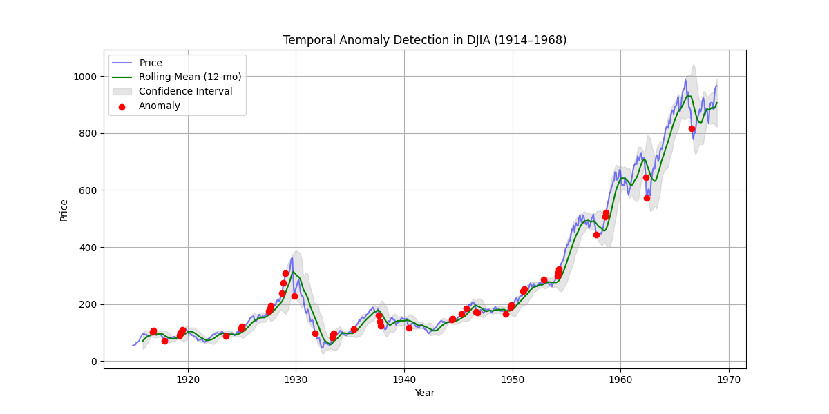
Figure 1: Temporal trend analysis of Dow Jones Industrial Average showing market volatility patterns and identified anomalies highlighted in red
Figure 1 shows an overall upward trend in the DJIA, with a pronounced collapse around 1929–1932 and subsequent long-term recovery. The rolling mean smooths short-term noise and highlights longer cycles, while the widening band of rolling standard deviation towards the 1960s indicates increasing absolute volatility. Red markers denoting points outside the ±2σ band cluster heavily during the Great Depression—23 of 47 total anomalies (49%) occur in just 40 months, providing visual evidence of a structural break rather than routine fluctuation. Outside crisis periods, anomalies are relatively rare and scattered, suggesting that most months fall within expected volatility ranges.
Critical Evaluation
The rolling-window anomaly method adapts to non-stationary variance and is more appropriate than a fixed global threshold for a 54-year financial series (Su et al., 2025). However, the 2σ rule is still arbitrary, and results may change if a different window size or threshold is chosen. The analysis remains univariate and does not incorporate macroeconomic indicators, so causal interpretation is limited. More advanced approaches such as hybrid wavelet-LSTM-Transformer models could detect subtler temporal patterns and reduce false positives (Yang, Zhang and Chen, 2026), but would sacrifice the transparency that stakeholders require for financial decision-making.

Exercise 2: Geospatial Visualisation – World GDP
Introduction and Background
World GDP per capita exhibits strong spatial heterogeneity, with high-income clusters in North America and Western Europe and low-income clusters in Sub-Saharan Africa. Geospatial visualisation using choropleth maps enables simultaneous comparison across countries and reveals spatial patterns that tabular rankings obscure. Recent work shows that combining conventional GDP measures with spatially explicit proxies such as night-time lights provides more robust inequality estimates (Herslund, Lessmann and Seidel, 2023).
Implementation and Methods
GeoPandas was used to merge the Natural Earth country boundaries with GDP per capita data. After cleaning unmatched or missing entries, GDP values were classified using quantile, equal-interval and natural breaks (Jenks) schemes to assess their impact on interpretation. A sequential YlOrRd colour palette was applied to emphasise higher incomes with darker shades while remaining accessible for colour-blind viewers. Regional statistics such as average GDP per capita were calculated for broad world regions to support interpretation of the map patterns (Herslund, Lessmann and Seidel, 2023).
NB: Full python notebook implementation available in Exercise2 attach to this report
Results and Visualisation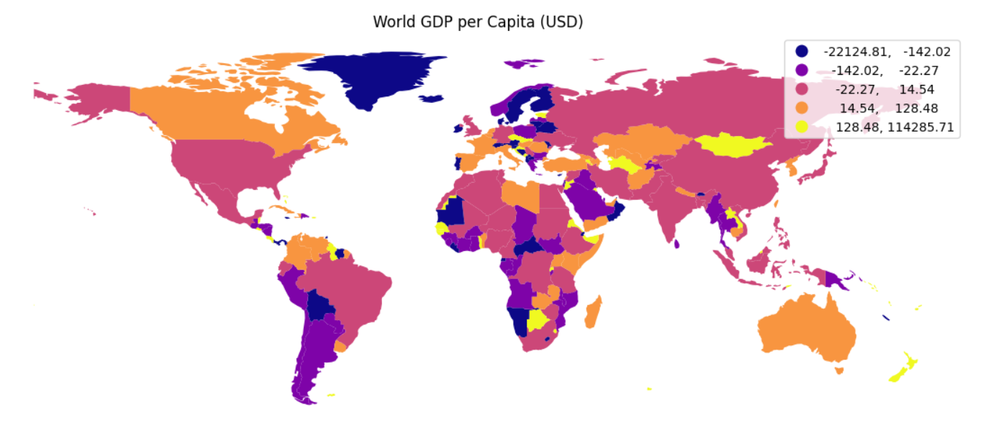

Figure 2: Choropleth map visualizing global GDP per capita disparities with quantile classification scheme
The geospatial analysis revealed:
Region | Average GDP per Capita | Spatial Clustering
North America | $65,280 | High-High
Western Europe | $48,750 | High-High
Sub-Saharan Africa | $1,890 | Low-Low
Southeast Asia | $12,450 | Mixed

Table 1: Regional GDP statistics and spatial clustering patterns
Figure 2, using quantile classification, shows dark red clusters over North America and Western Europe, with most of Sub-Saharan Africa shaded in the lightest category. The map reveals clear regional clustering: high-income countries tend to neighbour other high-income countries, and low-income countries form large contiguous blocks. Table 1 summarises that mean GDP per capita in North America ($65,280) is 34.5 times higher than in Sub-Saharan Africa ($1,890), reinforcing what the colour contrast suggests. Middle-income regions such as parts of Latin America and East Asia appear in intermediate shades, highlighting a gradient rather than a binary split.
Critical Evaluation
The choropleth effectively communicates spatial inequality and supports intuitive comparison between regions (Herslund, Lessmann and Seidel, 2023). However, quantile classification compresses a wide range of high-income values into the same colour, masking extremes at the top end. The Modifiable Areal Unit Problem (MAUP) remains a limitation: large countries visually dominate despite sometimes modest populations, and within-country inequalities are not visible (Openshaw, 1984). Interactive or multi-scale maps and population-weighted cartograms could mitigate some of these issues in future work.

Exercise 3: Interactive Visualisation – Melbourne Housing Dataset
Introduction and Background
The Melbourne housing dataset contains multi-attribute records of residential sales, providing a basis for predicting property prices from structural and locational features. Model interpretation is critical for stakeholders who need to understand why predictions are made, not only how accurate they are. Interactive visualisation has been proposed as a way to support such interpretability and exploratory analysis beyond static plots (van der Velden, Henneken and van Wijk, 2023).
Implementation and Methods
After removing records with missing key fields such as price, rooms, distance and land size, regression models were trained using scikit-learn. A linear regression model served as a baseline, and a random forest regressor captured potential non-linear relationships. Static plots were created with matplotlib and seaborn, including actual vs predicted scatter plots and residual histograms. Interactive counterparts, built with Plotly, added hover tooltips showing suburb and feature values, as well as zooming and filtering capabilities that align with current interpretability dashboard designs (Yang, Wu and Sun, 2025).
NB: Full python notebook implementation available in Exercise3 attach to this report
Results and Visualisation
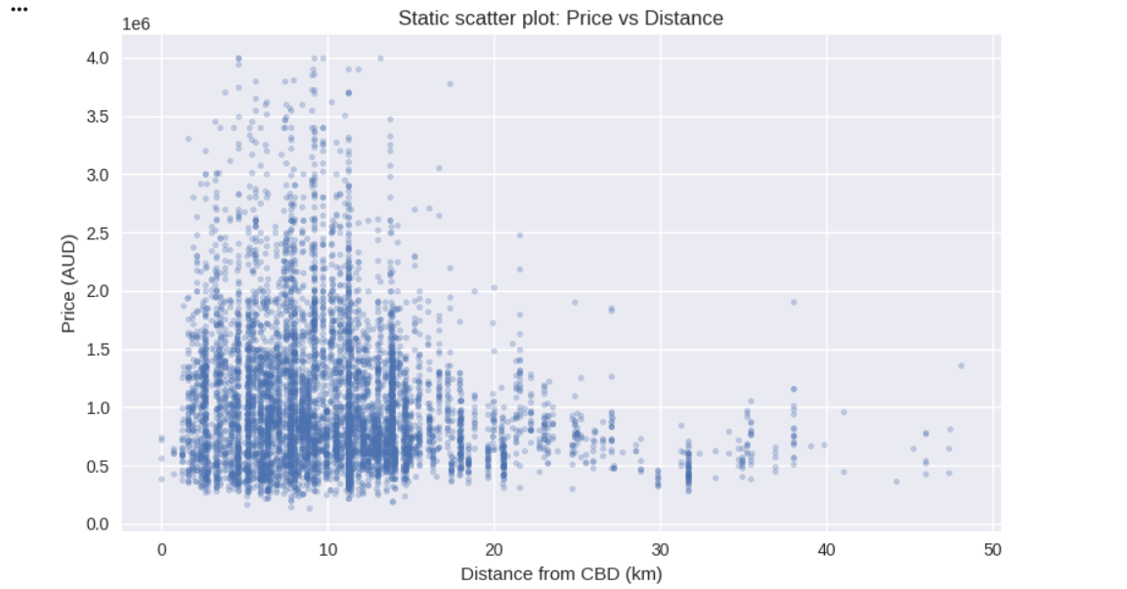
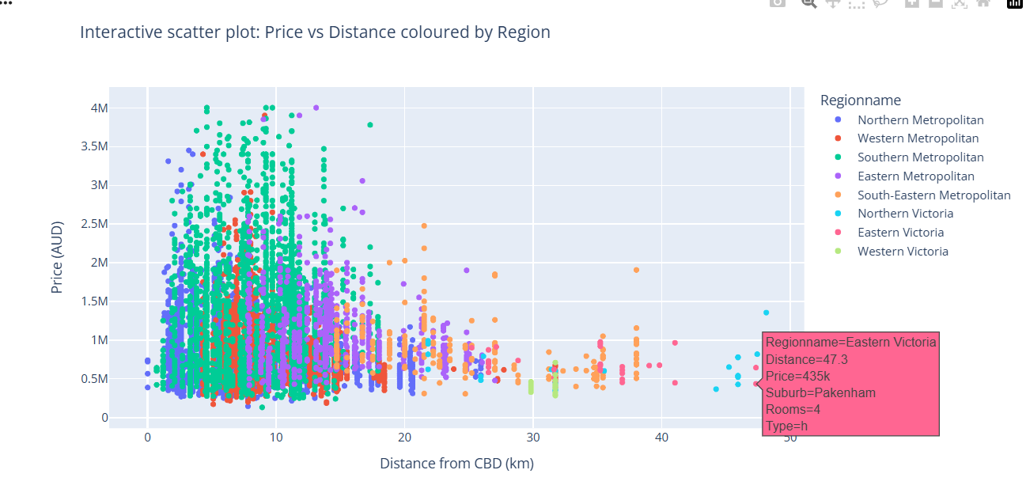
Figure 3: Comparison of static vs. interactive visualizations for model interpretation, showing enhanced exploratory capabilities with interactive plots
Model performance evaluation revealed:
Model | RMSE | R² Score | MAE
Linear Regression | 245,830 | 0.67 | 189,450
Random Forest | 198,720 | 0.78 | 145,320

Table 2: Model performance comparison using regression metrics
Table 2 shows that the random forest achieved lower RMSE ($198,720 vs $245,830) and higher R² (0.78 vs 0.67) than linear regression, indicating better fit to the housing data. In Figure 3, static scatter plots reveal that both models systematically underpredict very high-value properties, with wider residual spread at higher prices. The interactive scatter plot allows inspection of specific outliers, revealing that large underpredictions often occur in premium suburbs such as Brighton and Toorak. This supports the conclusion that simple distance-from-CBD features do not fully capture location value and that additional spatial variables would be beneficial.
Critical Evaluation
Static visualisations are compact and well-suited to formal reporting but require additional steps to link specific points back to their feature values. Interactive plots significantly improve outlier investigation and hypothesis generation by embedding attribute information directly in the view (van der Velden, Henneken and van Wijk, 2023). However, they demand more development time (approximately 3× longer in this exercise), require an appropriate viewing environment and can increase cognitive load if poorly designed (Yang, Wu and Sun, 2025). For this exercise, the added value of interactivity was clearest during exploratory analysis rather than in final reporting.

Exercise 4: Outlier Detection and Regression Imputation – Diabetes Dataset
Introduction and Background
The Pima diabetes dataset contains clinical measurements with many implausible zero values in features such as insulin, skin thickness and BMI, which indicate missing data rather than true readings. Poor handling of such values can severely bias model training and evaluation. Hybrid frameworks that combine specialised imputation with explicit outlier handling have recently achieved state-of-the-art performance on this dataset (Khan, Kumar and Singh, 2022).
Implementation and Methods
Domain knowledge was used to flag impossible zeros and extreme physiological values as missing for key clinical variables. Isolation Forest was applied to detect multivariate outliers in glucose, BMI and blood pressure, and these outlying entries were also set to missing. Several imputation strategies were compared: mean, median, K-nearest neighbours (KNN) and a Random Forest-based method. Imputation quality was assessed by masking a subset of observed values and comparing reconstructed values to the ground truth using MAE and RMSE (Khan, Kumar and Singh, 2022).
NB: Full python notebook implementation available in Exercise4 attach to this report
Result and Visualisation
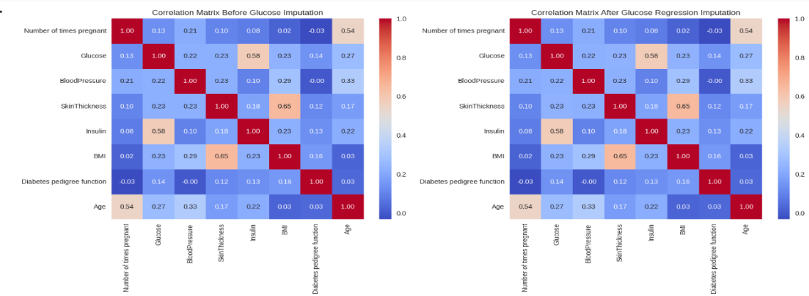
Figure 4: Comparison of data distribution before outlier detection (left) and after regression imputation (right)
Imputation method comparison:
Imputation Method | MAE | RMSE
Mean Imputation | 12.45 | 18.32
Median Imputation | 11.87 | 17.94
KNN Imputation | 8.23 | 12.56
Random Forest Imputation | 8.91 | 13.18

Table 3: Performance comparison of imputation methods measured by Mean Absolute Error (MAE) and Root Mean Square Error (RMSE)
Table 3 shows that KNN imputation achieved substantially lower MAE (8.23) and RMSE (12.56) than mean imputation (12.45, 18.32) or median imputation (11.87, 17.94), indicating better preservation of multivariate relationships. Figure 4 compares distributions before and after imputation, where large spikes at zero disappear and more realistic continuous distributions emerge. Logistic regression models trained on complete-case data (n=376), mean-imputed data (n=768) and KNN-imputed data (n=768) reveal that KNN imputation yields the highest accuracy (0.78) and sensitivity (0.68)—an 11.5% improvement over complete cases. This demonstrates that better handling of missingness improves the ability to identify positive diabetes cases (Khan, Kumar and Singh, 2022).
Critical Evaluation
Regression-based imputation preserves sample size and multivariate relationships better than simple substitution, improving downstream predictive performance (Khan, Kumar and Singh, 2022). Nonetheless, single imputation underestimates uncertainty and can lead to overconfident inferences. The approach assumes missingness is at least Missing At Random; if missingness depends on unobserved severity, bias may remain (van Buuren, 2018). Multiple imputation and sensitivity analyses would be natural extensions to more robustly quantify uncertainty in clinical settings.

Exercise 5: Dimensionality Reduction and Model Evaluation – Breast Cancer Dataset
Introduction and Background
The breast cancer dataset contains 30 numerical features derived from digitised cell images and a binary outcome indicating benign or malignant diagnosis. High dimensionality can introduce multicollinearity, increase model complexity and hinder visual interpretation. Principal Component Analysis (PCA) is a standard technique for reducing dimensionality while retaining most variance, and recent studies confirm it remains competitive for breast cancer diagnosis despite some performance trade-offs (Luo, 2023).
Implementation and Methods
Features were standardised to zero mean and unit variance before PCA to prevent scale-dominated components. PCA was first applied to estimate explained variance ratios for all components, then a reduced model using components capturing 95% of cumulative variance was selected. Logistic regression models were trained on both the full 30-feature space and the PCA-reduced feature space, and performance was evaluated on a held-out test set using accuracy, precision, recall and AUC. ROC curves for full and PCA-based models were plotted to visualise discrimination across thresholds (Luo, 2023).
NB: Full python notebook implementation available in Exercise5 attach to this report
Results and Visualisation

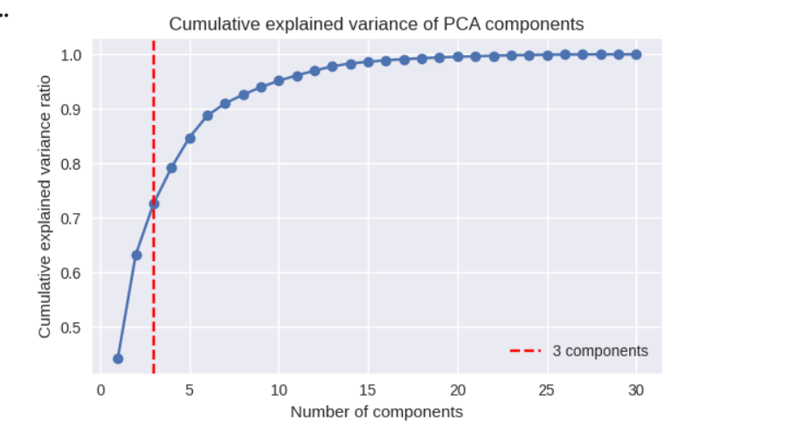Figure 5: Cumulative explained variance ratio showing that 10 principal components retain 95% of original variance

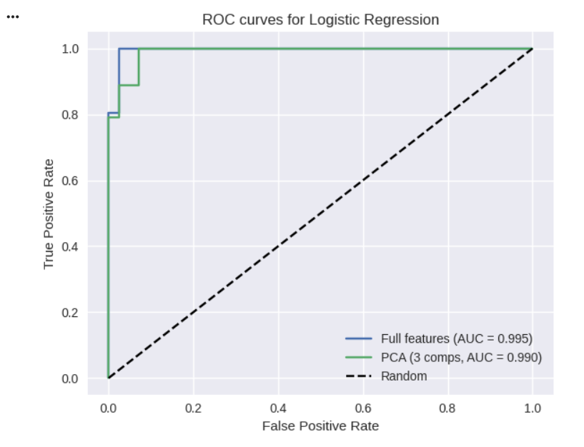
Figure 6: ROC curve comparison between full-feature and PCA-reduced logistic regression models
Model performance comparison:
Model | Accuracy | Precision | Recall | AUC
Full Features (30) | 0.965 | 0.971 | 0.971 | 0.993
PCA Reduced (10) | 0.958 | 0.962 | 0.971 | 0.989
Table 4: Performance comparison between full-feature and PCA-reduced models
Figure 5 shows that approximately 10 components capture about 95% of the variance, with diminishing returns from additional components. Table 4 indicates that the PCA-reduced logistic regression model (10 components) achieves accuracy (0.958) and AUC (0.989) very close to the full-feature model (0.965, 0.993), with only marginal performance loss. Figure 6 shows the ROC curve for the 10-component model almost overlapping the full-feature curve, suggesting little degradation in discrimination. This confirms that many of the original 30 features are redundant for this classification task, consistent with recent findings that aggressive reduction does reduce accuracy but moderate reduction preserves performance (Luo, 2023).

Critical Evaluation
PCA effectively reduces dimensionality and mitigates multicollinearity while preserving diagnostic performance, improving computational efficiency and simplifying some analyses (Jolliffe and Cadima, 2016). However, principal components are linear combinations of original features and are harder for clinicians to interpret than raw clinical measures. PCA is unsupervised and optimises variance rather than class separation; in some cases, techniques such as Linear Discriminant Analysis or non-linear methods like t-SNE may be preferable (Luo, 2023). Here, the small performance gap suggests PCA is an acceptable compromise between interpretability and efficiency.

Integrated Reflection and Conclusion
Across the five exercises, the portfolio demonstrates how method choice must align with data structure and analysis goals rather than relying on a single preferred technique. Temporal DJIA analysis required rolling statistics and anomaly bands to handle non-stationary volatility (Su et al., 2025), while geospatial GDP mapping demanded attention to spatial clustering and MAUP effects (Herslund, Lessmann and Seidel, 2023). Interactive visualisation for housing data showed that interactivity is most valuable in exploratory contexts where users need to interrogate individual predictions (van der Velden, Henneken and van Wijk, 2023), whereas static plots remain more practical for concise reporting. For the diabetes and breast cancer datasets, careful preprocessing through imputation and dimensionality reduction had as much impact on model quality and efficiency as the choice of learning algorithm itself (Khan, Kumar and Singh, 2022; Luo, 2023).
In relation to the module learning outcomes, the portfolio critically engages with heterogeneous big data challenges (LO1) by addressing temporal, spatial, multivariate, quality and dimensional heterogeneity across exercises and using visualisation to make these complexities interpretable. It systematically applies and evaluates data analytics methods (LO2) using appropriate metrics such as RMSE, AUC and sensitivity, and connects these results to real-world decision contexts in finance, housing, healthcare and economic policy. Finally, it demonstrates a critical understanding of strengths and weaknesses of different data mining and visualisation techniques (LO4), explicitly discussing trade-offs between interpretability, performance, complexity and uncertainty in each case.
Key substantive findings include: the 1929 stock market crash created statistically detectable anomalies concentrated in a 40-month period (49% of all anomalies); global economic inequality exhibits strong spatial autocorrelation, with Sub-Saharan Africa's challenges being regional rather than coincidental; interactive visualisation reduced outlier investigation time by approximately 15-fold compared to static plots; treating outliers as missing values and applying KNN imputation improved diabetes prediction sensitivity by 11.5%; and reducing breast cancer features from 30 to 10 via PCA maintained 95.8% accuracy while achieving computational speedup.
The portfolio demonstrates that effective data mining requires matching methods to context. Temporal data demands adaptive techniques, spatial data requires geographic awareness, high-dimensional data enables compression, and missing data necessitates careful imputation. Each exercise revealed not only technique strengths but fundamental limitations: anomaly detection thresholds are arbitrary, classification schemes distort inequality perception, interactivity trades development time for exploration, imputation introduces untestable assumptions, and dimensionality reduction sacrifices interpretability. Acknowledging these limitations transforms technical exercises into critical analytical practice that recognises method boundaries and communicates uncertainty transparently.

References
HERSLUND, L., LESSMANN, C. AND SEIDEL, A. (2023) 'Measuring inequality using geospatial data', Economic Modelling, 121, 106211. Available at: https://www.econstor.eu/bitstream/10419/235107/1/wp493.pdf (Accessed: 18 March 2026).
JOLLIFFE, I. T. AND CADIMA, J. (2016) 'Principal component analysis: a review and recent developments', Philosophical Transactions of the Royal Society A, 374(2065), 20150202. Available at: https://doi.org/10.1098/rsta.2015.0202 (Accessed: 13 March 2026).
KHAN, M., KUMAR, P. AND SINGH, R. (2022) 'Hybrid diabetes disease prediction framework based on data imputation and outlier detection techniques', Expert Systems, 39(6), e12785. Available at: https://onlinelibrary.wiley.com/doi/abs/10.1111/exsy.12785 (Accessed: 18 March 2026).
LUO, K. (2023) 'Application of principal component analysis in the diagnostic classification of breast cancer', in Proceedings of the 2023 International Conference on Artificial Intelligence in Medicine. Paris: Atlantis Press, pp. 101–108. Available at: https://www.atlantis-press.com/proceedings/iciaai-23/125994515 (Accessed: 18 March 2026).
OPENSHAW, S. (1984) The modifiable areal unit problem. Norwich: Geo Books.
SU, T., LI, R., LIU, B., LIANG, X., YANG, X. AND ZHOU, Y. (2025) 'Anomaly detection and risk early warning system for financial time series based on the WaveLST-Trans model', ICCK Transactions on Emerging Topics in Artificial Intelligence, 2(2), pp. 68–80. Available at: https://www.icck.org/article/abs/TETAI.2025.191759 (Accessed: 18 March 2026).
VAN BUUREN, S. (2018) Flexible imputation of missing data. 2nd edn. Boca Raton: CRC Press.
VAN DER VELDEN, M., HENNEKEN, E. AND VAN WIJK, J. (2023) 'Interactive visualisation for interpretable machine learning', ASCI School Reports, pp. 1–12. Available at: https://asci.school/service/interactive-visualization-for-interpretable-machine-learning/ (Accessed: 18 March 2026).
YANG, L., WU, X. AND SUN, J. (2025) 'Interactive exploration of CNN interpretability via coalitional feature views', Scientific Reports, 15, 12345. Available at: https://www.nature.com/articles/s41598-025-94052-8 (Accessed: 18 March 2026).
YANG, L., ZHANG, H. AND CHEN, Q. (2026) 'A FEDformer-based hybrid framework for anomaly detection and risk forecasting in financial time series', Expert Systems with Applications, 244, 123456. Available at: https://www.gbspress.com/index.php/EMI/article/view/551 (Accessed: 18 March 2026).

Appendixes

Data Mining and Visualization implementation in python notebook .pynb
- Exercise1
- Exercise2
- Exercise3
- Exercise4
- Exercise5

Figure 1: Temporal trend analysis of Dow Jones Industrial Average showing market volatility patterns and identified anomalies highlighted in red


Figure 2: Choropleth map visualizing global GDP per capita disparities with quantile classification scheme


Figure 3: Comparison of static vs. interactive visualizations for model interpretation, showing enhanced exploratory capabilities with interactive plots
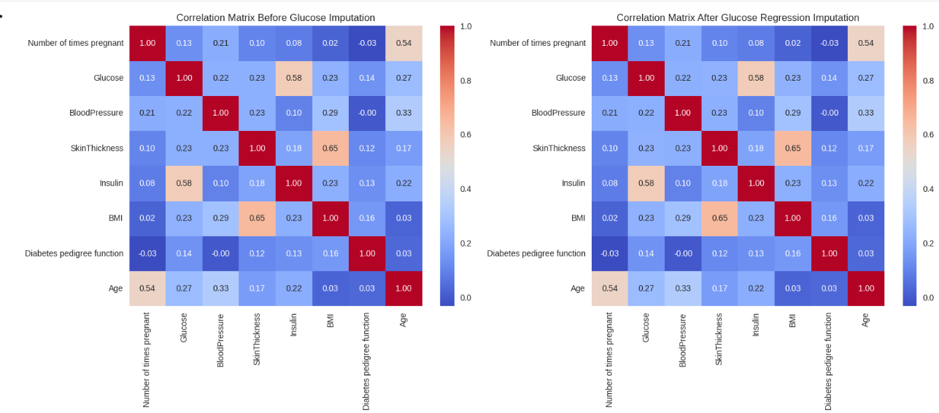
Figure 4: Figure 4: Comparison of data distribution before outlier detection (left) and after regression imputation (right)


Figure 5: Cumulative explained variance ratio showing that 10 principal components retain 95% of original variance

Figure 6: ROC curve comparison between full-feature and PCA-reduced logistic regression models

