# Product Documentation

## Product

* Fillable Fields:
* product_name
* product_description
* SKU
* discount_id
* category_id
* price
* inventory_id

## Data Validation

* Validation Rules:
* product_name: required, string, max:255
* product_description: required, string
* SKU: required, string, max:255
* category_id: required, must exist in categories table (exists:categories,id)
* discount_id: nullable, if present must exist in discounts table (exists:discounts,id)
* price: required, numeric, minimum value 0
* inventory_id: required, must exist in inventories table (exists:inventories,id)

## 3. Route List

### API Endpoints

|  |  |  |
| --- | --- | --- |
| Method | URL | Description |
| GET | <http://127.0.0.1:8000/api/v1/products> | Get List of Products |
| GET | [http://127.0.0.1:8000/api/v1/products/edit/{id}](http://127.0.0.1:8000/api/v1/products/edit/%7bid%7d) | Get a Specific Product |
| POST | <http://127.0.0.1:8000/api/v1/products> | Insert a Product |
| PUT | [http://127.0.0.1:8000/api/v1/products/{id}/edit](http://127.0.0.1:8000/api/v1/products/%7bid%7d/edit) | Update a Product |
| DELETE | [http://127.0.0.1:8000/api/v1/products/{id}](http://127.0.0.1:8000/api/v1/products/%7bid%7d) | Delete a Product |

### Client Routes

|  |  |  |
| --- | --- | --- |
| Method | URL | Description |
| GET | <http://127.0.0.1:8090/client/products> | Get List of Products |
| GET | [http://127.0.0.1:8090/client/products/{id}](http://127.0.0.1:8090/client/products/%7bid%7d) | Get a Specific Product |
| GET | <http://127.0.0.1:8090/client/products/create> | Create Product Form |
| POST | <http://127.0.0.1:8090/client/products> | Insert a Product |
| PUT | [http://127.0.0.1:8090/client/products/{id}/edit](http://127.0.0.1:8090/client/products/%7bid%7d/edit) | Update a Product |

## 4. Status Code

|  |  |
| --- | --- |
| Method | Description |
| 200 | Fetch Successfully |
| 201 | Insert New Product Successfully |
| 204 | Delete A Specific Product Successfully |
| 404 | Product Not Found |
| 422 | Invalid Id |
| 500 | Server Error |

## 5. Example

Before implementing this action, first open Google Chrome and search for "Postman." If you haven't registered yet, sign up for an account. After registration, open Postman , select a valid method(get,post,put,delete) , and then enter the URL in the request URL bar, and click "Send." You will receive the status code along with the response data.

* Fetching List of Product

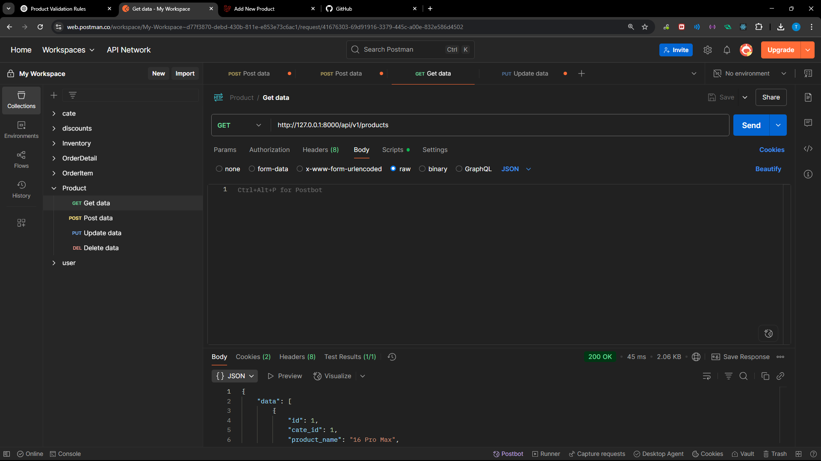

Note: if you got 422 status that mean selected id(discount_id , category_id,inventory_id)

Aren’t no exist yet so to achieve this u need to insert those field before inserting product.

Here is the result of fetching list of products:

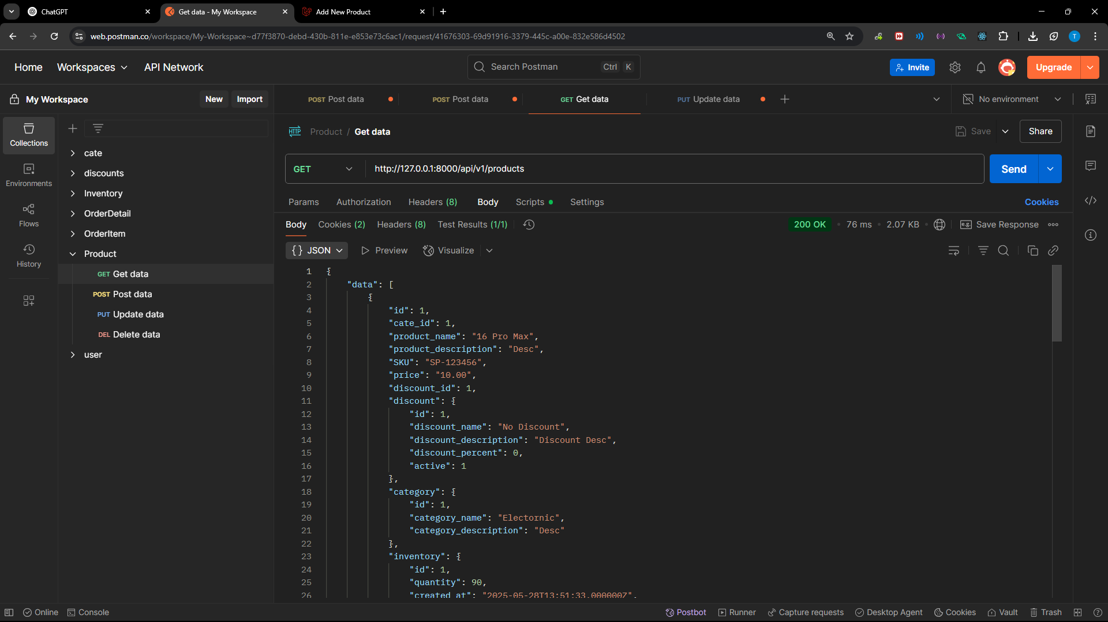

Sample Json Ressponse:

{

    "data": {

        "id": 1,

        "cate_id": 1,

        "product_name": "16 Pro Max",

        "product_description": "Desc",

        "SKU": "SP-123456",

        "price": "10.00",

        "discount_id": 1,

        "discount": {

            "id": 1,

            "discount_name": "No Discount",

            "discount_description": "Discount Desc",

            "discount_percent": 0,

            "active": 1

        },

        "category": {

            "id": 1,

            "category_name": "Electornic",

            "category_description": "Desc"

        },

        "inventory": {

            "id": 1,

            "quantity": 90,

            "created_at": "2025-05-28T13:51:33.000000Z",

            "updated_at": "2025-05-28T13:51:33.000000Z"

        }

    }

}

* Inserting New Product

Select the **POST** method, paste the URL, then go to **Body** > **raw** > and choose **JSON** as the format. Finally, paste the following JSON structure:

{

    "product_name": "Laptop 5090",

    "product_description": "A great product for testing",

    "SKU": "SP-123450",

    "category_id": 1,

    "discount_id": 1,

    "price": 990.99,

    "inventory_id":2

}

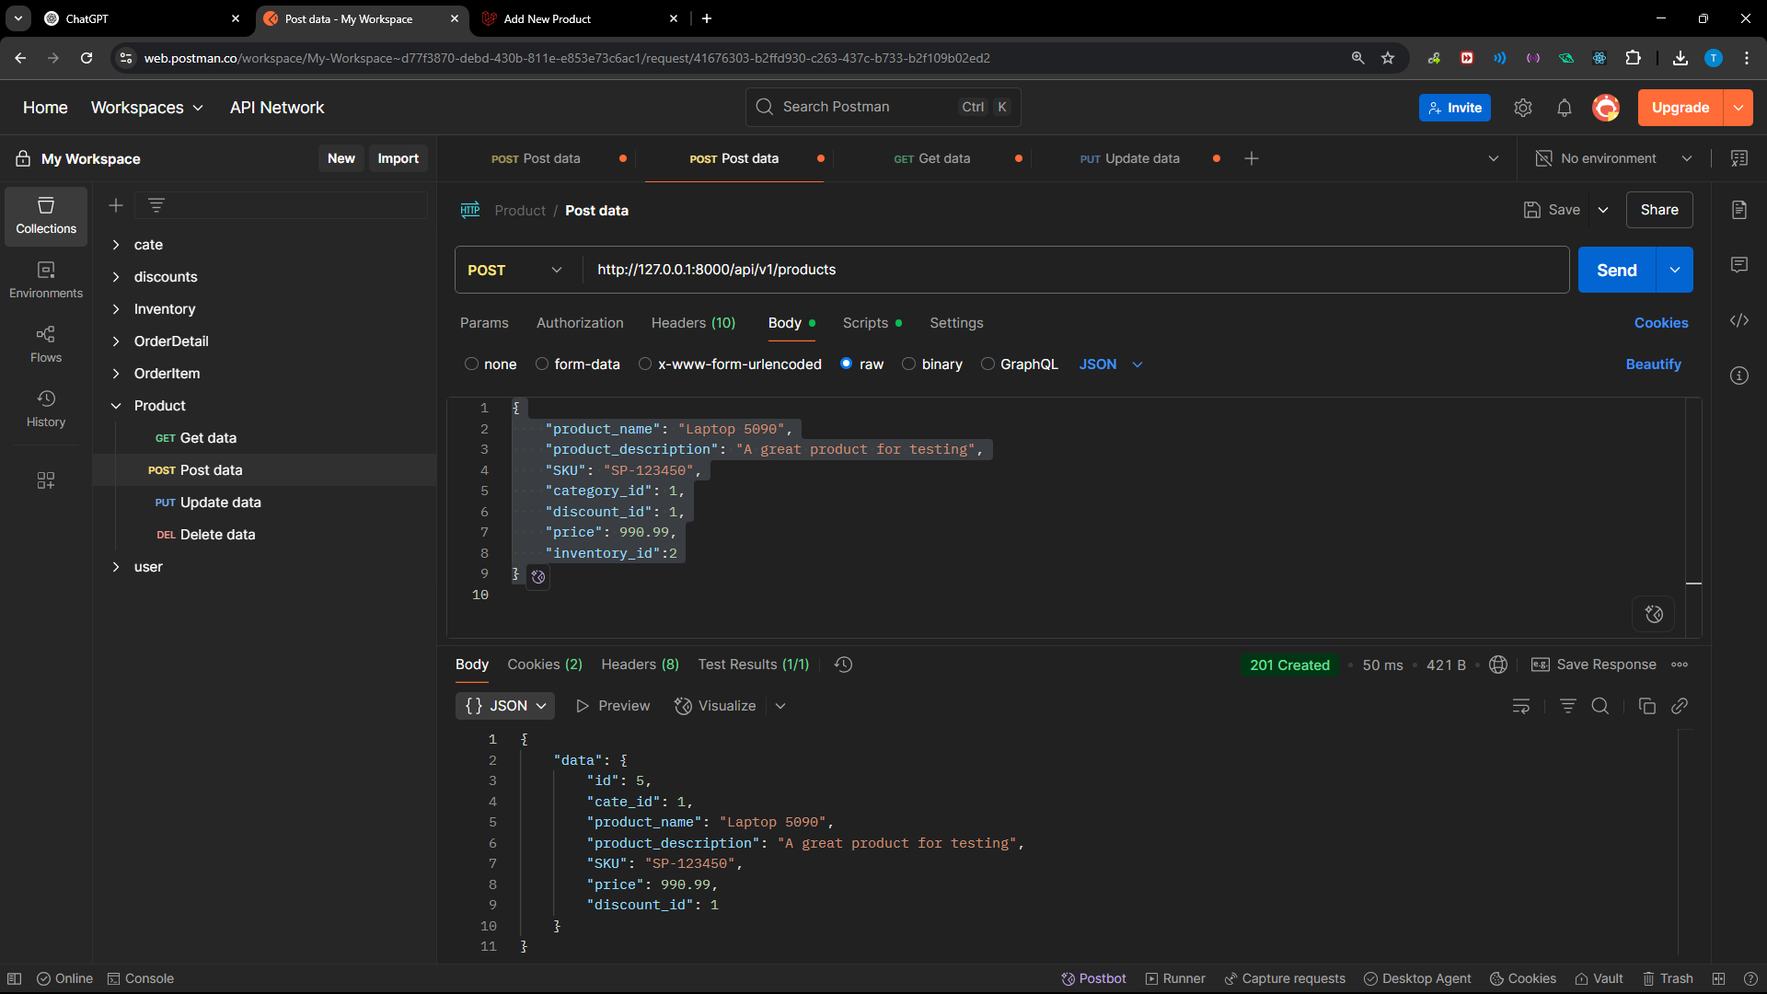

Note: If the status code is **201**, it means your insertion was successful.

* Eding Specific Product

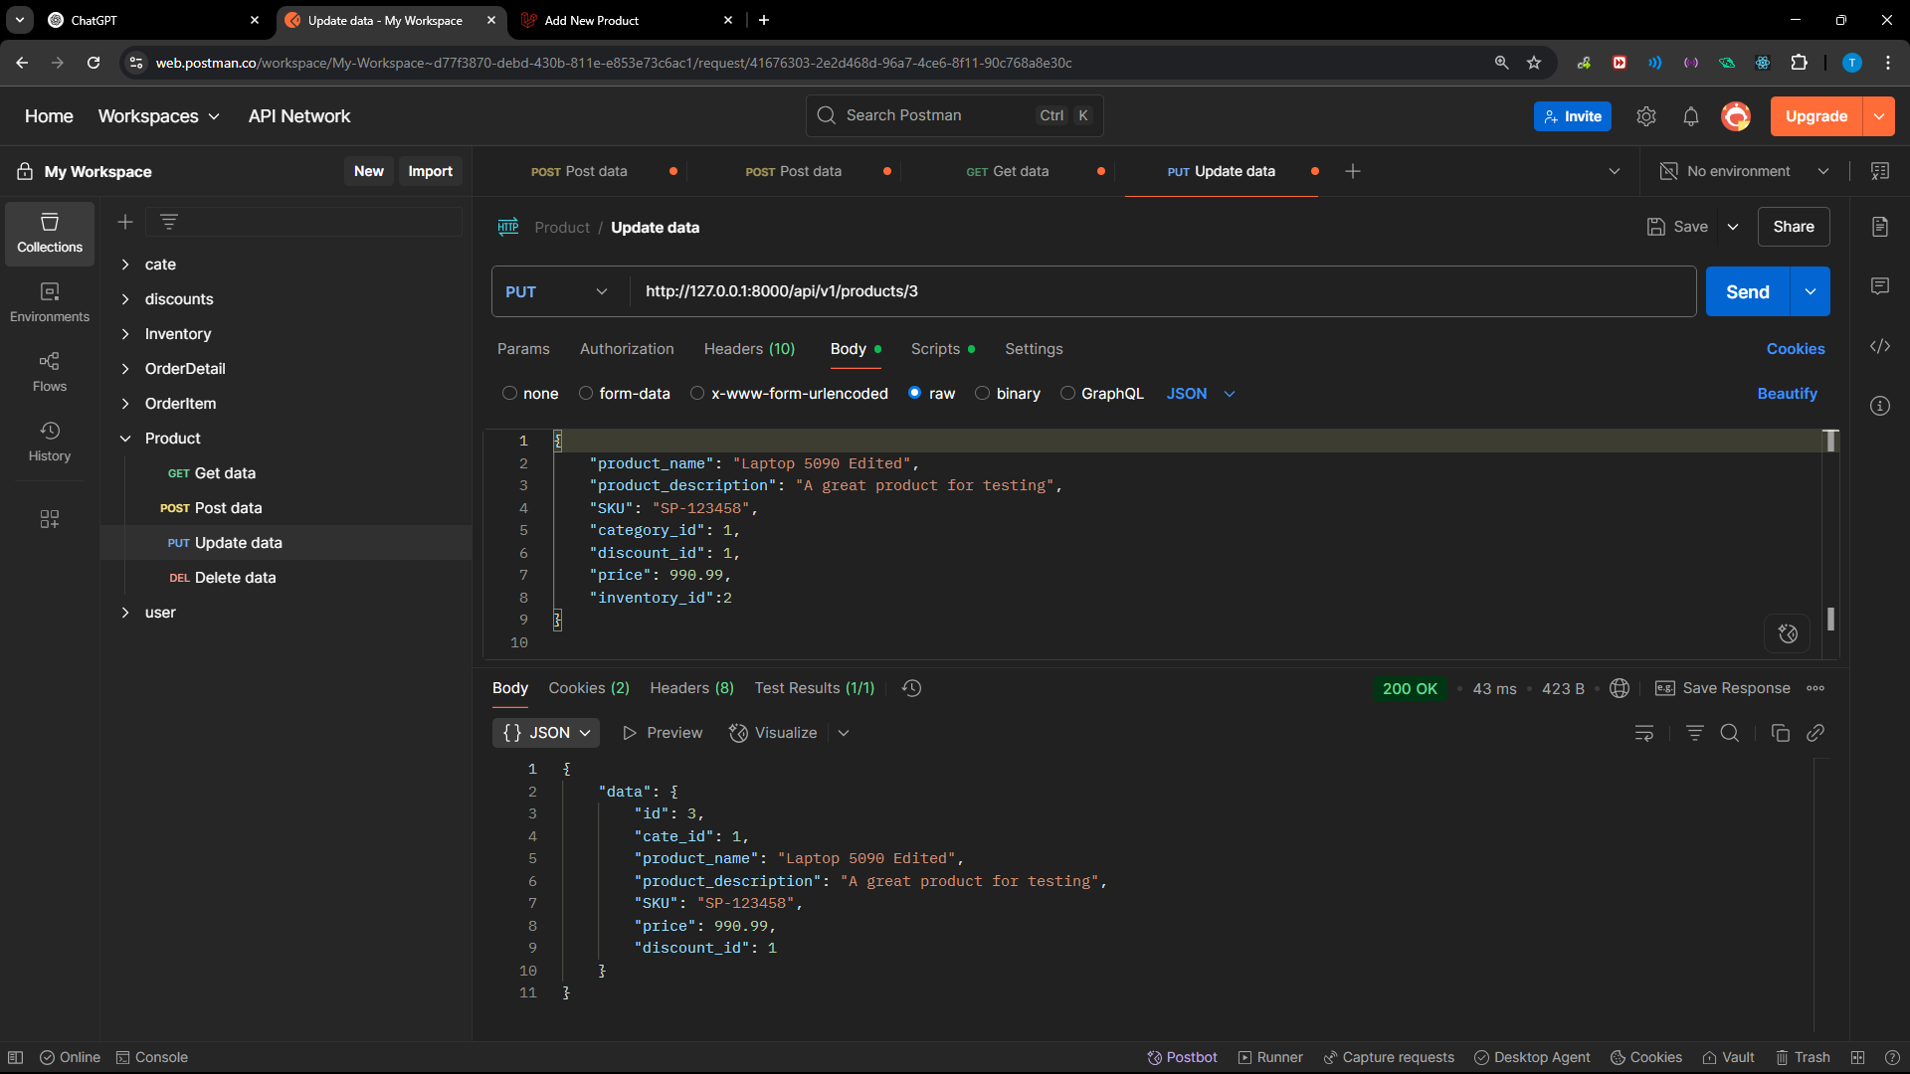

Note: If the status code is **200**, it means your updating was successful.

* Deleting Specific Product

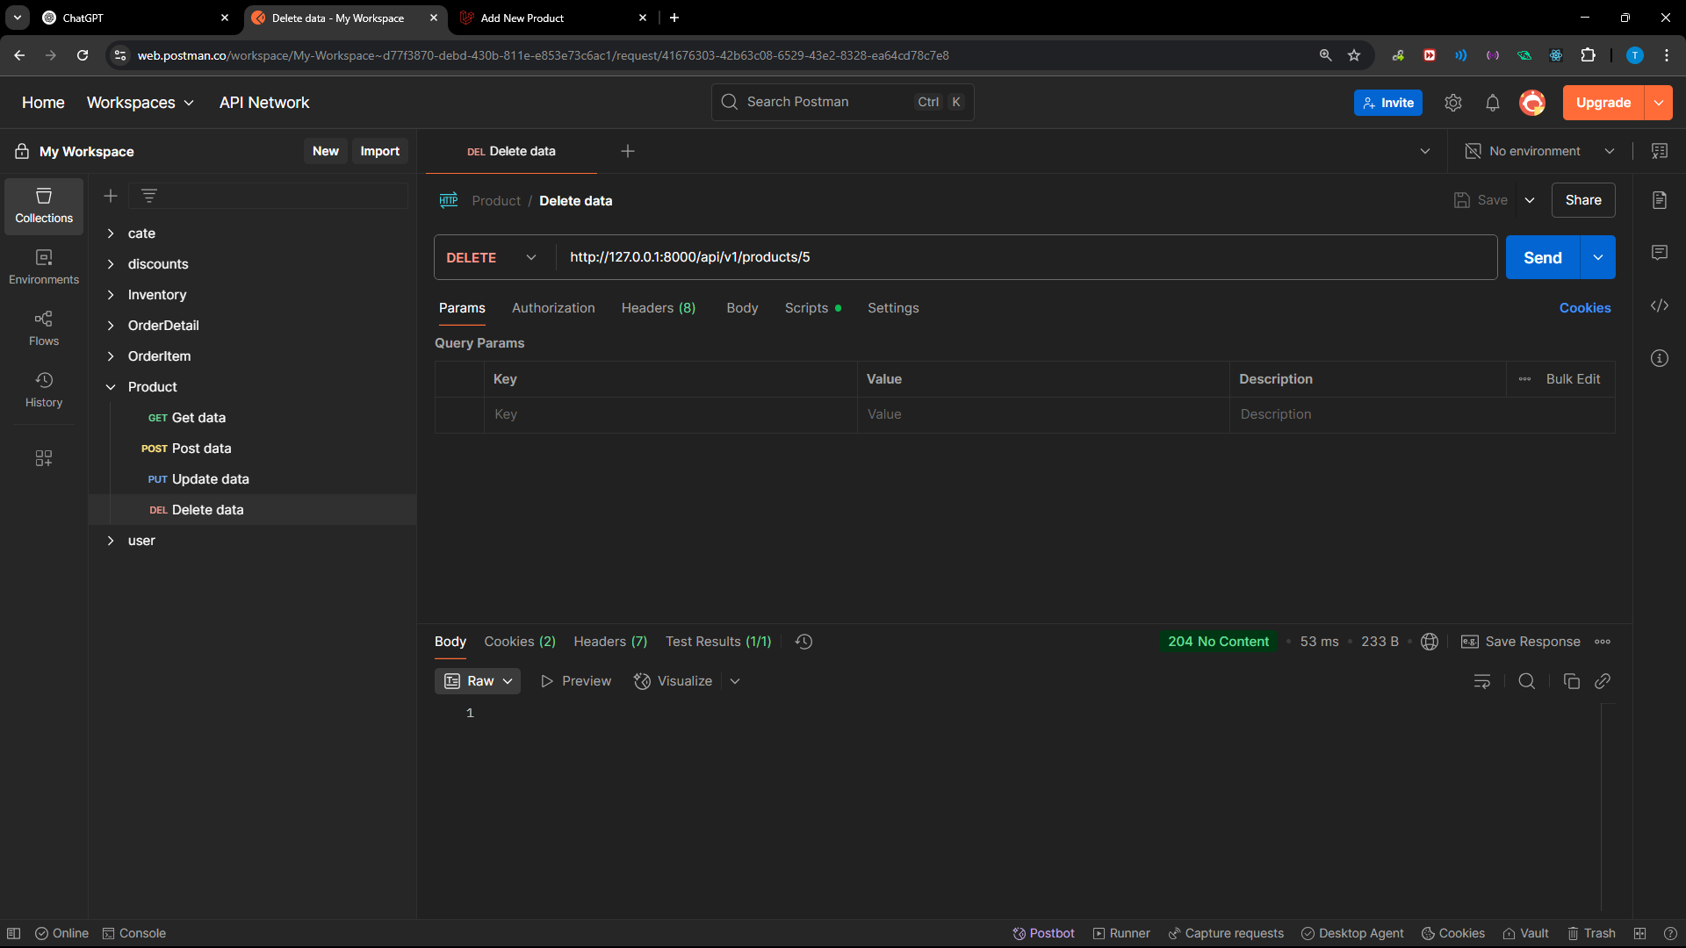

Note: If the status code is **204**, it means your deleting was successful. It’s ok if you don’t get any content.