Denis PC Poussard

Joan Baer

Web Frontend Development II (WDD 330)

15 October 2022

Notes Week 05

## Project Password Maker

I sturggled with the method execCommand(), VS Code deprecated it.

So, the line 33, document.execCommand(“copy”);, did not work

I replace it by line 34, navigator.clipboard.writeText(passwordOutput.value);,

https://www.w3schools.com/howto/howto_js_copy_clipboard.asp

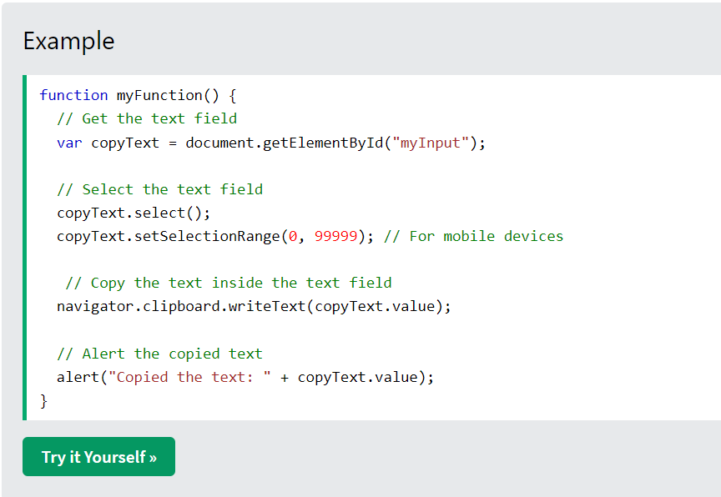

## Reading

|  |  |  |  |
| --- | --- | --- | --- |
| JAVASCRIPT: NOVICE TO NINJA | READING | | | |
|  | Acquired | In Progress | Not Read |
| W05 | Chapter 10 Testing and Debugging | | | |
| Errors, Exceptions, and Warnings | X |  |  |
| The Importance of Testing and Debugging | X |  |  |
| Strict Mode | X |  |  |
| Feature Detection | X |  |  |
| Debugging in the Browser | X |  |  |
| Error Objects | X |  |  |
| Tests | X |  |  |
| Quiz Ninja Project | To be Done | | |