Denis PC Poussard

Joan Baer

Web Frontend Development II (WDD 330)

15 October 2022

Notes Week 05

## Project Password Maker

I sturggled with the method execCommand(), VS Code deprecated it.

So, the line 33, document.execCommand(“copy”);, did not work

I replace it by line 34, navigator.clipboard.writeText(passwordOutput.value);,

https://www.w3schools.com/howto/howto_js_copy_clipboard.asp

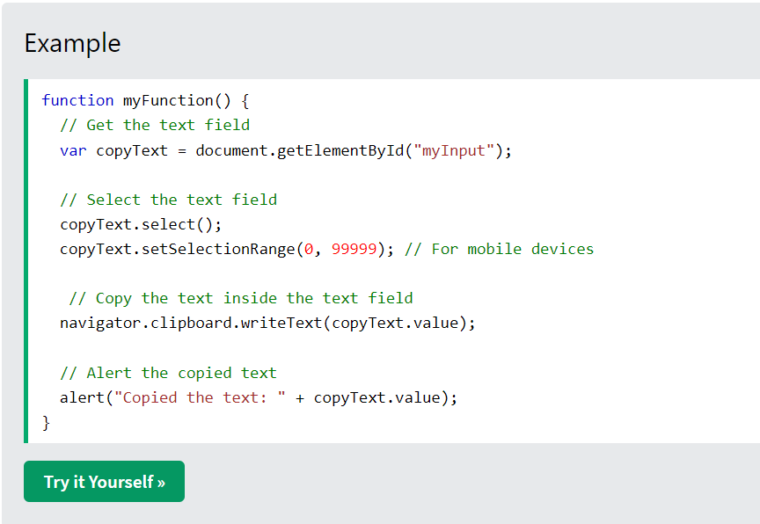

## Reading

|  |  |  |  |  |  |  |  |
| --- | --- | --- | --- | --- | --- | --- | --- |
| JAVASCRIPT: NOVICE TO NINJA | READING | | | | | | | |
|  | | Acquired | | In Progress | | Not Read | |
| W05 | Chapter 10 Testing and Debugging | | | | | | | |
| Errors, Exceptions, and Warnings | | X | |  | |  | |
| The Importance of Testing and Debugging | | X | |  | |  | |
| Strict Mode | | X | |  | |  | |
| Feature Detection | | X | |  | |  | |
| Debugging in the Browser | | X | |  | |  | |
| Error Objects | | X | |  | |  | |
| Tests | | X | |  | |  | |
| Quiz Ninja Project | | To be Done | | | | | |
|  | | | | | | | |
| W07 | Chapter 13 AJAX | | | | | | | |
| Clients and Servers | | X | |  | |  | |
| A brief History of Ajax | | X | |  | |  | |
| The Fetch API | | X | |  | |  | |
| Receiving Information | |  | | X | |  | |
| Sending Information | |  | | X | |  | |
| FormData | |  | | X | |  | |
| A living Standard | |  | | X | |  | |
| Quiz Ninja Project | | To be Done | | | | | |
|  | | | | | | | |