DET MIDTERM STUDY GUIDE
Data Engineering Techniques
AID30010 | SY B.Tech CSE AI DS | Sem IV
Unit I: Data Engineering & Preprocessing | Unit II: Data Warehouse

📌 Includes: Mind Maps • Topic Classification (Theory vs Practical) • Priority Rankings • PPT Guide • Study Order

SECTION 1 — PPT FILES: WHAT TO USE & WHAT TO SKIP
Based on your uploaded files, here is the decision for each resource:

PDF / File | Action | Notes
DET_Unit1_Introduction_PK.pdf | ✅ USE — Primary | Core Unit I file. Covers data engineering definition, all data types, all preprocessing techniques (cleaning, integration, reduction, transformation, discretization).
DET_Unit2_Data_Warehousing.pdf | ✅ USE — Primary | Core Unit II file. Covers DW concepts (4 properties), all schema designs (Star/Snowflake/Fact Constellation), OLAP operations, ETL, Data Lakes vs Lakehouses.

💡 KEY NOTE: Both PDFs are your primary sources — no duplicates, no files to skip. Study both completely.
Unit I PDF has 150 slides. Unit II PDF has ~105 slides. Focus on syllabus topics only (see sections below).

UNIT I — DATA ENGINEERING & PREPROCESSING
PDF: DET_Unit1_Introduction_PK.pdf | 150 slides

Mind Map — Unit I
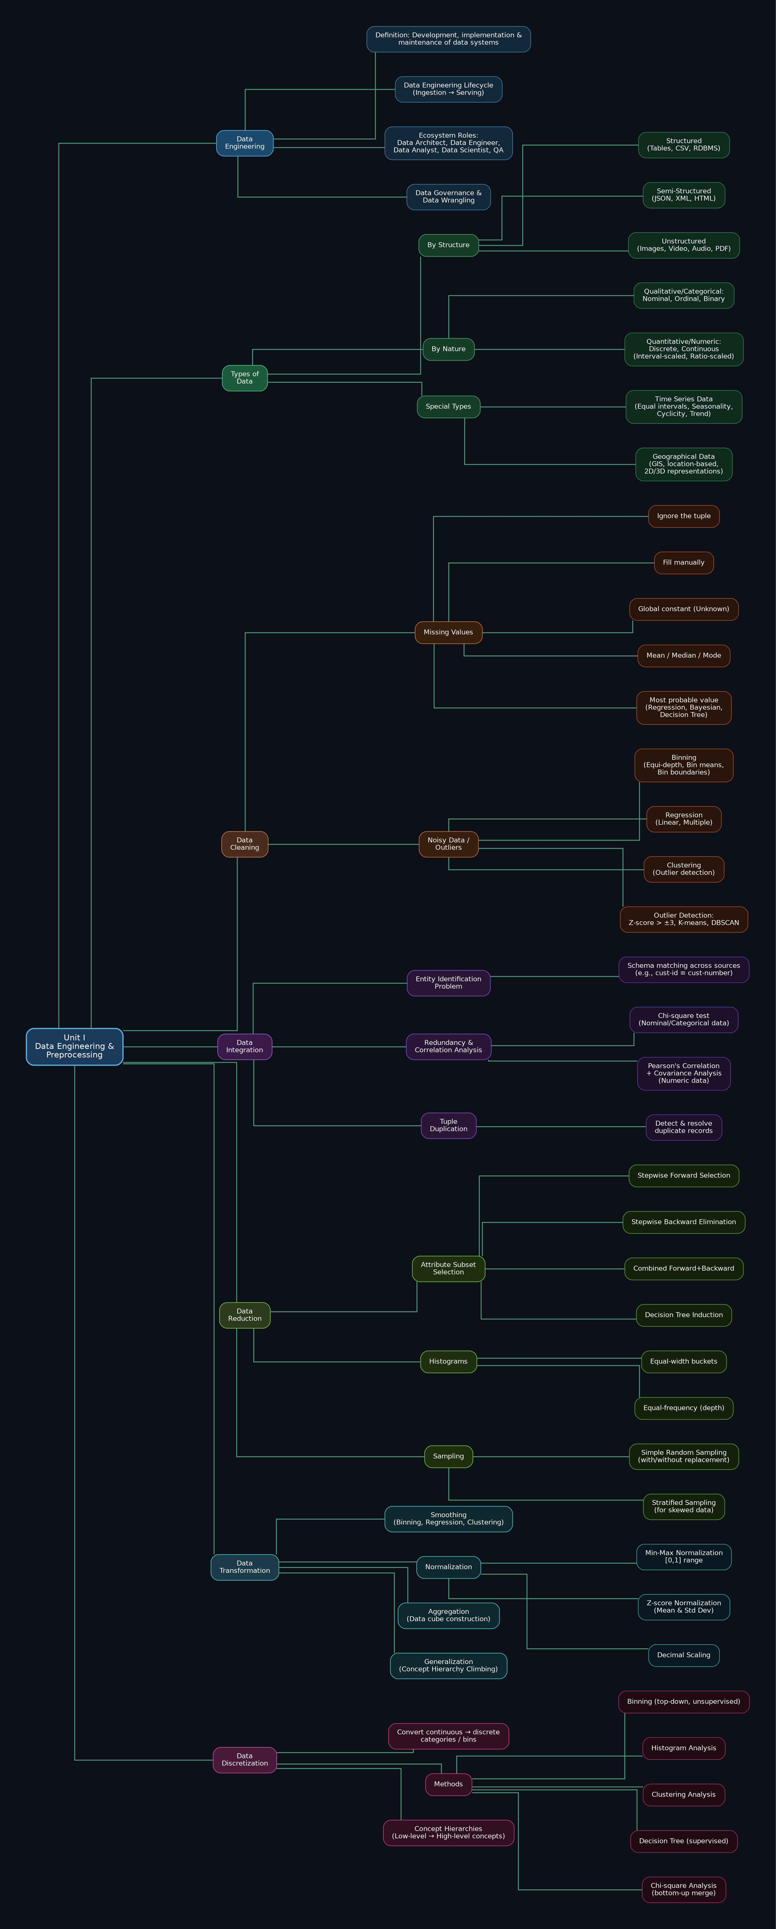

Topic Classification: Theoretical vs Practical

Data Engineering Basics
Topic | Type | Priority
Definition of Data Engineering (intersection of DM, DA, SE) | 📖 Theoretical | 🟠 HIGH
Data Engineering Lifecycle (Ingestion → Serving) | 📖 Theoretical | 🟠 HIGH
Ecosystem Roles (Data Architect, Data Engineer, Analyst, Scientist, QA) | 📖 Theoretical | 🟡 MEDIUM
Data Governance & Data Wrangling | 📖 Theoretical | 🟡 MEDIUM
KDD Process (7 steps) | 📖 Theoretical | 🟠 HIGH

Types of Data
Topic | Type | Priority
Structured (tables, CSV, RDBMS) | 📖 Theoretical | 🔴 MUST DO
Semi-Structured (JSON, XML, HTML) | 📖 Theoretical | 🔴 MUST DO
Unstructured (images, video, audio, PDF) | 📖 Theoretical | 🔴 MUST DO
Discrete vs Continuous Data — definitions + examples | 📖 Theoretical | 🔴 MUST DO
Nominal, Ordinal, Binary attributes | 📖 Theoretical | 🔴 MUST DO
Qualitative vs Quantitative (Interval-scaled, Ratio-scaled) | 📖 Theoretical | 🔴 MUST DO
Time Series Data — 4 characteristics (Equal interval, Seasonality, Cyclicity, Trend) | 📖 Theoretical | 🟠 HIGH
Geographical Data (GIS, 2D/3D, location-based) | 📖 Theoretical | 🟡 MEDIUM
Measures of Central Tendency: Mean, Median, Mode | 📖 + 💻 Compute | 🟠 HIGH
Measures of Dispersion: Range, Variance, Standard Deviation | 📖 + 💻 Compute | 🟠 HIGH

Data Cleaning
Topic | Type | Priority
Missing Values — 6 handling methods (Ignore, Manual, Constant, Mean/Mode, Class mean, Regression) | 📖 Theoretical | 🔴 MUST DO
Noisy Data — Binning (equi-depth, bin means, bin boundaries) | 📖 + 💻 Solve Example | 🔴 MUST DO
Regression-based smoothing (Linear, Multiple regression) | 📖 + 💻 Concept | 🟠 HIGH
Clustering-based outlier detection (Z-score, K-means, DBSCAN) | 📖 Theoretical | 🟠 HIGH
Data Discrepancy Detection (Unique rule, Consecutive rule, Null rule) | 📖 Theoretical | 🟡 MEDIUM

Data Integration
Topic | Type | Priority
Entity Identification Problem (schema matching, metadata use) | 📖 Theoretical | 🔴 MUST DO
Redundancy & Correlation Analysis | 📖 + 💻 Solve | 🔴 MUST DO
Chi-square (χ²) Test — for Nominal/Categorical data | 📖 + 💻 Calculate | 🔴 MUST DO
Covariance Analysis — for Numeric data | 📖 + 💻 Calculate | 🟠 HIGH
Pearson's Correlation Coefficient (formula + interpretation) | 📖 + 💻 Calculate | 🟠 HIGH
Tuple Duplication — detect & resolve | 📖 Theoretical | 🟡 MEDIUM

Data Reduction
Topic | Type | Priority
Attribute Subset Selection — 4 methods (Forward, Backward, Combined, Decision Tree) | 📖 Theoretical | 🔴 MUST DO
Histograms — Equal-width vs Equal-frequency/depth partitioning | 📖 + 💻 Construct | 🔴 MUST DO
Sampling — Simple Random, With/Without Replacement, Stratified | 📖 Theoretical | 🔴 MUST DO
Dimensionality Reduction (PCA, Wavelet — concept only) | 📖 Theoretical | 🟡 MEDIUM
Numerosity Reduction — Parametric (Regression) vs Non-Parametric (Histograms, Clustering) | 📖 Theoretical | 🟡 MEDIUM

Data Transformation & Discretization
Topic | Type | Priority
Smoothing (Binning, Regression, Clustering) | 📖 + 💻 Apply | 🟠 HIGH
Min-Max Normalization — formula + solve example | 📖 + 💻 Calculate | 🔴 MUST DO
Z-score Normalization — formula + solve example | 📖 + 💻 Calculate | 🔴 MUST DO
Decimal Scaling Normalization | 📖 + 💻 Calculate | 🟠 HIGH
Aggregation (Data Cube construction) | 📖 Theoretical | 🟡 MEDIUM
Generalization (Concept Hierarchy Climbing) | 📖 Theoretical | 🟡 MEDIUM
Data Discretization — converting continuous → discrete bins | 📖 Theoretical | 🟠 HIGH
Discretization Methods: Binning, Histogram, Clustering, Decision Tree, Chi-square | 📖 Theoretical | 🟠 HIGH
Concept Hierarchies for Nominal Data (tree-like structure) | 📖 Theoretical | 🟡 MEDIUM

Priority Practice List — Unit I
🔴 #1 All Data Types — be able to classify any attribute as: Structured/Semi/Unstructured AND Nominal/Ordinal/Discrete/Continuous
🔴 #2 Handling Missing Values — list and explain all 6 methods
🔴 #3 Binning for Noisy Data — solve equi-depth + bin means + bin boundaries on a given dataset
🔴 #4 Chi-square (χ²) Test — calculate and interpret for categorical data
🔴 #5 Normalization — solve Min-Max and Z-score on given values
🔴 #6 Attribute Subset Selection — explain all 4 methods
🔴 #7 Sampling Types — Simple Random, With/Without Replacement, Stratified
🟠 #8 Pearson's Correlation Coefficient — formula + example
🟠 #9 Covariance Analysis — formula + example
🟠 #10 KDD Process — write all 7 steps in order
🟠 #11 Time Series Data — 4 characteristics
🟡 #12 Concept Hierarchies — draw for a given domain (e.g., Location: country → state → city)

Pure Theory — Understand & Write Only
• Definition & lifecycle of Data Engineering
• Ecosystem roles (Data Architect, Engineer, Analyst, Scientist, QA)
• Data Governance and Data Wrangling definitions
• Comparison table: Structured vs Semi-Structured vs Unstructured
• Discrete vs Continuous comparison table
• Qualitative vs Quantitative attributes and their sub-types
• Geographical Data features and GIS
• Data Preprocessing importance and 6 quality parameters (Accuracy, Completeness, Consistency, Timeliness, Believability, Interpretability)
• Data Discrepancy — causes and detection tools
• Difference between Covariance and Pearson's coefficient

📊 Unit I Stats: 12 topics need calculation/practical trace | 10 are pure theory | ~55% practical, 45% theory

UNIT II — DATA WAREHOUSE
PDF: DET_Unit2_Data_Warehousing.pdf | ~105 slides

Mind Map — Unit II
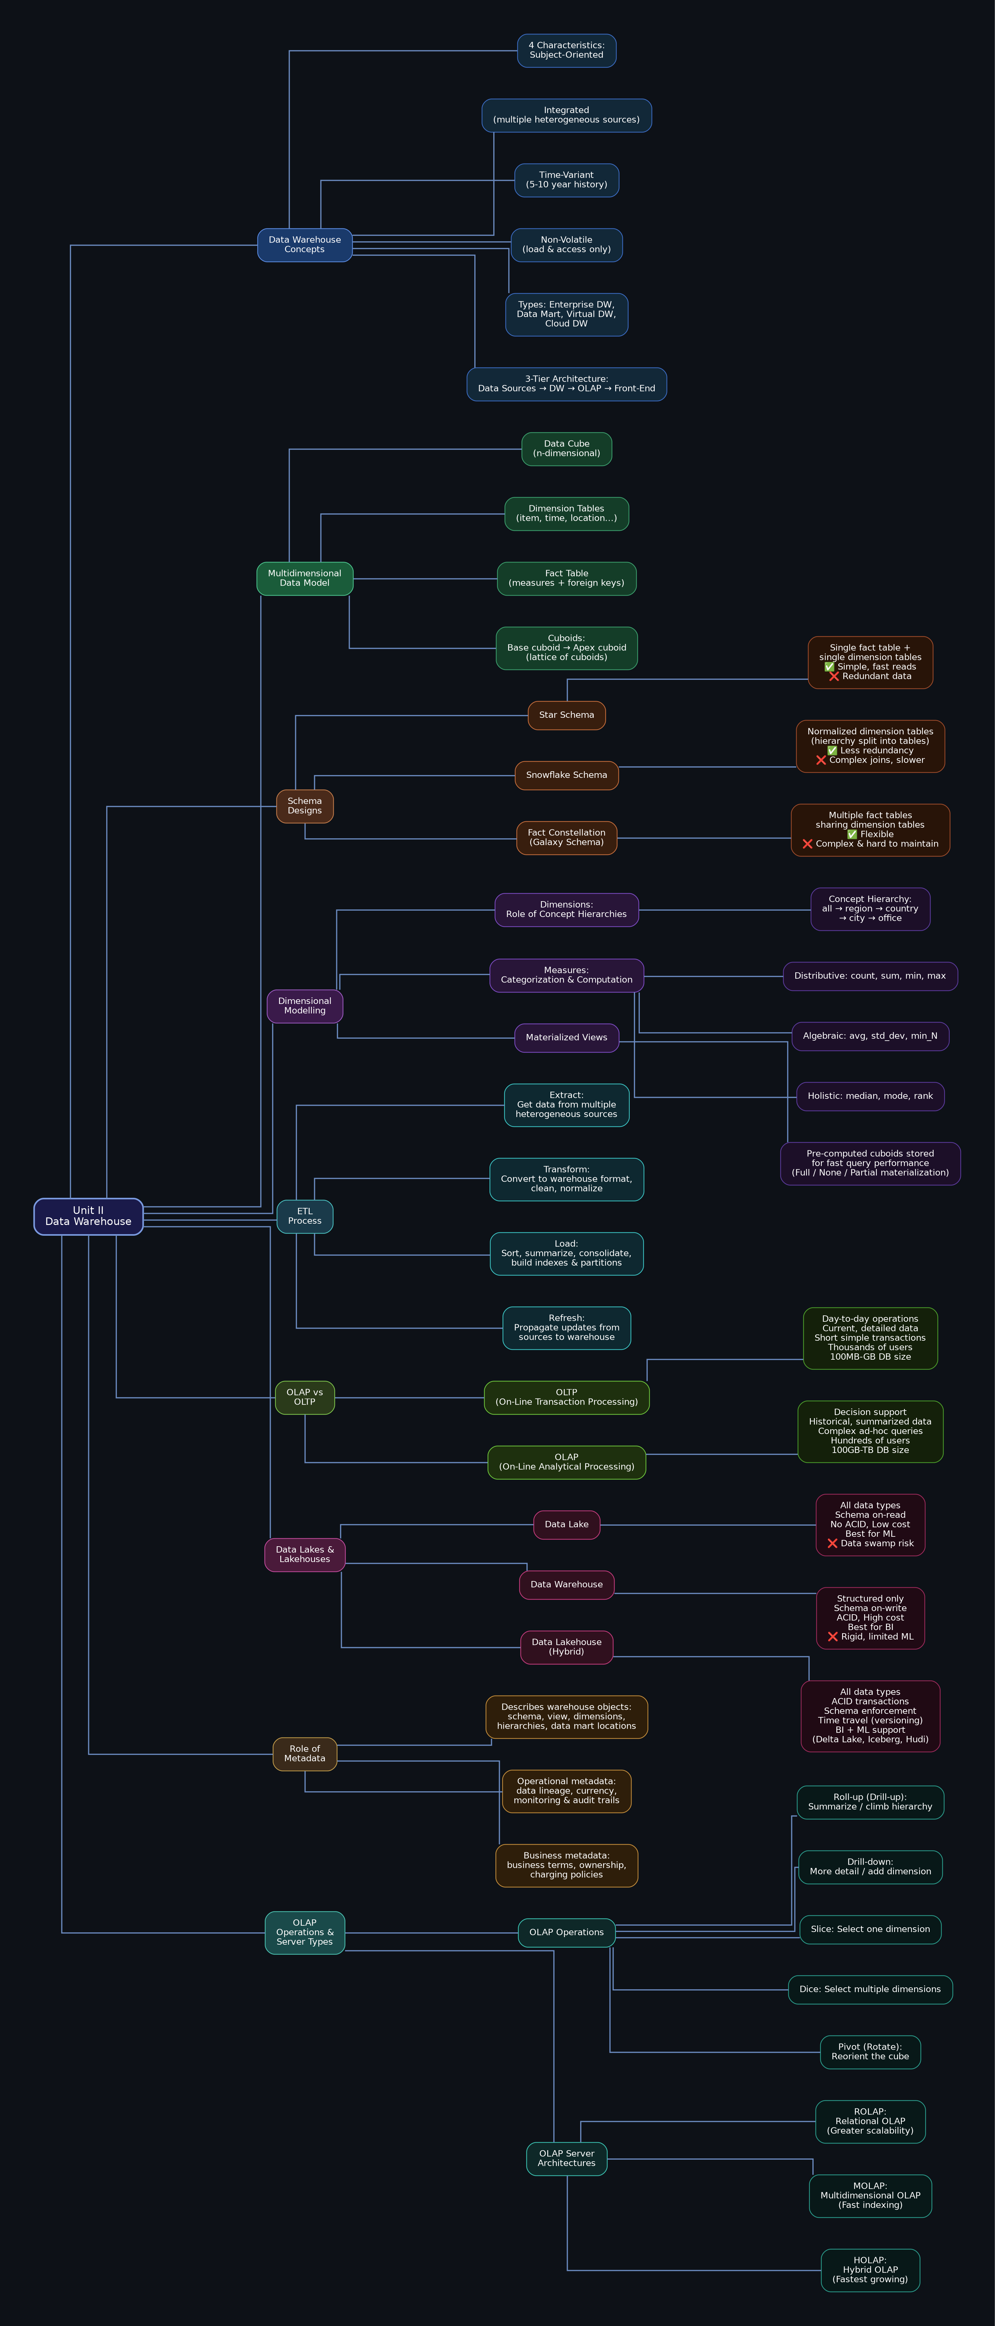

Topic Classification: Theoretical vs Practical

Data Warehouse Concepts
Topic | Type | Priority
Definition of Data Warehouse (Inmon's 4 properties) | 📖 Theoretical | 🔴 MUST DO
Subject-Oriented — organized around major subjects | 📖 Theoretical | 🔴 MUST DO
Integrated — consistent naming, encoding across sources | 📖 Theoretical | 🔴 MUST DO
Time-Variant — 5-10 year history vs OLTP 60-90 days | 📖 Theoretical | 🔴 MUST DO
Non-Volatile — load & access only, no updates | 📖 Theoretical | 🔴 MUST DO
DW Types: Enterprise DW, Data Mart, Virtual DW, Cloud DW | 📖 Theoretical | 🟠 HIGH
3-Tier Architecture: Data Sources → DW Storage → OLAP → Front-End | 📖 Theoretical | 🟠 HIGH

Multidimensional Data Model
Topic | Type | Priority
Data Cube — n-dimensional model | 📖 Theoretical | 🔴 MUST DO
Dimension Tables (item, time, location...) | 📖 Theoretical | 🔴 MUST DO
Fact Table — stores measures + foreign keys to dimension tables | 📖 Theoretical | 🔴 MUST DO
Cuboids — Base cuboid, Apex cuboid, Lattice of cuboids | 📖 Theoretical | 🟠 HIGH
Number of cuboids formula: T = Π(Li+1) for n dimensions | 📖 + 💻 Calculate | 🟠 HIGH
OLAP Operations: Roll-up, Drill-down, Slice, Dice, Pivot | 📖 + 💻 Apply on example | 🔴 MUST DO

Schema Designs
Topic | Type | Priority
Star Schema — structure, pros, cons + draw diagram | 📖 + 💻 Draw Diagram | 🔴 MUST DO
Snowflake Schema — normalized dimensions, pros, cons + draw | 📖 + 💻 Draw Diagram | 🔴 MUST DO
Fact Constellation (Galaxy) Schema — multiple fact tables + draw | 📖 + 💻 Draw Diagram | 🔴 MUST DO
Compare Star vs Snowflake vs Fact Constellation | 📖 Theoretical | 🔴 MUST DO
Primary Keys vs Surrogate Keys in DW | 📖 Theoretical | 🟡 MEDIUM

Dimensional Modelling
Topic | Type | Priority
Concept Hierarchies for Dimensions (all → region → country → city → office) | 📖 Theoretical | 🔴 MUST DO
Measures — 3 Categories: Distributive, Algebraic, Holistic | 📖 Theoretical | 🔴 MUST DO
Distributive: count(), sum(), min(), max() | 📖 Theoretical | 🔴 MUST DO
Algebraic: avg(), min_N(), standard_deviation() | 📖 Theoretical | 🟠 HIGH
Holistic: median(), mode(), rank() | 📖 Theoretical | 🟠 HIGH
Materialized Views — pre-computed cuboids for fast queries | 📖 Theoretical | 🟠 HIGH
Materialization: Full vs None vs Partial | 📖 Theoretical | 🟡 MEDIUM

ETL Process
Topic | Type | Priority
Extract — get data from multiple heterogeneous external sources | 📖 Theoretical | 🔴 MUST DO
Transform — clean, convert to warehouse format, normalize | 📖 Theoretical | 🔴 MUST DO
Load — sort, summarize, consolidate, build indexes & partitions | 📖 Theoretical | 🔴 MUST DO
Refresh — propagate updates from sources to warehouse | 📖 Theoretical | 🟠 HIGH
ETL Tools and role in data cleaning pipeline | 📖 Theoretical | 🟡 MEDIUM

OLAP vs OLTP
Feature | OLTP | OLAP
Users | Clerks, IT professionals | Knowledge workers, managers
Function | Day-to-day operations | Decision support & analysis
DB Design | Application-oriented (ER) | Subject-oriented (Star/Snowflake)
Data | Current, detailed, flat relational | Historical, summarized, multidimensional
Access | Read/write, short transactions | Read-only, complex ad-hoc queries
Records Accessed | Tens | Millions
Users Count | Thousands | Hundreds
DB Size | 100MB – GB | 100GB – TB
Metric | Transaction throughput | Query throughput & response time

Data Lakes, Data Warehouses & Data Lakehouses
Feature | Data Lake | Data Warehouse | Data Lakehouse
Data Type | All (Struct + Semi + Unstruct) | Structured only | All types
Schema | On-read (flexible) | On-write (rigid) | Flexible (enforce + evolve)
ACID Transactions | ❌ No | ✅ Yes | ✅ Yes
Cost | Low | High | Medium
BI Support | Limited | Excellent | Excellent
ML/AI Support | Excellent | Limited | Excellent
Key Problem | Data swamp, quality issues | Expensive, rigid schema | Solves both above
Examples | AWS S3, Azure Data Lake | Snowflake, Redshift, BigQuery | Delta Lake, Apache Iceberg, Hudi

OLAP Server Architectures
Architecture | Description | Key Feature
ROLAP  (Relational OLAP) | Uses relational/extended-relational DBMS to store & manage warehouse data | Greater scalability; supports star/snowflake schemas
MOLAP  (Multidimensional OLAP) | Uses specialized multidimensional DBMS (sparse array-based) | Fast indexing of pre-computed summarized data
HOLAP  (Hybrid OLAP) | Combines ROLAP and MOLAP; low-level relational, high-level array | Fastest growing; flexible but causes data redundancy

Role of Metadata
Metadata Type | Description
Structural Metadata | Schema, view, dimensions, hierarchies, derived data definitions, data mart locations
Operational Metadata | Data lineage, currency (active/archived/purged), monitoring, audit trails
Business Metadata | Business terms, definitions, ownership, charging policies
Role in DW | Data understanding, data governance, data integration, data accessibility

Priority Practice List — Unit II
🔴 #1 DW 4 Properties — Subject-Oriented, Integrated, Time-Variant, Non-Volatile (with explanations)
🔴 #2 Star Schema — draw from scratch with fact table + dimension tables
🔴 #3 Snowflake Schema — draw normalized version of Star schema
🔴 #4 Fact Constellation Schema — draw with multiple fact tables
🔴 #5 Compare all 3 schemas (Star vs Snowflake vs Fact Constellation) — pros/cons
🔴 #6 OLAP vs OLTP — full comparison table
🔴 #7 ETL Process — explain all 4 steps with examples
🔴 #8 OLAP Operations — Roll-up, Drill-down, Slice, Dice, Pivot with examples
🔴 #9 Measures Categorization — Distributive, Algebraic, Holistic with examples
🔴 #10 Data Lake vs Data Warehouse vs Data Lakehouse comparison
🟠 #11 Concept Hierarchies for Dimensions — draw hierarchy for location/time/product
🟠 #12 Materialized Views — explain with types (Full/None/Partial)
🟠 #13 ROLAP vs MOLAP vs HOLAP — differences and use cases
🟠 #14 Cuboid calculation formula — compute number of cuboids for given dimensions
🟡 #15 Metadata role in DW — types and functions
🟡 #16 DW Design Process — Top-down vs Bottom-up approaches

Pure Theory — Understand & Write Only
• Why separate Data Warehouse from OLTP? (missing data, consolidation, data quality)
• DW Types — Enterprise DW vs Data Mart vs Virtual DW vs Cloud DW
• 3-Tier DW Architecture with all components
• Problems with ER Model for DW (not user-friendly, normalization hurts performance)
• DW Design Approaches: Top-Down (Inmon) vs Bottom-Up (Kimball)
• 4 DW Design Process steps (Business process → Grain → Dimensions → Measures)
• Primary Keys vs Surrogate Keys
• Data Lakehouse features (ACID, schema enforcement, time travel, single source of truth)

📊 Unit II Stats: 10 topics need diagram drawing / application | 8 are pure theory | ~56% practical, 44% theory ← Schema drawing is key!

SECTION 2 — RECOMMENDED STUDY ORDER
Follow this sequence for maximum exam efficiency — MUST DO topics first across both units.

# | Topic | What to Practice | Unit / PDF
1  (Start) | DW 4 Properties (Inmon) | Write definition + 1-2 line explanation for each property with example | Unit II
2 | All Data Types Classification | Classify 10 given attributes as Structured/Semi/Unstruct AND Nominal/Ordinal/Discrete/Continuous | Unit I
3 | Star Schema Design | Draw Star schema for Sales: fact table + time, item, branch, location dimension tables | Unit II
4 | Snowflake Schema Design | Convert Star schema to Snowflake by normalizing one dimension table | Unit II
5 | Fact Constellation Schema | Draw Galaxy schema with 2 fact tables sharing dimension tables | Unit II
6 | OLAP vs OLTP Table | Write complete comparison table from memory — 9 rows | Unit II
7 | Handling Missing Values | List and explain all 6 methods. Know when to use each. | Unit I
8 | Binning for Noisy Data | Solve a binning problem using equi-depth + all 3 smoothing methods | Unit I
9 | Normalization Methods | Solve Min-Max and Z-score on a given set of values | Unit I
10 | Chi-square (χ²) Test | Solve a 2x3 contingency table completely | Unit I
11 | ETL Process | Explain all 4 steps: Extract, Transform, Load, Refresh with examples | Unit II
12 | OLAP Operations | Apply Roll-up, Drill-down, Slice, Dice, Pivot on a sample data cube | Unit II
13 | Measures Categorization | List Distributive, Algebraic, Holistic with 3 examples each | Unit II
14 | Data Lake vs DW vs Lakehouse | Draw comparison table + explain why Lakehouse was needed | Unit II
15  (If time) | Attribute Subset Selection | Explain all 4 methods (Forward, Backward, Combined, Decision Tree) | Unit I
16  (If time) | Sampling Types | Explain Simple Random, With/Without Replacement, Stratified with examples | Unit I
17  (If time) | Pearson's Correlation | Solve covariance + Pearson coefficient for a given dataset | Unit I
18  (Optional) | Concept Hierarchies | Draw hierarchy for Location and Time dimensions | Unit I + II

💡 STRATEGY TIP: Topics #1–14 cover the full exam. Spend 70% of time on #1–10.
Unit II schemas (Star/Snowflake/Fact Constellation) are MOST LIKELY to appear — practice drawing them from scratch.
Unit I numerical problems (Binning, Normalization, Chi-square) are practical questions — solve at least 2 examples each.

SECTION 3 — TOTAL TOPIC SUMMARY

Unit | Practical / Calculation Topics | Pure Theory Topics | Total | % Practical
Unit I — Data Engineering & Preprocessing | 12 | 10 | 22 | 55%
Unit II — Data Warehouse | 10 | 8 | 18 | 56%
TOTAL | 22 | 18 | 40 | ~55%

📌 PDFs to USE (both): DET_Unit1_Introduction_PK.pdf | DET_Unit2_Data_Warehousing.pdf

🔴 MUST-DO Topics (Unit I): Data Types Classification • Missing Values (6 methods) • Binning • Normalization • Chi-square Test • Attribute Subset Selection
🔴 MUST-DO Topics (Unit II): DW 4 Properties • Star Schema • Snowflake Schema • Fact Constellation • OLAP vs OLTP • ETL Process • OLAP Operations • Measures

⚠️ Unit II has more diagram-drawing questions — practice drawing schemas without looking at notes.
⚠️ Unit I has more numerical calculation questions — practice at least 2 examples of each method.

Good luck with your DET Midterm! Study smart. 🎯

