DATA EXPLORATION & TECHNOLOGY LAB
Experiment 5
Market Basket Analysis Using the
Apriori Algorithm

Submitted by
Sujal Sokande
PRN: 1272250913
SY AIDS | Panel C

Dataset
Groceries Dataset — 38,765 transactions, 3,898 members, 167 items

1. Objective
The aim of this experiment is to perform Market Basket Analysis on a real-world grocery store dataset using the Apriori algorithm. The goal is to discover frequent itemsets and generate meaningful association rules that reveal which products customers tend to buy together.
Such insights are used by modern retail platforms — like Zomato, Swiggy, Amazon, and BigBasket — to power recommendation engines, optimize product placement, and design targeted promotional offers.

2. Tools & Libraries Used
Library | Version | Purpose
pandas | 2.x | Data loading, cleaning, date parsing, grouping
numpy | 1.x | Numerical operations
matplotlib | 3.x | Base plotting, GridSpec dashboards
seaborn | 0.13.x | Statistical visualizations, heatmaps, countplots
mlxtend | latest | TransactionEncoder, apriori(), association_rules()

3. Dataset Overview
The dataset is a grocery store transaction log with the following structure:

Column | Type | Description
Member_number | Integer | Unique customer ID
Date | Date (DD-MM-YYYY) | Date of transaction
itemDescription | String | Name of item purchased

Key statistics derived from the dataset:
- Total transaction rows: 38,765
- Unique customers (members): 3,898
- Unique items: 167
- Date range: January 2014 – December 2015 (2 full years)
- Most purchased item: whole milk (2,502 purchases)

4. Methodology

4.1 Data Preprocessing
The CSV was loaded using pandas. The Date column was parsed with dayfirst=True to handle the DD-MM-YYYY format. Month, Month_num, and Quarter columns were derived for time-series analysis. No null values or duplicates were present after inspection.

4.2 Building the Transaction Matrix
Each customer (Member_number) can appear multiple times across different dates, each time buying a single item. All items purchased by the same member across all visits were grouped into a basket list. The mlxtend TransactionEncoder then converted this list of baskets into a boolean matrix where each column represents an item and each row represents one customer.

4.3 Running the Apriori Algorithm
The apriori() function from mlxtend was called with a minimum support threshold. It applies the Apriori principle: any subset of a frequent itemset must itself be frequent. Infrequent itemsets and all their supersets are pruned, which dramatically reduces computation. The function returns all frequent itemsets at every level (1-item, 2-item, etc.).

4.4 Generating Association Rules
The association_rules() function filtered all directional rules from the frequent itemsets. Each rule A → B was evaluated on two metrics:
- Confidence: P(B | A) = support(A ∪ B) / support(A) — how often B appears when A is present
- Lift: Confidence / support(B) — whether A genuinely increases the likelihood of B (lift > 1 means positive association)

5. Experiment Runs
The script was executed twice with different threshold settings to understand the sensitivity of the algorithm to these parameters.

Run 1 — min_support = 40%, min_confidence = 60%
In the first run, a very strict minimum support of 40% was used, meaning an itemset must appear in at least 40% of all customer baskets to qualify as frequent. With 3,898 customers, this requires an item or pair to appear in at least 1,559 baskets.

Result: No association rules were generated. The reason is that no pair of items co-occurred in 40% of baskets. Even the most popular item, whole milk, appeared in only ~64% of baskets individually, and no two items were bought together by that large a fraction of customers. With zero frequent 2-itemsets, no rules could be derived.

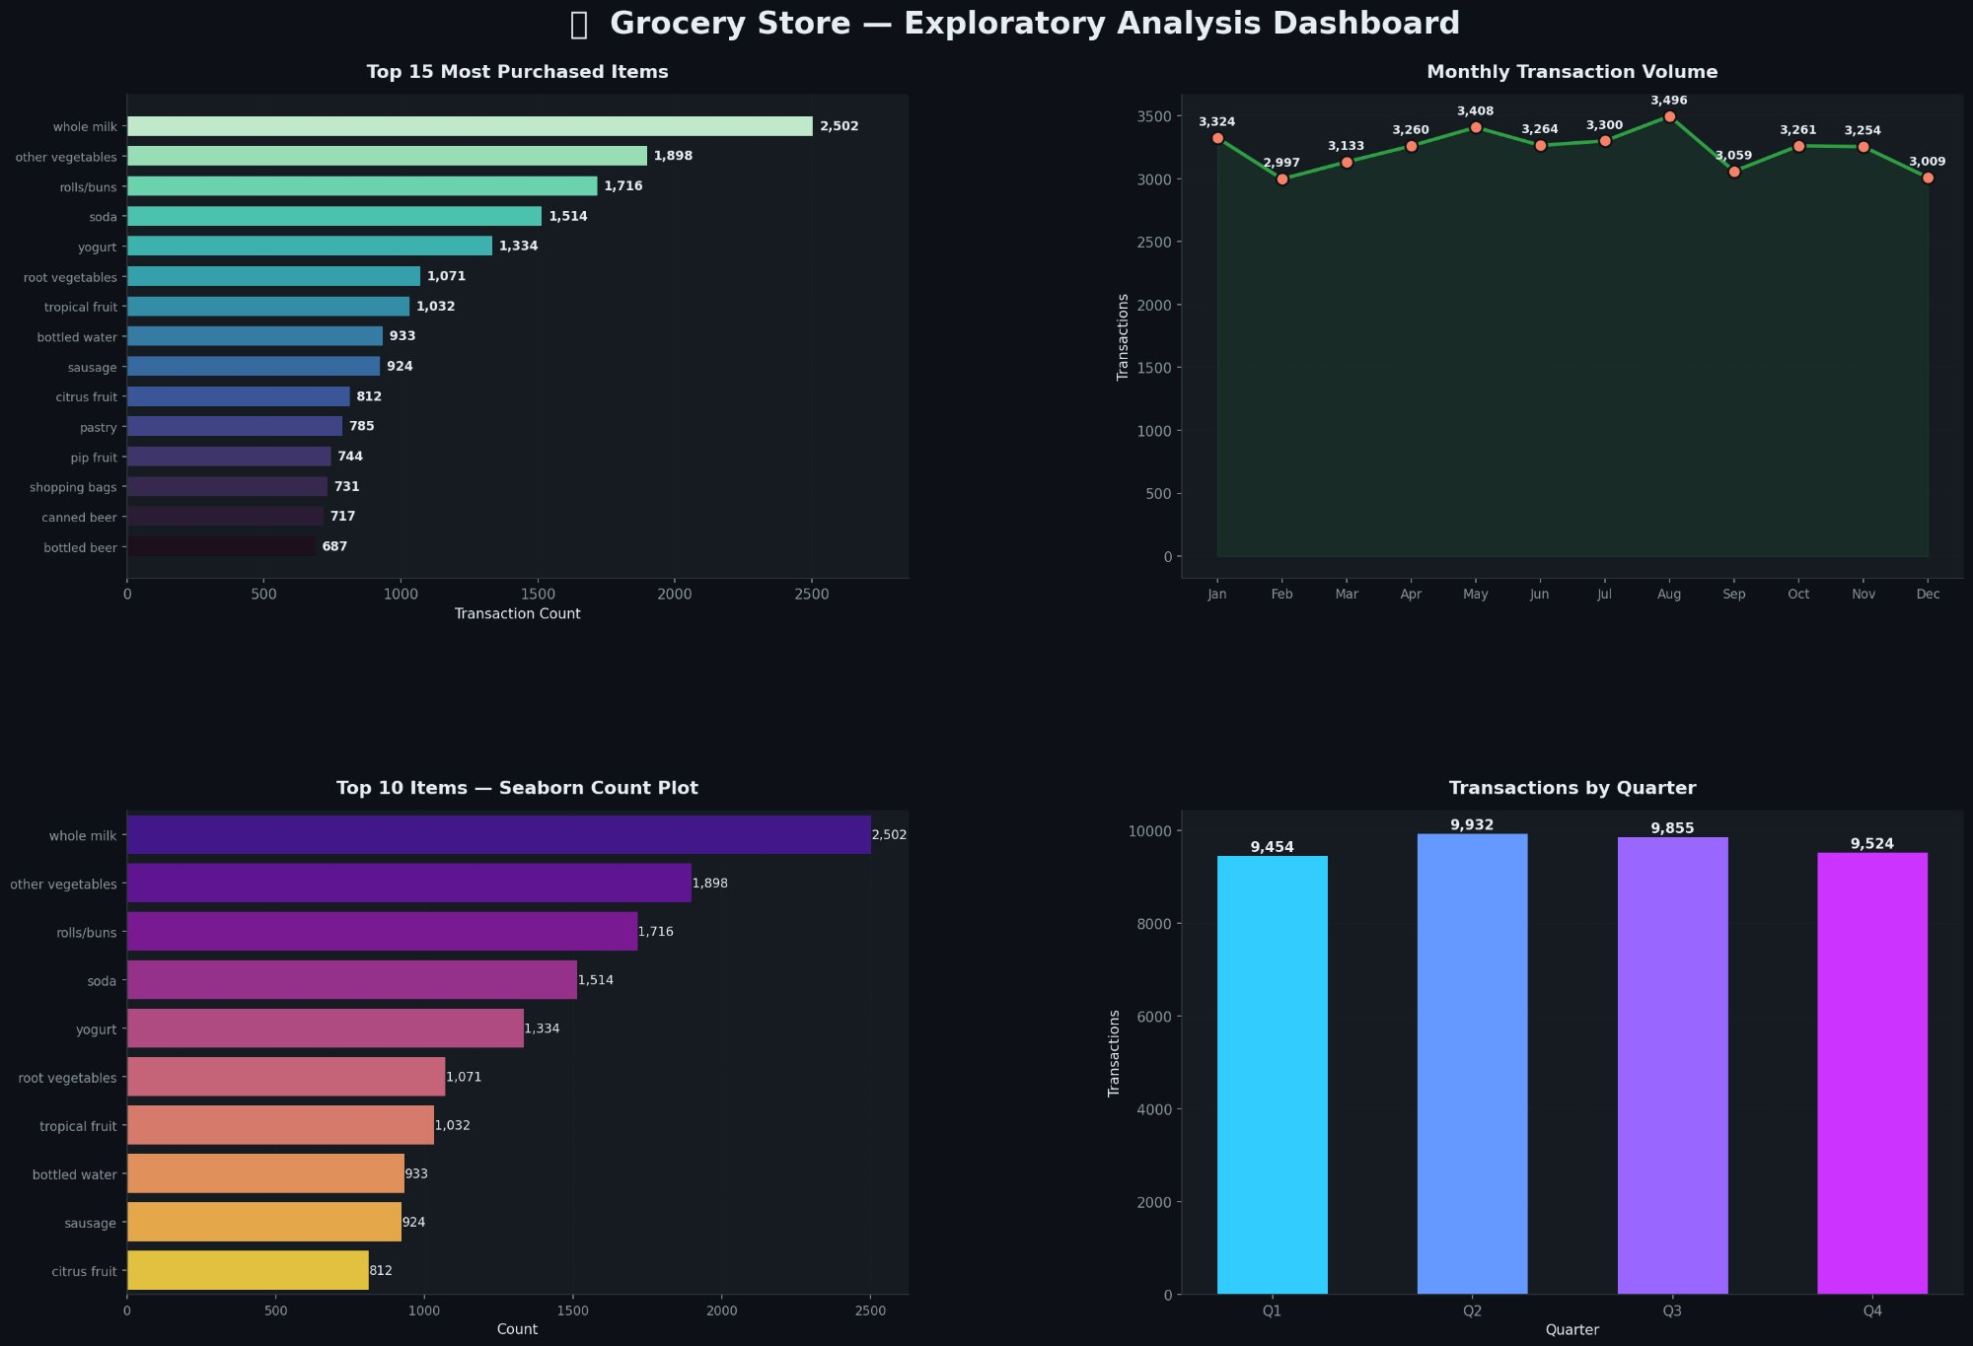
Figure 1a — Exploratory Dashboard (Run 1: min_support=40%, min_confidence=60%)
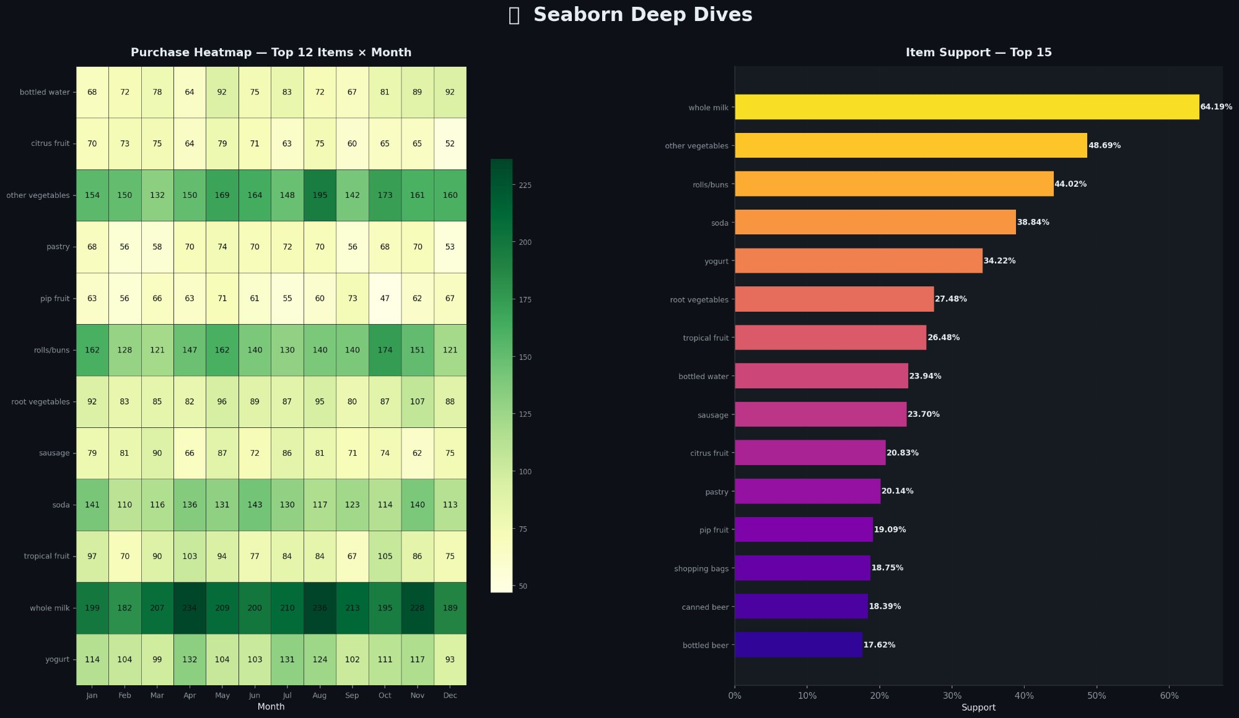
Figure 2a — Seaborn Deep Dives (Run 1: min_support=40%, min_confidence=60%)
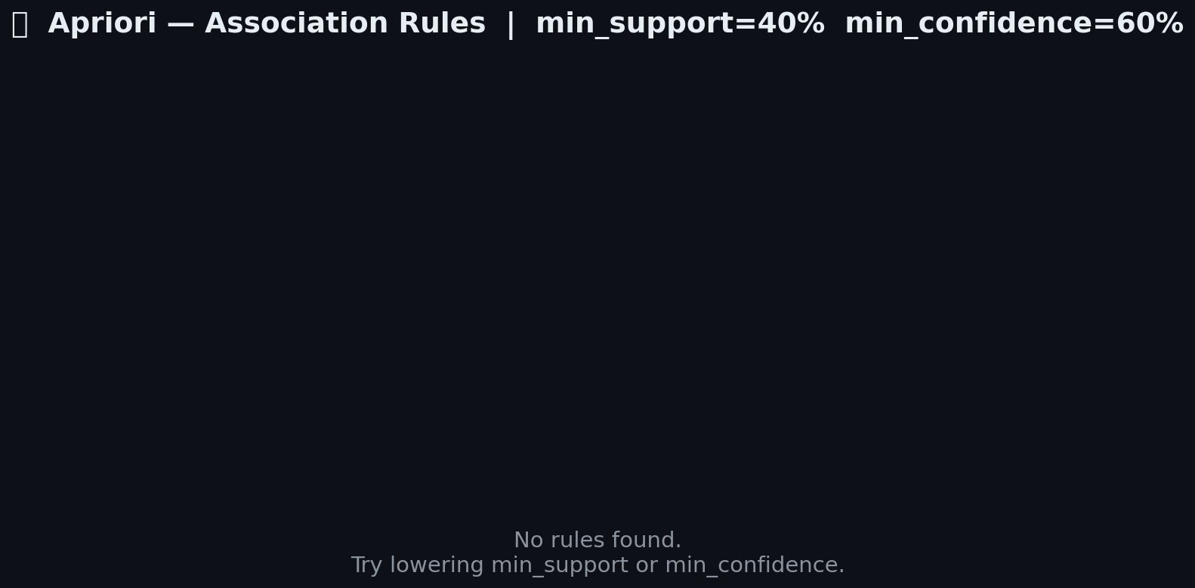
Figure 3a — Apriori Results (Run 1): No rules found at these strict thresholds

Run 2 — min_support = 1%, min_confidence = 30%
In the second run, thresholds were relaxed to min_support = 1% and min_confidence = 30%. This means an itemset only needs to appear in 1% of baskets (about 39 customers), making it realistic for a dataset with 167 diverse items.

Result: 3,398 association rules were discovered. The top rules all pointed to whole milk as the consequent, which makes sense given its dominant support of 64.19%. The highest-confidence rule was:

domestic eggs, meat → whole milk Confidence: 78% Lift: 1.71

A lift of 1.71 means customers who buy domestic eggs and meat are 71% more likely to also buy whole milk than a random customer, indicating a genuine association rather than just popularity of milk.


Figure 1b — Exploratory Dashboard (Run 2: min_support=1%, min_confidence=30%)

Figure 2b — Seaborn Deep Dives (Run 2: min_support=1%, min_confidence=30%)
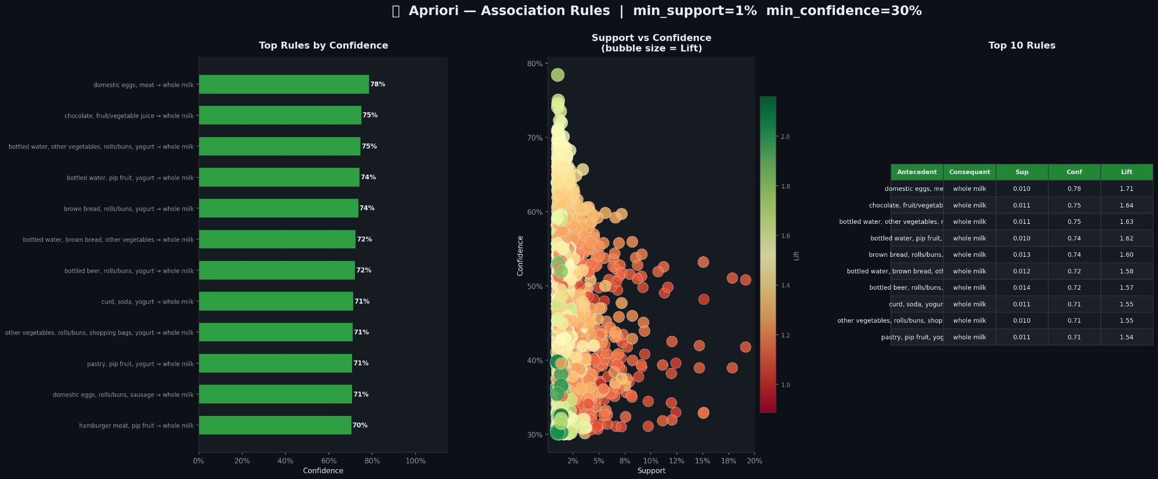
Figure 3b — Apriori Results (Run 2): 3,398 rules discovered

6. Top Association Rules (Run 2)
The table below shows the top 10 association rules by confidence from Run 2:

Antecedent | Consequent | Support | Confidence | Lift
domestic eggs, meat | whole milk | 0.010 | 78% | 1.71
chocolate, fruit/vegetable juice | whole milk | 0.011 | 75% | 1.64
bottled water, other veg, rolls/buns, yogurt | whole milk | 0.011 | 75% | 1.63
bottled water, pip fruit, yogurt | whole milk | 0.010 | 74% | 1.62
brown bread, rolls/buns, yogurt | whole milk | 0.013 | 74% | 1.60
bottled water, brown bread, other veg | whole milk | 0.012 | 72% | 1.58
bottled beer, rolls/buns, yogurt | whole milk | 0.014 | 72% | 1.57
curd, soda, yogurt | whole milk | 0.011 | 71% | 1.55
other veg, rolls/buns, shopping bags, yogurt | whole milk | 0.010 | 71% | 1.55
pastry, pip fruit, yogurt | whole milk | 0.011 | 71% | 1.54

7. Visualizations Produced
Three figures were generated per run, giving six total outputs:

Figure | Title | What it shows
Fig 1 | Exploratory Dashboard | Top 15 items, monthly trend, Seaborn countplot, quarterly breakdown
Fig 2 | Seaborn Deep Dives | Heatmap (item × month) and item support bar chart
Fig 3 | Apriori Results | Confidence ranking, Support vs Confidence scatter (bubble = Lift), rules table

8. Observations & Conclusions
- Whole milk is the dominant item with 64.19% support, making it the consequent in almost all top rules.
- Setting min_support too high (40%) yields no results — with 167 items, no pair achieves that co-occurrence threshold.
- Relaxing to min_support = 1% and min_confidence = 30% revealed 3,398 meaningful rules.
- All top rules have lift > 1.5, confirming these are genuine associations and not just a reflection of whole milk's popularity.
- Monthly volume is fairly stable (~3,000–3,500 transactions/month) with a slight peak in July (3,496) and trough in August (3,059).
- Q2 is the busiest quarter (9,932 transactions), while Q1 is the lightest (9,454).
- The Apriori algorithm's pruning strategy makes it efficient — infrequent itemsets are discarded early, preventing exponential growth of candidates.

In summary, this experiment demonstrates how threshold selection is critical in Market Basket Analysis. Overly strict thresholds produce no output; reasonable thresholds unlock hundreds of actionable rules that a retailer could use for cross-selling, shelf placement, and bundle promotions.

