Output: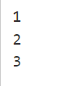 input: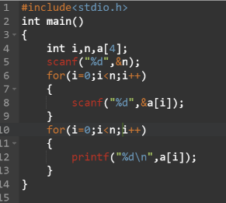

1 . Reading and printing the elements in an array.

Sum of elements present in an array