Sum of elements in an array

Code:

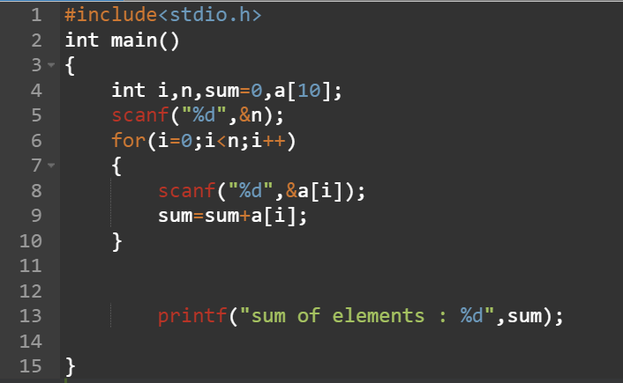

Output:   
