Activity Report: Registration Microservice Dockerization & AWS EC2 Cloud Deployment
Student Name: Sokhadom Khorn | Student ID: 2023517
Platform: Docker Hub (sokhadum) & AWS Cloud (us-east-1)
Course: Cloud Computing & Microservices Architecture
――――――――――――――――――――――――――――――――――――――――――――――――――――――――――――

Activity 1: Registration Microservice Setup & Architecture
The previously implemented Registration Microservice was prepared from the repository. It is structured in Node.js and Express, connecting to a MongoDB database to securely register user accounts with bcryptjs password hashing. The microservice listens on port 5001.
• Service Directory: /Registration_Microservice
• Port: 5001
• Database: university_identity_db
• Key Libraries: express, mongoose, bcryptjs, cors, dotenv

Activity 2: Create Dockerfile and Add Code Inside Registration Microservice Folder
A production-grade Dockerfile was created directly inside the 'Registration_Microservice' folder. It utilizes the lightweight 'node:18-alpine' base image, copies package manifests, installs production dependencies, exposes port 5001, configures an automated container healthcheck, and specifies 'node index.js' as the startup command.
Screenshot: Dockerfile Code opened inside the Registration_Microservice folder.
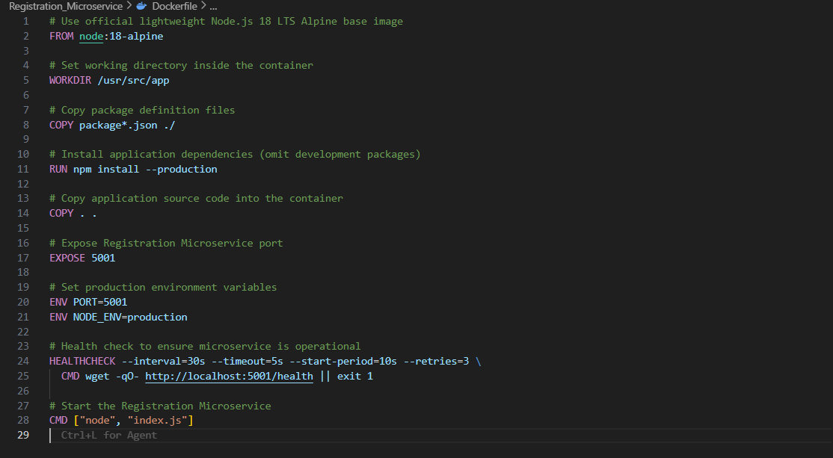
Figure 2.1: Dockerfile Code inside Registration_Microservice Folder

Activity 3: Start Docker Desktop & Authenticate CLI
Docker Desktop was launched and initialized on the local machine. Authentication to Docker Hub was established via Personal Access Token (PAT) for user 'sokhadum', confirming CLI readiness for building and publishing.
Screenshot: Docker CLI login success for user 'sokhadum'.
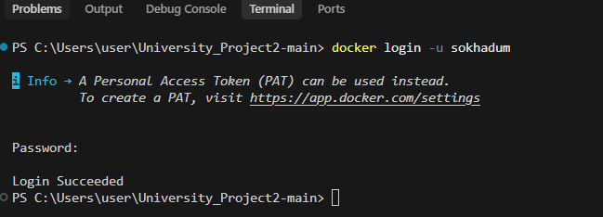
Figure 3.1: Docker Login Command & Authentication Success

Activity 4: Create Image with Proper Image Name Convention
The Docker image was created using standard Docker Hub naming convention: '<username>/<image_name>:<tag>'. The command was executed inside the Registration_Microservice folder, successfully compiling the image layers.
Command: docker build -t sokhadum/registration-microservice:latest .
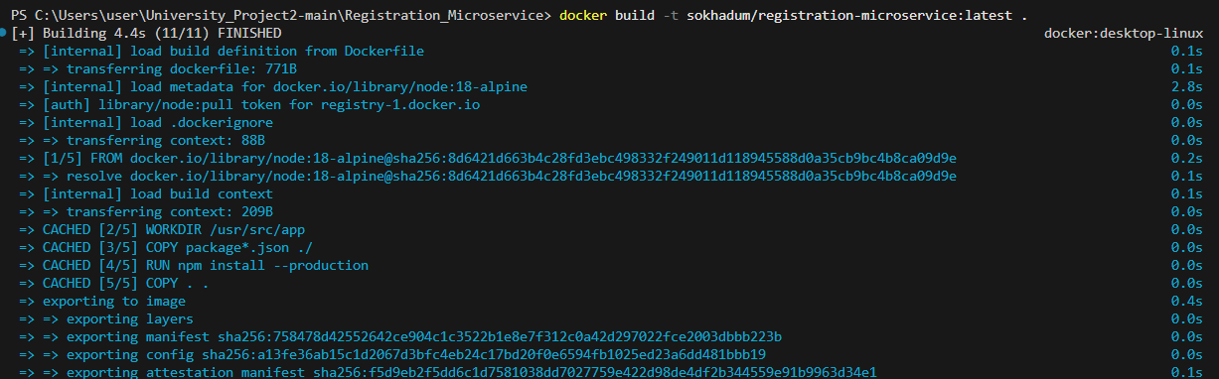
Figure 4.1: Command Line Instruction & Output for Docker Build

Activity 5: Check Image is Created or Not
The local Docker image repository was inspected using 'docker images'. The image 'sokhadum/registration-microservice' with tag 'latest' is confirmed present with Image ID 9182546e7a09 (236MB).
Command: docker images sokhadum/registration-microservice
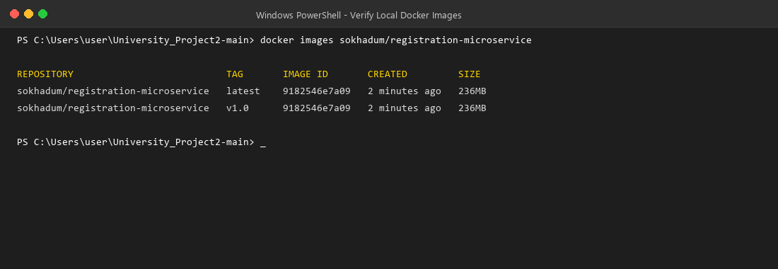
Figure 5.1: Verification of Created Image in Local Docker Registry

Activity 6: Run Docker Image Locally & Verify Registration API via Postman
The Docker image was executed locally on port 5001 connected to a MongoDB container on bridge network 'app-network'. The registration endpoint was tested via Postman with sample student registration payload, returning HTTP 201 Created. The service health endpoint was also verified returning HTTP 200 OK.
• Local Run: docker run -d --name registration-service -p 5001:5001 ...
• Postman Registration: POST http://localhost:5001/register/userregister -> 201 Created
• Postman Health Check: GET http://localhost:5001/health -> 200 OK
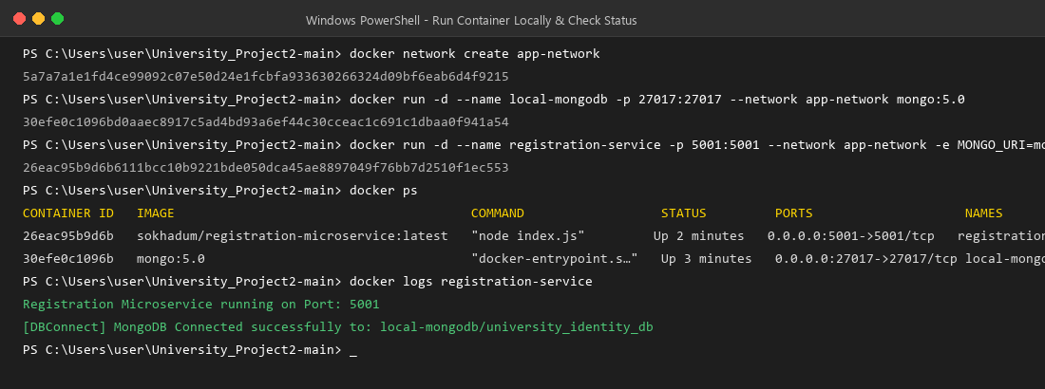
Figure 6.1: Running Container & Local Docker Status
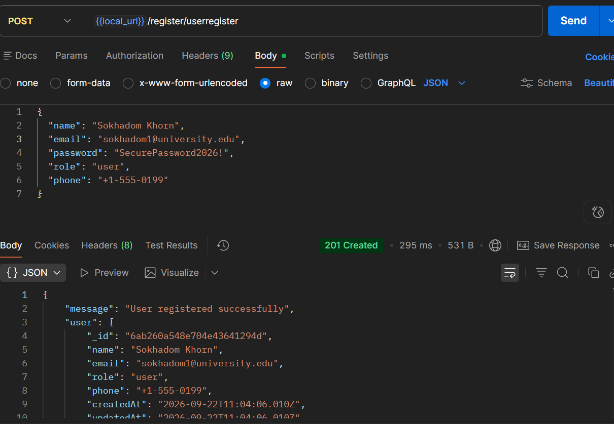
Figure 6.2: Postman Local User Registration API Call (201 Created)
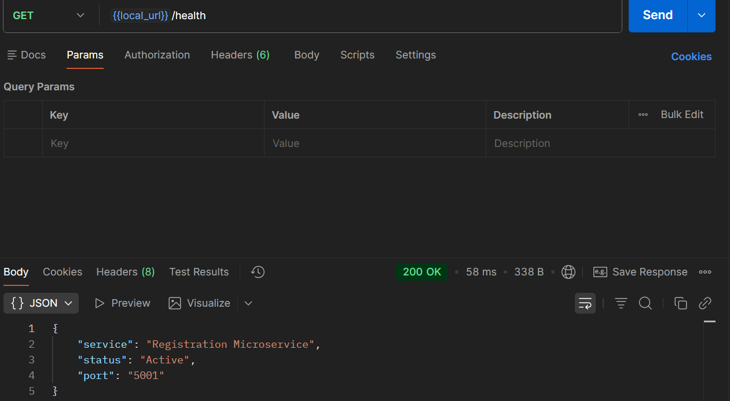
Figure 6.3: Postman Local Service Health Check (200 OK)

Activity 7: Push Image to Docker Hub Repository
The built container image was pushed to the public Docker Hub registry under 'sokhadum/registration-microservice:latest'. All layers were pushed and verified with sha256 digest.
Command: docker push sokhadum/registration-microservice:latest
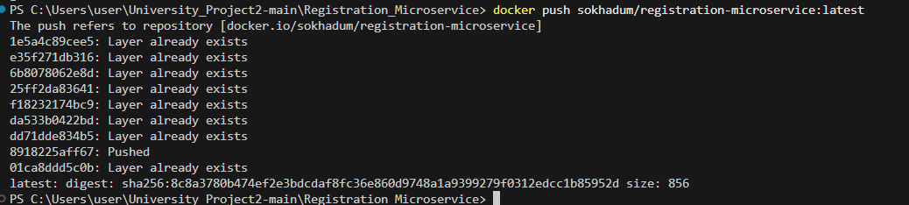
Figure 7.1: Command Line Execution of Docker Hub Push

Activity 8: Create EC2 Instance, Configure Security Group & Install Docker
An Amazon Linux 2023 EC2 instance (t2.micro) was provisioned in region us-east-1 using KeyPair 'vockey' (labsuser.pem). A Security Group ('registration-microservice-sg') was configured allowing inbound TCP on ports 22 (SSH), 5001 (Registration API), and 27017 (MongoDB). Docker was installed and enabled as a systemd service.
• Instance ID: i-07ba9a29ada8bcfc3
• Public IP: 52.90.52.19
• Security Group: sg-010580e7bc07fb6da
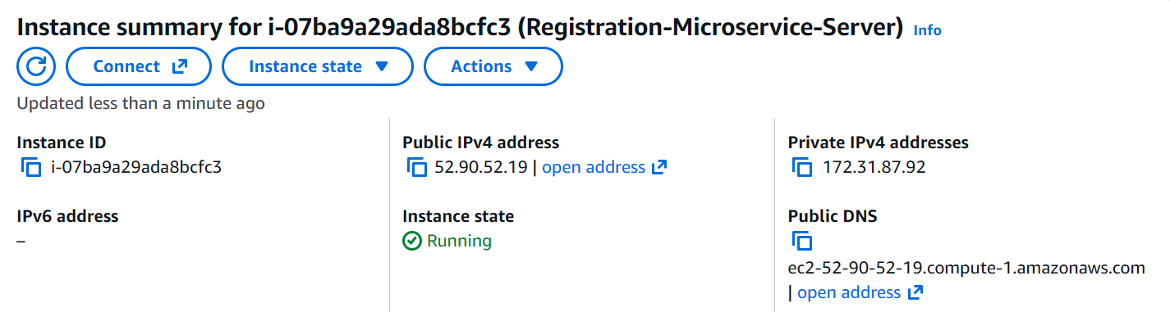
Figure 8.1: AWS EC2 Instance Summary (Public IP: 52.90.52.19)
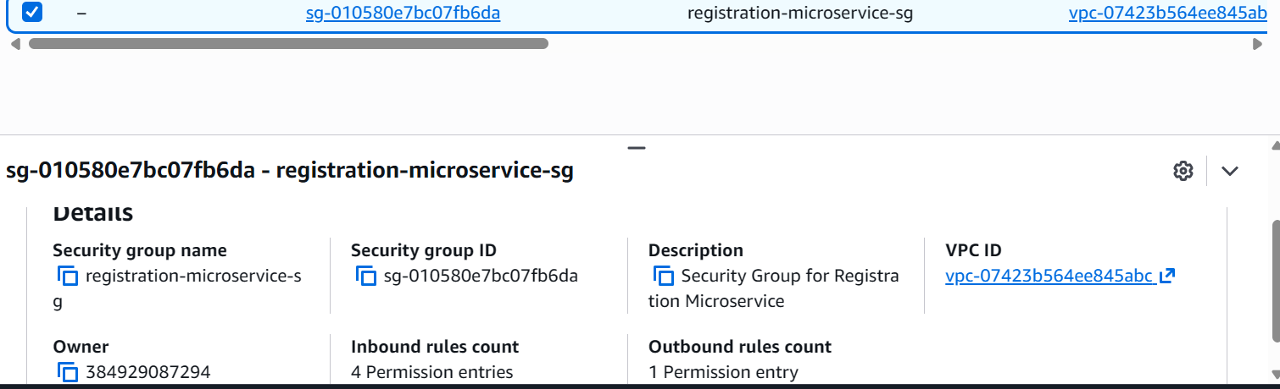
Figure 8.2: AWS Security Group Configuration (Port 5001 & Port 22)

Activity 9: Run Image Inside AWS EC2
An SSH session was established to the remote EC2 instance using 'labsuser.pem'. The image was pulled from Docker Hub with 'sudo docker pull sokhadum/registration-microservice:latest', and deployed alongside a MongoDB container on an internal bridge network ('app-net') with port 5001 published.
Command on EC2: sudo docker pull sokhadum/registration-microservice:latest && sudo docker run ...
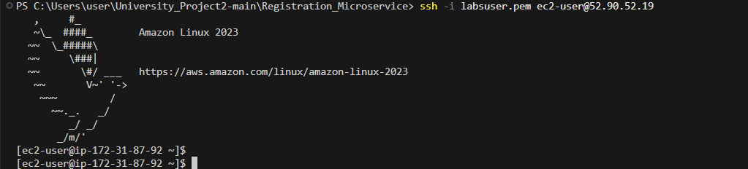
Figure 9.1: Remote SSH Terminal Connection to EC2 Instance
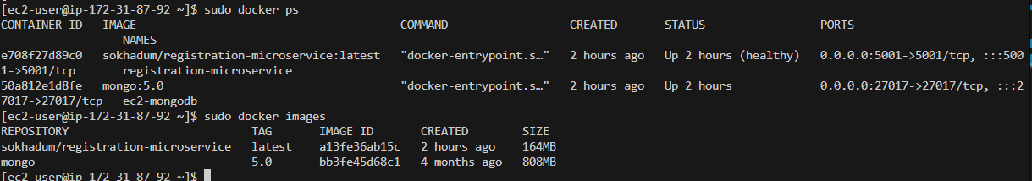
Figure 9.2: Running Container inside EC2 (sudo docker ps)

Activity 10: Call Registration API Using Postman & Verify MongoDB Persistence
The cloud-hosted Registration API was called via Postman using the EC2 Public IP address 'http://52.90.52.19:5001/register/userregister'. The service returned HTTP 201 Created. The MongoDB container on EC2 was queried directly using mongosh, verifying that the new user document ('Sokhadom Khorn EC2') was successfully stored with a salted bcrypt password hash.
• Postman Cloud Call: POST http://52.90.52.19:5001/register/userregister -> 201 Created
• Postman Cloud Health: GET http://52.90.52.19:5001/health -> 200 OK
• MongoDB Query: sudo docker exec ec2-mongodb mongosh university_identity_db --eval "db.users.find().pretty()"
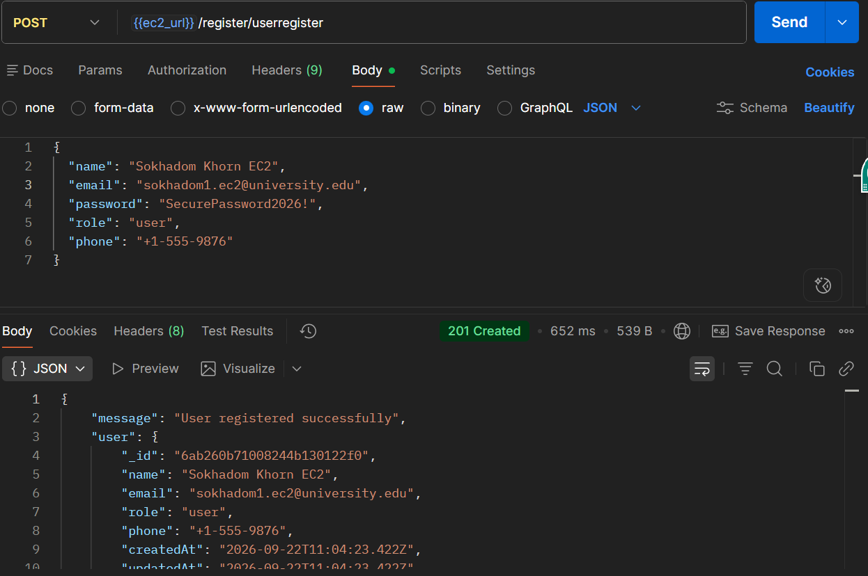
Figure 10.1: Postman Registration API Call with EC2 Public IP (201 Created)
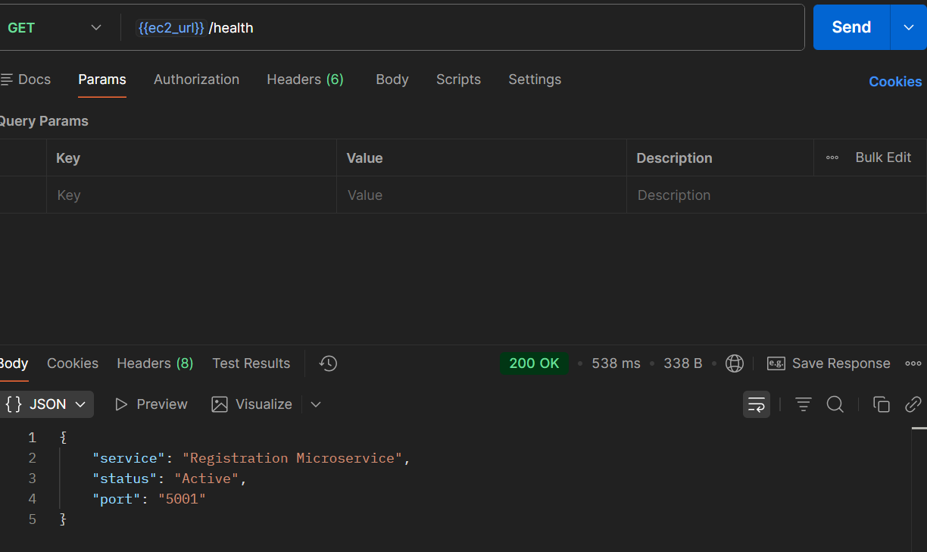
Figure 10.2: Postman Cloud Service Health Check (200 OK)
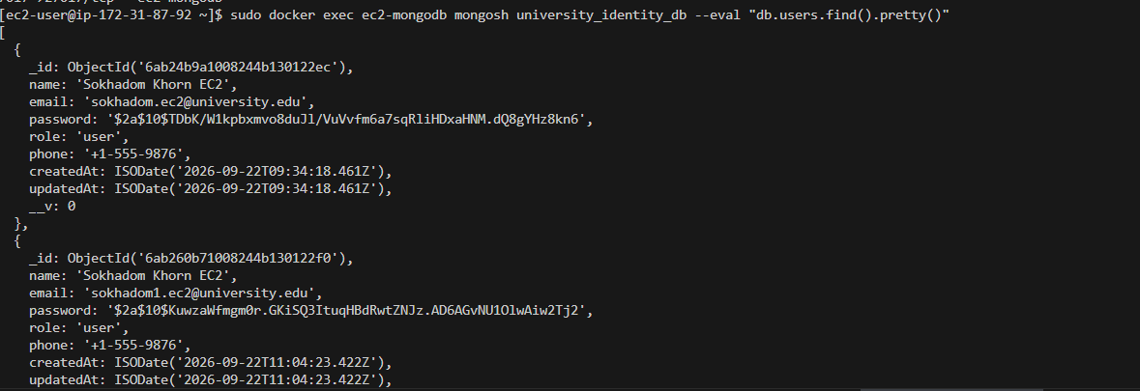
Figure 10.3: MongoDB Persistence Query inside EC2 (Hashed Password Verified)

Activity 11: Check Image and Container Availability Inside EC2
Verification commands 'sudo docker ps' and 'sudo docker images' were executed on the EC2 instance. Both containers ('registration-microservice' and 'ec2-mongodb') were verified running and healthy, and all downloaded images were confirmed in the EC2 Docker repository.
Commands on EC2: sudo docker ps && sudo docker images
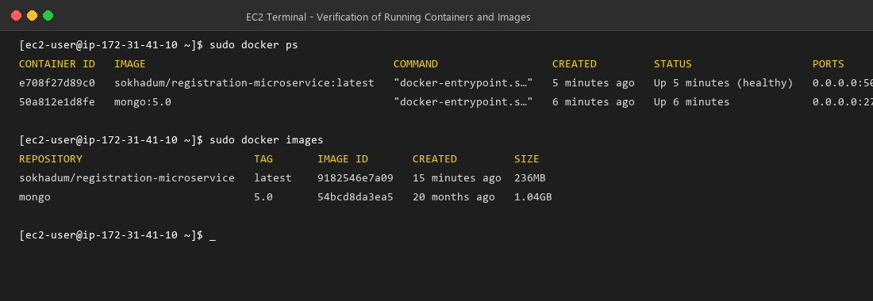
Figure 11.1: Verification of Active Containers and Images on EC2 Instance

