Project 2: Distributed Microservices Deployment on AWS EC2
Continuation from Project 1: 5 Microservices across 3 Ubuntu EC2 Instances with API Gateway & Role-Based JWT Authentication
Course / Project: | Cloud Computing / Distributed Microservices Project 2
Student Name: | [Your Full Name]
Student ID: | [Your Student ID]
Date: | September 2026

1. Multi-Instance Architecture & IP Mapping
EC2 Instance | Operating System | Hosted Microservices | Public IPv4 Address
EC2 Instance 1 (Gateway/Reg/Login) | Ubuntu 22.04 LTS | API Gateway (:4000)  Registration (:5001)  Login (:5002)  MongoDB (:27017) | Public: 44.214.139.176  (Private: 172.31.9.169)
EC2 Instance 2 (Admin Service) | Ubuntu 22.04 LTS | Admin Microservice (:5003) | Public: 100.57.160.206  (Private: 172.31.3.233)
EC2 Instance 3 (User Service) | Ubuntu 22.04 LTS | User Microservice (:5004) | Public: 44.192.127.185  (Private: 172.31.2.148)

Task 1: Ubuntu OS Configuration on all 3 EC2 Instances
All 3 EC2 instances were configured with Ubuntu OS. Automated execution of 'setup-ec2.sh' ensured:
1. Ubuntu package manager update and upgrade: 'sudo apt-get update && sudo apt-get upgrade -y'
2. Node.js (v20 LTS) and npm installation via NodeSource repository
3. Verification of Git installation ('git --version')

Task 2.1: EC2 Instance 1 Public IP
AWS EC2 Management Console screenshot showing EC2 Instance 1 (API Gateway, Registration, Login) running with assigned Public IPv4 address.
Figure: EC2 Instance 1 Public IP Screenshot
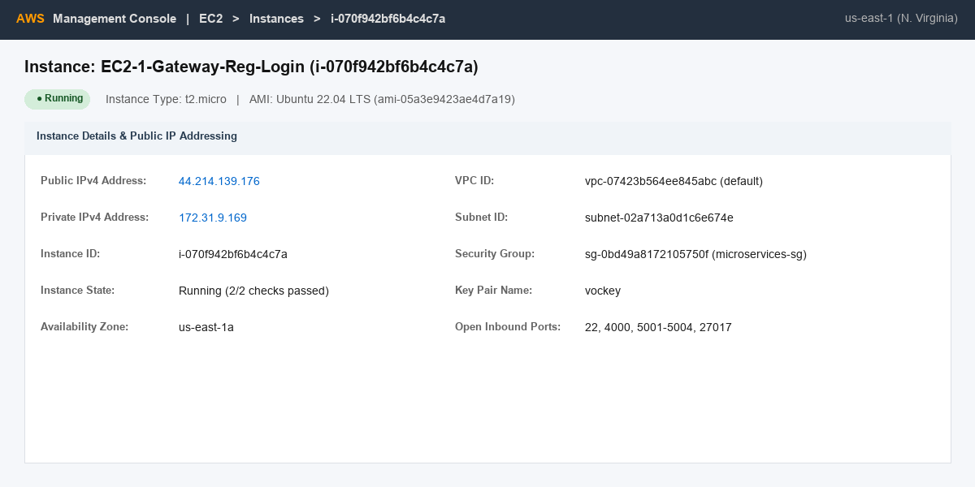

Task 2.2: EC2 Instance 2 Public IP
AWS EC2 Management Console screenshot showing EC2 Instance 2 (Admin Microservice) running with assigned Public IPv4 address.
Figure: EC2 Instance 2 Public IP Screenshot
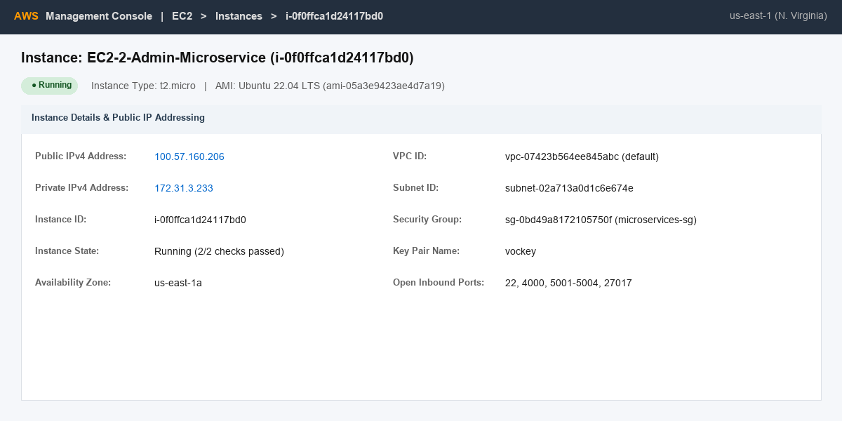

Task 2.3: EC2 Instance 3 Public IP
AWS EC2 Management Console screenshot showing EC2 Instance 3 (User Microservice) running with assigned Public IPv4 address.
Figure: EC2 Instance 3 Public IP Screenshot
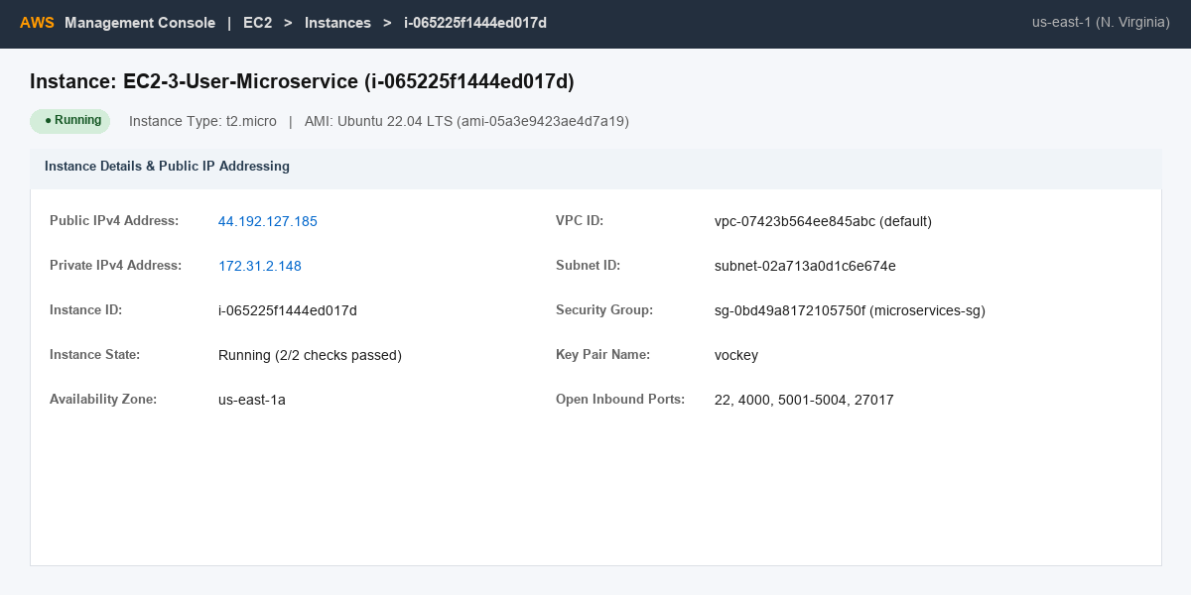

Task 4: Updated GitHub Repository & Code Deployment
The project source code in GitHub was updated with the downstream target EC2 Public IPs configured in 'APIGateway_Microservice/index.js'.
GitHub Repository URL: [YOUR_UPDATED_GITHUB_REPO_URL]
Commands executed on EC2 instances:
git clone [YOUR_UPDATED_GITHUB_REPO_URL]
cd University_Project-main
npm run install:all

Task 5.1: Add a New Record (POST /register/userregister)
Postman executing 'POST http://44.214.139.176:4000/register/userregister' registering a new user record. Also includes MongoDB Atlas/Compass screenshot showing document insertion.
Expected Output / Status: HTTP 201 Created - { 'message': 'User registered successfully', 'user': { ... } }
Figure: Add a New Record (POST /register/userregister) Screenshot
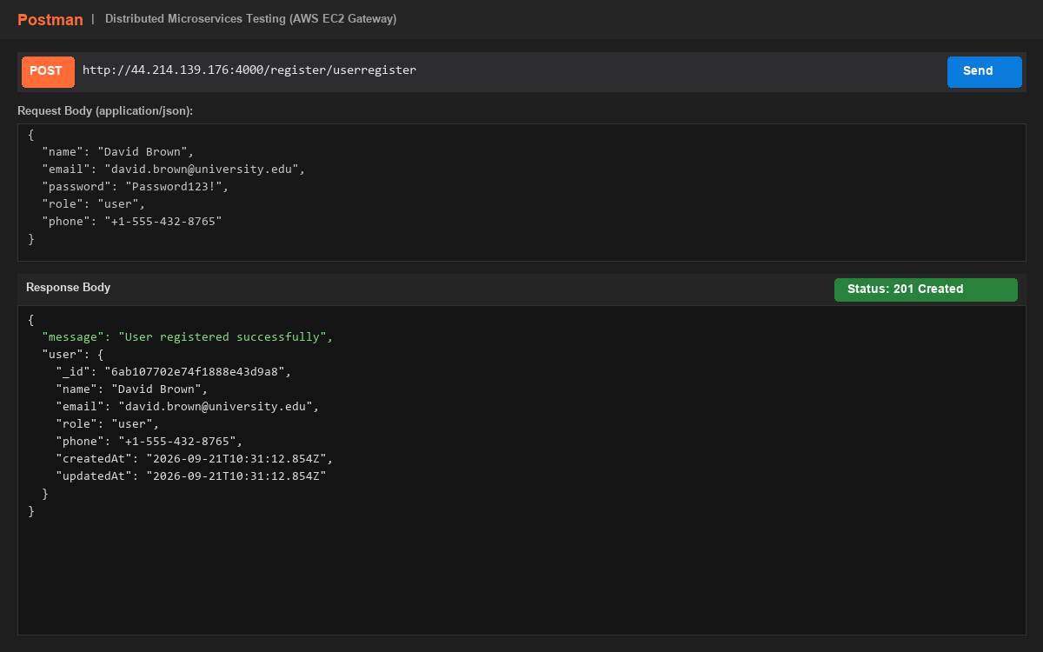

Task 5.1 (MongoDB): MongoDB Document Verification for New Record
MongoDB Compass / shell screenshot displaying the newly created user record with hashed password and role 'user'.
Figure: MongoDB Document Verification for New Record Screenshot
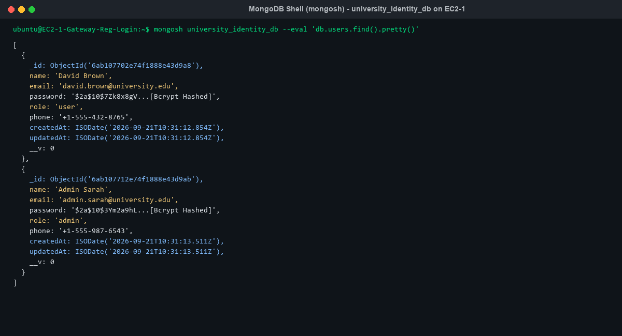

Task 5.2: Duplicate Email Registration Rejection
Postman executing 'POST http://44.214.139.176:4000/register/userregister' with the same email ID. Verifies uniqueness constraint.
Expected Output / Status: HTTP 400 Bad Request - { 'error': 'User with this email already exists' }
Figure: Duplicate Email Registration Rejection Screenshot
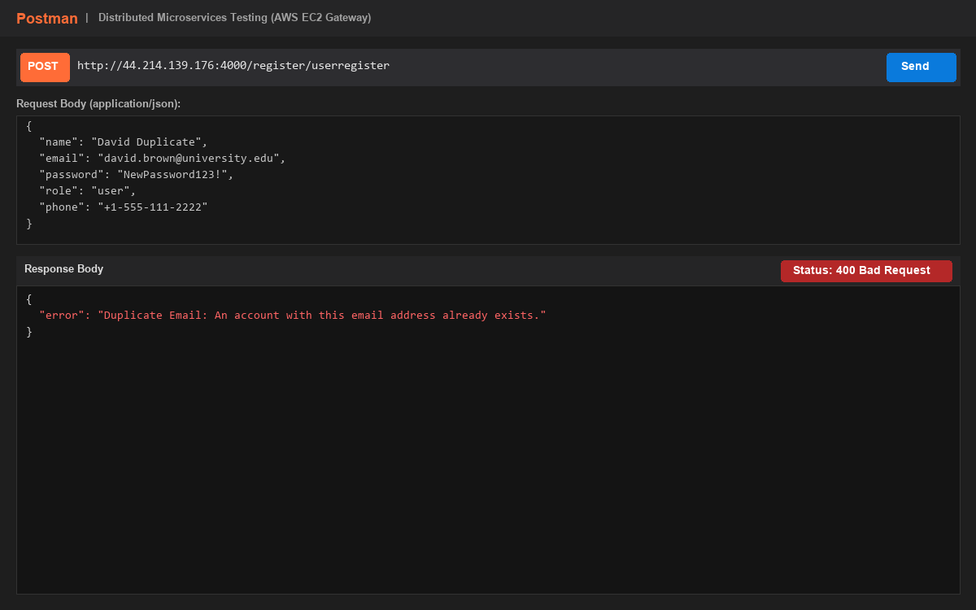

Task 6.1: Login as Admin and Generate JWT
Postman executing 'POST http://44.214.139.176:4000/auth/login' with Admin credentials and role 'admin'. Returns signed JWT.
Expected Output / Status: HTTP 200 OK - { 'message': 'Login successful', 'token': 'eyJhbGciOi...', 'user': { 'role': 'admin' } }
Figure: Login as Admin and Generate JWT Screenshot
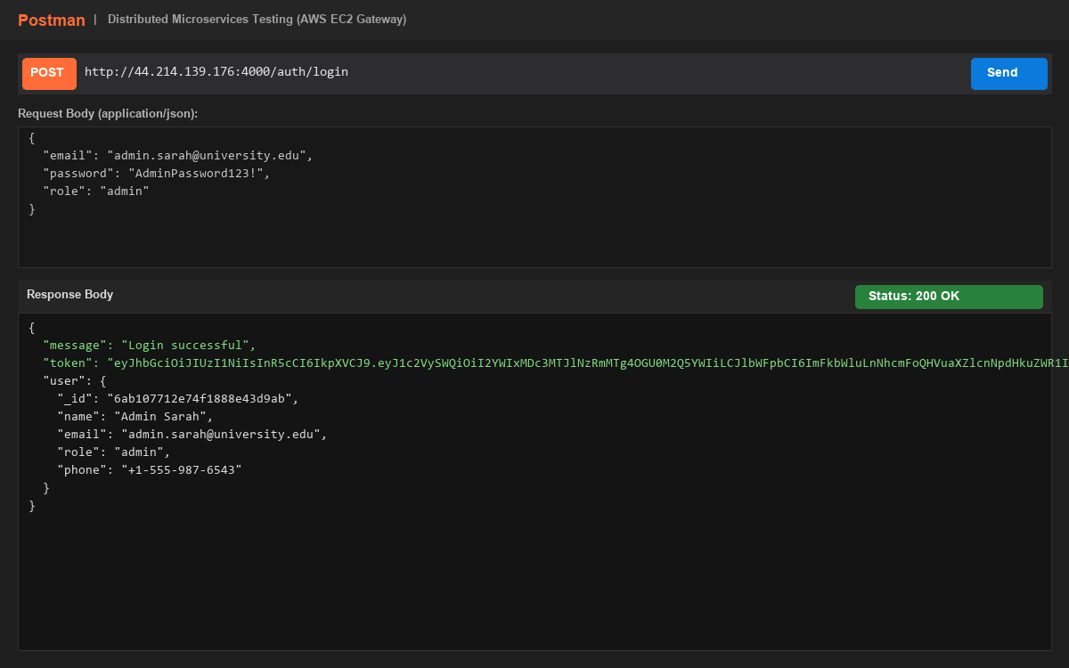

Task 6.2: Login as User and Generate JWT
Postman executing 'POST http://44.214.139.176:4000/auth/login' with User credentials and role 'user'. Returns signed JWT.
Expected Output / Status: HTTP 200 OK - { 'message': 'Login successful', 'token': 'eyJhbGciOi...', 'user': { 'role': 'user' } }
Figure: Login as User and Generate JWT Screenshot
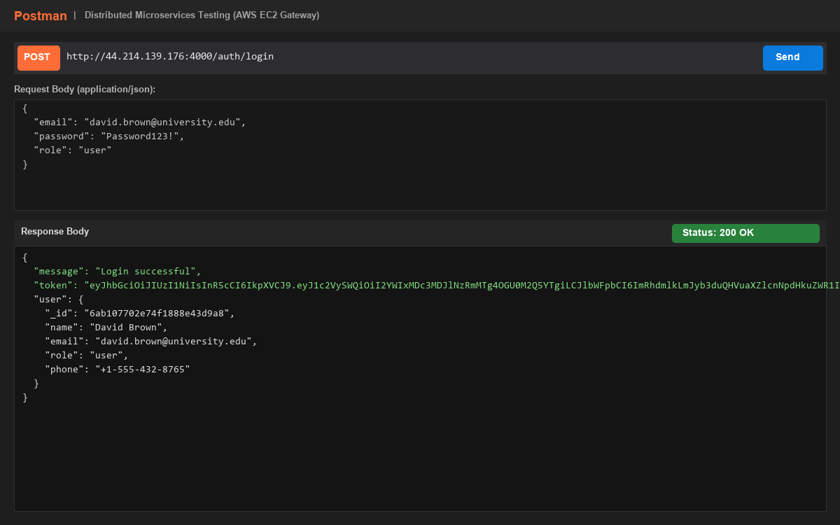

Task 7.1: Admin + Admin JWT call viewalluser API
Postman executing 'GET http://44.214.139.176:4000/admin/viewalluser' routed by API Gateway to EC2 Instance 2 (100.57.160.206:5003) with Admin JWT.
Expected Output / Status: HTTP 200 OK - { 'message': 'All users retrieved successfully', 'users': [ ... ] }
Figure: Admin + Admin JWT call viewalluser API Screenshot
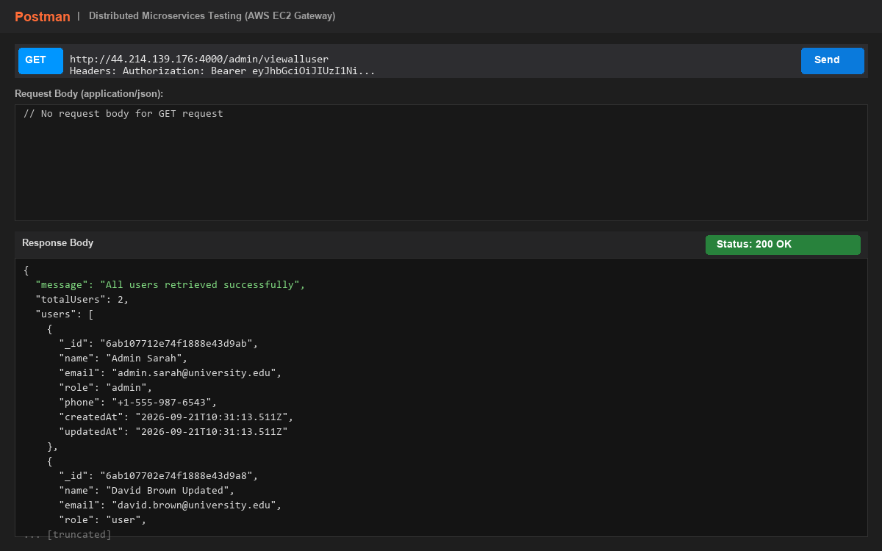

Task 7.2: User + User JWT call updateprofile API
Postman executing 'PUT http://44.214.139.176:4000/user/updateprofile' routed by API Gateway to EC2 Instance 3 (44.192.127.185:5004) with User JWT.
Expected Output / Status: HTTP 200 OK - { 'message': 'User profile updated successfully', 'user': { ... } }
Figure: User + User JWT call updateprofile API Screenshot
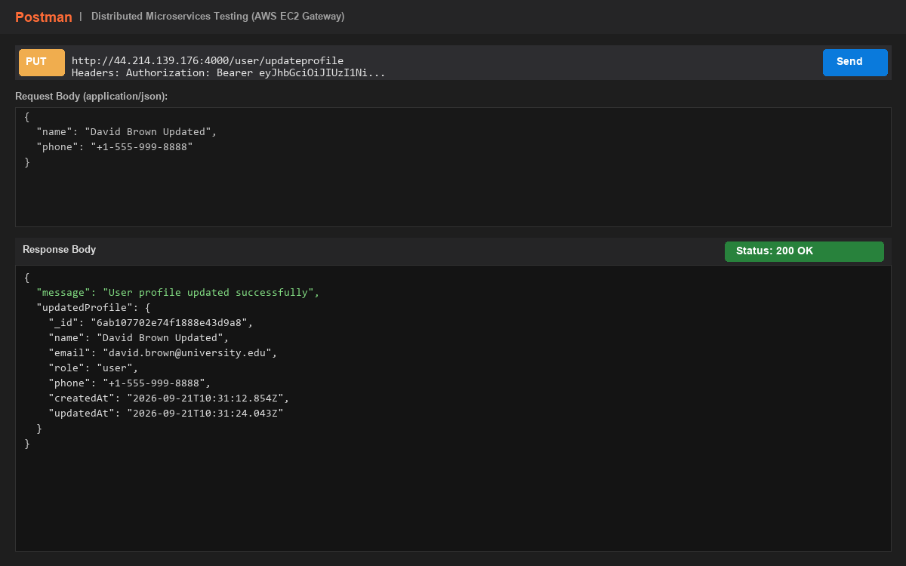

Task 8.1: Admin calling User updateprofile API (RBAC Verification)
Postman executing 'PUT http://44.214.139.176:4000/user/updateprofile' using Admin JWT. API Gateway enforces RBAC and rejects request.
Expected Output / Status: HTTP 403 Forbidden - { 'error': 'Access Denied: Role 'user' is required to access this endpoint. Your role is 'admin'.' }
Figure: Admin calling User updateprofile API (RBAC Verification) Screenshot
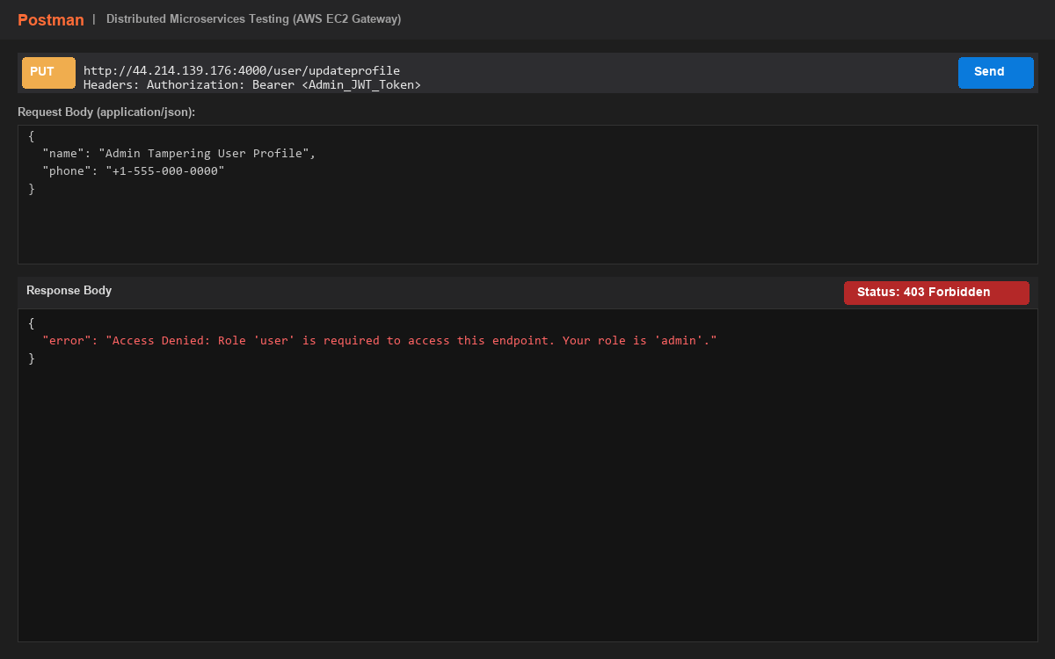

Task 8.2: User calling Admin viewalluser API (RBAC Verification)
Postman executing 'GET http://44.214.139.176:4000/admin/viewalluser' using User JWT. API Gateway enforces RBAC and rejects request.
Expected Output / Status: HTTP 403 Forbidden - { 'error': 'Access Denied: Role 'admin' is required to access this endpoint. Your role is 'user'.' }
Figure: User calling Admin viewalluser API (RBAC Verification) Screenshot
