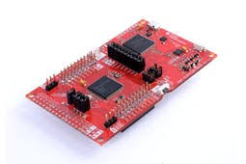

Unit 1 Lab:

Installing and Using Code Composer Studio

ECEN260: Microprocessor Based-System Design

Spencer Eccles & Gage Mikos

Br. Fisher & Br. Sheetz

# Objective

Install Code Composer Studio (CCS), create a new Assembly language project, run some code, and collect screen shots while doing it.

# Procedure

Followed instructions on iLearn with instructor, including copying and pasting example code to Code Composer Studio and seeing how it runs:

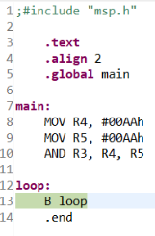 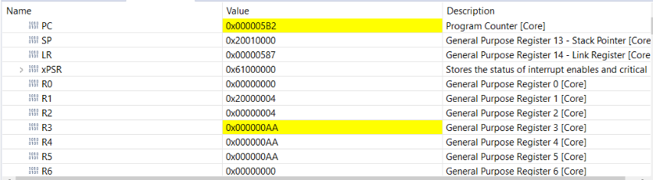

# Test

Tested project by compiling it, running it one step at a time with the “step-into” button, and monitoring the registers in the above screenshot.

# Conclusion

We coded in ARM Assembly for the first time and programed hardware directly for the first time.