Sokkun NORN

Street 371 Phum Tropeang Chhuk (Borey Sorla), Sangkat Tek Thla

Khan Sen Sok P.O. Box 511 Phmon Penh, Cambodia

Tel: 023 640 33 00

E-mail: [sokkun.norn1998@gmail.com](mailto:sokkun.norn1998@gmail.com)

Date: May 19th, 2019

Rotati Consulting

Rotati Villa No 2C, Street 490,   
Sangkat Phsar Daeum Thkov,

Khan Chamkar Morn,   
Phnom Penh, Cambodia

061 77 33 96

Website: www.rotati.com

E-mail: info(at)rotati.com

Re:Apply forWeb Developer

Dear Sir/Madam,

I am writing to express of my interest in applying for position forWeb Developer. I am interested in this position because it is suitable with my skills, so I would like to apply a CV to your company.

As my experiences in school project I and II, I am confident to develop dynamic and static website, analyze project, design database, build system, test project, design poster, logos and banner, and develop responsive website. For two-year studied at PNC, I have learnt several subjects such as PHP, JAVA, CMS, Database analysis, administrator, AJAX JSON, Laravel, MVC concept, English, and Professional Life.

I have my commitments when I study in PNC. I understood well with PNC value such as trust, responsibility, solidarity, respect, Demanding approach. Moreover, at PNC I have learning soft skills such as communication, task management, time management, leadership, team work, presentation, etc. Since PNC official language is English, I have really enhanced my English ability on communication.

I am confident that my two years of training and some experiences in leading skills with PNC can demonstrate my capability in this position. If you would like, please contact me through my phone number. Thank you so much for your consideration.

I am looking forward to hearing from you.

Sincerely,

SokkunNorn

**Sokkun NORN**

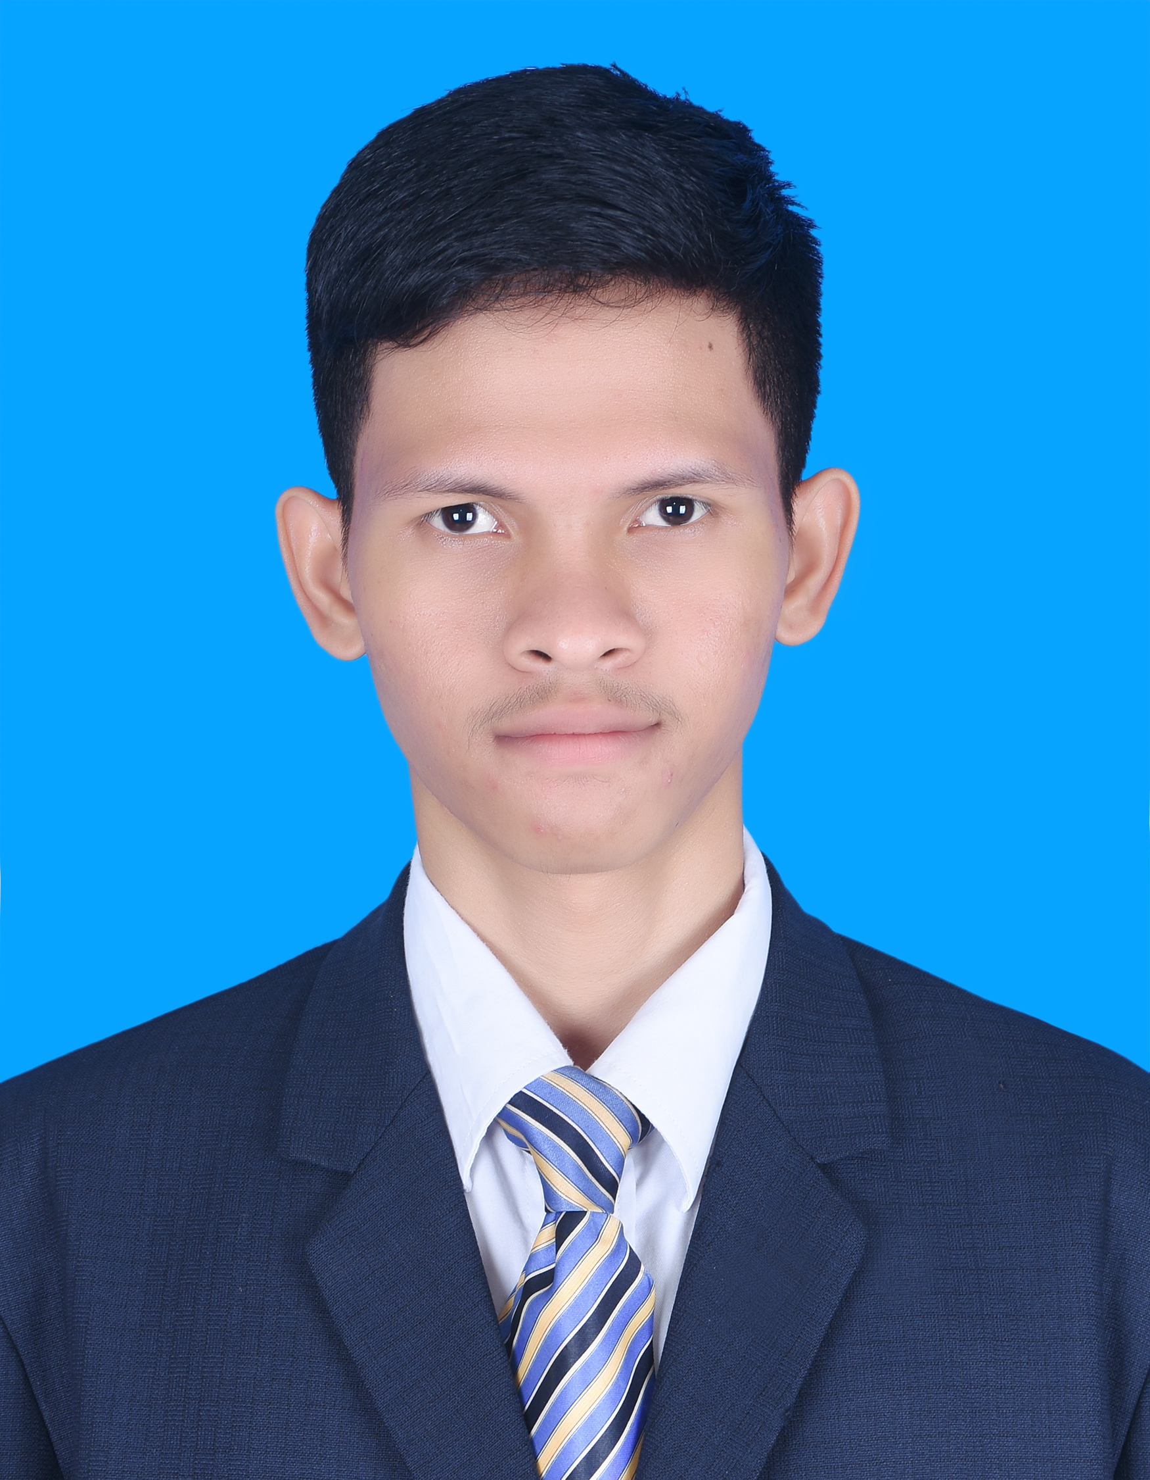

Address: Street 371, Phum Tropeng Chhuk (Borey Sol)

Phone number: 023 640 33 00

E-mail: [sokkun.norn1998@gmail.com](mailto:sokkun.norn1998@gmail.com)

**PERSONAL DATA:**

Last Name : Norn Gender : Male

First Name : Sokkun Data of birth : April 30, 1998

Marital Status : Single Nationality : Cambodia

Country : Cambodia Place of birth : Kandal

**OBJECTIVE:**

Apply for : Mobile App Development

**EDUCATION BACKGROUND:**

2017 – April 2019 : Scholarship to study in Passerelles Numeriques Cambodia (PNC),

in major Web Developer(WEP)

2016 – 2017 : High School certificate, Serimokol High School.

**SCHOOL PROJECTS:**

September – 2018 : **Virtual Company** at Passerelles Numeriques Cambodia (PNC)

* Installation window OS and soft wares
* Create and put permission on user
* Control on file share of group
* Design logo
* Build page contact us on project Resale shop
* Calculate on page product.

1 February – 2019 : **Topic IT Research** at Passerelles Numeriques Cambodia (PNC)

* Research React language
* Found component of React
* Build web application from React
* Problem solving.

Soon in May 2019, I will practice on Virtual Company 2

* Meeting client to understand about project and collect requirement
* Project management (analyzing, designing, planning, resourcing)
* Project development (Mock-up design, coding, demo, testing)
* Practice on languages of PHP, Js, JQuery, HTML&CSS, Bootstrap, Ajax, Laravel, MySQL
* Project result presentation and demonstration

**Additional Experiences:** study tour at 6 companies for 2 years, volunteer in several events in the school, participated in several external events (BarCamp, Career Forum, etc), and worked on several projects assigned by teachers.

**TRAINING COURSES:**

: Goal setting

: Time management

: Self-development.

**TECHNICAL SKILLS:**

PHP : Process of code and can crud data.

Database : Analyze database and query database.

JAVA : Understand process of code, process of concept OOP.

Laravel : Query data with database.

Responsive Design : Work with Bootstrap 4 and Materialize.

**SOFT SKILLS:**

: Good at communication, responsibility, team work, time management, work hard, honest, presentation.

**Language:**

Khmer : Mother Tongue

English : Medium speaking, listening, reading, and writing.

**HOBBIES:**

: Searching about new technology (specify on programming)

: Logical problem solving.

**REFERENCE:**

Name : Channak Chhon.

Relationship : WEB Programming Trainer

Organization : Passerelles Numeriques Cambodia(PNC).

Email : [channak.chhon@passerellesnumeriques.org](mailto:channak.chhon@passerellesnumeriques.org)

Phone : 010 797 245

Name : Sreymy Soeurng

Relationship : Math Trainer

Organization : Passerelles Numeriques Cambodia(PNC).

Email : [sreymy.soeurng@passerellesnumeriques.org](mailto:sreymy.soeurng@passerellesnumeriques.org)

Phone : 085 666 253