SokkunNorn

Street 371 Phum Tropeang Chhuk (Borey Sorla), Sangkat Tek Thla

Khan Sen Sok P.O. Box 511 Phmon Penh, Cambodia

Tel: +855 16 500 854

E-mail: [sokkun.norn@gmail.com](mailto:sokkun.norn@gmail.com)

**Date**: 15 1/ 2019

Ly Hour Group

No. 85-88, St. Kim il Sung(289),

Sangkat Boeung Kak II, Phnom Penh, Cambodia.

023 998 789

**Website**: [www.lyhourgroup.com](http://www.lyhourgroup.com)

**E-mail**: [info@lyhourgroup.com](mailto:info@lyhourgroup.com)

**Re:** Apply forInternship

**Dear Sir/Madam:**

I study at Passerelles Numeriques Cambodia organization (PNC) for 2 years. I am interesting in the company that want to get more employees to work with program language. So, I am applying to be a programmer to company.

According to my studying in PNC for 2 years. I get some skill: CMS, Algorithm, Java, PHP, PHP MVC project, Laravel, jQuery, UML and English. In my skill, I try to learn it for the best and I have experience from project VC1 in PNC that work in team and have good communication in my teamwork too. I think that my hard skills are matching and can work in your company for to be a programmer.

I have my commitments when I study in PNC. I get value from PNC take in my mind such as trust, responsibility, solidarity, respect, Demanding approach. Moreover, I learned soft skill from PNC too is professional lift (PL). I like to share my experience and knowledge to my friends and like to communication with other people in society. I like to learn working and always find solution for my working. I always have motivated in myself.

Specifically, I have a lot of skills from PNC that matching to working in company so I think that I can work in company to be a programmer. I want to develop company together if I pass in company. Now I am so interested to your company. Please accept me to work in your company. I finally hope that you can accept me for develop your company and go to success together.

Sincerely,

SokkunNorn

**Sokkun.Norn**

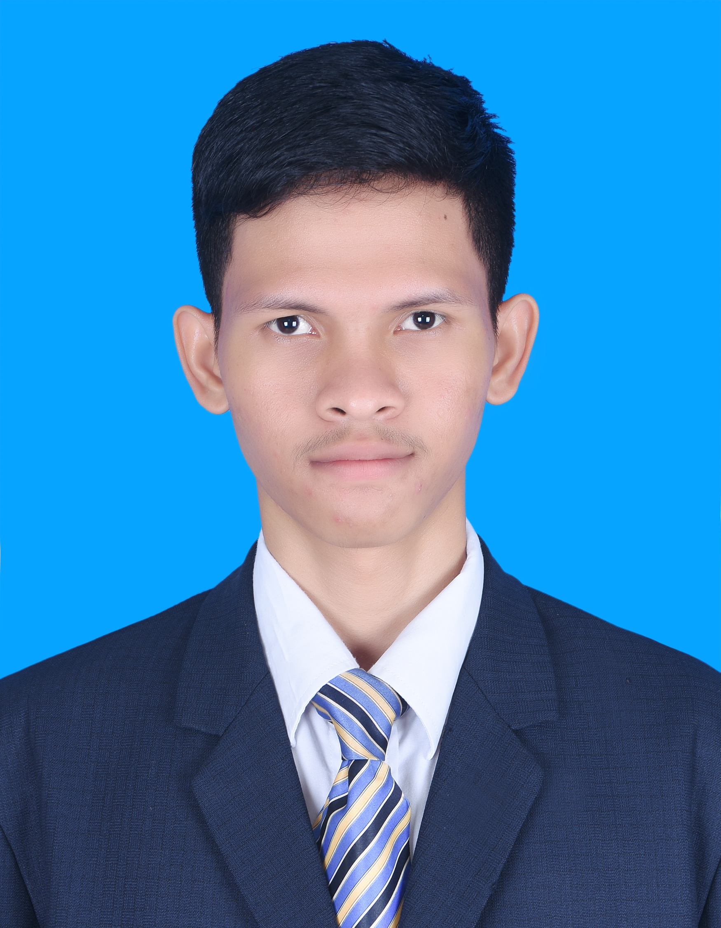

Address: Street 371, Phum Tropeng Chhuk (Borey Sol)

Phone number: (+855) 016 500 854

E-mail: [sokkun.norn1998@gmail.com](mailto:sokkun.norn1998@gmail.com)

**PERSONAL DATA:**

Last Name : Sokkun Gender : Male

First Name : Norn Data of birth : April 30, 1998

Material Status : Single Nationality : Cambodia

Country : Cambodia Place of birth : kandal

**OBJECTIVE:**

Apply for : INTERNSHIP.

**EDUCATIONAN BACKGROUDE:**

2017 – April 2019 : Scholarship to study in Passerelles Numeriques Cambodia (PNC),

in major Web Developer(WEP)

2016 – 2017 : Got High School certificate, Serimokol High School.

**SCHOOL PROJECTS:**

September – 2018 : **Virtual Company** at Passerelles Numeriques Cambodia (PNC)

* Installation window OS and soft wares
* Create and put permission on user
* Control on file share of group
* Design logo
* Build page contact us on project Resale shop
* Calculate on page product.

1 February – 2019 : **Topic IT Research** at Passerelles Numeriques Cambodia (PNC)

* Research React language
* Found component of React
* Build web application from React
* Problem solving.

**Additional Experiences:** During study in PNC school for 2 years, get more project in school that work in group and individual with new language programming, and volunteer in several events in school and event out school.

**TRAINING COURSES:**

: Goal setting

: Time management

: Self-development.

**TECHNICAL SKILL:**

PHP : Process of code and can crud data.

Database : Analyze database and query database.

JAVA : Understand process of code, process of concept OOP.

Laravel : Query data with database.

Responsive Design : Work with Bootstrap 4 and Materialize.

**SOFT SKILLS:**

: Good at communication, responsibility, team work, time

management, work hard, honest, presentation.

**LANGUAGE:**

Khmer : Mother Tongue

English : Good speaking, listening, reading, and writing.

**HOBBIES:**

: Thinking about programming.

: Find new idea, think about programming and preparation.

: Problem solving logical.

**REFERENCE:**

Name : Channak Chhon.

Relationship : Teacher (WEP).

Organization : Passerelles Numeriques Cambodia(PNC).

Email : [channak.chhon@passerellesnumeriques.org](mailto:channak.chhon@passerellesnumeriques.org)

Phone : 010 797 245

Name : Sreymy Soeurng

Relationship : Teacher (Math).

Organization : Passerelles Numeriques Cambodia(PNC).

Email : [sreymy.soeurng@passerellesnumeriques.org](mailto:sreymy.soeurng@passerellesnumeriques.org)

Phone : 085 666 253